Youth Custodial Rule 9 – Approved and Unauthorised Items
Banksia Hill Detention Centre

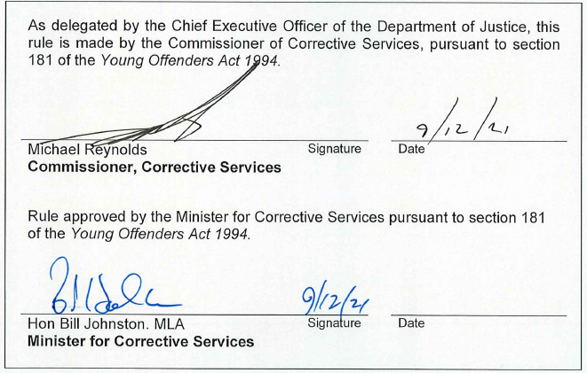

Version 1.0 approved
Current version
Current version approved | TBD
Current version effective | TBD
Document reference

Contents
1 Purpose 3
2 Scope 3
3 Detainees 3
4 Staff 3
5 Social Visitors 4
6 Official Visitors 4
6.2 Emergency services 5
6.3 Western Australia Police Force Officers, Australian Federal Police 5
6.4 Legal practitioners 5
6.5 Official visitors with statutory powers of entry 5
7 Contractors 6
8 Definitions 7
9 Related legislation 7
Appendix A: Prohibited Classifications 8

Purpose

This Rule provides for the approval by the Superintendent of items that can be brought into Banksia Hill Detention Centre (BHDC) by visitors, staff and other persons and the items that detainees can have access to and keep in their possession.

Restrictions on items is necessary to maintain the good order, security and safety of BHDC.

Scope

This Rule applies to all visitors and other persons entering BHDC and all BHDC detainees and staff.

Detainees
    - The Superintendent must use all reasonable endeavours to ensure detainees are not permitted access to any item:
- which may threaten the security or good order of BHDC; or
- which could be used by a detainee for harm or self-harm
- any other item classified as ‘Prohibited’ as classified in Appendix A.
    - The Superintendent must determine and approve the items that detainees are permitted to keep in their possession. The Superintendent must not approve an item if, in the opinion of the Superintendent, the item:
- constitutes a threat to the security or good order of BHDC; or
- could be used by a detainee for harm or self-harm
- is classified as ‘Prohibited’ as classified in Appendix A.
    - Detainees must not keep in their possession any item which has not been approved by the Superintendent under 3.1.2.
    - The Superintendent must advise detainees of items that are approved under 3.1.2 in the manner considered most appropriate by the Superintendent to bring the items to the attention of detainees.

Staff
    - The Superintendent must determine and approve the items that staff are permitted to bring into BHDC.
    - Superintendent has approved staff to bring daily dose quantities of prescribed personal medication into BHDC.
    - Items which are not approved by the Superintendent are unauthorised items.

The Superintendent must ensure a list of the items that staff are not permitted to bring into BHDC is displayed in a visible position at the Gatehouse.
    - Staff must only bring into BHDC items that have been approved by the Superintendent under 4.1.1, 4.1.2 or 4.1.7.

All items brought into BHDC by staff must be carried into BHDC in an approved clear carry bag and secured in a locker or locked office while in BHDC.

Where staff are required to carry an approved item on their person the Assistant Superintendent Security shall be informed by the staff member.

The Superintendent may consider individual requests from staff to bring into BHDC an unauthorised item and may grant approval in writing where the Superintendent is satisfied that the item:
- is necessary for the staff member to undertake their daily duties; and
- does not threaten the good order or security of BHDC.

Social Visitors
    - The Superintendent shall determine and approve the items which social visitors are permitted to bring into BHDC.
    - The Superintendent has approved social visitors to bring a bottle of baby formula and one additional nappy for any infants included in the visiting party into BHDC.
    - Items which are not approved by the Superintendent are unauthorised items.
    - The Superintendent must ensure a list of the items social visitors are not permitted to bring into BHDC is displayed in a visible position at the Gatehouse.
    - Social visitors are only permitted to bring into BHDC items that have been approved by the Superintendent under 5.1.1 or 5.1.6.
    - Custodial Officers must ensure social visitors are informed of the restrictions on items that can be brought into BHDC when visiting.

The Superintendent shall consider individual requests from social visitors to bring into BHDC an unauthorised item and may grant approval in writing where the Superintendent is satisfied that the item:
- is required by the visitor during their visit; and
- does not threaten the good order or security of BHDC.

Official Visitors
    - Official visitors are only permitted to bring into BHDC items which are necessary for undertaking their professional duty.
    - Items which are not necessary for an Official Visitor to undertake their professional duty are unauthorised items.

The Superintendent may consider individual requests from Official Visitors to bring into BHDC an unauthorised item and may grant approval in writing where the Superintendent is satisfied that the item does not threaten the good order or security of BHDC.
    - The following items are not considered necessary to performing the duties of official visitors and are therefore not permitted unless approved by the Superintendent
- electronic tablets (except for Emergency Services);
- removable media;
- SIM cards; and
- cable connection or other method of connectivity.

Custodial Officers must advise official visitors when booking an appointment that they may request written approval from the Superintendent to bring into BHDC unauthorised items.

The items considered necessary for the different categories of official visitors to perform their professional duties are set out below.

Emergency services

Emergency Services for the purposes of this Rule includes St John’s Ambulance and the Department of Fire and Emergency Services.

Emergency Services are permitted to bring any equipment into BHDC that is necessary to respond to an emergency. This includes mobile phones, iPads or electronic tablets that have the ability to transmit critical data. Mobile phones must be sighted and recorded on entry and exit from BHDC.

Western Australia Police Force Officers, Australian Federal Police

Officers of the Western Australian (WA) Police Force and Australian Federal Police are permitted to bring equipment including audio and video equipment and documentation that is necessary for the purposes of carrying out an investigation, interview or assisting in incidents occurring at BHDC.

Firearms shall not be brought into BHDC and shall be secured in the weapons safe.

Legal practitioners

Legal practitioners, who are visiting detainees in an official capacity, are permitted to bring the following:
- laptop (with Wi-Fi turned off)
- documents necessary for the interview
- dictaphone (without Wi-Fi capability).

The legal practitioner shall be permitted to display video or other photographic media on their laptop relating to their official business.

Official visitors with statutory powers of entry

Official visitors with statutory powers to enter BHDC, such as staff from the State Coroner’s office, Office of the Inspector Custodial Services and the Ombudsman WA may bring into BHDC any equipment necessary for performing their official duties.

Judges of the Supreme Court or District Court and members of their investigatory staff may bring into BHDC any equipment necessary for the recording of hearings or otherwise performing their duties.

Contractors
    - Contractors are only permitted to bring into BHDC items which are necessary for performing the works or services that they have been contracted to perform.
    - Items which are not necessary for performing such works or services are unauthorised items.

The Superintendent may consider individual requests from Contractors to bring into BHDC an unauthorised item and may grant approval in writing where the Superintendent is satisfied that the item does not threaten the good order or security of BHDC.
    - Contractors requiring tools to be taken into BHDC shall be required to provide the Gatehouse staff with a tool inventory which shall be checked prior to entry and exit. Items which are not necessary for performing such works or services are unauthorised items.
    - Tool management shall be in accordance with COPP 9.8 – Tools and Materials.

Definitions
Terms used in this rule have the meaning given to them in COPP 9.5 – Approved and Unauthorised Items.

Related legislation
- Young Offenders Act 1994
- Young Offenders Regulations 1995

Document version history
Version no | Primary author(s) | Description of version | Date completed
0.1 | Operational Policy | Initial draft | 20 September 2019
0.2 | Operational Policy | Updated following consultation | 15 March 2021
1.0 | Operational Policy | Approved by Minister for Corrective services | TBD

Appendix A: Prohibited Classifications
This Appendix provides direction as to the classification types that detainees are allowed to have access to as well as those that are prohibited.

Prohibited Classifications

Audio- CDs
- Restricted High Impact Themes (Level 3)
- Exceeding Level 3
- Refused Classification

Computer Games/DVDs:
- R (18+) - Restricted to 18+
- X (18+) - Restricted to 18+
- RC - Refused Classification

Printed Materials:
- Category 1 Restricted - Restricted to 18+ Years
- Category 2 Restricted - Restricted to 18+ Years
- RC - Refused Classification

