Re-establishing safety, rebuilding connections

Designing an FDV Hub service for Armadale

Thank You
To the people who shared their expertise and ideas informed
by their own lived experience.
To the Elders and community leaders who were so generous in advice and feedback.
To the many diverse representatives from community organisations and services who gave their time, expertise and passion to this project as well as their ongoing efforts to support those experiencing the impacts of family and domestic violence.
To the representatives from government and peak bodies who participated with open minds and contributed critical insights and guidance.
To all the people who contributed to this project. To those who chose to be named - - and to those who didn’t. Only with your collective efforts was this project possible.

Acknowledgement of Country
Innovation Unit acknowledges the Whadjuk Noongar people as the Traditional Owners of the country upon which this project was conducted. We acknowledge the importance of paying respect to their land, their Elders past, present, and emerging, and the continuing cultural and spiritual practises of Aboriginal people.
Caution
Some people may find parts of this content confronting or distressing.
Recommended support services include:
1800 Respect - 1800 737 732
Lifeline - 13 11 14
Women's Domestic Violence Helpline - 1800 007 339
Men’s Domestic Violence Helpline - 1800 000 599

This report explores the findings of a stakeholder engagement project commissioned by the Department of Communities and delivered by Innovation Unit.

Innovation Unit is a not-for-profit social enterprise that grows new solutions for complex social challenges. By making innovation happen we help create a world where more people belong and contribute to thriving societies. We build alliances with ambitious places, organisations and systems around the world to adapt, adopt and scale innovations that deliver lasting impact.

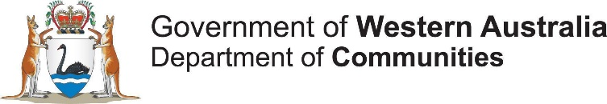
1. Executive Summary

In January 2017, the Western Australian (WA) State Government released their Stopping Family and Domestic Violence Policy, which committed to ending the cycle of family and domestic violence (FDV). It included the establishment of two One Stop Hubs in Mirrabooka and Kalgoorlie to facilitate access to specialist FDV support services. The Hub models in Mirrabooka and Kalgoorlie are showing significant engagement. The model provides for primary prevention, early intervention and post crisis intervention, filling gaps left by a focus on crisis response in other parts of the system.
On 28th October 2021, the Minister for the Prevention of Family and Domestic Violence announced that a third Hub will be opening in the Armadale Child Protection district. The Department of Communities (Communities) commissioned Innovation Unit to facilitate and support an engagement process, based on Innovation Unit’s ‘Model for Scale’, an evidence based method for adapting service models from one place to another.

The engagement process
Communities identified a number of clear goals for the engagement process:
- That the model meets a genuine need in the Armadale district, and therefore has the best potential for achieving outcomes.
- That there is local ownership of the FDV Hub, establishing a strong foundation for ongoing operations.
- That proposals are uncovered for several practical service design components including target groups, potential location and service offering
The process involved engaging with the team from Naala Djookan, the Mirrabooka FDV Hub, to understand the existing model and the learnings gained since operation. That knowledge then allowed for a nuanced conversation with the Armadale community, Elders and Service providers to adapt the model to the Armadale context. A key consideration of the process was the specific focus on the local Aboriginal community, given the overrepresentation of Aboriginal women in FDV statistics, and the under-servicing of their needs in existing service interventions. As a result, the process sought to engage with Aboriginal elders, service providers and community members as a priority during the short time period for engagement. Engagements in Armadale included:
- Online Community Survey
- Eight (8) semi structured interviews (three (3) with people with lived experience, four (4) with local service providers, one (1) with Naala Djookan leadership. This included representatives from CaLD and Aboriginal communities and service providers.
- Two (2) sessions with Armadale Elders based out of the Champion Centre
- Two (2) Aboriginal engagement sessions with diverse local groups of Aboriginal people, most with a lived experience of FDV
- Adopt and Adapt workshop bringing together Armadale stakeholders (mostly service providers), supported by key Naala Djookan staff
- Walkthrough session presenting two service models, and asking for feedback on key questions raised during the engagements.

Target group
This work considered the existing data around FDV incidents and Armadale demographic data. This data was presented to participants during the Adopt and Adapt workshop who were asked to imagine a successful Hub model and to define the key groups that would be accessing services. Following the workshop, participants’ responses were collated and analysed for themes. Local service providers prioritised Aboriginal people (50% of projected target population) and CaLD people (25% of projected target population) as key user groups for the service. This reflected the existing challenges of service accessibility and impact for these groups, validated by local FDV data. For both Aboriginal and CaLD service users, the communities that surround them have significant impact on their experience of and decision making around FDV. For Aboriginal women, the experience of shame preventing access to support was palpable in all our engagements with them.
Having taken a view that the primary role of the FDV Hub is in support of women experiencing FDV, many of the conversations during engagement activities turned to the role that the FDV Hub might play with men in order to achieve long term impact. Engagements recommended that 30% of delivery be targeted at male perpetrators or potential perpetrators.

Target groups for the Armadale FDV Hubs.

Cultural Background
- Other ( non – ATSI): 25 per cent
- CaLD: 25 per cent
- Aboriginal people: 50 per cent
Gender
- Other (LGBTQI, male): 10 per cent
- Male: 30 per cent
- Women 60 per cent

Service model for Armadale
In developing a service design that would meet the needs of these marginalised client groups, two service models emerged from the Adapt and Adopt workshop (see Appendix 2) attended by service system representatives. One more closely resembled the existing Mirrabooka service delivery, except with the provision for men’s work identified. The other took a more divergent position, focusing on embedding advocates within existing trusted community spaces, as a way to ensure diverse access. In providing feedback on these models, service providers confirmed that a centralised FDV Hub would better meet the needs for service coordination and decrease risks of service fragmentation. However, there remained a recognition that outreach would likely have a strong impact on engaging the most isolated service users, particularly CaLD women and Aboriginal service users.
As a result, the service model that emerged for the Armadale FDV Hub consisted of a main space for women experiencing FDV, that acts as a focal point for the service, with a smaller off-site operation for male perpetrators or potential perpetrators, in a separate location, likely based within an existing men’s service or space. In order to facilitate access to the FDV Hub by those who would find a centralised service delivery difficult, these two spaces are supported by outreach activities into existing community spaces. This includes the provision of a specific youth service delivery to allow the FDV Hub to intervene early, before problematic behaviours are cemented.
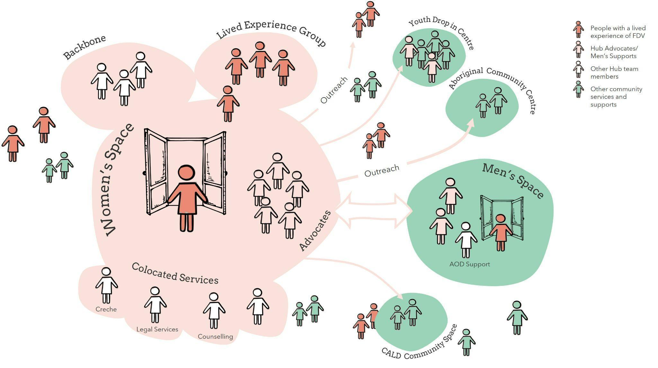
Participants described a range of criteria that would make a good location for the main space. This included:
- public transport accessibility
- proximity to amenities and relevant services
- discreet
- connected to outdoor space
- inclusive
- and not within existing ‘specialist’ service provision
This high-level model intentionally leaves a range of decisions in the hands of the service provider/s who will eventually take on the operations of the FDV Hub, however, this report dedicates specific space to service principles that surfaced from the Armadale community, advice from service providers, and the existing evidence base surrounding FDV interventions. They build on the previous codesign work done in this space and provide more detail for implementation. These service principles are to act as guide rails for procurement, and for the future service provider in establishing a fit-for-purpose model. If these principles are embedded, we believe that the Armadale model has the best opportunity to meet the ambition of having a significant impact for the Armadale community and those citizens who are most vulnerable.

Principle 1: Support to navigate complexity
The service follows its intended purpose of ensuring that women only have to tell their story once through several methods of service navigation and coordination.
- The Advocate Role
The service replicates and develops the Advocate role present in Mirrabooka and Kalgoorlie. This role primarily focuses on system navigation, supporting service users to overcome the complex and ever changing service system. This highly relational role uses an underlying philosophy of ‘doing what’s needed’ often through very practical support.
- Co-location of specialist support
The service provides a number of specialist services particularly legal support, creche services and therapeutic interventions, with off-site Drug and Alcohol work targeted at men. MOU’s with existing service provision allow the service to strengthen its offering, and connect into the wider service system. The collocation of these supports with advocate supports provides team cohesiveness and collaboration.
- Strong team support structures
The work of a FDV Hub is challenging, with risks that are ever-present. Strong team support structures and coordination through the ‘backbone’ organisation (refer to the FDV Hubs Model image on page 15) assists the team to provide a high quality, culturally responsive service.

Principle 2: Embedding in community
To be successful with the target groups, the FDV Hub must be ‘owned’ by its local community.
- Cultural connectedness and governance
The FDV Hub creates a space of trust and connection by focusing on cultural connectedness and governance. Whilst challenging in practice, this principle will be necessary to meet the desired Aboriginal representation. It will involve strong connection to local leaders in the Aboriginal community, and multiple strategies in service delivery. The Hub will also need to explore similar links with relevant CaLD communities, particularly Indian, Pakistani, African, Maori and Pacific Islander communities.
- Practical involvement of lived experience
In addition, the Armadale FDV Hub’s offering should be to find the practical strategies that allow for meaningful involvement of people with a lived experience in direct service delivery, beyond ‘advisory’ capacities. These practises are not yet well developed in the current FDV Hubs and might be shared across an emergent network.

Principle 3: Soft, practical access points

A ‘soft access point’ - a way to engage with the Hub that is not directly about FDV, is critical to decreasing stigma and increasing accessibility and safety. The existing Hubs have done this by way of a Healing Centre, providing wellbeing type activities like yoga or arts, but also by providing practical supports, such as access to computers, printing, laundry services, and showers.
- Practical or Universal paths to engagement
Practical services allow people to meet their core needs while assessing whether it’s safe to share their story. Universal basic services such as wellbeing and health can also be useful as their destigmatised nature means that people can feel comfortable accessing the Hub. Soft access points are equally important in working with men. The soft access point also must be supported by a built form that is warm and welcoming, allowing generous space for moving freely and maintains safety.
- Outreach for diverse access
Those people who might be disconnected from services physically, geographically, culturally or socially are unlikely to access or utilise a highly centralised model. By intentionally diversifying the way in which people are brought into the FDV Hub’s service, there will be an increased chance of reaching diverse cohorts. For the Armadale Hub, this particularly includes outreach to locations that are not serviced by the physical Hub.
- Balancing visibility and discretion
The main space of the FDV Hub needs to be visible and accessible for people to know it is there, and discreet so that it can maintain the safety of women who are often monitored closely and are managing significant risks.

Principle 4: Generational healing

Finally, by creating space for early intervention men’s work, by targeting prevention work at young people and by leveraging intergenerational interventions, the Hub can support the long-term healing necessary to see real results in Family and Domestic Violence. The exact activities of a men’s space were outside of the scope of this engagement period, and there remains some ambiguity about the kinds of delivery that would be most effective. Some clear principles were described by local stakeholders, particularly amongst the Aboriginal community. These are the most emergent responses, asking providers to look beyond traditional individualist service modalities and a Western lens on FDV, to work across generations to rebuild connections with people, place, culture and country. The demand for these kinds of interventions was communicated strongly by Elders, people with a lived experience and local service providers throughout our conversations.

Opportunity for Best Practice
This model has been driven by the stories of people who have experienced FDV and the work of those committed to see change. As the Armadale FDV Hub develops, together with the ongoing development of the existing Mirrabooka and Kalgoorlie Hubs and the future Kimberley Hub coming online, it creates an opportunity to establish a best practice for these innovative services. The result could be a community of practice doing the on the groundwork that sees significant improvements in this endemic and intractable social issue.

Defining the FDV Hub Model
The Western Australian FDV Hub model has developed through research and codesign engagements by Curtin University and the Centre for Social Impact. It balances the need for service coordination based on collocation with the need for engagement, accessibility and cultural security for marginalised groups. The engagement process detailed in this report sought to adapt it to the local context. Each location will have unique attributes but there are some generic defining features that all hubs will hold.
- Targeting Primary Prevention, Early Intervention and Post Crisis Support - filling a gap left by a focus on crisis services.
- Co-location of specialist supports - ensuring that women only tell their stories once through the coordination of the specialist supports, such as legal support, creche and therapeutic services that service users may need. In addition, wider relationships with service delivery outside of the Hub allows for holistic service.
- Soft access point - an initial way that service users can engage with the Hub that is not directly about FDV, in order to decrease shame and stigma and to increase safety and accessibility. This is usually delivered through ‘healing’ type activities and practical supports.
- Advocate role - A key navigation role that walks alongside women to overcome the complexity of the system. An initial, practical point of support.
- A ‘Backbone’ organisation - providing coordination and leadership for multi-disciplinary service delivery.
- Community outreach and engagement - Creating opportunities for connection outside of central sites.
- The involvement of people with a lived experience - regular involvement that is meaningful and active.
- Cultural governance - ensuring the service is able to meet the cultural safety needs of over-represented groups.

1.1 Acronyms
Below is a list of acronyms used throughout the document and their meaning.

ACCO - Aboriginal Community Controlled Organisation
AOD - Alcohol and other drugs
CaLD - Culturally and linguistically diverse communities
CHN - Child Health Nurse
CPFS - Child Protection and Family Services
FDV - Family and domestic violence and abuse
FTE - Full time equivalent
GP - General Practitioner
MOU - Memorandum of understanding

1.2 Definitions

FDV Hub – The whole service delivery of the FDV Hub. This includes both the main space and the off-site men’s space. It also includes the backbone, the Lived Experience group and all outreach activities of the Hub.

Main space - The main space/Healing Centre of the FDV Hub that works with victims.

Off-site men’s space - The separate, off-site space of the FDV Hub that works with male perpetrators or potential perpetrators. Other provision has described this as a ‘sub hub.’
Advocates - A role for workers within the FDV Hub that walks alongside victims, supports with system navigation, provides advocacy, information, practical support and prioritises safety.

Backbone - The organisation that leads the consortium approach and manages the FDV Hub’s operations, relationships and data.

Lived Experience - People who have been significantly impacted by FDV.

Lived Experience Group - A group with the service delivery to provide guidance about what is happening in the community. Some members will have an active role in service delivery.

2. Adapting the FDV Hub model to Armadale

In January 2017, the Western Australian (WA) State Government released their Stopping Family and Domestic Violence Policy, which committed to ending the cycle of family and domestic violence (FDV) and introduced a comprehensive package of reforms aimed at supporting those who have experienced FDV. It included the establishment of two One Stop Hubs, one in Mirrabooka and another in Kalgoorlie to facilitate access to specialist FDV support services. On 28th October 2021, the Minister for the Prevention of Family and Domestic Violence announced that a third Hub will be opening in the Armadale Child Protection District, as defined by Communities.
In October 2021, the State Government commissioned Innovation Unit to facilitate and support an engagement process, based on Innovation Unit’s ‘Model for Scale’ which focuses on how to adapt a service model to a new context. Between 28 October 2021 and the 24 January 2022, a series of bespoke stakeholder engagements were held to understand the experience of the existing Hubs and the unique context of the Armadale area so that recommendations for a localised model could be made.
Communities identified a number of clear goals for the engagement process:
- That the model meets a genuine need in the Armadale community, and therefore has the best potential for achieving outcomes.
- That there is local ownership of the FDV Hub in the Armadale community, establishing a strong foundation for ongoing operations.
- That proposals are uncovered for several practical service design components including target groups, potential location and service offering.
In addition, a key consideration of the process was the specific focus on the local Aboriginal community given the overrepresentation of Aboriginal women in FDV statistics, and the under servicing of their needs in existing service interventions. As a result, the process sought to engage with Aboriginal elders, service providers and community members as a priority during the short time period for engagement. Because of the short time frame of the project, deep engagement with CaLD communities was not possible. The project sought to ensure representation from CaLD spaces, in limited numbers, acknowledging the current barriers that people from these communities’ experience when attempting to accessing adequate support.

2.1 Model for Scale - Adopt & Adapt
The process for scaling social service models from one place to another is often fraught. Whilst a focus on strong practice and outcomes is essential, local communities can experience an imposition of ideas from elsewhere. This creates a barrier to on the ground implementation and can disrupt the expected outcomes.
Innovation Unit’s research into what works in scaling social innovation has shown that the most successful models are those that are ‘fixed’ enough to secure the outcomes and impact expected, and ‘flexible’ enough to adapt to local contexts, creating ownership in the local community. Developed from extensive research and tested with partners in health, social care, and education, the model for scale is a proven methodology for adapting and adopting an innovation within a place, to new places, or across a whole system. It asks us to think about what is fixed and what is flexible, by allowing codesign and collaboration between those who have been operating the intervention (the Innovators) and those who seek to see it realised in their new context (the Adopters). It recognises the strength of innovation from elsewhere, whilst understanding the deep need for place-based interventions.
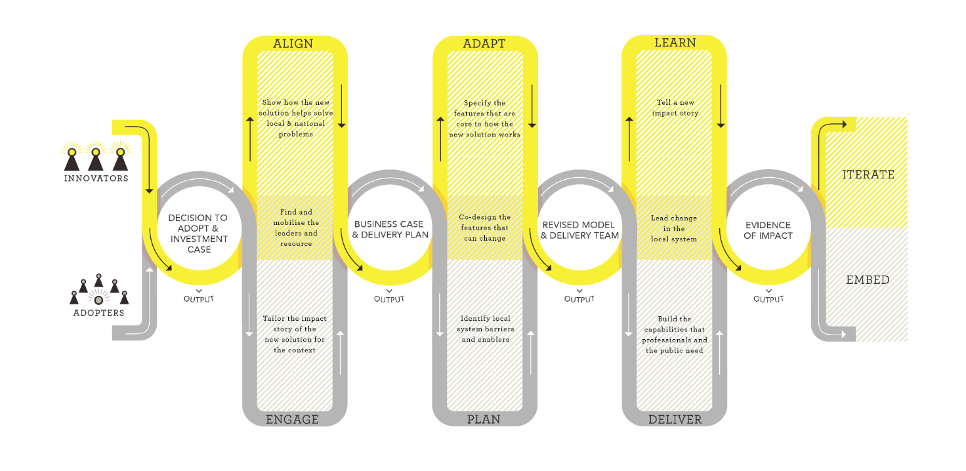As such, scaling the FDV Hub model to the new site in Armadale required understanding what parts of the model should be adopted by the new site, and which parts would need to be adapted for the local context and it’s unique needs.
Whilst the time frames involved in this engagement process could not encompass all of the components of the Model for Scale, a shorter ‘Adopt & Adapt’ process was utilised which focused most heavily on the Adapt/Plan stage of the model (see above image). The process began by engaging the existing Mirrabooka Naala Djookan team and Armadale stakeholders separately, before bringing them together in later stages of the project to learn from one another.

2.2 The Engagement Process
The table below outlines all the co-design and engagement activities undertaken by Innovation unit throughout the process.
DATE | ACTIVITY | DESCRIPTION
1 November 2021 | Stakeholder Mapping Session | A stakeholder mapping exercise with internal stakeholders to identify the key stakeholders across government, non-government, lived experience participants, Aboriginal Elders, and community leaders.
25 November - 5 December 2021 | Community Survey | An online survey requesting responses from a broad range of users and providers of FDV services in Armadale distributed by Innovation Unit.
11 - 23 November 2021 | Service User Interviews | Three individual interviews were conducted in-person with people with a lived experience of FDV and diverse experiences of accessing and utilising FDV services within the Armadale area. This included one CaLD participant.
11 November – 02 December 2021 | Service Provider Interviews | Four interviews were conducted in-person with key local stakeholders in the Armadale area who work directly with service users to complement the service user interviews and build an understanding of the service responses required to meet diverse needs in Armadale.  A fifth interview was conducted with service leadership from the Mirrabooka Hub, Naala Djookan.
25 November 2021 | Mirrabooka Engagement | A workshop in Mirrabooka with the existing FDV Hub, Naala Djookan, to understand the parts of their model that need to  transfer in the Armadale FDV Hub.  Seven members of staff from Naala Djookan worked in a group on activities and discussions around the successes and challenges they’ve experienced over the past 12 months of service. The aim of these discussions was to get clear on the fixed components of the model that need to be transferred to Armadale.
24 November 2021 | Aboriginal Elders Session 1 | A meeting to present the FDV Hub Model to a group of local Elders and seek feedback about how the model could work in Armadale.
25 November 2021 | Aboriginal Information and Engagement Session | A session with Aboriginal people in Armadale to present the FDV Hub Model and seek feedback about how this could work in Armadale.  After the information session, participants worked in small groups, engaging in ‘kitchen table’ conversations about the needs around FDV in Armadale. Specific feedback was sought on who needed support most in the Armadale area and what the most important supports are, the location of the Hub and how the space could be welcoming.
26 - 29 November 2021 | 1:1 Phone support for workshop attendees with Lived Experience | Phone calls to people with lived experience of FDV who planned on attending the larger Adopt & Adapt Workshop and Walkthrough.  Any needs were identified, and strategies were discussed to enable safe participation in Workshop/Walkthrough engagements with each participant separately.
30 November 2021 | Adopt & Adapt Workshop | A half day workshop with local stakeholders (service providers, advocates, government providers, key community members and women with a lived experience of FDV) and identified Naala Djookan team members. This included both CaLD and Aboriginal service providers.  The workshop brought the knowledge of the local Armadale sector together with input from the experiences of the existing Hubs in Mirrabooka and Kalgoorlie to explore how the FDV Hub model should be adapted for the Armadale area.  29 participants were briefed on the project and worked through a range of participatory activities to better understand the Armadale context, and the local experience of FDV. The workshop included discussions around insights emerging from user research, exploring the Hub service model (fixed and flexible principles), and designing a Hub Model for Armadale.  The outcome of this workshop created the two FDV Hub models (see Appendix 2) that were further refined by Innovation Unit.
2 December 2021 | Aboriginal engagement session (Aboriginal women with Lived Experience) | Through the community engagement process, a group of potential stakeholders was identified. The FDV Hub Model was presented to a local group of nine Aboriginal women and feedback was sought about how this could work in Armadale.
9 December 2021 | Walkthrough | A self-directed workshop to present and refine the two draft Hub Models (see Appendix 2) emerging from the Adopt & Adapt workshop to local stakeholders and receive further feedback on areas of ambiguity.  30 participants ‘walked through’ the proposed draft at their own pace, asking questions and providing feedback.  This session allowed the development of the model recommended in this report.
16 Feb 2021 | Elders Session 2 | A meeting with local Elders to present the model that emerged from the community engagement process and an opportunity to seek feedback.

2.3 The FDV Hubs Model: Fixed and Flexible

This engagement process was built on the previous work of Curtin University (2018), who developed a service model based on the existing evidence base and interstate delivery, and the Centre for Social Impact (2020), who conducted an extensive co-design process in the development of the Mirrabooka and Kalgoorlie Hubs. Curtin’s work strongly emphasised the need for co-location as a method of service coordination and information sharing. The Centre for Social Impact (CSI) emphasised the need for engagement, accessibility, and cultural security for marginalised groups, particularly CaLD and Aboriginal people. Together these processes proposed models for soft access and service coordination that have been put into practice with place-based variation in Mirrabooka’s Naala Djookan Healing Centre, and Kalgoorlie’s Mara Pirni Healing Place.

At the time of this engagement process, these models had been in operation for approximately 12 months. The implementation has created significant learning that has only been partially codified by the teams responsible for operations. As would be expected, since their implementation, the models have required adaptation and iteration to fit local contexts and trends, and both spaces are able to identify future improvements that might be made.

Referencing the Model for Scale process, the Innovation Unit team engaged with the service design activities of Curtin and the CSI, and more deeply with the Naala Djookan operational team. Lighter engagements with the Mara Pirni team were also included. The Model for Scale asks the ‘innovators’ - in this case Naala Djookan - to identify the fixed components of the model, and those components which should be more flexible. As previously described, the relatively short period of operation means that whilst strong practices are developing, they are not yet codified into best practises. Part of the engagement with Naala Djookan became about identifying the most important principles, rather than detailed practises.

The following ‘existing model’ is a synthesis of those data points. It was utilised as a starting point for providing opportunities to the Armadale community, service providers, local leaders, and those with a lived experience of FDV, to consider how the model should be realised in their community.

The “fixed” components and the “flexible” components
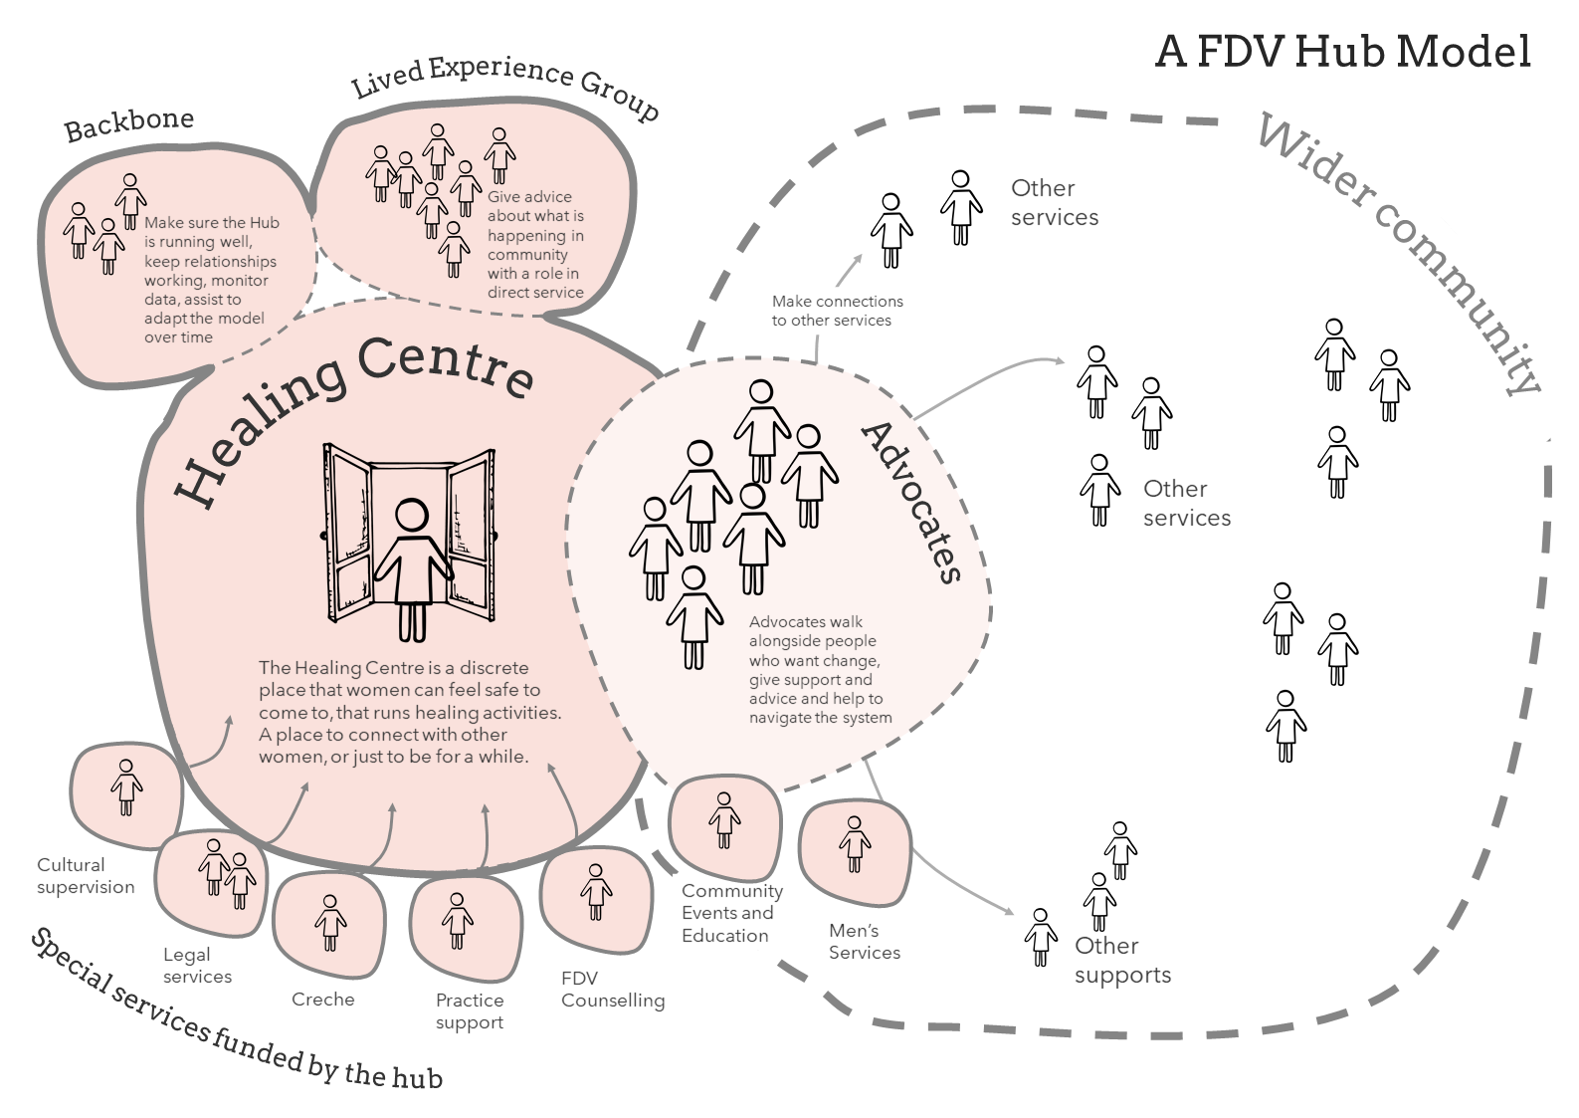
To adapt the FDV Hub Model to a new context requires understanding the fixed components (left), and then focusing codesign and engagement activities on questions to identify the flexible components. These fixed and flexible components were identified through the engagement process, and used in the Adapt and Adopt workshop to explore those components which would need to be adapted for the Armadale context.
Fixed Components | Questions to prompt design of Flexible Components
Co-location of specialist supports  - Co-location of highest demand specialist supports in main space of Hub (e.g. counselling, legal, health, or others depending on local need)  - Legal support and creche services are recommended as core  - Statutory services (police and child protection) are not recommended as it creates a barrier for hard to reach populations. | What kind of specialist intervention is right for the new location? What gaps need filling? What intervention should the Hub directly fund and what should be close relationships or MOU’s? (See page 48)
Targeting Primary Prevention, Early Intervention and Post Crisis Support  - The model is established to fill a particular gap in the system. Other interventions target crisis support as a key priority.  - NB: in practice there remains a need to support women in crisis from time to time | What mix of each of these activities is most appropriate for the new location? What target audiences are important for the new delivery? (See page 28)
Soft access point  - An initial way to engage with the Hub that is not directly about FDV.  - Decreases stigma, increases accessibility and safety. | What kinds of soft access activities and structures will best engage those requiring support? (See page 40) What locations will best meet this need? Is it more than one location? (See page 34)
Day time provision  - A limitation of the funding model is that the Hub only operates during the day. | What normal hours of provision best meet local needs? Should limited early evening sessions be included (as Mirrabooka has done)?
Advocate role  - A key navigation role that walks alongside women to overcome the complexity of the system  - An initial, practical point of support.  - Connects with other specialist service delivery. | How do Advocates reflect the local community and target client group? What emphasis is placed on particular parts of their role? What supports do they require to operate successfully? (See page 47)
A ‘Backbone’ organisation  - The multi-disciplinary (and often multi-agency) service delivery requires a backbone organisation to ensure coordination and localised staff support and management  - Data collection, and analysis and responsiveness to changing local contexts.  - Facilitation of advisory groups and cultural governance. | What governance arrangements should be in place between players?
Community outreach and engagement  - Creating opportunities for community and potential service users to engage outside of the central site. | What should the focus of community outreach and engagement be? What mechanisms will be in place to build awareness and engagement with the Hub? (See page 42)
The involvement of people with a lived experience  - Regular involvement from those with a lived experience in meaningful and active ways. | How will people with a lived experience be meaningfully and practically integrated into service delivery and design? (See page 46)
Cultural governance  - Ensuring the service is able to meet the needs of Aboriginal people who are significantly over-represented in FDV statistics.  - Engaging with the leadership of CaLD communities relevant to a local area. | Who will provide this governance and how will it be provided? How is the service ‘held’ by the local community so that it is trusted? (See page 44)

As practice expertise increases in the Hub Model in Western Australia, we would suggest that codification process might ‘fix’ more elements as standard, such as the specific role of the advocate or recommended governance structures. The establishment of a community of practice may play a role in this kind of codification into the future.

Key service decisions yet to be made
This engagement process has delivered a high-level proposal for the Armadale area, but intentionally leaves a range of decisions in the hands of the service provider/s who will eventually take on the operations of the FDV Hub. In the following sections of this report, we describe the insights we found as we sought to understand the intersection of the Armadale community, advice from service providers, and the existing evidence base surrounding FDV interventions. These service principles are to act as guide rails for the future service provider in establishing a fit-for-purpose model. We would recommend that the future service provider maintains a co-design-led approach for those future key service decisions, ensuring ongoing ownership by both the community and the new Hub team.

3. A FDV Hub for Armadale

3.1 Recommended components for an Armadale FDV Hub
Through engagement activities with the Armadale community, after allowing for a range of model variations (see Appendix 2), a recommended service model emerged that stakeholders felt would best fit the local context and the needs for service delivery. This model holds true to the pre-established fixed elements, while adapting to specific needs. The above image describes both the service components (inside the dotted line), and the service principles (outside the dotted line). The service components are detailed below.

A main space for women
The main focal point for the Armadale FDV Hub - this soft access point allows women to walk off the street and connect to service delivery through practical, universal activities, and/or service provision. In other FDV Hubs, this space is referred to as the ‘Healing Centre’. The Healing Centre houses a number of key activities:
- Advocates who can assist women to navigate the systems they need. The Healing Centre allows women to build relationships with Advocates before requesting direct support. That the diversity within the Advocate team reflects the diversity of the local community, particularly for Aboriginal and CaLD communities.
- A select group of specialist, co-located services are in place: creche services and legal services are seen as core to the model. Stakeholder engagement indicated a preference for therapeutic supports, children’s support, housing support and financial counselling, though the mix of services would need to change over time.
- Co-location of advocates and specialist services allows for strong service coordination and support for staff in this complex space.
- Friends or family members may also access support where they are providing support for a person experiencing FDV.
- Activities that encourage women to connect with one another allow peer support to build.

A separate off-site, but connected men’s space
This smaller provision targets the change needed amongst male perpetrators or potential perpetrators of FDV. The exact activities of this were outside of the scope of this engagement period, and there remains some ambiguity about the kinds of delivery that would be most effective. Some clear principles were described by local stakeholders, particularly amongst the Aboriginal community. This indicated a primary focus of healing for men, and this is validated by the latest ‘what works’ research for responses to FDV amongst the Aboriginal community (Carlson et al, 2021). Alongside this primary focus, a specialist service delivery described as essential by Elders, Aboriginal community and Aboriginal service providers was for support to manage Alcohol and other drugs. For more effective engagement, where feasible, the men’s space is best located away from the main women’s space, within an existing, trusted community space. Nevertheless, this engagement period wasn’t sufficient to define this component in detail, and there remains needs for future design.

Outreach capability
It is the nature of single site services that true accessibility cannot be achieved for all diverse target groups. The section on Target groups below outlines the challenges felt by many groups who feel marginalised from existing service delivery. To meet the need to service diverse groups, and to provide avenues of support for those who would struggle to access the main space/Healing Centre of the FDV Hub in the first instance, Hub Advocates must provide outreach into local community spaces where target groups feel connected and comfortable. Outreach should include:
- Embedding workers one or two days per week in external sites that are community spaces (e.g. the Champion Centre, a prominent Aboriginal community space, Men’s sheds) or mainstream services (e.g. health, education, employment, English classes), rather than specialist services. This improves accessibility for marginal groups by leveraging the trust that service users have with existing services/spaces, an addition to enhancing the information-sharing and referral processes.
- Staff maintaining most of their time and connection to the main space of the Hub for improved team cohesion.
- Outreach to individuals in their chosen space, such as parks, cafes or homes, where safety planning allows.

Youth service delivery
Young people are a high-risk cohort. During initial conversations with local service providers, staff provided anecdotal evidence of the prevalence of FDV in young parent families and in teenage couples. This data was validated during the Adopt & Adapt workshop with written suggestions emphasising the need to engage with young people early, for example through whole-of-family assessments or through outreach into schools. During whole-of-group conversations, several participants spoke about the need to address the high risk of harm for children and young people.

2016 Census data shows an increasing number of young people in the Armadale District. The proportion of people aged 13 and under (who are now teenagers), is higher than state averages making up more than 20% of the community.

Percentage of young people in the Armadale District versus Western Australia (2016, WA/Armadale District comparison)
Population | Gender | 13 years and under | Aged 14 to 18 | Over 18 years
Western Australia | Female | 8.8% | 2.9% | 38.2%
 | Male | 9.3% | 3.1% | 37.7%
 | Total | 18.1% | 6% | 75.9%

Population | Gender | 13 years and under | Aged 14 to 18 | Over 18 years
Armadale | Female | 10% | 3.0% | 36.8%
 | Male | 10.7% | 3.1% | 36.3%
 | Total | 20.7% | 6.1% | 73.2%

Source: Australian Bureau of Statistics, Census of Population and Housing (2016), usual residence data.
As a response, prevention work in the Armadale model is targeted through youth service delivery. The Hub provides this delivery by:
- Increasing FDV literacy amongst young people: young women, men, and those with diverse sexuality and gender.
- Providing a point of engagement for service delivery, helping to intervene early before problematic behaviours, particularly amongst young men, become cemented.
- By finding delivery spaces away from the other two ‘adult’ spaces to avoid the intersection of incompatible client groups (for example, youth centres, youth events, student services).
It should be noted that the Youth service delivery recommended here, whilst clearly identified by the community as desirable, may not be possible in a constrained funding environment.

Lived experience involvement
The Hub utilises the voice of lived experience in more than just an advisory capacity, integrating peers and community leaders with a lived experience into the direct service delivery to women and men who seek support through the Hub.
“Create a coordinated, integrated and holistic services that uses a range of service delivery model (i.e. colocation, outreach, hub-based) to reach a diverse group of victims/survivors and perpetrators to support end to cycle of violence. Every intervention and prevention must be supported”.
Walkthrough participant: A hope for the Hub

3.2 User journeys
Four user personas were developed through the engagements. Personas are semi-fictional characters, informed by the stories of people with lived experience of family violence who participated in service user interviews and workshops. These journey maps are used to illustrate the experience of a person through the proposed service, from their point of view. They do not capture every possible experience. These user journeys have been refined to reflect the ideal experience with the final model:

Mia and Darren
Mia hears about the Healing Centre from her Aunty
Mia has been yarning with her Aunty S about her six-month baby, Mia says that since she gave birth to Sas, Darren has hardly been around, except when him and his mates get on the drink. Aunty S knows the police have been out to Mia and Darren’s a couple of times and that Darren takes his anger out on Mia and Sas. Aunty S asks Mia if she wants to head along to one of the Mums and Bubs lunches at The Healing Centre.
Mia attends a Mum and Bubs group at the Hub
Aunty S, Mia and Sas head to The Healing Centre, where she’s welcomed by Jas, the worker who coordinates the lunches. Jas is a similar age to Mia and tells Mia about her baby twins while leading her to the outdoor area. While Jas is introducing Mia and Sas to the others, Aunty S chats to one of the workers about the Men’s groups the Hub runs.
Mia enjoys the lunch – the other mums talk about their parenting struggles and Mia feels less alone.
Mia connects with a Hub advocate
Aunty S has a chat with Darren’s Mum and his Uncle J about Sas, and about Darren’s behaviour. They knew Darren’s drinking had escalated but weren’t aware that Darren has been beating up Mia. Aunty S tells them about the Men’s Group.
Mia and Sas continue to head to the Mums n Bubs Lunches. Mia makes friends with Jenna, who shares how her partner used to beat her up and how it got worse when he’d be drinking, but he’s getting help and things are starting to change. Mia burst into tears and tells Jenna about Darren’s verbal and physical abuse. Jenna encourages Mia to talk to Jas, because Jas can help her get some information about her options.
Mia gets help to stay safe
Mia meets with Jas. Mia is worried about what might happen to Sas if she talks to Jas. Jas explains that she will give her some information about her options, but that Mia is the one who decides who Jas can share information with.
Jas gives Mia some information about support groups the Hub runs, and she refers Mia to an agency that helps install safety equipment. Mia gets a new lock, so she doesn’t have to let Darren in if he tries to come back with his mates after a session.
Darren gets some help
Uncle J comes over when the lock is installed. Darren shows up just as the job is done and he’s fuming. Uncle J has firm words with Darren. A couple of days later, Uncle J and Darren head along to the Men’s group. While working on a car together, the men yarn about using alcohol to escape their feelings. Darren doesn’t really listen, but he enjoys working with his hands.
Uncle J and Darren keep going to the Men’s group. Eventually, Darren begins to see how he uses drinking as a response to trauma – a way of coping with fears he’ll be just like his dad. He starts to understand how his aggression is impacting his family.
Things are changing…
Aunty S and Uncle J sit down with Darren to talk about the past and how things can look different. Darren agrees to ongoing sessions with a worker he met through the men’s group. Things are changing.

Aruvi
Aruvi hears about the Hub from her Child Health Nurse
Aruvi is a mother of a six-month girl and a seven-year-old boy who have been living in Australia for nearly a year.
After several home visits, her Child Health Nurse (CHN) is concerned about the family’s safety – she’s overheard Aruvi’s partner speaking abusively, and demanding that she does not leave the house. She’s also noticed severe bruising on Aruvi’s arms. She suspects that Aruvi and her children are experiencing FDV.
The CHN runs a clinic at Aruvi’s son’s primary school. She catches Aruvi in private during a morning drop-off. With Aruvi’s permission, the CHN refers Aruvi to the CaLD Hub Advocate based at the local Migrant Support Service one day a week.
Aruvi is referred to the CaLD Hub Advocate
When referring Aruvi to the CaLD advocate, the CHN explains that Aruvi relies on public transport, and it can be challenging for her to attend appointments with her two children in tow. She also tells the Advocate that Aruvi has little support with caring for the children and has some financial concerns.
The CaLD Advocate about Aruvi’s language skills, and after doing a risks assessment with her manager, organises to meet Aruvi at a library walking distance from her home.
The Advocate provides Outreach to meet Aruvi where she’s at
Aruvi and the Advocate meet at the local library later that week. The Advocate provides some information about the Hub services in Aruvi’s first language and listens while Aruvi shares her story.
Aruvi tells the Advocate that her partner hits her and that he doesn’t allow her outside. She says she has no family here and she struggles to make friends. The friends she does have she met through her partner – she fears what they would say if they knew she was talking to the Advocate. Aruvi tells the Advocate she’s scared for her safety and needs to know what to do in an emergency.
The Advocate shows Aruvi how to call 000 and tells her where the local refuges area. Before heading off, she gives Aruvo a bag containing nappies, school stationary and some other essential items.
Aruvi gets help she can understand
The Advocate continues to meet with Aruvi at the library. Aruvi says her partner is still hitting her and he’s becoming more controlling. She says he also started speaking aggressively to their seven-year-old son. Aruvi says that she’s considering leaving.
Aruvi needs some help understanding her rights in Australia, and the Advocate calls a Translator, who joins via speakerphone, while the Advocate explains Aruvi’s options.
The Advocate refers Aruvi for Specialist Support at the Healing Centre
The Advocate helps Aruvi to think of the documents and belongings she will need to bring with her, and they think about how she can do this safely. She provides a list of things to do in Aruvi’s language. The Advocate makes an appointment with her Specialist Housing Worker at the Healing Centre and together, they contact Centerlink to discuss crisis payments.
The Advocate uses one of the Hub cars to bring Aruvi to the Healing Centre for the appointment. While she’s there, she leaves her children with the Creche Worker, giving her the space she needs to make important decision.
Aruvi builds her resilience
At the Healing Centre, Aruvi learns that some of the other women organise a fortnightly morning tea, where people can bring in food if they want to and make a cup of coffee/tea and connect.
She decided she will attend the next morning tea. Aruvi begins to connect with a few women at the tea over shared experiences and this becomes a regular part of her routine. One of the women learns that Aruvi is a skilled bookkeeper and offers her work in her manufacturing business and says she can work from home.

Anita
Anita make an FDV incident report and learns about the Hub
Anita’s partner Jef has always been controlling. He likes to know where she is and used the GPS tracking on her phone to check. Anita isn’t aware that he has enabled this feature. He has a bad temper that no one knows about. Anita has tried to talk to Aunty Jess about it but struggles to – she doesn’t want people to think badly of Jef.
After a bad night, Anita calls Aunty Jess in tears. Aunty Jess tells her to call the police, so Anita calls and makes a FDV incident report. The FDV response team provide her with crisis support. They ask her if she can come to the situation the following day to discuss safety options. Anita tells them her partner can be controlling and that he likes to know where she is. The responding officer suggests that Anita goes to the Healing Centre instead and makes a referral to the Hub Safety Advocate.
Anita visits the Hub to meet with the Safety Advocate
Anita asks Aunty Jess to come to the Healing Centre with her. When they get there, Anita realises that she has actually walked past it before but hadn’t realised it offered FDV services. It is located near other services, so Anita and Aunty Jess could be here for something else, which helps her feel safe.
They are greeted warmly at reception and asked if they’d like to make a tea or coffee while they wait to meet with the Advocate.
Anita notices that some women yarning over a coffee in the kitchenette, another using the computer and others arriving at the Healing Centre for an activity and feels more at ease. Aunty Jess pick sup a timetable of activities and nudges Anita, “I reckon this ‘Healthy Heads’ class looks alright”. Anita pockets the timetable.
The Safety Advocate provides information and support to keep Anita safe.
When Anita meets the Advocate, she is relieved that she doesn’t have to tell her story again. The responding officer gave the Advocate all the necessary details.
The Advocate completes a risk assessment with Anita and asks about her partner’s behaviours. The Advocate listens patiently and responds empathetically, without any judgement – Anita feels heard.
The Advocate explains to Anita the ways that she can be tracked – she shows her location tracking on her phone, suggests she look for hidden camera in bedrooms/car and save the Advocate’s number in her phone under the name of a friend or family member. She helps Anita create an invisible, secure folder on her phone to store a list of things to check when she gets home.

Anita accesses legal support
Anita has been seeking the Advocate for a few months now. With support form Aunty jess, Anita is thinking about leaving Jef, but she needs more information about her legal rights. She makes an appointment with the Community Lawyer at the Hub.
Anita connects with other women who’ve had similar experiences
Anita has also been to a few ‘Healthy Heads’ classes with Aunty Jess and has started making connections with some of the other women. There’s a roster of people who run some of the different groups and Anita has been thinking of running one herself.

Keira
Kiera is a regular at the Youth Centre
Keira met Jay online. They’ve been dating for two months. Things are moving quickly – Jay told her he loved her on their second date. Even though Jay is a few years older (Keira is 17 and Jay is 21) they’re talking about moving in together.
Keira also loves basketball. When she needs to blow off steam, she heads down to the Youth Centre to shoot hoops. She’s been showing up at the Centre often lately, as she and Jay have been fighting about when it’s a good time for him to move in. She wishes she could talk to her friend, Em, about Jay moving in, but she stopped seeing Em after Jay said she was using her.
The Youth Hub Advocate offers support
At the Youth Centre, Keira see’s a flyer for a fortnightly group on ‘Health Relationships and Respect’. Jay’s pushy behaviour about moving in has been playing on her mind, so she decides to attend. The group is run by an Advocate who is based at the Youth Centre a couple of days a week. The information in the group increases Kiera’s worry about some of Jay’s behaviours and she hangs back go chat to the Advocate.
Later that week, during a game at the Youth Centre, Keira’s phone keeps ringing. Eventually she answers it. The Hub Advocate overhears Keira’s side of the conversation and is concerned – Keira keeps insisting she’s at the Youth Centre and she looks distressed. The conversation escalates and it’s clear Keira is arguing with Jay. The Advocate is worried about Jays’ controlling behaviour.
Keira is referred to the Healing Centre for legal advice
Following the phone call, the Advocate goes to comfort a crying Keira. Keira tells the Advocate that Jay’s been monitoring her social media and thinks she’s cheating on him. She says there’s more to it, but she doesn’t want to talk about it here. The Advocate offers to take Keira to an appointment at the Healing Centre.
Keira visits the Healing Centre and connects with Specialist Services
The following week, the Advocate transports Keira to the Healing Centre and introduces her to Rase, the DV counsellor. Rae is warm and kind and Keira agrees to attend some counselling sessions.
Keira receives court support
Through counselling, Kiera begins to see Jay’s behaviour in a new way. She decides to break up with him over breakfast one day, but it doesn’t go well. Jay threatens her and Keira leaves her home to go to the Youth Centre to ask the Advocate for help.
The Advocate transports Keira to the Healing Centre and introduces her to the Lawyer, Amanda. Amanda explains Keira’s options to her, and Keira decides she wants to proceed with a VRO. The Advocate takes Keira to the Armadale FDV Unit and stays with her while she applies for a VRO.
After the Courts make the CRO, Jay didn’t return to Keira’s home. But he did share private images online in an attempt to humiliate her, resulting in the police charging him. While going through the Courts, Keira learned a lot about cyber abuse and the law. Keira’s lawyer suggested she think about sharing her knowledge one things have settled down.
Healing through sharing
Some time later and with the encouragement of the Healing Centre Counsellor, Keira helps to facilitate the eSafety program that the Advocate runs at the Youth Centre. She’s thinking about becoming an Advocate herself.

3.3 Target group
This work considered the existing data around FDV incidents and Armadale demographic data. This data was presented to participants during the Adopt and Adapt workshop who were asked to imagine a successful Hub model and to define the key groups that would be accessing services. Following the workshop, participants’ responses were collated and analysed for themes. Service providers’ recommendations can be indicative of knowledge about local need acquired through experience: this knowledge may pertain to an understanding of the key gaps in existing provision, or practical knowledge of the relative resourcing required to address the factors underpinning FDV, particularly in complex cases. The following target groups are underpinned by this local knowledge, rather than being representative of regional demographic data.

Cultural background
The overrepresentation of Aboriginal and CaLD communities in FDV data, and their current difficulty in accessing service delivery led to a prioritisation of these groups. Whilst they are a priority in design, the Hub must remain universally accessible and be sensitive to the needs of others.

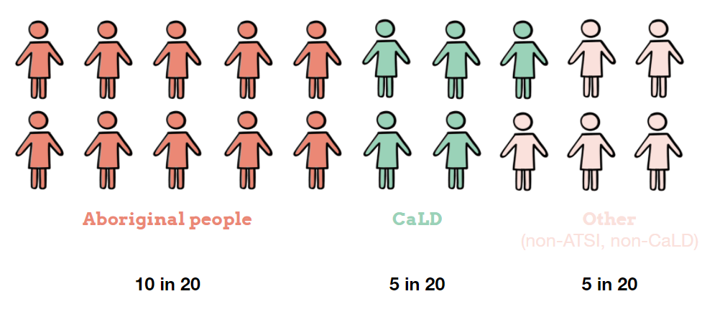

The local Aboriginal community
The initial framing of the brief for this engagement work was that Aboriginal women are significantly overrepresented in FDV data, and as such their needs must be considered in the development of any FDV Hub model. Service providers and local community confirmed this need, almost unanimously calling for a target of 50% Aboriginal service users. To see these levels of access to the Hub, the provider will need to carefully consider service design and delivery, and many of the model recommendations have been developed with this user group in mind.
We learned through the engagements that the Champion Centre is currently uniquely placed as a centre of strength and belonging for the Aboriginal community, but that there are still several Aboriginal families connected with the local area impacted by family violence and abuse that do not access services or support there. Successfully adapting the Hub Model to the Armadale area will involve understanding and responding to these diverse groups within the local Aboriginal community, and working with others to understand the relationship dynamics.

Diversity within the CaLD communities
Access to FDV services for people from CaLD communities can be complex due to stigma, isolation, perceptions of safety, and a range of barriers to accessing services generally. Interview data indicated that people from CaLD communities often face geographical barriers (not having a driver’s licence or limited access to public transport), language barriers (resources and service workers communicating in English only), and social and cultural barriers (childcare responsibilities, limited support network, fear of community consequences of seeking support).
The procurement and service delivery processes will need to be responsive to the diversity within the local CaLD communities. There is no single data point that can capture a person’s cultural background, so we present a number of different points below. We also acknowledge that the CaLD population is much higher than just those who were born outside of Australia. Agencies from the Armadale family violence service system report higher incidence rates for Indian/Pakistani families, African/African American families and Pacific Islander/Māori families.
According to 2016 Census data, 34.5% of the population within the City of Armadale was born overseas, and 43.2% in the City of Gosnells. India is the largest non-English speaking country of birth in both areas. (Australian Bureau of Statistics, n.d.). It should be noted that these areas only form part of the Armadale ‘District’.
For Armadale, between 2011 and 2016, the largest changes in birthplace countries were for those born in:
- India (+2,449 persons)
- Philippines (+842 persons)
- New Zealand (+646 persons)
- Malaysia (+594 persons)
For Gosnells:
- India (+2,724 persons)
- Philippines (+1,624 persons)
- China (+1,623 persons)
- United Kingdom (-1,530 persons)
(Australian Bureau of Statistics, n.d.)
According to 2016 Census data, Indo-Aryan languages, Chinese and Southeast Asian Austronesian Languages are the top 3 languages spoken at home by people living in the Armadale District, besides English:
Language (top 10 largest) | Percentage of population
Indo-Aryan | 4
Chinese | 3
Southeast Asian Austronesian Languages | 3
Dravidian | 2
African Languages | 1
Iranic | 1
Burmese and Related Languages | 1
Dutch and Related Languages | 1
Middle Eastern Semitic Languages | 1
Italian | 1
Other | 4

Nb:* Indo-Aryan includes languages such as Bengali, Hindi, Urdu etc. ** Southeast Asian Austronesian includes languages such as Indonesian, Malay, Tagalog etc. *** Dravidian includes languages such as Malayalam, Tamil etc.
Source: Australian Bureau of Statistics, Census of Population and Housing (2016), usual residence data.
Recent migrants are often disconnected from FDV specific services and may enter the FDV service through multiple different touchpoints, often engaging with mainstream services such as their GP, child health nurses or schools first, where services are more trusted or where existing relationships are found. We heard from participants with lived experience and from service providers that outreach is an essential model of service delivery for reaching CaLD communities, connecting with mainstream touchpoints. Engaging these communities will also bear on considerations around staffing, healing activities, and costs related to translation services and having resources available in multiple languages.

Gender
Given that 91% of victims of FDV are women (Chung, D. et al. 2016, as cited by Innovation Unit, 2020, p. 14) they will remain the primary target for intervention within the Armadale Hub, with the most significant mix of services responding to their needs. Service providers recommended that clients of the service should be 60% female.
Having taken a view that the primary role of the Hub is in support of women experiencing FDV, many of the conversations during engagement activities turned to the role that the Hub might play with men, with a recommendation that 30% of delivery be targeted at male perpetrators or potential perpetrators. Providers described that once a woman leaves an abusive relationship, her partner may go on to abuse future partners, continuing the damage. Here, participants recommended a role in prevention and early intervention with male perpetrators or potential perpetrators. The ‘Men’s space’ is the outcome of this recommendation and further detail on the findings here can be found in section 4.4.
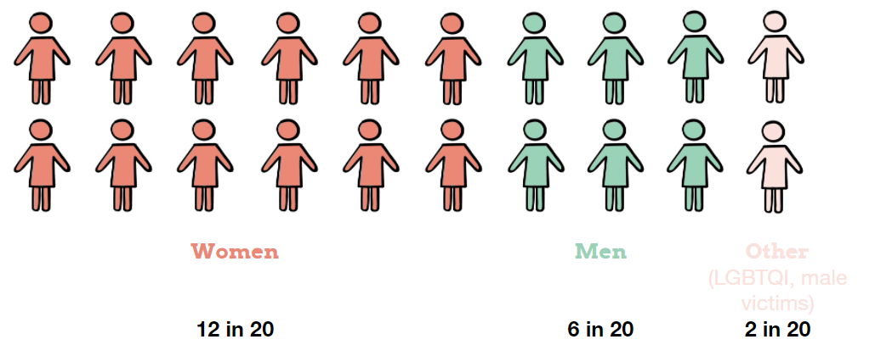

A note on gender inclusivity for a gendered social issue
Whilst family violence and abuse disproportionately impacts women, just under 1 in 10 victims of family violence and abuse do not identify as female, and these individuals can face additional barriers when accessing services due to misconceptions and stigma related to their gender identity. Across Australia, LGBTIQ+ people experience family violence and abuse at higher rates than cisgender women (Lay et al., 2017) and anecdotal reports suggest critically high rates of suicide for Aboriginal LGBTIQ+ people (Carlson et al., 2021).
Both interview and sector workshop participants expressed the need for the Hub Model to be gender-inclusive, suggesting that 10% might fit this category, yet this intent surfaced the practical tensions that emerge when delivering a safe and inclusive service response that addresses a complex, gendered social issue. To overcome this challenge, participants’ suggestions included working with advisory groups, avoiding language/terminology (e.g. in policies and documentation) that reinforces a gender binary and working closely with agencies that support people of diverse gender identities. Utilising outreach services where total inclusivity can’t be provided (e.g. male victims in female spaces) can be another option.
“Although women are the majority victims/survivors, need to ensure inclusivity for all victims”.
“Inclusive of all. Focus on the drivers of FDV – predominantly the men and their behaviour”.
Walkthrough participants feedback

Age
Throughout the engagements, we heard that family violence and abuse impacts people across the life-span:
- Infants and children are often the ‘silent victims’ of family violence
- Family violence and abuse can occur in relationships between teens/young people
- Older adults can be victims through elder abuse
- Children can be victims though child abuse
Whilst the model will primarily target those who are over 18, a specific delivery is recommended for young people if resources allow. In addition, participants described a need for the model to be ‘family inclusive’. Previous research discussing the model suggests that this can be achieved through providing short-term access for friends and family of those seeking support (Chung et al., 2018). We suggest future procurement and service design is sensitive to the need to work flexibly with family and kin systems, beyond simply the presenting or direct user.
“This is a whole community issue. Oftentimes, we are dealing with the ripples of FDV in other services.”
FDV Service Provider
“For every person regardless of background to be safe, protected, cared for, to easily access services who work collaboratively in the best interest of the service user, to not re-traumatise the service users. For children to always be the priority. For the Hub to fill the current gaps in services. One stop shop”.
Walkthrough participant: A hope for the Hub

3.4 Location criteria
Workshop, walkthrough and survey participants were invited to suggest locations for the main space/Healing Centre of the FDV Hub and explain their responses. Responses were grouped into themes. These themes - or Location Criteria - are described below.
Location Criteria | What we heard | Why is this important
Accessible via public transport | The main space/Healing Centre should be located near the Armadale line or a well serviced bus station. Some participants also said having a taxi rank close by would be beneficial. | Many people experiencing FDV rely solely on public transport to get around.  Even when they have access to a vehicle, using that vehicle to access FDV services can put a victim at risk if the perpetrator uses GPS tracking as a method of control.
Close to amenities and relevant services | Locating close to relevant mainstream services, or public amenities (i.e. shops, libraries) was a priority for participants.  Licenced venues (such as pubs, TABs) were examples given by two Walkthrough participants as places to avoid. A small number of participants recommended that safety needs would need to be considered if the service was close to schools or child care centres. | Mirrabooka’s Naala Djookan Healing Centre is able to retain its discreet position because it is located within an existing group of mainstream services including medical services and Centrelink.  The complicated historic relationship between police and Child Protection and Aboriginal communities, and the fear of child removal, means that close visible proximity would be a barrier for Aboriginal people accessing support.  Proximity to relevant services improves access and a greater likelihood of service coordination.
Discreet | All engagements with providers and those with a lived experience described discretion as a key enabler of service access. Suggested strategies included co-location with universal services, back door entry, rear parking.  “[The Healing Centre should be] somewhere that is easy to access but not really obvious as to the services provided.”  (Survey participant) | Discretion is a key principle for people at high/escalating risk of violence and for community. Participants described FDV victims having their movements monitored, and to be seen accessing a service provision known for FDV delivery can be a risk to them and their safety.  Stigma and shame surrounding access to specialist services remains a barrier for many groups to access service delivery.  Approaches that ensure discretion are particularly effective when working with migrant communities (Levine & Benkert, 2011).
Connection to outdoor space | Participants talked about being close to pre-existing gathering spaces, or having outdoor spaces attached to the building. | Elders in our workshops, and Aboriginal service providers explained that outdoor spaces could be used for yarning, socialising, and activities that could support healing.  Naala Djookan described that this was a current, noticed gap for their service provision and had made some efforts to beautify local gardens, but that an outdoor engagement space would be preferable.
Inclusive | The engagement process identified a number of potential existing spaces that could be locations for the Hub. Some of these had a more specific focus and ownership for particular target groups. As a result, they may be poor neutral spaces for the desired inclusivity, though they may be excellent outreach or secondary sites.
Not within existing “Specialist” service provision | The Healing Centre needs to be located in a ‘mainstream’ space, rather than space that is already dedicated to specialist, and potentially stigmatised, service delivery such as mental health, other FDV services, Drug and Alcohol etc. Participants in the walkthrough workshop suggested that existing service hubs at Challis Primary and Gosnells Lotteries House were unlikely to be effective. | As above, stigma and shame surrounding access to specialist services remains a barrier for many groups to access service delivery. An effective soft entry point needs to avoid stigma for access.

“There’s no infrastructure here [Armadale]. There’s no place that’s safe and ‘for everyone’. What’s safe for some, might not be safe for others.”
FDV Service Provider

Geographic location
The FDV Hub is to be located within the Armadale Child Protection District. This geographical boundary, defined by Communities, captures Armadale, Gosnells and Serpentine-Jarrahdale local government areas.
Data suggesting specific geographic locations for the service was inconsistent. A split between a preference for the Armadale area and a preference for the Gosnells area emerged. These splits generally followed where service providers had a greater depth of knowledge, with Gosnells based providers recommending Gosnells and Armadale based providers recommending Armadale. There were emerging recommendations for specific locations in both areas (indicated on the maps below), and with the current information at hand both locations are likely justifiable. There was desire for the service to be able to stretch its geographical reach and this may be achieved by locating the Women’s and Men’s spaces in different locations, or through a focus on outreach work. For example, should the Main space be located in Armadale, then outreach to Gosnells will be needed to complement, and vice versa.
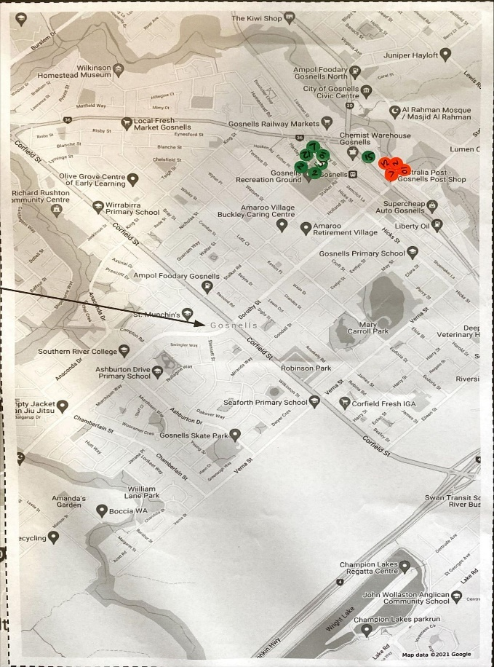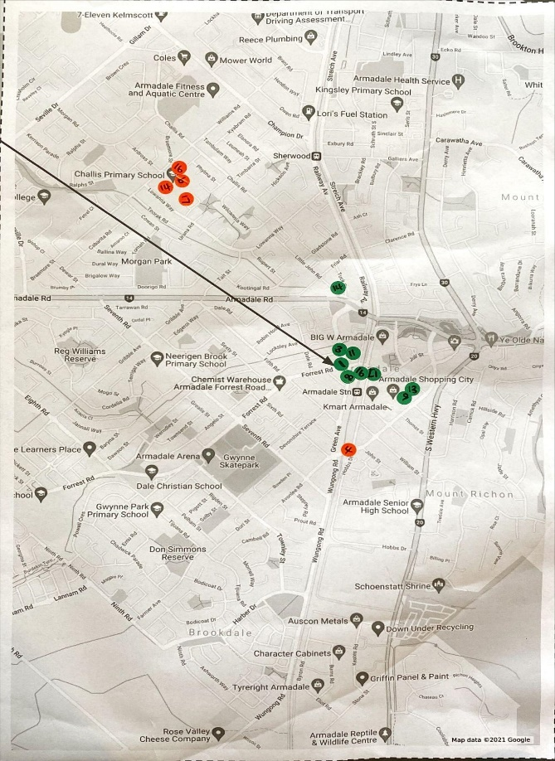Further validation is recommended before approving proposed locations for the main space of the FDV Hub.

4. Design principles Armadale FDV Hub

Whilst previous sections have provided a high-level overview of the Hub model recommended by Armadale community and service providers, developing a successful FDV Hub will be the responsibility of the chosen service provider. The following section outlines the design principles that can be engaged to make future decisions about service design, partnership and on the ground practice. There are four key principles that the Hub must retain as a focus:
- Soft, practical access points
- Embedded in community
- Support to navigate complexity
- Generational healing

4.1 Soft, practical access points
Having soft entry points into the Hub makes it easier for people to reach out for help. One of the clear messages we heard is that people are unlikely to access an ‘FDV specialist Hub’, due to stigma and concerns around safety. A ‘soft access point’ - a way to engage with the Hub that is not about FDV, is critical to decreasing stigma and increasing accessibility and safety. The existing Hubs have done this by way of a Healing Centre, providing wellbeing type activities like yoga or arts, but also by providing practical supports, such as computers, printing, laundry services, and showers. Universal or mainstream services, such as Health or Education services are also a potential soft access point.

Practical or universal paths to engagement
Utilising practical services is a way that people meet their core needs and assess whether it’s safe to share their story. While people might desperately want help, it might take time to ask for it, often because they’re worried that doing so could put them or the people they care about at risk of harm.
Both existing Hubs have framed their core spaces as ‘Healing Centres’ focused on open programs and classes such as yoga and art. The additional practical provision has also proved a useful connection point; Naala Djookan offers coffee, food, computers and internet connection and Mara Pirni offers food, showers and laundry facilities. Both Hubs described that offering these practical and open services have become a vital part of their service delivery and have been key in building a sense of trust among service users. These practical entry points have also enabled people to build connections and relationships with each other and bond over shared experiences.
In the Armadale community, we heard a strong desire from service users for the main space of the Hub to house both these practical supports and Healing activities. Elders and others in the Aboriginal community highlighted the need for cultural healing activities (storytelling and Nyoongar language, bush medicine.), as well as food and showering/laundry facilities. Service users also identified a need for computers and printing to be able to safely print important documents and access information.
“I had to leave my house. I have nowhere to print documents for lawyers and other things. I’m spending a fortune on printing at places.”
Lived Experience Participant
Universal basic services may be a key way that people who are not connected to the FDV service system can access the support they need. FDV is an issue that can impact every area of a person’s life from housing to mental health, giving rise to a diverse range of needs. While some of these needs will be met by specialist services (counselling, advocacy support, AOD services), others will be met by universal services (housing and tenancy services, healthcare). In particular, service providers and community participants indicated a co-location with health service delivery would be a desirable soft access point.
“I think because people know [other] services are here, they come. And they know that I’m here, so if they want to, they can come and talk to me.”
FDV Service Provider

Perpetrator soft access points at the off-site men’s space
Through our Walkthrough session, we heard that soft access points will be equally important in men’s work and should be built into any service that aims to target perpetrators or potential perpetrators. Many programs struggle to engage perpetrators or potential perpetrators in voluntary service delivery as they may not recognise their behaviours as a form of FDV. Spaces to build trusting relationships with service providers are essential to promoting change and can be created through ‘softer’ entry points. In Mara Pirni, Men’s Bush Trips are offered where informal conversations are utilised to explore power and control, and the impact of FDV on family.

Built form
The built form is an important soft access consideration in enabling a service to feel warm and welcoming. The challenge in this space is that it must also meet safety requirements for staff and women who are managing significant risks. Some learnings from the existing Hubs about what works in the built form, include;
- a generous reception and waiting spaces to allow people to move through the service easily (consideration of prams, disability access etc.)
- sufficient space to meet the needs of soft access activities
- outdoor space, particularly important for trauma-informed design
- creche facilities that allow women to focus on their own needs at the main space of the Hub
- flexible staffing areas that allow for changes to and growth in service delivery over time
- comfortable interiors
- security systems that balance the need for safety for staff and service users, whilst not creating and overly institutionalised experience and impeding a sense of freedom in the building (for example a series of card swiped doors that give the impression of a lack of trust, or small rooms that can make a service user feel trapped.

Outreach to community spaces for diverse access
Having multiple entry points into the FDV Hub is another way of creating soft-entry points. Through the Adapt and Adopt workshop, two models emerged (see Appendix 2). One of these was a far more distributed model, with Advocates being primarily based out of existing community spaces and services. Ultimately, the feedback was that a more centralised FDV Hub model would better meet the needs for service coordination and decrease risks of service fragmentation. However, there remained a recognition that distribution of services would likely have a strong impact on engaging the most isolated service users. A single site risks missing the diverse cohorts of people who experience FDV. Those people who might be disconnected from services generally (physically, geographically, culturally or socially) are unlikely to access, utilise or benefit from a highly centralised model. By intentionally diversifying the way in which people are brought into the Hub’s service, there will be an increased chance of reaching diverse cohorts, increasing accessibility and safety and decreasing stigma. In Armadale, we heard from service users and service providers at every point in our engagement process that outreach work is essential to engaging with CaLD people, where access to FDV services can be complex due to stigma, isolation, perceptions of safety, and a range of geographical, social, cultural and language barriers.
Both Naala Djookan and Mara Pirni validated that outreach work is critical to their service delivery and is embedded in different ways. Naala Djookan utilise vehicles for outreach, while Mara Pirni have a coffee van that is taken out to community spaces, as well as a Hub worker that sits within CPFS for several hours per week to build network and engagement. However, both providers described difficulties in adequately resourcing outreach.
Adapting the FDV Hub model for Armadale will require consideration of how this need for outreach work can be met in a safe and coordinated way. Any form of outreach work will need to prioritise the safety of service users and service providers.
“They kept making short appointments for me on different days. I have to travel to them and it’s not easy on public transport with a child. And at the appointment, they [child] don’t sit still.”
Lived Experience Participant
“We need to be thinking about what are the things that people are doing anyway. We can meet them there.”
FDV Service Provider
“There are lots of people responding to this issue, who are not trained to do so [doctors, teachers]. We need to be trained and FDV-informed.”
FDV Service Provider

Balancing visibility and discretion
Both the main space and the off-site men’s space need to be visible and accessible for people to know they’re there and to be able to use them, but this must be done discreetly. Previous codesign work (Hanson, K et al, 2020) - validated through our community engagement - that people (both victims and perpetrators or potential perpetrators) are unlikely to use an ‘FDV specialist Hub’ for reasons linked to shame, stigma and safety. Crucially, if the main space for victims is evidently an FDV service that is known to the community, this could put service users at risk. Balancing this tension between enabling visibility while still retaining discretion is an essential consideration.
One way of managing this tension in the main space is by promoting the space as a community space, and making more universal services highly visible, with specialist FDV services being more discreet. For example, inside Naala Djookan, the reception area is joined to a ‘waiting’ area that houses a dining table and a kitchenette, while the counselling rooms are at the back of the building - not visible from the entrance. Consideration will need to be given to how to manage the tensions between specialist FDV services that need to be discrete and universal services that need to be visible. Another important consideration will be how to ensure services are still targeting those people who need FDV support, while offering what looks like universal service delivery.
Naala Djookan also manages this tension by being located within central Mirrabooka, but amongst a group of other services (Centrelink, Ishar, ASeTTs), so that a service user in the area could be accessing any of these services. Additionally, the entrance is around a quiet corner and the branding on the front is plain and discreet.
“[Location] was a good option - it has a front of being a daycare, so it already presents as looking like one.”
Survey participant

Design options/recommendations
- Make key decisions about whether open, practical services (like the Healing Centre provision at Mirrabooka) is the best soft access option, or whether integration with a universal service delivery, in particular health services, is more feasible.
- Ensure universal or open services are more visible in the main space/Healing Centre operation than the specialist service delivery which should remain discreet.
- Develop soft access opportunities for men seeking support with violent behaviours to build the possibility of strong voluntary engagement.
- Ensure Hub buildings/spaces have enough space for the provision of open, welcoming reception and soft access activities.
- Focus any embedded outreach work on those spaces where diverse populations feel most comfortable, community spaces rather than service provision around complex needs.
- Suggest Communities works closely with the chosen provider to procure and design the built form. If this is not possible due to timing of procurement, the creation of a ‘Design team’ which involves people with lived experience, service providers with expertise in this area, and existing Naala Djookan team members would be valuable.
- Build on the experience of the existing Hubs as the built form for the Hub is developed.

4.2 Embedded in Community

Cultural Connectedness and Governance
Embedding cultural knowledge and leadership throughout the model will be a crucial enabler of outcomes and impact, for individuals, families and community. Elders and Aboriginal service providers told us the responsibility for delivering a culturally safe, accessible and responsive service needs to be the responsibility of all stakeholders within the system.

“While external change agents might catalyse action or help create spaces for people to undertake a change process, healing and empowerment can occur only when/if communities create their own momentum, gain their own skills, and advocate for their own changes. To be effective, each language group/nation and/or community needs to be supported to achieve the goal of restoring social and emotional wellbeing at individual, family and community levels through a process of healing and empowerment.”
Pat Dudgeon and colleagues (2014, p. 439)

Cultural governance to ensure cultural safety
Multiple participants said that consideration will need to be given to strategies to embed community knowledge and community leadership across all layers of decision making in the Hub Model - from future design, to administrative, to operational, to strategic decisions. We heard that approaches that situate the responsibility for culturally safe delivery in one or two workers can result in silos and burnout, constraining outcomes and impact. Alternatively, participants suggested diverse strategies for embedding cultural safety more meaningful and practically throughout the model:
- Resources for service users and practitioners - that improve access to culturally information, tools, referral pathways that are culturally responsive
- Learning opportunities for practitioners - that encourage critical reflection on knowledge, skills, attitude, practises and power differentials when delivering culturally safe services
- Connection with community voices - to enable the service to sense and respond to changing need (e.g. cultural advisory groups, community engagement/research roles)
- Governance roles for cultural/community leaders - to embed cultural perspectives at strategic decision-making points (e.g. cultural governance groups, policies/frameworks that embed cultural governance in leadership roles)
- Investing in community - to shift language, knowledge, attitudes and behaviours throughout the community and increase opportunities for future leaders (e.g. providing learning opportunities for local schools, traineeships for young leaders)
- Finding a name and brand that resonates strongly with the local Aboriginal community, involving elders in the naming.
“You can’t use our language in the name and have key things missing at the core.”
Aboriginal service provider

Practical involvement of Lived Experience
The active involvement of people with lived experience will be an important enabler of healing. Being involved in the creation of wellbeing - for oneself, for one’s family and for community - rather than being viewed as a victim of a traumatic event, plays an important role in a trauma-informed healing process (Ginwright, 2018). Active involvement of people with lived experience of FDV can help to create a sense of trust for new users.

Active not just advisory involvement
Throughout the engagements, we heard that whilst there is an essential role for lived experience in advisory capacities, there is a strong need to involve people with lived experience of FDV in the direct service delivery. (e.g. groups facilitators, mentors, gardening/maintenance) and the need to develop clear pathways for people with lived experience to become involved in operational and/or governance roles. Strategies that enable lived-experience engagement are consistent with healing-centred engagement approaches when they encourage collective wellbeing and when the individual determines when and how they engage (Carlson et al., 2021): One walkthrough participant suggested that mentoring others should be universally promoted and encouraged for all, “without the expectation that a person with lived-experience has sorted everything else out first”.
“Service users have a sense of trust in people with lived experience”.
Feedback from Adopt & Adapt participant
It is worth noting that the active involvement of people with a lived experience of FDV was also described as an important design principle in the Centre for Social Impact’s recommendations in 2020, but for a range of resourcing and disruption reasons, has struggled to be realised in the existing Hub service models. In addition, we noticed in conversations during the Adapt and Adopt workshop that a lack of widespread practice expertise in developing peer work in complex spaces means that the involvement of people with a lived experience can be easy to de-prioritise during times of high workload.
We recommend that this focus is not lost in the development of the Armadale FDV Hub, and that models for the involvement of people Lived Experience are included as part of the procurement process. This short engagement process surfaced a number of women and men with lived experience who were passionate about this issue and keen to continue their involvement. Where possible, these engagements should be maintained between now and contracting.

Design options/recommendations
- Focus on practical strategies for cultural governance of the Hub both in procurement processes and through ongoing service operations.
- Work with local elders and the contracted service provider to develop a name that resonates strongly with the Aboriginal community.
- Focus on active participation models, not just advisory models, for involving those with lived experience in service operations. Ensure procurement processes request models for this participation.
- Iterate models for the involvement of people with lived experience overtime, working with other Hubs to develop best practises.

4.3 Support to Navigate Complexity
A key driver for adopting a hub model for FDV is its ability to coordinate complex service delivery, with a principle that women only need to tell their story once, avoiding the re-traumatising experience of bouncing from service to service. The Hub has two methods for coordination; the work of Advocates, and the power of co-location where strong relationships between diverse service providers can build, increasing the trust between them required for strong collaborative work.

Advocates that walk alongside

System navigation through advocacy
The FDV system is a complex web made up of many different agencies, each having different roles within the system and different criteria for support, which can shift with policy or contractual changes. Service users will need to engage with multiple people and agencies to regain a sense of safety and progress along their journey to healing. One interview participant with lived experience described the process of determining which services can meet their needs, completing/following up with referrals and accessing services as “a full time job”. By sharing this navigation labour, Advocates will reduce service users' feelings of overwhelm and leverage their knowledge of and experience with the FDV system to enable timely access to appropriate support.
The Advocates play an integral role in the Model because of their navigation function: they facilitate access to accurate information, support users to understand their options and provide warm referrals to specialist services and advice. We spoke to several people who were currently fulfilling this role in Armadale, both in interviews and in workshops. We have also spent some time understanding the role as it exists at Naala Djookan. The underlying philosophy of the Advocate role is “doing what’s needed” to rebuild service users’ sense of safety and to support them to move forward on their healing journey. At times, Advocates are required to represent the user’s interests and desires, which requires the service user to feel they can trust the Advocate with significant matters related to their privacy and safety. Assuming a trusting relationship is present, successful advocacy can occur when Advocates are flexible and adaptive to the service user’s varied needs. Building relationships and trust in this way requires sufficient time.
“I don’t give advice, I give options. I walk alongside and I only do one thing - what they [service user] want me to do.”
FDV service provider
“It’s about being there when they need you and then just being around.”
FDV service provider
“So much of this process is so hard. You don’t know what the right thing is to do. Having someone who knows what they’re talking about, and someone you can trust makes a difference.”
Lived Experience participant
“You’ve just left. There’s so much to do and yes it's emotionally heavy, but you’re not thinking about this [counselling].”
Lived Experience participant
“I keep finding out new things as I go along, it’s hard to keep up. A lot of places and services you’re dealing with have Safe Teams that you can ask to be put through to, but I didn’t know this.”
Lived Experience participant
“The information you get seems to depend on who you’re talking to. Sometimes it felt like I was getting personal advice rather than a response.”
Lived Experience participant

Staffing to reflect the local community
The diversity within the Advocate team will need to reflect the diversity of the local community. Multiple Aboriginal workers and CaLD workers are needed to respond to the diversity within the local Aboriginal and CaLD communities. Consideration should be given to strategies for recruiting and retaining a diverse workforce.

Practical interventions first
We heard that during critical moments, safety is the absolute priority, with longer term healing through counselling or other interventions as later consideration. At these critical moments, service users told us they need access to accurate information, practical support and safety planning - yet there is a gap in delivering information in a systematic, coordinated, and accessible way. Advocates will play a highly practical role in facilitating access to key information. This could include:
- Explaining options and assisting the service user to record key information in a safe and appropriate manner
- Talking through the advantages and disadvantages of different courses of action so that the service user is able to make an informed decision about the best way to stay safe
- Enlisting translation services to ensure the person understands their rights and entitlements
- Transporting a service user to an appointment and staying with them throughout to ensure they understand what to expect
“Dealing with all of this stuff is like work. Between setting up a new bank account, applying for Centrelink, redirecting mail, selling the property and communicating with lawyers, it feels like a fulltime job.”
Lived Experience participant
“I had to ring so many different [legal] places to try and get the property sorted. You need someone to go to court with you and not every place offers representation, but you don’t know that.”
Lived Experience participant
“I didn’t know about Centrelink’s payments, or that I was eligible. They did it all for me.”
Lived Experience participant
“There’s so much information - finance, legal, housing. There’s service silos and duplication. People don’t need 100 agencies supporting them, they need one person.”
FDV service provider

Co-locating specialist and generalist services
Co-location is the other model by which service coordination occurs in this model. It is this model of collaboration that the initial service development research that Curtin University focused on, and is part of the reason a consortium approach is desirable.
In the FDV Hub staffing model, the consortium is able to co-locate specialist service provision with the more generalist work of the Advocates. This specialist service delivery can either be provided by the Hub (useful where gaps in service provision or long waitlists for service exist) or can be delivered in partnership through connecting existing service delivery. Ultimately the required mix of specialist delivery will be decided by the incoming provider, however a few key recommendations have surfaced.
Service Type | Description
Legal services | In both existing Hubs Legal support is identified as critical and is overwhelmed with demand. Naala Djookan resources two providers to ensure independent representation. Mara Pirni employs a full-time paralegal.
Drug and Alcohol Services | Aboriginal community members and Elders made frequent connections between FDV and problematic drug and alcohol use. As a contributing factor, they believed that any intervention for potential perpetrators needed to include support with Drug and Alcohol usage.
Creche | Onsite, dedicated creche services are an essential complement to the work of the Hub, allowing women to focus on their own needs while attending for service delivery or activities.
Therapeutic supports | Service providers in Adopt and Adapt workshops acknowledged a key need for therapeutic service delivery as part of Hub operations. Most prioritised was FDV specific counselling services. Others identified children’s counselling, family counselling and trauma counselling. Codesign activities asked providers to prioritise the specialist roles they would retain in a constrained funding environment, it was often counselling services that the providers reluctantly deprioritised.

Developing specialist delivery over time
The experience of Naala Djookan has shown that some of the additional services that are needed will develop over time as the service better understands local needs and the demands that present through their service users. Partnerships within their consortium have led to opportunities to develop innovative new responses, for example between CaLD and Aboriginal providers. Flexibility in the funding model has allowed them to make later decisions about specialist service delivery, and this has presented valuable opportunities to better meet the needs of the client group.

Additional partnerships
To ensure a holistic, connected provision, other partnerships may be developed for Hub services, allowing co-location of a greater number of services. Workshop participants identified the following service types as potentially important for holistic delivery:
- Financial counselling
- Migration agent
- Housing
- Mental Health support
- 'Soft services' / education facilitators program (yoga, circle of security etc)
- Education & training (early intervention outreach, social wellbeing)
- Legal - property specialists
- GP/Allied Health/ Dentist/Child Health Nurse
- Job Provider
- Men's Shed
- Aboriginal Legal Service & Legal Aid
- Volunteers
- Carer supports (particularly for family members caring for vulnerable people)

Strong team support structures
Service providers identified that the other important need that is delivered by the co-located service provision recommended here is strong support for the team tasked with this work. Service provision within FDV is complex, requiring staff to hold significant risk and safety concerns. Teams must be versed in specialist FDV practises, but also have strong cultural competency. The Advocate role in particular must remain flexible to meet needs, which can make understanding the boundary of the role difficult. There are significant risks of burnout amongst staff members if their support is not adequately resourced.
Some of this support can come from bringing improved structure to the roles and governance structures within the service provision, and with other FDV hubs now in operation, there is an opportunity for joint work around some of these areas.
Additional support, particularly in Supervision and coaching practises, and in Cultural supervision will need to be included as part of the overall funding of the Hub model.

Design options/recommendations
- While retaining the flexibility of the role, work with existing and future Hubs to create better definitions and structure around the Advocate role to make it more sustainable for organisations and the workers themselves.
- Recruit Advocates who reflect the diversity of the Armadale community
- Avoid comprehensive assessment type activities as first steps into service relationships, instead focusing on practical assistance and safety planning.
- Ensure Legal service provision and Creche services are part of the mix of specialist service provision. Consider drug and alcohol support and therapeutic supports to meet identified needs.
- Consider retaining flexibility in funding and governance for the required specialist supports, allowing the backbone organisation and/or consortium to make decisions about changing specialist supports as local needs and trends change. This may mean utilising specialist service providers as sub-contractors rather than consortium members.
- Ensure providers can demonstrate strong local relationships and the capability to work closely in partnership. Consider commitments for partnership (i.e. unfunded by this funding stream) as part of procurement.
- Develop strong formal and informal support structures for roles within the Hub including in practice and cultural supervision.

4.4 Generational Healing
The articulated desire from participants and Communities to have a significant focus on outcomes for Aboriginal service users requires the Armadale FDV Hub to explore opportunities that while focused on individual interventions, reach into intergenerational impacts and family systems. The academic literature, knowledge from Elders, Aboriginal community members and practitioners suggest adopting approaches based on healing will have the greatest impact.

“Healing seeks to renew communities so that everyone feels good about the way they live and the way they feel. Ways to support healing include reconnecting with culture, strengthening identity, restoring safe and enduring relationships and supporting communities to understand the impact that their experiences have had on their behaviour to help create change.”
(The Healing Portal n.d.)
According to very recent literature on what works in Aboriginal and Torres Strait Islander healing programs that respond to family violence (Carlson et al, 2021), the four principles of healing are:
- Addressing causes rather than symptoms: avoiding punitive responses to FDV and framing violence as a response to trauma
- Self-determination: promoting individual agency and community ownership
- Holistic: adopts a holistic, whole-of-life approach to health and wellbeing
- Strengths-based: builds on the unique strengths and resilience within people and community instead of prescribing ‘fixes’ to ‘problems’
Participants shared strategies illustrating how the Hub Model can create healing - through working across generations to rebuild connections with people, place, culture and country.

Off-site Men’s space
Engagements with Elders very quickly turned to the question of how the FDV Hub would impact men. In Aboriginal engagement sessions, and in Adapt and Adopt workshops, the need for interventions with men were consistently expressed. At the walkthrough, providers were presented with two models - one that resourced men’s work through a limited outreach capability and one that provided higher resourcing and a separate space for men’s work. This model featuring the off-site men’s space was collectively chosen by the community, with one walkthrough participant stating, “while my personal preference is for the Centre and Satellites model (see Appendix 2), the one with the Men’s space is what’s needed for the community.” We heard from local service providers (including ACCOs, migrant service providers and mainstream providers) that unless men’s work is emphasised and adequately resourced through the localised Hub Model, this important, yet complex work, may not occur. While they talked about the importance of men’s work, they were ambivalent about the form this work could take, and the limited nature of these engagements did not intend to design those interventions. Future service design work by the contracted provider will need to think carefully about the most impactful model for this work in the model.

“We are not fixing the issue because we are focusing on the wrong person. Until we start working with men more, these are just band aid fixes.”
FDV service provider
“They go hand in hand. Without working with both the victim and the perpetrator, we will fail.”
FDV service provider
Whilst this engagement was not sufficient to make recommendations about the specific nature of men’s work in the model, the existing literature provides some guidance. Many existing programs that focus on men’s behaviour emphasise individual accountability and target the symptoms, rather than the causes, of trauma. While Aboriginal communities experience family violence at significant rates, they are also disproportionately criminalised by the legal system (Campbell & Vlais, 2018). Consequently, existing FDV frameworks that emphasise perpetrator accountability, while important, can result in pathways into the criminal justice system (Carlson et al., 2021). Addressing the underlying causes of FDV requires well-resourced, Aboriginal-led models and approaches that result in Healing. these might include:
- Understanding the impact of the past on the present
- Rebuilding connections with people, place, culture and/or country
- Reclaiming positive roles and identities (e.g. as ‘fathers’ or ‘community leaders’) (Carlson et al., 2021)
In the Mara Pirni model (Kalgoorlie), healing is achieved by a Men’s Worker, still in early days of operation. This worker delivers a mobile service, taking men out on country for day trips. The men visit places that are significant to them for yarning, like the creek, water holes, and the bush. During these interactions, the worker utilises informal conversation to build relationships, and then discuss relationships, issues of power and control and impact on families, beginning the first steps of behaviour change.

Connecting women
An accidental outcome of the healing activities generated at Naala Djookan has been the powerful supportive relationships built between women who access the service delivery. Health activities (such as yoga, group fitness) are facilitated by Naala Djookan (Mirrabooka), and when combined with a space for people to connect over tea and coffee, have become an opportunity to form relationships and connections. These relationships have become powerful vehicles for change for women, as “agents in the creation of their own well-being” (Ginwright, 2018). For the Armadale Hub we recommend intentionally designing possibilities for this connection.

Aboriginal engagement sessions provided many suggestions for groups and activities to support relationship building, including trips to country to learn about bush medicine, handicraft making, pacific hair braiding, gatherings to prepare and share food. Groups and activities that provide opportunities for participants to interact, to share knowledge/skills and to reconnect with culture and/or country are well aligned with healing principles.
“Offer a nice range of group-based activities to support connection – e.g., health, fitness, hobbies, yarning circles”.
Feedback from Adopt & Adapt participant

Intergenerational interventions and connecting men’s and women’s work
Healing work is likely to be intergenerational, with a focus on family systems. Elders and community leaders expressed a desire to remain involved in the work of the Hub and offered important Aboriginal spaces as potential sites for Hub activities. It was clear from engagements that Family and Domestic Violence was a significant issue that leaders were motivated to address.
Whilst maintaining separate Women’s and Men’s spaces was the agreed approach by participants, there was a view, particularly amongst Aboriginal stakeholders, that part of the solution to family violence and abuse would involve connection between women’s and men’s work. Many Aboriginal stakeholders expressed a desire for a neutral space that could be for Aboriginal-led interventions to support individual, family and community healing. This is consistent with calls from Aboriginal and Torres Strait Islander women, who “seek to include men in the process of addressing family violence as part of a wider approach promoting community ownership of the problem and potential solutions” (Carlson, Day and Farrelly, 2021 p. 7). The challenge of designing a model that includes men’s and women’s work, while ensuring women are not burdened with the responsibility of improving safety for themselves and their children, cannot be understated. This design work that provides for neutral space without mutualising blame was beyond the scope of the engagements, but should be considered by incoming service delivery.
“For our people it’s always been “that’s their business, leave it between them” but we can’t do that anymore, we have to get involved.”
Aboriginal Elder

Design options/recommendations
- Support the development of a strong model for off-site men’s service delivery focused on healing and informed by the latest research and further codesign with men, the Aboriginal community and service providers.
- Intentionally build opportunities for women to connect with each other informally for mutual support.
- Focus prevention activities on specialist youth services delivery, where the funding model allows.
- Consider partnerships to connect women’s and men’s service delivery through models that strengthen family functioning.
- Allow wider family networks to access support services, and consider the role that family and kinship systems can play in the support of both men and women with an experience of FDV.

References
Australian Bureau of Statistics. (n.d.). Community Profile | Armadale | Birthplace. Western Australia Parliamentary Library | Community Profile. Retrieved 14 December 2021, from https://profile.id.com.au/wapl/birthplace?WebID=110
Australian Bureau of Statistics. (n.d.). Community Profile | Gosnells | Birthplace. Western Australia Parliamentary Library | Community Profile. Retrieved 14 December 2021, from https://profile.id.com.au/wapl/birthplace?WebID=110
Australian Indigenous HealthInfoNet. (n.d.). Women—Healing. The Healing Portal. Retrieved 16 December 2021, from https://healthinfonet.ecu.edu.au/learn/health-topics/healing/women/
Campbell, E., & Vlais, R. (2018). Bringing pathways towards accountability together – Perpetrator journeys and system roles and responsibilities. Centre for Innovative Justice (RMIT University). https://cij.org.au/cms/wp-content/uploads/2018/08/bringing-pathways-towards-accountability-together-perpetrator-experiences-and-system-roles-and-responsibilities-170519.pdf
Carlson, B., Day, M., & Farrelly, T. (2021). What works? Exploring the literature on Aboriginal and Torres Strait Islander healing programs that respond to family violence (Research Report No. 01/2021; ANROWS Research Report Series). ANROWS. https://www.anrows.org.au/publication/what-works-exploring-the-literature-on-aboriginal-and-torres-strait-islander-healing-programs-that-respond-to-family-violence/
Chung, D., Hodgson, D., Watts, L., Schulze, D., Anderson, S., & Warren, A. (2018). Research for the Development of Two ‘One Stop Hubs’: Executive Summary [Prepared for the Department for Communities]. Curtin University. https://www.wa.gov.au/system/files/2021-06/Research-for-the-development-of-two-one-stop-hubs-curtin-university-2018.pdf
Dudgeon, P., Walker, R., Scrine, C., Cox, K., D’Anna, D., Dunkley, C., Kelly, K., & Hams, K. (2014). Enhancing Wellbeing, Empowerment, Healing and Leadership. In P. Dudgeon, H. Milroy, & R. Walker (Eds.), Working Together: Aboriginal and Torres Strait Islander Mental Health and Wellbeing (2nd ed., pp. 437–448). Commonwealth of Australia. https://www.telethonkids.org.au/globalassets/media/documents/aboriginal-health/working-together-second-edition/working-together-aboriginal-and-wellbeing-2014.pdf
Ginwright, S. (2018). The Future of Healing: Shifting From Trauma Informed Care to Healing Centered Engagement. Medium. https://ginwright.medium.com/the-future-of-healing-shifting-from-trauma-informed-care-to-healing-centered-engagement-634f557ce69c
Hanson, K., Kickett, G., Kenny, S., Perera, S., Clark, K., & Stubley, K. (2020). One Stop Hubs—Mirrabooka stakeholder engagement and co-design consultancy report. Centre for Social Impact. https://www.wa.gov.au/system/files/2021-06/mirrabooka-consultancy-report.pdf
Innovation Unit. (2020). A Healing Journey: Peel Therapeutic Women’s Refuge [Co-Design and Stakeholder Engagement Report]. Report commissioned by Department of Communities. https://www.wa.gov.au/system/files/2021-07/peel-refuge-co-design-report-a-healing-journey.pdf
Lay, Y., Leonard, W., Horsley, P., & Parsons, M. (2017). Primary prevention of family violence against people from LGBTI communities [An analysis of existing research]. Our Watch. https://media-cdn.ourwatch.org.au/wp-content/uploads/sites/2/2019/11/07031955/Primary-Prevention-of-FV-against-LGBTI-people-Report-Accessible-PDF.pdf
Levine, M., & Benkert, N. (2011). Case studies of community initiatives addressing family violence in refugee and migrant communities: Final report. Ministry of Social Development and Ministry of Women’s Affairs. https://women.govt.nz/documents/case-studies-community-initiatives-addressing-family-violence-refugee-and-migrant

