Bore replacement information template
When replacing a bore, the following templates need to be completed and submitted to DWER Asset Management Group measurement@water.wa.gov.au.

Location and identification
Owner |  |  |  |  | Department of Water and Environmental Regulation
Location
Mga ref |  |  |  |  | Zone |  | Easting |  |  |  | Northing
Survey accuracy |  |  |  |  | Surveyed ±0.1m (horizontal) ±0.003m (vertical)
Purpose / status |  |  |  |  | Monitoring bore
Dwer site ref

Bore construction
Drilled by
Drill method
Drill date
Elevation |  |  | Surveyed levels (m AHD)  Survey method
 |  |  | Ground level
 |  |  | Top of headworks
 |  |  | Top of PVC casing
 |  |  | Cement block
Drilled diameter |  |  |  |  |  |  |  | Depth (m bgl)
 |  |  | Surface Casing
 |  |  | Pilot/Main hole
 | Depth intervals  (m bgl) |  |  | Type |  |  |  |  |  | ID  (mm) |  | OD  (mm)
 |  |  |  | 12” Galvanised steel bore cover
 |  |  |  | Mild steel surface casing 10” NB; 9.3 mm WT
Blank PVC casing 100 ND:
Class 12, Wall thickness 6.3 mm, bell joins
Screen interval
PVC casing 100 ND, 1 mm aperture slots:
Class 12,
Blank PVC casing 100 ND, with PVC end cap:
Class 12,

Annulus fill
Depth  intervals  (m bgl) |  | Fill type | Cement (SG)
0 | 6 | Steel surface casing  Cement grouting of 10” NB steel surface casing  Tremmie Pressure | 1.6
 |  | Natural Pack (Backfilled cuttings) | NA
 |  | Bentonite Seal (Pellets) | NA
 |  | Graded Gravel Pack (1.6 – 3.2 mm) | NA

Geological data
Sampling interval | Drill cutting samples at 1 m intervals
Logged by

Stratigraphic summary
Depth (m bgl) |  | Formation

Hydrogeological summary
Aquifer screened
Groundwater level
Groundwater level date

Bore development
Bore development method
Duration
Airlift rate
Water level

Airlift water quality
pH
Conductivity (µs/cm)
Temperature

Lithology log
From | To | Lithology | Lithology description
0 | 2 | SANDY CLAY | Colour, grain size, sorting, sphericity, mineralogy and other observations
2 | 6 | SAND | Example: Pale beige/white, fine to coarse grained, moderately-well sorted, sub-angular to rounded, quartz, trace iron, minor iron staining.
 |  | CLAY
 |  | LIMESTONE
 |  | SILT
 |  | SILTY SAND
End of hole at XX m bgl.

Location diagrams (examples)
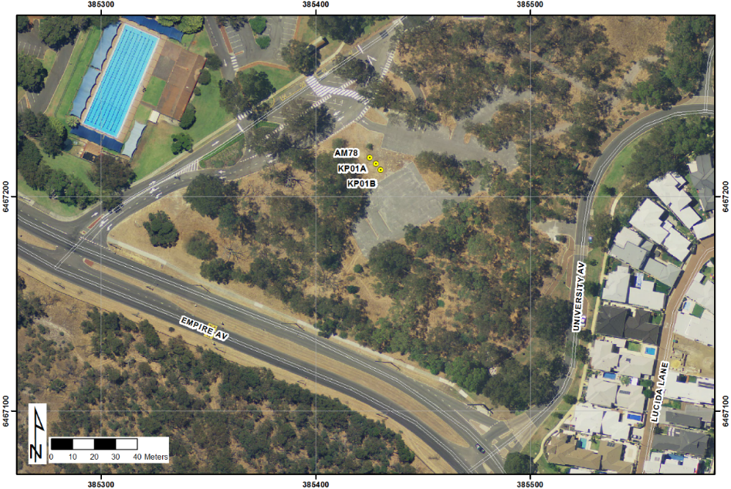

Local map showing location of bore
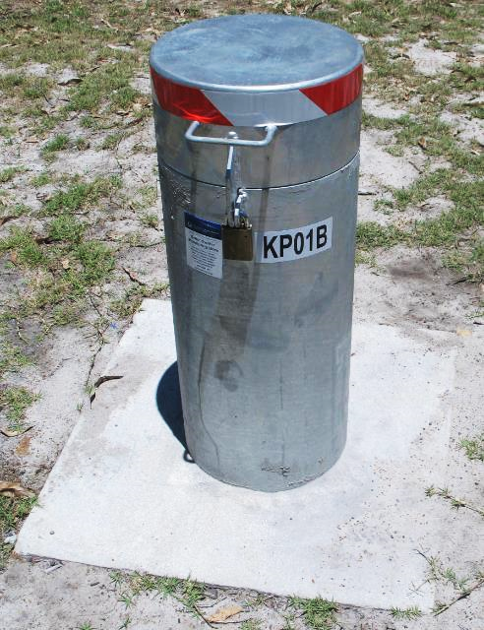

Photograph of completed headworks for groundwater monitoring bore

