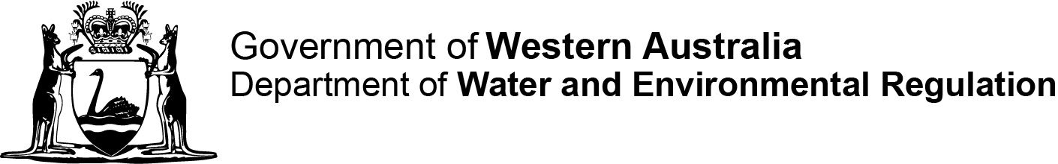
[DER reference no.]
DMO:
Contaminated sites auditor scheme
Contaminated Sites Regulations 2006 regulation 55(3)
Form G: Notification of auditor engagement

This form is to be prepared by the contaminated sites auditor.

Details of accredited auditor
Full name
Contact address
Postal address
(if different from above)
Telephone
Mobile
Fax
Email
Current employer
(company name)
Auditor’s assistant
(nominated person)
In accordance with r 55(3) of the Contaminated Sites Regulations 2006, I formally advise the CEO of the Department of Water and Environmental Regulation that I have been engaged to supply services to provide a mandatory auditor’s report in respect of the following site.
Site address
Certificate of title details
(parcel/lot number)
Site description
(attach site plan as appropriate)
Name of person engaging the auditor
Date of engagement
________________________________ Date
(Auditor’s signature)

