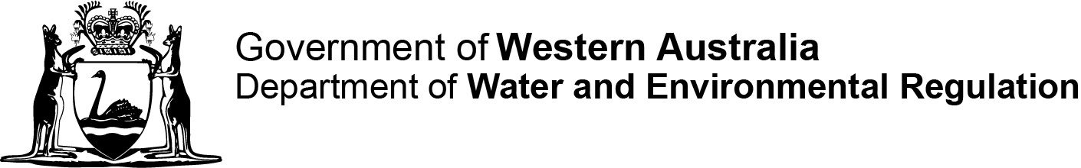
[DWER reference no.]
DMO:
Contaminated sites auditor scheme
Contaminated Sites Act 2003 section 73(a)
Form H: Mandatory auditor’s report—commissioner’s statement

This form is to be prepared by the person commissioning the mandatory auditor’s report.

Part 1 Details of person commissioning auditor’s report
Full name
Contact address
Postal address
(if different from above)
Telephone
Mobile
Fax
Email
Current employer:
(company name)
In accordance with s 73(a) of the Contaminated Sites Act 2003 I formally advise the CEO of the Department of Water and Environmental Regulation that I have engaged an accredited auditor to prepare a mandatory auditor’s report in respect of the following site.
Site address
Certificate of title details
(parcel/lot number)
Site description
(attach site plan as appropriate)
Name of accredited auditor engaged to provide a mandatory auditor’s report
Date of engagement

Part 2 Declaration and signature
Under s 73(a) of the Contaminated Sites Act 2003, a mandatory auditor’s report cannot be accepted unless it is accompanied by a statement identifying and signed by the person who engaged the auditor to prepare the mandatory auditor’s report.
I declare that
I (the person described in this statement)
am the person who engaged the auditor to prepare this mandatory auditor’s report, relating to
certificate of title details (parcel/lot number)
site description
site address
and, that
- I have not provided information to the auditor that I know is false or misleading in a material particular;
- I have not provided information with reckless disregard as to whether or not the information is false or misleading in a material particular; and
- I have disclosed to the auditor all information that I know is materially relevant.
________________________________ Date
(Signature—person who commissioned the
mandatory auditor’s report)
________________________________
(Full name in block capitals)

