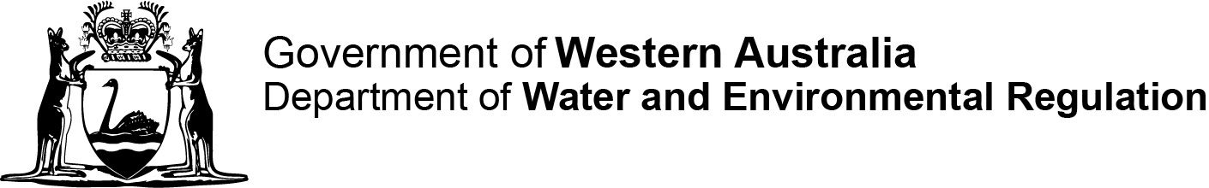
[DWER reference no.]
DMO:
Contaminated sites auditor scheme
Contaminated Sites Act 2003 section 73(a)
Form I: Mandatory auditor’s report—auditor’s statement

This form is to be prepared by the contaminated sites auditor.

Part 1 Details of accredited auditor
Full name
Contact address
Postal address
(if different from above)
Telephone
Mobile
Fax
Email
Current employer:
(company name)
In accordance with s 73(b) of the Contaminated Sites Act 2003 I formally advise the CEO of the Department of Water and Environmental Regulation that I have prepared the attached mandatory auditor’s report in respect of the following site.
Site address
Certificate of title details
(parcel/lot number)
Site description
(attach site plan as appropriate)
Name of person engaging the auditor to provide a mandatory auditor report
Date of engagement

Part 2 Declaration and signature
Under s 73(b) of the Contaminated Sites Act 2003, a mandatory auditor’s report cannot be accepted unless it is accompanied a statement identifying, and signed by the auditor to the effect that the report is accurate.
I declare that
I, (the auditor described in this statement)
am the auditor engaged to prepare this mandatory audit report, relating to
certificate of title details (parcel/lot number)
site description
site address
and, that
- I have not provided information in the report that I know is false or misleading in a material particular;
- I have not provided information in the report with reckless disregard as to whether or not the information is false or misleading in a material particular; and
- I have disclosed in the report all information that I know is materially relevant.
________________________________ Date
(Accredited auditor’s signature)
________________________________
(Full name in block capitals)

