Screening analysis
Instructions
Applicants undertake a screening analysis to assess whether further detailed analysis of odour emissions and impacts is required.
The analysis primarily involves comparison of the screening distance (Appendix 2), with the sensitive receptor distance (Appendix 3), together with consideration of other information.
Screening distances are not provided for some activities. In these instances, applicants are generally required to undertake a detailed analysis.
Applicants are required to provide sufficient information with their application to enable the Department to substantiate the screening analysis.
Separate screening procedures are provided for applications for new or existing premises.
The Screening analysis comprises three steps:
Step 1: Complete the questionnaire relevant to the application (for new or existing premises)
Step 2: Use the flowchart and questionnaire responses to determine whether a Detailed analysis is required
Step 3: Compile information to support the Screening analysis. This can include maps of sources and receptors, topographical maps, specifications for proposed emissions controls and details of screening distance calculations.
If an industry category is not listed in Appendix 2 and the odour risk is considered to be low by the applicant, an exemption from the requirement for Detailed analysis may be granted by the Department. In these cases, the Department can be contacted before commencing preparation of an application.
Questionnaires and flowcharts for new or existing premises are shown below.
An electronic version of the questionnaire for new or existing premises is available on the Department website.

Screening analysis for new premises
Step 1: Questionnaire
Q1. Description of odour emissions
Use the table below to provide brief information about activities and sources that emit odour.
Activity / odour source | Description, including proposed controls
 | Add more rows as required.
Q2. Screening distance
Screening distances for categories of odour-generating activities are listed in Appendix 2.
Select the appropriate option from the list below.
Option 1:  The screening distance is listed in Appendix 2 for this industry category and throughput level.  Screening distance (A) = m  Sensitive receptor distance (B) = m  OR  Option 2:  The screening distance for this industry category and throughput level is specified as ‘case-by-case’ in Appendix 2.  OR  Option 3:  There is no entry for this industry category in Appendix 2. |  | ☐ B < A: Go to flowchart.  - ☐ B ≥ A: Go to Question 3.  - ☐ Case-by-case: Go to flowchart.  - ☐ Industry category is not listed: Go to flowchart.

Q3. Special case factors
Are there special case factors that might increase odour impacts beyond the screening distance shown in Question 2?  Please tick all applicable special case factors:  ☐ Odour impacts from nearby sources  ☐ Presence of an existing elevated odour background  ☐ Complex terrain  ☐ Unusually large and / or complex facility when compared with other Australian operations  ☐ Unusual configuration of odour sources or technology compared with other Australian operations  ☐ The proposal is located in a Strategic Industrial Area (SIA)  ☐ Multiple industry categories that emit odour are present on the same site | ☐ YES or Can’t determine: Go to flowchart.  OR  ☐ NO: Go to flowchart.  Justification should be provided to support a ‘NO’ response.
Special case factors – justification for ‘NO’ response.
Additional comments.

Step 2: Flowchart – new premises
The Screening analysis result is determined using the flowchart below and responses to the questionnaire overleaf.
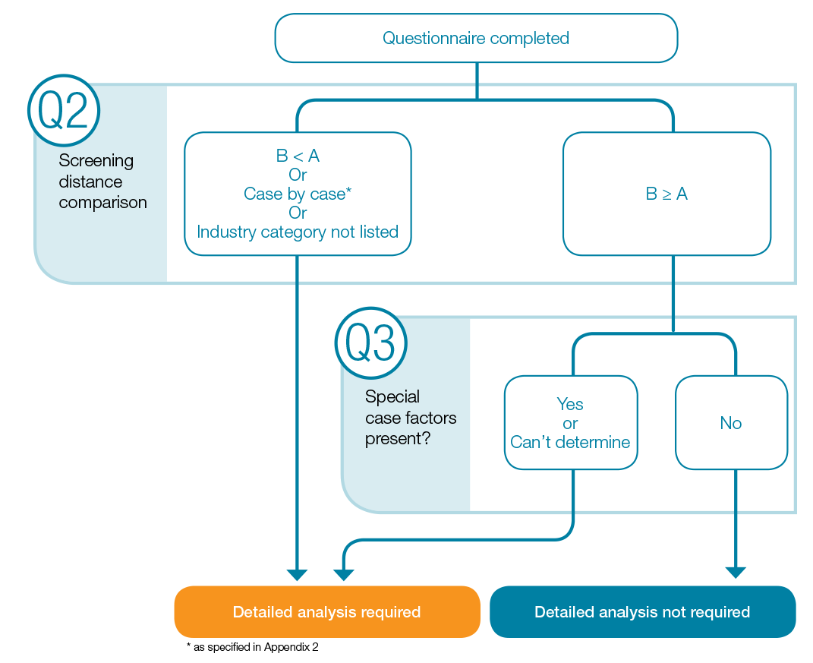
Figure 1: Screening analysis for new premises

Screening analysis for existing premises
Step 1: Questionnaire
Q1. Description of odour emissions
Use the table below to provide brief information about activities and sources that emit odour.
Activity / odour source | Description, including proposed controls  New source? (Yes or No)
 | Add more rows as required.
Q2. Identification of current odour impacts
Have odour impacts occurred as a result of the current operational configuration and / or practices? Please tick all applicable boxes:  ☐ Complaints  ☐ Odour diaries  ☐ Field odour assessments  ☐ Community feedback  ☐ Other._________________________ |  | ☐ YES or Can’t determine: Go to flowchart.
 |  | ☐ NO: Go to Question 3.
Q3. Changes to emissions
Are there proposed changes to the existing premises that are likely to increase the odour emissions, or change the configuration of any source in the facility? |  | ☐ YES or Can’t determine: Go to Question 4.
 |  | ☐ NO: Go to flowchart.

Q4. Screening distances
Screening distances for categories of odour-generating activities are identified in Appendix 2.
Select the appropriate option from the list below.
Option 1:  The screening distance is listed in Appendix 2 for this industry category and throughput level.  Screening distance (A) = m  Sensitive receptor distance (B) = m  OR  Option 2:  The screening distance for this industry category and throughput level is specified as ‘case-by-case’ in Appendix 2.  OR  Option 3:  There is no entry for this industry category in Appendix 2. |  | ☐ B < A: Go to flowchart.  ☐ B ≥ A: Go to Question 5.  ☐ Case-by-case: Go to flowchart.  ☐ Industry category not listed:  Go to flowchart.
Q5. Special case factors
Are there special case factors that might increase odour impacts beyond the screening distance shown in Question 4?  Please tick all applicable special case factors:  ☐ Odour impacts from other nearby sources  ☐ Presence of an existing elevated odour background  ☐ Complex terrain (Glossary)  ☐ Unusually large and/or complex facility when compared with other Australian operations  ☐ Unusual configuration of odour sources compared with other Australian operations  ☐ The premises is located in a Strategic Industrial Area (SIA)  ☐ Multiple industry categories which emit odour are present on the same site | ☐ YES or Can’t determine:  Go to flowchart.  OR  ☐ NO: Go to flowchart.  Justification should be provided to support a ‘No’ response.
Special case factors – justification for ‘NO’ response.

Additional Comments.

Step 2: Flowchart - existing premises
The Screening analysis result is determined using the flowchart below and responses to the questionnaire overleaf.
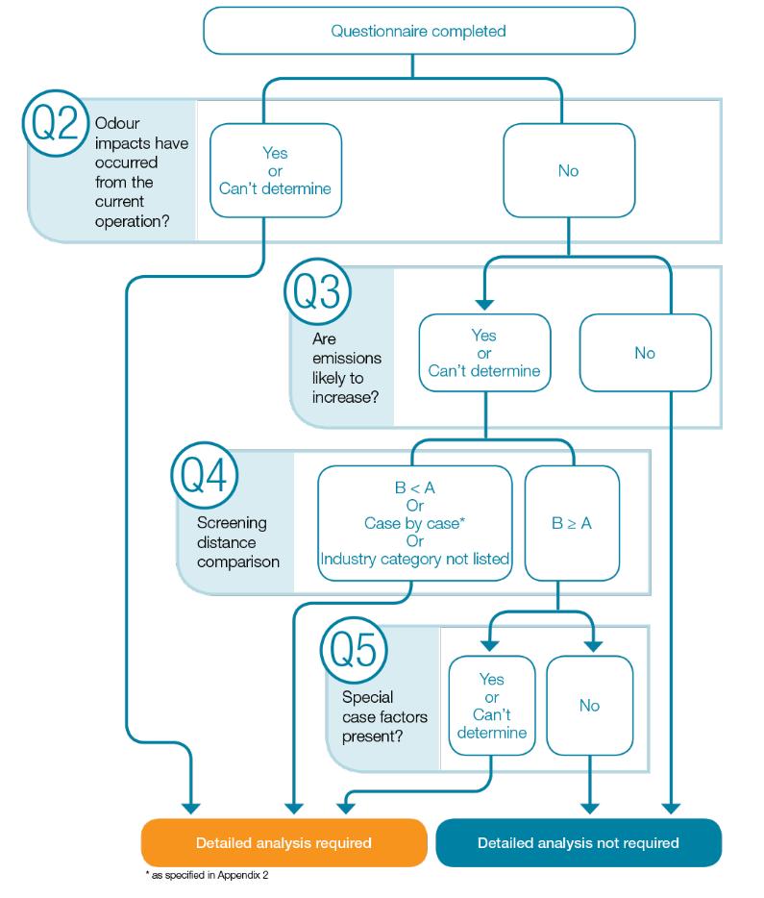
Figure 2: Screening analysis for existing premises

