Commissioning Toolkit for Community Services
Tool 4: Design Services
These Commissioning Capability Tools have been developed by the Western Australian Department of Finance, in partnership with Rebbeck.
Rebbeck is a boutique strategy consultancy and commissioning support organisation that specialises in commissioning capability development. Rebbeck works with healthcare and public services organisations across Australia to support commissioning with a focus on reshaping services to achieve sustainable outcomes for the people of Australia. Find out more at www.rebbeck.com

Design Services: At a glance

1. Overview
Service design is the process of agreeing on the inputs, activities and outputs that will address the identified needs to deliver the targeted outcomes for the communities and cohorts with that need.

2. Purpose
The design services tool aims to ensure that services are designed logically and supported by best practices and evidence to achieve desired outcomes.
3. Workflow

Develop a coherent logic model that considers community needs, desired outcomes, and responses.
1
Identify best practices and adapt service design to fit specific needs.
2
Engage in culturally responsive codesign to ensure that services meet the needs of the target communities.
3
4. Output
On completing service design, we should have a logic model for the commissioning program.

5. Tools and resources
Program logic guidelines

Community Services Template - Outcomes-Based Program Logic Template

Aboriginal Empowerment Strategy

Planning in Partnership Guide

1. Overview

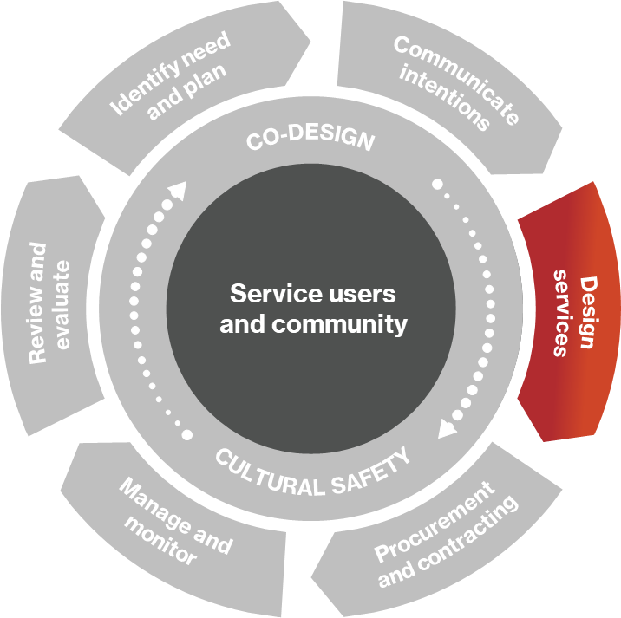
1.1 What is service design?
Service design is the process of identifying the interventions the commissioner will put in place to address identified needs. Good service design should be supported by a logic model that describes the needs that will be addressed, the desired outcomes and experiences of the cohorts facing the need, and the key inputs, activities and outputs required to address the need.
The logic model should describe the services with summary-level statements.
Figure 1: Commissioning cycle
The logic model and service models should be based on best practice and co-designed with relevant stakeholders.

2. Purpose

2.1 What will our service design achieve?
Service design should address some critical questions about our commissioning program:
- What are the needs that the program should address?
- Who are the people experiencing these needs?
- What are the outcomes and experiences we aim to achieve for these people?
- What service models do we believe will be effective in meeting the needs of the target cohort?
- What practical considerations must we consider to ensuring the service model works for the target cohorts?
On completion of the service design phase, we should have an agreed approach for intervention that is clear, logical, and actionable.

2.2 Logic models as a foundation for commissioning
Logic modelling is helpful for commissioners to describe the logic underpinning commissioning interventions.
The commissioning process starts with identifying the need, which is the issue we are trying to address, and for whom. From our needs analysis, we can understand the outcomes that will be achieved when the need is addressed. Finally, we identify proposed responses to the need to meet the outcomes. The logic model provides a framework to develop our understanding of the needs, outcomes, and responses.

3. Develop a logic model

3.1 What is logic modelling?
Developing a program logic is essential for understanding how commissioned services and programs deliver desired outcomes. It provides the central thinking to our service design.
We start by understanding the problem we are trying to solve. These are summary statements from the needs analysis findings (see Identify needs tool). We then describe what we intend to achieve, the ‘outcomes’, which are the resolutions of the problems faced. It is essential to consider the outcomes and consequences of a particular service or intervention in the short-term, medium-term, and long-term.
We can then identify the service responses, which is the plan to solve the problem and achieve the outcomes. They provide the logical sequence for how the need is addressed and the outcomes are delivered, drawing out the necessary inputs, activities, and outputs in the process.
Logic models should be developed through co-design with relevant stakeholders, including service providers, service users, subject matter experts and project stakeholders. This will be further discussed in the co-design section.

3.2 Step guide for developing a logic model
Step A – Needs
We begin by understanding our target community and the issues they face. Most of this work should have already been done in the Identify needs tool. We then develop a set of needs statements to summarise the problems we want to address through the program. Our needs statements should describe the situation (issues) and the communities experiencing the issue.
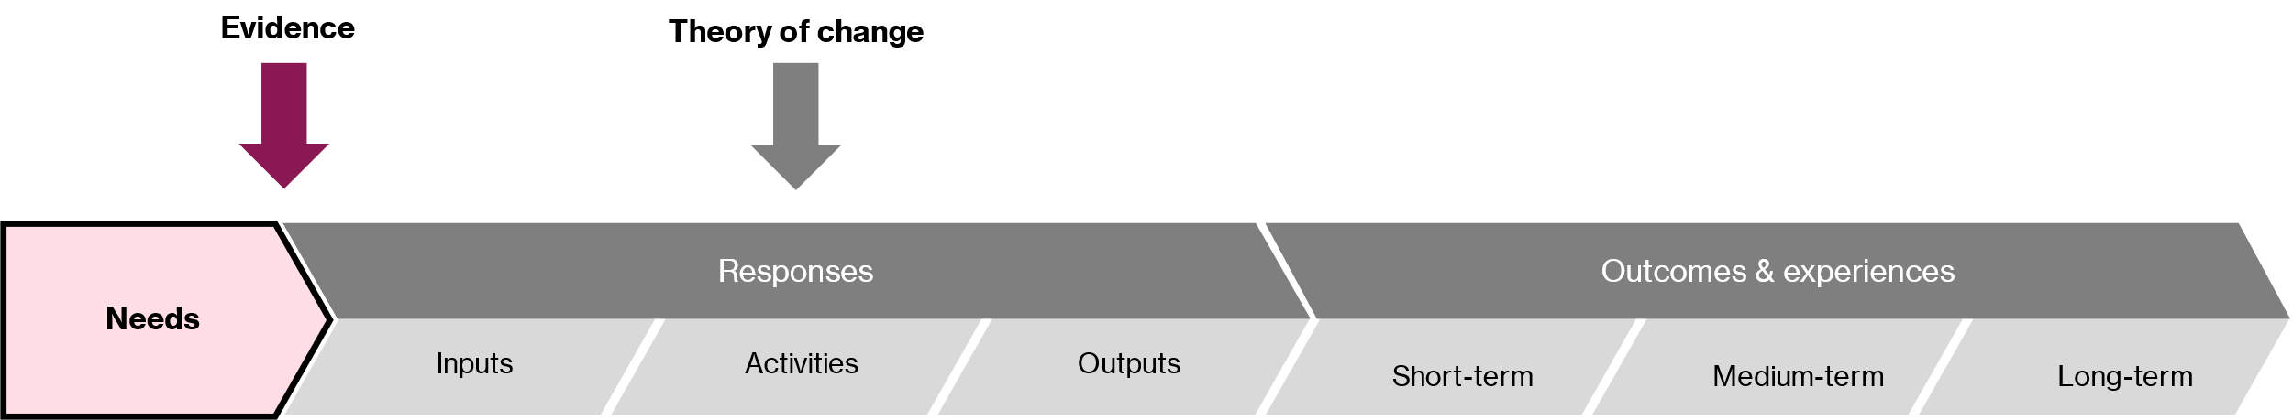
Figure 2. Example of logic model highlighting Step A – Needs.
Situation (issues): Clearly define the issue being addressed. It should be clear from the statement of need what is being addressed. For example, "residents living in remote areas achieve poorer socioeconomic outcomes" is unclear about how our government agency would help. However, "residents in remote areas experience poor socioeconomic outcomes because they find it difficult to access tertiary education" makes it clear what the need is to be addressed.
This should be done during the Needs Analysis and should draw on research, including:
- community and client-level data
- client, community, and staff perspectives
- existing research literature
- conversations with experts and stakeholders.
Target community: Identifying the cohort experiencing the need and the target community for the program is essential. Be specific in describing the number of individuals and communities in scope for the program, their age group, gender, geographical area, and cultural group.
Step B – Outcomes
The main goal of this step is to identify short, medium, and long-term outcomes.
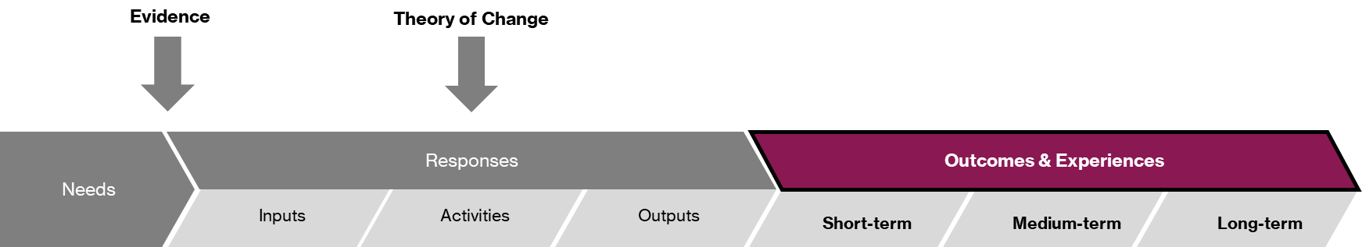
Figure 3. Example of logic model highlighting Step B – Outcomes.
The next step in developing a program logic is articulating the intended outcomes for the program. The desired outcomes should reflect the stated needs.
Defining outcomes: An outcome can be an increase in positive changes or a reduction in negative changes. Outcomes may be intangible (e.g., changes in attitudes, values, or behaviours), as well as tangible (e.g., educational outcomes, life satisfaction, or improving physical and mental health).
Timeframes:
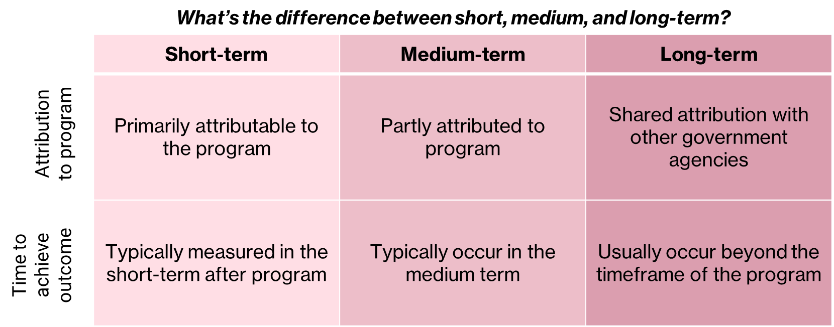
Figure 4. The differences between short, medium and long-term outcomes.
Outcomes can be experienced over different timeframes (short, medium, and long-term). The short-term outcomes should lead to the medium-term, which in turn leads to the longer-term outcomes that often occur after the program. The long-term outcomes are typically measured by an impact evaluation, sometimes years after the program has ended. Capturing outcomes at all stages is important so we can be clear on the impact we want from the program.
Attributability: As the timeframes of outcomes move further away from the program's outputs, so will the degree to which we can say that the program has directly caused the outcomes. While short-term outcomes are often primarily attributable to the program, long-term outcomes are only partly attributable to the program as other services, programs, or societal changes will also influence the outcomes. Where outcomes have lower attributability to the program, it is often inappropriate to include them as an indicator but they should be included in the narrative/justification for the program.
Step C – Responses
This step aims to develop responses based on the best evidence and indicate the theory and mechanism of change. This includes inputs, activities, and outputs.
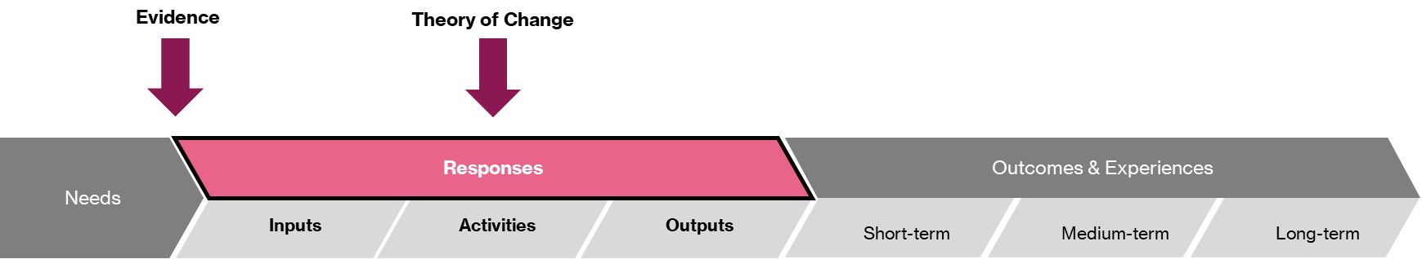
Figure 5. Example of logic model highlighting Step C – Responses.

Evidence: Responses in the program logic should be based on the best evidence available that the model of care will deliver the outcomes. The strength of evidence depends on whether the program is well-established or more innovative and how applicable that evidence is to the context of our program. The Needs Analysis is a good starting point for evidence collection.
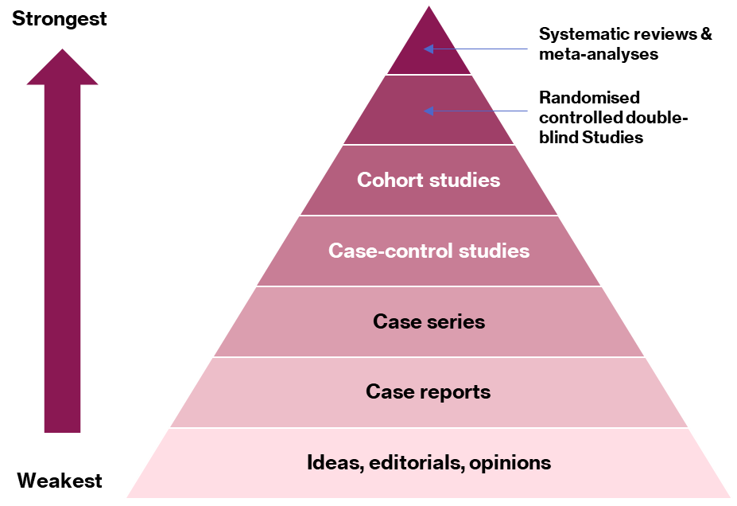
Figure 6. Types of evidence available for program responses, ranked by strength.
Inputs: Identifies the resources required to run the activities and are typically the parts of a program that are associated with cost. These include the people needed to run the program and the resources required to conduct the activities.
Activities: Identifies what the inputs will be doing and are the actions and tasks taken to respond to the issue being addressed. These should be based on what the evidence tells us is the most effective way to address the problem and support achieving the outcomes.
Note: Activities in our logic model should be high-level; the detail of our activities can be captured in an activity plan or service model paper.
Outputs: Identifies what the direct results of the activities will be and are measurable and often tangible. An output may be something that will help the person to achieve the outcome or an improvement to a service that enables people to achieve better outcomes.
Theory of change: Briefly summarises the mechanism of change and is a simple theory behind how or why we think a particular intervention or activity leads to the outcomes. This should be logical and succinct and draw on the best possible evidence.

4. Design services

4.1 Identify best practice
Commissioning programs are often developed based on service models that have demonstrated success elsewhere. The first step of this process is to identify best practice and find the best service delivery model for the specific need in similar jurisdictions. We should consider existing services that are evidence-based and close to our commissioning context.
Commissioners need to consider the most robust evidence available to support their decision-making (see figure 6 on the types of evidence). However, we also need to consider whether the evidence is applicable. For example, a robust study in a metropolitan area may not apply to a remote community.
A range of variables should be considered to determine how close the best practice service context is to our own commissioning context. These variables include political, economic, geographic, target demographic, and funding environment.

4.2 Adapting best practice
Best practices can be sourced worldwide and used across different contexts. There is no one-size-fits-all public service design, and as such, three main considerations must be made to adapt best practices to our commissioning context:
- Can it be adapted to the geographic context?
- Can it be adapted to the target demographic?
- Can it be adapted to the political, economic, and funding environment?

4.3 Principles for Service Design
We should follow ten principles for service design that reflect good commissioning practice. Service design should be:
- outcomes-focused
- based on service users’ needs
- evidence-based
- integrating existing services rather than establishing new components
- adaptable to service users’ circumstances
- tested at a small scale before a full-scale launch
- starting with a minimum-viable service
- co-designed
- implemented collaboratively
- culturally responsive.

5. Considerations for co-design and cultural safety

5.1 What is co-design?
The Delivering Community Services in Partnership Policy defines co-design as “to collaboratively design services with service users, organisations and service providers and government agencies.”
Co-design is the act of creating with stakeholders.

5.2 The IAP2 Framework
The International Association for Public Participation (IAP2) offers a spectrum of possible engagement with public stakeholders, from simply informing the public about the design process to empowering stakeholders to develop solutions.
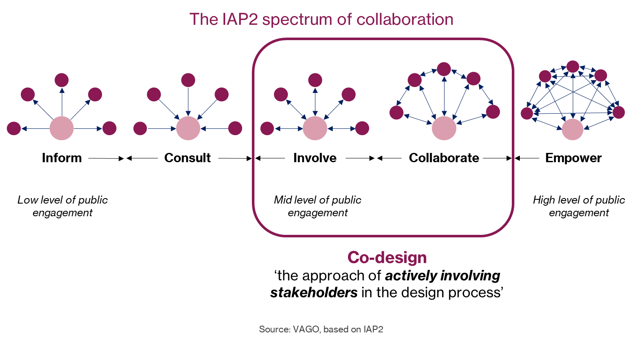
Figure 7. Diagram showing co-design in relation to the IAP2 spectrum of collaboration.
Within the spectrum, the options of involvement and collaboration are ways to engage stakeholders in a co-design process. The co-design process is distinct from other levels of stakeholder engagement in that stakeholders collaborate with each other and the government agency to develop service solutions. The flow of ideas and information in a co-design process is multi-dimensional, whereas lower levels of public engagement, such as informing or consulting, only facilitate the one-way flow of information from or to stakeholders.

5.3 Why do we undertake co-design?
Co-design actively involves a diverse range of participants exploring, developing, and testing responses to identified needs. When the co-design process is run well, it:
- focuses on addressing the needs of defined communities
- considers the differing perspectives of the public, service providers, and partners
- makes the best use of the available expertise from this diverse group of stakeholders.
The combination of perspectives can help the commissioner design services that are:
- supported by evidence
- supported by the experience of what works
- practically helpful for the service users
- representative of good value for taxpayers.

5.4 Co-design techniques
The co-design process provides multiple perspectives to create a robust program logic. The number and variety of co-design activities will depend on the complexity and novelty of the program and the time and funding available to complete the design stage. Where possible, stakeholders involved should include those with subject matter expertise, those with lived experience, project stakeholders, service providers and possibly third-party facilitators.
It is possible to complete a logic model with the right group of stakeholders in a dedicated logic modelling workshop. However, other complementary techniques can be used to inform or develop sections of the program logic. These are illustrated in figure 8 below.
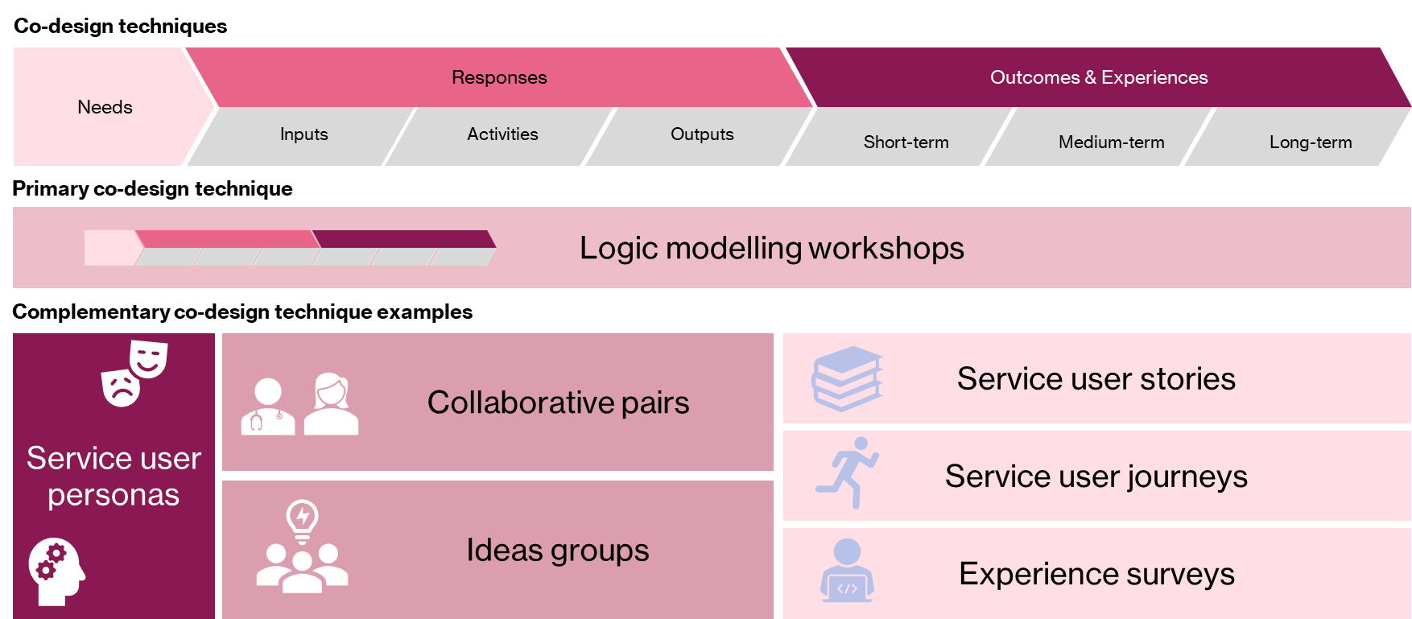
Figure 8. Co-design techniques available to commissioners.

5.5 Identify stakeholders for co-design
Firstly, we need to identify the key stakeholder groups to include in the co-design process. We often cluster our stakeholders into the following groups:
- Public: service users, families and support persons
- Service providers: front line staff, management
- Partners: system partners, which can be from various relevant industries across the government, non-government and private sectors, including community groups, professional bodies, or politicians.
We then need to develop effective engagement strategies for each stakeholder group. These should be based on our experience and understanding of the local context. This needs to be carefully developed with reference to the following:
- target cohort
- cultural context
- regional-specific issues
- historical pattern of service provision.
A common mistake in co-design is engaging with all our stakeholders using the same method instead of a more targeted approach for each stakeholder group. While workshops can be a particularly effective method to engage with service providers and system partners, they are not always appropriate for engaging with service users, mainly due to the power imbalance that can arise when service users are in the same room as service providers and system leaders.
Once we have identified effective strategies for engaging with stakeholder groups, we need to develop a co-design plan that outlines who, how, where and when we will engage with them. The co-design plan should include what is in scope to be the co-design and what is not in scope. It is important to be clear on any limitations or constraints on the co-design process.

5.6 Considerations for inclusive, culturally responsive co-design
Aboriginal and Torres Strait Islander communities
Commissioners should be aware of the intergenerational trauma, negative stereotypes, racism, and prejudices that Aboriginal and Torres Strait Islander people have been subject to for generations. Commissioners should aim to design inclusive services that serve Aboriginal and Torres Strait Islander people equitably but do so in a culturally safe manner. The five cultural safety principles should be followed through the co-design process.
Table 1. Explanation of the cultural safety principles
Cultural safety principle | Explanation
Protocol | Before engaging with any Aboriginal community for co-design, commissioners should learn the protocols and customs of the community. Commissioners should recognise the importance of reciprocity in engagement - that ‘learning goes both ways’.
Personal knowledge | Commissioners should be aware of their cultural identity and socio-historical location in relation to the Aboriginal communities we engage with. Commissioners should also be prepared to share our story out of respect for reciprocity and to engender trust.
Partnership | Commissioning is always a collaborative process; never is this more important than engaging with Aboriginal communities. Aboriginal communities are best placed to understand their people's needs and what will work for them more than commissioners, and commissioners should collaborate with First Nations people to design solutions.
Process | Processes of engagement with Aboriginal communities for co-design need to reflect the need for mutual learning. We must ensure equity and dignity for all parties and ‘talk less, listen more’.
Positive purpose | Commissioners should seek to engage communities purposefully to shape positive steps towards better outcomes. These principles should be demonstrated in any engagement with Aboriginal communities and be documented in written deliverables to achieve better outcomes throughout the commissioning life cycle.

Culturally and Linguistically Diverse (CALD) communities
For culturally diverse communities, significant barriers often exist to fully using the public services on offer. These are primarily divided into cultural, structural, and service-related barriers and are illustrated below.
Table 2. Barriers to accessing services for the CALD community
Cultural barriers | Structural barriers | Service-related barriers
- Language barriers and misinterpretation of body language  - Cultural norms that prohibit seeking extra-familial support  - Traditional gender roles that prevent men from engaging with services,  - Lack of CALD-specific support services and interpreters | - Practical barriers to accessing services  - A lack of knowledge or understanding of available services  - Social isolation | - Culturally inappropriate services  - Services not being perceived as relevant due to lack of cultural diversity in marketing/ diversity in the workforce  - Reluctance to engage with services because of concern that they will not be understood  - Mistrust of government agencies
Some important considerations for creating safe spaces and services for CALD communities include:
- Show interest and respect for cultural diversity.
- Work within the cultural context of an individual, family, or community.
- Have an awareness of how the cultural norms of the CALD group differ from your own.
- Offer interpreting and translation services.
- Use plain language in both verbal and written communications,
- Promote the dissemination of services.
- Partner with personnel in CALD-focused centres.
- Have managers who are knowledgeable about diversity.

LGBTQIA+ (Lesbian, Gay, Bisexual, Transgender, Queer, Intersex, Asexual and more) communities
The barriers faced by the LGBTQIA+ community can be split into three categories: experiences of stigma, abuse, and conscious and unconscious bias. These are discussed in the following table.
Table 3. Barriers to accessing services for the LGBTQIA+ community
Experiences of stigma | Experiences of abuse | Conscious and unconscious bias
- Stigma or discrimination when accessing non-LGBTQIA+ specialist services  - Negative experiences when accessing services, including overt and covert homophobia, biphobia, or transphobia  - Incorrect assumptions being made by staff about a person’s gender and/or sexual orientation | - High levels of harassment  - Verbal and physical abuse  - Violence  - Sexual assault  - Abuse or discrimination from staff or other clients | - Lack of correct terminology used by service providers  - Misgendering or misnaming of service users  - Lack of community-specific knowledge and sensitivity
Some important considerations for creating safe spaces and services for LGBTQIA+ communities include:
- Increase staff knowledge of LGBTQIA+ terminology, issues and needs with LGBTQIA+ specialist training. As staff increase their knowledge, they should be able to demonstrate comfort when using LGBTQIA+ language.
- Provide a proactive and positive reception to LGBTQIA+ individuals and their families.
- Use open questions that do not assume someone is heterosexual and cisgender. For example, use gender-neutral pronouns (they/them), and use gender-neutral language when referring to relationships.
- Show a willingness to let service users authentically represent their lives and their chosen terms.
- Update content to ensure it is inclusive and develop inclusive registration forms and privacy protocols. For example, when service users are asked about gender on forms, a third response option should always be included. Where possible, this should be a free text opportunity for individuals to describe their gender.

6. Communicating intentions

6.1 Seeking participation in co-design
Commissioners should aim to build productive relationships with service providers and provide advance notice of service design activities to ensure that key service providers are available to collaborate. This will enable appropriate refinement of the service design and ensure that the final service design can be delivered on time.
Commissioners should also consider engaging service users when co-designing. It is helpful to build a pool of service users who would like to participate in service design ahead of time. Commissioners can then use this pool of people to gain insights into how well-received and culturally responsive a service design is. We should ensure that the collection of service users is representative of the population.
When communicating intentions to service providers and service users, limitations and constraints of the co-design should be communicated as early as possible to avoid creating unrealistic expectations.

7. Links to resources

7.1 Program Logic Guidelines
For information on developing outcomes, check out the Outcomes based Program Logic Model Guidelines found under Contract planning: Templates and workbooks here.

7.2 Community Services Template – Outcomes-based program logic template
For an outcomes-based program logic template, visit here.

7.3 Aboriginal Empowerment Strategy
To view the Western Australia Aboriginal Empowerment Strategy 2021-2029 policy guide, visit here.

7.4 Planning in Partnership Guide
The Planning in Partnership Guide is a useful guide for government agencies conducting co-design, which can be found under the Resources for Buyers here.

