Commissioning Toolkit for Community Services
Tool 2: Develop Strategy
These Commissioning Capability Tools have been developed by the Western Australian Department of Finance, in partnership with Rebbeck.
Rebbeck is a boutique strategy consultancy and commissioning support organisation that specialises in commissioning capability development. Rebbeck works with healthcare and public services organisations across Australia to support commissioning with a focus on reshaping services to achieve sustainable outcomes for the people of Australia. Find out more at www.rebbeck.com

Develop Strategy: At a glance

1. Overview
After identifying our commissioning needs, we need to formulate a strategy that is consistent with the objectives of both the departmental strategy and the external context that we operate in.

2. Purpose
Strategy is the development of a coherent set of choices that are informed by the data and our best theory of how the choices will deliver the intended outcomes.
3. Workflow

Confirm the internal strategic context for the commissioning program

2
Assess the external strategy landscape for the specified commissioning program
1

Identify a coherent set of objectives to achieve the desired results
3
4. Output
On completing the Develop Strategy stage of our commissioning process, we will have assessed the internal and external landscape and confirmed the context in which we are working. These insights will be used to make coherent choices about how we will address the needs.
5. Tools and resources
National Agreement on Closing the Gap

Community Services Template Business Case

4

Consider cultural safety and communicate strategic intentions to stakeholders

1. Overview
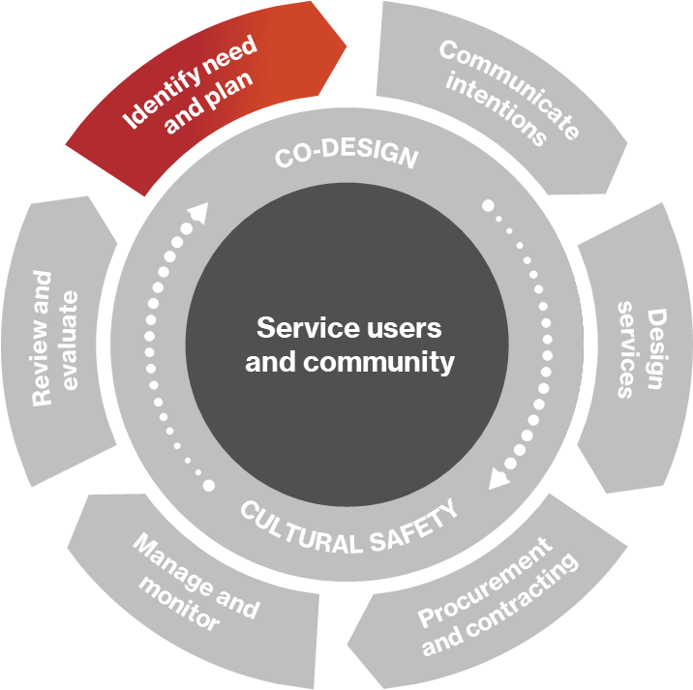
The Develop Strategy tool is the second of three tools that cover the ‘Identify need and plan’ phase of the commissioning cycle.
In the first tool, Identify Needs, needs were identified and prioritised. From these prioritised needs, commissioners formulate a strategy and set a course to address the need.
In this tool, we examine how government agencies in Western Australia can develop a strategy by assessing both the external strategic landscape and their internal context. We are then able to make a set of coherent choices that are grounded in this context to address the identified needs.
Figure 1: Commissioning cycle

1.1 What is strategy?
Strategy is about making coherent choices about what we will do and what we won’t do to achieve desired results. A good strategy provides a clear roadmap for executing the desired change. This consists of a set of guiding principles that defines the actions people should take and what they should prioritise to achieve desired goals.

1.2 The strategy landscape
Strategy development can take place at all levels of public service, from national and state strategies to specific program strategies. When developing a strategy, departments should align with the internal landscape, which the department has control over, and the external policy landscape, which the department is subject to.
The levels of the strategy landscape are represented in Figure 2.
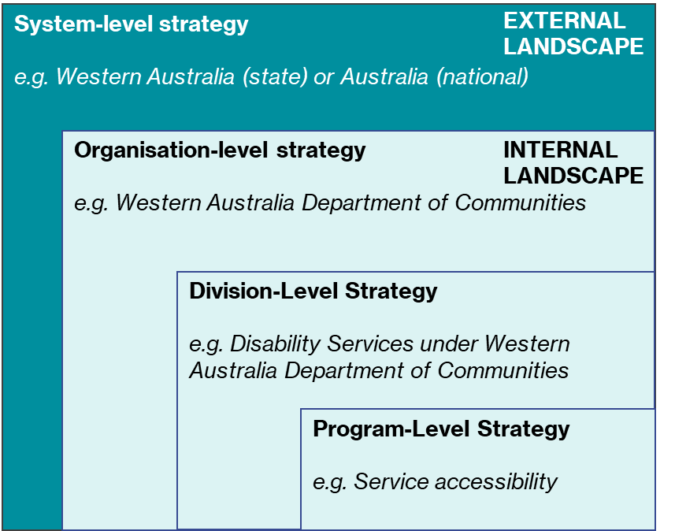
Figure 2. The strategic landscape of a government department
External landscape
When developing a strategy, we must first consider whether it aligns with the external landscape. Governments at state and federal levels may have system-level strategies for achieving certain outcomes for the populations they serve and we must ensure that our strategies are consistent with these.
Internal landscape
Organisation-level strategy allows department goals and priorities to be set. Under this strategy, less pressing social issues may receive less funding so that higher priority issues can receive more. Not all outcomes can be achieved simultaneously, so trade-offs are made according to the department’s strategy.
Division-level strategy, which nests under the organisation-level strategy, makes similar trade-offs and allocation choices at the division or portfolio level.
Cohort or individual-level strategy is important in upholding outcomes for the target demographic. Operating strategically at the cohort level means that the root cause of an issue is carefully considered. For example, allocating transfer payments to unemployed youth may not be as effective as investing in education or training programs that upskill the cohort and addresses the root cause of youth unemployment.
It is critical to accept that not all issues can be solved at once, and long-term solutions may be uncomfortable or costly in the short term.

2. Purpose
A strategy is a coherent set of choices that, when executed correctly, deliver the intended results. Without a clear strategy, initiatives, divisions, organisations, and government systems can act without the knowledge of others and can potentially strive for mutually inconsistent or conflicting objectives.
The purpose of this tool is to explain the key components of strategy development to provide a structured approach for departments and individuals reading the tool.

3. Assess the external strategic landscape
Before we can determine how we will address the needs prioritised following our Needs Analysis (see Identify Needs tool), we should understand the strategic landscape in which our department operates.
To assess the external strategic landscape, we must consider the implications of the following on our strategy:
- problem(s) demonstrated by the Needs Analysis
- external context we are operating in
- wider system planning
- system leadership and governance
- system finance.

3.1 Inputs from Needs Analysis
The Needs Analysis (see Identify Needs tool) should be carefully consulted when developing our strategy since it gives us insight into service user demands and the existing state of service supply. The strategy generated following this tool should address the gaps in the market (the problem) identified in the Needs Analysis.

3.2 Review external context
The PESTLE framework provides a structured way of considering the external context of a program.
PESTLE is a mnemonic to examine the wider context. These letters stand for:
P – Political
E – Economic
S – Social
T – Technological
L – Legal
E - Environmental
The outputs of this analysis enable the program to align its strategic thinking with the context it is working in.

Table 1. PESTLE framework
Lens | Description | Australia (national) examples | Western Australia (regional) examples
Political | - Political factors examine the political landscape within which our organisation operates and how political motivations, developments and constraints impact the sector of interest and, most specifically, the commissioning project or program at hand  - It includes an analysis of the extent to which a government may influence the wider economy and / or the industry in isolation | - Federal government priorities (and subsequent changes to community services financing)  - Upcoming federal elections  - Revision to policy incentives  - Revision to government policy | - Agenda of local politicians  - Upcoming state or local elections
Economic | - Economic factors consider the aspects of economic performance that directly impact social issues and public services spending  - Economic factors include inflation, unemployment rates, fiscal policy, interest rates, and regional economic growth patterns (i.e., any factors that influence public spending, affect service user purchasing power and change demand/supply models for the economy) | - Economic including fiscal (budget) stimulation strategies  - Inflation rate  - National (regional) unemployment rates | - State-level fiscal stimulation policies  - Capital spending e.g., new infrastructure investments  - Regional unemployment rates  - Regional economic growth
Social | - Social factors relate to the social environment surrounding public services in Western Australia, gauging determinants such as demographics, community size, and cultural norms  - They seek to understand changes in demographics and public values  - Different communities have different fears, beliefs, and cultural norms. Any culturally responsive commissioner should fully understand these considerations before commencing. Additionally, commissioners need to stay aware of new trends | - Cultural norms in accessing public services (and variants among different groups within)  - National core values and public priorities  - Changes in attitudes e.g., more openness to mental health discussions | - Regional demographics (age, gender, nationality, marital status, job, education level, and income.)  - Regional community size  - Regional core values  - Awareness and understanding of local commissioners of new social trends
Technological | - Technological factors assess innovations that will likely disrupt the market (favourably or unfavourably)  - Factors include automation, research and development and the amount of technological awareness that a market possesses  - Public services are changing positively due to technological advancements that enable enhanced community engagement and remote accessibility  - In healthcare settings, app developments are putting preventative measures in place, helping patients to control and monitor their own needs | - Public apps/websites (e.g., MyGov), including integrations  - National R&D developments | - State-level applications and websites
Legal | - Legal factors review current legislations that regulate the industry and any changes to legislation and/or regulatory shifts  - There are both external and internal factors: external factors consider country-wide laws; internal factors consider department policies  - Legal analysis takes both angles into account and develops strategies considering these factors | - Any relevant national legislations (e.g., national labour laws) | - Any relevant state legislation  - Government and department policy
Environmental | - Environmental factors determine environmental concerns for public services – both those that influence and are determined by the surrounding environment  - Factors of an environmental analysis include climate, weather, and geographical location | - National climate concerns  - National controls/advice on sustainable procurement practices | - Geographical spread of regional communities  - Regional droughts, heatwaves, flooding  - Regional strategies and plans

3.3 Review system planning
Understanding the national, state, and local strategic landscape leads to:
- better integration of services
- more outcome-driven models of service
- reduced duplication of services.
When we are reviewing the system planning landscape, we need to consider the plans that have been developed by the range of organisations working across the broader public service to find opportunities for better alignment of strategic plans. This will improve our ability to commission across government and improve the overall impact of government department strategies.
It is particularly important to identify what strategies are already in existence relating to the commissioning program in Western Australia and nationally. Once we develop a good understanding of these strategies, we will be better placed to develop an aligned strategy that is widely supported.

3.4 Review system leadership and governance
Following a review of system planning, we should understand the wider system leadership and governance arrangements in place so we can identify the key players and potential strategic partners. To do so, we should:
- identify what forums are already in place addressing the commissioning program
- identify any governing bodies associated with the commissioning program
- understand if any performance targets have been set concerning the target outcomes of the commissioning program
- determine if any cross-department governance arrangements are in place with a scope that would include the commissioning program.
The Identify Needs tool highlights that commissioners should look at problems with a multidisciplinary approach. Health, education, justice, and social care are all closely interlinked, so it is important to look for system leaders across the public service system to learn from and collaborate with.

3.5 Review system finances
Understanding our context includes understanding the other commissioners or funders of public services in our region, especially those with a specific interest in our commissioning program.
Other commissioners or funders may include:
- federal organisations
- state-level organisations
- large not-for-profits
- private institutions
- community organisations.

4. Assess the internal context

4.1 Understand the implications of the internal strategy landscape
We need to consider the existing organisational strategy, including the department’s purpose, vision, and mission statements, and any short, medium, or long-term strategic plans that have been established.
Several additional factors listed below are also important to consider:
- The strategic approach set by the department: e.g., attitudes to collaboration/partnering, the specified funding period, views of in-house provision vs. external sourcing, the role of co-design, executive’s risk appetite, and the perceived role of innovation.
- The organisation’s strategic intent: e.g., cost containment, efficiency improvements, addressing unmet needs, and others.
- The risk appetite the department sets in its strategic guidance: e.g., political and media.
- The key stakeholders identified in the strategic guidance: the key stakeholders to be considered and the interests to be preserved.
- The interdependencies identified in the strategic guidance.
- The enabling actions that are being undertaken by the organisation that will support the commissioning program: e.g., IT systems development, digital enablement, organisation restructuring, staff training, sector readiness activities, and internal policy changes.
We can then begin to draw conclusions about where our commissioning project or program sits in terms of priorities for the wider organisation and define where we can best align with its current purpose and medium-long term strategy.

4.2 Understand the funding available
Understanding how the program aligns with the wider organisation’s strategy will allow us to target funding allocated for certain priority areas. A key funding consideration is our spending power as a department or a program team and understanding any thresholds for overspending, for which a business case may be required.
This will inform decisions in the Plan and Design Services tools, as we must identify and understand the budget envelope we must work with.

4.3 Understand resource capability/capacity
We need to determine the resources available to support any commissioning initiatives that might be developed. This includes:
- Understanding the workforce capacity of the organisation and the relevant department. This involves identifying the availability, skillset and experience of potential program managers and a supporting team to design and/or lead the initiative.
- Identifying any enabling functions that might be required to support the various stages of the project life cycle, e.g., finance, human resources, information services, quality and safety, and communications.
- Identifying busy periods and other constraints for these departments, which will need to be factored into any plans made.
- Understanding the appetite to hire new staff should the desired commissioning project or program require additional resources.
- Distinguishing what technology is available in-house to support project development and implementation.

4.4 Understand policy enablers and constraints
We need to understand the implications of existing internal policies. There are three key questions to ask at this stage:
- Do we have any existing policies which provide direction for the commissioning strategy?
- Do we have policy levers that can be engaged to assist the cause?
- Do we have existing policies that guide us away from exploring the program altogether?
The answers to these questions should guide how the final strategy should take shape.

5. Making coherent choices

5.1 What does a coherent strategy look like?
A coherent strategy is one where all the parts make sense when brought together. When executed correctly, a coherent strategy should effect change through several goals being met in unison.
A coherent strategy will make educated trade-offs and announce multiple goals that will work together. We should be comfortable with any trade-offs made if they are evidence-based and backed by experience.

5.2 Articulating strategy
Once a coherent strategy is formed for the commissioning activity, we need to articulate it to gain support from key stakeholders. Stakeholders may include end-users, government employees, co-commissioners, and other relevant departments.
A strategy report should be developed, and the following sections should be included:
- Context: The external environment that informs the choices we make, including threats and opportunities.
- Vision: Convey to stakeholders what ‘winning’ looks like for the department or program – what is the ultimate objective/outcome?
- Theory of change: How will our coherent set of choices lead to the vision?
- Strategic pillars/priorities: What are the main components of the strategy?
- Enablers: What are the necessary inputs to enable the strategic pillars?
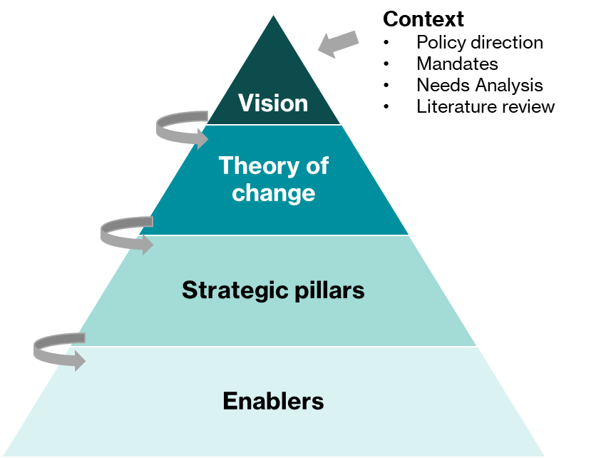

6. Considerations for co-design and cultural safety

6.1 Gaining different perspectives
Stakeholder groups should be consulted before finalising the strategy and we must identify the most appropriate means of collecting information from these groups, whether through focus groups, meetings, surveys, or phone calls. We must ensure minimal biases within the data/information collection process and that the end-user sample is appropriate and representative of the target community.
We need to be sensitive to the cultural and social considerations of various relevant community groups and ensure that our strategy addresses the specific needs of relevant marginalised communities.

6.2 Testing the strategy
Various methods are available to commissioners to test a strategy before full-scale implementation.
Consulting with service providers is often the best way to test a hypothesised strategy as their first-hand experience working in the relevant field means they can often point out any flaws in the strategy. However, be aware that service providers may have preconceived notions about what the best solution is based on past experiences. We should consider any service provider’s opinions alongside our own judgement.
A pilot program, though not always necessary, may also be a useful tool to gauge the strategy’s feasibility in a real-world situation.

7. Communicating intentions

7.1 Communicating strategy to different audiences
Our strategy must be communicated effectively to both internal and external stakeholders to enable its adoption. Ideally, the order in which we communicate the proposed strategy should be:
- Internal decision-makers: Presentation to internal decision makers should be succinct, supported by evidence, and focus on how the strategy works with the other initiatives the organisation runs.
- Market participants and suppliers: Outline the procurement intentions of the strategy, overall strategic intention at the organisation level, and any potential downstream impacts on future procurement. Communications should be transparent with the entire market so that all market participants are informed and engaged.
- Service users and the community: Communications to the public should be succinct, less technical, and designed to engage citizens with the strategic vision and outcomes. Media forms such as explainer decks, videos, and infographics are ideal. Accessibility of these communications should be carefully considered to ensure that the entirety of the target community can gain information about the program.

8. Links to resources

8.1 National Agreement on Closing the Gap
To view the National Agreement on Closing the Gap, visit here.

8.2 Community Service Template Business Case
For the community services business case template, visit here.

