Commissioning Toolkit for Community Services
Tool 7: Manage and Monitor
These Commissioning Capability Tools have been developed by the Western Australian Department of Finance, in partnership with Rebbeck.
Rebbeck is a boutique strategy consultancy and commissioning support organisation that specialises in commissioning capability development. Rebbeck works with healthcare and public services organisations across Australia to support commissioning with a focus on reshaping services to achieve sustainable outcomes for the people of Australia. Find out more at www.rebbeck.com

Manage and Monitor: At a glance

1. Overview
This tool uses the logic model (developed in Design Services) to explain how we can identify and measure the data needed to manage performance and drive improvements.
2. Purpose
Manage and Monitor will aid commissioners in driving improved outcomes, which are good value for money and improve relationships with service providers.
3. Workflow

Identify measures and indicators
1
Develop a monitoring plan
2
Conduct performance monitoring for improvement
3

4. Output
The tool enables commissioners to develop a plan for measurement and performance improvement which considers the barriers and evolution of data collection across a program.
5. Tools and resources
Nil

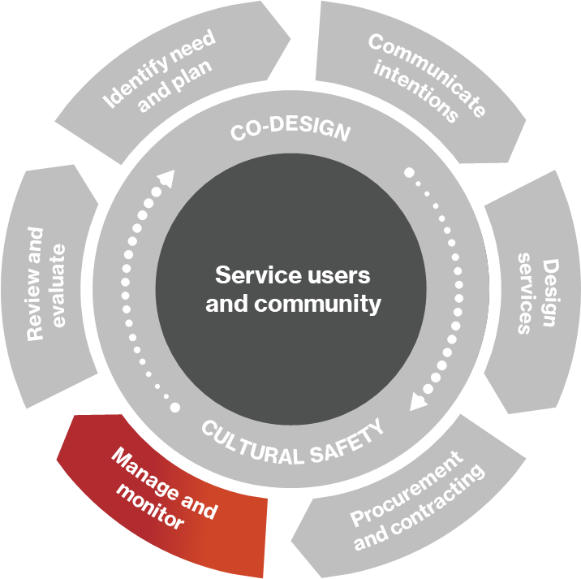
1. Overview

Once services have been procured, commissioners need to have oversight of the performance of the contracted service provider. This tool covers the Manage and Monitor phase of the commissioning cycle.
We will discuss how government agencies in Western Australia can measure the most relevant service delivery indicators to ensure services are being delivered correctly and work collaboratively with service providers to resolve issues to drive service performance and achieve outcomes for communities.
Figure 1: Commissioning cycle

1.1 Performance management vs performance monitoring vs performance improvement
Performance management involves reviewing service delivery reports to ensure Key Performance Indicators (KPIs) or service outcomes are being met, and we are obtaining value for money. While we need to manage and monitor contracts, we should also work collaboratively with service providers to enable them to perform to the best of their ability and ensure that we are in the best position to react to changing priorities and opportunities. Performance monitoring and improvement is a cycle that involves planning the collection of data, monitoring, and analysing the data, identifying and implementing improvements and providing feedback.

1.2 Logic models to frame performance monitoring
Logic modelling is a central technique in outcomes-based commissioning and explains the rationale linking needs, responses and the outcomes and experiences of service users. This tool uses logic models to establish the fundamental philosophy for performance monitoring.
Taking a logic model approach means that we are focused only on the important inputs, activities and outputs and outcomes to reduce unnecessary reporting burdens. The logic model describes the sequence of events of the program across time and provide guidance as to which indicators are most important to focus on at the beginning, middle, and end of the program.

2. Purpose

2.1 Why do we conduct performance management and monitoring?
Performance management and monitoring are essential to ensure we obtain value for money. It also ensures that selected service providers are performing against KPIs. If poor performance is identified, it serves as a feedback mechanism to drive improvement.

3. Assess community needs

3.1 Identifying target indicators from logic models
As well as providing an understanding of how the program delivers outcomes to address identified needs, logic models also provide the logical underpinning for our performance monitoring. The statements under each section of our logic model can be translated into a series of indicators.
The logic model provides an understanding of when in the program's lifecycle we can expect to measure changes in the respective indicators. For example, we shouldn’t expect any changes to outcome measures in the early stages of the program as the interventions have not happened yet.
In the planning and set-up stages, we should focus on tracking input indicators to make sure the correct resources are helping establish the program. Once launched, we move on to tracking activity indicators to ensure the program is happening. When the program is established, we can track output indicators to ensure the program activities result in the desired outputs. At this point, we keep track of the input indicators, but these are no longer our focus.
Once the program has been implemented, we focus on short-term outcome indicators to demonstrate that the program is achieving the intended results. We may also be able to track medium-term outcome indicators during the program. Often the long-term outcome indicators can only be measured after the life of the program.
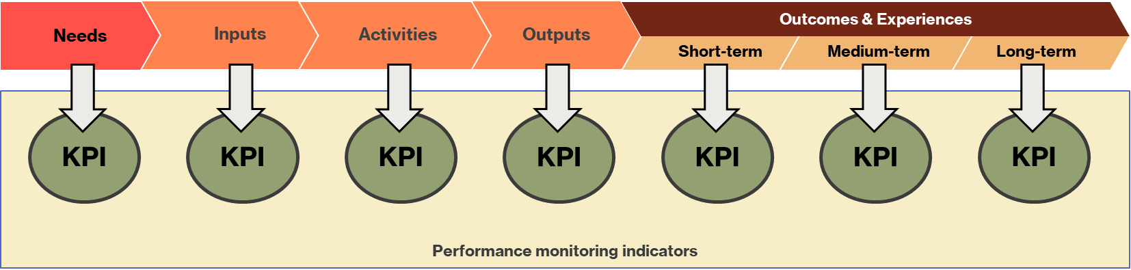
Figure 2. Performance monitoring indicators are extracted from the program logic model.

3.2 Evolving data collection over time: Understanding and addressing data barriers
Some data we collect will be readily available, while other data will be harder to obtain and we will need to work with providers, partners and other program stakeholders to be able to collect the data in the future. There are some barriers to data collection, including:
- Data availability: Some data points will not be available from the outset of the program and systems or processes may need to be put in place to enable the capturing of the data. For example, new data collection templates may need to be created to request service providers provide certain information. Additional technology, such as a mobile app for service users, can also offer a way to collect more data.
- Data sharing: Service providers or partners may have policies that prevent them from sharing data with external organisations so data sharing agreements may be required. Demonstrating how the data will be used and the value it provides the program can help open up data sharing.
- Data sovereignty: Historically, Aboriginal people have been isolated from the language, control and production of data. This has led to data framing Aboriginal people as ‘the problem’ and has reduced the agency of Aboriginal people to govern their communities, which contravenes their inherent human rights. Indigenous data sovereignty principles set out the restoration of data ownership to Aboriginal communities.
We should work closely with service providers and partner organisations to establish appropriate data governance to achieve the performance monitoring and evaluation aims of the program, while also respecting the proper ownership of data assets.
Data collection is vital for us to monitor performance. The collection of data should be assessed on its ease of collection and the impact that it has. The Ease and Impact Matrix is a practical way of working out which data we can collect from the beginning of the program and which we need to work on with our service providers.
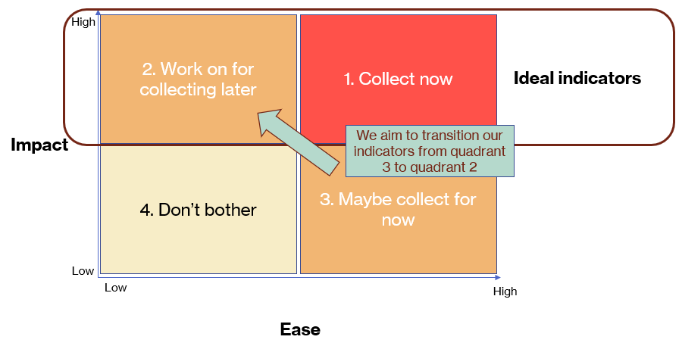
Figure 3. Ease and Impact matrix to assess indicators.
Data that score high on both ease and impact are those that we should collect immediately and continue to collect. High-impact data with low ease should be actively targeted through closely working with service providers and partners.

4. Developing a monitoring plan

4.1 Developing a monitoring plan
The performance management and monitoring plan should describe the indicators identified from the logic model and the data collection plan aligned to the program progression, along with the evolution of data collection derived from the Ease and Impact matrix. However, there are further practical considerations that will need to be described in the plan. This will include considerations around the effort and resource allocated to program monitoring and evaluation, the frequency of reporting and monitoring activities and the dependencies that our monitoring and evaluation activities have on other timelines.
Further considerations for how each of these components should shape the program monitoring plan are outlined below:
Size
- What scale effort/resource allocation for monitoring is appropriate? This is determined by several factors including:
  - size of investment in the program
  - level of risk in the program (including delivery risk, political/reputational risk, financial risk, systematic risk etc.)
  - level of innovation (more innovative programs may require closer scrutiny than established programs)
  - strategic importance of the program to the government agency.
- Is there a budget set aside for the monitoring plan? Some program budgets will have provisions for performance monitoring, others may need budget allocation.
Frequency
- How often should performance be monitored? Performance monitoring is an ongoing activity, with various formal and informal methods used to ensure that contracted service providers achieve their contracted deliverables. The frequency of reporting needs to be balanced between effectively tracking performance without placing excessive reporting burden on service providers.
- Is external performance monitoring expected? Any external monitoring, whether conducted by funding bodies or other external agencies, will have an impact on planning for internal evaluations, including the timelines and resources available to conduct the evaluations.
Timing
- Are there key milestones in the program that are natural points for performance monitoring? Key points in the program plan provide natural opportunities to hold performance improvement conversations.
- Are performance updates expected at the end of funding periods? Some funding agreements will stipulate evaluation activities, including when the reports are expected to be completed.
- When in the program should we expect to shift focus on types of indicators? Our focus on specific indicators will change over the program’s course as it moves from establishment into implementation and beyond.
- When are data going to be available? Our ability to measure indicators will also depend on when we can expect the data to be available.

5. Conducting performance monitoring for improvement
Performance monitoring is often undertaken to ensure compliance with contracts and to fulfil our internal reporting obligations. However, effective performance monitoring and evaluation should be more about performance improvement than monitoring. We must ‘close the loop’ with our service providers and partners, using the insights gained from performance monitoring to inform improvement focussed conversations.
All program team stakeholders should approach performance monitoring with a commitment to continuous improvement and work collaboratively to create strategies to achieve the improvements. This requires all parties to be equally invested in achieving the improvement rather than placing the burden solely on the contracted service provider. This doesn’t replace the need to monitor contract compliance but is important for building lasting and effective relationships with service providers.
Providing useful feedback is an effective way to encourage the required behaviours and performance from service providers and drive outcomes from our programs. Feedback should be outcomes focused and include recognising strong performance as well as identifying areas for improvement. Providing feedback offers value to the service provider and promotes greater data sharing.

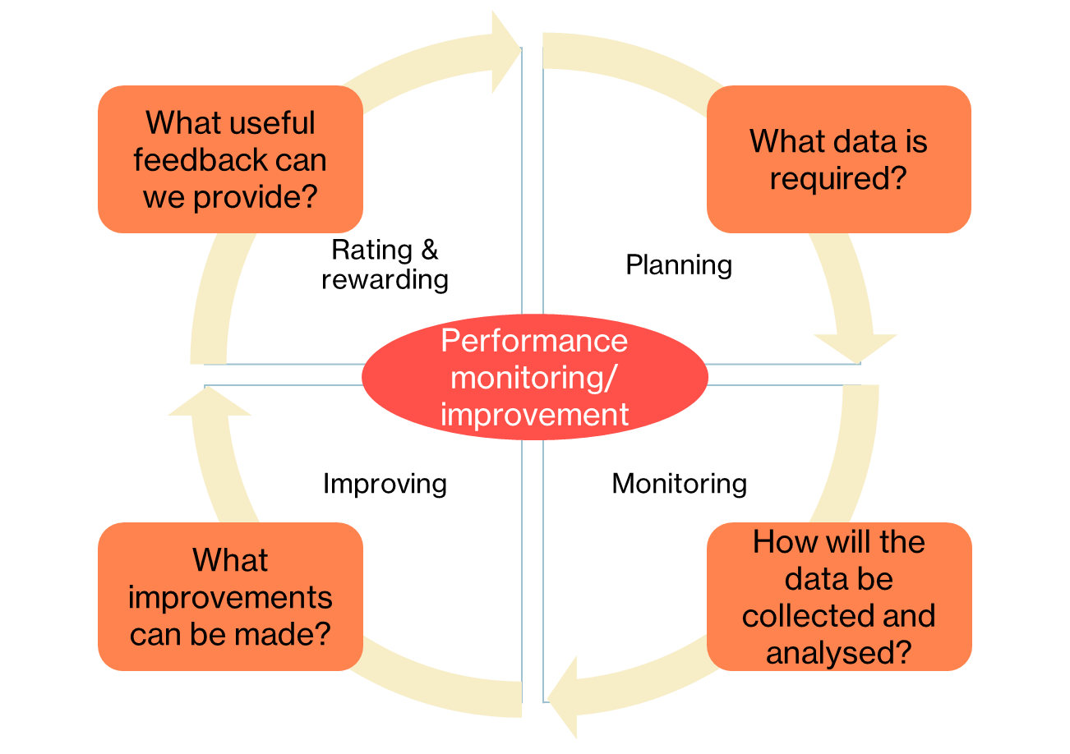
Figure 4. The continuous cycle of performance improvement and the steps involved.

6. Developing a performance monitoring plan

6.1 Developing a performance monitoring plan with service providers
Collaboration to produce a performance monitoring plan allows commissioners and service providers to identify and agree on the most appropriate indicators to monitor and associated timeframes. If data barriers are identified, we can collaborate to develop solutions to data collection issues.
Working together ensures that the monitoring plan is going to work for both the government agencies as well as the service providers. However, commissioners are ultimately responsible for delivering positive outcomes for the community and must ensure the performance management plan keeps service providers accountable.

7. Communicating intentions

7.1 Share performance monitoring plan
Given that it is recommended that service providers are involved in developing a performance monitoring plan, the agreement should be shared with them. It is a record of what has been agreed to and will help service providers track their performance against the agreed KPIs, which in turn should lead to improved program delivery.

8. Links to resources
Nil

