Commissioning Toolkit for Community Services
Tool 3: Planning
These Commissioning Capability Tools have been developed by the Western Australian Department of Finance, in partnership with Rebbeck.
Rebbeck is a boutique strategy consultancy and commissioning support organisation that specialises in commissioning capability development. Rebbeck works with healthcare and public services organisations across Australia to support commissioning with a focus on reshaping services to achieve sustainable outcomes for the people of Australia. Find out more at www.rebbeck.com

Planning: At a glance

1. Overview
Following development of a coherent strategy based on identified needs, we are now ready to plan our commissioning activities at the portfolio, program, and project levels to bring our strategy to action.

2. Purpose
Each commissioning activity requires planning to ensure we anticipate challenges, allocate resources and ultimately deliver the intended outcomes.
3. Workflow

Plan a change portfolio
1

Plan a change program
2

Develop a stakeholder engagement plan
3

4. Output
Upon completing this tool, we will have developed a plan for our commissioning program. We would have also identified our target stakeholders in the stakeholder engagement plan and communicated our plans to the market.

5. Tools and resources

Kotter Change Management

Communicate plans to stakeholders and the market
4

Overview
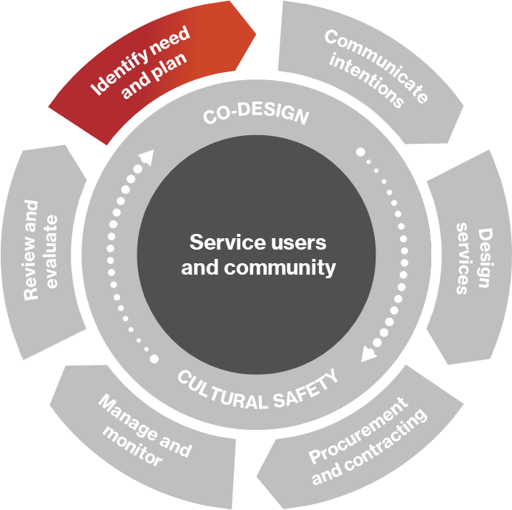
The Planning tool is the third of three tools that cover the ‘Identify need and plan’ phase of the commissioning cycle.
Within the Identify Needs tool, we identified and prioritised a list of change opportunities for our organisation after undertaking the Needs Analysis. In the Develop Strategy tool, we considered the strategic landscape we operate in and defined our strategic direction.
We now move on to planning, which elaborates the strategy and adds important details so that we can execute the strategy properly. These details may include adding timelines for execution, setting up plans for procurement, and performance monitoring. The goal of planning is to ultimately have a good idea of how each part of the commissioning cycle will be carried out, when, and by whom.
Figure 1: Commissioning cycle

1.1 What is a plan?
A plan describes how we will implement our strategy to move from the current state towards our vision via a series of future states. This is illustrated in the diagram below.
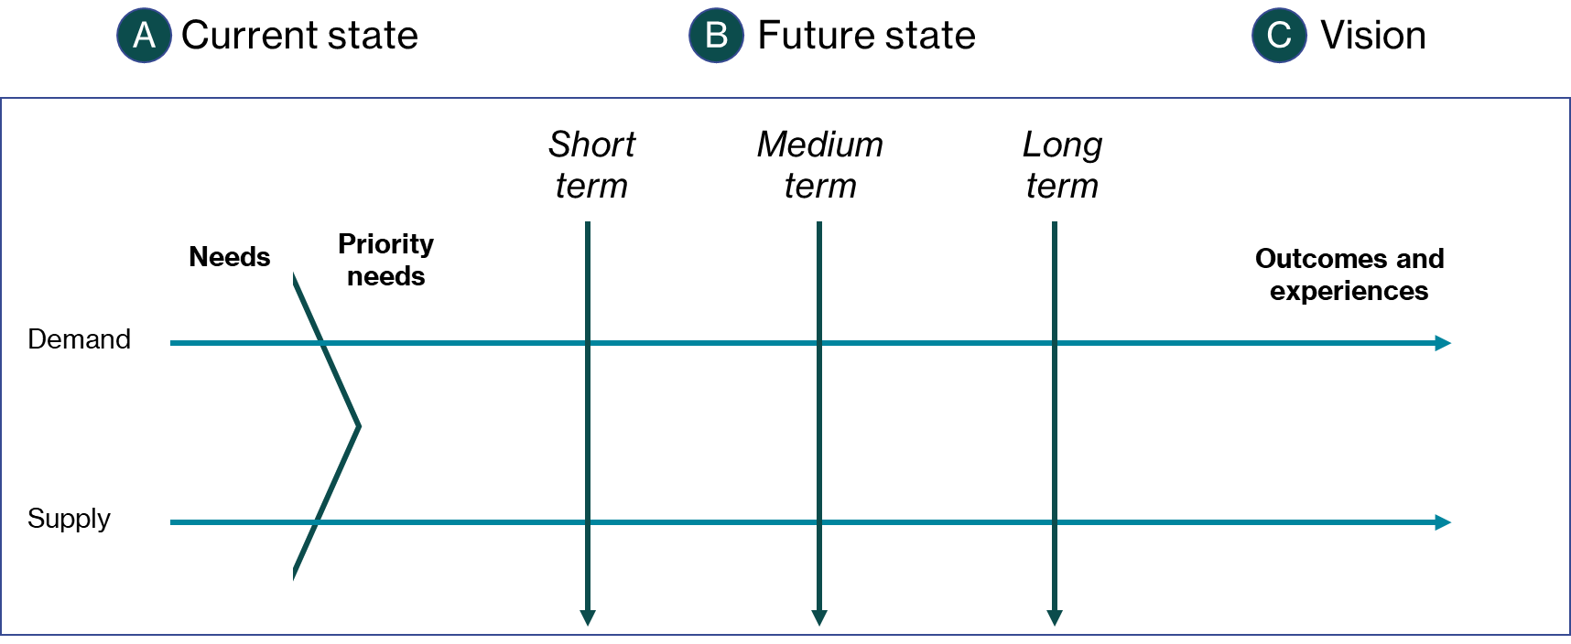
Figure 2. The plan bridges the current state and the vision via a series of future states.

Planning provides a clear roadmap for commissioning and breaks the overall commissioning process into a small and manageable number of phases, each with clear timelines, activities and owners. The plan must be easy to follow so that any team member who picks it up can follow it consistently.

1.2 Planning at different levels
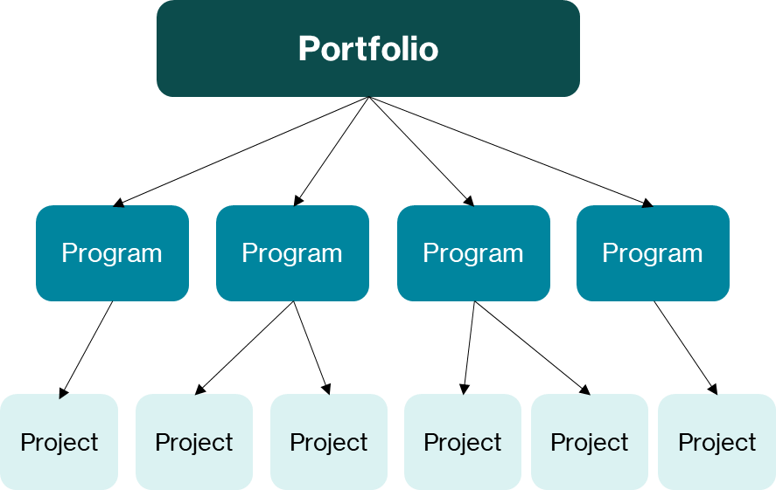
Figure 3. Illustration of the relationship between portfolios, programs, and projects in commissioning.
There are three planning levels that we consider. Within each level, the commissioner must use planning to ensure that adequate resources are allocated and that no conflicts occur between and within each level of planning.
Project level: Projects are discrete and time-bound and set out to achieve a clear purpose. Planning at the project level should reflect a clear starting point, the activity in the middle and a defined end. An example of a project may be the delivery of a training seminar to support local small businesses.
Program level: The complexity of planning increases at the program level. Each program may contain several projects that work together to deliver the program's overall outcomes. For instance, a program that aims to upskill small businesses may deliver a range of seminars, provide coaching support and distribute technical information. Each of these could be considered a project, and each needs to work together to achieve the program's overall goals.
Portfolio level: Planning at the portfolio level is the most complex. Portfolio level planning involves the collection of programs within the scope of the department. For example, for the Western Australian Department of Communities, this may include programs for disability services, housing, and volunteering. Portfolio planning is ultimately about making key decisions about how programs should stop, start, continue or be changed to work coherently to achieve the department or division strategy.

2. Purpose

2.1 Why do we undertake planning?
Making real change through commissioning requires careful planning. Each commissioning activity requires planning to ensure we anticipate challenges, allocate resources and ultimately deliver the intended outcomes.
Planning provides a clear roadmap of activities for the rest of the commissioning process. This ensures that the whole team is clear about what needs to be delivered, when, and by whom. A clear plan reduces delivery risk and supports teams to work in a coordinated way towards an agreed commissioning goal.
Commissioning plans should be iterated as the process progresses. For example, we may develop a monitoring and evaluation plan, but this should be updated as we progress into service design and contract negotiation with service providers.

3. Planning a change portfolio
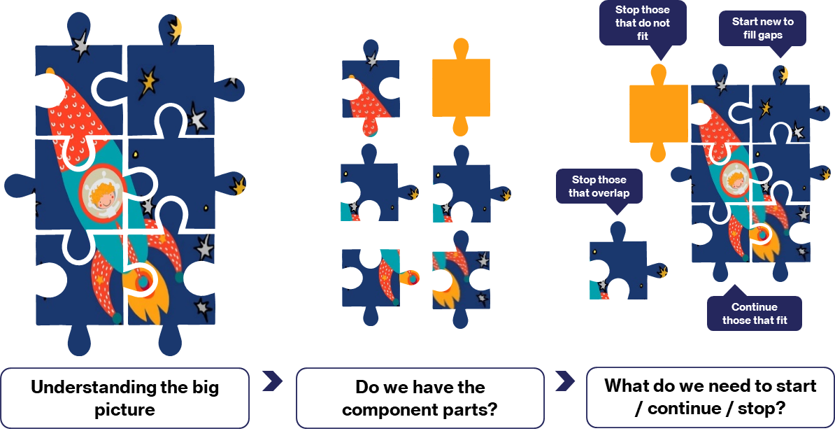
Figure 4. The process of planning a change portfolio

There are three steps to planning a change portfolio. These are:
- Understanding the big picture, i.e., everything that our portfolio needs to deliver.
- Assessing the existing set of programs and projects.
- Stopping, starting, and continuing commissioning programs and projects.
Overall, planning changes to the portfolio should include identifying programs to continue from the current portfolio, starting new programs to fill the gaps within the target portfolio, and stopping (decommissioning) programs that are duplicative or no longer required.

3.1 Understand the big picture
The first step in planning a change portfolio is understanding the big picture. We need to understand the full extent of what the portfolio aims to achieve, as set out in the strategy. Several circumstances might trigger a review of the portfolio’s overall aims including refreshes of the portfolio aligned with scheduled updates of the department strategy or one-off events such as significant policy reform.

3.2 Assessing the existing portfolio
Launching a commissioning portfolio from a clean slate is rare and typically only some existing programs would need to change. Once we identify what we need the new portfolio to include, we must assess each of the existing programs to determine how well aligned they are with the ‘big picture’ goals.
Programs aligned with the new vision for the portfolio should continue, perhaps with minor modifications.

3.3 Stopping, starting, and continuing commissioning programs and projects
After comparing the existing portfolio with the proposed portfolio, we need to decide how to address the portfolio's gaps, overlaps and unaligned programs.
Specifically, we make decisions to:
- decommission programs that are no longer aligned with the vision or are duplicative (further discussed within the Modify and Enhance tool)
- continue or improve existing programs that meet the aims of the vision
- start new programs to fill gaps within the portfolio.

Some important considerations in this process include the following:
- End-user experience: Will the service user be affected by any decommissioning activities? If so, what are some ways to mitigate that?
- Stakeholders: Will internal and external stakeholders support the commissioning/decommissioning?
- Timing: Will service decommissioning and new commissioning activities need to be simultaneous? Is a lengthy transition phase required?
- Cost: Is allocating resources towards commissioning new programs financially feasible?
Existing programs should be evaluated without bias and based on merit and alignment with the overall vision.

4. Planning a commissioning program

4.1 Developing a program plan for the end-to-end commissioning process
The commissioning cycle describes a program of projects that will achieve a change when followed. While the commissioning cycle shows each stage as occurring one after the other, we often revisit elements of our commissioning cycle as more information becomes available as shown in figure 5. For instance, we may prepare a draft Performance Monitoring and Evaluation (PME) Plan in the initial planning phase of our program and will update this plan during service design and again during contract negotiation with the selected provider. Our commissioning projects aren’t sequential but overlap and intersect in different ways depending on the nature of the program.
A multidisciplinary program team can identify a roadmap for the commissioning program, which should also reflect imposed deadlines. This roadmap will set timelines for each commissioning stage and identify how the stages will relate to the others.
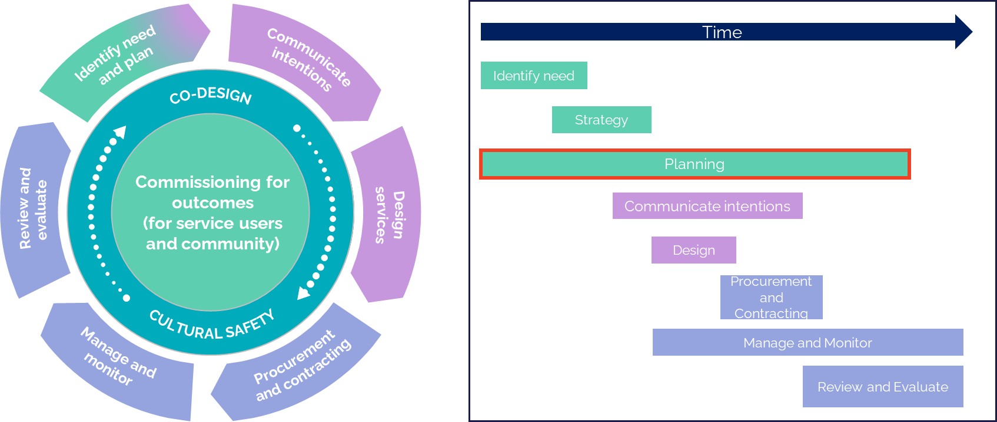
Figure 5. The commissioning cycle (left) vs an illustration of overlapping commissioning activities (right)

4.2 Planning commissioning projects
We need to plan out the individual components/projects within our program so that we can deliver them on time, to an agreed level of quality and within our allocated resources.
The quality of commissioning activities depends on how well each preceding activity is planned and executed.
- A well-planned and executed needs analysis ensures our commissioning program is focused on the right set of priority needs.
- A well-planned strategy development process means that we end up taking the right approaches to address the needs.
- A well-planned co-design process means that we are designing the right solutions with the right people.
- A well-planned procurement means that we will be delivering the right services with the right providers.
- A well-planned monitoring and evaluation will ensure we are measuring the right indicators to drive the right outcomes.
The purpose of a project plan is to communicate expected timelines and dependencies and give the project manager and other relevant stakeholders oversight. The project plan may need to be regularly updated as project tasks, and timelines can often change as the overall commissioning program evolves.

4.3 Documenting the project plan
The level of detail each project plan needs to cover depends on the project’s scale, complexity, and predictability. A good project plan should always describe the timing, sequencing and interdependencies of tasks, activities, and milestones within the project.
These terms can be defined as follows:
- Task/activity: Things done by the project’s resources. A task should begin with a verb.
- Milestone: Important events/dates in the project that marks the completion of a significant set of activities.
- Deliverable: Tangible outputs resulting from the tasks/activities.
- Interdependency: The relationship between tasks, milestones or deliverables that describes how they impact each other’s ability to be performed.
Various tools can assist with creating and visualising project plans, including Gantt charts, task tables, and Excel sheets.

5. Change management

5.1 The change process
One of the most important aspects of commissioning is change management. The commissioning process makes changes to the current public service landscape and this process must be carefully planned and managed to ensure that commissioning/decommissioning goes smoothly.
To achieve lasting outcomes, commissioners should plan the change management process using change frameworks before co-designing or implementation.
One such applicable framework is Kotter’s 8-step change management approach:
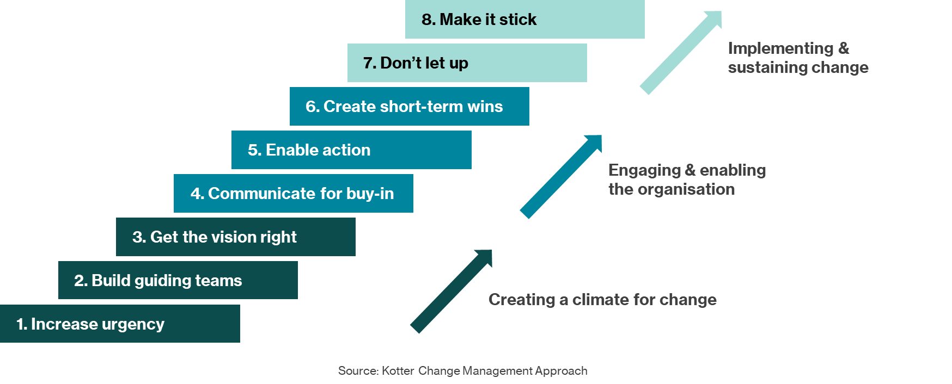
Figure 7. Kotter’s 8 steps (Source: Kotter Change Management Approach)
The steps used in Kotter’s 8 steps are specifically defined below:
Table 1. Description of Kotter's 8 steps
Step | Description | Examples
Increase urgency | - Communicate clearly what the problem is and why it is necessary  - Engage all stakeholders to ensure that the thesis for change is well appreciated | - Presenting the severity of the homelessness problem internally to other potential partner organisations and peak bodies
Build guiding teams | - Identify engaged internal actors to guide the change process | - Preliminarily establish relationships with engaged leaders within a local community shelter to enhance future buy-in
Get the vision right | - Formulate the vision for change and future outcomes through the strategy developed in the Develop Strategy tool | - Developing a coherent strategy to reduce homelessness
Communicate for buy-in | - Communicate the overall strategic vision to stakeholders | - Have meetings with each stakeholder group with the understanding of the change process
Enable action | - Create an environment in which action towards change can be quickly taken  - Remove silos to enable further collaboration | - Allocating necessary resources for change at the program level  - Work collaboratively with service providers and stakeholders to further change
Create short-term wins | - Communicate and recognise any short-term wins resulting from the change | - Boost morale by showcasing the success of pilot programs, and the effectiveness of interventions.
Don’t let up | - Anticipate problems with change, including any resistance  - Formulate a strategy to deal with such resistance | - Anticipating and actively resolving any issues within a decommissioning project
Make it stick | - Continue to communicate the progress and outcomes of the change process to all stakeholders regularly  - Ensure that engagement and buy-in remain high after the change is implemented | - Updating stakeholders with progress/outcome reports every quarter  - Evaluate & monitor the adoption of change post-implementation

5.2 Understanding reaction to change (Kubler-Ross)
The Kubler-Ross change curve describes how individuals typically react to change and the stages of transition they usually work through psychologically, depicted in Figure 8.
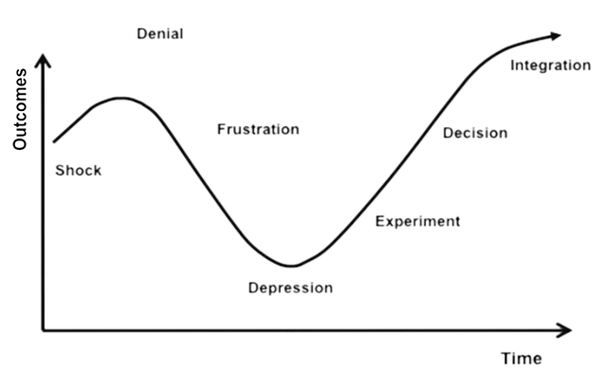
Figure 8. The Kubler-Ross curve
The commissioner’s change management plan should propose measures to support stakeholders in reaching the integration stage of the Kubler-Ross curve. This will increase support from all stakeholders, which will maximise commissioning outcomes.
Figure 9 illustrates another depiction of a change journey from unawareness. This depiction recognises that each stakeholder or group may start at a different point on the journey and may need to end up at a different point. For each stakeholder, we should identify where groups or individual stakeholders are on the change curve and where they need to be by the end of the change management process.

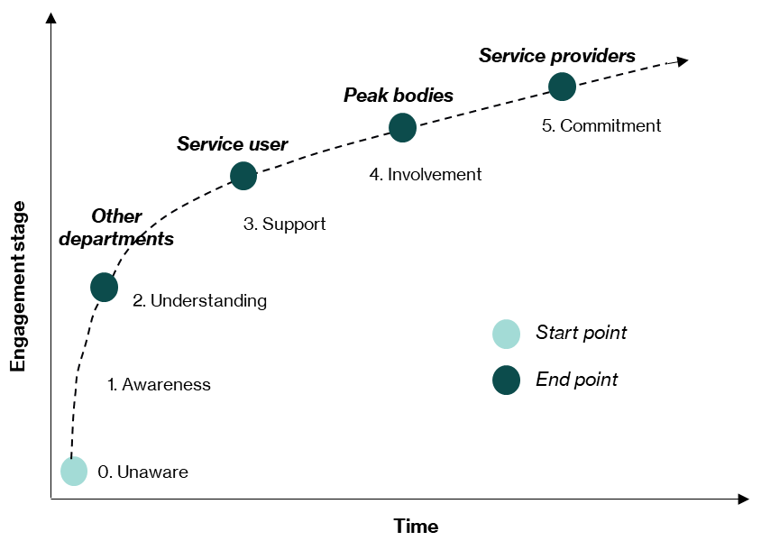
Figure 9. An example evaluation of current and desired stakeholder engagement levels for a change program

6. Considerations for co-design and cultural safety

6.1 Stakeholder analysis
When planning for co-design, stakeholder analysis will help us identify the key stakeholders (and stakeholder groups) and understand where they sit in the commissioning project/program context.
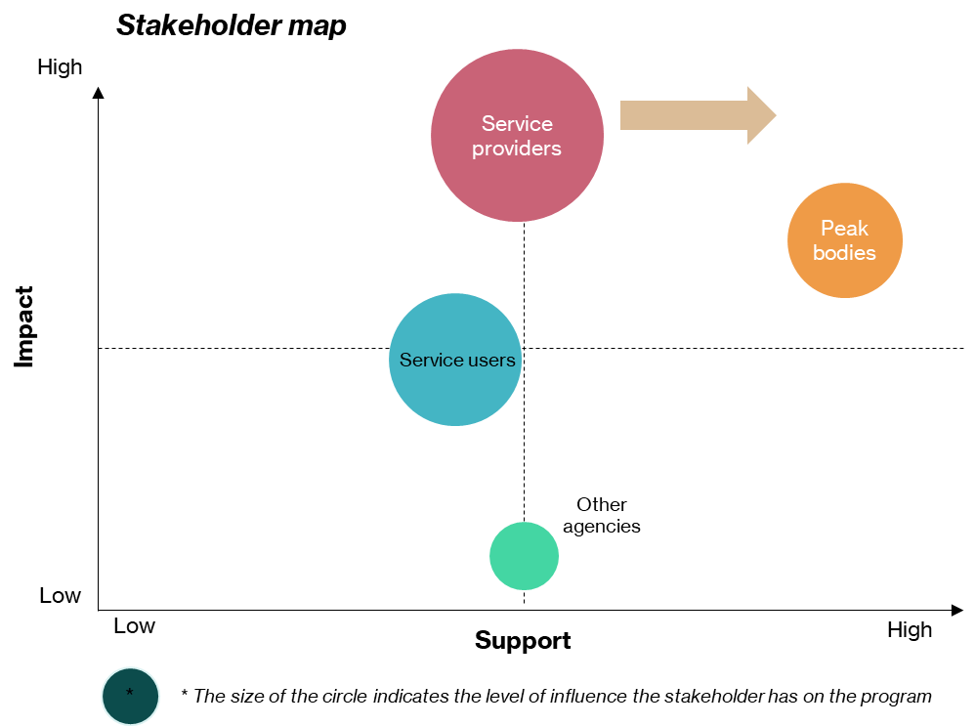
Figure 10. An example stakeholder map visualises stakeholder influence, support and impact.
As illustrated above, key stakeholders are identified and assessed (on a 1-10 scale) on the following three metrics:
- Their support of the commissioning project/program (X-axis).
- The level of impact the commissioning project/program will have on them (Y-axis).
- The stakeholder’s influence on the program (the size of the circle).
The stakeholder analysis is a valuable tool as it:
- provides a baseline to understand where our key stakeholders sit
- helps us to identify where we should focus our engagement efforts
- enables us to develop communication strategies to improve the support of key stakeholders.

6.2 Stakeholder engagement approach
The first step in planning stakeholder engagement is to prioritise stakeholder groups and decide who to engage. We should focus on moving highly impacted stakeholders with low or modest support towards being more supportive of the change. Highly influential stakeholders can be our most significant opposition or our greatest allies, depending on their level of support. We should focus efforts on working collaboratively with potential opposition and empower our supporters to engage with other stakeholders on our behalf.
After prioritising which stakeholder groups to engage, we should plan how to engage those stakeholders. Key considerations include the type of communication and how frequent contact will be. If there are tensions between the government agency and the relevant stakeholder, communication through a third party may be more effective. We should consider the possible concerns of stakeholders and prepare appropriate responses.
Lastly, we should plan where in the commissioning life cycle to engage these stakeholders. This will depend on how we intend to engage the stakeholders. For example, if we are planning to engage a stakeholder group for co-design then this should be communicated to them as soon as possible before the Design Services step of the commissioning cycle starts.

7. Communicating intentions

7.1 Communicating our plans to the market
Finalising our plans provides another opportunity to communicate our intentions to the market. Just as we shared our strategy with the market, we should consider providing details on our plans. The plan is more detailed and contains more specific information, including a commissioning timeline. This can be helpful information for service providers and other stakeholders who can see when activities (e.g., procurement processes) are likely to take place so they can begin any necessary preparations.

8. Links to resources

8.1 Kotter change management
For information on the Kotter change management methodology, visit here.

