Commissioning Toolkit for Community Services
Tool 8: Review and Evaluate
These Commissioning Capability Tools have been developed by the Western Australian Department of Finance, in partnership with Rebbeck.
Rebbeck is a boutique strategy consultancy and commissioning support organisation that specialises in commissioning capability development. Rebbeck works with healthcare and public services organisations across Australia to support commissioning with a focus on reshaping services to achieve sustainable outcomes for the people of Australia. Find out more at www.rebbeck.com

Review and Evaluate: At a glance

1. Overview
The Review and Evaluate tool considers how to assess and report a program's effectiveness and the different types of evaluations we can use.

2. Purpose
This tool will help commissioners conduct program evaluations that drive quality improvement and evidence-based decision-making.
3. Workflow
Plan an evaluation
1
Gather and analyse data
2
Report findings and recommendations
3

4. Output
On the completion of this tool, commissioners will have developed a hypothesis-driven evaluation which is translated into an evidence-based report.

5. Tools and resources
Western Australia Evaluation Guide

Western Australia Program Evaluation: Sunset Clauses

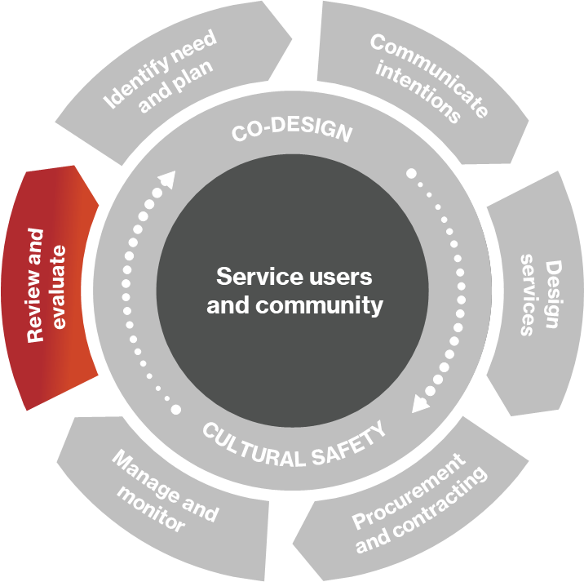
1. Overview
The Review and Evaluate tool is the final tool in the series. In this tool, we will discuss practical methods for evaluating commissioned programs at various stages of their lifecycle. Commissioners conduct evaluations to make informed decisions about the future of programs and services. The evaluation process involves making critical commissioning decisions.

1.1 What is an evaluation?
Figure 1: Commissioning cycle
The Western Australian government describes program evaluation as ‘assessing the effectiveness, efficiency and appropriateness of programs, policies or strategies to support evidence-based decision-making in the public sector’.

1.2 Types of evaluation
In the Manage and Monitor tool, we demonstrated that we change the indicators we focus on during the program lifecycle based on the logic model. Similarly, we also select the types and methods of evaluation based on the stage of the program's progress.
Figure 2 demonstrates the types of evaluations that are related to sections of the program logic.
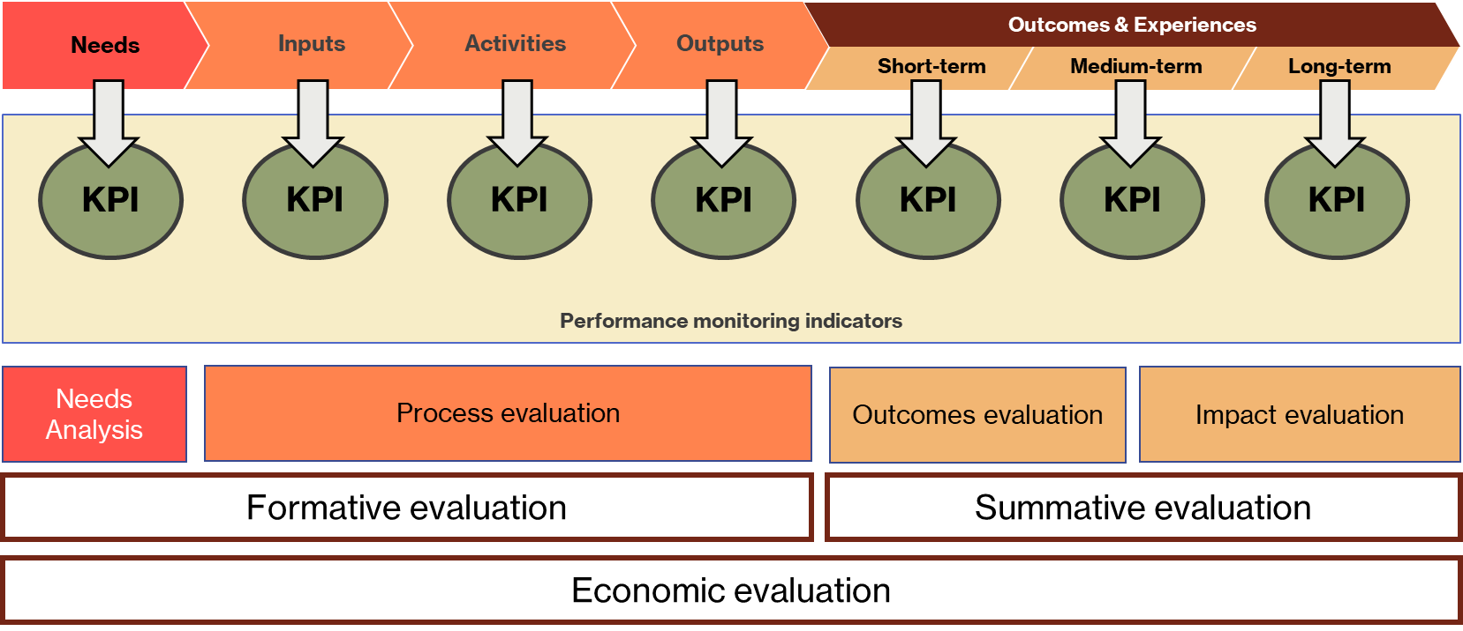
Figure 2. The different types of evaluation which take place as we progress through the program.

Please see below for the definitions of the types of evaluation.
- Needs Analysis: Identifies the needs or ‘gaps’ in the current landscape (For further information, please see the Identify Needs tool).
- Process evaluation: Reviews inputs, activities, and outputs to determine whether the program has been correctly established and is being delivered efficiently and effectively.
- Formative evaluation: Combines needs analysis with an early form of process evaluation. The goal of formative evaluations is to ensure that the program needs are established and that the program activity is feasible, appropriate, and acceptable before it is fully implemented.
- Outcomes evaluation: Assesses the shorter-term outcomes that have occurred because of the intervention. We are looking to demonstrate that changes have occurred for individuals and communities because of the program. We may also assess service user and service provider experiences during this evaluation.
- Impact evaluation: Looks at the longer-term effects of the intervention and any broader impacts it has had (positive and negative) on individuals and communities and the public service.
- Summative evaluation: Combines both outcomes and impact evaluation. Assesses the impacts of the intervention on target groups to determine if the project has met its goals and whether there were any unintended consequences.
- Economic evaluation: Reviews the value of the intervention to assess the appropriateness of the allocation of resources. It can be done in conjunction with a process evaluation and summative evaluation, which provide information on costs and outcomes.

2. Purpose
Commissioners need to understand their programs' effectiveness, efficiency and impact to make decisions about the future of those programs and obtain learning that can be applied to other programs. It allows commissioners to look deeper at service provision and understand what is and isn't working and why.
Evaluation is part of a commissioner's toolkit for measuring and driving outcomes. Understanding why service providers are not on track to deliver outcomes helps commissioners to intervene to get programs back on track. Conversely, gaining a deep understanding of a program that is effectively delivering outcomes provides commissioners with the opportunity to replicate or scale those interventions to achieve more outcomes.

2.1 Why we evaluate programs and services
There are many reasons to conduct an evaluation, including:
- To inform quality improvement.
- Make decisions on the future of the program such as:
  - Should we continue the program?
  - Should we expand the program?
  - Should we adjust the program?
  - Should we decommission the program?
- Provide evidence of the program's effectiveness to funders and key stakeholders.
- Compare program service providers, perhaps to reallocate funds.

3. Plan an evaluation

3.1 Purpose
We must establish a clear rationale for conducting an evaluation. An evaluation may inform quality improvement, help us make recommendations regarding the program's future or provide evidence for future funding decisions. By defining our purpose, it allows us to align our evaluation methods with our rationale.

3.2 Audience
Our approach to engaging with our audience and meeting their needs for the evaluation will differ according to which of the four audience types they fall into.
- Primary Audience: These are the decision-makers and the main recipients of the evaluation report. It is essential to understand what these stakeholders need from the evaluation to answer their questions and provide all the information they need to make decisions.
- Program participants/service users: These individuals and communities may be using the services and will be impacted by any decisions made because of the evaluation. The evaluation needs to provide sufficient justification for any changes so that this audience can understand the changes.
- Stakeholders to engage: These are the people we would like to consult with to form our qualitative data and can be service providers, service users or other professionals involved with the delivery of the services. They may also be other government agency staff members actively involved in program delivery who may have a vested interest in the evaluation results. This can be managed by being clear about the purpose of the evaluation and their involvement.
- Stakeholders to inform: This is anyone else that needs to be, or would like to be, notified of the evaluation results. The extent to which evaluation results are shared will depend on the change impact of the evaluation and the change management approach to be taken.

3.3 Approach
The evaluation plan should guide the scale of evaluation, informing us of the approach we should take. The approach also needs to confirm whether an external contractor will be procured or whether internal resources are available.
In addition to the scale and complexity of the evaluation, there are other reasons to appoint an external contractor to complete the evaluation, such as:
- lack of expertise required to conduct the evaluation
- capacity limitations
- needing an independent and objective third party.
Set aside time for joint planning with the contractor to fine-tune the evaluation design, identify data collection issues and confirm timeframes.

3.4 Questions
An evaluation answers a series of questions about a program to inform decision-making. As part of our planning we need to clarify the questions we seek to answer in the evaluation. This will be informed by the purpose and the types of evaluation we are conducting. From our questions, we can set our initial hypotheses to test in the evaluation (see section 4.1).
The following are examples of evaluation questions.

Formative evaluation example questions
1) Cultural appropriateness: Does the initiative consider cultural appropriateness in its design and delivery?
- For Aboriginal people and communities?
- For communities at risk e.g. Culturally and Linguistically Diverse or LGBTIQA+?
2) Integration: Does this initiative promote system and service integration?
- Multi-disciplinary teams: Does the initiative support integration of multi-disciplinary teams, management, and practice?
- Holistic: Does the initiative integrate holistic programs and services around service users and communities relative to needs? Does the initiative promote collaboration between providers and sectors?
- Complementary contribution: Does this initiative contribute to other initiatives aimed at achieving the same outcomes?
3) Workforce planning: Does the initiative consider workforce needs and the collaboration required to enable successful implementation?
4) Governance: Does the initiative reflect good practice governance, policies, and frameworks? Improving the experience of those accessing it?
5) Engagement: Does the initiative actively engage service users and communities to participate? Does the initiative motivate service users and communities to engage with the program?
6) Access: Does the initiative improve access?
- Awareness: Are service users and communities aware of the initiative and the outcomes it can support?
- Trust: Do individuals and communities trust the initiative and the people who deliver it?
- Cultural safety: Does the initiative provide cultural safety?
- Coverage: Does the initiative reach the service users and communities it is intended for?
- Place based: Can the initiative be accessed close to home and community equitably?
- Affordability: Does the initiative impact direct and indirect out-of-pocket costs?
7) Self-management: Does the initiative build self-management capacity among consumers and communities? Does the initiative build capacity to self-manage?
Summative evaluation example questions
1) Effectiveness: Does the initiative achieve its purpose?
- Did the initiative achieve its desired outcomes?
- Does the initiative result in outcomes that matter to service users and communities?
- Does the initiative address prioritised need?
- Does the initiative integrate current and emerging evidence?
- Does the initiative result in a cumulative benefit over time against its intended goals?
- Does the initiative have any unintended consequences?
2) Community: Does the initiative improve outcomes in the intended communities?
3) Social determinants: Does the initiative impact on social determinant related outcomes? Does the initiative promote prevention and early intervention?
4) Equity: Does the initiative contribute to addressing root causes? Does the initiative contribute to equitable outcomes? Do service users and communities experience the initiative equitably? Does the initiative feel right for the intended service users and communities?
5) Experience: How do individuals and communities experience the initiative?
- Service users and community: Does the initiative measure and address service user and community experience?
- Satisfaction: Are individuals and communities satisfied with the initiative?
- Expectations: Does the initiative deliver the outcomes that matter to service users and communities?
- Integration: Does the initiative address barriers experienced by service users and communities?
- Service user and community awareness: Does the initiative promote feedback to the service user and community to encourage engagement and trust in the services?
6) Health and wellbeing of the workforce: Does the work (structure and support) promote the health and wellbeing of the workforce? Does the work feel safe?
7) Satisfaction: Is the work itself satisfying for the workforce? Is the workforce satisfied with their working conditions?

Economic evaluation example questions
1) Cost-effectiveness: Does the funding achieve its intended objectives?
2) Funding: Is the initiative appropriately funded?
- Cost: What does the initiative cost (funded and in-kind) to deliver?
- Duplication: Is there potential for duplication of effort? (Initiative or workforce)
- Affordability: Is there an unmet need (financial / non-financial) that the initiative does not include?
- Capacity building: Does the initiative include adequate funding for provider capacity building?
- Does the funding provide sufficient funding for monitoring and evaluation?
3) Benefits:
- Financial benefits: What are the financial benefits (indirect and direct benefits) to service users and communities resulting from the initiative?
- Non-financial benefits: What are the non-financial benefits (indirect and direct benefits) to service users and communities resulting from the initiative?
4) Cultural value: Does the initiative provide culturally appropriate value? Does the initiative deliver the best health outcomes for the community in a culturally appropriate way?
5) Sustainability: Is the initiative financially sustainable?
- Continuity: Does the initiative provide continuity of service delivery and /or funding?
- Scalability: Can the initiative be scaled?
6) Integration: Does the initiative deliver integration value? Does the initiative promote integration and coordination?
7) Service user and community value: Does the initiative provide value for money from the service user and community perspective?

3.5 Methods
Once we are clear on the questions we need to answer or the hypotheses we need to test, we can identify the methods. The boxes below describe the data-gathering and analysis techniques that we can use.
- Surveys (online, telephone, face-to-face)
- Clinical data
- Administrative data
- Interviews (structured, semi-structured and unstructured)
- Focus groups
- Case studies
- Document analysis
- Observational methods
Data sources and data gathering techniques
Analysis techniques
General evaluation methods:
- Quantitative analysis
- Qualitative analysis
- Interpretation and insights
Economic analysis methods:
- Cost benefit analysis
- Cost effectiveness analysis
- Cost utility analysis
- Cost consequence analysis
- Social return on investment
- Impact assessment

Figure 3. Data sources, data gathering and analysis techniques.

3.6 Governance, risk and reporting
Finally, we need to consider key governance, risk, and reporting considerations. We must consider the following:
- What ethics approvals are required?
- What are the risks?
- Who will manage/oversee the evaluation?
- Who needs to be aware of the results?
- How often does progress need to be reported?

4. Gather and analyse data

4.1 Developing hypotheses
The hypothesis-driven approach is a useful method of linking existing knowledge of a program with available data to develop a set of statements relevant to the questions being explored. Instead of searching for patterns through data, researchers’ expertise is used to generate targeted assertions which are then tested by the data gathering and analysis of the evaluation. This results in a more focused approach to conducting the evaluation.
Hypothesis-driven approach: A person or team who knows about, or becomes knowledgeable in, the program generates a list of informed assertions about the state of it – the hypotheses. Sources of information for the hypotheses can come from the researchers’ own knowledge, literature reviews, local understanding, or anticipating the impacts of national or global events.
These hypotheses are then proved, disproved, or refined by using data sources gathered by, or available to, the program. The output is a set of proven findings that can be reported to decision-makers and used to make recommendations.
A hypothesis-driven approach is almost always the preferred approach for evaluating as it offers efficiency and a focus on the questions the evaluation poses. The disadvantage of a hypothesis-driven approach is the risk of confirmation bias. Researchers should be careful not to introduce bias in their data gathering and analysis.
Inductive approach: The alternative approach is to collect a large amount of relevant data and analyse it for patterns relating to the program. These observed findings can be reported and used to make recommendations to decision-makers. This approach may appear more comprehensive but is also far more time and labour intensive. Also, key findings can be missed if the researchers aren't looking for them.

4.2 Data gathering plans (quantitative and qualitative)
For a complete evaluation, both quantitative and qualitative data are required and neither are sufficient on their own. Quantitative data allows us to measure needs and qualitative data gives us a sense of why a need exists. Bringing both types of data together allows us to generate insights into the program.
By understanding what we expect to demonstrate (our hypotheses), we can work out what analyses we want to perform and what data we need to collect. Quantitative data could be identified and requested through a data request to service providers. Qualitative data could be gathered through interviews or surveys. Once we have collected all the data, we can perform our analysis. Our actual evaluation findings will be a combination of proven hypotheses and discoveries that weren't anticipated.
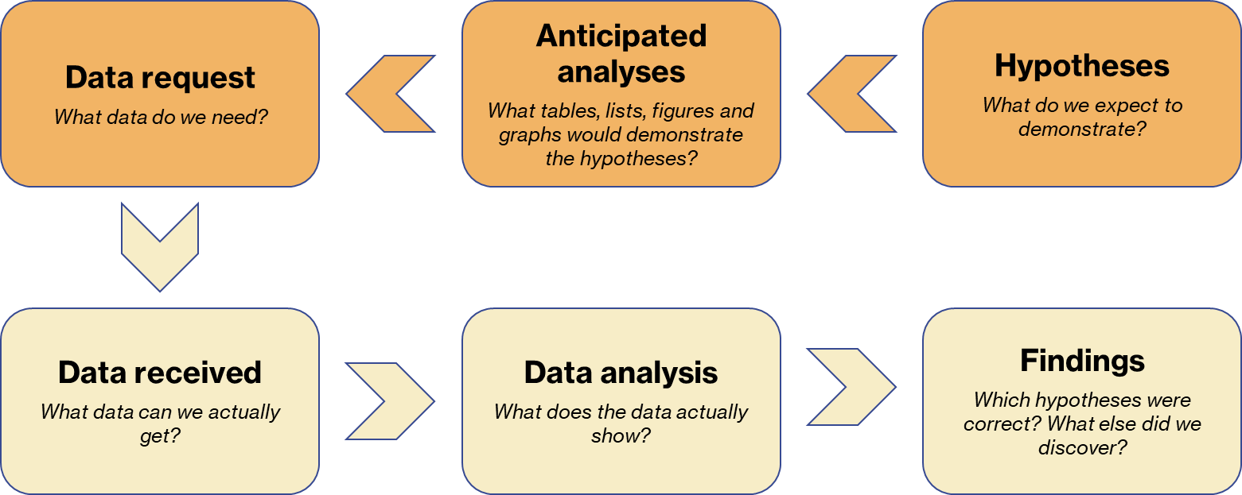
Figure 4. Progression from hypotheses through the data request/collection process for quantitative data.

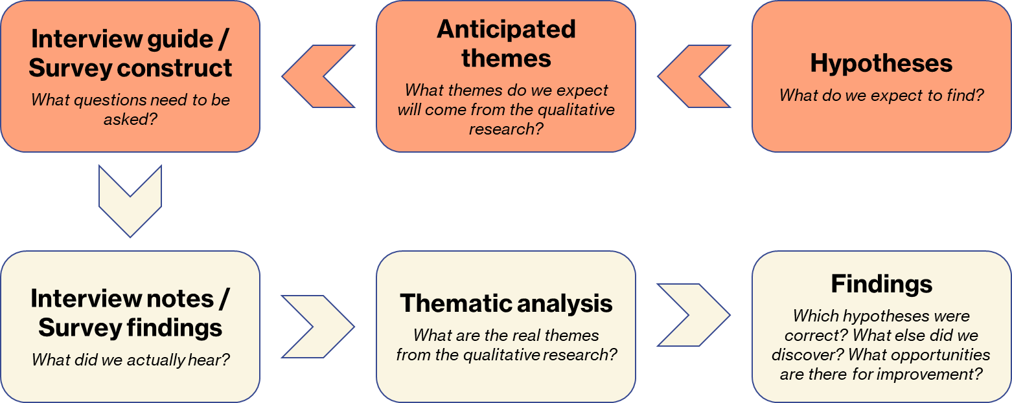
Figure 5. Progression from hypotheses through the data request/collection process for qualitative data.

5. Report findings and recommendations

5.1 Completing an evaluation report
The evaluation report is our key device for communicating the findings and recommendations. Given that the primary audience for the report is generally executives and senior managers, we need to be efficient in our written communication and start with the answers first, following the ‘pyramid principle’. The evaluation report should open with an executive summary followed by the evaluation findings, conclusions, and recommendations. Appendices can describe the program, the scope and focus of the evaluation, the methodology, and include a stakeholder and terminology list.
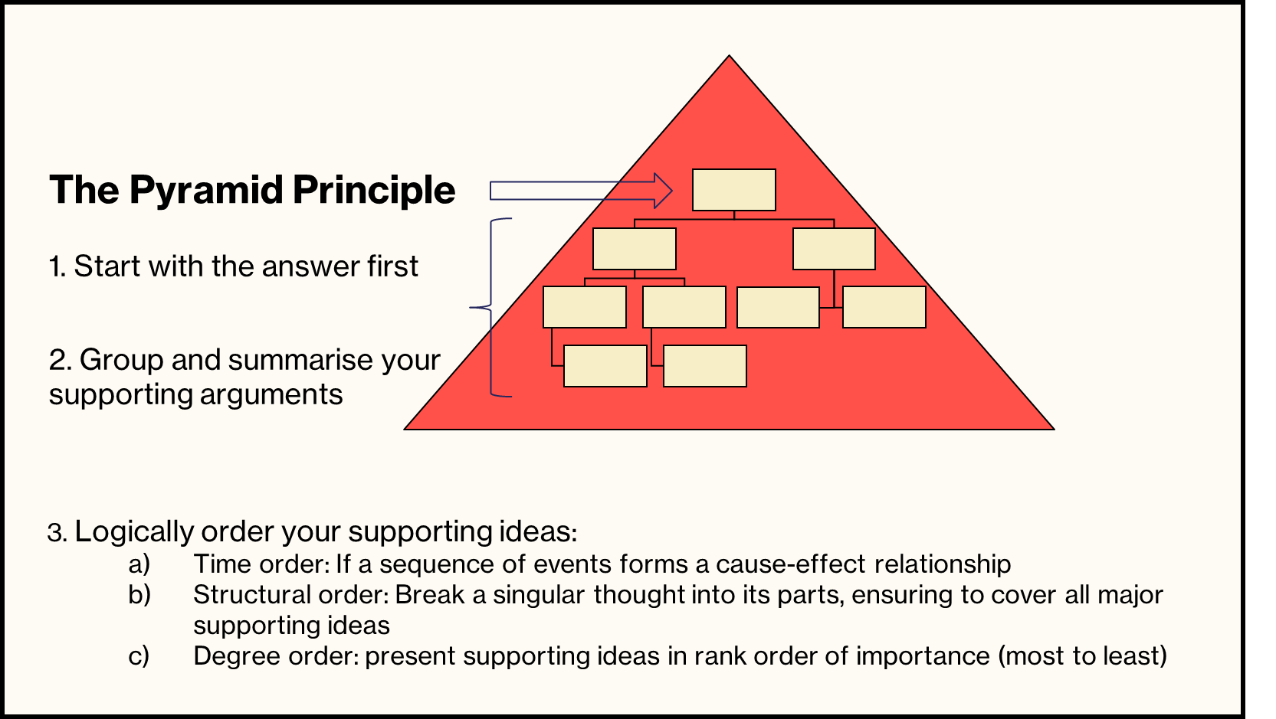
Figure 6. Use of the 'pyramid principle' to structure an evaluation report.

5.2 Making decisions and taking action
The purpose of an evaluation is to provide stakeholders with findings that can inform decision-making leading to action. Decisions based on the findings and recommendations could include continuing, expanding, refining, or decommissioning a program. Once the evaluation report is completed, we must ensure that decisions are made, and actions implemented.

6. Communicating intentions

6.1 Considerations for publishing findings
It may be appropriate to communicate the findings of an evaluation and the recommendations made. We should consider sharing the evaluation findings as widely as possible, including with the evaluation audiences (see section 3.2) who were engaged during the evaluation process. There are multiple ways to share the evaluation findings, including distribution via mailing lists, posting the report on our website, submitting an article for inclusion in peer-reviewed journals or presenting the evaluation.

There are many benefits to distributing our evaluation findings, including:
- Celebrating success: An evaluation report showcases the efforts put into the program from its inception. Many people may have invested their time and energy into the program and will feel a sense of recognition on the publication of the evaluation.
- Advocate for future funding or support: The evaluation report pulls together a concise summary of evidence about the program, which can be used to garner support from key stakeholders for continuing the program, including funders.
- Being accountable to service users: We should also inform service users of the results of our commissioning activity.
- Build community support: Evaluation findings can showcase positive commissioning stories with our communities which will foster increased community support for our work.
- Informing service providers of potential challenges and changes: The evaluation may include recommendations that trigger changes to the future service landscape, giving service providers foresight into our future requirements.
- Contributing to the global evidence base: Our evaluation represents a body of evidence for our service model that others may find helpful in their commissioning activity. Regardless of whether the results of the evaluation are positive or negative, any findings are informative for another commissioner embarking on a similar journey (see Design Service tool).
Innovation and best practices are built from the experience of others and publishing our results may be the best way we can contribute to improving the outcomes for vulnerable people.

7. Links to resources

7.1 Western Australia Program Evaluation Guide
To view the program evaluation guide, visit here.

7.2 Western Australia Evaluation: Sunset Clauses, Agency Guide
To view the program evaluation: sunset clauses, visit the bottom of the page here.

