Someone to sit beside us

A Family and Domestic Violence Hub for Broome

Co-Design and Stakeholder Engagement Report

November 2022

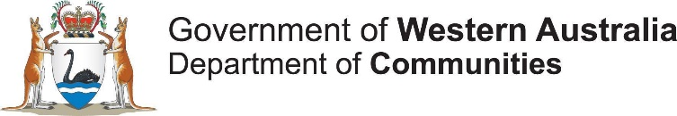

Acknowledgement of Country
Innovation Unit acknowledges the wide range of Traditional Owners of the West Kimberley country upon which this project was conducted.
We specifically acknowledge the Yawuru, Nyikina,
Mangala, Warrwa and Karajarri Traditional Owners of the lands upon which our interviews and engagements were conducted.
We also acknowledge the Whadjuk Noongar people as the Traditional Owners of the country upon which we work. We acknowledge the importance of paying respect to their land, their Elders past, present, and emerging, and the continuing cultural and spiritual practices of Aboriginal and Torres Strait Islander people.
Thank you to Yawuru artist Brenton McKenna (‘ESZRA’) for his illustration work used in our engagements and this report.
Thank You
To the people who shared their expertise and ideas informed by their own lived experience, and those of their families and communities.
To the Elders and community leaders who were so generous in providing their knowledge, advice and feedback.
To the many diverse representatives from community organisations and services who gave their time, expertise and passion to this project as well as their ongoing efforts to support their communities and those experiencing the impacts of family and domestic violence.
To the representatives from government and peak bodies who participated with open minds and contributed critical insights and guidance.
To all the people who contributed to this project. Only with your collective efforts and generosity of time, wisdom and spirit was this project possible.
Caution - Some people may find parts of this content confronting or distressing.
Recommended support services include:
1800 Respect - 1800 737 732
Lifeline - 13 11 14
Women’s Domestic Violence Helpline - 1800 007 339
Men’s Domestic Violence Helpline - 1800 000 599
DV Assist – 1800 080 083 (regional assistance).
This report explores the findings of a community consultation and engagement, and human-centred design project commissioned by the Department of Communities and delivered by Innovation Unit.
Innovation Unit is a not-for-profit social enterprise that grows new solutions for complex social challenges. By making innovation happen we help create a world where more people belong and contribute to thriving societies. We build alliances with ambitious places, organisations and systems around the world to adapt, adopt and scale innovations that deliver lasting impact.
No to Violence is the national peak body for organisations and individuals working with men to end family violence. No to Violence supports the diverse work of the specialist men’s family violence sector and safeguarding the wellbeing of women and children.

1. Executive Summary

In January 2017, the State Government released its Stopping Family and Domestic Violence Policy, which committed to ending the cycle of family and domestic violence (FDV) and introduced a comprehensive package of reforms aimed at supporting those who have experienced FDV.

It included the establishment of two One Stop Hubs (one in Mirrabooka and one in Kalgoorlie) to facilitate access to specialist FDV support services. In February 2021, the Minister for the Prevention of Family and Domestic Violence (Minister) announced plans to open two additional Hubs in the Armadale and Kimberley regions of WA.
Innovation Unit was commissioned by the Department of Communities (Communities) to facilitate a place-based engagement process, which took place in Oct 2021-Jan 2022, that would inform the service design of the Armadale Hub.
On 14th June 2022, the Minister announced that a fourth Hub will be opening in Broome. Innovation Unit was commissioned again, along with Aboriginal Engagement Lead, Kyalie Moore (of No to Violence), to complete the place-based design work for the
Broome Hub commencing in July 2022. This engagement process is built upon Innovation Unit’s ‘Model for Scale’, an evidence-based method for adapting service models from one place to another that emphasises human-centric design.

Defining the FDV Hub model: What is ‘fixed’?
The Western Australian FDV Hub (Hub) model has developed through research and co-design engagements through Curtin University and the Centre for Social Impact at The University of Western Australia (CSI UWA) and refined over the process of developing and operating the subsequent Hubs. It balances the need for service coordination based on co-location, with the need for engagement, accessibility and cultural security for marginalised groups. The engagement process detailed in this report aimed to adapt the Hub model to the local context. Each location has unique attributes but there are some generic defining features that all Hubs will hold in some form. We refer to the latter as the ‘fixed’ elements.

Advocate role:
A key role that walks alongside women to provide support, informal counselling, coaching, advocacy, and to help navigate the system. The Advocate is the victim- survivors’ main point of contact.

A ‘Backbone’ organisation:
Provides coordination and leadership for multi-disciplinary service delivery.

Community outreach and engagement:
Creating opportunities for connection outside of central sites.
Cultural governance:
Ensuring the service can meet the cultural safety and needs of victim-survivors accessing the service.

A lived experience voice:
Regular involvement and input from people with a lived experience that is active and meaningful.
Targeting Primary Prevention, Early Intervention and Post-Crisis Support:
A focus on ‘non-crisis’ services that are generally underserved.

Soft access point:
‘A reason to be that is not FDV’ – a way to engage in the Hub for activities that are open to all women and help destigmatise the service while promoting accessibility and safety. May be cultural or group activities.

Co-location of specialist supports:
Ensuring that women only tell their stories once through the coordination of specialist supports, such as legal support, creche, and therapeutic services that victim-survivors may need. Additionally, wider relationships with service delivery outside of the Hub allows for holistic, wraparound support.

The engagement process for Broome
In alignment with the commitment of Communities to meaningfully engage with the local community during the design phase of the project, Innovation Unit and Aboriginal Engagement Lead Kyalie Moore, developed a place-based engagement process to connect with key stakeholders.
This included people with lived experience of FDV in Broome, local service providers, and Elders as well as key groups from Derby and Bidyadanga, to understand how a FDV Hub could be most successful in this region. A Design Team composed of Innovation Unit, the Aboriginal Engagement Lead and Communities staff was formed to facilitate this process.

The engagement process occurred in four phases:

Phase 1: Setting the Conditions

» Engaged with the team from Mara Pirni, the Kalgoorlie Hub, to understand the existing model and the learnings gained during operation.

» Presented to stakeholders in a Communities-hosted webinar; and

» Undertook stakeholder mapping and commenced early engagements with key service providers.

Phase 2: Collecting Stories

» Engaged Broome and Derby-based stakeholders to understand local experiences and context. This included six

(6) micro-workshops with lived experience participants (21) and Elders (10), and

over 20 semi-structured service provider interviews. Previous stakeholder mapping was strengthened through “snowball sampling” while in the region.

» Following this regional engagement, the Design Team undertook an analysis

session to distil the key insights from these engagements and use them to inform the next stage of community engagements.

Phase 3: Co-designing and Closing the Loop

» Further regional engagements in Broome and Bidyadanga included an ‘Adapt and Adopt’ Workshop in which local service providers collectively took part to respond to insights and develop potential models for the Hub.

» Additional micro-workshops and semi-structured interviews with lived experience and service provider participants.

» A Design Team analysis session to review the community-designed outputs stemming from the Adapt and Adopt workshop (that spoke to refined insights, demographics, locations, and key features and functions of the Hub).

Phase 4: Finalise and Report

» Final engagements in Broome, Derby, and Bidyadanga which included a highly visual ‘Walkthrough’ presentation in Broome of three conceptual options for the Hub, as well as re-presenting other key data for further comment.

» Further interviews with Elders (Bidyadanga) and service provider participants (Derby).

» A Design Team analysis session to review all outputs from the third on-site engagement to determine the final form of the conceptual Hub model.

» A reporting phase in which all information is synthesised and presented.
Target Group
Potential service users of the Broome Hub were suggested by Communities and included an emphasis on Aboriginal and Torres Strait Islander women, Culturally and Linguistically Diverse (CaLD) women, and pre- and post-natal mothers. Using this as a starting point, the target groups were then tested with stakeholders throughout the engagement process:

» Semi-structured interviews with service providers helped to map the composition of existing service users.

» The Adapt and Adopt workshop provided participants with an opportunity to respond to early insights and define the Hub’s target group.

» A draft target group was presented in the Walkthrough, where further feedback was captured.

The results emphasised that the Broome Hub should primarily service Aboriginal women, with a need to engage young women and teenagers. In the Kimberley, the Hub will need to assist in situations where a victim-survivor may wish to remain in their domestic relationship and work on safety. Where possible it would be ideal if the victim- survivor’s partner was also engaged in men’s interventions in relevant local services.

The Hub model is built on the statistically higher needs of women and children in the circumstances of FDV. Given this and the fact that ‘perpetrator services’ in the Kimberley have been separately funded, the boundaries of this engagement required that the Hub was a service primarily for women and children. As such, this work did not ask for participants to provide a breakdown of Hub services based on gender.

It did however look at age, presenting family type, and noted that the cultural background of victim-survivors would likely include First Nations women from diverse communities and language groups around the edges of Broome.
We found a lack of engagement with CaLD communities amongst most service providers, with most suggesting this was due to a combination of lower population numbers, cultural stigma, service barriers and service capacity. There was a suggestion that the Hub itself could build a relationship with these communities over time, especially through connections to medical services and thoughtfully considered outreach.

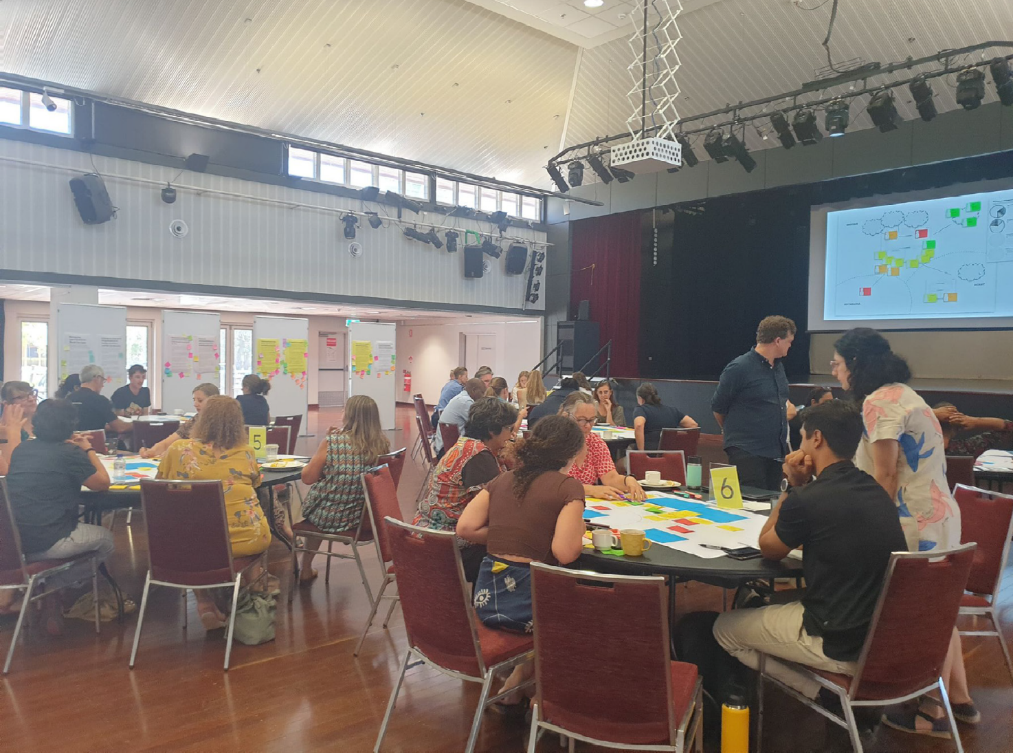
Figure 1 – Adapt and Adopt Workshop, Broome.

Service model for Broome Hub
In developing a service design that would best suit the needs of the client groups that emerged out of the Broome consultation, three conceptual service models (see Appendix No. 3) surfaced from workshops and were then presented back to the community for comment.

One of the conceptual models was overwhelmingly chosen as the community’s preference, however, select elements from the two other models were also favoured.
Those elements were amalgamated into a final conceptual model that endeavours to meet all the key needs that surfaced, whilst staying within the intent of the Hub model, and considering practical implementation for the service provider.

This model emphasises conducting FDV work through a whole of family lens where appropriate and chosen by women. It also fosters a community-wide approach that incorporates primary prevention and a focus on young people and seizes upon opportunities for early intervention at key moments. This model acts to help connect the existing service system within the region and draw upon the strengths of the local
community while meeting the complex needs that are present.

Key recommendations specific to the Broome Hub include:
» Youth specialisations and family specialisations within the mix of Advocates in the Hub to respond to the unique presentations of FDV in the regions.

» Clinical/Practice Excellence Leadership to support other roles in the Hub, foster best practice, and manage risks that will present for this service.

» A Primary Prevention and Community Education function, reaching out into community to improve awareness and community accountability for FDV.

» Workforce Development within the hub and within the region to increase local FDV capacity, develop communities of practice, and overcome workforce challenges.

» Focusing peer, social, and healing activities on cultural needs through a Cultural Coordinator role and brokerage funding for On-Country and cultural activities.

» Aboriginal Community-Controlled Organisation (ACCO) leadership within the Backbone and governance of the Hub.

» Support for an Elders reference group, and Elder engagement within the activities of the Hub.

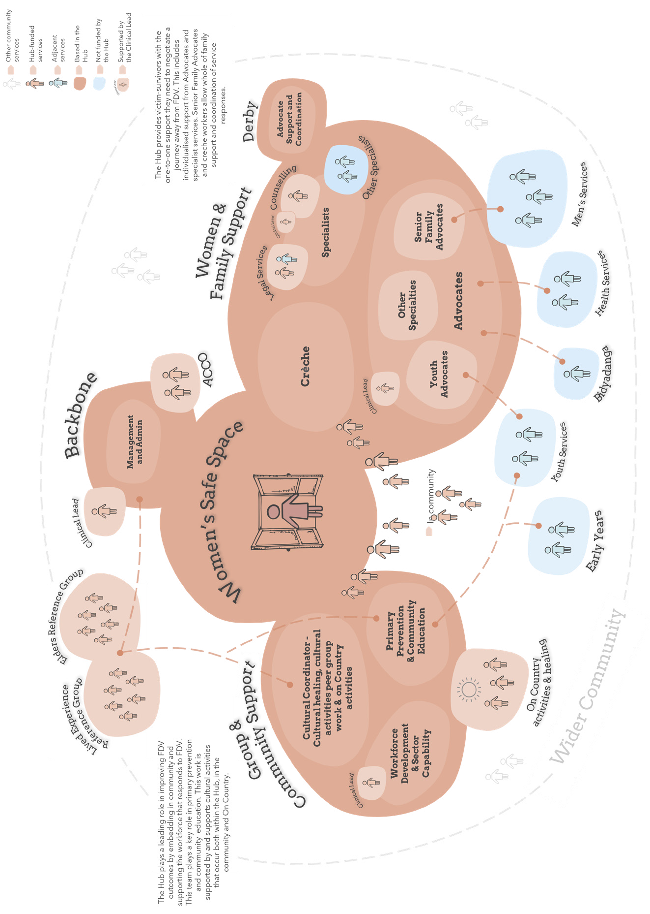
Figure 2 - FDV Hub Model Broome

Guiding Insights
This engagement identified a complex picture of FDV and FDV provision within Broome and the wider Kimberley, indicating that deep listening to guiding insights was a necessary first step in the design process.

The model is derived from a series of 16 key insights (see Appendix 6) formed over the course of the engagements with local service providers, Elders and lived experience voices. These insights were developed and refined over the course of all engagements and refined to six (6) guiding insights for Broome. These went beyond describing merely good practice, or basic tenets of the Hub model (such as ‘a place for respite’), and instead support the unique design of the Broome Hub. These ‘Guiding Insights’ can be considered design principles and critical success factors for the development of the Broome Hub:

What we heard
- FDV work through a whole family lens
» People spoke of a need to be able to work flexibly, and coordinate with the whole family unit (where appropriate and chosen by the victim-survivor).
» FDV can involve broad family networks with complex interactions.
» All ages are experiencing intergenerational cycles of violence and need healing.
» In some cases people have experienced family violence from very young ages, which has contributed to their perpetrating family violence themselves later on.
- Peer and trusted entry points
» People have existing relationships in the community with trusted service providers and staff that should be leveraged.
» First Nations staff and Aboriginal Community- Controlled Organisations (ACCOs) are an essential part of creating a trusted team.
» Peer networks are a strong driver for encouraging early help seeking and should be better supported.
» All of these create important avenues for engaging victim-survivors early (‘soft access’).
- An emphasis on young people
» There is a clear need and community desire for primary prevention work and early years education.
» Primary prevention could be supported or led by the Hub, with a focus on both very young children, and the 13 - 21-year-old age group.
» More education around respectful relationships, consent, sex positive and culturally safe discussion are wanted.
» People noted that early teens relationships can already be characterised by violence and coercive control and can result in early parenting.
- A strong, supported workforce
» Local workers are desirable as they are trusted by the community, and may have more longevity than attracting people to move to the region
» Building a skilled FDV workforce including First Nations staff will be necessary but challenging.
» Gaps in FDV knowledge within the local sector are a barrier to coordination and
require training and development of a shared ‘community of practice’.
» Burnout is a significant risk requiring targeted support for the workforce.
- Embedded in culture
» There is strong support for the Hub from Elders and people with lived experience.
» Cultural healing and cultural activities that acknowledge intergenerational trauma around the impacts of colonisation, the stolen
What we heard
generations and ongoing systemic racism, and emphasise a focus on traditional knowledge and healing practices as a recognised way to address this trauma and reconnect people to culture, community and self.
» Aboriginal and Torres Strait Islander people and service providers desire sustainable, practical means of doing healing and family work ‘On Country’.
» The upholding of strong Cultural accountability measures as a key ingredient for breaking the cycle.
- Seizing opportunities to break the cycle
» Midwives, Child Health Nurses (CHNs), and caregivers are well placed as early intervention levers.
» Post-crisis opportunities from health services in hospitals such as referrals to the Hub after incidents of violence.
» Change requires a focus on longer-term journeys empowering victim-survivors and the community (such as providing links to training and employment pathways).
Other insights (see Appendix 6)
» Complexity in the Kimberley means that the Hub needs to be able to grow and adapt flexibly over time.
» The Hub is a space for respite.
» The Hub must be physically, emotionally, and culturally safe.
» Need for the Hub to integrate within and support the existing service system.

Enablers and Barriers in Broome
During the engagement process, the community undertook various activities and reported feedback that illustrated certain enablers and barriers that would play a part in the success of the ultimate operation of the FDV Hub. Notably, some of the enabling factors were so prominent that they ultimately formed some of the Guiding Insights. These enablers and barriers included:

Enabler | Barrier
Workforce support and development  Integrating, collaborating, and connecting the existing service system  The ability to be flexible over time  Victim-survivor-led pace and programming  Cultural accountability and cultural support  “A rising tide lifts all boats” – peer education, community education, primary prevention, workforce development, and sector capability work all support a holistic approach to improving FDV outcomes in the community | The issue of poverty in the region – people’s immediate needs of food and housing overwhelm their abilities to manage safety  The lack of men’s healing work being funded and undertaken in the region (as opposed to perpetrator accountability work)  A lack of adequate support for crisis intervention (i.e., limited refuge options)  Lack of housing options in the region (for staff attraction and retention, and to support victim-survivors to reduce risk and improve safety)  Disparate needs for FDV services in different areas (i.e., Broome and Derby have different needs)  Some Aboriginal people who may access the Hub are transient and not usually based in Broome. People from communities across the Kimberley are going to present with diverse needs which adds to complexity within the Hub

Opportunity for best practice
This model has been driven by the stories of people who have experienced FDV and the work of those committed to see change. As the Broome FDV Hub develops, together with the ongoing development of the soon-to-be operational Armadale Hub, and the existing Mirrabooka and Kalgoorlie Hubs, there is an opportunity to establish a best practice for these innovative services. The result could be a ‘community of practice’ of those doing the on-the-ground work that results in significant improvements in this endemic and intractable social issue. At this stage in the development of FDV Hubs, we recommend seeking resourcing to see this community of practice realised, and its full range of benefits and opportunities explored.

Acronyms
Below is a list of acronyms used throughout the document.

Acronym Meaning

ACCO Aboriginal Community Controlled Organisation

AFSS Aboriginal Family Safety Strategy

AOD Alcohol or Other Drugs

CaLD Culturally and Linguistically Diverse

CHN Child Health Nurse

CPFS Department of Child Protection and Family Services

FDV Family and Domestic Violence
FTE Full Time Equivalent

GP General Practitioner

IU Innovation Unit

LE Lived Experience

MOU Memorandum of Understanding

PP Primary Prevention

SP Service Provider

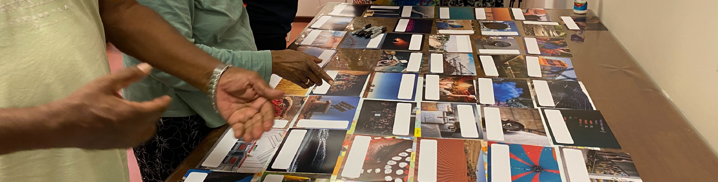
Definitions
Someone to sit beside us A Family and Domestic Violence Hub for Broome
18
Figure 3: Micro-workshop participants in Broome
The following terms describe parts of the FDV Hub model that are discussed within this report. The following table provides clarity for their usage.

FDV Hub Co-location of key FDV supports and community services that prioritises ease of access for victim-survivors

Safe Space A place of respite for women and children

Advocates A support role that walks alongside women to help navigate the system and be a first point of contact

Backbone An organisational body that provides organisation and leadership for the Hub and oversees the multi-disciplinary service delivery

Lived Experience Those with knowledge gained through personal first-hand experiences

Embedded Outreach Outreach workers that are embedded in community, meeting people where they are

Community of Practice A network of interested stakeholder that collaboratively work towards a common goal

Workforce Development Building the capacity and expertise of the wider workforce to meet the growing needs of the sector and allied services

Primary Prevention Early intervention by addressing underlying drivers of violence before it occurs

Community Education Promoting learning and development in the wider community, building capacity and awareness

Capacity building Assisting individuals and organisations to develop the skills, knowledge, and attitudes necessary to manage new ways of working

Sector A connected system of organisation, services, and policies (e.g., community service sector, transport sector)

Men’s interventions Support services and accountability programs for male perpetrators

Women’s Safe Space The Women’s Safe Space is the physical foundation of the Hub, a discrete place that women can feel safe to come to and connect with other women and support services

Design Team A diverse team of core stakeholders from across the system that collaborate to develop and test ideas and practices

On-Country Culturally significant places On-Country with less surrounding
structures of colonisation (e.g., bush, coast)

Design principle Actionable values that inform the design of the final model and practice

Soft access Engagement pathways that are discrete, indirect, and informal

Snowball sampling A recruitment technique in which research participants are asked to assist researchers in identifying other potential subjects
Throughout this report the terms ‘Aboriginal and Torres Strait Islander’, ‘Aboriginal’ and ‘First Nations’ are used interchangeably to refer to Aboriginal and Torres Strait Islander people.

2. The Approach: Adapting the FDV Hub model to Broome

Background to Broome Hub
Prior to the engagement process that forms the basis for this report, Communities undertook a process to determine a location for a Kimberley based hub.
This recommended that the Hub would be based in Broome with opportunities to
service Derby and Bidyadanga. This process took into consideration demand indicators (sourced from WA Police, Department of Health, and Child Protection); service mapping of the existing service system in the Kimberley; opportunities for resourcing, accommodation, and infrastructure; and finally, the opportunities to create synergies with other related projects.

Having gained insight from leading the design and engagement process for the Armadale Hub, Innovation Unit was confident that Model for Scale would apply well to adapting the Hub model to the Broome context. The design engagement process was to occur over a six-month period from July–December 2022. To ensure a culturally sensitive approach to engagement, Innovation Unit worked closely with Aboriginal Engagement Lead Kyalie Moore from No to Violence.

From the outset it was noted that adapting the model to Broome posed unique challenges. Given the location, it was necessary to gain the trust and input of diverse Aboriginal and Torres Strait Islander communities and service providers to support local ownership of the Hub. It was also recognised that Broome, Derby, and Bidyadanga are each different regions with diverse and disparate populations, needs, and service systems. Reaching a suitably diverse range of potential service users and stakeholders in the engagement period required emphasising relational approaches to stakeholder identification. This included building iteratively on early stakeholder mapping through established relationships in the region, and snowball sampling for greater diversity. Service providers generously supported the team’s ability to connect with people with a lived experience.

The Design Team for the Broome Hub were also able to draw upon the lessons learned from the operating Hubs in Mirrabooka and Kalgoorlie (Naala Djookan and Mara Pirni). While there were ‘fixed’ elements of the Hub and parameters set by Communities based on the Hub model design, Innovation Unit together with the Aboriginal Engagement Lead and Design Team endeavoured to take a co-designed approach to all flexible elements of the Hub. This approach also supported testing the fixed elements of the
Hub to ensure they would operate in practice in the Kimberley context.

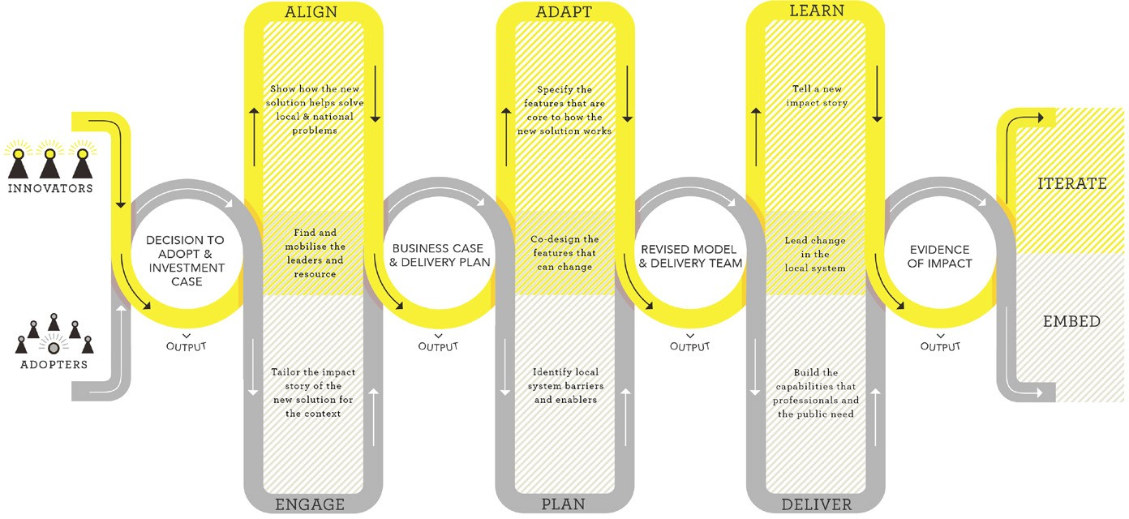

Figure 4: Innovation Unit’s ‘Model for Scale’

2.1 Adapt and Adopt – Model for Scale
The process for scaling social service models from one place to another is often fraught. Whilst a focus on strong practice and outcomes is essential, local communities can experience an imposition of ideas from elsewhere. This can result in a ‘one size fits all’ approach to implementation that can result in a service that is not fit for purpose in a local context.
Innovation Unit’s research into what works in scaling social innovation has shown that the most successful models are those that are ‘fixed’ enough to maintain the fidelity and integrity of the original model, and ‘flexible’ enough to adapt to a local, place-based context, and local community needs. Developed from extensive research and tested with partners in health, social care, and education, the Model for Scale is a proven methodology for adapting and adopting an innovation within a place, to new places, or across a whole system. It recognises the strength of innovation from elsewhere, whilst acknowledging and understanding the deep need for place-based interventions that create ownership in the local community.
As such, scaling the FDV Hub model to the new site in Broome required developing an understanding of what parts of the model should be adopted, and what should be adapted for the Broome community’s unique needs.

2.2 FDV Hubs model: Fixed and Flexible, generally
The generic Hub model design includes fixed and flexible elements, as previously outlined on page 12. The below image of this general model was utilised in early engagement activities as a visual reference and source of discussion.

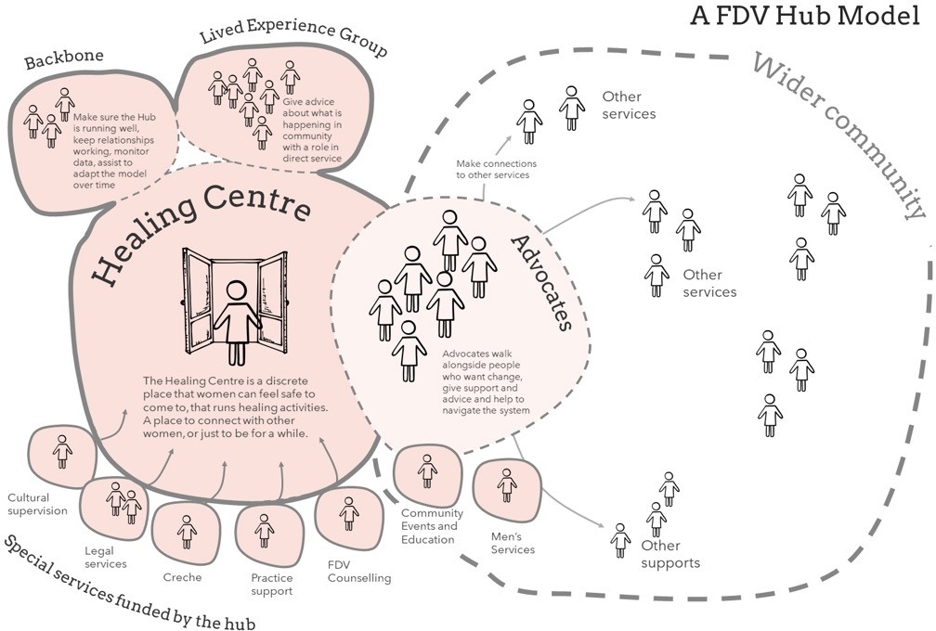

Figure 6: Generic FDV Hub model diagram

2.3 The Engagement Process
For further detail on stakeholders engaged please see Appendix 5.
DATE | ACTIVITY | DESCRIPTION
Phase 1
July 2022 | Facilitation and methodology plan | Design of engagement plan and timeline that would capture planned engagement with key service providers, lived experience, and Elders’ voices in community
Late July 2022 | Stakeholder mapping exercise | Developing a stakeholder register of service providers within Broome, Derby, and Bidyadanga
Late July – early August 2022 | Early stakeholder engagement | Email and telephone communication with service providers who could facilitate lived experience workshops
July 2022 | Mara Pirni engagement | Members of the Design Team met with staff of Kalgoorlie FDV Hub Mara Pirni to review their lessons learned as previous Hub “adopters”
9 August 2022 | Webinar | Hosted by Communities to provide an outline of the project to interested service providers and stakeholders

DATE | ACTIVITY | DESCRIPTION
Phase 2
15 – 18 August 2022 | Lived Experience micro-workshops x 4 (Broome), Elders  workshop x 1 (Broome) and Lived Experience micro-workshop x 1 (Derby) | Traveling to Broome and Derby, the Design Team conducted on-site micro workshops (2 hours) with lived experience groups facilitated via key service providers. Activities included ‘hopes and fears’ exercise, rich pictures, and semi structured group and individual interviews
15 – 19 August 2022 | Semi structured service provider interviews  in Broome (x 20) and Derby (x 3) | With some interviews pre-arranged, and additional interviews arranged through snowball sampling, the Design Team met with various key service providers in Broome to develop a clear understanding of the local context of FDV and the relative roles and  perspectives of providers working in the space
25 August 2022 | Synthesis – Design Team analysis of community engagement | The Design Team met to compile the information and notes taken while on- site. Using a thematic analysis, the team collaboratively analysed the patterns and themes of the engagements
26 August 2022 | Compile draft detailed insights | From the engagements so far, a detailed set of key insights was distilled – drawing on quotes and repeated themes heard in the region
Phase 3
13 September 2022 | Adapt and Adopt Workshop Broome | A large, half day ‘Adapt and Adopt’ Workshop was  presented to 40+ service provider staff (including  those who identified as elders and as having lived  experience). Activities included presenting the insights  for comment, a discussion of target demographics  and location needs for the Hub, as well as staffing roles  required and enabling factors for success. Participants  also devised potential Hub models in small groups
14 September 2022 | Bidyadanga Lived  Experience and Service  Provider engagement | Design team engaged with lived experience and  service providers in Bidyadanga and conducted semi structured interviews to determine the needs of FDV victim-survivors in the community
19 September 2022 | Synthesis - Design Team  analysis of community  engagement | The Design Team met to collaboratively analyse the  materials and feedback generated through the Adapt and Adopt workshop activities. This developed three potential Hub models synthesised from the Hub models developed in community
21 September 2022 | Interim insights  report | An interim insights report was provided to Communities detailing the engagements and findings so far
Phase 4
11 October 2022 | Walkthrough | An on-site engagement in Broome allowing participants to ‘walkthrough’ the content produced from various engagements. This included a highly visual presentation of the three Hub model options that emerged from the Adapt and Adopt Workshop. Participants could engage in feedback activities and could ‘vote’ for their preferred conceptual Hub model. Findings on target  demographic, location, big questions, and insights were presented for further comment. More than 40 attendees engaged in the Walkthrough and provided detailed feedback (including Elders, lived experience voices, service provider and regional government staff)
12 October 2022 | Bidyadanga – male Elders’ group and female Elders group | Design Team engaged with two well attended Elders  groups (one for male Elders and one for female Elders)  in Bidyadanga to receive cultural insight and guidance on the needs of the community, especially with regards to FDV
13 October 2022 | Derby Service Providers micro workshop and semi structured interviews (x7) | Design Team engaged with service providers and conducted an informal micro-workshop and semi micro structured interviews in Derby to determine a better view of the service system context in the community and to clarify what value Derby based FDV Hub staffing roles could bring, and what those roles may look like
19 October 2022 | Synthesis - Design Team analysis of community engagement | The Design Team met to assess feedback generated through the Walkthrough activities and to develop final model
November 2022 | Finalise conceptual  model | Based on the feedback received from the Walkthrough engagement and Communities, the Design Team developed a final conceptual model in detail as well as defining key functions of the Hub and potential staffing  implications

3. Guiding Insights and their practical implications for Broome’s FDV Hub

3 Guiding Insights in Action –
How what we heard was embedded in our recommendations for the Hub
“Everybody got that (drugs) in their family here”, – Elder, Bidyadanaga.
“Not nuclear family stuff” – Elder, Broome.

3.1 Guiding Insight 1:
FDV through a whole of family lens
What we heard –
The presentation of FDV in the Kimberley is complex, and a one size fits all approach is unlikely to work. First Nations people have different, multifaceted needs and situations regarding FDV and FDV responses and an intersectional approach is required. This often relates to the interconnectedness of family, extended family, responsibilities to community, and culture. People spoke of a need to be able to work flexibly, and coordinate with the whole family unit (where appropriate, and where desired by the victim-survivor). This is supported by Focus Area 2 of the Aboriginal Family Safety Strategy (AFSS).
For First Nations (and non-First Nations) people FDV can also involve broad family networks; it can be elder abuse, between family members, children on parents, parents on children or have further impacts on the community that need to be considered.
In some cases people have experienced family violence from very young ages, which has contributed to their perpetrating family violence themselves later on. We were told this speaks to a need for holistic intensive family support with services well-coordinated for families.

Recommendations for service design:
- Pool of Advocates to include Senior Advocates with experience in convening external services around a family, or experience in working across a family unit.
- Hub to have a close partnership with men’s interventions in community with the Advocate role to liaise with men’s intervention staff to provide awareness of interventions the whole family unit is receiving, and to ensure coordination*.
- The Safe Space is just for women (and children) and is promoted as being accessible by intergenerational family groups to attend together (e.g., Mother, children, and grandmother).
- Women’s Safe Space to have effective intake processes for women who are cohabitating with their partner/the perpetrator or plan to continue a relationship with this person to ensure specific family safety planning.
- Where possible, Advocates to provide support to map the genogram of family to identify the broader family context. This will include identifying any young people at risk and including them in any safety planning, as well as identifying any ‘safe’ family members who may be key to support.
- Some Advocates in the Hub to have specialty knowledge or subject matter expertise, for example an FDV worker able to provide accountability education to female FDV victim- survivors who also use violence.
*As an example, we heard of instances where men undertaking men’s interventions were being taught to ‘walk away’ from conflict as a means of de-escalating. As the female partner is not aware of this or doesn’t understand what the men are being taught, this can create confusion and conflict in the family system and re-escalate the situation.

3.1 Guiding Insight 2:
“Awareness happens in community” – Service Provider, Broome.
“Aboriginal people don’t want to be alone - we like being in groups and having company” –
Lived experience participant, Broome.
Peers and trusted entry points
What we heard –
People want an existing, trusted access point.

People have existing relationships in the community with trusted service providers and staff. These might be leveraged to ensure that it is easy for people to reach out for help and create avenues for ‘soft access’.

Aboriginal and Torres Strait Islander staff are an essential part of creating a trusted team. Workers with a lived experience, or who are community peers, have proved successful in creating entry points for many people (provided that confidentiality and conflicts of interest are well managed).
An ACCO being closely involved (either as Backbone organisation or in partnership with the Backbone) would be beneficial given the makeup and trusted relationships in the area that are central to the work. The involvement of ACCO’s and chief roles for Aboriginal and Torres Strait Islander staff was strongly supported in the Adopt and Adapt Workshop.
Other key trusted soft access points could include health services, especially those that relate to maternal and childhood health. Strong relationships and referral pathways through informal networks. We heard about the value of craft groups, sports groups, and other informal mechanisms that bring women together.
Championing peer led work for encouraging early help seeking allows for softer entry, however, there should be greater support and training for peers inadvertently undertaking FDV support work in their communities, especially as many are victim- survivors themselves.
Women’s groups, peer support groups, and support for peer leaders should be a role of the Hub.

Recommendations for service design:
“My home is part of the safety plan for the mob down there, ‘cause they know I live there… it can be any hour” – Service worker, Derby.
“I’ve experienced healing through the various women’s groups I’m part of - helps build confidence to use our voices” – Elder, Broome.
- Facilitate the conditions for peer led work to emerge as part of cultural healing and group activities provided in the Hub.
- Ensure close partnership with an ACCO – either as the Backbone or adjacent to the Backbone (or in another key role).
- Hub/Backbone to implement strong confidentiality systems and procedures among staff and peer workers.
- Inclusion of a dedicated Community Engagement role – the provision of community FDV education to help better equip women in communities who may also be inadvertently undertaking FDV support work (i.e., peer upskilling).
- Inclusion of a dedicated Workforce Development role to support capacity building across Hub staff and in the wider workforce to ensure sufficient FDV expertise in the region.

3.3 Guiding Insight 3:
FDV through a whole of family lens
“Teach the young ones while they’re in school” – Lived experience participant, Derby.
“Need to help the younger ones - they don’t get help until it’s too late - too many suicides of young people” – Lived experience participant, Broome.
What we heard –
We heard an overwhelming response that FDV work in the region needs to include a focus on young people and children. This is important for both primary prevention and early intervention.

Primary prevention could be supported or led by the Hub, with a focus on both very young children, and the 13 to 21-year-old age group who are experiencing intimate relationships.
We heard that the community and service providers thought it important that more education around respectful relationships, consent, sex positive and culturally safe discussion occur.

It was noted how exposure to FDV starts at a very young age, and that even early teens
relationships could already be characterised by violence and coercive control. Early parenting for women in the Kimberley meant that adult responsibilities and relationships are often in place much earlier than in other contexts.

Recommendations for service design:
“We have to fight tooth and nail to be able to do education in the schools” – Service Provider, Derby.
I need someone to talk to [young person, high school age] – Lived experience participant, Derby.
- Support and encourage women/girls as young as 12 or 13 to access the Hub services if they are experiencing FDV or show early indicators of being subject to coercive control. Ensure sensible risk mitigation to ensure safety.
- Employ some Advocates with a specialist youth services knowledge and capability, e.g., a youth work background.
- Provide a key role to target primary prevention and community education.
- Establish close partnerships with local youth services, with Advocates able to undertake some outreach to these spaces to develop trust and relationships.
- Explore potential partnerships with local schools (primary and secondary).
- Create avenues for young people to engage with the Hub’s cultural and On Country activities.

3.4 Guiding Insight 4:
A strong, supported workforce
“We’ve got salary funding and that’s it. Us staff have to do it all until we burn out” – Service Provider, Derby.
What we heard –
with trusted service providers and staff. These For the Hub to be successful, it will need a strong, supported workforce and the ability to build the capacity of local staff. Recruitment and retention of a skilled FDV workforce is a challenge for any new service delivery in the Kimberley.

The Hub could play a role in supporting staff retention, long term careers, staff moving in and out of the frontline to manage burnout and allow for professional development.
Fostering an employment development pipeline for Aboriginal and Torres Strait Islander workers as well as sector and community wide training in order to develop a ‘community of practice’ were emphasised as key levers.

Building the capacity of the local workforce would have significant benefits. These locals are the people who have the relationships, experience, and trust with victim-survivors of the region. Employing local staff increases service feasibility due to practical considerations (i.e. lack of housing for new- to-the-region staff).

Staff support and development roles are required more in the Kimberley than in the metro.
The sector in the region were strongly in favour of salaries and employment terms being in line with other sectors and the cost of living in the area.

With staff retention so difficult, and housing new staff both logistically hard with low housing availability it is essential that local staff are supported, developed and trained. This is also due to the complexity of FDV work and the need for victim-survivors to build trust and relationships with workers over time. Many spoke to the need for a community of practice in FDV across the Kimberley, and in relation to the Hub especially. Without this enabling factor, the effectiveness of the Hub will be limited.

Recommendations for service design:
- Provide a key role to target Workforce Development and Sector Capability, both for those within the Hub and in the wider community.

- Provide a Clinical Lead/Performance Excellence role to support the staff who have direct client management roles as well as providing support for the Workforce Development role.

- Clinical Lead/Performance Excellence role to also form part of the governance structure and provide technical information within the Backbone organisation.

- Create opportunities for the acknowledgment and development of peer leaders with lived experience for key cultural roles.

- Cultural support and activity involvement to come from the Elders and Lived Experience Reference groups.

- Emphasise the hiring of local workers where possible, to avoid transient nature of staff in an environment that requires high trust.

- Ensure sufficient leadership and administrative support for Hub sustainability.

3.5 Guiding Insight 5:
Embedded in culture
“Out on Country for a whole-family healing would be good” – Elder, Broome.
“We don’t go out bush anymore. We can heal there” – Lived Experience Participant, Derby.
What we heard –
Cultural accountability as a key ingredient for breaking the cycle

Engaging communities and community leaders to provide accountability for perpetrators is a powerful driver of change in FDV. As such there are key roles for Elders to play in the Broome FDV Hub. We also heard that the Hub might be a support for Elders looking to increase cultural accountability across their families and broader communities.

As cultural abuse is also part of the picture for FDV in Broome, some victim-survivors are looking for guidance from Elders and those with a deep knowledge of lore. Female Elders were especially sought after for key mentoring roles in the FDV space. Elders and people with a lived experience and cultural knowledge saw themselves as having a role both in providing advice to the governing body as well as working directly in the Hub and community through cultural activities and healing.

There is a need for a sustainable, practical means of embedding ‘Culture and Country’ in the Hub.

For First Nations victim-survivors and their families, the ability to engage in cultural practices and ‘On Country’ activities is an important aspect of healing and should be a key part of the Hub’s activities. Connection to Country is one of the eight central features of PACFA’s Indigenous Healing model, described as the land, skies, and seas to which Aboriginal and Torres Strait people experience belonging (PACFA, 2021). Existing research and best practice guidelines depict Country as a co-therapist - a safe and
spiritual place - and identify cultural activity and connection to Country and community as the strongest pathway to healing (McKendrick et al., 2013).

Several service providers (especially in Broome) combine healing and family- strengthening with On Country visits. Some though, advise that sustaining those practices is difficult (primarily noted in Derby). Many groups advised that there are men’s and women’s On Country services but that there is a gap in services assisting family groups going out together - with children, partners, and intergenerational groups.

Recommendations for service design:
“Open your heart on country… think about your old people” – Elder, Bidyadanga.
“I keep hearing talk about ‘On Country’ and ‘culture’ but we don’t have sustainable means to do this” – Service Provider, Derby.
- Include a key role to Coordinate Cultural activities.
- Support trainee roles to assist in coordinating cultural activities.
- Establish a brokerage fund to assist in payment for specialist cultural leaders and activity presenters to engage in cultural practice and healing work.
- Create opportunities for the acknowledgment and development of peer leaders with lived experience for key cultural roles and other roles with attainment of appropriate qualifications.
- Provide ‘On Country’ activities to include transporting victim-survivors and families to culturally significant places on country (e.g., bush, coast) with less surroundings structures of colonisation (e.g., buildings, townships).
- Elders and Lived Experience Reference groups to be involved both in an advisory capacity to the governance structure, but also direct involvement in cultural activities and direct engagement with victim-survivors and community around FDV.

3.6 Guiding Insight 6:
Seizing opportunities to break the cycle
“Long term support work is needed - risks won’t just disappear for these users” – Service Provider, Broome.
“Things like Tafe courses, housing help, employment information would be good” – Lived Experience Participant, Broome.
What we heard –
Early intervention and post-crisis intervention

Identifying opportunities for intervention through significant life moments for victim- survivors and through external mandated services can be key.

Service providers and victim-survivors both noted that there are often early help seeking opportunities when babies are born. New children are a strong motivation for change and as many lived experience participants noted, an opportunity to “break the cycle”.
Midwives, CHNs, and caregivers are well placed as early intervention levers.

There are also opportunities in moments post-crisis, where a victim-survivor also may be most receptive to support and engagement with a worker from the FDV Hub. These could occur through engagement with hospital social workers or general practitioners.

A benefit of using these moments as an impetus is that the victim-survivor may not be in immediate crisis. Focusing on a non- crisis moment may allow the exploration of a
greater range of options, and an increased capacity to look beyond immediate safety.

A focus on long-term empowerment of victim-survivors and the community

People we spoke to said that ‘breaking the cycle’ required longer-term journeys that focus on empowering victim-survivors and the community.

This includes facilitating services like education and training, housing, and employment, as well as peer work programs.

Service providers perceived that some victim-survivors may need long-term support work, noting the complexity of their cases.

It was also noted that these processes can develop strong role models empowered to tell their stories to others.

Recommendations for service design:
I don’t want my daughter growing up thinking that going to the refuge is normal” – Lived experience participant, Broome.
“Community midwife knows and sees early signs” – Service Provider, Broome.
“Break the cycle. You don’t have to do what your parents did” – Lived experience participant, Broome.

Create opportunities to embed (or send on regular placement, i.e., one day a week) an Advocate to health services to develop a Hub presence in key early intervention points such as alongside a CHN, midwife, or hospital social worker.

Establish close partnerships with health services.

Where relationships with victim-survivors are already established, Advocates should create safety planning opportunities prior to instances of increased vulnerability (such as pregnancies with subsequent children).

Part of the Advocate role should be to provide space for victim-survivors to set and manage longer term goals and outcomes, especially around housing, training, and employment.

Create opportunities for the acknowledgment and development of peer leaders with lived experience for key cultural roles (and other roles with attainment of required qualifications) via both the Community Education and Workforce Development roles.

3.7 Critical Success Factors and Barriers for decreasing FDV in Broome
While conducting community engagements in Broome, Derby, and Bidyadanga the Design Team became aware of various key enabling conditions that would likely be critical success factors for having impact on FDV rates. Similarly, several key barriers were uncovered.
Many of the key enablers have already been discussed and proposed as part of the Broome Hub design, manifesting either as key roles or as recommendations emanating from the guiding insights.
Some of these barriers represent strong community feedback on matters that were out of the scope of this project but have been included in the report in case it is determined in the future that the Hub may have a role in addressing these areas. These barriers are discussed in some more detail below.
Poverty
When we spoke to victim-survivors about the Hub, they often described their basic needs including food, housing, transport, children’s supplies, and phones (for safety), as well as services like housing supports, NDIS, and legal assistance.
It was clear that FDV intersects strongly with poverty, which creates a need for very practical, holistic support. A lack of housing prevents women from making choices to leave, transport issues prevent accessing services, financial abuse impacts food security.
While emergency relief is a driver for help seeking, many services and victim-survivors note that food vouchers are not sufficient, and the process is disempowering. It can also change the relationship between worker and victim-survivor and remove the focus from healing work.
Addressing poverty is a complex issue (Spicker, 2016) and there is not a clear answer on how the Hub can best assist with the need for practical supports, or if it is the role of the Hub to do so.

Men’s interventions
In emphasising that the community wanted to embrace a whole of family approach to FDV work, it became clear that men’s interventions are a key component of that. This Hub model is built around the premise that men’s interventions are being carried out in the community by external service providers. This work is currently under funding agreements to 2027.
It was heard that while men’s perpetrator work was funded and is occurring within Broome, that men’s healing work was a gap that is ongoing and is needed. We also heard that a men’s “breathing space” or chill out space would be of great benefit, to enable men and women to each retreat to a designated place of respite to help de- escalate any disagreements.
If the goal is to decrease FDV in Broome and the wider Kimberley, then sustainable perpetrator services will need to be an ongoing part of the service mix.
Crisis intervention
Whilst the Hub focuses on early intervention and primary prevention, support for crisis intervention in FDV is still greatly needed in the region. Refuge, crisis, and short-term housing as well as emergency support and staffing were reported as being insufficient to meet demand through all our engagements.
FDV in Derby and other close regions
Some of what was sought from Derby and Bidyadanga was outside of the scope of this project. We also heard of need for FDV services from other communities in the region which fell outside of the service area for the Hub model.
The feedback received from Derby indicated that the approach to FDV work in Derby may vary from approaches suitable for Broome given the different dynamics. The Derby community expressed that the need for FDV support in Derby was great enough to justify requiring their own, stand-alone physical hub.
Feedback for Bidyadanga expressed that the greatest level of violence is between young men who are fighting each other due to alcohol and drug use. It was also noted that redevelopment of a ‘men’s space’ to be used as a chill out space, similar to the existing women’s resource centre was desired.
Service providers, Elders, and lived experience voices also reported a need for FDV support in other areas of the Kimberley, including Fitzroy Crossing, the Dampier Peninsula, One Arm Point, and many other communities within the region.

4. An FDV Hub for Broome

An FDV Hub for Broome
The Hub model that emerged out of the Broome, Derby, and Bidyadanga engagement process demonstrates three clear areas of the Hub required to support women and see long term change in FDV:
1. The Backbone - the overarching governance, leadership and administration structure that supports overall hub functioning and impact.
2. Group and Community Support - elements that target peer group and community support and wider community change.
3. Women and Family Support - the area of the service dedicated to directly
supporting victim/survivors as individuals and in the context of their families.
4. Key partnerships external to the Hub.
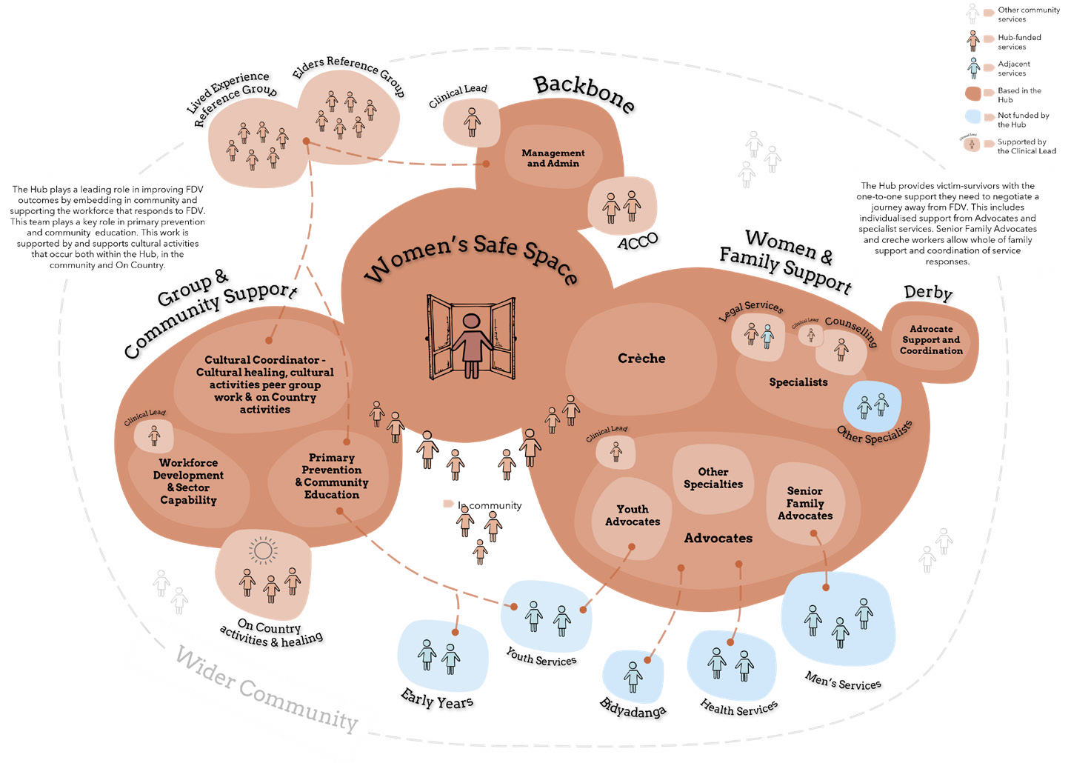
Figure 7: FDV Hub Broome - full conceptual model with key (for larger image see Figure 3)
The following sections describe the way that these areas will need to be realised in a Broome context.

4.1 Recommended components for a Broome Hub FDV:
4.1.1 The Backbone and governance stuctures
The Backbone role will be vital in bringing service providers together in a unifying way that puts the service user at the core, rather than previous siloed organisational objectives. The Backbone will need to convene, support, and manage all the disparate service providers that come together to form the Hub taskforce and will need to consider the short-, medium-, and long-term outcomes for FDV victim-survivors that the Hub aims to bring about, as well as how this will be measured.
Ultimately it will be the chief role of the Backbone to build a collaborative vision and culture across the Hub, provide leadership and drive best practice.

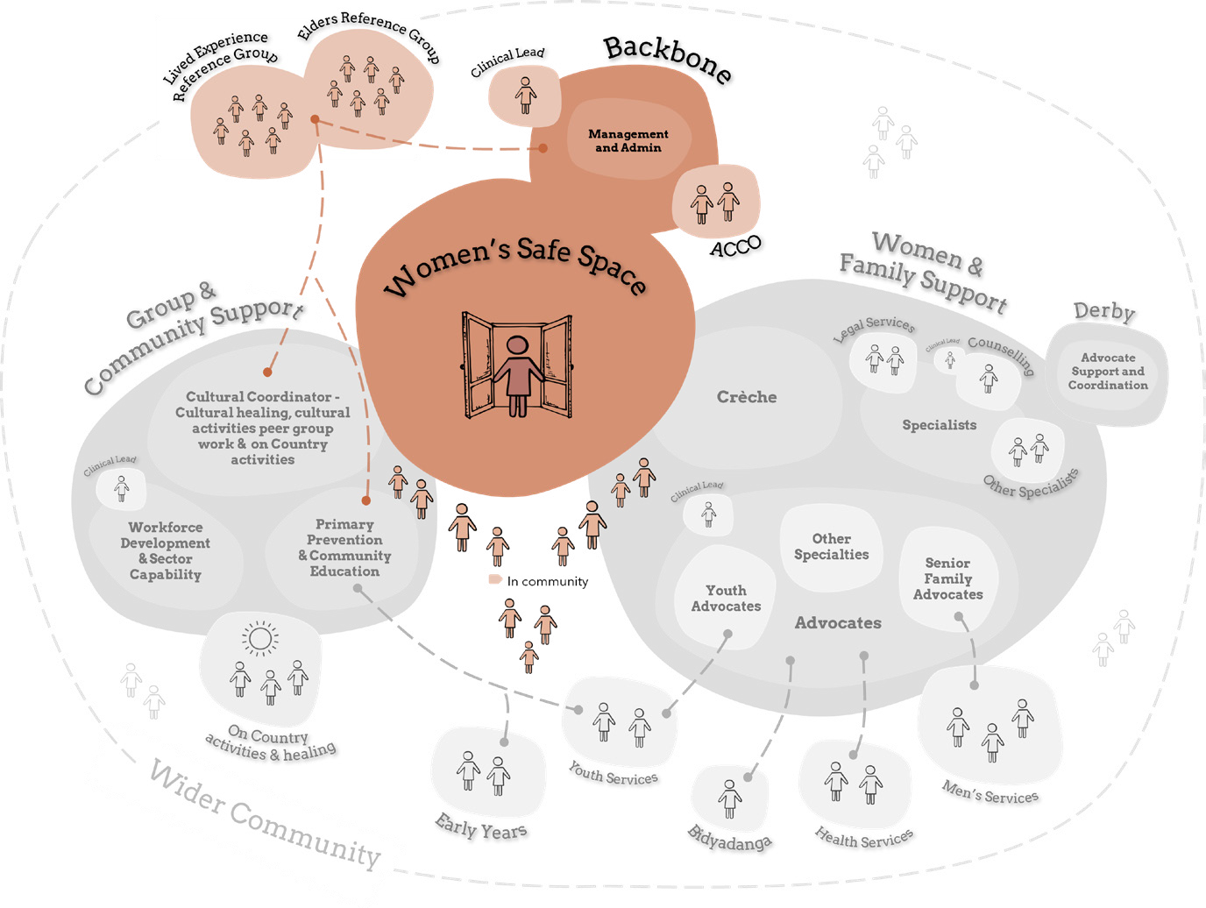
Figure 8: FDV Hub Broome - Backbone and Governance structure highlighted
ACCO role
In Broome, it will be essential to see the involvement of an ACCO either as Backbone or strong partner to the Backbone. An ACCO was seen as important in helping to develop Aboriginal and Torres Strait Islander workers and also as a trusted access point. There are also possibilities for an ACCO owned premises to be leased as a physical location for the Hub. We saw evidence of strong community focussed service provision from ACCOs in Broome, with a number of organisations transitioning to First Nations control. There may be a reputational risk to the Hub without strong ACCO involvement.
A safe space for women
The Women’s Safe Space is the primary ‘soft access point’ for the Hub, a physical space that creates the foundation for the Hub. It should be a place for respite, where women could come together and have a reprieve from chaos, knowing that they and their children are safe while at the Space. Here, cultural activities form the basis for healing and peer groups to support each other. It is also the space where relationships can be built with key Advocates to enable more intensive one-to-one and family directed work to happen. Like other Hubs, the key point for the Women’s Safe Space in Broome is balancing accessibility with safety and security.
The Design Team proceeded on the basis that the Hub would be primarily a space for women and children based on the information provided by Communities. It was considered that men’s interventions are already funded in the area (see page 28 and 39 for more on this point). However, strong feedback was received that having the option to tackle FDV work through a whole family unit lens, is an important service focus, especially for First Nations people and their families in the region. It is likely that this whole of family work will occur through outreach, rather than at the ‘Safe Space’, although forming a full understanding of a victim- survivor in the context of their family will also be a key part of the work of Advocates.
Clinical Lead/Performance Excellence lead
A Clinical Lead or ‘Practice Excellence Supervisor’ was recommended in our consultation process, and we have recommended this role forms part of the Backbone/governance structure. Given the context of FDV in the Kimberley, the Hub will hold significant clinical risk which will need to be managed to keep people safe while allowing the flexible work necessary to make change in a complex environment. This role would provide direct support to therapeutic counsellors, and Advocates managing caseloads, and would also provide guidance and support to the Workforce Development/ Sector Capability role (see page 45).
Lived experience and cultural guidance
Lived experience input is a ‘fixed’ element of the Hub model. In Broome, it is recommended this manifest as Lived Experience and Elders Reference groups. An interesting aspect of Broome is that many of the service provider employees also have a lived experience of FDV. While we still suggest separate Lived Experience and Elders Reference groups, it would be beneficial if there was also a mechanism for staff with a lived experience to be able to provide feedback based on their dual experience. While the Elders and Lived Experience Reference groups would be a key element of the Hub, we suggest that they be funded by a brokerage fund rather than being part of the Hub’s paid workforce capacity. It is recommended that these groups have input into direct provision of cultural activities within the Hub, community engagement activities outside of the Hub, and an advisory capacity to assist the governance structure.
4.1.2 Group and community support structures
The Hub plays a leading role in improving FDV outcomes by embedding in community and supporting the workforce that responds to FDV. This team plays a key role in primary prevention and community education. This work is supported by and supports cultural activities that occur both within the Hub, in the community and On Country.

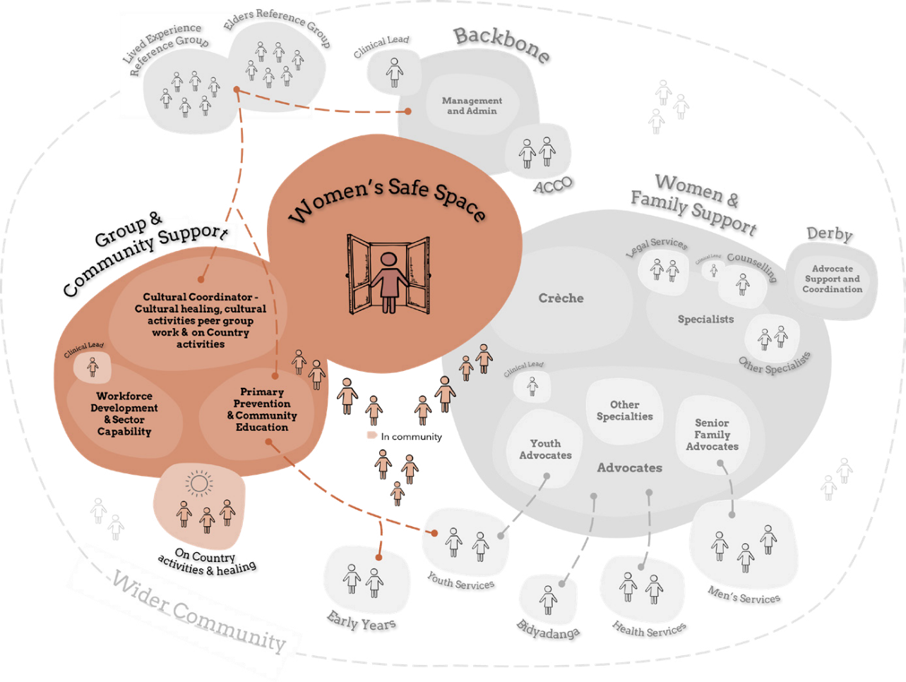
Figure 9: FDV Hub Broome - Group and Community support structures highlighted
Soft access
The ‘soft access point’ is a fixed element of the generic Hub model and requires that there be reasons to access the Hub other than for the sole reason of receiving assistance in FDV situations. This acts to reduce any stigma or shame associated with accessing the space. This can be difficult in regional spaces where the purpose and activities occurring in all spaces are generally known to locals. It has been framed as ‘a reason to be that is not FDV’. Community and service providers suggested various options that include classes for women and their children, cultural activities, and learning sessions as well as possible formalised training and development and peer group circles that could include incursion presentations from other local service providers. For Broome, these activities take on a cultural focus.

On Country/Cultural roles
With such a large Aboriginal and Torres Strait Islander population, disproportionately impacted by FDV, our consultation revealed that cultural healing, cultural activities, and On Country engagement was key to supporting this population of victim-survivors. Cultural activities were seen as a necessary complement to traditional western therapeutic counselling. This regular program of cultural activities, group yarning sessions, arts and crafts, and excursions requires staffing of a Primary Cultural Coordinator as well as a trainee or support coordinator. It would interact with both the Elders and Lived Experience Reference groups, as well as the Primary Prevention and Community Education role. The importance of being able to do cultural activities ‘On Country’ cannot be understated. Cultural activity and connection to Country and community are noted as the strongest pathway to healing (McKendrick et al., 2013). This aspect of the Hub would also likely require a brokerage to fund individual leaders. It is suggested that Aboriginality be a requirement of this Cultural Coordinator position (a s.50D identified position/s) 2.
Primary Prevention and Community Education Role
Given that primary prevention, a focus on young people and the emphasis on building capacity across community arose so prominently in consultation, we recommend a function dedicated to Primary Prevention and Community Education (this may be a split into each area of focus, within the same role). This role would build strong partnerships in community with youth organisations and other key community service providers whose work would intersect with FDV and provide the outreach education necessary for primary prevention. It would also liaise with the Advocates and could provide direct education sessions to the victim-survivors accessing the Hub. Community education activities would likely have strong intersection with Workforce Development and Sector Capability role (see below). It would also likely interact and collaborate with the Cultural Coordinator role and their activities.
2 A s.50D identified position is a position where an employer may identify that a position is to be filled only by a person with a particular attribute, such as Aboriginality. Conferred under the Equal Opportunities Act 1984.
Workforce Development and Sector Capability Role
A role dedicated to Workforce Development (within the Hub and its outreach areas) as well as Sector Capability. Service providers spoke to the importance of supporting and developing a local workforce to ensure sustainability of this Hub. It seeks to address what emerged as one of the greatest risks in the Hub operating successfully - retaining and managing the workforce. This would include the intentional development of local Aboriginal and Torres Strait Islander workers, and support to staff within the hub who don’t have specialist FDV roles, for example creche workers.
The need for workforce development stretches beyond the hub, with community identifying a lack of FDV capability within the wider ecosystem as a barrier to long term change. As such, this role should contribute to and lead sector-wide ‘community of practice’ around FDV in the Kimberley.
This role would receive support from the Clinical Lead role to collectively develop an appropriate best practice model. Similarly, it would interact with and support the Primary Prevention/Community Education role where required so that community education and sector education are linked. For further role description details, please see Appendix 2.
4.1.3 Women and family support
The Hub provides victim-survivors with the one-to-one support they need to negotiate a journey away from FDV. This includes individualised support from Advocates and specialist services. Specialised Advocates allow a focus on young people, and whole of family work. Creche services allow for a contribution to early childhood development and respite for victim-survivors.

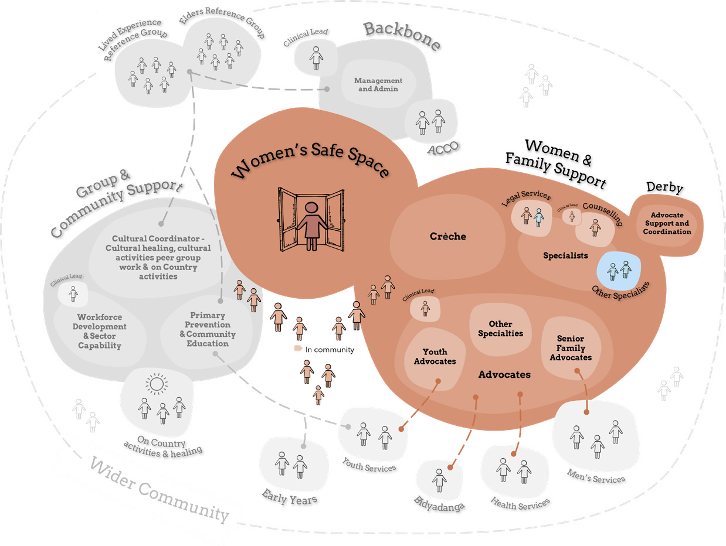
Figure 10: FDV Hub Broome - Women and Family support structures highlighted

Advocates
The Advocate role is another key fixed element of the Hub model that we see as having an important part to play in Broome.
The Advocate will be the key contact for the victim-survivor for the journey of their engagement with the Hub. This single point of focus allows for strong relationships which are the foundation for change. The Advocate walks besides the victim-survivor
and ensures that they are not retraumatised by having to retell their story over again.
While the role of the Advocate in the Hub model has not yet been codified within other Hubs, there are various activities this role undertakes, including:
» Developing strong, one-to-one trust-based relationships with victim-survivors through informal connection in the Hub.
» Creative case management to assist women to navigate the system, including advocacy.
» Information navigation - providing support, advocacy, and referral.
» Safety planning and risk mitigation.
» FDV psychoeducation.
» Coaching, informal counselling, and encouraging action.
» Practical supports, for example assistance with getting to appointments and overcoming other obstacles.
» Key contact through the whole journey, including periods of crisis and times of
A key finding for these engagements was the need for a whole of family lens to the work
of the Hub, which necessitates the work of the Advocates including developing a full understanding of the family context of the victim-survivor they are supporting.
Specifically, within the Broome FDV Hub model context, we see that the group of Advocates working in the Hub may also take on ‘specialties’ that are geared towards supporting certain demographics of
victim-survivors. For example, based on the consultation that we have undertaken it may be appropriate to have advocates trained or with a background in:
» Youth work (where the victim-survivor is also a young person).
» Family work (see below).
» Mental health and alcohol and other drugs (AOD) work.
» Experience working with CaLD clients.
» Female FDV perpetrator work (where the victim-survivor is identified as also having been a perpetrator of FDV) - this may be an emerging practice, requiring support from the Clinical Lead.
Senior Family Advocates
In recognition of the key finding that there is a need for a whole of family lens to the work of the Hub, it is acknowledged that this approach can hold a higher level of risk and a diversified skillset. As such, it is advised that more Senior Advocates bring a capability to convene families and service providers around a family to coordinate support. In some cases, this will need to ensure a link between the work the Hub does with victim-survivors and the work done with the partner/perpetrator in other services in the community.
This will ensure that the education and counselling undertaken by each party in the relationship is ‘linked up’.
This recommendation flows from repeated references to the ‘Strong Families’ program in our engagements. This provision was identified as a strong, useful service response that supported system coordination and was noted as a loss for the community. The ‘Strong Women, Strong Families’ program (not connected to ‘Strong Families’) was also described in its success of joining and coordinating men’s and women’s interventions for the support of whole families. These responses were broad based, from service providers, Elders, lived experience voices and government authorities including Legal Aid (and through Legal Aid, a Magistrate). Having one or more Senior Advocates with the extra skills and abilities who can lead this work and support the other Advocates as needed, is recommended. This convening work of the more Senior Advocates should also be supported by the Clinical Lead to avoid any sense of collusion. There is a risk that this additional convening work might make the Advocate role unwieldy. Whilst this might be mitigated by development of clear boundaries around the role, future flexibility should be provided should this convening capacity need to be separated into a distinct role in future iterations of the Hub.
Specialist services
The key specialist services for Broome follow its Hub predecessors, with creche, legal, and therapeutic counselling considered vital. Local legal services are in support of their role within the Hub. Therapeutic counselling would involve one-to-one counselling sessions for victim-survivors and could also be appropriate for group sessions. The Therapeutic Counsellor role would be supported by the Clinical Lead.
To promote the integration of the Hub within the existing local service system, we recommend that other specialist services could also be co-located within the Hub.
This would provide wraparound support to victim-survivors. Throughout engagements we heard that a need for AOD counselling, financial counsellors, health services, and housing services may be useful additions.
Support in Derby and Bidyadanga
The Advocate role would also incorporate Derby and Bidyadanga. In Bidyadanga one of the Advocates based out of the Broome Hub would spend regular time in the Bidyadanga community. The community’s preference includes overnight stays to assist in embedding the Advocate in the community as well as increasing the range of availability to see the Advocate while in town.
This Advocate would also provide a connection for the Bidyadanga community back to the broader Broome Hub. Community in Bidyadanga also highlighted issues with youth mental health and suicide, and with drug and alcohol use, and workers with this expertise could be beneficial.
The Derby engagements emphasised the importance of Advocates being based in Derby, rather than drive-in-drive-out from Broome. The roles of the Advocates who are Derby-based may vary to the Broome-based Advocates to ensure their roles and tasks best meet the needs of their community. Roles based in Derby could provide for an early intervention and primary prevention FDV response. This includes Advocate support and coordination of local service delivery.
Engagement in the region also identified that Advocates with a background in youth work and/or AOD work could be beneficial. Some of the proposed functions of the Hub may be able to be managed by considered outreach from the Broome Hub, such as workforce development and sector capability building, clinical lead support and legal support.
It is again acknowledged that the Derby community felt that a range of additional services and supports were required to comprehensively address family violence in the region, and that the quantum of those services was likely beyond the scope of this project.

4.1.4 Key partnerships outside of the Hub
Significant feedback was received from the service system community in the region that integrating and collaborating with and supporting the existing service structure was vital to the Hub’s success. A non-exhaustive list of potential key sector partnerships is recommended below.

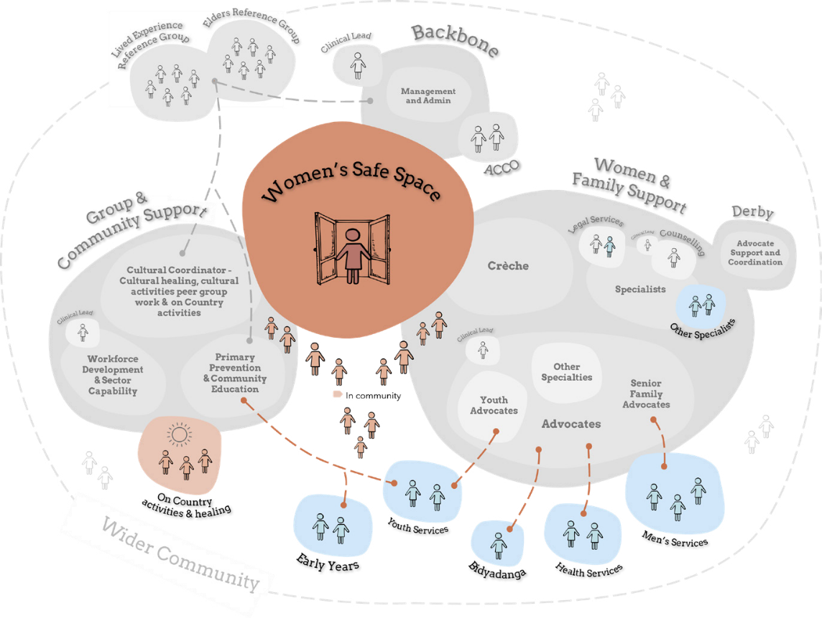
Figure 11: FDV Hub Broome - Wider community structures highlighted

4.2 Target Group
4.2.1 Process on target group
Throughout the engagement process (see page 17) the team conducted exercises and interviews around what a target demographic for Broome’s FDV Hub would look like. Consistent with what came through in the Guiding Insights, these included a predominantly Aboriginal and Torres Strait Islander demographic, with an emphasis on support for young people and a focus on family, community, and culture (in addition to one-on-one interventions).
4.2.2 Cultural background
With regards to the cultural background of the victim-survivors expected to access the Hub, the engagement overwhelmingly
considered that the vast proportion would be Aboriginal and Torres Strait Islander women and children. It was noted however, that there is a diverse mix of cultures, language, and family groups within the local First Nations community who would present with disparate needs and priorities, and that the Hub would have to be able to appropriately respond to that.
Difficulty accessing the CaLD communities within the region
While an exploration of the barriers facing CaLD victim-survivors in the region was part of the initial engagement plan, the Design Team was unable to engage with the CaLD community despite a number of attempts. Service providers noted that CaLD victim-survivors accessed their services in extremely low numbers. Providers speculated that this was due to cultural norms as well as language and trust barriers and lower population numbers. Despite this, it was noted that CaLD victim-survivors do exist in the area, that support for them is a gap, and that outreach to these communities is likely to take patience, targeted activities, and network building of the FDV Hub over time.
4.2.3 Age
The community engagements around demographic also sought information on the age range(s) that local community and service providers anticipated would need assistance from the Hub. Feedback highlighted that the age demographic was younger than in other Hubs, with teen (and even pre-teen) relationships characterised by coercive control and emotional, physical, and sexual violence. We heard that the Hub would need to be able to assist victim- survivors accessing services who were as young as 12 or 13 years old.
It was also noted that parenting was occurring at a younger age in the region, and so many young women and girls found themselves facing adult responsibilities and relationships at earlier ages, often with minimal support.
It was also noted that while the younger demographic need presented strongly, that family violence was also occurring within families with violence perpetrated on mothers and grandmothers by children and grandchildren and that all ages should be welcomed.
4.2.4 Presenting family type
Community engagement generated interesting discussions regarding family types presenting at the Hub, and how they might be supported in diverse forms. It was noted that while the primary demographic would likely be single women with children, other family types also expected to be represented included:
» Single women without children.
» Intergenerational family groups of women.
» Women in a relationship who wished to continue that relationship despite the FDV, but wanted to be safe (i.e., where the male partner was undertaking work at an external men’s intervention service provider).
4.2.5 Gender
We note that the boundaries of this engagement specified that the Hub was to be primarily for women, as men’s interventions in the region had pre-existing funding. As a result, our work did not ask for participants to provide a breakdown of Hub services based on gender.
Despite this we did conduct a lived experience micro-workshop with a group of male victim-survivors, and we also heard extensively from organisations who provided perpetrator/accountability work programs for men (often referred to as “men’s interventions”) and from the broader service sector who raised the need for women’s healing work and men’s interventions to happen in a connected up way rather than a siloed approach.
We also received extensive feedback that due to the nature of intergenerational violence and trauma since colonisation, some victim-survivors of FDV can also end up using violence themselves and would benefit from services to assist them to manage conflict within families without resorting to violence. The conceptual Hub model suggested addresses these recommendations from community. As with other hubs, male victim-survivors should be supported through outreach activities, rather than at the Hub itself.
4.3 Location
In exploring possible locations for the FDV Hub in Broome, the Design Team undertook various methods throughout the engagement process. These included seeking specific suggestions as well as raising discussion of location criteria in semi-structured interviews with service providers, micro-workshops with people with a lived experience and Elders, as well as undertaking specific activities. In both the Adapt and Adopt Workshop and Walkthrough engagements, participants were presented with a large map on which they could indicate their most and least preferred locations. Detailed feedback was also sought on the reasons for these decisions.
It is acknowledged that there are limitations in Broome given that vacant spaces are
at a premium, with many service providers looking for new spaces themselves in order to expand their services. It is unlikely that a perfect space will appear. Despite this, several criteria emerged for selecting a useful space.
General criteria
The feedback received in the Broome engagements largely validated and aligned with the criteria from other Hubs. These recommendations included:
Secure/safe Protected, monitored access - not everyone can get in
Indoor/outdoor element Able to sit outside in elements of nature
Cultural/blessing Prefer it be blessed by Elders before becoming
operational – e.g. through a smoke ceremony
Culturally safe An area that is free from negative historical
connotations to Aboriginal and Torres Strait Islander people
Warm and welcoming Not to feel clinical or overly formal
Soft access/discrete “Not a stand-alone building but a building in
amongst other buildings” – feedback from a Walkthrough participant

Geographic location criteria
» Not near any liquor sales venues.
» Close to other services, including medical services.
» Some preference given to ‘Old Broome’ area as more able to walk between services.
» Away from busy shopping precincts or tourist precincts.
» Away from justice service offices.
» Away from areas known for antisocial behaviour.
» Specific location suggestions were also indicated through the map exercise and service provider interviews.

Summary
In this report, the Design Team have provided a summary of the insights gleaned from community engagement in the Broome region and have formulated a series of service design elements and a conceptual hub model that emanates from this consultation.
The input received from local service providers, Elders and people with a lived experience in Broome, Derby and Bidyadanga was rich and illustrative, and it is clear that while their concerns regarding FDV are significant, so is the local passion and capability for tackling this complex, meaningful work.

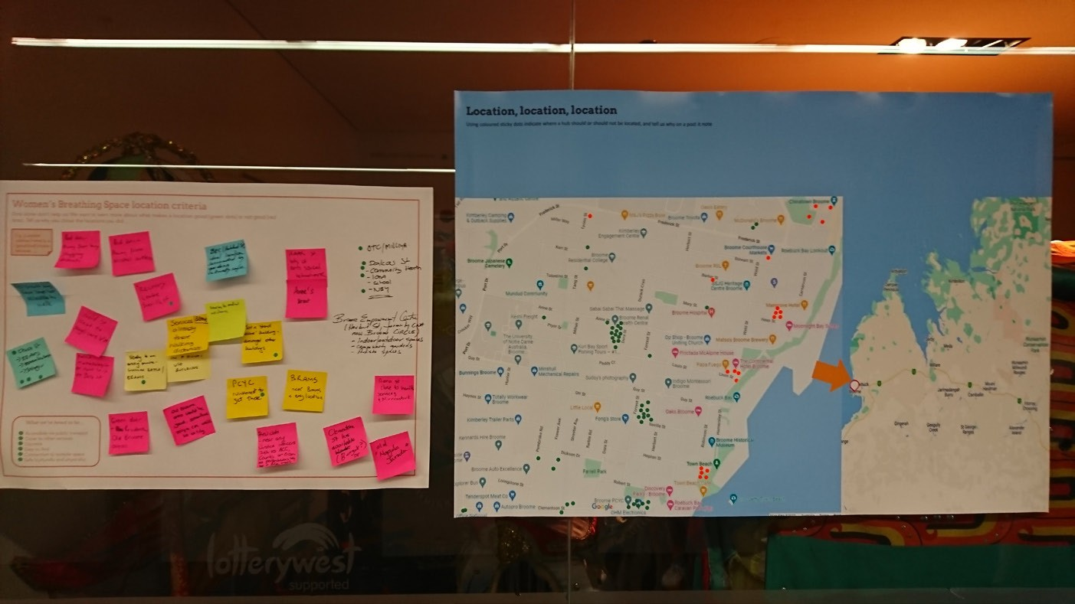
Figure 12: Location map and feedback canvas at Broome Walkthrough event

References
Australian Institute of Health and Welfare (AIHW). (2016). Family violence prevention programs in Indigenous communities (Resource sheet no. 37). https://www.aihw.gov.au/ getmedia/c0e5bdde-e9c4-4a1f-808e-256191835cde/ctgc-rs37.Download%20PDF.aspx
Department of Communities, (2022). Aboriginal Family Safety Strategy - draft for consultation. Western Australian State Government. http://www.wa.gov.au/government/ publications/aboriginal-family-safety-strategy-draft-consultation
Emerging Minds. (2021). Aboriginal and Torres Strait Islander family violence practice profile example. https://d2p3kdr0nr4o3z.cloudfront.net/content/uploads/2021/05/31110834/ ABORIG1.pdf
Emerging Minds. (2021). Honouring Aboriginal and Torres Strait Islander voices in healing family violence. https://emergingminds.com.au/resources/honouring-aboriginal-and- torres-strait-islander-voices-in-healing-fdv/
McKendrick, J., Brookes, R., Hudson, J., Thorpe, M., & Bennett, P. (2013). Aboriginal and Torres Strait Islander Healing Programs: A Literature Review. Healing Foundation. https:// healingfoundation.org.au/app/uploads/2017/02/Aboriginal-and-Torres-Strait-Islander- Healing-Programs-A-Literature-Review.pdf
Morgan, G., Butler, C., French, R., Creamer, T., Hillan, L., Ruggiero, E., Parsons, J., Prior, G., Idagi, L., Bruce, R., Gray, T., Jia, T., Hostalek, M., Gibson, J., Mitchell, B., Lea, T., Clancy, K., Barber, U., Higgins, D., Cahill, A., & Trew, S. (2022). New Ways for Our Families: Designing an Aboriginal and Torres Strait Islander cultural practice framework and system responses to address the impacts of domestic and family violence on children and young people (Issue 6). Australia’s National Research Organisation for Women’s Safety (ANROWS). https://20ian81kynqg38bl3l3eh8bf-wpengine.netdna-ssl.com/wp-content/uploads/2022/04/Morgan-et-al-RR1_NewWaysOurFamilies.pdf
Psychotherapy and Counselling Federation of Australia (PACFA). (2021). Indigenous Healing Practice Training Standards 2021. https://www.pacfa.org.au/common/Uploaded%20files/ PCFA/PACFA_CATSIHP_IndigenousHealingPracticeTrainingStandards_2021.pdf
Spicker, P. (2016). Poverty as a wicked problem. CROP poverty brief, no. 35. Bergen, Norway: CROP Secretariat [online]. http://www.crop.org/viewfile.aspx?id=1062
Stanley, N., & Humphreys, C. (2017). Identifying the key components of a ‘whole family’ intervention for families experiencing domestic violence and abuse. Journal of Gender- Based Violence, 1(1), 99-115.

