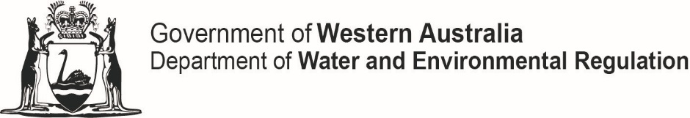
 

Waste discharge notification form
Environmental Protection Act 1986
This form should be used to report a discharge of waste to the environment that has caused or is likely to cause pollution, material environmental harm or serious environmental harm, in accordance with section 72 of the Environmental Protection Act (EP Act).
Provide a preliminary notification to the Pollution Watch service on Tel 1300 784 782.
To: Chief Executive Officer  Attention: Click here to enter text. | Email to: pollutionwatch@dwer.wa.gov.au  Post to: Department of Water and Environmental Regulation  Locked Bag 10  JOONDALUP WA 6919

Discharge of waste from: | ☐ premises ☐ vehicle  Name of premises/vehicle: Click here to enter text.  Address/location: Click here to enter text.  Town/suburb: Click here to enter text.
Map of discharge location: | ☐ Attach a map of the premises showing the discharge location
The following notification and information is provided in accordance with s 72 (1) of the EP Act:
Provide reference to any instrument issued under the EP Act (e.g. licence, works approval, Ministerial Statement) | (If applicable, type in your EP Act licence or works approval number.)
Relevant condition | (If this notification is a requirement under a licence, works approval or pollution abatement notice, type in the relevant condition or measure.)
Description of operation or equipment | (If any of the above two blocks were not filled, please type a brief description of your operation and/or the equipment that malfunctioned.)
Description of incident | (Describe the cause of waste discharge.)
Prescribed details of discharge of waste under regulation 5K of the Environmental Protection Regulations 1987:
Date of incident: | DD/MM/YY  Time: Click here to enter text. Choose an item.
Address/location: | ☐ Map attached of the premises to this notification showing the location of the discharge and the impacted area
Name of person responsible for discharge of waste | (If the discharge of waste was a result of the operation of equipment or otherwise, the name of person operating the equipment that resulted in, or otherwise responsible for, the discharge of waste.)
Composition of waste.  Provide a description of the waste(s), include a sample analysis (as required). | Click here to enter text.
Quantity of waste discharged  If providing an initial estimate, further information confirming the quantity discharged must be provided to the department. | Click here to enter text.
Environmental impact | Did the discharge cause pollution?  ☐ Yes ☐ No  (If yes, describe the nature and extent of the pollution or environmental impact.)  ☐ Map attached to this notification indicating discharge point and impacted area
Remedial action | (What action is to be taken to minimise the effect on the environment from the discharge of waste? Who coordinated this action?)
Waste removal | (Is the waste involved to be removed, dispersed, destroyed, disposed of or otherwise dealt with? If so, in what manner and where to?)

Name of reporter: | Click here to enter text.
Job title: | Click here to enter text.
Contact number: | Click here to enter text.
Organisation: | Click here to enter text.
Date: | Click here to enter text.

Please complete this form and attach to an email along with a map of discharge point and send the completed form and map to pollutionwatch@dwer.wa.gov.au.

