Implementing the National Principles for Child Safe Organisations
Case Study: City of Melville

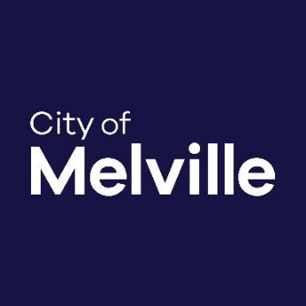
At the City of Melville (City), we engage with our diverse community to achieve an inclusive, vibrant and sustainable future. Our mission is to provide good governance and quality services for the City of Melville Community.
The City is a large metropolitan local government with 720 staff providing services to approximately 102,393 residents (including 21,801 children) across the suburbs of Attadale, Ardross, Applecross, Bicton, Booragoon, Brentwood, Bull Creek, Kardinya, Leeming, Mt Pleasant, Melville and Willagee.

Project in brief
The City is focused on demonstrating leadership as a child safe organisation through the implementation of the National Principles. This will embed a culture and understanding of child safety within the organisation and enable the City to support the community by building capacity and sharing knowledge and information to ensure the wellbeing of children is paramount.
Leading into this, the City’s elected members carried unanimously a motion to participate in the National Redress Scheme in May 2020 and conducted an organisational assessment using the Self-Assessment and Review Tool on the WA Commissioner for Children and Young People website.
Image 1: The 10 National Principles for Child Safe Organisations (National Principles)
The findings were used to create a matrix of the services and programs provided to children and young people by the City and identified the potential associated risks. Work is also underway to develop a policy and procedure in response to the Reportable Conduct Scheme, which came into effect in January 2023.
The City’s leadership team recognised the need to support this important work and approved a business case requesting dedicating resourcing to create a role specific to the Child Safe Melville project.
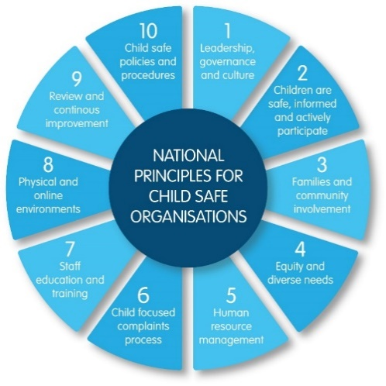
In May 2023, the Child Safety and Wellbeing Facilitator role was established with a focus on the implementation of the child safe National Principles and the wellbeing of children and young people in the City more broadly.

The journey

What motivated the City to undertake an organisational self-assessment?
All organisations engaged with children have a responsibility to provide a safe environment for children.
Local governments offer a range of services to children that support their growth and development, including library and recreational services, arts and cultural events, engagements, after school and holiday activities and programs, etc. We know that children are more likely to participate in these activities and spaces when they feel safe and supported.
The City has considered the findings of the Royal Commission into Institutional Child Sexual Abuse which highlighted the vulnerability of children in a range of settings, including local government services. The City is committed to implementing the National Principles across all areas of service delivery to reduce the risk of child abuse and support our children and young people to thrive and become healthy, active participants in the community.
Implementing the National Principles can seem daunting, and it is difficult to know where to start. As part of the Chid Safe Melville project, the City will identify where children engage most with our services, what we are doing well to promote their safety, and what needs to improve.
The project also aims to embed a culture of child safety within the organisation and the community more broadly by building and sharing knowledge as well as reviewing policies and procedures and creating a child friendly complaints and feedback process.

Challenges
The City was very fortunate to have support at a leadership and governance level (National Principle 1) but work was required to highlight the importance of the project to the Executive Leadership Team.
The self-assessment and risk matrix exercise helped to highlight the existing gaps and need for attention. Full engagement and support from executive leadership is key to driving cultural and practical change and harnessing the resources and momentum to achieve the project outcomes.
There was also a particular focus early on to start to build knowledge and information internally, so work was done with the City’s Communications Team to develop a Child Safe Melville logo and start introducing the National Principles to staff through internal publications.
The aim of this was to put a focus on the project and give staff an understanding of how it relates to their roles, their work and how child safety is everyone’s business.

Achievements so far
The City’s executive leadership has committed to making child safety a priority by establishing a dedicated position and resources to develop an action plan towards becoming a child safe organisation and implementing the National Principles.
Still in the early stages of the work, there is much to learn and sharing knowledge and ideas with others in the local government sector and continuing to be part of the Department of Communities’ Community of Practice will be very important to the success of the project.

Sharing the learning
- Allocate a dedicated staff member/s to coordinate a National Principles self-assessment process using tools that have been developed, such as the Self-Assessment and Review Tool on the WA Commissioner for Children and Young People website.
- Use the tools and assessment process to understand where your organisation has contact with children, what the current processes are for reporting, and identify the gaps.
- Highlight these risks to your organisational leadership. For example, if your organisation has a risk committee, establish it as an ongoing risk that needs to be managed and reported on.
- Focus on knowledge and information sharing internally to begin to shift the way people think about child safety and how it relates to the work they do.
- Make a case for better and continued resourcing in relation to child safety as a priority, particularly in light of the Reportable Conduct Scheme and impending legislation of the National Principles. It’s important to be prepared.

Next steps
The next step for the City is to engage a consultant with specialist skills, and work with them to develop a plan for implementation of the National Principles.
This will also be an opportunity to review existing relevant policies and procedures and identify training opportunities to support staff to develop their knowledge and understanding around keeping children and young people safe.

Last updated: August 2023

