Implementing the National Principles for Child Safe Organisations
Case Study: Department of Communities – Complaints process and resources

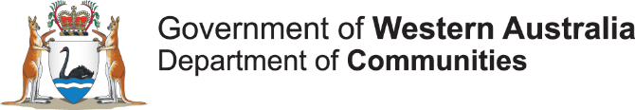
The Department of Communities (Communities) is Western Australia’s major human services department that brings together vital services and functions that support individual, family and community wellbeing.
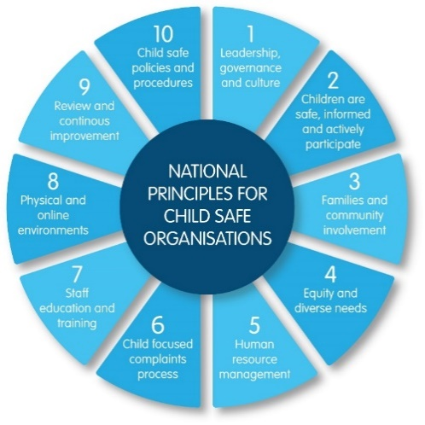
Communities protects and cares for Western Australian children and young people who are in need and supports families and individuals who are at risk or in crisis.
Communities also supports children and young people who are in care by working with community sector organisations and foster carers to provide them with a safe and stable environment.

Project in brief
As part of Communities’ ongoing process to build on and maintain a child safe organisation, its Complaints Management Unit (CMU) is strengthening the agency’s complaints process to meet National Principle 6: Processes to respond to complaints and concerns are child focused.
The CMU is responsible for overseeing and responding to complaints about Communities’ services, including complaints made by children and young people about the services they receive.
The CMU has developed a range of resources aimed at children and young people in care that explains the complaints process.
Image 1: The 10 National Principles for Child Safe Organisations (National Principles)
Having these resources available and designed for children and young people also contributes to implementing:
- National Principle 2 – Children and young people are informed about their rights, participate in decisions affecting them and are taken seriously; and
- National Principle 10 – Policies and procedures document how the organisation is safe for children and young people.

The implementation process
Communities’ CMU undertook a self-assessment against the National Principles in business units across various divisions using the WA Commissioner for Children and Young People (CCYP) Self-Assessment and Review Tool in 2021, which was endorsed by CCYP.
The results indicated that Communities’ complaints process was largely aligned to National Principle 6 and assisted Communities to identify several areas for improvement to ensure the complaints process was more child friendly.
Communities developed a project plan incorporating the action areas and also engaged interns from the University of Western Australia’s McCusker Centre for Citizenship Internship Program to help implement it.
Activities in the plan include:
- Consultation with Communities staff including those from the Standards and Monitoring Unit, the Specialised Care and Accommodation and Intelligence and Professional Standards directorates, and the Advocate for Children in Care.
- Developing a survey to better understand children and young people’s awareness and experience of the complaints process and how children and young people prefer to make complaints, including those from culturally and linguistically diverse backgrounds. The survey data will inform process improvements and updates to existing resources for children and young people on making a complaint, including:
  - Children and Young People Complaints - Poster
  - Children and Young People Complaints - Frequently Asked Questions
  - Children and Young People Complaints - Wallet Card
  - Child Friendly Complaints Kit
  - Complaints Management Policy
The survey findings will also inform new resources including an easy-read Complaints Management Policy for Children and Young People.

Achievements so far
- Communities’ website has a dedicated online tile for children and young people to make complaints.
- The website includes links to the resources available for children and young people.
- Complaints from children and young people are lodged at Tier Two for investigation by a Senior Complaints Investigator from CMU.
- Complaints from children and young people are allocated on the same day they are received.
- Children and young people are encouraged to have an advocate or support person (including the Advocate for Children in Care) to support then during the complaints process.
- Complaint outcomes are customised using child and young person friendly language and delivery.

Sharing the learning
- Keep project plans simple and break the work down into achievable tasks, including specifying the needs and nice to haves. This helps to prioritise tasks.
- Seek the voice of children and young people to inform planning and development wherever possible.
- The Ombudsman Western Australia has useful information to strengthen complaints processes.

Last updated: August 2023

