Implementing the National Principles for Child Safe Organisations
Case Study: Department of Communities and CREATE Foundation – Charter of Rights

The Department of Communities (Communities) is Western Australia’s major human services department that brings together vital services and functions that support individual, family and community wellbeing.
Communities protects and cares for Western Australian children and young people who are in need and supports families and individuals who are at risk or in crisis.
Communities also supports children and young people who are in care by working with community sector organisations and foster carers to provide them with a safe and stable environment.

CREATE Foundation (CREATE) is the national consumer body representing the voices of children and young people with an out-of-home care experience. Its vision is that all children and young people with a care experience achieve their full potential.

Image 1: The 10 National Principles for Child Safe Organisations (National Principles)

Project in brief
Communities worked with the Western Australian CREATE branch and young people with a care experience to revise the Charter of Rights for Children and Young People in Care (Charter of Rights). Three new versions were published for three different age groups in 2021: 0-6 years, 7-12 years, and 13-17 years. Practice guidance for Communities’ caseworkers was also amended to reflect the changes and importance of applying the Charter of Rights and the role of the Advocate for Children in Care (Advocate) in this.
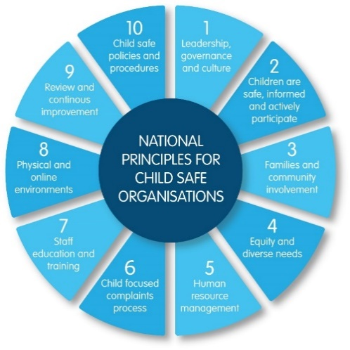
The project outcome is strongly aligned to National Principle 2: Children are safe, informed, and actively participate but has linkages to implementation of all other principles.

Image 2: Screenshots of the Charter of Rights publications

Charter of Rights
The Charter of Rights was developed in 2006 in partnership with CREATE as part of legislation amendments to the Children and Community Services Act 2004 (the Act) which received Royal assent on 20 October 2014. A key area of the Act was the provision for a Charter of Rights for children and young people in care (s.78).
The Charter of Rights was developed within 12 months of legislation coming into operation.
The purpose of the Charter of Rights encompassed the thoughts, ideas, wishes and aspirations of children and young people either entering, leaving or residing within the care system.
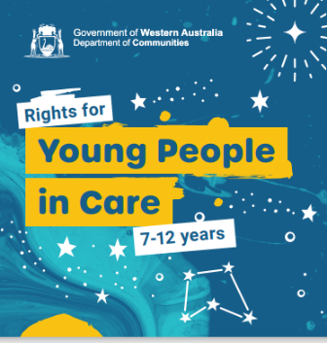
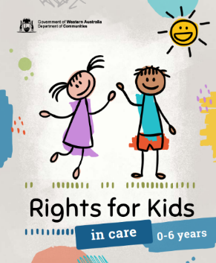
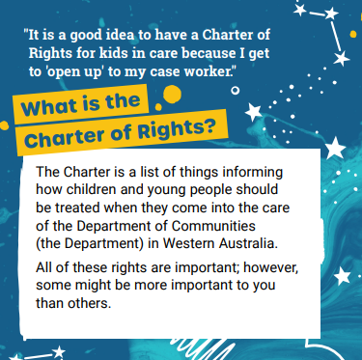
Twelve articles (principles) were agreed by children and young people from the hundreds of written statements provided by them.

What motivated the initiative
Communities recognises that children are better protected from abuse and neglect in care when they know and can act on their rights.
The Charter of Rights is aligned to the United Nations Convention on the Rights of the Child and provisions in the Act, including the right and requirement for children to participate in decisions being made about them under the Act (s.10).
Children and young people should be able to freely express their views on decisions that have a significant impact on their lives. These views must be sought and considered in planning and decision-making processes in all matters that have a significant impact on the child’s life and given due weight according to the developmental capacity and age of the child, and other circumstances.
Communities and CREATE reviewed the Charter of Rights in consultation with young people with care experience to inform guidance for caseworkers. They also emphasised the importance of having regular age-appropriate conversations about them with children and young people, and the role of the Advocate in supporting children in care to exercise their rights.
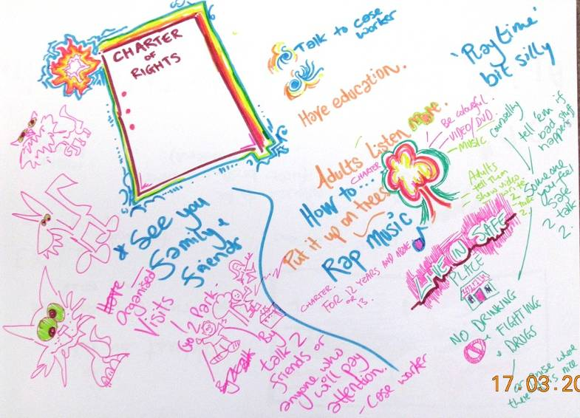
The revisions were informed by recommendations of the Statutory Review of the Children and Community Services Act 2004 (2017) and the Royal Commission into Institutional Responses to Child Sexual Abuse Final Report (2017) on informing, empowering, and supporting children to have a say and make complaints on organisational and individual practices that impact their safety and wellbeing in out-of-home care.

The journey
Communities commissioned the then WA Children and Young People in Care Advisory Committee (CYPCAC) to undertake the development of the Charter of Rights in partnership with CREATE and Communities.
Image 3: Photo of feedback provided by children and young people
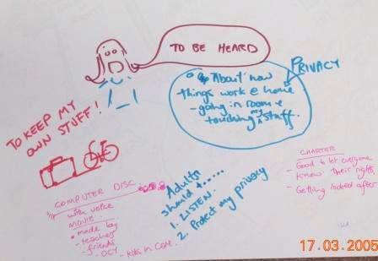
One hundred and forty children and young people participated along with 60 stakeholders from various agencies and organisations including community service organisation providing care arrangements, carers, peak bodies, placement agencies and Communities staff.
It was imperative that the consultation sample was representative of the children in care profile across regional and metropolitan from the ages of 4 to 19 years including Aboriginal and Torres Strait Islanders and those with culturally and linguistically diverse backgrounds, disabilities or special needs.
Image 4: Photo of feedback provided by children and young people
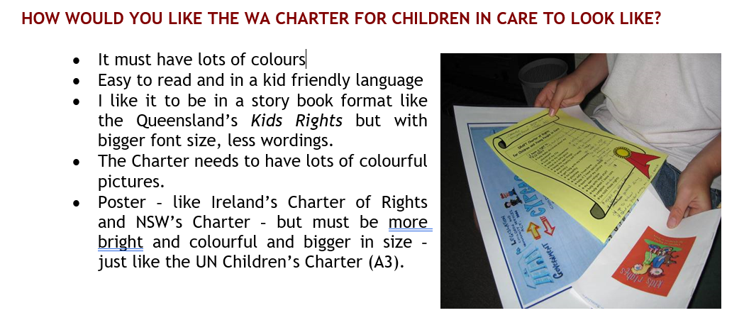
The consultations were led by a young person who with a care background and/or a facilitator from a culturally and linguistically diverse background. They were age appropriate and flexibly tailored to the participants. Methods included games, small group activities and/or individual interviews in familiar settings or of their choosing.
The development process provided children and young people in care the opportunity to tell Communities and out-of-home care agencies what is important to them and how they can improve their care experience. Their input and feedback were provided in many ways, including words and pictures, emails, by phone and face to face participation.
Image 5: Sample feedback provided by children and young people
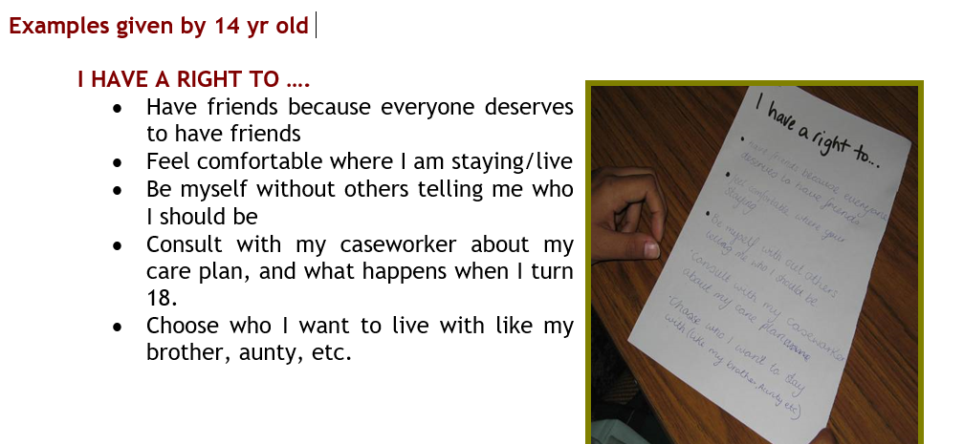
Image 6: Sample feedback provided by children and young people

Challenges
Balancing organisational needs (e.g. being accountable for implementing recommendations in a timely way) and taking the time necessary for engagement with children and young people who need to understand and use the Charter of Rights was a challenge.
CREATE worked with the young people to establish a schedule for their involvement in workshops along with staff from Communities. Work progressed in the workshops at the pace of the young people. A consultation planning toolkit was developed for a consistency approach and guidance to assist the facilitation process. Communities, CYPCAC and CREATE maintained organisational awareness of progress and co-facilitated consultations in the metropolitan, and regional areas including Pilbara, Murchison, Southwest, Great Southern, Wheatbelt and Kimberley.
It took significant time and effort to identify and engage a group of young people who represented the diversity of children in care, including children with disability. The benefit of this investment was that the number of children and young people who participated in the consultations was sufficiently diverse and higher than any other similar known consultation throughout Australia and the world at the time.
It was not possible to include all the statements and artwork made by children in the final versions due to the large number of participants. Therefore, it was important to explain how children’s work would be incorporated at the start and throughout the project, so they felt valued and knew how their efforts had informed the final products, even if their words and pictures were not all present.

Outcomes
The development of the Charter of Rights has the capacity to positively affect every child or young person in care, their carer, caseworker and all future policy development in Communities.
Communities recognised that the existing relationships CREATE had with children and young people in care, together with Communities’ expertise in planning and conducting consultations with children, meant that as partners they were well positioned to undertake this benchmark project. This innovative way of developing the Charter of Rights recognised the skills of children and young people and that as consumers they were best placed to inform the development of this charter and its implications for the standard of service delivery.
Positive outcomes of the project’s consultation phase with children were:
- Young people who took part in the project felt empowered to express their views and experiences and proud of their work to development documents that would support other children in care to know and speak up about their rights. They took ownership of sharing the final documents with others.
- CREATE reflected that because of the project they were able to make lasting links with children and young people and Communities’ district offices in regional areas that they otherwise may not have made.
- This document is used within all programs at CREATE to support our mission of Connecting to Empower to Change and to bring meaning to feedback that young people provide about their experiences of participation in life decisions.

Sharing the learning
The key learnings we would like to share from this project are:
- Identify key stakeholders and seek their buy in as early as possible in the process.
- Prioritise the involvement of people with lived experience in service and resource design. Think ahead to tensions or organisational risks longer consultation timeframes may generate and communicate early and often to manage these.
- Make sure everyone is clear on the ‘why’, as this keeps everyone persevering past hurdles.
- Accessibility including audio and visual options should be explored as ways of presenting information such as a Charter of Rights to children and young people, including those with special needs.
- Honour children’s input and feedback on the design and colours as a priority and then think about how to incorporate any necessary organisational elements as the secondary consideration.

Next steps
Communities will continue to implement the National Principles considering the learnings from this project.

Last updated: August 2023

