Implementing the National Principles for Child Safe Organisations
Case Study: Department of Communities – Care Plan Review Panel

The Department of Communities (Communities) is Western Australia’s major human services department that brings together vital services and functions that support individual, family and community wellbeing.
Communities protects and cares for Western Australian children and young people who are in need and supports families and individuals who are at risk or in crisis.
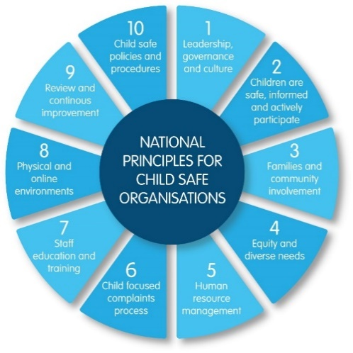
Communities also supports children and young people who are in care by working with community sector organisations and foster carers to provide them with a safe and stable environment.

Project in brief
Communities is improving the access of children in care to the Care Plan Review Panel which will contribute to more effective implementation of National Principle 2: Children are safe, informed and actively participate; and National Principle 3: Families and community involvement; and implementation of the child participation principle (s.10) in the Children and Community Services Act 2004 (the Act).

What motivated the project
Communities’ Specialist Child Protection Unit (SCPU) completed a comparative data analysis which highlighted a large disparity in the applications received by the Care Plan Review Panel – notably, children in care, Aboriginal and Torres Strait Islander children and families and culturally and linguistically diverse children and families. The proportion of applications from children and families in rural and remote areas was also much lower in comparison to the metropolitan area.
Image 1: The 10 National Principles for Child Safe Organisations (National Principles)
Communities recognises that action is needed to better support effective participation of these children in care in both care planning and care plan reviews by the Care Plan Review Panel. Children in care in rural and remote areas face additional barriers and the project will have a specific focus on improving their access, including with culturally appropriate resources for Aboriginal and Torres Strait Islander children.

What the project aims to achieve
The project is vital to ensure that children in care can exercise their rights to participate in care planning and care plan review processes to inform and respond to decisions made about them in a timely manner.
The Act requires that children in care must have meaningful involvement in significant decisions made about them and opportunities to respond to decisions including asking for clarification and formal review of certain decisions.
Several significant decisions are made in care planning meetings and recorded in a written care plan. Every child who is in care must have a care plan that is reviewed annually or more often if necessary to meet their changing needs.
The care plan records the outcome of discussions on how to meet the child’s needs, including decisions that are reviewable by the Care Plan Review Panel:
- where the child will live
- contact arrangements with family and other people who are significant to the child
- services for the child, such as counselling.
Certain people must receive a copy of the child’s care plan generally within 14 days of a care planning meeting, including the child, appropriate to their age, language, and cognitive development.
There is then a 14-day period for a child, another family member or carer receiving the care plan to seek a Care Plan Panel review of certain decisions if this cannot be resolved at a local level.
Several factors impact on the ability of children in care to fully participate in care planning and review processes, including lack of knowledge, skills and support.
Therefore, the project will consider what children need to know; how we might communicate this to children of different ages, cultural and language groups and abilities; and how we might increase children’s capacity to raise concerns and seek review, including available supports.

The journey

What was in place, or did you need to get in place, to start the project successfully?
There were indications of poor access by certain groups of children in care and their families to the Care Plan Review Panel, the data analysis was needed to focus attention, understand the problem, and inform agreed actions to address it.

What challenges have you encountered so far?
Several related issues have emerged that we will need to address to make sure that this project achieves positive change for children and families, including ongoing workforce development.
To address this, we are creating strong linkages with another project that is underway to improve the quality and timeliness of care planning.
Everyone in Communities wants to do the best work they can for children in care and one of the exciting aspects of the project to date is the overwhelmingly positive response from Communities’ staff in regional areas who want to be involved.

What is your best hope for the project?
We want all children in care to thrive and feel able to participate actively in their communities.
We want to reduce barriers that prevent effective access to care planning and the Care Plan Review Panel by the most vulnerable children in care and their families, so they are safer, better informed, and well supported to participate and achieve positive outcomes for themselves and their families.

Outcomes
So far, the project has helped us focus attention on a key issue impacting vulnerable groups of children in care and their families.
The data is informing an achievable action plan and we look forward to making changes that lead to a lasting improvement in these children’s access to care planning and the Care Plan Review Panel.
The biggest achievement so far has been taking the time to thoroughly analyse the relevant data on care planning to identify who is accessing the Review process and who isn’t. This has assisted the team to highlight the risk that barriers to access pose to the most vulnerable children in care and to Communities at an organisational level.
Importantly, considering the data has also allowed us to clarify where to focus our efforts and why.

Sharing the learning so far
- Identify key stakeholders and seek their buy in as early as possible in the process.
- Use available information and data to understand where there are significant safety risks to children and use this as your evidence base to gain support from leadership for change.
- Develop a plan that reflects your evidence base and is meaningful to all stakeholders.
- Don’t be afraid to review and revise – the journey isn’t linear and sometimes it is necessary to take a step back or get a different perspective to move further forward.

Next steps
In consultation with stakeholders, including children and young people in care, via the Advocate for Children in Care and District staff, the SCPU is reviewing the Care Plan Review Panel application process, tools and the way we inform children and families about the Panel’s role and how to access it.

Last updated: August 2023

