Implementing the National Principles for Child Safe Organisations
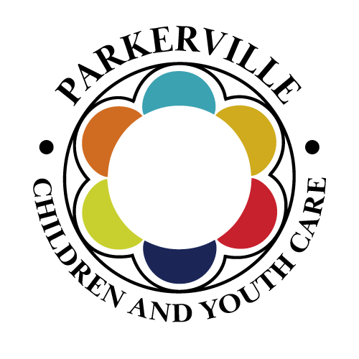
Case Study: Parkerville

Parkerville supports children, young people and their families to build skills and capacity, address the impact of trauma and adverse childhood experiences, and develop capabilities to enable them to be the best versions of themselves.

Project in brief
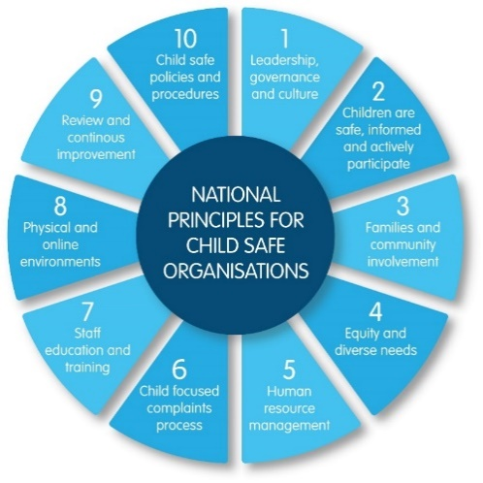
Parkerville has developed a Safeguarding Children Framework that focuses on implementation of all the National Principles, including organisational culture, processes and practices.
Image 1: The 10 National Principles for Child Safe Organisations (National Principles)

The journey
Our starting point is National Principle 1: Leadership and governance, with a whole of organisational commitment to safeguarding children.
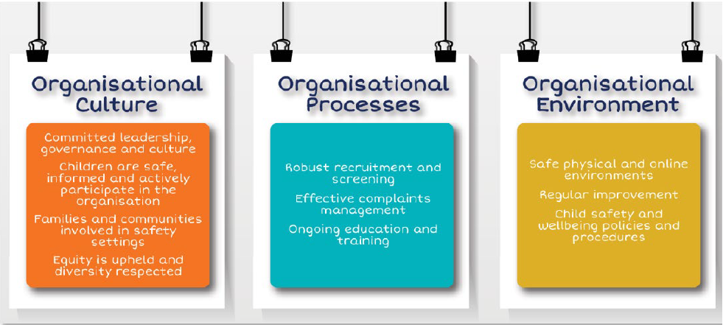
Image 2: A diagram Parkerville provided its staff, outlining how its Values unpin a child safe culture, processes and environment.
The team at Parkerville has taken a proactive interest in the recommendation of the Royal Commission into Institutional Child Sexual Abuse and active steps to implement them. This is in the best interests of the children we work with; it’s just the right thing to do.
When independent oversight of the National Principles is in place, we will be well prepared and able to keep building our child safe practices on solid foundations.

What was already in place to support the project?

Good governance, safety and risk management
Parkerville has an established Risk Committee that identified ‘Failure to create and maintain a child safe culture’ as a key organisational risk in 2021.
We then looked at what was needed to create and maintain a child safe culture including:
- Child safe leadership in the organisation.
- Maintaining key knowledge, attitudes, and behaviours through staff changes.
- Regular child safe communications.
- Appropriate guidance and training for staff, volunteers, board members on safeguarding children and young people.
- Broad staff awareness of roles and responsibilities to child safeguarding, including obligations and the ability to use reporting protocols.
- Good understanding of changes to policies, processes, procedures, and forms including why certain elements are in place.
- Monitoring of who is on the premises and why.
- Changes to mandatory training on working therapeutically with children.
We also considered the risks and possible consequences of not doing these things, including the safety and wellbeing of children, staff and the organisation.
Next, we looked at what we currently do to reduce the likelihood of not maintaining a child safe culture (existing controls):
- Accreditation with Australian Childhood Foundation on a three-yearly cycle that includes yearly mini-audits of child safety and a full re-accreditation audit that helps us to assess where we are progressing well and where we need to plan and focus extra effort.
- Safeguarding children policies and procedures in place, including a Code of Conduct and Statement of Commitment, signed by each staff member, volunteer and board member.
- Amended human resources practices to incorporate the National Principles.
- Staff, volunteers and board members complete an induction to Parkerville’s safeguarding standards and practices, including safeguarding children training.
- Safeguarding concerns reporting protocols implemented, including through training.
- Accredited logo included on internal and external communications in addition to other visible communications of our commitment to child safeguarding in Parkerville offices and care homes.
- Safeguarding Children, easily available for public feedback and reporting concerns, including a child safe feedback/complaints process.
- Process for continuous risk identification and improvement, including seeking feedback and ideas from staff and the children we work with to inform good practice.
- Recognising champions and acknowledging staff and others in the organisation who come forward to report concerns and put children’s safety first.

Project challenges
One of the key factors to address in developing a whole-of-organisation child safe culture was an existing perception that child safety related solely to staff undertaking direct service delivery or that it was primarily connected to child protection.
A child safe culture is created through child safety being a part of every aspect of the organisation. This includes everything we do, from how we talk about children and young people in media and advocacy, to how we set up our spaces or venues to how we support the voices of children and young people.
Supporting staff to recognise their role as active enablers facilitated a strong child safe culture and participation in child safe activities and the Child Safe Committee.

Outcomes
In 2022 Parkerville was reaccredited for the third time as a child safe organisation. Our results pointed to strengths in culture, practice, and commitment to setting and exceeding child safe principles. We have taken the basic principles and expanded them to be in everything we do and everything we say.
The Parkerville Child Safe Committee (Committee) is well established as a voluntary committee that seeks to engage Parkerville staff members and foster carers from all teams involved in child safe activities and decisions.
The Committee supports Parkerville through activities such as reviewing policies and resources, responding to queries and concerns, planning and running key child safe events and activities and ensuring that child safety is an ongoing conversation in all teams.
Some recent activities of the Committee have been:
- reviewing proposed changes to the child safe interview questions
- reviewing and providing feedback on Parkerville’s Diversity and Inclusion statement
- promoting and delivering child safe training
- developing child safe induction resources
- planning staff events relating to child safety
- reviewing and providing feedback on incident reporting processes.
There are currently 13 people in the Committee, so we are trialling place-based sub-committees, within the broader Committee.

Sharing the learning
Parkerville has been active in sharing knowledge about accreditation and how to still meet the National Principles if an organisation cannot afford to undergo a full accreditation process.
Two examples of this include the CEO presenting to a local government executive and team on why being child safe is just good business (we have been invited back to assist them to implement their approach) and the delivery of a workshop in partnership with Anglicare WA on child safe practices and how any organisation can build their own approach.

What key messages you would like to share with others who may be at the start of their project?
- Create your hook: use imagery to present recognisable and consistent communications.
- Connect to the ‘why’ so you can harness the energy and involvement of others with this why.
- Involve children and young people as advisors and designers – the voices of children are powerful. Include them in your ongoing continuous improvement processes.
- Make your efforts matter and take child safeguarding further than just window dressing.
- Leadership – strongly step into child safety as being the right thing to do and the only way an organisation or service should operate. Say it so much that it reaches every corner of the organisation, and the team are saying it before you do.
- Audit – consider what you already do that is aligned to the National Principles and amplify and celebrate this.
- Gap analysis – use the Commissioner for Children and Young People child safe or Ansvar check list to identify where your strengths and risk areas are and use this information to develop an action plan with priorities that you get your CEO or Board to sign off on.
- Draw on existing resources – several organisations have developed resources that you can use to self-audit, identify and plan actions to address risks and become child safe organisations aligned to the National Principles. Make use of these to save and make best use of limited resources.
- Report on audits/self-assessment process and progress on actions to the CEO or Board.
- Set expectations – establish a Child Safe Code of Conduct and Statement of Commitment to being a child safe organisation that all staff, volunteers and people involved in governance must sign. Have a child safe organisation policy and processes that everyone knows about and can follow to raise concerns. Make sure there is a child friendly version of this that children engaged with your organisation know about and feel comfortable using. Make child safety a standard agenda item for leadership meetings.
- Showcase great practice and continue to share learnings with others.
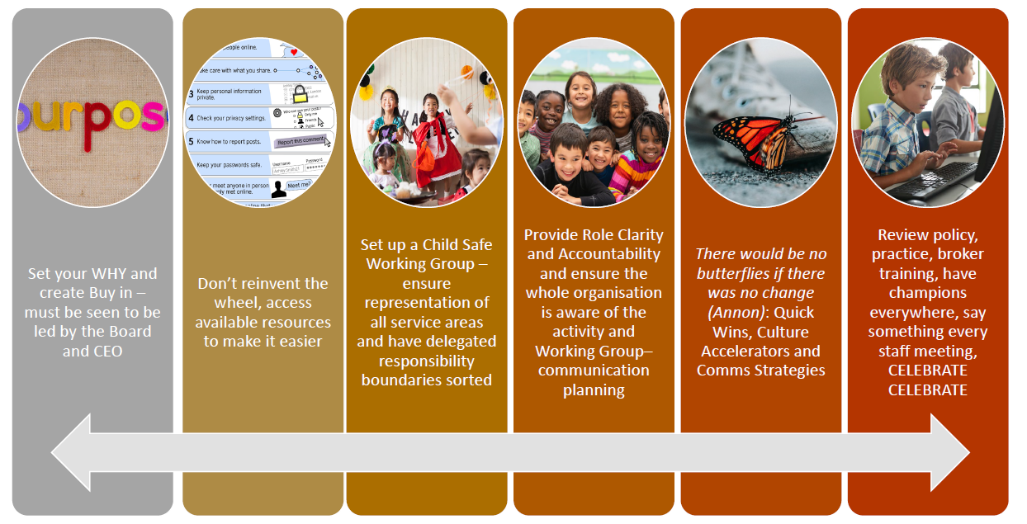
Image 3: A diagram Parkerville provided its staff, outlining how to set up great practice and risk management approaches.

Next Steps
As part of our continuous improvement processes, all Parkerville services are regularly reviewed to ensure that they consistently embedding child-focussed principles and overtly speak to child safety in ways that are measurable.
We have been approached to assist another organisation to embed their version of child safety. This work will be mainly coaching and sharing our learnings.
Parkerville are excited to continue embedding our child safe culture. We are looking forward to seeing the impact of our expanded Child Safe Committee with a focus on being place based and are improving our communication processes to support staff in raising issues or providing feedback that relates to child safeguarding.
The Committee is also currently reviewing our existing resources for communicating to children, young people and their families about their rights and how they can give feedback as well as developing a more in-depth training session to support staff in addressing more complex child safe related issues.
We have recently developed and are implementing ‘level 3’ child safe mandatory training.
Our Audit and Risk Sub-committee of the Board is in its final stages of being implemented. Child Safety is number one on their agenda, which means the Board will have direct reports from the Child Safe Committee on a quarterly basis and will also be able to discuss child safety with our Child Safe Advocates and Champions.

Last updated: August 2023

