Implementing the National Principles for Child Safe Organisations
Case Study: Shooting Stars

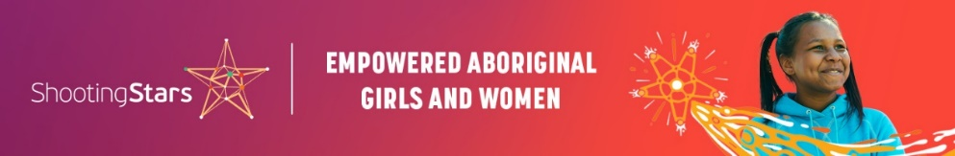
Shooting Stars is an education engagement program working to empower Aboriginal girls and young women by growing their confidence, identity, cultural connection capacity and resources to make informed decisions that lead to positive outcomes in their lives. We have over 60 staff based across Western Australia and Whyalla, South Australia working with up to 1,200 young women at any time.
We engage with communities, local Aboriginal organisations sporting associations, program participants and host schools in a whole-of-community approach to offer advocacy and support, engagement activities, incentives and rewards and health and wellbeing sessions.

Project in brief
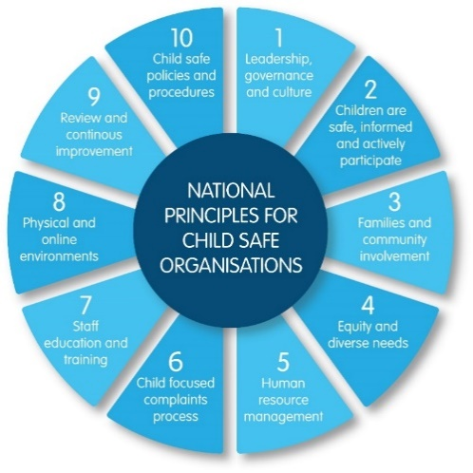
Shooting Stars is developing a Child Safe Framework that supports implementation of all 10 National Principles.

Image 1: The 10 National Principles for Child Safe Organisations (National Principles)

The journey
In January 2022, Shooting Stars staff completed an organisational self-assessment using the WA Commissioner for Children and Young People Self Assessment and Review Tool to identify practices already aligned to the National Principles and areas for improvement.
We identified three immediate action areas from this process:
- Making our Child Safe Complaints process more visible on posters.
- Introducing ’Safety in Schools’ as a Yarning Circle topic for 2023-24.
- Developing a Child Safe Framework to align with the Shooting Stars Way of Practice Framework.
Image 3 shows the Shooting Stars Child Safe Framework and depicts the relationship between the National Principles, Shooting Star’s organisational culture and participants and communities, grounded within and strengthened through yarning.
The circular lines and images at the centre depict water holes, or flowing water, and women. Both water and women signify life, which is represented by the circular forms. Circles also represent reciprocity, with Shooting Stars always supporting one another to grow and give back, creating more and more positive journeys. The mid left central circle shows women sitting together and yarning. These are the Shooting Stars staff who help the lives of many young women. The bottom right circle represents the program participants who have ongoing conversations where they learn from and support one another. The hands symbolise that participants hold the answers in their own way from viewing the world with their own eyes. The top circle represents conversations with the steering committees and communities. All three circles are linked to create a shared journey.
Each conversation is a journey which builds on the previous conversation, creating collaboration. It is through these relationships that Shooting Stars has decolonised its theorisation, policies, practices and evaluation to provide a safe space for Aboriginal girls and women and the women that support them.
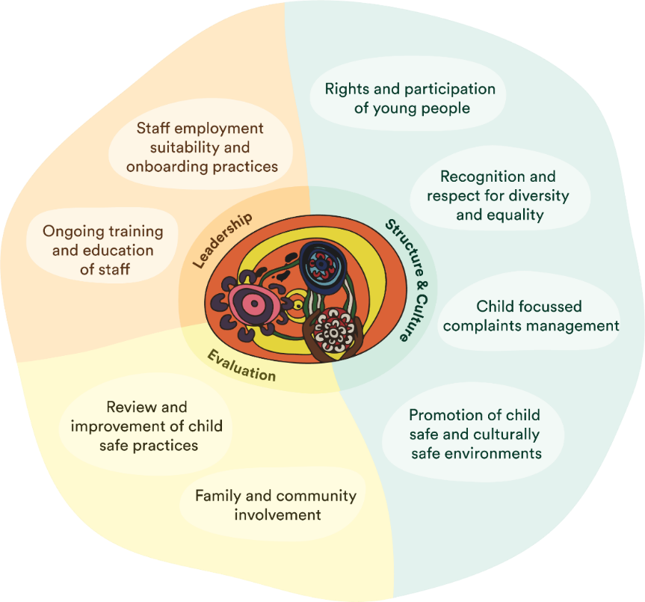
Image 2: Child Safe Framework - interior image by former Shooting Stars Regional Manager and current Glass Jar Board Member Helen Ockerby (Bardi-Jawi, Noongar). Full image by graphic designer Drew Brockway.

What did the team do that you are most proud of?
The Australian Childhood Foundation worked alongside Shooting Stars staff, participants, families, communities, and schools to develop the Shooting Stars Way Practice Framework which describes both who we are and who we want to be.
We are currently developing an implementation strategy for the Shooting Stars Way Practice Framework, this will involve working collaboratively with staff, participants, communities, and schools, to ensure that we provide a child-centred, place-based, trauma-informed approach.
The Child Safe Framework is currently being integrated alongside the Shooting Stars Way Practice Framework as shown below in image 3.
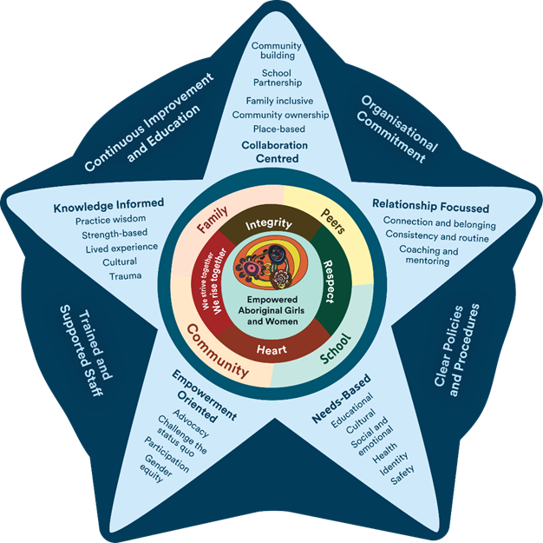
Image 3: Shooting Stars Way Practice Framework integrated with and Child Safe Framework
Elevating the voices of children and young people is at the core of how Shooting Stars works. Shooting Stars uses yarning circles to build the views of the girls and young women, staff and community into our program design and delivery. Anyone can suggest a topic for a Yarning Circle, with previous topics being: barriers to attending school and staying in class, attitudes to participants, healthy relationships, wellbeing, and defining what a successful young woman is.
Having the yarning circles and communication processes between them in place at the start provided a strong foundation for seeking input from staff, participants, communities and the steering committee into the National Principles self-assessment process and to inform decisions on what actions to take from this. The connected yarning circles also allow us to keep the girls and young women at the centre of the work to achieve the actions we agreed on.
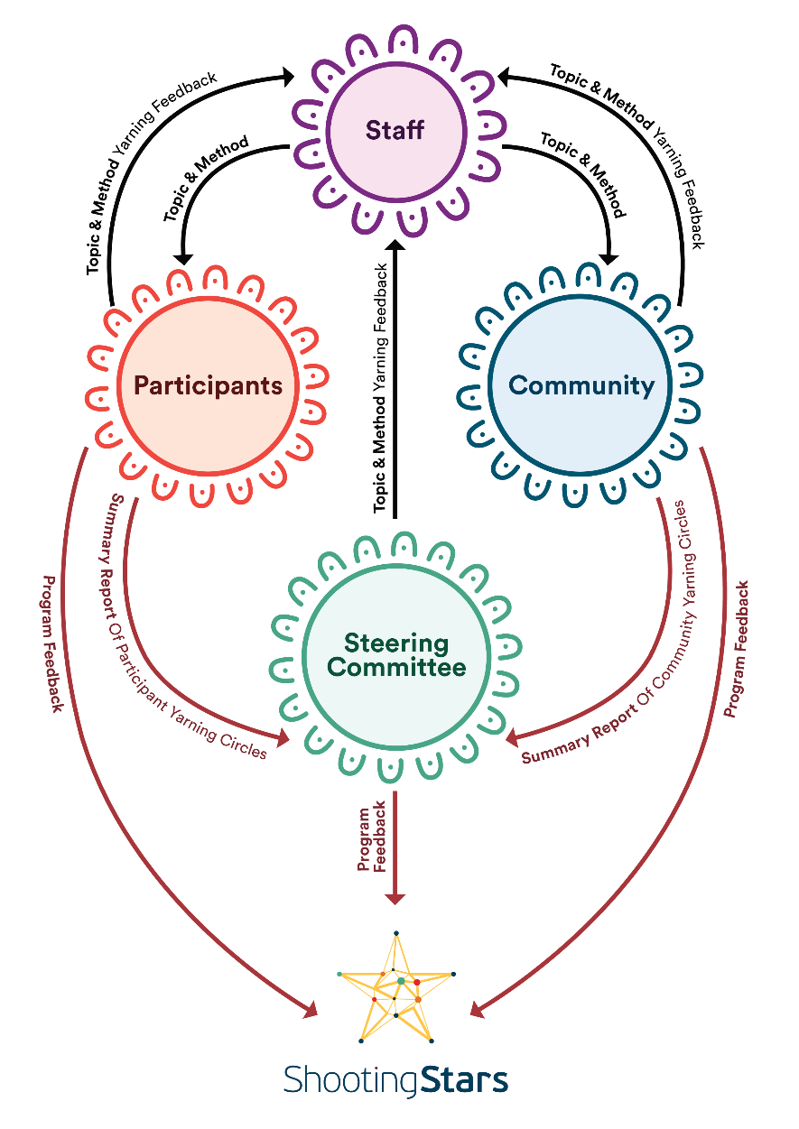
Image 4: An illustration of how everyone involved in Shooting Stars is connected and working together

Sharing the learning
Our advice to other organisations would be to prioritise creating safe, healthy relationships with the young people you work with. From here you can provide opportunities for young people to share their voices and vision for your organisation in a way that is meaningful and real.

Next steps
The future implementation of the Child Safe Framework will be in line with our Shooting Stars Way Practice Framework.
Our journey will take time. But that is okay, so long as we walk together with all the people – our participants, our communities, and our schools – to ensure that our Child Safe Framework and the National Principles are embedded in a way that is authentic, sustainable, and grounded within the safe, nurturing relationships that we build on the ground.

Last updated: August 2023

