Implementing the National Principles for Child Safe Organisations
Case Study: SportWest – True Sport Child Safeguarding

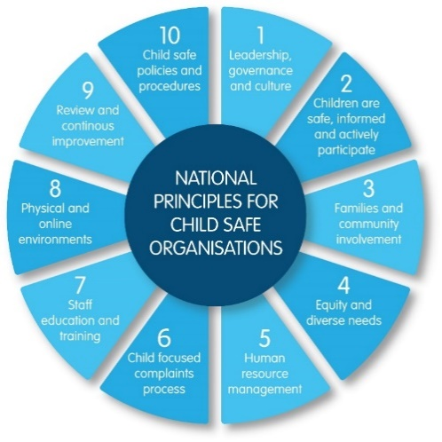
SportWest is the peak industry body for sport in Western Australia (WA), working to promote, strengthen and advocate for the sporting community.
SportWest represents over 130 members, made up of 5,500 affiliated sporting clubs and more than 700,000 participants in grassroots sport in WA.

Project in brief
The objective of the True Sport Child Safeguarding initiative is to support SportWest members and affiliate organisations to create and maintain safe environments for children and young people, in alignment with the National Principles.
The True Sport Child Safeguarding concept was developed following engagement with the sports industry to clarify their needs for relevant information and support to create and maintain child safe environments. Establishing collaboration with numerous government departments was also critical to the project’s development and was achieved through the establishment of an advisory group.
The intent of True Sport Child Safeguarding is to support the WA sports industry to understand and embed the National Principles into all facets of organisations.
Image 1: The 10 National Principles for Child Safe Organisations (National Principles)
Over the next four years, SportWest aims to develop resources, tools, education and ongoing support for sport at all levels to embed child safeguarding practices in community sporting organisations.

Which of the National Principles is your project implementing?
True Sport Child Safeguarding has the intention of assisting the WA sports industry to implement all 10 of the National Principles over time with a strong focus on National Principle 1: Leadership, governance, and culture.

Project in more detail
True Sport Child Safeguarding is an initiative for all participants, coaches, volunteers, officials, spectators, parents, children and adults.
The objective is to support SportWest member and affiliate organisations to create and maintain safe environments for children and young people in alignment with the National Principles.
The vision is for children’s safe and enjoyable participation across all sporting contexts, building on sporting values to enhance child safeguarding with integration of the National Principles.
The True Sport Child Safeguarding principles include children and their best interests being at the centre of the initiative and all decision making.

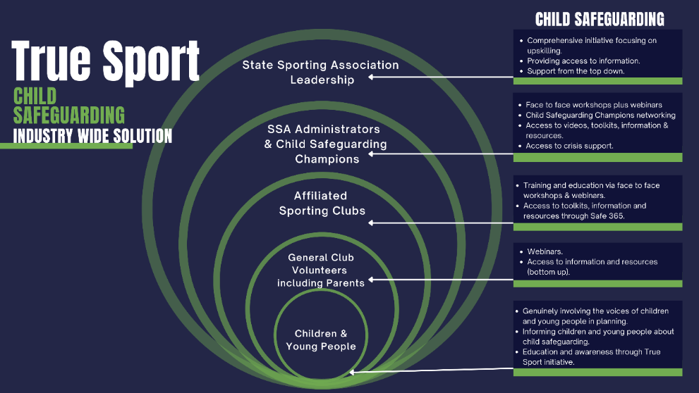
Image 2: A diagram showing children and young people at the centre of the True Sport Child Safeguarding initiative and decision making.

The Pillars of True Sport Child Safeguarding

Pillar 1: Awareness and advocacy
- Governance and partnership development
- Advocacy (local, state and national)
- Sharing examples of good practice
- Identifying the elements of child safeguarding
- Enabling collaboration and sharing ideas and experiences across the industry through networking and professional development, including sharing good practice through case studies
- Coordinated and ongoing effort to identifying the elements of child safeguarding and translating information into easy-to-use language
- Research and evaluation to collate and share trends to and from the industry.

Pillar 2: Resources and education
- Learning and development
- Central sports resource hub
- Communications campaign
- Coordinated communications on the ‘why’ and ‘how’ to create a child safe environment (aligned to the National Principles)
- Online Resource Hub available online to all state sports authorities and affiliated clubs with new and existing resources
- Education and training via webinar series and face to face workshops.

Pillar 3: Ongoing support
- First point of contact for proactive enquires and critical incident triage
- Access to central sports resource hub
- Focus on wellbeing and mental health
- Conduit to expert advice through Advisory Group Members for both proactive and reactive enquiries
- Data and trend analysis to inform continuous improvement in Pillars 1 and 2
- Link to True Sport Mental Health and Wellbeing initiative.

The journey

What motivated you to undertake the project?
SportWest has taken an active interest in the Royal Commission into Institutional Responses to Child Sexual Abuse recommendations.
We know that children can get the most out of sport when they feel safe and supported. There is a growing need for a coordinated and simplified approach to child safeguarding, aligned to the National Principles, with consistent messages, to assist State Sport Associations and their affiliated clubs navigate child safeguarding in WA – including where to start and where to go for trusted information.
True Sport Child Safeguarding aims to assist the sports industry in the creation of a brighter WA sports industry for children and young people.
As a peak body, SportWest, in collaboration with government agencies, is well placed to raise awareness on the importance of child safeguarding as well as providing support and practical resources to assist sporting organisations to make decisions about what they need to do to create and maintain child safe environments, aligned to the National Principles.

Last updated: August 2023

