Implementing the National Principles for Child Safe Organisations
Case Study: Starick

Starick is an independent not-for-profit organisation based in Perth’s south-eastern metropolitan region. Starick supports women, young people and children who are victim survivors of family and domestic violence through prevention, early intervention, crisis, re-establishment, and recovery.

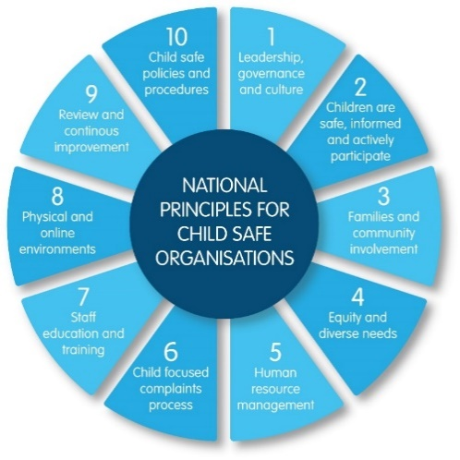
Project in brief
Starick’s work to implement the National Principles has focused initially on National Principle 2: Children and young people are informed about their rights, participate in decisions affecting them and are taken seriously.
Starick has completed a Children and Young People’s Engagement Project (CAYPEP) to build on service delivery staff capacity to undertake consultation with children and young people as key element of service delivery. We chose this strategy to ensure that children and young people’s voices are heard and inform ongoing service provision, from individual interactions to service design and delivery and governance.
The result was professional development workshops in consultation with children and young people and the development of a Children and Young People’s Participation and Engagement Resource Toolkit and COVID-19 booklets
Image 1: The 10 National Principles for Child Safe Organisations (National Principles)

What inspired you to start here?
We recognised that for our organisation to be child safe we needed to actively support children’s participation in the ongoing design and operation of the services we provide to them. This is especially significant for survivors of family and domestic violence who may have concerns about speaking up or doubts about being heard and having their needs addressed.

The journey

Partnerships and support
The CAYPEP was initiated by refuge services in Perth’s eastern corridor – Koolkuna, Orana, Starick, Rise, Nardine and Wungening – with Starick leading the work.
In-kind support was provided by the following services who hosted Consulting with Children and Young People workshops: Wooree Miya in Kenwick, Naala Djookan Healing Centre in Mirrabooka, Pat Giles Centre for Non-Violence in Merriwa, Orana House SWiTCH Centre in Noranda, OVIS in Mandurah, the Pilbara FDV network, and Tuart House in Busselton.

Research and consultation
We undertook an interjurisdictional scan to identify existing programs and evidenced-based resources related to the engagement and participation of children and young people. This included connecting with the WA Commissioner for Children and Young People and the National Office for Child Safety, New South Wales Guardian and the Victorian and South Australian Commissioners for Children and Young People.
We visited services to gain an understanding of current practices for consulting with children and young people and insights to inform the content of professional workshops.
We surveyed staff on their current knowledge and skills in consulting with children and young people.
We consulted with women, children and young people to inform the content of the COVID-19 booklets.

Building in evaluation at the start
We employed a consultant to evaluate the CAYPEP including the training outcomes, booklets, and resources.

Meeting different social and cultural needs
We tailored our methods of engaging children and young people from Aboriginal and culturally and linguistically diverse families to ensure cultural safety. We delivered resources and training in more targeted segments to accommodate the diverse needs of individuals in different locations and cultural contexts.

Designing the tools for change
All the information gathered in the initial stage was used to design tools and resources to support staff skills, knowledge, and practice in seeking children and young people’s views and ideas to inform ongoing service delivery.

Professional development workshops
A total of 76 service staff attended a combination of two online and five face-to-face workshops between September and December 2021. The workshops were designed and co-facilitated by Starick in partnership with the Youth Affairs Council of WA to:
- develop the participants’ understanding of National Principle 2
- explore the benefits and challenges of consulting with children and young people
- provide practical guidance on planning a consultation with children and young people
- identify ways to embed National Principle 2 in practice.
The toolkit was developed to support services’ ongoing engagement with children and young people to inform our organisation’s planning, decision making and continuous improvement processes.
The toolkit is targeted to staff working in the family and domestic violence sector, including refuges and support services. However, it can be adapted by any organisation to help them meet the needs of children and young people they engage with. It is available on the Starick website as part of an online resource hub that also includes child safe templates, posters and external resources.

Challenges
Our most significant challenge was the COVID-19 pandemic which impacted the delivery of our workshops, development of resources and opportunities to continue engaging with children and young people in services.

Outcomes
Workshop participants told us:
- We realised how many opportunities there are to include children’s voices and how much they like to be included.
- We learned how children can be involved in decision making processes and the areas they can make decisions on.
- I have come away being more open to children’s feedback and input.
- The training has made all staff aware to make sure that children’s voices and wishes are asked for and heard. They will hopefully be more considered in future planning ideas.
Starick staff reported that children and young people’s voices are included in planning, evaluation and decision making more frequently, with a reminder that listening takes practice.

Sharing the learning
We are happy to share some lessons during the project to support other organisations doing similar work to implement the National Principles.
Take a strengths-based approach – many staff realised they were already listening to the voices of children and young people which provided a strong foundation to identify further practice opportunities. The project highlighted how well children understand their own needs and their ability to contribute to organisational decisions when given the opportunity.
Check in with children and young people regularly from the start of your contact with them. Involve them from the start when planning, evaluating, and decision-making processes for new projects, as well as any changes to existing programs and services.
Meeting the social and cultural needs of children and young people from different communities across WA is an important consideration from the start. Be prepared to adapt engagement methods and break down training and resources to cater to the unique requirements of individuals in remote locations or with different cultural and language needs.
Plan for ongoing sustainability from the very beginning of the project.
The support of leaders in the organisation is critical including identifying a key worker to lead projects to implement the National Principles.

Next steps
We are planning to continue our work to meet the National Principles. We have accessed a small amount of funding to enable us to look at National Principle 8: Physical and online environments promote safety and wellbeing while minimising the opportunity for children and young people to be harmed.
We have opted to focus on this principle next because we are concerned about the issue of technology facilitated abuse. Our learning about consulting with children will help to inform this next stage of our work.

Last updated: August 2023

