Implementing the National Principles for Child Safe Organisations
Case Study: Uniting WA

Uniting WA is a multi-disciplinary community service organisation operating throughout the Perth-metro and Great Southern regions of Western Australia.
We provide a range of services and programs that offer support to people experiencing complex challenges which may be the result of intergenerational trauma or situational crisis, including:
- People experiencing mental health crisis, or who are living with mental health conditions.
- People who are experiencing, or who are at risk of experiencing, homelessness.
- People who are living with disability.
- People who are at risk of being affected by family breakdown.
- People facing, or at risk of, financial hardship.
- People re-joining community after leaving prison.
We also deliver out of home care, specialised foster care and counselling services to children and young people who have experienced significant trauma and experiencing vulnerability in our community.
Our Uniting WA team is made up of over 400 employees who are supported by over 300 volunteers.

Project in brief
In 2017, Uniting WA’s Child Safe Working Group (CSWG) was formed – tasked with driving the adoption and application of the Uniting Church National Child Safe Policy Framework (which is reflective of the National Principles for Child Safe Organisations).
The CSWG consisted of members from across the organisation – including operational areas that are not directly involved in child-related work.

The journey
Initially, our focus was on embedding our commitment to child safety throughout all aspects of our operations – from recruitment and onboarding, through to service delivery. We were able to make significant progress – but did struggle to maintain momentum longer-term.
In 2020, we sought advice from Uniting Vic.Tas who have a breadth of experience in the sector. This inspired the creation of our Child Safety and Wellbeing Approach – a living document which consists of a comprehensive self-assessment against the National Principles for Child Safe Organisations, a communications strategy and an annual focus.
The development of our Approach has enabled us to track our achievements so far – and identify opportunities for improvement that are used to drive the actions of our CSWG.
Ongoing consultation and collaboration with children and young people who access our services was – and continues to be – a key focus of our Approach. Our CSWG continues to look for ways to ensure the voices of children and young people continue to be heard and listened to as part of our broader commitment to continuous improvement.
So far, this has seen the involvement of children and young people throughout the development of our Foster Carer Manual, House Manual(s) and a number of other resources and documents. This has also seen the implementation of regular house meetings in the residential settings, providing a platform for the children and young people to provide feedback, voice their concerns and inform decision-making.
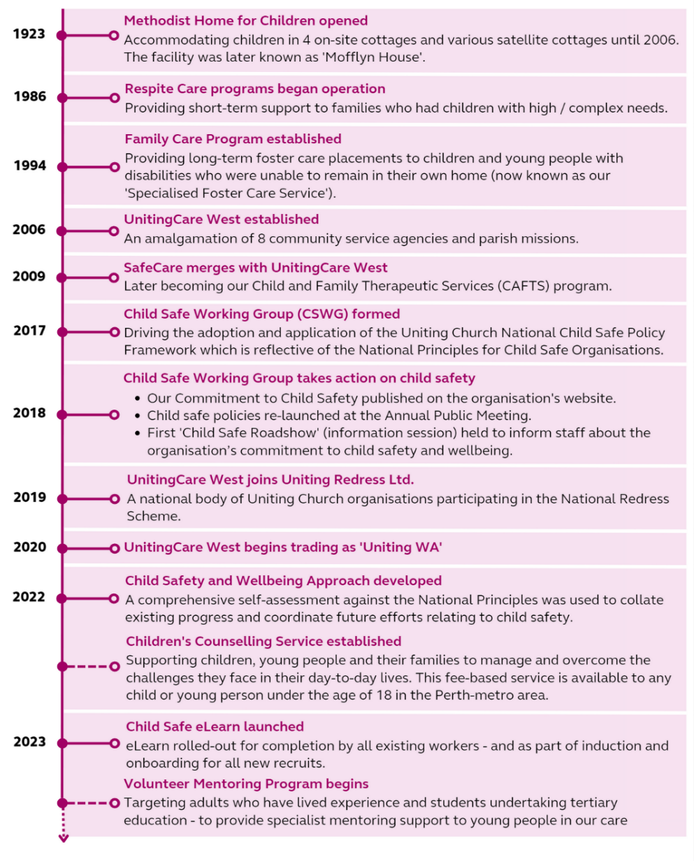
Image 1: A timeline outlining Uniting WA’s achievements from 1923 to 2023.

Outcomes
Over the last 12 months, we’ve seen an increase in feedback provided by children and young people who access our services. This feedback has been used to directly inform the way we deliver our services.
Furthermore, the project has helped to raise awareness about child safety in service areas and programs that are not directly involved in child-related work. For example, several programs involving incidental contact with children have sought the expertise of our CSWG members to workshop how child safety can be embedded within the delivery of their services.
The CSWG continues to be a key driver of child safety across the organisation, providing a forum for collaborative discussion about how we can continuously improve and embed child safety within all operational areas.

Sharing the learning
If we were to start the project again, we’d undertake a comprehensive self-assessment against the National Principles for Child Safe Organisations at the beginning. This step has been pivotal to driving our continued efforts in this space and enabling us to identify opportunities for improvement. Doing this in the beginning may have helped to ensure that the efforts of our CSWG had ongoing momentum following the initial period of engagement and interest.

Next steps
As an organisation, we’re undergoing some significant changes to our digital systems and processes. Our CSWG is looking at how this digital transformation can help us continue to improve engagement with child safety across the organisation.
Additionally, our teams are preparing for the roll-out of changes to WA’s mandatory reporting legislation – and our CSWG are looking at how to support these teams through these changes.
As an organisation, we’re always keen to learn from – and work with – other organisations in the sector who are also working to improve the safety and wellbeing of children in our community.

Last updated: August 2023

