[Program title]

[Organisation name]

[Submission date]
Department of Water and Environmental Regulation
Prime House, 8 Davidson Terrace
Joondalup Western Australia 6027
Locked Bag 10 Joondalup DC WA 6919
Phone: 08 6364 7000
Fax: 08 6364 7001
National Relay Service 13 36 77
dwer.wa.gov.au
© Government of Western Australia
September 2023
This work is copyright. You may download, display, print and reproduce this material in unaltered form only (retaining this notice) for your personal, non-commercial use or use within your organisation. Apart from any use as permitted under the Copyright Act 1968, all other rights are reserved. Requests and inquiries concerning reproduction and rights should be addressed to the Department of Water and Environmental Regulation.
Disclaimer
This document has been published by the Department of Water and Environmental Regulation. Any representation, statement, opinion or advice expressed or implied in this publication is made in good faith and on the basis that the Department of Water and Environmental Regulation and its employees are not liable for any damage or loss whatsoever which may occur as a result of action taken or not taken, as the case may be in respect of any representation, statement, opinion or advice referred to herein. Professional advice should be obtained before applying the information contained in this document to particular circumstances.

This publication is available at our website www.dwer.wa.gov.au or for those with special needs it can be made available in alternative formats such as audio, large print, or Braille.

Contents
1 What is this business case? 4
1.1 Checklist for completion of this business case 4
1.2 Part 1: Program overview 7
Program overview (addresses PRG criteria 1, 2 and 6) 7
Values (addresses PRG criterion 1) 7
Threats (addresses PRG criterion 1) 7
Program growth opportunities (addresses PRG criteria 1, 2 and 6) 7
Rights and interests to land (addresses PRC criteria 4 and 5) 8
Options to ‘secure’ offset outcomes over the long term (addresses PRG criterion 5) 8
Project stakeholders (addresses PRG criteria 2 and 3) 8
Engagement approach (addresses PRG criteria 2 and 3) 9
Project logic for program of work (links to the PEOF vegetation investment plan and funding concepts work) 9
1.3 Part 2: Project overview 1
Project overview 1
Project objectives 1
Current management of project area 1
Proposed activities 1
Project delivery organisation 1
Finance and governance arrangements for delivery organisation 2
Funding requirements 2
Monitoring 2
Program risks 4

Tables
Table 1 PRG business case assessment criteria 5
Table 2 Example indicative costings table 2
- Figures
Figure 1 Example stakeholder map 9
Figure 2 Example project logic diagram 10

What is this business case?
Business cases provide an overview of a proposed project for delivery through the Pilbara Environmental Offsets Fund (PEOF). This begins with identifying the values that we are seeking to improve, the threats to those values, and the people seeking to manage the threats and protect the values. The business case will articulate how values will be improved (e.g. weed management) and how we ensure that the benefits of the project continue over the longer term. The business cases will be developed in partnership with Traditional Owners and regional land managers.
The PEOF team will use the business case to get advice from government and stakeholders on whether the project can work, what needs to happen to get it up and running, and to get endorsement from the Minister for Environment before we spend a lot of effort developing it.
Before developing this business case, the PEOF team would have already reviewed information and spoken to people about where problems are for Country (e.g. too much wildfire) and who would like to be involved in fixing them. The PEOF team then collates the ideas that come out of these conversations and uses them to develop business cases.
Before we decide on a specific project for a business case (e.g. managing pigs along the Yule River), we discuss all the ‘problems’ (e.g. weeds, feral animals, fire) for Country in an area. We then narrow down what problems we should fix first – either because they will get us the best results or because they are the most straightforward to progress.
This business case summarises all the problems (the program) for the project area so it is clear how we will connect and integrate work over time, and then focuses on the one problem (weeds) we’ve chosen to fix first (the project).

Checklist for completion of this business case
Business cases are assessed for eligibility for funding by the PEOF Project Recommendation Group (PRG). The PRG assesses each business case based on the defined eligibility criteria outlined below.
☐ | Does the project aim to improve vegetation, priority ecological communities (PECs) and/or habitat for species required to be offset? PRG criterion 1)
☐ | Does the project consider and integrate the aspirations of Traditional Owners to manage Country? (PRG criterion 2)
☐ | Does the project avoid ‘no go’ areas as defined in the PEOF’s implementation plan (e.g. infrastructure, towns, mining lease areas)? If it doesn’t, then state why and how. (PRG criterion 4)
☐ | Can the benefits of the proposed offset activity be maintained over the longer term? (PRG criterion 5)
☐ | Are the proposed activities in addition to what is already required to legislatively manage land? E.g. it is in addition to what mining companies are already required to do to rehabilitate land, what pastoralists must do to manage their pastoral leases, and what government must do to manage land?) (PRG criteria 6, 7 and 8)
☐ | Are the proposed activities listed as acceptable for funding the PEOF implementation plan? (PRG criterion 6)
☐ | What are the finance and governance stability of delivery organisations? (PRG criterion 7)
Table 1 PRG business case assessment criteria
No. | Criteria details
1 | Do proposed activities support the improvement of one or more of the following environmental matters? Note: the project only needs to support outcomes for one of the listed matters to qualify for funding.  - Good to excellent vegetation  - Good to excellent vegetation which is also habitat for conservation significant fauna  - Mulga vegetation  - Riparian vegetation  - Groundwater dependant vegetation to include coolabah/river red gum conservation significant vegetation  - Four plant assemblages of the Wona Land System PEC  - Proposed Fortescue Marsh Conservation Reserve  - Fortescue Marsh PEC  - Fortescue Marsh Management Zone  - Vegetation of sand dunes of the Hamersley Range/Fortescue Valley PEC  - Greater bilby habitat  - Northern quoll denning/shelter habitat  - Northern quoll foraging habitat  - Ghost bat foraging habitat  - Pilbara olive python habitat  - Pilbara leaf-nosed bat foraging habitat and night roosts  - Night parrot habitat
2 | Has Traditional Owners’ support been established for the project, or has the engagement pathway for this program area been clearly defined with Traditional Owners?
3 | Does the PRG consider that the business case aligns with the intent and process defined in the engagement and co-design plan?
4 | Does the project avoid or propose a pathway to managing intersections with ‘no go’ areas as defined in the PEOF implementation plan?
5 | Can one of the following mechanisms be used to protect offsets from being destroyed or degraded for at least 20 years?  Existing protections:  - Areas designated for protection under s19 of the Aboriginal Heritage Act 1972  - Areas reserved for conservation, water and Aboriginal use under the Land Administration Act 1977  - Project falls within an area designated to be converted to a reserve under Plan for Our Parks  - Project falls within an area with exclusive native title, where the Traditional Owners are willing to enter into an agreement to protect offset outcomes  A pathway to establish the following protections:  - Biodiversity Conservation Act 2016 conservation covenants  - Environmental Protection Act 1989 conservation covenants  - Section 79 leases over unallocated land under the Land Administration Act 1977
6 | Do the proposed activities fall under one of the following categories which are listed as acceptable for funding in the PEOF implementation plan?  - Revegetation (re-establishment of native vegetation in degraded areas)  - Rehabilitation (repair of ecosystem processes and management of weeds, disease or feral animals), which may include but are not limited to management of:  - weeds  - inappropriate fire regimes  - introduced species  - total grazing pressure, including grazing by introduced herbivores like cows or goats  - Restoring species and their habitat (e.g. re-introduction of species, building habitat structures)  - Protecting high-value vegetation and habitat where it complements areas targeted for rehabilitation and revegetation  - Activities that are needed to design successful projects, such as mapping of vegetation and habitat  - Projects with a research focus may include:  - testing new approaches to manage threats and conserve biodiversity  - filling gaps in our understanding of the best strategies to address threats to the environment  - research that adds to the understanding of the environmental value being impacted
7 | Financial and governance stability
8 | Is the project in addition to what is already required to manage land?
The sections below provide guidance on the information you need to provide in this business case to meet the selection criteria above.

Part 1: Program overview

Program overview (addresses PRG criteria 1, 2 and 6)
- Define the location of the project in relation to PEOF priority areas, tenure and rights and interest to land (e.g. native title determination, pastoral leases, mining tenements).
- Describe and provide a map.
- Define the environmental matters the project aims to improve (see Table 1, point 1).

Values (addresses PRG criterion 1)
- Describe the cultural and ecological values of the area.
- State whether there are PECs, Threatened Ecological Communities (TECs) or observations of priority fauna that occur in the project area. This should include (but not be limited to) the matters listed in Table 1, point 1.
- List the communities and species in the area that are required to be offset thorugh the Fund (see Table 1, point 1).
- Use heritage mapping and information Traditional Owners are comfortable sharing to define the area’s cultural values. Are there cultural values that Traditional Owners would like protected in the project area? Insert a figure that illustrates the relevant TECs/PECs, threatened and priority fauna.

Threats (addresses PRG criterion 1)
- Define the threats (problems for Country) in the project area (e.g. weeds, feral animals, unmanaged fire).
- If possible, provide photos – either on-ground or aerial or maps like weed and fire maps – to detail the nature of the threat and why it is an issue for vegetation or habitat. For example, there may be weed infestations that are preventing native vegetation regenerating along a river.

Program growth opportunities (addresses PRG criteria 1, 2 and 6)
- Outline the potential for the project to expand over time, either to cover a larger area or to manage other threats. What is the sequence of activities that is most practical and would best manage the threats in the long term should the project be expanded to neighbouring properties/tenure/catchments?
- Identify existing cross-tenure relationships or programs within the project area that could be leveraged. For example, would a neighbour have a mutual interest in managing a weed along a river that runs over both properties?
- Is there a need for a survey of vegetation and habitat to inform a potential expansion of the project?

Rights and interests to land (addresses PRC criteria 4 and 5)
- Detail the native title, pastoral and mining rights and/or management orders that exist over the land (e.g. water source protection area, Indigenous Protected Area).
- Identify whether there are any guidance documents or agreements in place (e.g. Indigenous Land Use Agreements, Ecologically Sustainable Rangelands Management plans, water source protection plans, management orders).
- The Department of Water and Environmental Regulation (department) can source geospatial information to help map boundaries and specify the purpose of these various plans if required.
- Does the program avoid ‘no go’ areas? If not, how will intersections with ‘no go’ areas be managed?

Options to ‘secure’ offset outcomes over the long term (addresses PRG criterion 5)
- The department and the delivery agent will identify options and processes to secure offset outcomes over the long term. This may be through a covenant, caveat or lease. As part of this:
- the department will request advice from relevant State Government agencies (Department of Planning, Lands and Heritage; Department of Mines, Industry Regulation and Safety; Department of Jobs, Tourism, Science and Innovation)
- the delivery agent (with support from the department if required) will need written support for the project from Traditional Owners and parties with an interest in the land, and will need assurance from relevant parties that they are willing to enter into an agreement to maintain and secure offset outcomes.

Project stakeholders (addresses PRG criteria 2 and 3)
- What stakeholders are involved in the project? What is their role and interest in the project? What is their level of engagement, and have they provided in-principle and/or written support for the project?
- Provide a stakeholder map that shows the stakeholders and how they relate to one another. This should focus on the people involved in developing the project right now as the core, but where possible include other stakeholders, like neighbours that could be included in the scope of the project if it were to be expanded in future. An example stakeholder map is provided in Figure 1 below.
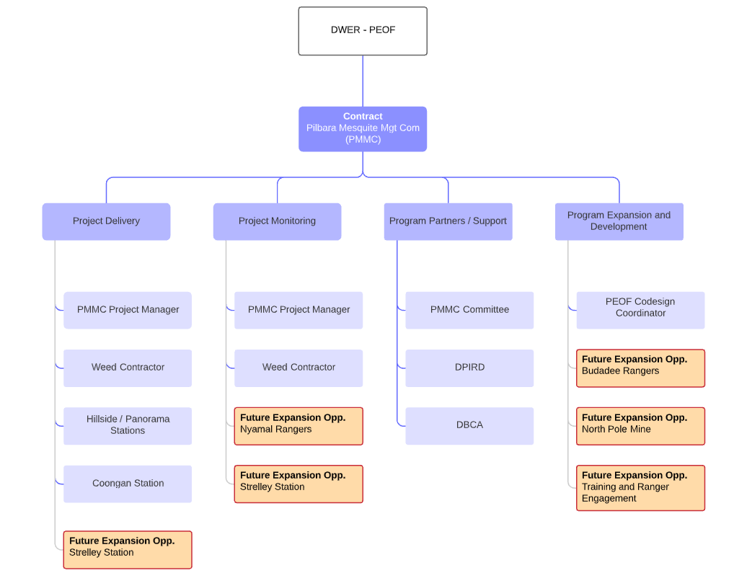
Figure 1 Example stakeholder map

Engagement approach (addresses PRG criteria 2 and 3)
- How has the approach to develop the project aligned with the PEOF engagement plan? For example:
- Have project ideas and information been shared between the PEOF team, Traditional Owners and other relevant land mangers?
- Has this business case been drafted together with regional land managers, with support from the PEOF team?
- Has everyone with rights and interests in the project area been engaged, and are they supportive of the project going ahead?
- Have people been given the time and support they need to engage in and help develop the project?
- What future engagement is needed to support this project?

Project logic for program of work (links to the PEOF vegetation investment plan and funding concepts work)
- Provide a project logic diagram. For example, a diagram showing the problems for vegetation along a river, who can help manage it, and what outcomes we want for the river and the vegetation that fringes it. An example project logic diagram for integrated riparian management is provided in Figure 2.
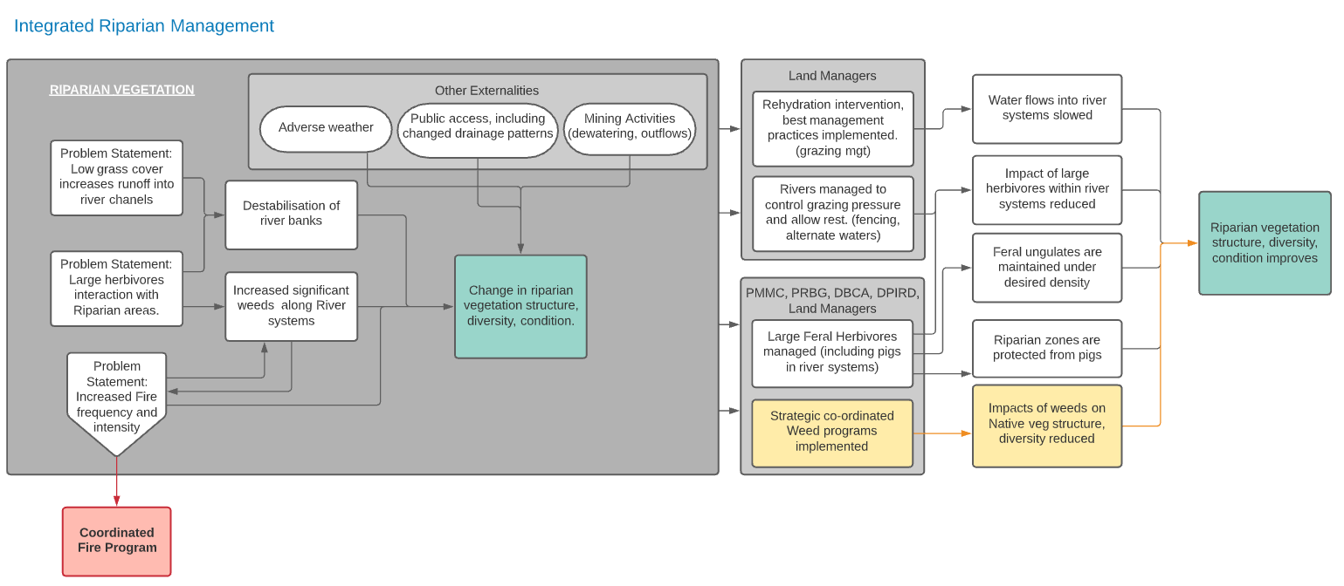
Figure 2 Example project logic diagram

Part 2: Project overview

Project overview
- Provide an overview of the first project that is being proposed under this broader program of work.

Project objectives
- What will the project achieve in terms of ecological outcomes (link to conditioned offsets where possible (e.g. ‘improvement of 100 hectares of vegetation to “good to excellent condition”’) and benefits for Traditional Owners. For example, are there other benefits like cultural heritage places being protected or rangers receiving training and access to manage Country?
- Project objectives should be SMART: specific, measurable, achievable, realistic and time bound.

Current management of project area
- What other management activities are currently taking place within the project area?
- Who is doing what and how does that fit in with this project?
- Is there an existing weed control/cattle management/fire management program?
- How does this project add to what is already required to manage the area (e.g. Weeds of National Significance (WoNS) are required to be managed by pastoral lessees).

Proposed activities
- What will be the on-ground management activities? Who is doing what?
- What are the monitoring goals and what methodology will be used to measure whether these goals are reached? Consider, for example, the number of field trips required, biological/chemical treatment methods, timelines, ongoing maintenance and monitoring frequency.
- What thresholds will trigger a change of management?
- How will project outcomes be maintained (e.g. follow-up weed treatment)? For example, for a project we may recommend funding for five years to reduce a weed species to a specific percentage target or original levels within five years in the defined project area. Annual control trips would then be undertaken for another five years to maintain or further reduce levels to a specified percentage target within 10 years.

Project delivery organisation
- Who is delivering what activities? Are subcontractors involved?
- Is there a capacity-building element to the project (e.g. on-the-job weed training – this must link to on-ground project activities)?
- Will there be any in-kind support (e.g. people, vehicles, accommodation)?

Finance and governance arrangements for delivery organisation
- Detail the governance structure and finance arrangements of your organisation. The financials from project deliverers are required in the appendices.

Funding requirements
- Detail the indicative costs for the project, include costs for project management, project activities, consumables, reporting and monitoring at a minimum. An example costings table provided below.
Table 2 Example indicative costings table
Item | Detail |  | Units | Rate | Budget (exc. GST)
1 | Project administration
2 | Project management
3 | Contractors
4 | Logistics (e.g. accommodation)
5 | Weed management chemical and biological control
6 | Monitoring
 | Year one total
Year |  | Notes |  |  | Total
Jan–Dec 2022
Jan–Dec 2023
Jan–Dec 2024
Jan–Dec 2025
Jan–Dec 2026
Five-year program total (estimated)

Monitoring
To effectively monitor vegetation, we will need to understand the ecosystem we are working in and carefully design the monitoring program with clear goals. PEOF monitoring design will include adaptive monitoring to assess the effectiveness of the applied management so that it can be adapted to ensure that the threat is being managed.
Monitoring will also include long-term vegetation condition monitoring that intersects with adaptive monitoring. This will determine whether the applied management is helping to achieve improved vegetation condition.
A delivery agent will need to develop effectiveness-monitoring to assess, for example, whether the applied management such as weed control on an invasive species in a project area is effective. Data would be collected to clearly determine whether weed control is meeting the stated target levels (abundance) within the expected time frame. If the monitoring shows that the management is not effective, management needs to be adapted to better manage the threat.
Vegetation monitoring will also need to be developed and undertaken by the project deliverer with guidance, input and review from the department’s PEOF team so that there is a standard approach to vegetation monitoring and data storage and analytics across all PEOF projects.
Vegetation condition monitoring involves a deeper understanding of the complexities of the ecosystem we are working in. It requires an understanding of how the management of a threat is expected to influence the ecosystem, and careful consideration of how to capture the resultant change.
This might occur by identifying indicator species expected to occur after many years of management or, for example, by identifying and measuring changes in vegetation cover of a selected group of native species. This might be done over a specified time period (e.g. 10 years) or by identifying the target of germination of a specified native species after 10 years of management and monitoring.

Appendix

Program risks
This section is to be completed with the assistance of the department’s PEOF engagement coordinator. It will outline the risks, their treatment options and who will manage them throughout the life of the project.

