Implementing the National Principles for Child Safe Organisations
Case Study: Yorgum Healing Services

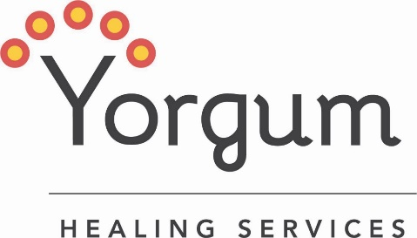
Yorgum provides a wide range of culturally secure community-based healing services that utilise a trauma informed approach to positively impact social and emotional wellbeing for Aboriginal and Torres Strait Islander Children, young people and adults.

Project in brief
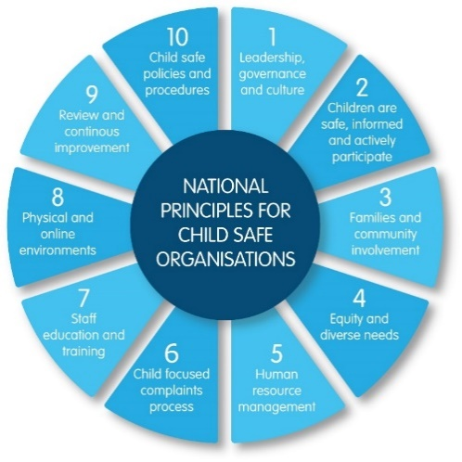
Yorgum produced an animated story illustrating how it integrates all the National Principles in its governance and daily practice to enhance the safety of children engaged with the service.

The journey

What led you to develop Yorgum’s Child Safety Principles animation?
Yorgum was established in 1991 by a group of Aboriginal women to provide a culturally safe healing space for Aboriginal people experiencing spiritual, emotional, and psychological pain.
“We are here for the children we work with and their families – they are at the heart and centre of everything we do.”
When we started to think about the National Principles and how to implement them, we realised that we already have them integrated into in our governance and ways of working. The focus then became how to explain the National Principles and express our commitment to practice these in a way that is meaningful to the Aboriginal children and families we work with, along with others.
Aboriginal people are strong communicators with a rich tradition of verbal storytelling and imagery, so the idea of using illustration and storytelling in the video emerged organically as the best way to share information on our child safe approach.
Yorgum is the Noongar name for a large red flowering gum tree that has healing properties. It signifies the approach we take to our role as an organisation focused on healing and how we keep children safe and in our service. We started with the Yorgum and recognised that our statement of commitment to being a child safe organisation and child safe policies are the strong roots that ground our child safe practices. The branches and leaves are our culturally safe practices that the roots feed and support. The Yorgum blossoms are the children who bloom and thrive in this safe, nurturing environment.
Image 1: The 10 National Principles for Child Safe Organisations (National Principles)

Challenges
The main challenge for us was taking the images and ideas we had in our minds and bringing them to life in the video with a small budget. We were able to work with a local animation design company to express our ideas through illustration and storytelling. The process was an interesting journey of mutual learning – the designers learning about Yorgum and Aboriginal culture and Yorgum learning about the finer details of animation production.

Outcomes
The animation has only just been launched so it’s a bit too early to say how it will benefit the children, families, and communities we work with. However, for the Yorgum team, it was a valuable opportunity to explore and translate the National Principles from an Aboriginal perspective and recognise and appreciate our existing strengths in this area. Part of healing for Aboriginal people is decolonising, which starts with restoring our spirits and strengthening healthy connections to country, culture, and family. This creates safety and allows us to honour and practice strong, culturally safe ways of working with children and doing business.
The most important outcome so far is having a culturally appropriate and engaging way to communicate how we apply the National Principles – in our language for our mob.

Sharing the learning
We were really surprised at how quickly the project progressed from the time we yarned about the National Principles and the imagery connected to the Yorgum, through to the design process.
The key learnings we would like to share with others is “start with your strengths” and “yarn about what you do using images”.
When you read the National Principles, implementing them can seem like a daunting task, start by looking at what you are doing. You will probably find that you already have some of the elements built into your existing policies and practices. Then consider how you can build on what you have and how to communicate your child safe practices to the children who use your service and others. It is vital to translate formal language into terms and concepts that the children and other people connected to your service understand, this helps to create safe organisations where children thrive in all ways.

Next steps
After the animation is launched, we will continue to find ways of using it to make sure that everyone understands what it means to create a culturally and child safe organisation where children thrive in all ways.

Last updated: September 2023

