WA Health Region Maps by SLA
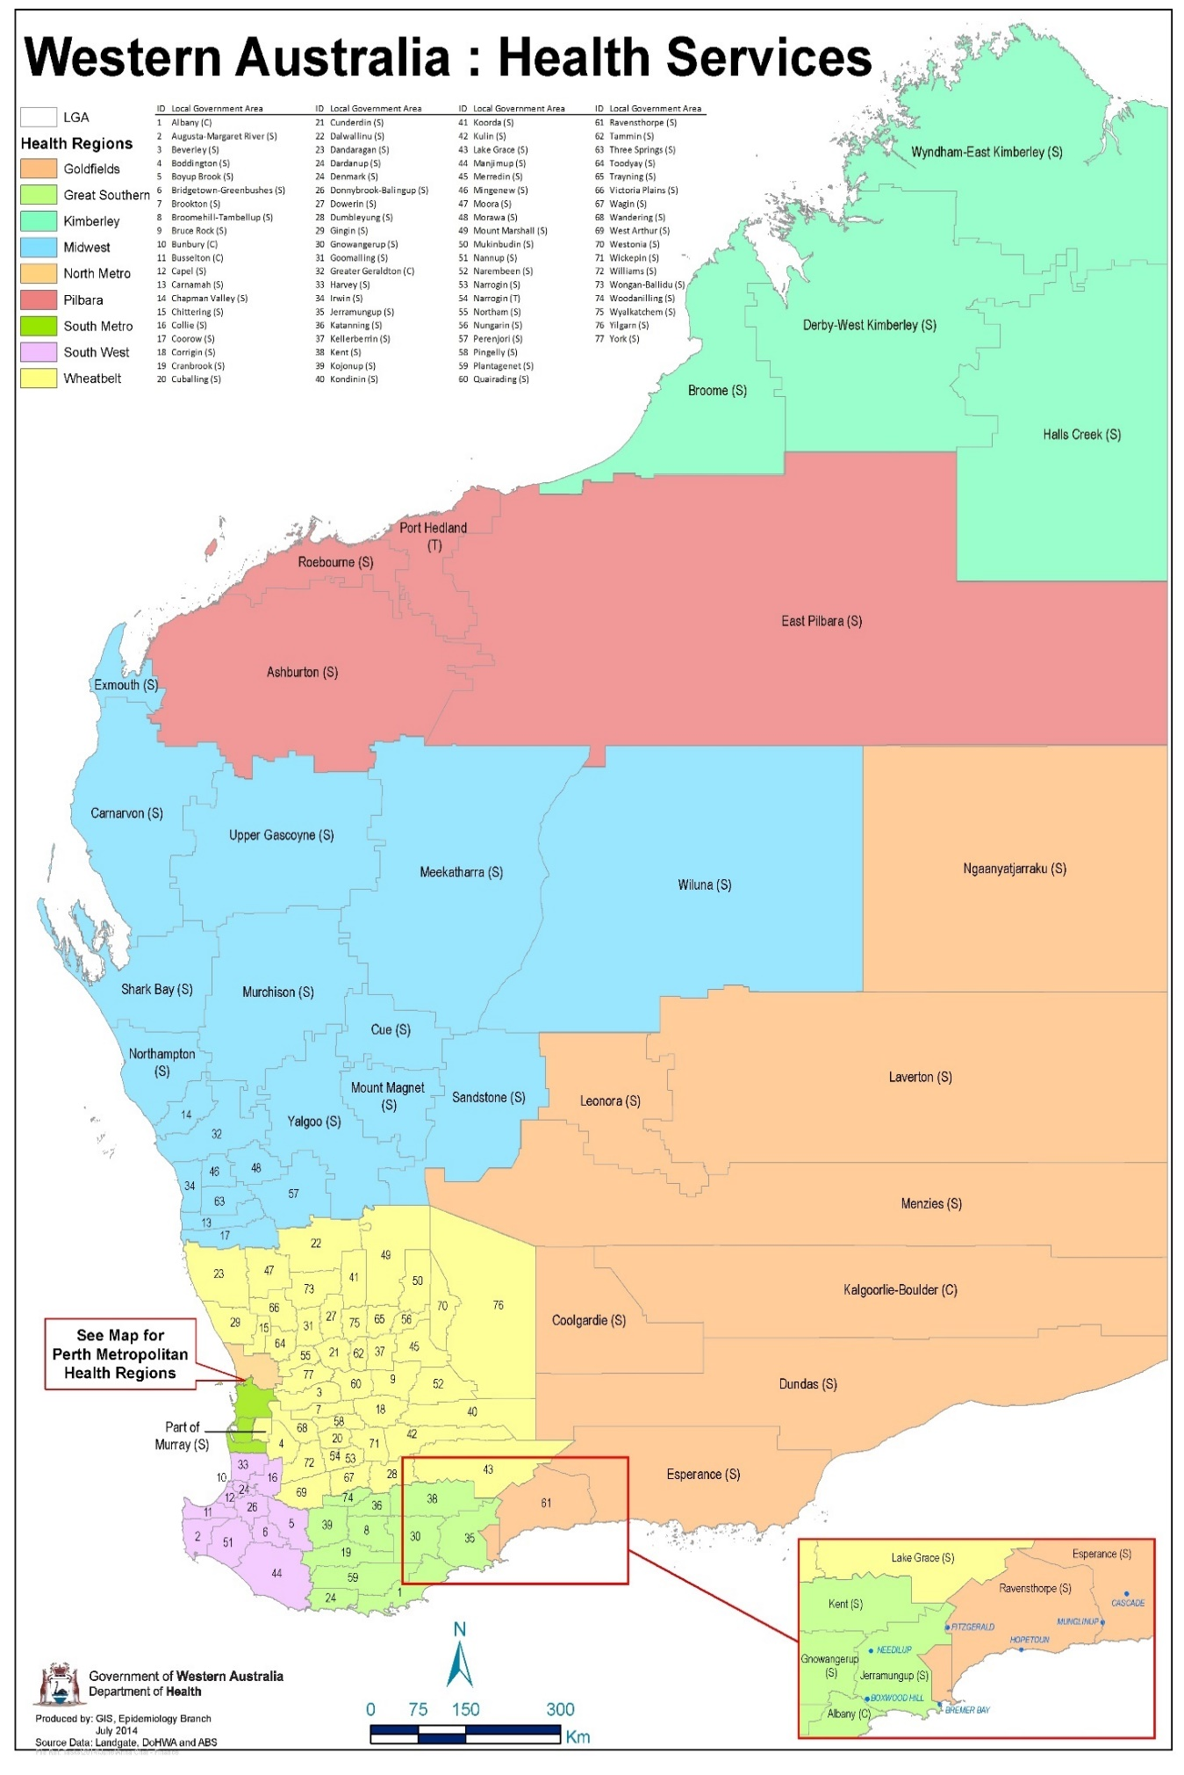

WA Health Metropolitan Maps by SLA
