Western Australian public sector quarterly workforce report –
December 2022

About this information
This page presents a snapshot of the public sector workforce based on the most recent data available. More detailed workforce information (including information on other government entities) is available in the State of the WA Government Sector Workforce 2021-22.

Please see the Commission’s About our workforce data page for additional contextual information.

Overview of the public sector as at December 2022
Headcount |  | 160,923
Full-time equivalent (FTE) |  | 126,136
General government salaries expenses  (December quarter) |  | $3,942 M
Public sector median age |  | 45
Top 3 occupation groups (FTE) | Teachers | 18.3%
 | Clerical workers | 16.8%
 | Nurses and midwives | 11.1%

Diversity groups | December 2022 |  | Aspirational target
Women in the SES | Representation | 49.4% | 50.0%
Aboriginal and Torres Strait Islander people | Representation | 2.8% | 3.7%
 | Headcount | 3,409
People with disability | Representation | 1.5% | 5.0%
 | Headcount | 1,880
Culturally and linguistically diverse people | Representation | 16.2% | 15.5%
 | Headcount | 18,698
Youth  (aged 24 and under) | Representation | 5.2% | 5.8%
 | Headcount | 8,336
Mature  (aged 45 and over) | Representation | 50.3% | n.a.
 | Headcount | 80,916

Sector profile

Employment trends
In December 2022 the WA public sector employed 160,923 people, equating to 126,136 full time equivalent (FTE) employees.

In headcount terms, this reflected a quarterly decrease of 607 (-0.4%) since September 2022, and an annual increase of 4,960 (+3.2%) since December 2021.

In FTE terms, this reflected a quarterly decrease of 285 (-0.2%) since September 2022, and an annual increase of 3,775 (+3.1%) since December 2021.

The Department of Education reported a decrease of 222 headcount (-0.4%) and 568 FTE (-1.3%) since the September 2022 quarter. The quarterly movement reflects the seasonal pattern of school operations that results in a lower FTE and headcount in December due to the school holiday period.

The WA Health portfolio decreased by 1,041 headcount (-1.8%) and 314 FTE (-0.7%). Within the health portfolio, Health Support Services reported an increase by 84 Headcount (+3.5%) and 115 FTE (+6.6%) since September 2022 quarter, mainly due to an uplift of major ICT programs. In the same period, all other health agencies reported a decrease. South Metropolitan Health Service had the largest nominal decrease (-152 FTE), followed by East Metropolitan Health Service (-91 FTE). The changes in the WA Health portfolio are mainly due to:
- decrease in COVID-19 related activities such as a reduction in vaccination and booster programs and scaling down of the State Health Incident Coordination Centre
- decrease in nursing and nursing support staff due to reduction of demand in Intensive Care Units, COVID leave and subsequent backfill, and the return of expected furloughed staff.

The Department of Communities reported an increase of 137 FTE (+2.6%) since September 2022, with almost 50% of the increase occurring in roles providing service delivery and case load support.

Main Roads reported an increase of 72 FTE (+6.0%) since September 2022. The majority of the increase is due to the transition of external contractors into Main Roads as a result of the Government’s commitment to the return of road maintenance jobs to the public sector.

Salaries expenditure

Salaries represent the single largest component of general government sector expenses (at almost 41% for the six months to December 2022, or 45% if concurrent superannuation costs are also included).
General government salaries for the first six months of 2022-23 grew by 8.1% to total $7,663 million.
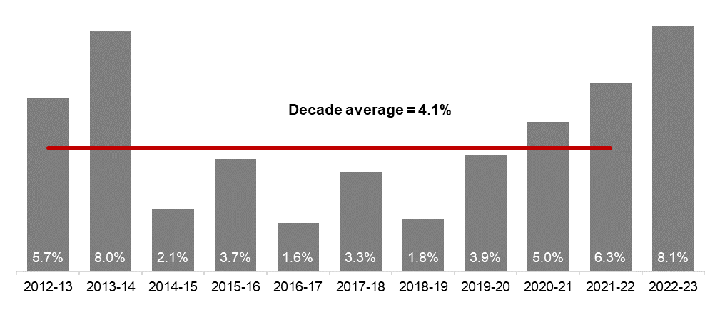
Source: Department of Treasury

Historical headcount, FTE and salaries expenditure
Quarter | Headcount | FTE | Quarterly salaries  expenditure ($M)
September 2017 | 141,609 | 111,472 | 2,980
December 2017 | 137,878 | 108,371 | 3,029
March 2018 | 140,799 | 110,404 | 3,049
June 2018 | 139,812 | 110,373 | 3,135
September 2018 | 141,744 | 111,255 | 3,023
December 2018 | 138,678 | 108,601 | 3,091
March 2019 | 142,278 | 112,099 | 2,982
June 2019 | 142,735 | 111,932 | 3,172
September 2019 | 143,775 | 113,367 | 3,140
December 2019 | 143,586 | 113,143 | 3,212
March 2020 | 146,343 | 115,548 | 3,147
June 2020 | 146,562 | 116,878 | 3,366
September 2020 | 148,408 | 117,773 | 3,319
December 2020 | 148,532 | 117,664 | 3,350
March 2021 | 151,753 | 120,357 | 3,298
June 2021 | 153,396 | 121,298 | 3,502
September 2021 | 155,931 | 123,034 | 3,512
December 2021 | 155,963 | 122,361 | 3,574
March 2022 | 159,839 | 125,623 | 3,476
June 2022 | 160,281 | 125,623 | 3,717
September 2022 | 161,530 | 126,421 | 3,721
December 2022 | 160,923 | 126,136 | 3,942

WA public sector agencies’ staffing levels
Agency | Dec-22  Headcount | Dec-22  FTE | FTE change from  Sep-22 | FTE change from  Dec-21
WA public sector | 160,923 | 126,136 | -285 | 3,775
Department of Education | 58,683 | 43,446 | -568 | 753
WA Health | 57,292 | 43,243 | -314 | 2,108
WA Health (North Metropolitan Health Service) | 12,313 | 9,183 | -9 | 341
WA Health (South Metropolitan Health Service) | 11,683 | 8,726 | -152 | 584
WA Health (WA Country Health Service) | 11,245 | 8,534 | -32 | 383
WA Health (East Metropolitan Health Service) | 9,830 | 7,597 | -91 | 555
WA Health (Child and Adolescent Health Service) | 6,069 | 4,342 | -82 | 78
WA Health (Health Support Services) | 2,482 | 1,866 | 115 | 165
WA Health (PathWest) | 2,377 | 1,889 | -8 | 3
WA Health (Department of Health) | 1,293 | 1,106 | -55 | -1
Department of Justice | 7,302 | 6,663 | 16 | -258
Department of Communities | 6,090 | 5,358 | 137 | 257
Western Australia Police | 2,895 | 2,129 | 14 | -12
Department of Biodiversity, Conservation and Attractions | 2,468 | 2,107 | 79 | 87
Public Transport Authority | 2,386 | 2,249 | 64 | 82
Department of Primary Industries and Regional Development | 1,957 | 1,776 | -2 | 47
Department of Fire and Emergency Services | 1,815 | 1,719 | 9 | 28
Department of Mines, Industry Regulation and Safety | 1,768 | 1,624 | 31 | 11
Department of Transport | 1,632 | 1,467 | 15 | 9
North Metropolitan TAFE | 1,460 | 1,210 | -6 | 30
South Metropolitan TAFE | 1,383 | 1,163 | 0 | 29
Main Roads Western Australia | 1,377 | 1,280 | 72 | 130
Department of Local Government, Sport and Cultural Industries | 1,211 | 991 | 3 | 69
Department of Finance | 1,116 | 1,019 | -12 | 3
Department of Water and Environmental Regulation | 1,029 | 917 | 19 | 63
Department of Planning, Lands and Heritage | 962 | 853 | 26 | 59
Department of the Premier and Cabinet | 705 | 647 | 15 | 54
South Regional TAFE | 566 | 423 | 10 | 20
VenuesWest | 519 | 265 | 12 | 5
Department of Training and Workforce Development | 498 | 447 | 10 | 14
Landgate | 488 | 435 | -4 | -8
Insurance Commission of Western Australia | 472 | 421 | 12 | 38
Department of Jobs, Tourism, Science and Innovation | 456 | 412 | 35 | 79
Legal Aid Commission of Western Australia | 436 | 386 | 13 | 39
Central Regional TAFE | 413 | 344 | 1 | 11
Mental Health Commission | 413 | 333 | -26 | -19
Office of the Director of Public Prosecutions | 346 | 304 | 13 | 21
North Regional TAFE | 309 | 285 | 1 | -18
Department of Treasury | 289 | 256 | 2 | 15
Lotterywest | 285 | 272 | 7 | -2
Office of the Auditor General | 206 | 183 | -5 | 4
Forest Products Commission | 174 | 159 | 10 | -19
Public Sector Commission | 168 | 131 | 6 | 0
ChemCentre | 159 | 146 | 8 | 6
Metropolitan Cemeteries Board | 157 | 141 | 6 | -2
WorkCover Western Australia | 142 | 130 | -1 | 2
Corruption and Crime Commission | 131 | 126 | -1 | 9
Ombudsman Western Australia | 79 | 65 | 1 | -3
Small Business Development Corporation | 74 | 62 | 1 | 5
Economic Regulation Authority | 70 | 64 | 3 | 0
GESB | 67 | 63 | 3 | 4
Animal Resources Centre | 58 | 53 | -5 | -10
Western Australian Electoral Commission | 49 | 46 | -3 | -2
Legal Practice Board | 43 | 41 | 1 | 1
Department of the Registrar, Western Australian Industrial Relations Commission | 43 | 40 | 0 | 4
Western Australian Meat Industry Authority | 42 | 23 | 2 | 3
Construction Training Fund | 37 | 35 | -2 | 6
National Trust of Australia (W.A.) | 31 | 26 | -1 | 4
MyLeave | 27 | 26 | 3 | 3
Health and Disability Services Complaints Office | 24 | 22 | 0 | 8
Infrastructure WA | 21 | 19 | 1 | 5
Office of the Inspector of Custodial Services | 18 | 16 | 1 | 0
Office of the Information Commissioner | 15 | 13 | 0 | 0
Metropolitan Redevelopment Authority | 15 | 14 | 1 | -2
Commissioner for Children and Young People | 13 | 11 | -2 | -3
Burswood Park Board | 11 | 9 | -1 | 2
Keep Australia Beautiful WA | 8 | 7 | 0 | 0
Minerals Research Institute of Western Australia (MRIWA) | 8 | 8 | 0 | 3
Veterinary Practice Board | 6 | 5 | 0 | 0
Salaries and Allowances Tribunal | 4 | 4 | 0 | 1
Architects Board of Western Australia | 2 | 2 | 0 | -1

Data quality statement
Information is based on an aggregate of agency supplied data, collected quarterly through the Human Resource Minimum Obligatory Information Requirements (HR MOIR). Data is supplied by agencies according to the guidelines set out in HR MOIR Data Definitions 1.5.1.
The information provided reflects the Commission’s holdings at the date of release. Workforce data is occasionally revised for quality, and corrections applied may result in figures being adjusted over time. This information relates only to public sector (Department, SES and non-SES agencies), and excludes sworn officers of the WA Police Force, public universities, local governments, government trading enterprises and other authorities.
All data is accurate as reported to us by contributing agencies.
As some figures have been rounded, discrepancies may occur between sums of the component items and totals. Salaries expenditure data and information is provided by the Department of Treasury.

Contact
All enquiries about the Public Sector Commission’s data should be directed to stateadministrator@psc.wa.gov.au.

Representation reported as 2.8% (due to standard rounding convention of the 2 decimal figure of 2.761%).
On 1 July 2022, Energy Policy WA (EPWA) commenced as a business group of the Department of Mines, Industry Regulation and Safety (DMIRS). Employee numbers continue to be included within DMIRS for the purposes of this report.
With the commencement of the Veterinary Practice Act 2021 on 18 June 2022, a title change has been made from the ‘Veterinary Surgeons’ Board’ to the ‘Veterinary Practice Board of Western Australia’. The new Board is a continuation of, and the same legal entity as, the former Board.

