Western Australian Public Sector Quarterly Workforce Report –
June 2022

About this information
This page presents a snapshot of the public sector workforce based on the most recent data available. More detailed workforce information (including information on other government entities) is available in the State of the WA Government Sector Workforce 2020-21.

Please see the Commission’s About our workforce data page for additional contextual information.

Overview of the public sector as at June 2022
Headcount |  | 160,281
Full-time equivalent (FTE) |  | 125,623
General government salaries expenses |  | $3,717 M
Public sector median age |  | 45
Top 3 occupation groups (FTE) | Teachers | 18.5%
 | Clerical workers | 16.8%
 | Nurses and midwives | 11.3%

Diversity groups | June 2022 |  | Aspirational target
Women in the SES | Representation | 45.2% | 50.0%
 | Headcount | 168
Aboriginal and Torres Strait Islander people | Representation | 2.7% | 3.7%
 | Headcount | 3,363
People with disability | Representation | 1.5% | 5.0%
 | Headcount | 1,861
Culturally and linguistically diverse people | Representation | 16.0% | 15.5%
 | Headcount | 18,268
Youth  (aged 24 and under) | Representation | 5.3% | 5.8%
 | Headcount | 8,451
Mature  (aged 45 and over) | Representation | 50.4% | n.a.
 | Headcount | 80,823

Sector profile

Employment trends
In June 2022 the WA public sector employed 160,281 people, equating to 125,623 full time equivalent (FTE) employees.

In headcount terms, this reflected a quarterly increase of 442 (+0.3%) since March 2022, and an annual increase of 6,885 (+4.5%) since June 2021.

In FTE terms, there was no change (+0.0%) since March 2022, and an annual increase of 4,325 (+3.6%) since June 2021.
Over the quarter, the Department of Education increased by 387 headcount (+0.7%) and decreased by -126 FTE (-0.3%). The increase in headcount and decrease in FTE reflects a higher level of fixed-term and casual staff employed to meet operational requirements in response to COVID-19 public health measures.
The WA Health portfolio increased marginally overall by 23 headcount (+0.0%) and 2 FTE (+0.0%) over the quarter though this varied by agency. Health Support Services increased by 130 FTE (+7.6%) attributed to continued provision of support to frontline COVID related services and activity and commissioning activities for the new Enterprise Medical Imaging Solution, while WA Country Health Service decreased by 192 FTE (-2.2%) attributed to a reduction in COVID-19 related activities and a return to business as usual activities.

Salaries expenditure
Salaries represent the single largest component of general government sector expenses (40.1% in 2021 22, or 44.2% if concurrent superannuation costs are also included). At $14.3 billion, annual growth in general government salaries expenditure was 6% in 2021 22. For more information on salaries expenditure, please refer to Department of Treasury’s 2021-22 Annual Report on State Finances.
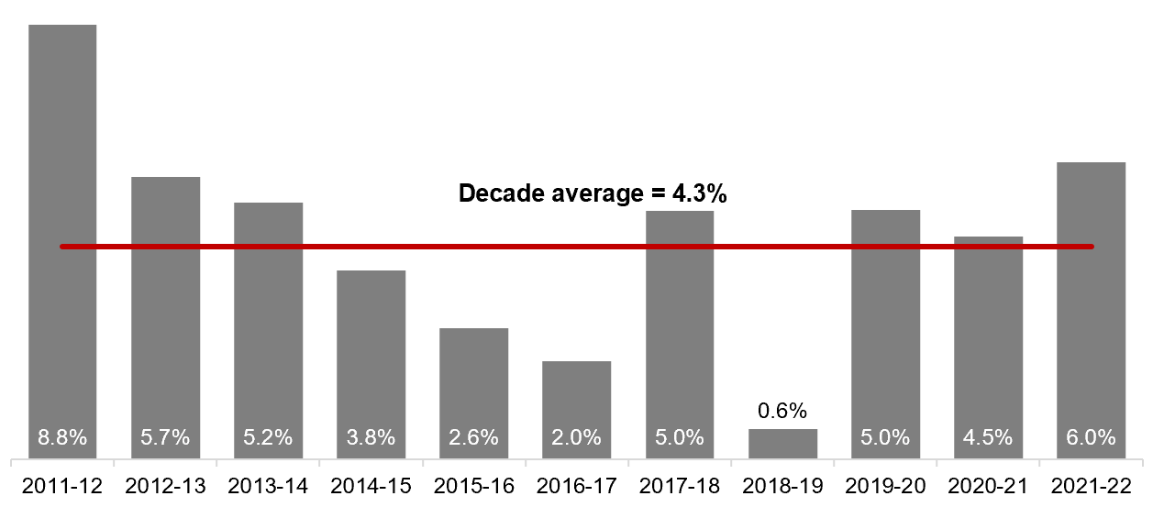

[ALT text - Salaries growth for the June quarter of 2021-22 was 6.0%, compared to a ten-year average of 4.3%.]

Source: Department of Treasury

Historical headcount, FTE and salaries expenditure
Quarter | Headcount | FTE | Quarterly salaries  expenditure ($M)
September 2015 | 139,277 | 109,919 | 2,837
December 2015 | 137,520 | 108,325 | 2,888
March 2016 | 137,371 | 108,722 | 2,801
June 2016 | 135,770 | 107,809 | 2,857
September 2016 | 137,746 | 109,295 | 2,887
December 2016 | 135,936 | 106,830 | 2,931
March 2017 | 139,144 | 109,895 | 2,880
June 2017 | 140,403 | 110,662 | 2,912
September 2017 | 141,609 | 111,472 | 2,980
December 2017 | 137,878 | 108,371 | 3,029
March 2018 | 140,799 | 110,404 | 3,049
June 2018 | 139,812 | 110,373 | 3,135
September 2018 | 141,744 | 111,255 | 3,023
December 2018 | 138,678 | 108,601 | 3,091
March 2019 | 142,278 | 112,099 | 2,982
June 2019 | 142,735 | 111,932 | 3,172
September 2019 | 143,775 | 113,367 | 3,140
December 2019 | 143,586 | 113,143 | 3,212
March 2020 | 146,343 | 115,548 | 3,147
June 2020 | 146,562 | 116,878 | 3,366
September 2020 | 148,408 | 117,773 | 3,319
December 2020 | 148,532 | 117,664 | 3,350
March 2021 | 151,753 | 120,357 | 3,298
June 2021 | 153,396 | 121,298 | 3,502
September 2021 | 155,931 | 123,034 | 3,512
December 2021 | 155,963 | 122,361 | 3,574
March 2022 | 159,839 | 125,623 | 3,476
June 2022 | 160,281 | 125,623 | 3,717

WA public sector agencies’ staffing levels
Agency | Jun-22  Headcount | Jun-22  FTE | FTE change from  Mar-22 | FTE change from  Jun-21
WA public sector | 160,281 | 125,623 | n.c. | 4,325
Department of Education | 58,193 | 43,588 | -126 | 399
WA Health | 57,878 | 43,394 | 2 | 3,631
WA Health (North Metropolitan Health Service) | 12,379 | 9,185 | -91 | 347
WA Health (South Metropolitan Health Service) | 11,652 | 8,675 | 17 | 1,225
WA Health (WA Country Health Service) | 11,145 | 8,418 | -192 | 424
WA Health (East Metropolitan Health Service) | 9,857 | 7,596 | 88 | 748
WA Health (Child and Adolescent Health Service) | 6,519 | 4,537 | 49 | 536
WA Health (PathWest) | 2,592 | 2,009 | -6 | 177
WA Health (Health Support Services) | 2,401 | 1,844 | 130 | 127
WA Health (Department of Health) | 1,333 | 1,130 | 9 | 48
Department of Justice | 7,329 | 6,715 | -45 | -217
Department of Communities | 5,897 | 5,200 | 87 | 196
Western Australia Police | 2,858 | 2,110 | -17 | -75
Department of Biodiversity, Conservation and Attractions | 2,367 | 2,017 | -28 | 75
Public Transport Authority | 2,309 | 2,159 | -15 | 29
Department of Primary Industries and Regional Development | 1,973 | 1,756 | 28 | 67
Department of Fire and Emergency Services | 1,826 | 1,699 | 26 | 35
Department of Mines, Industry Regulation and Safety | 1,751 | 1,615 | 2 | -50
Department of Transport | 1,628 | 1,462 | -2 | 6
North Metropolitan TAFE | 1,505 | 1,211 | 10 | 31
South Metropolitan TAFE | 1,409 | 1,178 | -10 | 12
Department of Local Government, Sport and Cultural Industries | 1,242 | 972 | 29 | 21
Main Roads Western Australia | 1,228 | 1,151 | -6 | -12
Department of Finance | 1,094 | 1,008 | -5 | -26
Department of Water and Environmental Regulation | 993 | 887 | 27 | 47
Department of Planning, Lands and Heritage | 935 | 824 | 9 | 35
Department of the Premier and Cabinet | 656 | 584 | -18 | 13
South Regional TAFE | 569 | 415 | 0 | 4
VenuesWest | 505 | 249 | -10 | 1
Department of Training and Workforce Development | 495 | 438 | 3 | 7
Landgate | 476 | 432 | 0 | -25
Insurance Commission of Western Australia | 443 | 393 | 9 | 11
Mental Health Commission | 436 | 362 | 14 | 42
Central Regional TAFE | 417 | 342 | 10 | 5
Legal Aid Commission of Western Australia | 400 | 352 | -2 | 26
Department of Jobs, Tourism, Science and Innovation | 399 | 357 | 13 | 38
North Regional TAFE | 323 | 298 | -3 | -12
Office of the Director of Public Prosecutions | 319 | 283 | 0 | 3
Lotterywest | 283 | 265 | -9 | 19
Department of Treasury | 275 | 245 | -5 | -8
Office of the Auditor General | 208 | 191 | 2 | 9
Forest Products Commission | 181 | 167 | 10 | -3
Public Sector Commission | 173 | 122 | -8 | -3
ChemCentre | 155 | 142 | 2 | 1
Metropolitan Cemeteries Board | 154 | 141 | 0 | -3
WorkCover Western Australia | 140 | 127 | -2 | -5
Corruption and Crime Commission | 127 | 122 | 7 | 5
Small Business Development Corporation | 72 | 63 | 4 | 6
Ombudsman Western Australia | 72 | 61 | -5 | -7
Economic Regulation Authority | 69 | 63 | 4 | -3
Animal Resources Centre | 66 | 62 | 1 | -1
GESB | 65 | 61 | 0 | 5
Western Australian Electoral Commission | 47 | 44 | 0 | -8
Legal Practice Board | 45 | 42 | 8 | 1
Western Australian Meat Industry Authority | 38 | 22 | 2 | 6
Department of the Registrar, Western Australian Industrial Relations Commission | 36 | 33 | -2 | 0
Construction Training Fund | 35 | 31 | 0 | 9
National Trust of Australia (W.A.) | 28 | 23 | 1 | -3
MyLeave | 23 | 22 | -1 | -1
Health and Disability Services Complaints Office | 20 | 19 | 2 | 3
Commissioner for Children and Young People | 17 | 15 | 3 | -2
Infrastructure WA | 17 | 17 | 4 | 2
Office of the Inspector of Custodial Services | 17 | 15 | -1 | -3
Metropolitan Redevelopment Authority | 15 | 14 | 0 | -10
Office of the Information Commissioner | 13 | 12 | -1 | 0
Burswood Park Board | 9 | 7 | 0 | 1
Keep Australia Beautiful WA | 8 | 7 | 0 | -1
Minerals Research Institute of Western Australia (MRIWA) | 7 | 6 | 0 | 1
Veterinary Surgeons' Board | 6 | 5 | 0 | 0
Salaries and Allowances Tribunal | 4 | 4 | 0 | 1
Architects Board of Western Australia | 3 | 2 | 0 | 0

Data quality statement
Information is based on an aggregate of agency supplied data, collected quarterly through the Human Resource Minimum Obligatory Information Requirements (HR MOIR). Data is supplied by agencies according to the guidelines set out in HR MOIR Data Definitions 1.5.1.
The information provided reflects the Commission’s holdings at the date of release. Workforce data is occasionally revised for quality, and corrections applied may result in figures being adjusted over time. This information relates only to public sector (Department, SES and non-SES agencies), and excludes sworn officers of the WA Police Force, public universities, local governments, government trading enterprises and other authorities.
All data is accurate as reported to us by contributing agencies.
As some figures have been rounded, discrepancies may occur between sums of the component items and totals. Salaries expenditure data and information is provided by the Department of Treasury.

Contact
All enquiries about the Public Sector Commission’s data should be directed to stateadministrator@psc.wa.gov.au.

