Western Australian Public Sector Quarterly Workforce Report – September 2020

About this information
This page presents a snapshot of the public sector workforce based on the most recent data available. More detailed workforce information (including information on other government entities) is available in the State of the WA Government Sector Workforce 2019-20.
Please see the Commission’s About our workforce data page for additional contextual information.

Overview of the public sector as of 30 September 2020
Headcount |  | 148,408
Full-time equivalent (FTE) |  | 117,773
General government expenses (September quarter) |  | $3,319M
Senior Executive Service (SES) |  | 413
Public sector median age |  | 46
Top 3 occupation groups (FTE) | Teachers | 19.3%
 | Clerical workers | 16.5%
 | Nurses and midwives | 10.9%

Diversity groups | Sep 2020 |  | Aspirational target
Women in SES | Representation | 42.4% | 50.0%
 | Headcount | 175
Aboriginal and Torres Strait Islander people | Representation | 2.7% | 3.7%
 | Headcount | 3,011
People with disability | Representation | 1.5% | 5.0%
 | Headcount | 1,704
Culturally and linguistically diverse people | Representation | 14.2% | 15.5%
 | Headcount | 14,651
Youth  (aged 24 and under) | Representation | 3.9% | 5.8%
 | Headcount | 5,758
Mature  (aged 45 and over) | Representation | 52.6% | n/a
 | Headcount | 78,106

Sector profile

Employment trends
In September 2020 the WA public sector employed 148,408 people, equating to 117,773 full-time equivalent (FTE) employees.
In headcount terms, this reflected a quarterly increase of 1,846 (+1.3%) since June 2020, and an annual increase of 4,633 (3.2%) since September 2019. In FTE terms, this reflects a quarterly increase of 895 (+1.2 per cent) since June 2020 and an annual increase of 4,406 (+3.9 per cent) since September 2019.
WA Health continues to drive growth in staffing levels, accounting for over 60% of the 1,846 increase in headcount this quarter. Between June and September 2020, WA Health headcount increased by 1,138 (+2.3%) while FTE increased by 653 (+1.7%). These increases reflect WA Health maintaining preparedness to respond to COVID-19, through both COVID-19 specific positions and coverage of positions where staff have been reallocated to COVID-19 response.
The Department of Education also contributed to the increase, with headcount up by 468 (+0.8%) and FTE up by 39 (+0.1%) between June and September 2020:
- Growth was due largely to ongoing growth in student numbers, resulting in an additional headcount of 452 teachers and 393 education assistants. Most of these staff were casual and worked less than one FTE, resulting in a smaller increase in FTE than headcount.
- Increases in teaching staff were offset by a decrease of 348 fixed term cleaners (headcount) in the Department of Education, occurring approximately six months from the end of March 2020 when staff were engaged to respond to emerging COVID-19 related health and safety requirements.
TAFE colleges also increased, up 205 headcount (211 FTE) since June 2020, in line with the resumption of semester.
In response to the COVID-19 pandemic, VenuesWest reduced its workforce from 518 employees (262 FTE) in September 2019 to 233 employees (107 FTE) in September 2020. VenuesWest reported that casual employees have started to be re-engaged as normal business at VenuesWest venues resumes.

Salaries expenditure
Salaries represent the single largest component of general government expenses (42% for the September 2020 quarter).
General government salaries totalled $3,319 million in the first three months of 2020–21 (an increase of 5.7% compared to the same period in the prior year), with a decade average of 4.5% per annum.
Figure 1. Salaries growth for the September quarter since 2010–11 (general government)
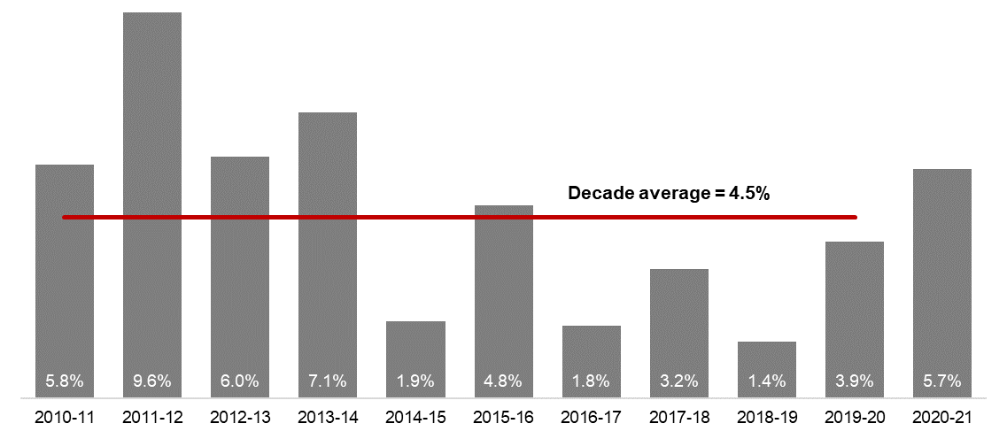
[ALT text - Salaries growth for the September quarter was 5.7 per cent, compared to a ten-year average of 4.5 percent.]
Source: Department of Treasury

Historical headcount, FTE and salaries expenditure
Quarter | Headcount | FTE | Salaries  expenditure ($M)
September 2015 | 139,277 | 109,919 | 2,837
December 2015 | 137,520 | 108,325 | 2,888
March 2016 | 137,371 | 108,722 | 2,801
June 2016 | 135,770 | 107,809 | 2,857
September 2016 | 137,746 | 109,295 | 2,887
December 2016 | 135,936 | 106,830 | 2,931
March 2017 | 139,144 | 109,895 | 2,880
June 2017 | 140,403 | 110,662 | 2,912
September 2017 | 141,609 | 111,472 | 2,980
December 2017 | 137,878 | 108,371 | 3,029
March 2018 | 140,799 | 110,404 | 3,049
June 2018 | 139,812 | 110,373 | 3,135
September 2018 | 141,744 | 111,255 | 3,023
December 2018 | 138,678 | 108,601 | 3,091
March 2019 | 142,278 | 112,099 | 2,982
June 2019 | 142,735 | 111,932 | 3,172
September 2019 | 143,775 | 113,367 | 3,140
December 2019 | 143,586 | 113,143 | 3,212
March 2020 | 146,343 | 115,548 | 3,147
June 2020 | 146,562 | 116,878 | 3,366
September 2020 | 148,408 | 117,773 | 3,319

WA public sector entities staffing levels
Agency | Sep-20 Headcount | Sep-20 FTE | FTE change from  Jun-20 | FTE change from Sep-19
Western Australian Public Sector | 148,408 | 117,773 | +895 | +4,406
Department of Education | 55,530 | 41,748 | +39 | +1,200
WA Health | 49,973 | 38,085 | +653 | +1,857
North Metropolitan Health Service | 11,541 | 8,739 | +163 | -76
WA Country Health Service | 10,378 | 7,882 | +223 | +317
South Metropolitan Health Service | 9,335 | 7,070 | +114 | +297
East Metropolitan Health Service | 8,231 | 6,455 | +56 | +274
Child and Adolescent Health Service | 5,064 | 3,658 | +31 | +576
Health Support Services | 2,176 | 1,589 | +27 | +197
PathWest | 2,149 | 1,743 | +5 | +115
Department of Health | 1,099 | 948 | +34 | +156
Department of Justice | 7,328 | 6,833 | +68 | +597
Department of Communities | 6,111 | 5,357 | -140 | -39
Western Australia Police | 2,930 | 2,175 | +12 | +62
Department of Biodiversity, Conservation and Attractions | 2,213 | 1,852 | +16 | +56
Public Transport Authority | 2,188 | 2,104 | +30 | +165
Department of Primary Industries and Regional Development | 1,789 | 1,611 | +27 | +66
Department of Fire and Emergency Services | 1,775 | 1,662 | +18 | +41
Department of Mines, Industry Regulation and Safety | 1,742 | 1,625 | +26 | +182
Department of Transport | 1,536 | 1,415 | +28 | +85
North Metropolitan TAFE | 1,448 | 1,182 | +57 | -41
South Metropolitan TAFE | 1,407 | 1,195 | +60 | +19
Main Roads Western Australia | 1,167 | 1,123 | +24 | +95
Department of Local Government, Sport and Cultural Industries | 1,156 | 936 | +36 | +55
Department of Finance | 1,013 | 947 | +20 | +41
Department of Water and Environmental Regulation | 969 | 868 | 0 | +23
Department of Planning, Lands and Heritage | 864 | 780 | -2 | +12
Department of the Premier and Cabinet | 624 | 547 | -6 | +33
South Regional TAFE | 591 | 428 | +51 | +18
Landgate | 503 | 463 | -11 | -12
Department of Training and Workforce Development | 473 | 419 | -1 | +8
Central Regional TAFE | 427 | 354 | +33 | -2
Insurance Commission of Western Australia | 418 | 379 | -5 | +13
Mental Health Commission | 358 | 289 | +4 | +11
Legal Aid Commission of Western Australia | 355 | 309 | +1 | +4
Department of Jobs, Tourism, Science and Innovation | 322 | 292 | +8 | +21
North Regional TAFE | 311 | 280 | +10 | -14
Office of the Director of Public Prosecutions | 296 | 268 | -2 | +14
Department of Treasury | 279 | 257 | +1 | -27
Lotterywest | 258 | 246 | -11 | +2
VenuesWest | 233 | 107 | -89 | -155
Forest Products Commission | 181 | 170 | -22 | +2
Office of the Auditor General | 171 | 159 | +6 | +2
Metropolitan Cemeteries Board | 170 | 152 | -3 | +5
Public Sector Commission | 149 | 117 | -4 | +15
ChemCentre | 145 | 136 | -1 | +2
WorkCover Western Australia | 135 | 126 | +2 | 0
Corruption and Crime Commission | 133 | 126 | +1 | +6
Ombudsman Western Australia | 76 | 65 | +1 | +1
Economic Regulation Authority | 70 | 64 | -1 | +5
Small Business Development Corporation | 61 | 55 | -2 | +2
Animal Resources Centre | 60 | 56 | -6 | -5
GESB | 58 | 52 | +1 | +4
Metropolitan Redevelopment Authority | 53 | 49 | -34 | -52
Western Australian Electoral Commission | 48 | 44 | +3 | +4
Legal Practice Board | 47 | 44 | -1 | +2
National Trust of Australia (W.A.) | 39 | 29 | -1 | +2
Department of the Registrar, Western Australian Industrial Relations Commission | 38 | 35 | +2 | +4
Western Australian Meat Industry Authority | 28 | 17 | -1 | -2
Construction Training Fund | 24 | 21 | -1 | +2
Health and Disability Services Complaints Office | 22 | 19 | -2 | +3
Equal Opportunity Commission | 21 | 20 | 0 | 0
Commissioner for Children and Young People | 16 | 15 | -1 | +2
Office of the Inspector of Custodial Services | 16 | 14 | -1 | -2
Infrastructure WA | 14 | 13 | 0 | +13
Office of the Information Commissioner | 13 | 12 | +2 | +1
Keep Australia Beautiful WA | 11 | 10 | +1 | +1
Burswood Park Board | 7 | 5 | 0 | 0
Veterinary Surgeons' Board | 6 | 4 | 0 | 0
Minerals Research Institute of Western Australia (MRIWA) | 5 | 5 | 0 | +1
Architects Board of Western Australia | 2 | 2 | 0 | 0
Salaries and Allowances Tribunal | 2 | 2 | 0 | -1

Data quality statement
Information in this report is based on workforce data collected from agencies on a quarterly basis. Data is supplied by agencies according to the guidelines set out in the HR MOIR Data Definitions 1.5.1. Workforce data is occasionally revised (e.g. discrepancies in agency data identified) and this may result in figures being adjusted over time.
Data covers only public sector agencies and does not include the WA Police Force (sworn officers), parliamentary electorate offices, local governments, government trading enterprises or public universities.
All data is accurate as reported to us by contributing agencies.
Totals may be affected by rounding.
Salaries expenditure data and information is provided by the Department of Treasury.

Contact
All enquiries about the Public Sector Commission’s data should be directed to stateadministrator@psc.wa.gov.au.

The Department of Communities supports the Disability Services Commission (Headcount: 1,071; FTE: 911) and Housing Authority (Headcount: 1,870; FTE: 1,703) which remain statutory authorities.
Sworn officers are employed by the Police Force (a non-public sector entity as defined in the Public Sector Management Act 1994), separated from the Police Service.
The Department of Biodiversity, Conservation and Attractions includes the Botanic Gardens and Parks Authority (Headcount: 143; FTE: 101), Rottnest Island Authority (Headcount: 135; FTE: 115), and Zoological Parks Authority (Headcount: 205; FTE: 153) as part of administrative arrangements. However, these statutory authorities remain as separate entities and continue to employ their own staff.
While staff of regional development commissions are part of the Department of Primary Industries and Regional Development, regional development commissions and their respective chief executives and boards remain as separate entities under legislation. For the purposes of this report, the nine regional development commissions are included in the Department of Primary Industries and Regional Development.
Energy Policy WA was established on 5 September 2019 as a new sub-department within the Department of Mines, Industry Regulation and Safety (DMIRS) and employee numbers are included within DMIRS for the purposes of this report.
Staff of the Metropolitan Redevelopment Authority are transitioning to WA Land Authority under the DevelopmentWA banner. WA Land Authority is a government trading enterprise, hence not captured in this report. This quarter 38 headcount (34 FTE) moved from Metropolitan Redevelopment Authority.
Infrastructure WA was established in July 2019 but had no employees in September 2019.

