Western Australian Public Sector Quarterly Workforce Report – September 2021

About this information
This page presents a snapshot of the public sector workforce based on the most recent data available. More detailed workforce information (including information on other government entities) is available in the State of the WA Government Sector Workforce 2020-21.

Please see the Commission’s About our workforce data page for additional contextual information.

Overview of the public sector as at September 2021
Headcount |  | 155,931
Full-time equivalent (FTE) |  | 123,034
General government expenses (June quarter) |  | $3,512 M
Senior Executive Service (SES) |  | 373
Public sector median age |  | 45
Top 3 occupation groups (FTE) | Teachers | 19.2%
 | Clerical workers | 16.6%
 | Nurses and midwives | 11.1%

Diversity groups | June 2021 |  | Aspirational target
Women in the SES | Representation | 44.2% | 50.0%
 | Headcount | 165
Aboriginal and Torres Strait Islander people | Representation | 2.7% | 3.7%
 | Headcount | 3,217
People with disability | Representation | 1.5% | 5.0%
 | Headcount | 1,777
Culturally and linguistically diverse people | Representation | 15.1% | 15.5%
 | Headcount | 16,476
Youth  (aged 24 and under) | Representation | 4.5% | 5.8%
 | Headcount | 6,948
Mature  (aged 45 and over) | Representation | 51.6% | n.a.
 | Headcount | 80,447

Sector profile

Employment trends
In September 2021 the WA public sector employed 155,931 people, equating to 123,034 full-time equivalent (FTE) employees.

In headcount terms, this reflected a quarterly increase of 2,535 (+1.7%) since June 2021, and an annual increase of 7,523 (+5.1%) since September 2020.

In FTE terms, this reflects a quarterly increase of 1,736 (+1.4%) since June 2021 and an annual increase of 5,261 (+4.5%) since September 2020.

Approximately 80% of the change in FTE between June 2021 and September 2021 can be attributed to WA Health. In total, WA Health increased by 2,249 headcount (+4.3%) or 1,385 FTE (+3.5%). This growth was driven by COVID-19 related activities particularly support for additional hospital beds, and the return of privately employed patient support staff to public employment in the South Metropolitan Health Service.

The Department of Education also increased by 293 headcount (+0.5%) or 430 FTE (+1.0%) between June 2021 and September 2021, with additional staff required to meet demand in student growth and new schools, more special needs education assistants in mainstream schools and an increase in operational support roles.

The Department of Communities decreased by 39 headcount (-0.7%) or 77 FTE (-1.5%) continuing a series of quarterly decreases.

All other agencies remained relatively stable over the quarter.

Salaries expenditure
Salaries represent the single largest component of general government sector expenses (42% for September 2021, or 46% if concurrent superannuation costs are also included).
General government salaries totalled $3,512 million in the first three months of 2021-22 (an increase of 5.8% compared to the same period in the prior year).
Figure 1. Salaries growth for the September quarter since 2011-12 (general government)
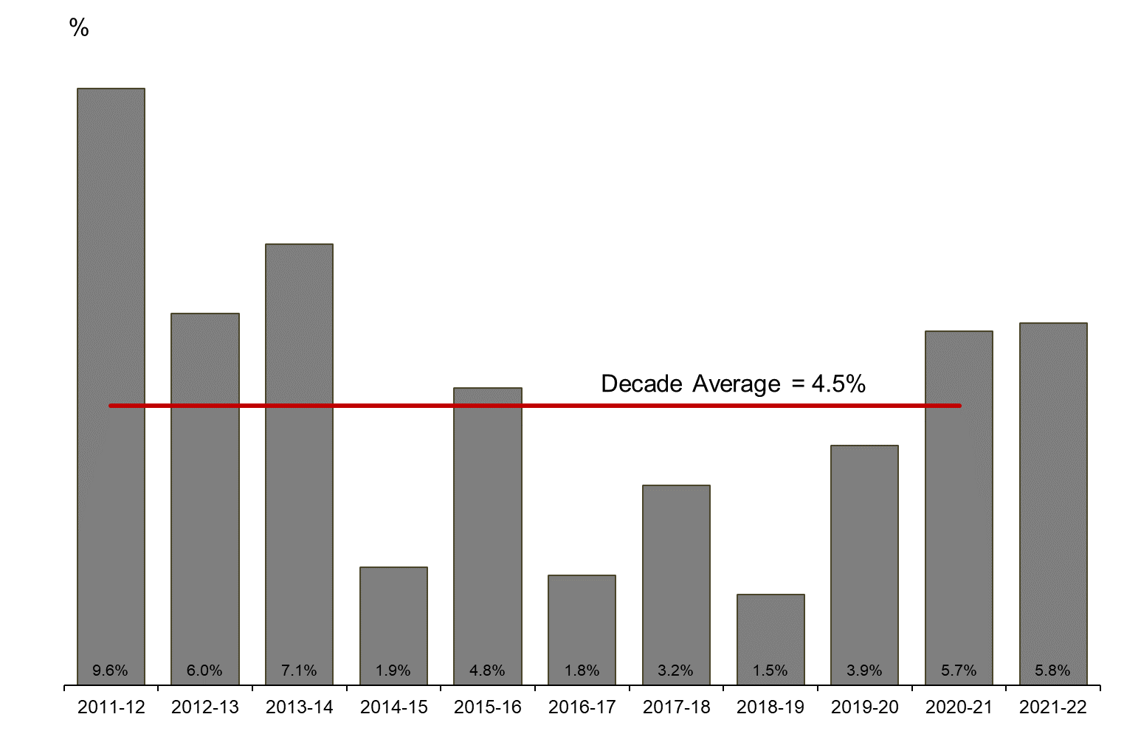
[ALT text - Salaries growth for the September quarter of 2021-22 was 5.8%, compared to a ten-year average of 4.5%.]
Source: Department of Treasury

Historical headcount, FTE and salaries expenditure
Quarter | Headcount | FTE | Quarterly salaries  expenditure ($m)
September 2015 | 139,277 | 109,919 | 2,837
December 2015 | 137,520 | 108,325 | 2,888
March 2016 | 137,371 | 108,722 | 2,801
June 2016 | 135,770 | 107,809 | 2,857
September 2016 | 137,746 | 109,295 | 2,887
December 2016 | 135,936 | 106,830 | 2,931
March 2017 | 139,144 | 109,895 | 2,880
June 2017 | 140,403 | 110,662 | 2,912
September 2017 | 141,609 | 111,472 | 2,980
December 2017 | 137,878 | 108,371 | 3,029
March 2018 | 140,799 | 110,404 | 3,049
June 2018 | 139,812 | 110,373 | 3,135
September 2018 | 141,744 | 111,255 | 3,023
December 2018 | 138,678 | 108,601 | 3,091
March 2019 | 142,278 | 112,099 | 2,982
June 2019 | 142,735 | 111,932 | 3,172
September 2019 | 143,775 | 113,367 | 3,140
December 2019 | 143,586 | 113,143 | 3,212
March 2020 | 146,343 | 115,548 | 3,147
June 2020 | 146,562 | 116,878 | 3,366
September 2020 | 148,408 | 117,773 | 3,319
December 2020 | 148,532 | 117,664 | 3,350
March 2021 | 151,753 | 120,357 | 3,298
June 2021 | 153,396 | 121,298 | 3,502
September 2021 | 155,931 | 123,034 | 3,512

WA public sector agencies’ staffing levels
Agency | Sep-21  Headcount | Sep-21  FTE | FTE change from  Jun-21 | FTE change from  Sep-20
Western Australian Public Sector | 155,931 | 123,034 | +1,736 | +5,261
Department of Education | 57,715 | 43,619 | +430 | +1,871
WA Health | 54,714 | 41,148 | +1,386 | +3,062
WA Health (North Metropolitan Health Service) | 11,993 | 8,937 | +100 | +198
WA Health (WA Country Health Service) | 10,926 | 8,324 | +330 | +441
WA Health (South Metropolitan Health Service) | 10,833 | 8,176 | +726 | +1,105
WA Health (East Metropolitan Health Service) | 9,014 | 6,918 | +69 | +463
WA Health (Child and Adolescent Health Service) | 6,082 | 4,223 | +222 | +565
WA Health (PathWest) | 2,351 | 1,857 | -119 | +9
WA Health (Health Support Services) | 2,249 | 1,598 | +25 | +114
WA Health (Department of Health) | 1,266 | 1,115 | +33 | +167
Department of Justice | 7,471 | 6,921 | -10 | +88
Department of Communities | 5,547 | 4,927 | -77 | -430
Western Australia Police | 2,927 | 2,165 | -21 | -10
Department of Biodiversity, Conservation and Attractions | 2,302 | 1,950 | +8 | +98
Public Transport Authority | 2,275 | 2,162 | +32 | +59
Department of Primary Industries and Regional Development | 1,879 | 1,700 | +12 | +90
Department of Fire and Emergency Services | 1,803 | 1,672 | +8 | +10
Department of Mines, Industry Regulation and Safety | 1,746 | 1,626 | -40 | +0
Department of Transport | 1,609 | 1,473 | +16 | +58
North Metropolitan TAFE | 1,468 | 1,191 | +10 | +9
South Metropolitan TAFE | 1,406 | 1,160 | -6 | -34
Main Roads Western Australia | 1,234 | 1,167 | +4 | +44
Department of Local Government, Sport and Cultural Industries | 1,212 | 936 | -14 | +1
Department of Finance | 1,081 | 1,019 | -15 | +71
Department of Water and Environmental Regulation | 941 | 844 | +4 | -24
Department of Planning, Lands and Heritage | 877 | 783 | -6 | +3
Department of the Premier and Cabinet | 669 | 582 | +11 | +35
South Regional TAFE | 577 | 409 | -2 | -19
Department of Training and Workforce Development | 490 | 432 | +2 | +14
Landgate | 482 | 450 | -7 | -13
VenuesWest | 466 | 250 | +3 | +143
Insurance Commission of Western Australia | 425 | 380 | -1 | +1
Central Regional TAFE | 419 | 341 | +5 | -13
Mental Health Commission | 403 | 330 | +9 | +41
Legal Aid Commission of Western Australia | 385 | 335 | +9 | +27
Department of Jobs, Tourism, Science and Innovation | 364 | 328 | +9 | +37
North Regional TAFE | 342 | 315 | +4 | +34
Office of the Director of Public Prosecutions | 311 | 278 | -3 | +10
Lotterywest | 274 | 257 | +11 | +11
Department of Treasury | 268 | 244 | -9 | -13
Office of the Auditor General | 206 | 188 | +7 | +29
Public Sector Commission | 170 | 126 | +1 | +9
Forest Products Commission | 168 | 158 | -11 | -11
Metropolitan Cemeteries Board | 161 | 146 | +1 | -6
ChemCentre | 152 | 137 | -4 | +1
WorkCover Western Australia | 142 | 127 | -5 | +1
Corruption and Crime Commission | 120 | 114 | -3 | -13
Ombudsman Western Australia | 80 | 68 | +0 | +3
Economic Regulation Authority | 67 | 62 | -4 | -2
Small Business Development Corporation | 65 | 57 | +0 | +2
GESB | 64 | 59 | +3 | +7
Animal Resources Centre | 62 | 58 | -4 | +3
Western Australian Electoral Commission | 55 | 51 | -1 | +7
Legal Practice Board | 43 | 41 | -1 | -3
Department of the Registrar, Western Australian Industrial Relations Commission | 39 | 36 | +2 | +0
Construction Training Fund | 34 | 27 | +6 | +6
National Trust of Australia (W.A.) | 32 | 24 | -2 | -6
Western Australian Meat Industry Authority | 28 | 17 | +1 | +0
MyLeave | 23 | 22 | -1 | +22
Metropolitan Redevelopment Authority | 21 | 17 | -6 | -32
Health and Disability Services Complaints Office | 21 | 19 | +2 | +0
Office of the Inspector of Custodial Services | 18 | 16 | -2 | +1
Commissioner for Children and Young People | 18 | 15 | -1 | +2
Infrastructure WA | 14 | 14 | -1 | +1
Office of the Information Commissioner | 13 | 12 | +0 | +0
Keep Australia Beautiful WA | 9 | 8 | +0 | -2
Burswood Park Board | 8 | 6 | +0 | +1
Veterinary Surgeons' Board | 6 | 5 | +0 | +0
Minerals Research Institute of Western Australia (MRIWA) | 5 | 5 | -1 | +0
Salaries and Allowances Tribunal | 3 | 3 | +0 | +1
Architects Board of Western Australia | 2 | 2 | -1 | +0

Data quality statement
Information is based on an aggregate of agency supplied data, collected quarterly through the Human Resource Minimum Obligatory Information Requirements (HR MOIR). Data is supplied by agencies according to the guidelines set out in HR MOIR Data Definitions 1.5.1.
The information provided reflects the Commission’s holdings at the date of release. Workforce data is occasionally revised for quality, and corrections applied may result in figures being adjusted over time. This information relates only to public sector (Department, SES and non-SES agencies), and excludes sworn officers of the WA Police Force, public universities, local governments, government trading enterprises and other authorities.
All data is accurate as reported to us by contributing agencies.
As some figures have been rounded, discrepancies may occur between sums of the component items and totals. Salaries expenditure data and information is provided by the Department of Treasury.

Contact
All enquiries about the Public Sector Commission’s data should be directed to stateadministrator@psc.wa.gov.au.

