Western Australian public sector quarterly workforce report –
September 2022

About this information
This page presents a snapshot of the public sector workforce based on the most recent data available. More detailed workforce information (including information on other government entities) is available in the State of the WA Government Sector Workforce 2021-22.

Please see the Commission’s About our workforce data page for additional contextual information.

Overview of the public sector as at September 2022
Headcount |  | 161,530
Full-time equivalent (FTE) |  | 126,421
General government salaries expenses |  | $3,721 M
Public sector median age |  | 45
Top 3 occupation groups (FTE) | Teachers | 18.6%
 | Clerical workers | 16.7%
 | Nurses and midwives | 11.2%

Diversity groups | September 2022 |  | Aspirational target
Women in the SES | Representation | 47.7% | 50.0%
Aboriginal and Torres Strait Islander people | Representation | 2.7% | 3.7%
 | Headcount | 3,368
People with disability | Representation | 1.5% | 5.0%
 | Headcount | 1,856
Culturally and linguistically diverse people | Representation | 16.2% | 15.5%
 | Headcount | 18,519
Youth  (aged 24 and under) | Representation | 5.2% | 5.8%
 | Headcount | 8,464
Mature  (aged 45 and over) | Representation | 50.2% | n.a.
 | Headcount | 81,041

Sector profile

Employment trends
In September 2022 the WA public sector employed 161,530 people, equating to 126,421 full time equivalent (FTE) employees.

In headcount terms, this reflected a quarterly increase of 1,249 (+0.8%) since June 2022, and an annual increase of 5,599 (+3.6%) since September 2021.

In FTE terms, this reflected a quarterly increase of 798 (+0.6%) since June 2022, and an annual increase of 3,387 (+2.8%) since September 2021.

The Department of Education reported an increase of +712 headcount (+1.2%) and +426 FTE (+1.0%) since the June 2022 quarter. The quarterly movement reflects the seasonal pattern of school operations that peaked in the September quarter.

The WA Health portfolio increased by 455 headcount (+0.8%) and 163 FTE (+0.4%) although this varied by health service providers. The changes to the WA Health portfolio can mainly be attributed to:
- new Junior Medical Officer rotation and orientation at three health service providers
- increased demand for nurses due to opening of new wards, increasing activity in Activity Based Funding services and hospitals, and increased intake of overseas doctors
- reduction in COVID-19 related activities including the scaling down of the COVID-19 related vaccination programs and closure of testing centres.

Salaries expenditure
Salaries represent the single largest component of general government sector expenses (at almost 40% for the three months to 30 September 2022, or almost 44% if concurrent superannuation costs are also included).

General government salaries totalled $3.7 billion for the first three months of 2022-23 (an increase of 5.9% compared to the same period in 2021-22).

For more information on salaries expenditure, please refer to Department of Treasury’s 2021-22 Annual Report on State Finances.
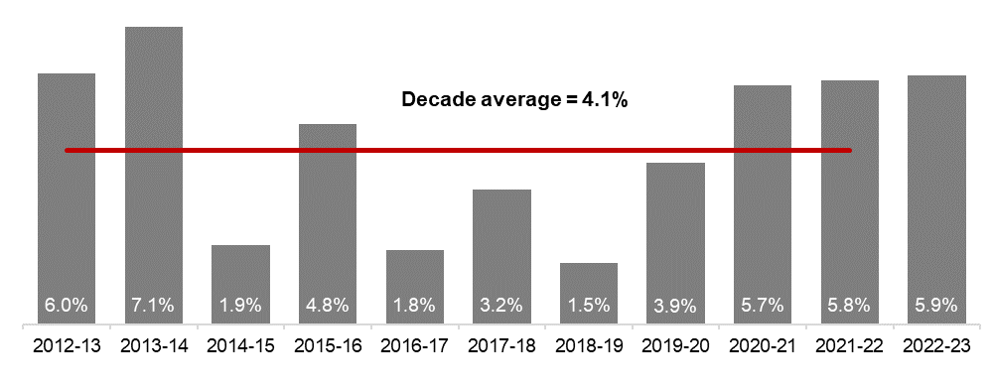
Source: Department of Treasury

Historical headcount, FTE and salaries expenditure
Quarter | Headcount | FTE | Quarterly salaries  expenditure ($M)
September 2015 | 139,277 | 109,919 | 2,837
December 2015 | 137,520 | 108,325 | 2,888
March 2016 | 137,371 | 108,722 | 2,801
June 2016 | 135,770 | 107,809 | 2,857
September 2016 | 137,746 | 109,295 | 2,887
December 2016 | 135,936 | 106,830 | 2,931
March 2017 | 139,144 | 109,895 | 2,880
June 2017 | 140,403 | 110,662 | 2,912
September 2017 | 141,609 | 111,472 | 2,980
December 2017 | 137,878 | 108,371 | 3,029
March 2018 | 140,799 | 110,404 | 3,049
June 2018 | 139,812 | 110,373 | 3,135
September 2018 | 141,744 | 111,255 | 3,023
December 2018 | 138,678 | 108,601 | 3,091
March 2019 | 142,278 | 112,099 | 2,982
June 2019 | 142,735 | 111,932 | 3,172
September 2019 | 143,775 | 113,367 | 3,140
December 2019 | 143,586 | 113,143 | 3,212
March 2020 | 146,343 | 115,548 | 3,147
June 2020 | 146,562 | 116,878 | 3,366
September 2020 | 148,408 | 117,773 | 3,319
December 2020 | 148,532 | 117,664 | 3,350
March 2021 | 151,753 | 120,357 | 3,298
June 2021 | 153,396 | 121,298 | 3,502
September 2021 | 155,931 | 123,034 | 3,512
December 2021 | 155,963 | 122,361 | 3,574
March 2022 | 159,839 | 125,623 | 3,476
June 2022 | 160,281 | 125,623 | 3,717
September 2022 | 161,530 | 126,421 | 3,721

WA public sector agencies’ staffing levels
Agency | Sep-22  Headcount | Sep-22  FTE | FTE change from  Jun-22 | FTE change from  Sep-21
WA public sector | 161,530 | 126,421 | 798 | 3,387
Department of Education | 58,905 | 44,014 | 426 | 395
WA Health | 58,333 | 43,557 | 163 | 2,409
WA Health (North Metropolitan Health Service) | 12,435 | 9,192 | 7 | 254
WA Health (South Metropolitan Health Service) | 11,955 | 8,878 | 203 | 702
WA Health (WA Country Health Service) | 11,385 | 8,566 | 148 | 242
WA Health (East Metropolitan Health Service) | 10,096 | 7,688 | 92 | 771
WA Health (Child and Adolescent Health Service) | 6,278 | 4,424 | -113 | 201
WA Health (PathWest) | 2,429 | 1,897 | -112 | 40
WA Health (Health Support Services) | 2,398 | 1,751 | -93 | 153
WA Health (Department of Health) | 1,357 | 1,161 | 31 | 46
Department of Justice | 7,308 | 6,647 | -67 | -274
Department of Communities | 5,952 | 5,221 | 21 | 294
Western Australia Police | 2,842 | 2,115 | 4 | -50
Department of Biodiversity, Conservation and Attractions | 2,387 | 2,028 | 11 | 78
Public Transport Authority | 2,329 | 2,185 | 26 | 22
Department of Primary Industries and Regional Development | 1,924 | 1,778 | 21 | 77
Department of Fire and Emergency Services | 1,839 | 1,710 | 11 | 39
Department of Mines, Industry Regulation and Safety | 1,691 | 1,593 | -22 | -32
Department of Transport | 1,620 | 1,452 | -11 | -21
North Metropolitan TAFE | 1,487 | 1,216 | 5 | 25
South Metropolitan TAFE | 1,401 | 1,163 | -15 | 3
Main Roads Western Australia | 1,285 | 1,208 | 57 | 41
Department of Local Government, Sport and Cultural Industries | 1,227 | 988 | 15 | 51
Department of Finance | 1,125 | 1,031 | 23 | 12
Department of Water and Environmental Regulation | 1,001 | 898 | 10 | 54
Department of Planning, Lands and Heritage | 910 | 827 | 3 | 44
Department of the Premier and Cabinet | 693 | 632 | 48 | 49
South Regional TAFE | 571 | 413 | -2 | 5
VenuesWest | 519 | 253 | 5 | 3
Department of Training and Workforce Development | 487 | 437 | -1 | 4
Landgate | 484 | 439 | 7 | -11
Insurance Commission of Western Australia | 450 | 409 | 16 | 29
Mental Health Commission | 441 | 359 | -3 | 29
Legal Aid Commission of Western Australia | 421 | 373 | 21 | 38
Central Regional TAFE | 418 | 343 | 2 | 2
Department of Jobs, Tourism, Science and Innovation | 409 | 377 | 20 | 49
Office of the Director of Public Prosecutions | 334 | 291 | 8 | 13
North Regional TAFE | 307 | 284 | -14 | -30
Department of Treasury | 287 | 254 | 8 | 10
Lotterywest | 278 | 265 | 0 | 8
Office of the Auditor General | 208 | 188 | -3 | 0
Public Sector Commission | 164 | 125 | 3 | -1
Forest Products Commission | 162 | 149 | -18 | -10
ChemCentre | 151 | 138 | -4 | 1
Metropolitan Cemeteries Board | 148 | 135 | -6 | -11
WorkCover Western Australia | 142 | 131 | 5 | 4
Corruption and Crime Commission | 132 | 127 | 5 | 13
Ombudsman Western Australia | 76 | 64 | 4 | -3
Small Business Development Corporation | 71 | 61 | -2 | 3
Economic Regulation Authority | 68 | 61 | -3 | -2
GESB | 65 | 60 | -1 | 1
Animal Resources Centre | 64 | 58 | -4 | 0
Western Australian Electoral Commission | 52 | 49 | 5 | -2
Legal Practice Board | 43 | 40 | -2 | 0
Department of the Registrar, Western Australian Industrial Relations Commission | 43 | 40 | 7 | 5
Construction Training Fund | 39 | 37 | 6 | 10
Western Australian Meat Industry Authority | 37 | 21 | -1 | 4
National Trust of Australia (W.A.) | 32 | 27 | 4 | 3
Health and Disability Services Complaints Office | 24 | 22 | 3 | 3
MyLeave | 23 | 23 | 0 | 0
Infrastructure WA | 19 | 18 | 2 | 5
Office of the Inspector of Custodial Services | 17 | 15 | 0 | -1
Office of the Information Commissioner | 15 | 13 | 2 | 2
Commissioner for Children and Young People | 15 | 13 | -2 | -3
Metropolitan Redevelopment Authority | 14 | 13 | -1 | -4
Burswood Park Board | 12 | 10 | 2 | 3
Keep Australia Beautiful WA | 8 | 7 | 0 | -1
Minerals Research Institute of Western Australia (MRIWA) | 8 | 8 | 2 | 3
Veterinary Practice Board | 6 | 5 | 0 | 0
Salaries and Allowances Tribunal | 4 | 4 | 0 | 1
Architects Board of Western Australia | 3 | 2 | -1 | 0

Data quality statement
Information is based on an aggregate of agency supplied data, collected quarterly through the Human Resource Minimum Obligatory Information Requirements (HR MOIR). Data is supplied by agencies according to the guidelines set out in HR MOIR Data Definitions 1.5.1.
The information provided reflects the Commission’s holdings at the date of release. Workforce data is occasionally revised for quality, and corrections applied may result in figures being adjusted over time. This information relates only to public sector (Department, SES and non-SES agencies), and excludes sworn officers of the WA Police Force, public universities, local governments, government trading enterprises and other authorities.
All data is accurate as reported to us by contributing agencies.
As some figures have been rounded, discrepancies may occur between sums of the component items and totals. Salaries expenditure data and information is provided by the Department of Treasury.

Contact
All enquiries about the Public Sector Commission’s data should be directed to stateadministrator@psc.wa.gov.au.

