Commissioning Toolkit for Community Services
Tool 1: Identify Needs
These Commissioning Capability Tools have been developed by the Western Australian Department of Finance, in partnership with Rebbeck.
Rebbeck is a boutique strategy consultancy and commissioning support organisation that specialises in commissioning capability development. Rebbeck works with healthcare and public services organisations across Australia to support commissioning with a focus on reshaping services to achieve sustainable outcomes for the people of Australia. Find out more at www.rebbeck.com

Identify Needs: At a glance

1. Overview
A Needs Analysis focuses on the highest priority needs of our communities to address physical, social and economic disadvantage, maximise potential, and enhance community well-being.

2. Purpose
A Needs Analysis helps us fulfil consumer needs which are currently unmet by supply. Commissioners are then able to identify where interventions are required.
3.Workflow
4

Communicate Needs Analysis findings
Delivering Community Services in Partnership Policy

Assess community service needs
1

Conduct market research
2

Prioritise needs and opportunities
3
4. Output
A Needs Analysis forms the basis of the strategy development, planning and service design that will meet the needs and achieve the desired outcomes for service users and the community.
5. Tools and resources
State Commissioning Strategy for Community Services

1. Overview

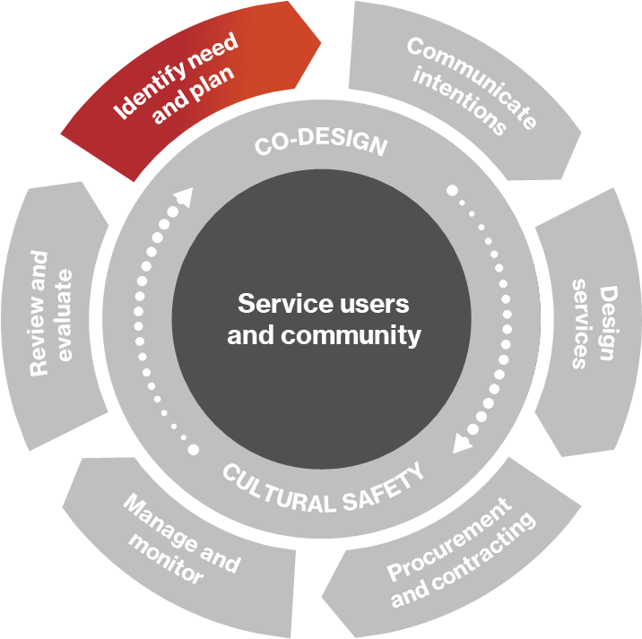
1.1 What are needs?
Figure 1. Commissioning cycle
A need is the gap between the services that exist for individuals and the community and the services that should exist to address physical, social and economic disadvantage, maximise their potential, and enhance community well-being.
Needs can be met or unmet. Met needs are those that are already being addressed by beneficial services, while unmet needs are those needs that still should be addressed.
Comprehensive service mapping and associated market analysis can help understand which needs are being met.
Some needs can be identified by reviewing excessive demand for existing services (e.g. surgery waiting lists, overpopulated classrooms, high incarceration rates) while others can be seen through statistical analysis of community data.
Section 5 contains more information on how to conduct market research.

1.2 What is a Needs Analysis?
A Needs Analysis (NA) is a systematic approach to information gathering to ensure we are prioritising the high-priority social needs or issues of the community. We complete a NA at the start of the commissioning cycle as it emphasises our focus on addressing the needs of people and targeting meaningful outcomes.
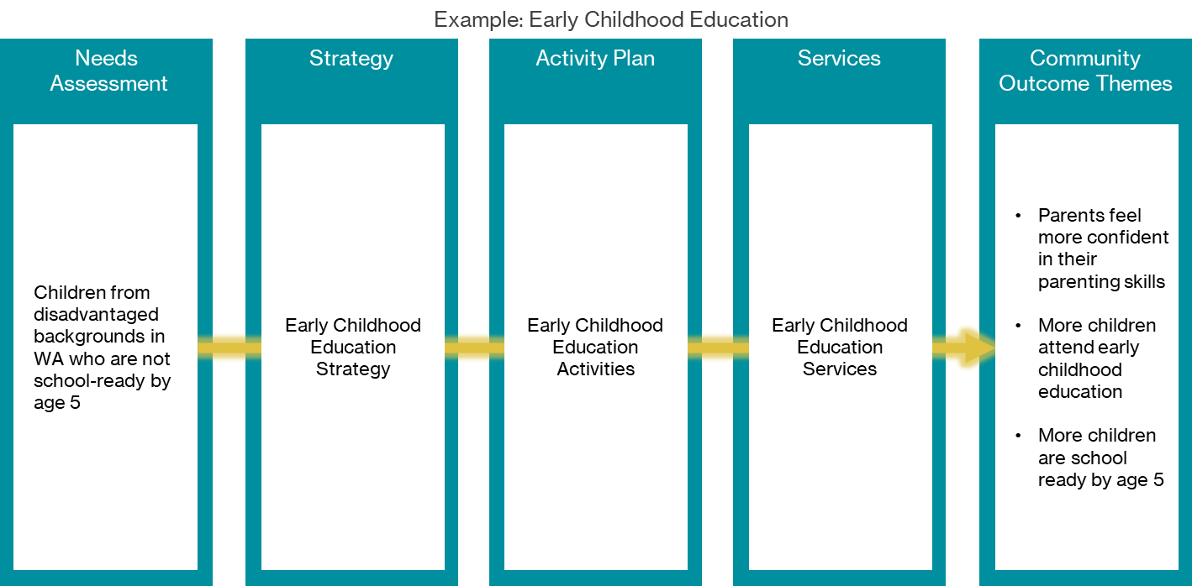
Figure 2. Example - Early Childhood Education: Connection between the Needs Analysis and outcomes
In this example, the NA recognises a cohort of children who are not school-ready by the age of five. The need is prioritised, and it is determined that an intervention is required. The NA also provides the market analysis to understand the options to address the need.
Strategy development and planning identify the intervention or set of interventions that will best meet the need. Services are then designed and implemented to address the need, and programs and contracts are managed, monitored and evaluated to ensure the needs are being met and outcomes are achieved.

2. Purpose

2.1 Why do we conduct a Needs Analysis?
Understanding needs and current service availability helps us make well-informed resource prioritisation decisions for improved community outcomes. A NA is constantly updated and used as a source of information to assist us with decision-making. The NA will be used at many points within the commissioning cycle and will be crucial for strategy formulation, planning, and co-design.
A NA assists us to:
- identify current and future community needs
- identify communities with poor access and inquality
- provide data to enable resource prioritisation decisions.
The NA is the basis of everything we do in commissioning.

3. Approach to conducting a Needs Analysis
Conducting a NA requires a funnel-like approach (see figure 4) to understand the community's needs. The process begins with refining the scope of the NA. Once the scope is established and well-defined, secondary research is conducted to understand what is currently known about the community’s needs to develop hypotheses about the priority needs.
The hypotheses then form the basis of the qualitative and quantitative data-gathering plan. The evidence collected from the primary research will enable us to validate or disprove the hypotheses.
Market analysis is conducted to identify which needs are met, partially met or unmet and this data assists us in prioritising our needs. Prioritisation allows resources and funding to be allocated to the priority needs of the community.
Sections 4, 5 and 6 provide more information on the approach to conducting a NA.
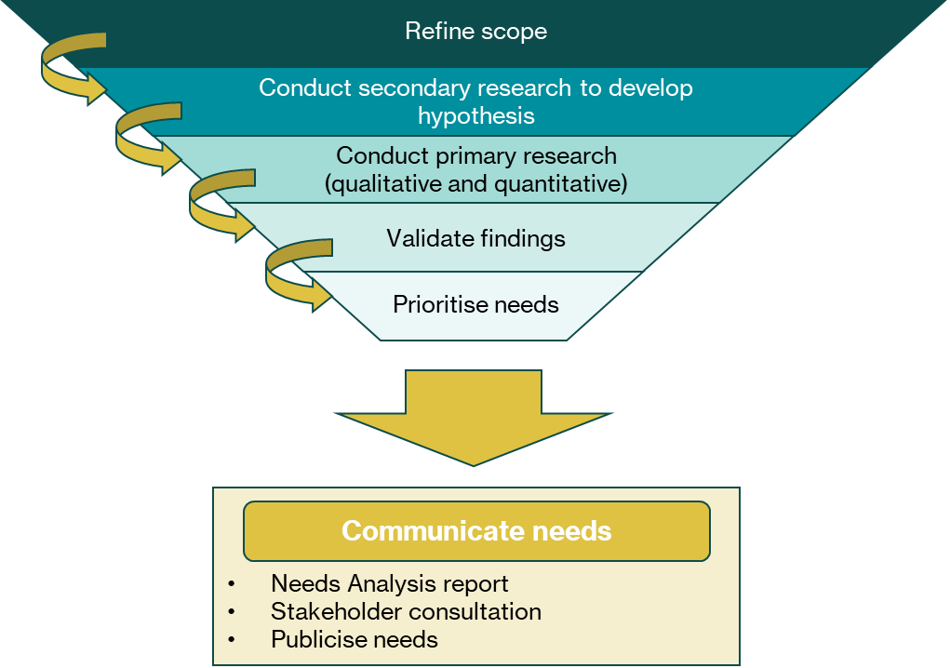
Figure 3. Approach to conducting a Needs Analysis

4. Assess community service needs

4.1 Scoping a Needs Analysis
It is not possible to look at every aspect of community needs so a well-defined scope will ensure the NA aligns with the purpose of the government agency and accomplishes what it intends to achieve.
When scoping a NA, several questions should be addressed.
What is the purpose of the NA?
A NA can be conducted for various reasons. It may be to inform future programs within a government agency or assess the suitability of current programs.
What is the size of the NA?
A NA can be targeted or broad depending on the purpose. A targeted NA may be used to inform the activities of a specific portfolio within the government agency, while a more comprehensive NA may be used to inform priorities across the whole department or even multiple government agencies over a longer period of time.
Where the scope is broad, the depth of analysis may be less extensive than a targeted NA. It is important to limit the scope to what can be reasonably delivered.

What are the characteristics of the community?
The scope should detail the characteristics of the relevant community. Is the NA for the whole community in a geographic region or is it for a certain locality, cohort or group in the community?
During this stage, it can be beneficial to write a list or table of what is in and out of scope to ensure the scope is clear and agreed by necessary stakeholders.

4.2 Secondary research
Once the scope is refined, we can start our secondary research. Secondary research is about gathering existing data to understand what is already known about the community's current needs. We want to build on existing knowledge and investigate areas that will give us the greatest insight into the social determinants influencing the community's needs. Our secondary research could include reading past NAs undertaken by our government agency or other government agencies, or reviewing publicly available documents specific to the relevant community.

4.3 Hypothesis development
Hypotheses are statements that describe what we believe to be the community's priority needs. Hypotheses are informed by the secondary research and the experience and expertise of people who understand the NA scope. It may be necessary to speak with people outside of the NA process who have the appropriate experience and expertise to inform the hypotheses. For example, if our NA focuses on the needs of Aboriginal communities, involving Aboriginal community representatives in the NA would enable us to develop the right hypotheses.
The hypotheses will form the basis of the primary research and will be proved, disproved, or refined through the NA work.

4.4 Conducting primary research - quantitative and qualitative data gathering
Primary research involves gathering qualitative and quantitative data for the NA. Primary data is gathered by the researchers undertaking the NA to address the hypotheses we want to explore.
Quantitative data
Quantitative data is data that be counted or measured and helps us measure the extent of needs in the community for our NA. Examples include information on community size, number of children and families, languages spoken, crime rates, education rates, and employment data. We can gather quantitative data through data requests, data searches, surveys or other forms of research.
The data can be compared to other areas to evaluate the issue's importance and scale relative to other regions. For example, unemployment rates may be higher than in comparable areas, so this could be a potential issue requiring attention.
Qualitative data
Qualitative data is more descriptive and can’t be expressed in numbers. Examples of qualitative data are case studies and verbal or written answers provided by stakeholders. To obtain qualitative data, researchers need to engage with stakeholders that have knowledge or experience with the topic being investigated.
Planning stakeholder engagement
Stakeholder engagement is a form of qualitative data gathering and is an important part of a NA. Stakeholder engagement focuses on participants’ experiences and perspectives and gives us a deeper understanding of the community's needs. Stakeholders include community members, service users and service providers. Engaging with these stakeholders gives us better insight into what is driving the needs in the community.
Planning stakeholder engagement involves identifying our stakeholders and determining the information we want to gather to increase our understanding of the needs. This information is grouped into anticipated themes, such as service user experience or barriers to accessing services. We can then identify which engagement approach best suits gathering data for the anticipated themes.
Commonly used methods in stakeholder engagement are interviews, focus groups and surveys. We must choose an approach which is respectful and culturally safe. Refer to section 7 in this tool for further information on stakeholder consultation considerations.
Combining quantitative and qualitative data
Quantitative data allows us to measure needs and qualitative data gives us a sense of why a need exists. Combining our quantitative and qualitative data allows us to generate our findings about the needs and prove or disprove the hypotheses we developed.
Another option is a sequential approach where we complete our quantitative research before we conduct the qualitative research. In this approach, quantitative research points the researcher towards the areas of greatest need, and raises questions that can then be answered by qualitative research. This approach enables the qualitative data gathering to be even more focused than it would be otherwise.

4.5 Validating findings
Once we have generated our findings, we must validate them with a knowledgeable audience to ensure we haven’t neglected anything critical.
Validation of findings often involves sharing the outputs and methods of our needs analysis with panels of experts and consumer representatives. The aim is to receive feedback on our approach and the identified and prioritised needs. We need to be mindful of allowing panel members to skew the discussion of needs to matters of their personal interests, as this would threaten the objectivity of the NA.

5. Conduct market research

5.1 Why we assess the market
We need to understand the market and infrastructure serving the targeted communities to recognise which of the identified needs are met or unmet. Market analysis involves three key steps: workforce mapping, service mapping and understanding service vital statistics.

5.2 Workforce mapping
Workforce mapping helps us understand the number and distribution of relevant professionals. It also helps us understand the characteristics of the workforce, including part-time versus full-time or public versus private. The workforce is often considered in terms of the ratio between the number of professionals and the community population. Workforce shortages are identified by low ratios of professionals to community population.

5.3 Service mapping
Service mapping allows us to understand which service providers are delivering which services in which locations and the relationships between services. It also helps us understand if any other service providers outside our region could be delivering into the region. Over time a database of service providers can be built, making the service mapping faster and more accurate. Service maps need to be periodically updated to reflect changes.

5.4 Service vital statistics
Once the location and mix of service providers are mapped, we must understand service provider scope, performance, capacity, capability, accessibility, eligibility requirements and service models. This gives us an understanding of the range, depth and quality of the services provided across our geography. This data is collected through consultation with service providers, for example through an online service profile survey.

6. Prioritise needs and opportunities

6.1 Why we need to prioritise needs and opportunities
Prioritisation of needs is critical to ensure we allocate resources in a focused way to deliver a strong return on investment. We want to commission a few high-impact initiatives rather than many low-impact initiatives. The number of high-impact initiatives will depend on the size, capacity and funding constraints of the government agency or division.
Figure 4 below illustrates the purpose of prioritisation. At the top of the funnel, we have numerous potential opportunities identified in our NA. A clear set of prioritisation criteria is used to determine which potential opportunities will form a portfolio of high-impact programs that can be delivered.
Figure 4. Prioritising to a shortlist of investment priorities
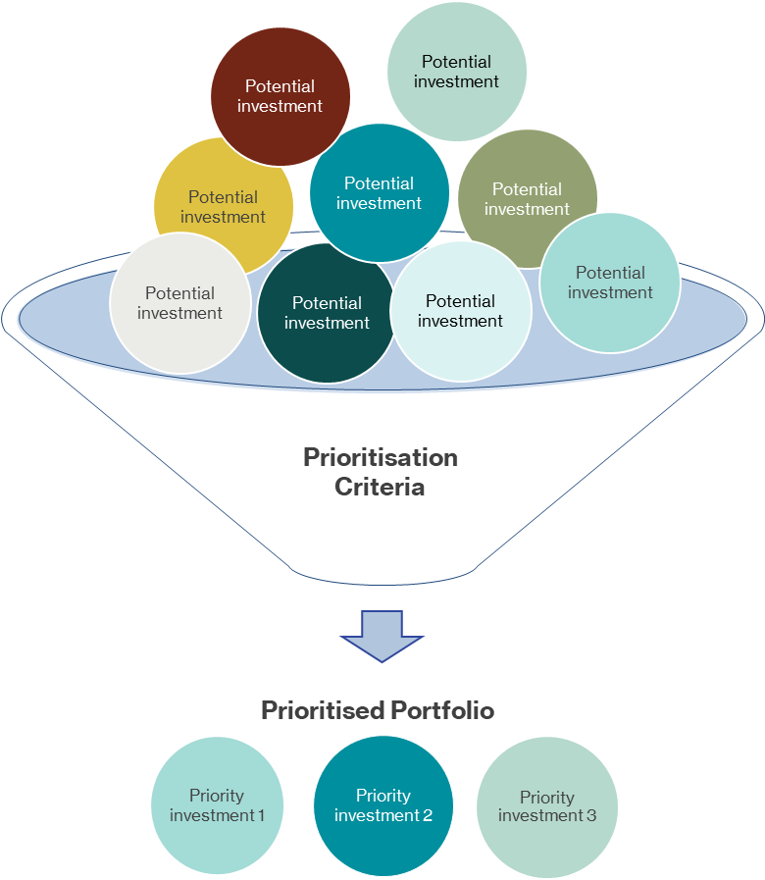

6.2 Prioritisation methods
There are various prioritisation methods and criteria that can be used. These include:
Multi-voting technique: Used when there are many problems or issues that need to be reduced to a couple of options. This process enables a problem that is favoured by everyone to rise to the top, even if it may not be a high priority. Find out more here.
Strategy grids: Focuses on addressing problems or issues that will yield the best results. This method is useful when government agencies are restricted in capacity and want to focus on areas that provide the highest return on investment. Find out more here.
Nominal group technique: Involves participants identifying and contributing ideas toward a topic or question specified by the facilitator. Participants then discuss and individually prioritise the ideas. Find out more here.
The criteria weighting method: Mathematical process where participants establish a relevant set of criteria and assign a priority ranking to issues based on how they measure against the criteria. Find out more here.
Prioritisation matrix: Used when problems must be tested against multiple criteria or when a government agency is limited to focusing on only one priority problem. Find out more here.
Example: Hanlon method
The Hanlon method is a technique that uses a clearly defined criteria and considers feasibility factors.

Figure 5. Hanlon Method

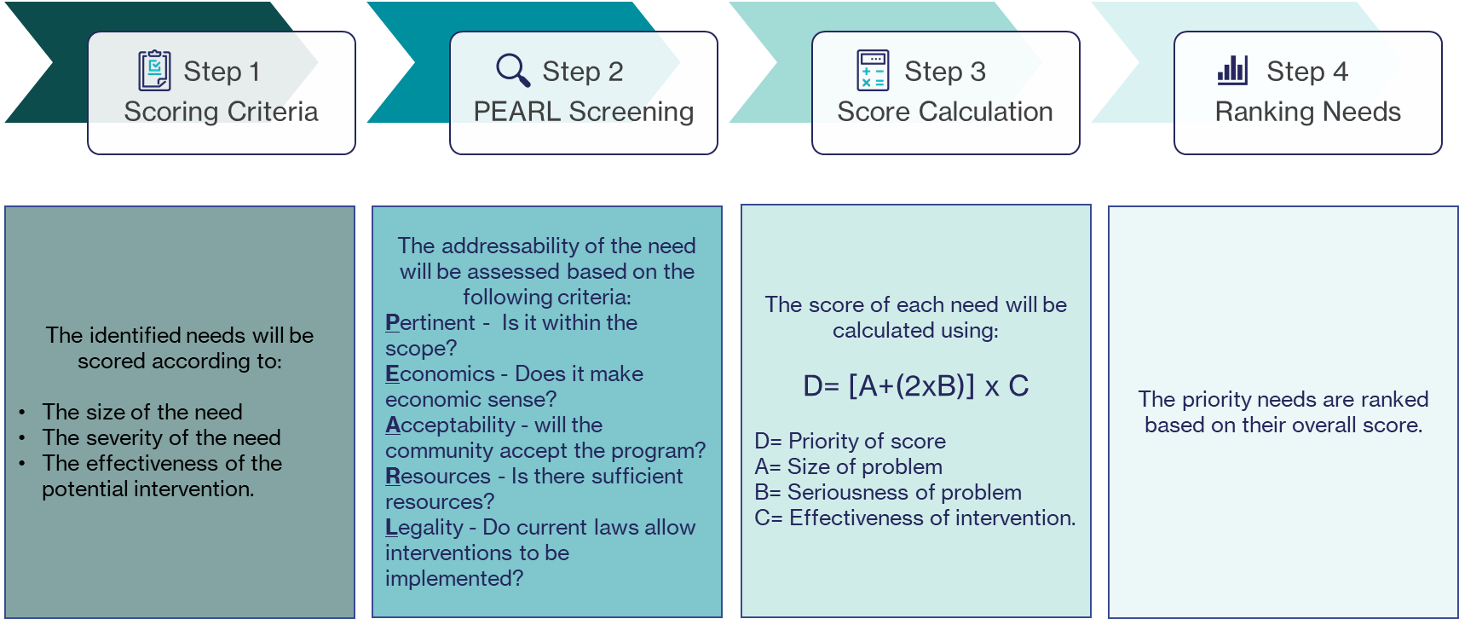

7. Considerations for co-design and cultural safety

7.1 Stakeholder consultation considerations
Stakeholder consultation is an important element of conducting a NA and we need to ensure that we gain a good understanding of the community’s needs, and the service provider’s ability to meet those needs, from their own perspective.
There are a number of ways we can build trust with stakeholders:
- Understand who our stakeholders are.
- Understand stakeholder’s perception of our government agency or division.
- Engage in one-to-one conversations.
- Seek to understand their world view.
- Communicate with clarity and honesty.
The trust equation (figure 6) highlights that the key to building strong stakeholder relationships is high credibility, reliability and intimacy, and low self-orientation.
In cases where we know that a stakeholder group has low levels of trust in our government agency or division, we may need to gain support from a third party with a better reputation with the stakeholder group or community to conduct the consultation.
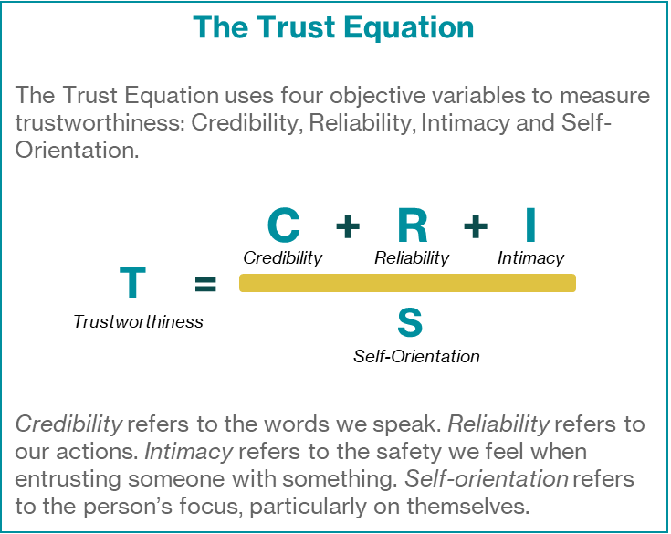
Figure 6. The Trust Equation
Showing respect and valuing the time of contributors
We can respect the time that stakeholders provide in their contributions towards the NA in multiple ways, including:
- Finding an appropriate time for engagement that suits the stakeholder’s time pressures and schedule: Could include conducting consultations after normal business hours, holding virtual consultations or meeting at a place of their choosing.
- Ensuring consultations are planned: Prepare the consultation questions carefully to maximise the usefulness of the information provided by the stakeholders.
- Ensuring consultation runs on time: Starting a consultation late or over-running the allocated time disrespects the participant’s time.
- Compensating stakeholders for their time: We could demonstrate that we value the contributor’s time by compensating them for their contribution. This can include monetary and non-monetary compensation.
It is important to communicate the findings of the NA and what we intend to do with the results with stakeholders. Respectful and transparent communication ensures stakeholders feel appreciated and can see the tangible results from their participation. Stakeholders who have a positive consultation experience will be more willing to participate in future consultations.

7.2 Culturally safe consultation
Promoting culturally safe consultation ensures participants can feel comfortable, supported and respected. Representation from relevant stakeholder groups helps to ensure the information in the NA is complete.
When planning consultations, we need to follow the five cultural safety principles:
Principles to engender cultural safety
1. Protocols - Find out about the cultural forms of engagement and respect these. This involves:
- showing respect by asking permission and obtaining informed consent.
- seeking cultural knowledge by asking questions or researching
- demonstrating reciprocity by learning from participants
- engaging community accompaniment by bringing on a with stakeholders with lived experience representative into the NA who can to provide their expertise.
2. Personal knowledge - Become mindful of our own cultural identity and socio-historical location in relation to the communities we engage with. Be prepared to share information about ourselves if this will help create equity and trust.
3. Partnerships - Promote collaborative practice with those we are engaging with. This involves ‘sharing’ knowledge instead of ‘telling’ and strengthening mutual capacity instead of one-way delivery.
4. Process - Engage in mutual learning and frequently check in to ensure that the findings and decisions of the NA ‘fit’ with the participants’ values, preferences, and way of life.
5. Positive purpose - Ensure that the findings and recommendations of the NA will achieve a positive and beneficial outcome.

8. Communicating intentions

8.1 Setting expectations
We must be clear on purpose when engaging stakeholders, including internal stakeholders, system partners and the community, in the NA process. We need to be clear that not every problem identified in the NA can be addressed and the focus during the commissioning cycle is on larger-scale change, which can take time. We must set reasonable expectations so that stakeholders are not disappointed if their particular issues aren’t immediately addressed.

8.2 Communicate findings
We must present our findings to stakeholders, decision-makers and the community after the NA is complete. The format for communicating the identified needs depends on the audience. A NA report can be used which details the essential information required to assist stakeholders in making decisions. The table below demonstrates an example structure of a NA report.
Table 1. Example contents of Needs Analysis Report
Needs Analysis Report
Executive summary | Summary of key findings and recommendations
Introduction | The background, purpose and scope of the NA
Needs analysis | Summary of key findings from analysis of the needs including:  - secondary data review  - quantitative data analysis  - thematic analysis from stakeholder consultation.
Market (service) landscape | Service mapping and discussion of service gaps and service performance that give rise to unmet need
Opportunities and priorities | List of identified needs and opportunities to address them.
Appendices | Methodology – detailed description of the methodology  Stakeholders engaged (where appropriate) – list of engagement techniques and names or numbers of stakeholders engaged  Bibliography – references to sources of evidence used to complete the NA  Glossary of terms  List of tables and figures
We need to communicate our findings to the community in an easily accessible and engaging way, such as videos or brochures, to show them what we believe are the priority needs and areas of focus.

9. Links to resources

9.1 State Commissioning Strategy for Community Services (all tools)
For resources on the State Commissioning Strategy for Community Services, visit here.

9.2 Delivering Community Services in Partnership Policy (all tools)
For resources on the Delivering Community Services in Partnership Policy, visit here.

