Commissioning Toolkit for Community Services
Tool 5: Procurement and Contracting
These Commissioning Capability Tools have been developed by the Western Australian Department of Finance, in partnership with Rebbeck.
Rebbeck is a boutique strategy consultancy and commissioning support organisation that specialises in commissioning capability development. Rebbeck works with healthcare and public services organisations across Australia to support commissioning with a focus on reshaping services to achieve sustainable outcomes for the people of Australia. Find out more at www.rebbeck.com

Procurement and Contracting: At a glance

1. Overview
This tool describes procurement and contracting within commissioning. These approaches use the outputs of previous commissioning stages to inform the procurement and contracting design.

2. Purpose
The purpose of this tool is to enable commissioners to understand the basics of running a procurement process and use logic models in the development of contracts.

3. Workflow
Plan for procurement by identifying requirements, developing a strategy and acquisition plan.
1

Select suppliers through the development of request documents, evaluation plans and interactions with providers.
2
Prepare for contracting by using the logic model and collaborating with providers.
3

4. Output
The outputs of this commissioning stage include tender documentation and a contract with the preferred provider that is developed collaboratively.
5. Tools and resources
Community Services Template – Procurement Timeline Form
Western Australia Procurement Rules

Community Services Template – Declaration of Confidentiality and Interest Form
Delivering Community Services in Partnership Policy

Community Services Template – Procurement Plan 2022

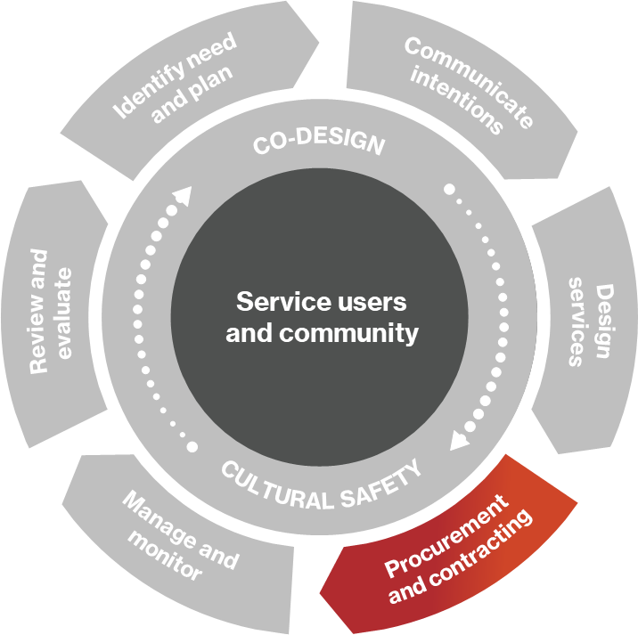
1. Overview

What is procurement?
The Western Australian Procurement Rules define procurement as ‘obtaining goods, services or works by purchase, lease, license, public, private partnerships or other means; and disposing of goods or works’ and defines procurement activities as ‘decisions or other things done in the course of, or as a result of, a process to procure goods, services or works’.
Figure 1: Commissioning cycle
Procurement is a multi-stage process which is summarised in figure 2.
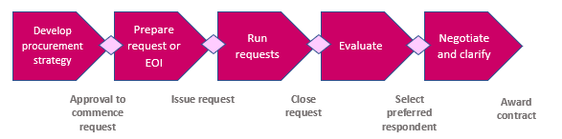
Figure 2. An overview of the procurement process
When commissioners choose procurement, it is essential to consider how it can best address the needs prioritised, secure quality services efficiently, achieve value for money and deliver desired outcomes for service users.

1.2 What is contracting?
Contracting is the process of entering into a legally binding agreement. While the Western Australian government does not define contracting, it describes specific contracting types. A service agreement is defined as ‘a form of contracting for services through a procurement process’. In contrast, a master agreement is an amalgamation of ‘individual service agreements between the organisation and the state agency into a single contract’.

2. Purpose

2.1 Why do we undertake procurement?
Procurement is our opportunity to deliver services which offer high quality and good value for money for service users. Before undertaking procurement, it is essential to consider the following questions:
- Are there any strategic reasons why the services should be kept in-house?
- Can an external service provider deliver the services as well as, or better than, the Western Australian government agency?
- Can an external service provider deliver the services as efficiently, or more efficiently than, the government agency?
- Are there enough service providers in the market to create a competition?
- Do the government agencies have, or could they acquire, the skills, knowledge, and experience necessary to manage a service provider properly?

3. Plan for procurement

3.1 Identify requirements
Before setting our procurement strategy, we need to review three key components of information:
- What does the needs analysis tell us about the unmet service user need?
- What does the market analysis tell us about the market’s ability to provide the services?
- What direction do we have from our organisational strategy?
We need to review our needs analysis to understand which service users are the highest priority, which geographic location they are in, and whether they are from a specific community with its own needs. This helps describe the problem we are trying to solve and what we need service providers to address.
We then need to consider the market analysis to help us anticipate suppliers’ responses to our procurement approach. Market research will help us to identify whether the market can respond to our needs. We may recognise that the market cannot provide the services we need, so we should also consider methods to shape the market so it can respond to the challenges our service users face.
We also need to assess the strategy of the government agency and what they are seeking to achieve. A series of procurement rules and policies apply to Western Australian government agencies, and links to these can be found in Section 8.

3.2 Plan procurement strategy
Once we have assessed our service user needs, conducted market research, and identified the organisation’s strategy, we need to consider our procurement options. The table below provides an overview of the various procurement approaches and their advantages and disadvantages.

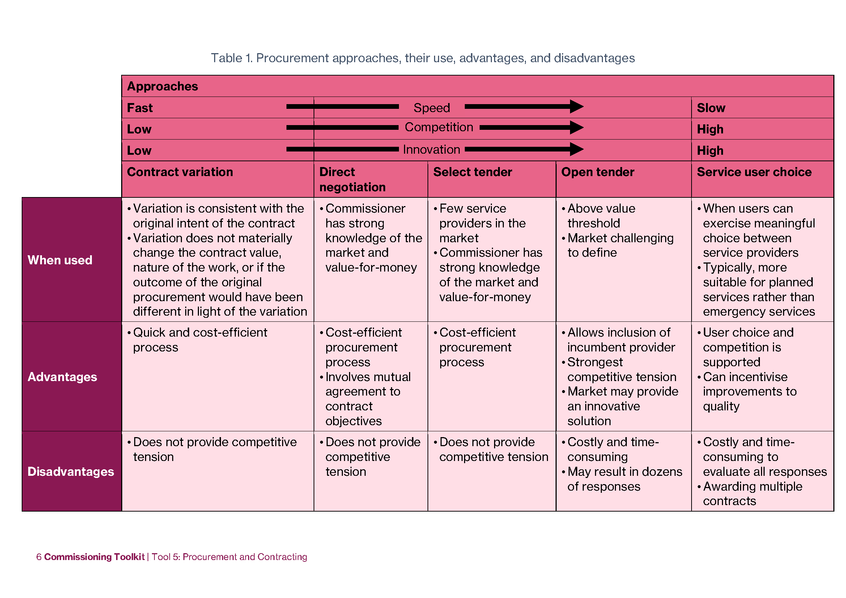

Prepare procurement plan
The steps and processes detailed within a procurement plan will be specific to the services we want to procure. The Western Australian government has produced the ‘Community Services Templates – Procurement Plan’. The template provides users with a detailed, time-dependent plan which includes the following sections:
- summary of the proposed procurement
- current service arrangements
- proposed procurement timetable
- risk analysis
- procurement research and planning
- procurement methodology and strategy
- contract management.
Within the procurement plan there is a series of recommended tasks, also found in a separate template - ‘Community Services Templates – Procurement Timeline Form’ which can be found in section 8.

4. Select suppliers

4.1 Develop a request document
Supplier selection encompasses multiple processes, from developing bid documentation, completing evaluations, and finalising contracts, to debriefing the market and other stakeholders. When creating a request document, there are several things we need to consider. It is recommended that commissioners:
- use plain language
- clearly delineate responsibilities
- fully describe the requirement.
The program logic developed in the Design Services tool provides a framework to describe the required services and the expected outcomes clearly.

4.2 Develop an evaluation plan
An evaluation process needs to take place to select the best service provider. Ideally, evaluation plans should be developed during the planning stage of the commissioning cycle as this allows a comprehensive evaluation to be incorporated into the design of the procurement process.
As per the Western Australian Procurement Rules, we should consider value for money through the evaluation process. To determine the best value, we must judge how the provider will improve outcomes, service user and service provider experiences, and equity while striving to deliver this at the lowest cost possible.
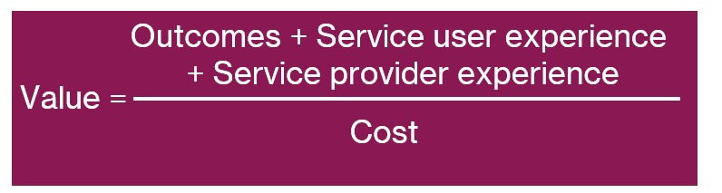
Figure 3. Value equation
The steps below outline what should take place during a procurement evaluation process:
Step 1: Define selection criteria
For a program’s desired outcomes to be delivered, we need to consider what aspects of the competing service providers will determine the successful delivery of a project and outcomes. Examples to consider include the following:
- previous relevant experience
- previous performance
- resources
- cost
- management and technical skills.
These criteria can then be further categorised into sub-criteria.
At times, there will be an extensive list of potential tenderers competing for a contract. When this occurs, it may be beneficial to incorporate ‘non-negotiable’ (or mandatory) criteria to aid shortlisting of suitable providers. In other words, the absence of a specific criterion may lead to the exclusion of these tenderers from the evaluation process.
Step 2: Define weightings
The evaluation team will assess which selection criteria reflect the most significant predictor of positive outcomes. This will be reflected as a percentage. If a criterion is expected to have a more substantial impact on the delivery of a project/outcomes, then a more significant portion will be allocated to it.
Step 3: Define the scoring of the criteria
Selection criteria may be absolute, qualitative or quantitative, so the scoring criteria must reflect this. Some requirements may be mandatory, and a pass/fail score can be applied to exclude some of the bids from the competition. For qualitative criteria, such as level of experience and past performance, the score can be allocated on a predetermined scale, e.g., 0 to 9.
Step 4: Calculating the score
Once the selection criteria have been chosen and weights and scores have been defined, the tender scoring process can begin. It is recommended that the evaluation team individually score the bids and then collaborate to form a consensus score for each criterion. Justifications for the score should be adequately documented. The score for each criterion is multiplied by the weight (%), and the sum provides a total score.
It is recommended that procurement evaluations assess the qualitative criteria separately and before the price criteria. By assessing qualitative and price components separately, evaluators can be confident that the evaluation panel is making value-for-money judgements knowing that both aspects have been considered impartially. The diagram below explains how this can work in practice:
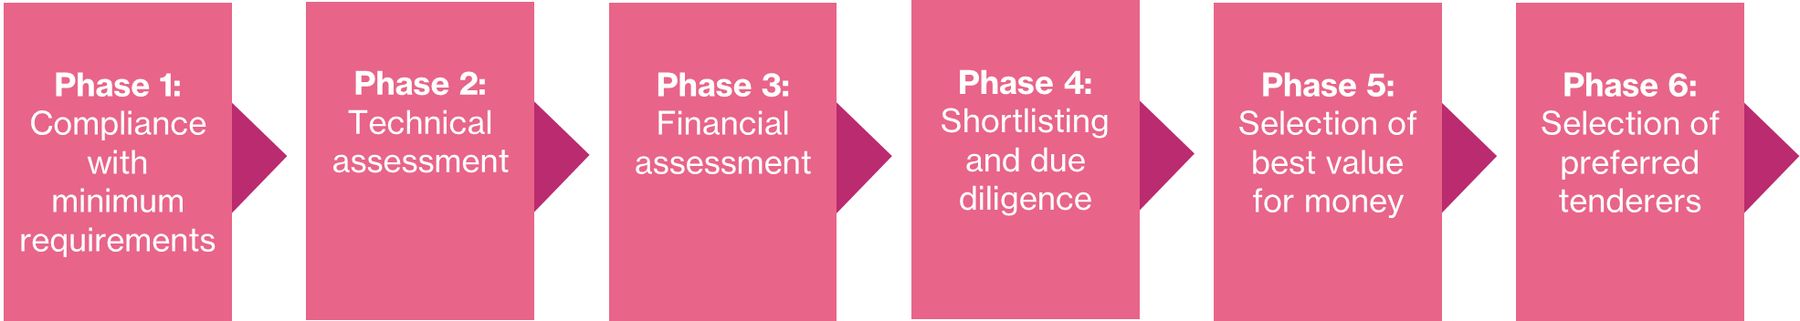
Figure 4. Diagram to demonstrate the various phases involved in the evaluation process

4.3 Pre-tender briefings to assist potential service providers
During the procurement and contracting phase of commissioning, we may wish to conduct pre-tender briefings to assist potential service providers to understand the requirements by facilitating a two-way clarification process.
It involves potential bidders being given the opportunity to attend a workshop. Relevant personnel from the evaluation team participate in the briefings with other people with technical, operational, commercial, legal and corporate knowledge to address bidders’ queries. Any matter raised in the briefing that is relevant to the requirements is shared with all tenderers by way of an addendum unless any case discussed is commercial in confidence for a tenderer.

5. Prepare for contracting

5.1 Identify scope and KPIs from the logic model
When preparing the contract, we rely on our logic model. The logic model will have identified the needs, inputs, activities, outputs and outcomes for a specific project or program. We can create Key Performance Indicators (KPIs) or service outcomes based on these logic model components. In turn, these indicators can become the foundations of our contract.
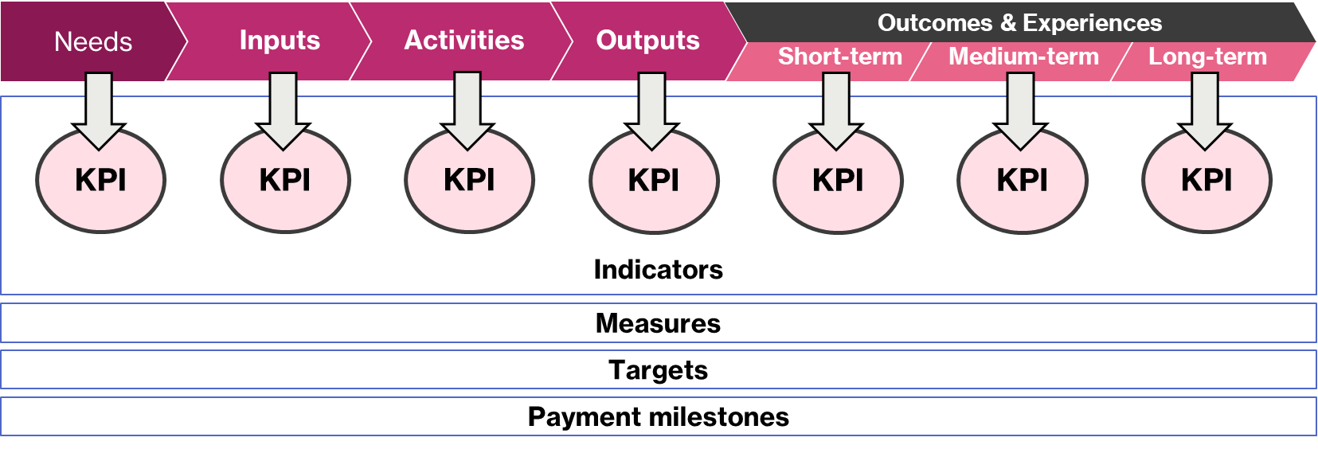
Figure 5. Logic model diagram illustrating how inputs, activities, outputs and outcomes can lead to the development of KPIs and how these can be incorporated into a contract.
Reporting outcomes performance ensures we understand whether the service effectively achieves the intended outcomes for the target cohort.

5.2 Collaborative approach to contracting
When contracting, commissioners should consider the importance of the following:
- Involving the selected service provider(s) in the development or refinement of the logic model: It is appropriate that the selected service provider has the opportunity to test and refine the logic model as it will inform the contract that they will be agreeing to.
- Working with service providers to define key performance indicators based on the program logic: Reporting between the service provider and commissioner will be most effective if there is an agreement between both parties as to what will be measured.
- Agree targets for performance: Setting targets through negotiation will strike the right balance between what is realistic for the provider and what the commissioner strives to achieve for the community.
- Execute a contract that both parties fully understand and are bought into: Commissioners can bring the perspective of what they envisage, and the provider can base the contract on the realities of what will happen on the ground.
- Commence performance monitoring of service delivery: Commissioners will get the best performance out of service providers if they adopt a mixture of contract and relationship management approaches.

6. Considerations for co-design and cultural safety

6.1 Service user representation in evaluation panels
Service users should be involved during the evaluation process. They can provide feedback through focus groups, interviews, and surveys. Ideally, we would include a service user representative within our evaluation panel. From the service user representative/s, we can collect valuable ideas and insights about whether proposed procurement strategies will meet the needs of service users. The service user representative can also provide a unique perspective on the viability and practicality of a potential provider’s tender submission.

6.2 Joint procurement with system partners
For best practice commissioning, government agencies across the whole system should collaborate through multiple stages of the commissioning cycle for an integrated response to the challenges our communities face. Although we may not have the infrastructure to practically provide joint commissioning across all system partners, we encourage agencies to communicate with each other to share ideas, challenges, and successes to improve efficiency across public services.
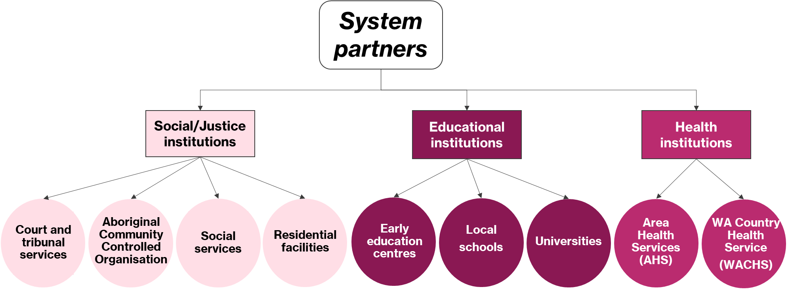
Figure 6. Examples of public service institutions we can consider as system partners.

7. Communicating intentions

7.1 Feedback to applicants
For unsuccessful bidders, a debrief provides an opportunity to:
- Relay positive feedback on the elements of their tender that received high scores
- Give constructive feedback on their response
- Show that the effort and time they took to develop a bid is appreciated.
Debriefing unsuccessful bidders provides an opportunity to maintain goodwill with the market and improve understanding between government agencies and service providers so service providers can better meet the requirements of future bids.
Providing feedback to the successful bidder is also helpful. It can give the successful bidder an understanding of what you value and insights into potential commissioning project/program risks and where they may need to focus their effort.

8. Links to resources

8.1 Western Australia Procurement Rules
To view the Western Australia procurement rules, visit here.

8.2 Delivering Community Services in Partnership Policy
To view the Delivering Community Services in Partnership Policy, visit here.

8.3 Community services template – Procurement plan
For a community services procurement plan template, visit here.

8.4 Community services template – Procurement timeline form
For a community services procurement timeline template, visit here.

8.5 Community services template – Declaration of confidentiality interest form
For a declaration of interest and confidentiality template, visit here.

