Implementing the National Principles for Child Safe Organisations
Case Study: Child Australia

Child Australia is a leading not-for-profit organisation that advocates for children, their families and sector professionals. We are committed to ensuring every child has the best possible start in life.
With operations across Western Australia and the Northern Territory, Child Australia works together with individuals, local communities, governments, our partners and other key stakeholders to improve developmental outcomes for children.

Project overview
As part of our commitment to becoming a child safe organisation, Child Australia reviewed our supervision and safety practices across our early learning and outside school hours care services.
The primary goal of this project was to assess policies, procedures, staff conduct, and programs with the aim of enhancing Active Supervision Practices among our staff teams and fostering a stronger culture of safeguarding children.
The project was initiated to reinforce the position, views, and stance held by Child Australia and communicate our organisation's legal, moral, and mission-driven responsibility to protect children and young people from harm. Additionally, the project sought to ensure that our responsibilities related to safeguarding, including protection, supervision, and safety, are effectively communicated, comprehended, and appropriately managed.
Child Australia commenced this project to ensure a shared understanding across the organisation and to encourage and promote individual accountability in safeguarding children.
The goal is to establish consistency across the organisation, ensuring that everyone shares the same core values, approach, and commitment to embedding child safety.
Aligning our organisation’s existing policies, practices and procedures to the requirements of the National Principles for Child Safe Organisations (National Principles) allowed us to identify our gaps and strengths. From this, we developed a roadmap for continuous improvement. Creating safer environments for children and upholding their rights continues to be the driving force of this project.
"The standard you walk past is the standard you accept.”
The project outcome is strongly aligned to:
- National Principle 1 – Child safety and wellbeing is embedded in organisational leadership, governance and culture.
- National Principle 3 – Families and communities are informed and involved in promoting child safety and wellbeing.
- National Principle 5 – People working with children and young people are suitable and supported to reflect child safety and wellbeing values in practice.
- National Principle 7 – Staff and volunteers are equipped with the knowledge, skills and awareness to keep children and young people safe through ongoing education and training.
- National Principle 10 – Policies and procedures document how the organisation is safe for children and young people.
“At Child Australia, the safety and wellbeing of children is our highest priority and we stand committed to the Principles of Child Safe Organisations. Our mission is not just to make a different but to ensure that every step we take in pursuit of our goals leaves no child behind and no child at risk.
We pledge to continuously strengthen our policies, practices, and culture, to uphold the highest standards of child safety, nurturing an environment where every child can thrive, learn, and reach their full potential.” – Tina Holtom, Child Australia CEO.

The journey
Child Australia is an approved provider of Early Learning Centres and Outside School Hours Care services operating across Western Australia and the Northern Territory.
Being an Approved Provider requires Child Australia to maintain compliance with the National Early Childhood Education and Care Law. Our services must also comply with National Quality Standards, which are aligned to the National Principles. To meet our obligations, Child Australia is required to develop and maintain robust policies and procedures that are reflected in educators practice, ensuring we safeguard children at all times.
As an organisation entrenched in a variety of activities supporting children, families, sector professionals and communities, our journey of becoming a child safe organisation is underway.
Child Australia is conducting a self-assessment process across all operations to identify gaps. This assessment aims to further refine our roadmap and will be reviewed by an independent third party. To date the self-assessment tool has assisted Child Australia to:
- Assess our current organisational culture, behaviours and practices.
- Reflect on the 10 National Principles and what we are doing well.
- Identify action areas requiring improvement or development.
- Celebrate positive changes with our teams.
- Implement effective organisation-wide communication messaging.
- Review our ongoing progress.
- Develop our Continuous Improvement Framework.
We have designed and developed resources for staff and visual posters for children, staff and the community.

Outcomes
To date the project has achieved several notable outcomes including:
- Increased awareness of the National Principles and a collaborative approach towards becoming a child safe organisation.
- Enhanced our Active Supervision Framework, ensuring all educators are highly skilled, informed, competent, and well-supported to ensure children's safety. New staff members undergo mandatory child protection and a range of organisation required training.
- Regular audit cycles to ensure compliance and currency with the organisation’s Safeguarding Children Framework.

Practical strategies in action
The following outlines some practical examples of how Child Australia implements the National Principles.

Supervision plans
Supervision Plans highlight identified high risk areas and provide instruction for educators on where to position themselves. They also detail what is required to ensure active supervision practices are implemented, ensuring all children are safe and visible at all times.
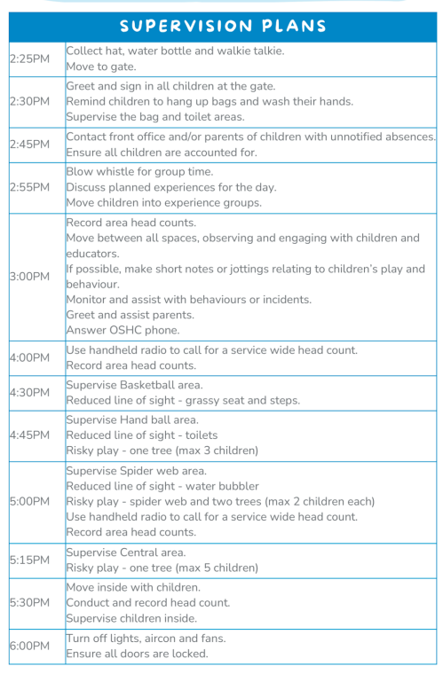
Image 1: An example supervision plan.

Active supervision strategies
- Positioning – prevent harm, see and hear all children, clear paths, additional support needs.
- Listen – specific sounds or absence of sound (systems like bells).
- Engage and redirect – use knowledge of each child’s development.
- Anticipate children's behaviour – interests, skills, risks (e.g. triggers, allergies, flight risks).
- Scan and count – always able to account for children, transitions.
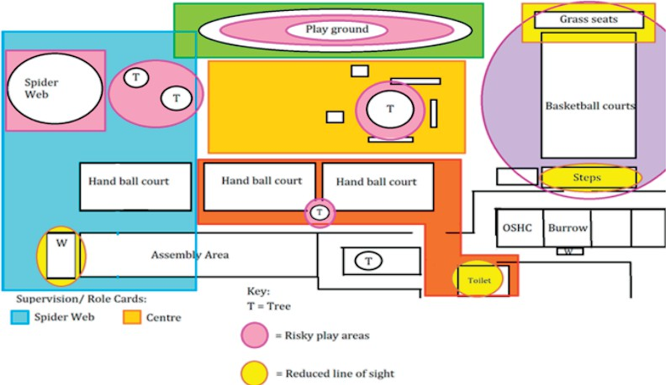
- Environment – activities grouped, waist height or lower, clutter free.
Image 2: Map showing example risk areas.

Professional learning
Ensuring training programs are based on the National Principles is crucial for safeguarding our most vulnerable members of society.
The National Principles provide a comprehensive framework that ensures a child’s wellbeing, protection, and development. By aligning training with the National Principles, we equip sector professionals and organisations with the knowledge and tools needed to create safer environments, prevent harm, and promote the healthy growth of our children.
It's not just about compliance; it's about nurturing a culture of child safety and creating a brighter, more secure future for the next generation. Child Australia offers professional learning for the Education and Care Sector on a range of topics including:
- Child Aware
- Supervision Essentials
- Enabling Environment
- Introduction to Child Protection
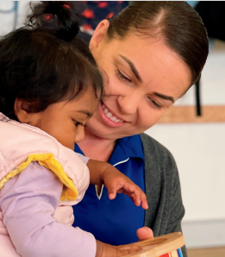
- Child Protection Champions.
Image 3: Photo of two Child Australia employees.
Image 4: A Child Australia employee with a child.

Sharing the learning
As a leading provider of professional development opportunities for educators within the education and care sector, Child Australia is deeply committed to sharing and promoting best practices to improve child safety sector wide.
By sharing our achievements and insights, our goal is to inspire other organisations to join us in our commitment to child safety. We especially aim to support smaller organisations that may face challenges in navigating the intricacies of child safeguarding.
Our experiences can serve as a valuable resource for all sector professionals, fostering a culture of child safety across the sector.

Next steps
Child Australia is deeply committed to fostering a culture of continuous improvement with a firm focus on ensuring a best practice child-safe culture throughout the organisation.
Our roadmap involves implementing more robust educational campaigns for all staff members.
To ensure the effectiveness of our efforts, we've enlisted the expertise of an external consultant to conduct a thorough review of our progress. This analysis will serve as a crucial guide for our future steps as we strive to achieve compliance with the 10 National Principles.

Last updated: 8 February 2024

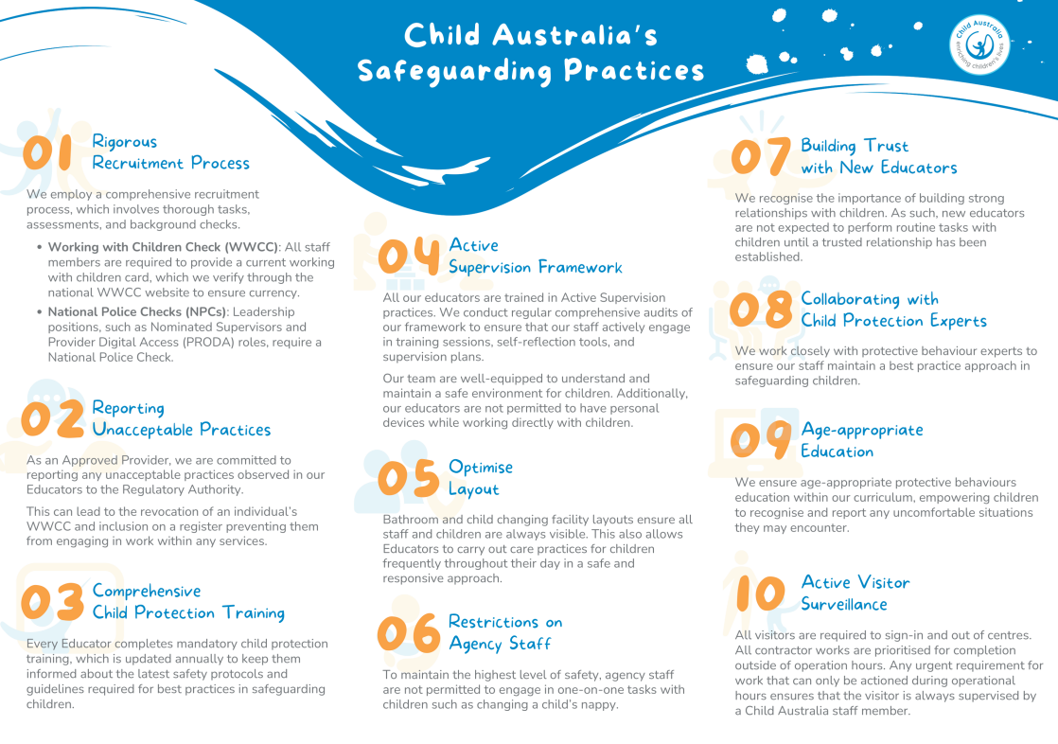
Image 5: A diagram of Child Australia's Safeguarding Practices.

