Implementing the National Principles for Child Safe Organisations
Case Study: Sexual Health Quarters
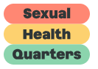
Sexual Health Quarters (SHQ) is a dynamic, non-profit organisation that works to educate, inform, and empower people to enjoy sexual health and relationship wellbeing.
The organisation has built a strong profile as the state's leading for-purpose sexual health provider, with its range of services including community education, professional training, clinical services, counselling and psychology, disability services, research, health promotion and advocacy.
As an organisation, our focus is on providing non-judgemental and culturally safe services that improve the reproductive and sexual health and relationship wellbeing of people of all ages, genders, cultures, beliefs, abilities and sexualities, with a focus on groups who may be vulnerable, marginalised or experience barriers to accessing services. This includes young people, people living with disability, people in justice or care system, Aboriginal and Torres Strait Islander communities, culturally and linguistically diverse communities, LGBTIQA+ communities, and those living in regional and remote areas.
SHQ has over 100 employees. We have a dedicated Youth Clinic on Thursday evenings. We are centrally located in Northbridge, WA (corner of Roe and Lake streets) close to Yagan Square Busport and Perth City Train Station.

Project Overview

Rainbow Tick Project (National Principle 4)
SHQ has implemented National Principle 4 of the National Principles for Child Safe Organisations: Equity upheld and diverse needs respected in policy and practice.
This principle examines how recognition of children and young people's diverse circumstances enables an organisation to work in a more child centred way and empowers children and young people to participate more effectively.
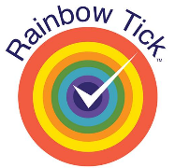
This has been achieved at SHQ through the organisation obtaining Rainbow Tick Accreditation.

The Journey
Given the nature of services provided by SHQ, ensuring that services are safe for people of all sexualities is a priority.
Rainbow Tick Accreditation was achieved in March 2022 for the following six standards:
- Organisational Capability
- Workforce Development
- Consumer Participation
- Welcoming and Accessible Organisation
- Disclosure and Documentation
- Culturally Safe and Acceptable Service.
All staff worked together to achieve Rainbow Tick Accreditation. Children, youth and adults also informed the project though our consumer engagement framework and consultation of our external reference groups. Our internal Queer and Ally (Q&A) Committee regularly met to discuss issues facing the LGBTIQA+ community and promote inclusion.
Our organisation and staff highly valued the Rainbow Tick Project. Some improvements and changes to our service included, pronoun pins, pronouns in email signatures, clients are asked their pronouns, inclusive facility signage, a staff glossary of terms and updates made to our health clinic information system.
SHQ has now progressed to consider the implementation of other National Principles. This process has commenced through completing a self-assessment of the organisation using the tool developed by the WA Commissioner for Children and Young People. The tool was found to be very useful although was time consuming to complete and required the dedicated attention of a senior staff member.

Outcomes
SHQ has an excellent reputation as an inclusive and diverse organisation. We are a leading provider of LGBTIQA+ Diversity and Inclusion education training across all sectors.
Our workplace is safe and affirming and we have been recognised and awarded for our culture of diversity and inclusion and for our consultation with young people.
We take immense pride in the reputation we have developed. We have mitigated risks to children in our health service.

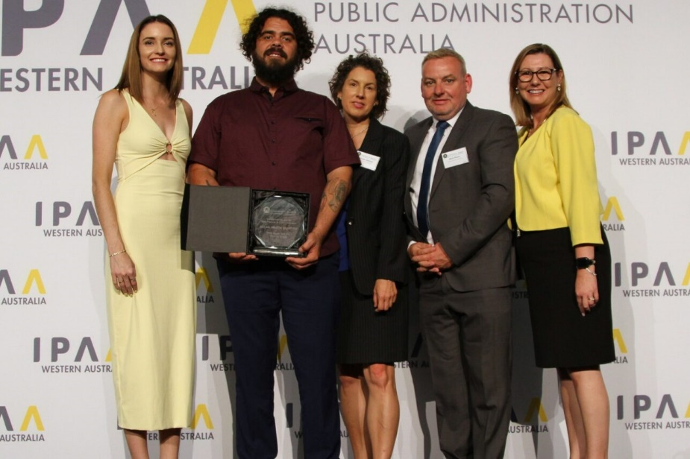
Sharing the learning
Image 1: Photo of SHQ staff.
SHQ states: “The Q&A Committee is wonderful. It is voluntary and staff join and leave when they wish. Meetings are held every 6 weeks. Be positive! Keep on! Mistakes will happen!
Undertaking the accreditation process has considered all aspects of organisational function including governance, practice and consultation with children and young people.
This recent experience will aid implementation of the National Principles by applying a similar approach.

Next steps
The implementation of the National Principles will continue in line with a plan developed through using the self-assessment and review tool.
SHQ will organise a cross-staff committee to aid in implementation of the National Principles.

Last updated: 26 February 2024

