Implementing the National Principles for Child Safe Organisations
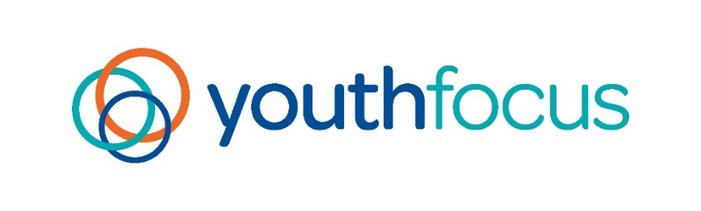
Case Study: Youth Focus

Established in 1994, Youth Focus is a leading not-for-profit organisation that delivers innovative and accessible mental health services and programs across Western Australia to help young people (12- 25 years old) to thrive.
Youth Focus provides services from eight metropolitan and regional offices, in Burswood, Bunbury, Peel, Albany and Meekatharra and as the lead agency at headspace sites in Albany, Midland, Geraldton and Northam. We also deliver services in schools, and in other locations in partnership with the communities in which we work.
Organisation size: Large (more than130 staff)

Project in brief
Youth Focus’ organisational purpose is aligned significantly with the National Principles for Child Safe Organisations (National Principles) in empowering young people to thrive in their communities, free of harm. We recognise that effective and ethical approaches to youth safety are crucial to achieving this.
As a result, Youth Focus aims to consistently and comprehensively assess our adherence to the National Principles; celebrating areas of alignment and transparently identifying opportunities for development.

The journey
As a youth mental health organisation, Youth Focus' commitment to the wellbeing of young people is well established throughout its purpose and practices. This represents a significant strength of the organisation and has motivated consistent progress toward the development of a youth safe culture and structure.
A key objective of our youth safety and wellbeing approaches has been to ensure that we are proactively meeting our responsibilities through value-aligned actions.
In addition to governance and literature reviews, we consulted a variety of stakeholders to gain insight into their experiences and understanding. Including:
- Four youth reference groups
- One carers reference group
- Three staff focus groups
- One child and youth disability peak body.
Although resource intensive, this feedback and information gathering provided invaluable information regarding our current approaches and informed several recommendations for improvement.
Sourcing training from external providers was a significant challenge. There appears to be few high-quality and contextually relevant options available to meet the ongoing educational needs of our cohort.

Outcomes
A more targeted engagement with the National Principles has been impactful for our organisation. As part of this journey, we have:
- Experienced a tangible increase in general understanding of youth safety and wellbeing and our safeguarding responsibilities.
“Everyone has a role to play in ensuring young people's safety…It is important that everyone engages in youth safe behaviours, regardless of whether you're a youth or not." – Youth Reference Group member
- Investigated and implemented Youth Safety training approaches for staff, contractors, and volunteers.
- Developed several key documents which facilitate and communicate our youth-safe governance, including Our Statement of Commitment, a Youth Safety and Wellbeing Policy, and our Youth Safe Behaviours (Code of Conduct).

Sharing the learning
Effective implementation requires dedication and resourcing through a person or team with the scope and capacity to drive progress.
For implementation to be embedded, a broad range of stakeholders need to be consulted. A steering committee with regular engagement throughout implementation would be helpful to guide decision-making.
The external resources available provide conceptual guidance. However, they are not specific enough to offer a structured framework. It has been more effective to view this as an internal project which requires extensive stakeholder engagement, collaboration, and fit-for-purpose approaches.

Next steps
Youth Focus intends to champion child safe culture and practices both internally and externally. We are committed to building and maintaining a culture with clear expectations and accountability.
We continue to integrate our youth safety and wellbeing strategies into ‘business as usual’, ensuring that all approaches are sustainable and consistent. We will continue to identify opportunities for improvement, including avenues to educate and upskill our team on youth safe culture, leadership, and clinical approaches.

Last updated: 6 March 2024

