Implementing the National Principles for Child Safe Organisations
Case Study: Department of Local Government, Sport and Cultural Industries

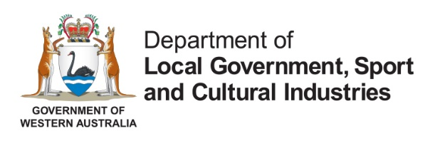
The Department of Local Government, Sport and Cultural Industries (DLGSC) is committed to enriching the lives of Western Australians (WA), supporting, and enhancing communities, and building and maintaining strong regulatory functions. We work collaboratively with government agencies, community organisations, peak bodies and other stakeholders to achieve our vision of creating a vibrant, inclusive and connected WA community.
The DLGSC provides services to children and young people through the five recreation camp facilities, and the operation of the State Library of WA, Art Gallery WA and WA Museum which children and young people attend. DLGSC also funds or oversees a range of other initiatives that involve engagement with children, including sporting and arts programs, community language schools, activities in local governments and multicultural events.

Project in brief
The DLGSC is working to implement the National Principles for Child Safe Organisations (National Principles) within the department. The DLGSC leadership is committed to embedding child safe practices and culture in the department to make sure we are keeping children who engage with our services and funded programs safe from harm.

The journey
In June 2022, DLGSC established a Child Safeguarding Implementation Unit (CSIU) to support DLGSC, its industry sectors, and partner organisations in implementing child safety reforms arising from the Royal Commission into Institutional Responses to Child Sexual Abuse.
It was recognised there is significant work required to integrate the National Principles into DLGSC’s own policies and practices, to implement other child safe reforms, and to genuinely embed child safeguarding into DLGSC’s culture. It is a long-term and ongoing process and a collective responsibility of all areas across DLGSC.
To begin this work, the CSIU convened a meeting of the DLGSC Child Safeguarding Working Group (Working Group). This group comprises representatives from each of the business and operational areas of DLGSC, including Local Government, Sport and Recreation, Culture and the Arts, the Office of Multicultural Interests, Racing, Gaming and Liquor, Corporate Services, Infrastructure and the Combat Sports Commission.
The Working Group collaboratively developed a Child Safe Actions Workplan (Workplan) that identifies specific and measurable actions, timeframes and the lead and support areas for each, within the four pillars of child safe reforms under which DLGSC has obligations: National Principles; Working with Children Checks; Reportable Conduct Scheme; and the National Redress Scheme.
The involvement of all business and operational areas in the development of the Workplan has been essential. It enabled agreement on lead and support responsibilities of areas to progress each of the actions in the Workplan. This supports shared ownership of the work to embed child safe practices and culture at DLGSC.
The Workplan was endorsed by the DLGSC Corporate Executive which has provided the authorising environment for each area to begin delivery of the actions for which they have lead responsibility.

Outcomes
The expected outcomes that will be achieved through the delivery of actions in the Workplan are to:
- build the capacity and capability of DLGSC to create safer environments and better outcomes for children through matured policies, processes, and practices
- lead a cultural shift which prioritises the safety of children, by empowering every level of DLGSC to implement child safe practices
- assist DLGSC to meet emerging and existing legislative and regulatory requirements
- enable DLGSC to demonstrate its commitment to child safety to its staff, stakeholders, sector partners and the broader community.

Sharing the learning
Engaging with each of DLGSC’s business and operational areas to seek input and understanding of its individual child safeguarding risks and needs was pivotal to the development of a comprehensive Workplan. It reinforces the message and approach that child safeguarding is a collective responsibility across the department and not the responsibility of one area, similar to the collective responsibility for workplace health and safety.

Next steps
The CSIU has recently developed a framework for monitoring and reporting to Executive on progress to deliver actions in the Workplan. This will involve a collaborative effort from all business and operational areas in DLGSC to track progress of the actions they lead or support and provide regular status updates on work to progress and deliver actions. It will also enable the CSIU and Working Group to identify and respond if actions are at risk of not being completed by their designated due date.
This regular monitoring and reporting on progress will enable DLGSC robust oversight of internal implementation of child safe reforms.

Last updated: April 2024

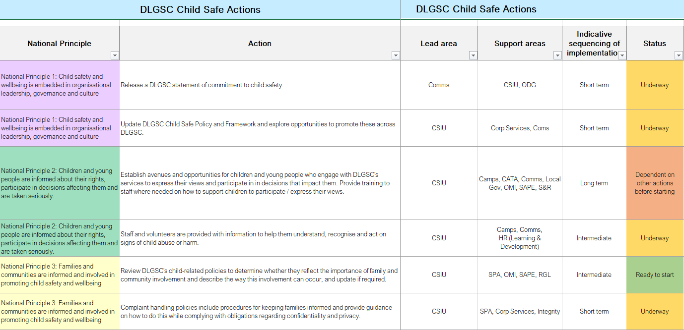
Figure 1. DLGSC Child Safe Actions Workplan

