# WESTERN AUSTRALIA IRON ORE PROFILE – March 2024

**Major global iron ore suppliers1**



Mt = Million tonnes. 1 Iron ore mined production.

Source: CRU, Iron Ore Market Outlook – Statistical Review – January 2024 (Quarterly).

* Western Australia is the largest iron ore supplier in the world, accounting for 39% of global supply in 2023, followed by Brazil (16%).
* China (13%), India (11%) and Russia (4%) are major global iron ore producers, but retain most of the iron ore they produce for domestic steel manufacturing.
* In 2023, iron ore supply from:
  + Western Australia rose 1% to 919 million tonnes
  + Brazil fell 1% to 387 million tonnes
  + China rose 1% to 295 million tonnes
  + India rose 28% to 249 million tonnes
  + Russia rose 2% to 92 million tonnes.
* Western Australia’s iron ore supply increased by 313 million tonnes between 2013 and 2023. The increase in supply from Western Australia was greater than the net increase in global iron ore supply between 2013 and 2023 (176 million tonnes) as supply from China and some other countries fell over this period.

**Iron ore demand1 in Asia**



Mt = Million tonnes. 1 Total iron ore consumption. (a) India and other Asian countries.

Source: CRU, Iron Ore Market Outlook – Statistical Review – January 2024 (Quarterly).

* Asia accounted for 81% of global iron ore demand in 2023. Among Asian countries, China (63%), India (9%), Japan (4%) and South Korea (3%) had the largest shares of global iron ore demand.
* In 2023, Asia’s iron ore demand increased 3.5% to 1,866 million tonnes. Within Asia, iron ore demand from:
  + China rose 2.7% to 1,441 million tonnes
  + Japan, South Korea and Taiwan combined rose 1.2% to 188 million tonnes.
  + The rest of Asia rose 10.8% to 237 million tonnes.
* CRU forecasts Asia’s iron ore demand will fall by 158 million tonnes between 2023 and 2028, with the forecast decrease in demand over this period from China (down 215 million tonnes) and Japan, South Korea and Taiwan combined (down 4 million tonnes) more than offsetting forecasted higher demand from the rest of Asia (up 62 million tonnes).

**Western Australia’s iron ore exports by market**



Mt = Million tonnes. (a) Includes mainly Vietnam, Indonesia, Singapore, Hong Kong (SAR of China), Malaysia and India.

1 Excludes China, Japan, South Korea and Taiwan.

Source: Based on data from ABS 5368.0 International Trade in Goods and Services, Australia (Monthly).

* Western Australia’s iron ore industry has established long‑term trade relationships across Asia. In 2023, Western Australia accounted for an estimated 65% of China’s iron ore imports, 50% of Japan’s iron ore imports and 69% of South Korea’s iron ore imports.
* In 2022-23, China accounted for 85% of Western Australia’s iron ore export volumes. The volume of the State’s iron ore exports to China rose 3% to 747 million tonnes in 2023.
* The volume of Western Australia’s iron ore exports to Japan, South Korea and Taiwan combined fell 8% to 115 million tonnes in 2023.
* The volume of Western Australia’s iron ore exports to all other countries1 fell 5% to 20 million tonnes in 2023.
* In January 2024, the value of Western Australia’s iron ore exports to:
  + China fell 10.4% to $10.2 billion
  + Japan, South Korea and Taiwan combined rose 10.0% to $1.8 billion
  + All other countries fell rose 35% to $292 million.

**Western Australia’s iron ore resources1**



1 Estimated as 87% of Australia’s economic demonstrated iron ore resources taken from Geoscience Australia’s Australia’s Identified Mineral Resources 2022. 2 US Geological Survey.

Source: Based on data from ABS 5204.0 Australian System of National Accounts (Annual).

* Western Australia has large iron ore reserves, accounting for an estimated 28% of the world’s crude iron ore reserves in 2023.2
* Western Australia had an estimated 51.7 billion tonnes of economic demonstrated iron ore resource in 2022‑23, which could sustain production for 62 years at 2022‑23 production rates.
* Western Australia’s reserves had an average iron content of 47% in 2023, the same as the world average of 47%.2
* The value of Western Australia’s exploration expenditure on iron ore rose 10% to $648 million in 2022-23.

**Total cash cost1 of global iron ore production2: 2023**



1 Total cash cost per dry metric tonne in US dollars, cost and freight (CFR). 2 Includes the ten largest iron ore producers only.

3 CRU, Iron Ore Market Outlook - Price tables – Jan 2024 (Monthly).

Source: S&P Global Market Intelligence (Annual).

* Western Australia’s iron ore miners are among the world’s lowest cost seaborne iron ore exporters.
* The average total cash cost of Western Australia’s iron ore exports was US$40.0 a tonne in 2023, below the world average of US$52.1 a tonne, and below its main competitor in Brazil (US$49.7 a tonne).
* Western Australia’s major iron ore ports are close to the largest iron ore markets in Asia, reducing shipping costs relative to some of its competitors.
* The iron ore freight rate for capesize vessels from Western Australia to China fell 16% to US$8.1 a wet tonne in 2023. The iron ore freight rate for capesize vessels from Brazil to China fell 17% to US$24.0 a wet tonne in 2023.3

**Western Australia’s iron ore sales**



Mt = Million tonnes.

Source: WA Department of Mines, Industry Regulation and Safety, Resource Data Files (Bi-Annual); and WA Government Mid‑year Financial Projections Statement 2023‑24 (December 2023).

1 S&P Global Market Intelligence.

* The volume of Western Australia’s iron ore sales rose 1.9% to 861 million tonnes in 2022-23.
* The WA Government Mid-year Financial Projections Statement 2023-24 forecasts Western Australia’s iron ore sales volumes will rise to 898 million tonnes in 2025‑26, before declining to 890 million tonnes in 2026-27.
* Western Australia produced mainly iron ore fines (73%) in 2023, followed by lump (23%) and concentrate (4%).1
* Western Australia’s major iron ore fines products in 2023 were FMG’s Chichester Hub Fines (97.3 million tonnes), BHP’s Mining Area C Fines (85.7 million tonnes) and FMG’s Solomon Hub Fines (66.7 million tonnes).
* Western Australia’s major iron ore lump products in 2023 were BHP’s Mining Area C Lump (36.1 million tonnes), Rio Tinto’s Brockman Lump (26.1 million tonnes) and Hancock Prospecting’s Roy Hill Lump (24.4 million tonnes).
* Western Australia also produced iron ore concentrates in 2023 from CITIC Pacific’s Sino Iron (19.5 million tonnes) and FMG’s Iron Bridge (10.9 million tonnes) operations.

**Iron ore price1**

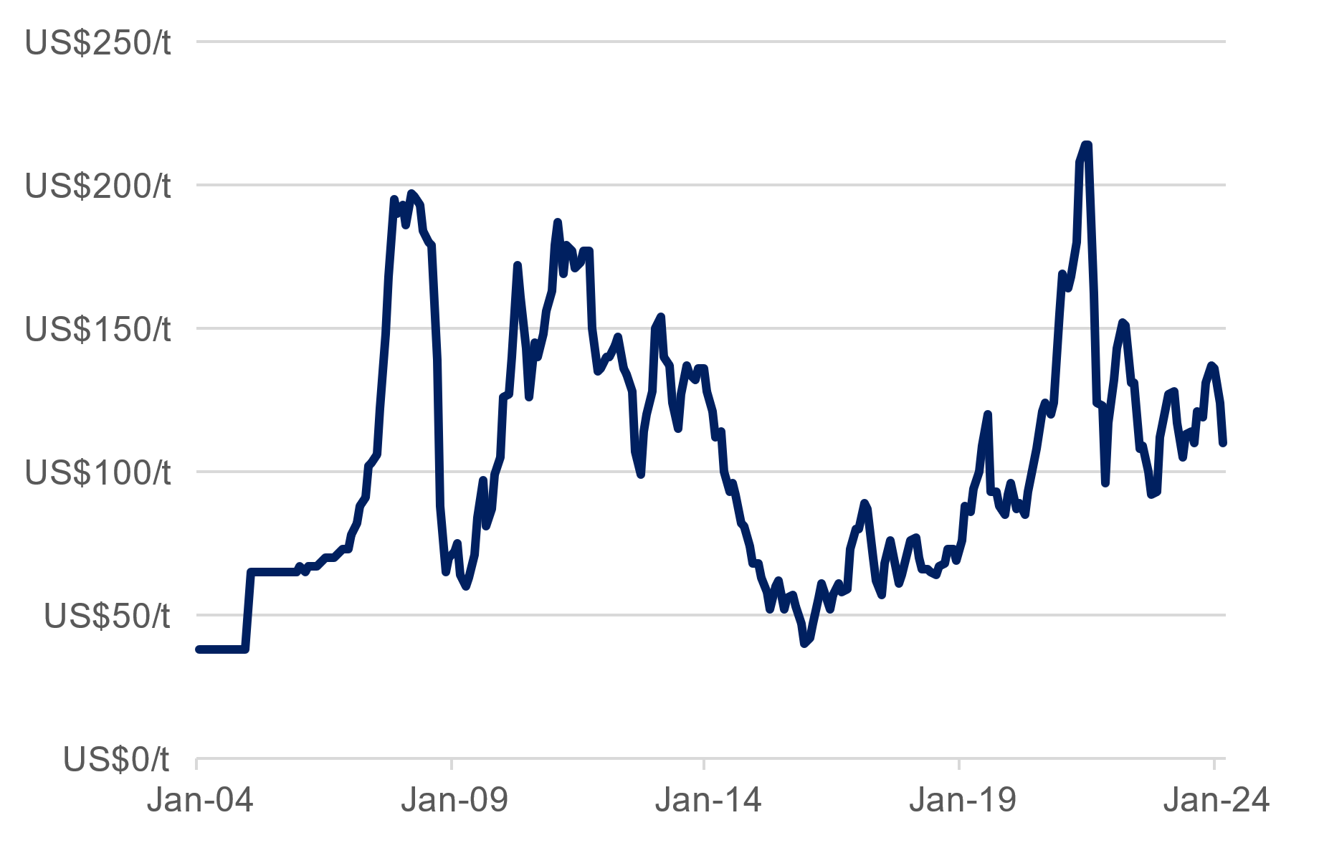

1 The monthly average benchmark (62% iron content) iron ore price delivered to China inclusive of cost and freight.

Source: World Bank, Commodity Markets (Monthly).

* The average monthly iron ore price fell 12% to US$109.8 a tonne in March 2024, continuing a fall from the recent high of US$137.05 reached in December 2023.
* Iron ore prices in 2023 were supported by the global recovery from COVID-19, particularly the reopening of China after a prolonged lockdown. However, weakening steel demand from China’s sizeable property and construction sector and uncertainty regarding the extent of China’s future stimulus spending on infrastructure have dampened expectations for iron ore demand and prices in 2024.
* Forecasts for the remainder of 2024 vary but many predict the iron ore price to settle lower than its current value, trading between US$90 and US$110 a tonne for the remainder of the calendar year.
* The WA Government Mid-year Financial Projections Statement 2023-24 forecasts the iron ore price will average US$104.2 a tonne in 2023-24, before returning to its long‑term annual average of US$66.0 a tonne in 2024‑25.

**Western Australia’s iron ore sales and royalty revenue1**



1 Actual royalty paid during the year. Regulation 86A of the Mining Regulations 1981 requires that royalties be paid within 30 days following the end of a quarter. As a result, cash receipts are necessarily offset by one quarter. Royalty income published in the State Budget (and associated financial statements) differ in value because they are recorded in the year that they are earned rather than paid. 2 Excludes North West Shelf Grants.

Source: WA Department of Mines, Industry Regulation and Safety, Resource Data Files (Bi-Annual).

* The iron ore industry is a large part of Western Australia’s economy, accounting for an estimated 28% of the State’s nominal gross state product in 2022-23.
* In 2023, iron ore accounted for 51% of the value of Western Australia’s exports of goods.
* The value of Western Australia’s iron ore sales fell 9% to $125.1 billion in 2022-23, in contrast to the compound annual growth of 8% over the past 10 years.
* Iron ore royalties in Western Australia fell 13% to $9.4 billion in 2022-23.
* In 2022‑23, iron ore royalties accounted for 84% of Western Australia’s royalty revenue2.
* The WA State Budget 2023‑24 forecasts iron ore royalty income will decline to $5.1 billion in 2026-27, based on the assumption, noted above, that the iron ore price will return to its long‑term annual average.

**Western Australia’s iron ore industry employment1**



1 Direct employment. Full-time equivalent (average on site).

Source: WA Department of Mines, Industry Regulation and Safety, Resource Data Files (Bi-Annual).

* Direct full‑time equivalent employment in Western Australia’s iron ore industry rose 2.5% (1,478) to 61,203 in 2022‑23.
* Iron ore accounted for 48% of direct full‑time equivalent employment in Western Australia’s minerals mining industry in 2022‑23 (excluding exploration).
* Western Australia’s largest employing iron ore mine sites in 2022‑23 were:
  + Roy Hill Operations (4,113 or 6.7% of iron ore employment in Western Australia)
  + FMG’s Solomon Operations (4,059 or 6.6%)
  + BHP’s Mining Area C (3,997 or 6.5%).

**Western Australia’s iron ore sales by major producer1**



Mt = Million tonnes. 1 Western Australian operations only. Inclusive of third party tonnes. Wet tonnes.

Source: Rio Tinto, BHP and Fortescue Metals Group Investor Information, Operations reports (Quarterly).

* Rio Tinto, BHP and FMG are the largest global iron ore producers behind Vale from Brazil.
* Rio Tinto’s iron ore sales volumes from Western Australia rose 3.2% to 332 million tonnes in 2023. Production guidance for 2023 is 320 to 335 million tonnes. Rio Tinto’s rail and port capacity is 360 million tonnes a year and it is developing new mines to enable its production to meet this capacity.
* BHP’s iron ore sales volumes from Western Australia fell 1.1% to 280 million tonnes in 2023. Production guidance for 2023‑24 is 254 to 264 million tonnes. BHP is expanding its port capacity to 330 million tonnes a year.
* FMG’s iron ore sales volumes from Western Australia fell 1.7% to 190 million tonnes in 2022-23 and its sales guidance for 2023‑24 is 192 to 197 million tonnes. FMG is expanding its port capacity to 210 million tonnes a year for the additional production from its Iron Bridge project.

**Major iron ore projects1 in Western Australia**

|  |  |  |  |  |  |
| --- | --- | --- | --- | --- | --- |
| Operator | Mine/deposit | Capex ($m) | Capacity (Mtpa) | Fe content2 | Start of operations |
| Recently completed | | | | | |
| FMG | Eliwana | 1,800 | 30 | 60 | 2020 |
| GWR Group | Wiluna West | 200 | 10 | 60 | 2020 |
| Atlas Iron | Sanjiv Ridge | 53 | 5 | 57 | 2020 |
| BHP | South Flank | 4,700 | 80 | 62 | 2021 |
| Rio Tinto | West Angelas C+D | 735 | n.a. | 62 | 2021 |
| Mt Gibson | Shine | 20 | 1.5 | 59 | 2021 |
| Rio Tinto | Western Turner Syncline 2 | 1,000 | 30 | 62 | 2021 |
| Rio Tinto | Gudai-Darri | 4,300 | 43 | 59 | 2022 |
| Rio Tinto | Robe Valley | 1,200 | n.a. | 62 | 2022 |
| FMG | Iron Bridge 2* | 5,600 | 22 | 67 | 2023 |
| Under construction or committed | | | | | |
| MRL | Onslow Iron | 2,500 | 30 | 58 | 2024 |
| Rio Tinto | Western Range | 3,000 | 25 | 62 | 2025 |
| BHP | Western Ridge Crusher | 943 | 25 | n.a | 2027 |

Mtpa = million tonnes per annum. n.a. – not available or not applicable. * Magnetite. 1 Includes mines and rail and port infrastructure. 2 Product grade if available, otherwise reserve grade for direct shipping ores.

Source: S&P Global Market Intelligence; CRU, Iron Ore Market Outlook – Project list; and company investor information (announcements, reports and presentations).

* Rio Tinto started developing its Western Range project in early 2023, with annual production of 25 million tonnes of iron ore expected to start in 2025. Rio Tinto has approved a $110 million pre‑feasibility study to progress development of the 40 million tonnes a year Rhodes Ridge project. The study is expected to be completed in 2025 and followed by a feasibility study. First ore from the initial development is expected by 2030.
* BHP completed its development of South Flank in May 2021, which is ramping up production to 80 million tonnes a year by 2024. BHP has announced approval for the Western Ridge Crusher Project, expected to deliver an average of 25 million tonnes of iron ore annually from 2027, replacing production volumes from other depleting orebodies around Newman.
* Fortescue Metals Group (FMG) has developed Iron Bridge (Magnetite) Stage 2. The project will produce 22 million tonnes a year of high‑grade magnetite concentrate.
* Construction on Mineral Resources Limited’s (MRL) Onslow Iron project began in August 2022. Iron ore shipments from the project are expected to start in June 2024.

**Western Australia’s iron ore exports by port**



Mt = Million tonnes.

Source: Based on data from ABS 5368.0 International Trade in Goods and Services, Australia (Monthly).

* Port Hedland, the world’s largest bulk export port, accounted for 60% of Western Australia’s iron ore sales volumes in 2023. The next largest ports in Western Australia for iron ore sales volumes in 2023 were Cape Lambert (20%) and Dampier (15%).
* In 2023, the volume of iron ore exports from:
  + Port Hedland fell 1% to 531 million tonnes
  + Cape Lambert rose 4% to 174 million tonnes
  + Dampier rose 3% to 131 million tonnes
  + All other ports rose 49% to 49 million tonnes.
* Rio Tinto expanded Cape Lambert and Dampier in 2015, raising annual capacity to 210 million tonnes and 150 million tonnes respectively.
* The Port of Port Hedland is planning to increase iron ore export capacity to 660 million tonnes a year. FMG has approval to expand its material handling capacity at Herb Elliott Port to 210 million tonnes a year.