Implementing the National Principles for Child Safe Organisations
Case Study: Anglicare WA

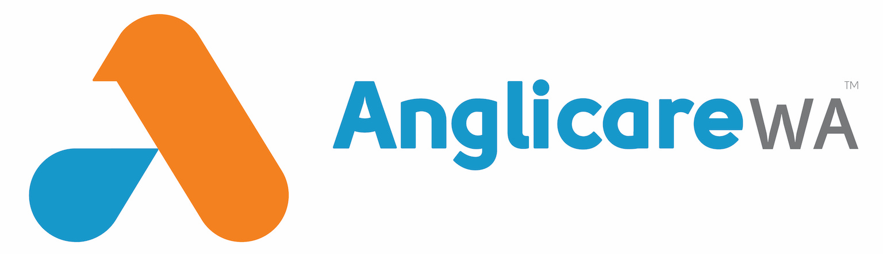
In 2022-23 Anglicare WA supported 24,973 children and young people through family domestic violence counselling, child sexual abuse therapy, Headspace, Child and Parent centres, family law services, women’s crisis accommodation, and housing/homeless services for young people.
Anglicare WA is a large organisation of over 700 staff and volunteers. In 2022-23 we delivered 104 services across 75 locations across metropolitan, regional, and remote locations.

Project in brief
Anglicare WA commenced its Child Safe Youth Safe (CSYS) Project in 2015 with its first CSYS Strategy developed in response to the initial findings of the Royal Commission into Institutional Child Sexual Abuse (Royal Commission). The objective was to implement all the National Principles for Child Safe Organisations to ensure that the organisation was safe for children and young people.
In 2020, Anglicare WA commenced a self-assessment process in preparation for an external audit to pursue accreditation. The CSYS Project over the next two years involved a core internal CSYS Project team with Primary Owners in various leadership positions. A Reference Group was established to oversee all the policies, procedures, and frameworks that were either developed or refined.

The journey
The journey required engagement from the whole organisation. The approach of focusing on structure and culture proved to be successful.
Organising the recommendations from the audit involved collating them into Areas of Focus with assigned Primary Owners for actioning. The CSYS Reference Group consisted of representatives across the state and tiers of leadership, both in corporate and service delivery, that provided important input and oversight.
Barriers were around assuring safeguarding structures and culture were strong in areas that are not involved in service delivery for children and young people. This required relationship building and authentic conversations about the ‘why’ and at times, explicit conversations around the case studies from the Royal Commission.
The culture shift and language around the CSYS Strategy and safeguarding overall is something Anglicare WA is proud of, alongside achieving accreditation. The buy-in from all areas felt like a ‘team’ approach supported by the Board and Executive team.
In areas such as our youth services programs, the voice of young people is a regular part of the feeding back into service delivery. Organisation-wide inclusion of the voice of children and young people occur through Client Voice, being a key part of the Strategic Plan with many projects underway. Anglicare WA chose a considered and place-based approach to capture the voice and input of children and young people.

Outcomes
Since the formal accreditation process, teams have continued to innovate and align to best practice, with strong responses to CSYS Advocate nominations. Identifying and responding to concerns of harm has also become more refined.

Sharing the learning
If we had to undergo the process again, it would be helpful to keep the CSYS Project team and Areas of Focus with Primary Owners together. This would share the workload, increase the depth of culture change and enable the refining and development of policies and frameworks to be fit-for-purpose.
A key message to share with others who may be at the beginning of the journey is that there is a lot of expertise and resources in the sector locally and nationally. There is a strong professional community that is committed to safeguarding – so networking and staying connected is useful so you can learn of different approaches and access support if feeling overwhelmed. The process will look different for your organisation!

Next steps
Anglicare WA is working on a series of place-based projects to include the voice of children and young people that is client-focused and trauma-informed. A particular focus is on the inclusion of vulnerable cohorts of children and young people, we will be looking at how to do this while reducing barriers to their participation.

