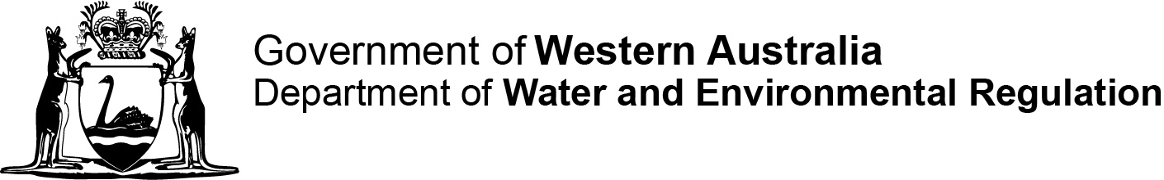
Ref No.
Contaminated sites auditor scheme
Contaminated Sites Regulations 2006 regulation 36(1)
Form A: Application for first time/primary accreditation
This form is for first time accreditation. Please also complete and attach forms D, E and F.

Part 1 Applicant details
Full name
Contact address
Postal address
(if different from above)
Telephone
Mobile
Email
Current employer
(company name)

Part 2 Required supporting information/documentation
This application will not be processed without the following documents being attached/completed.
 | Yes | No
Original statement addressing all relevant elements of the selection criteria detailed under sections 4 and 5 in Accreditation of Contaminated Sites Auditors (DWER, 2024) | ☐ | ☐
Copy of current curriculum vitae and certificates of educational/professional qualifications and membership of professional associations in Australia | ☐ | ☐
Project synopsis | ☐ | ☐
Form F, permission to reference client reports and copies of the relevant reports | ☐ | ☐
Payment details for the application fee ($440) | ☐ | ☐
Details of your current auditor [civil liability] insurance (refer regulation 59A of the Contaminated Sites Regulations 2006), or do you undertake to obtain such cover if the application is successful? | ☐ | ☐
Details of your supporting experts (refer Form D) | ☐ | ☐

Part 3 Declaration and signature
Under the Contaminated Sites Act 2003, s71, it is an offence to obtain or attempt to obtain accreditation as an auditor by:
- providing information which you know is false or misleading in a material particular
- providing information that is false or misleading in a material particular, with reckless disregard as to whether or not the information is false or misleading in material particular
- failing to disclose information that you know is materially relevant.
I declare that the information in this form, and provided with this form, is true and is not misleading in any material particular and that I have disclosed all information that I know is materially relevant to this application.

________________________________ Date Click here to enter a date.
(Applicant’s signature)
________________________________
(Full name in block capitals)

APPLICATION FEE FOR FIRST TIME/PRIMARY ACCREDITATION
Form A [r. 36(1)(c)]
Contaminated Sites Regulations 2006, regulation 36(1)
PAYMENT FORM / TAX INVOICE ABN: 28 420 443 065
PAYMENT METHOD
☐ | Credit card payment (online) – access DWER payment portal and select Contaminated Sites (Biller Code 1568872). Please include:  - Full name  - Company name  - Your reference  Before submitting the application, record the receipt number and payment date below.
Bpoint receipt no: |  | Date paid:
☐ | EFT/bank transfer – BSB: 066040 Account No: 018300113 Name of Bank: Commonwealth Bank of Australia  Please include in the description:  - Form A and your reference number  Please send remittance advice to: accounts.receivable@dwer.wa.gov.au and contaminated.sites@dwer.wa.gov.au
☐ | Cheque/Money order  - Make payable to Department of Water and Environmental Regulation
Email completed form to: info@dwer.wa.gov.au
If paying by cheque/money order, please mail completed form to:
Manager, Contaminated Sites Branch
Department of Water and Environmental Regulation
Locked Bag 10
Joondalup DC WA 6919
Important: If lodging your Form A by mail, please do not send cash through post.

