Western Australia Economic Profile – June 2024

Western Australia – Economic conditions
The Western Australian economy continues to operate at close to full capacity, but there are some signs that activity is slowing. State final demand fell in the March quarter 2024 and although labour utilisation remains high, average hours worked per employed people and job vacancies are trending down, and the value of engineering construction activity work in the pipeline may have passed its recent peak. The outlook for the Western Australian economy is still relatively positive, although current challenges associated with population growth and the housing market are likely to take some time to resolve.
State final demand
Western Australia’s state final demand fell 1.0 per cent in the March quarter 2024, the first quarterly contraction since the June quarter 2020 when the restrictions imposed to combat the spread of COVID-19 led to state final demand falling by 5.6 per cent. Unlike the COVID-19 pandemic, the contraction in the March quarter 2024 was not a shock, primarily reflecting private investment on major resource projects having passed a peak after high levels of activity during 2023. Household consumption and public final demand still grew in the March quarter 2024. Taking a longer view, in the year to the March quarter 2024, Western Australia’s state final demand growth was 5.5 per cent, the highest of all the states and territories.
Labour market
Employment in Western Australia reached a new high in May 2024, increasing by around 28,000 to 1.616 million people. There was also a 0.3 percentage point decrease in the unemployment rate to 3.6 per cent, with Western Australia reclaiming the title of having the lowest unemployment rate of all states and territories. Data on employment by industry shows the health care and social assistance industry accounted for a large share of the increase in employment over the past year, including workers in social assistance services, hospitals and allied health services. In contrast, average employment in the mining industry fell over the past year, although this was after particularly high growth over the two prior years.
Population and housing
Western Australia’s population is pushing 3 million people, having grown 3.3 per cent to 2.93 million in the year to December quarter 2023. Net overseas migration continues to drive population growth at both a state and national level, with ongoing net interstate migration also contributing to Western Australia having the highest population growth of all the states and territories.
High population growth has been one contributing factor to growth in house prices, with Perth’s median established house price increasing 21 per cent between the March quarters of 2023 and 2024. This was the highest rate of growth for all Australian capital cities.

Economic conditions – Contents

Whole of economy
State final demand
Commodity prices, interest rates and exchange rates
Consumer prices and household spending
Labour market – employment
Labour market – spare capacity and vacancies

Link to Economic structure and industries section
Labour market – wages
Population
Housing
Construction
International trade

Whole of economy
Back to contents

Gross state/domestic product (change)
Note – Chain volume measures. Original series. Annual change.
Source: Based on ABS data.
- Gross state product (GSP) is a measure of the total economic production of a state or territory and is the state/territory equivalent of a nation’s gross domestic product (GDP).
- In Australia, GDP estimates are produced on a quarterly basis, while GSP estimates are produced on a financial year basis.
- Western Australia’s GSP was less affected by the COVID-19 pandemic in 2019-20 compared to other states and territories and grew at a relatively consistent rate in the next three financial years.
- Western Australia’s real gross state product (GSP) rose 3.5% in 2022-23, higher than the growth of Australia’s real gross domestic product (GDP) of 3.0%.
- The WA Government State Budget 2024-25 forecast Western Australia’s real GSP would rise 1.75% in 2023-24 and 2.0% in 2024-25.

State final demand by component (contribution to change)
Note – Chain volumes measures. Seasonally adjusted series. Quarter-on-quarter change. pp = percentage points. (a) Private gross fixed capital formation. (b) General government final consumption expenditure and public gross fixed capital formation.
Source: Based on ABS data.
- State final demand (SFD) measures total consumption and investment by the private and public sectors. SFD accounts for most of Western Australia’s GSP – 62% ($274.6 billion) in 2022-23 – although this share is low compared to other states and territories due to net exports being particularly high for Western Australia.
- Western Australia’s SFD fell in the March quarter 2024, the first fall in SFD since the June quarter 2020 when SFD fell sharply due mainly to the restrictions imposed in the early phase of the COVID-19 pandemic.
- Western Australia’s real SFD fell 1.0% in the March quarter 2024, following growth of 1.2% in the December quarter 2023.
- Private investment detracted 1.5 percentage points from SFD growth in the March quarter 2024, more than offsetting the positive contributions of household consumption and public final demand to SFD growth.
- Western Australia’s real SFD rose 4.4% in 2022-23 and the WA Government State Budget 2024-25 forecast Western Australia’s real SFD would rise 5.25% in 2023-24 and 3.25% in 2024-25.

Interstate comparison of state final demand by component (contribution to change): March quarter 2024
Note – Chain volumes measures. Seasonally adjusted series. Change between the sum of the latest four quarters and the sum of the same quarters of the previous year. pp = percentage points. (a) Private gross fixed capital formation. (b) General government final consumption expenditure and public gross fixed capital formation.
Source: Based on ABS data.
- Western Australia’s real SFD grew 5.5% in the year to the March quarter 2024. This was the highest rate of growth of all the states and territories. The next highest rates of SFD growth over this period were in Queensland (2.9%), Australian Capital Territory (2.4%) and Victoria (2.3%).
- In the year to the March quarter 2024, contributions to Western Australia’s real SFD growth were:
- Private investment: 2.4 percentage points
- Household consumption: 1.7 percentage points
- Public final demand: 1.3 percentage points
- The contribution of private investment to real SFD growth in Western Australia in the year to the March quarter 2024 was significantly higher than in all other states and territories. The contribution of household consumption to real SFD growth was also the highest of all states and territories.

State final demand
Back to contents

Household consumption by component (contribution to change): March quarter 2024
Note – Chain volume measures. Seasonal adjusted series. Change between the sum of the latest four quarters and the sum of the same quarters of the previous year. pp = percentage points.
Source: Based on ABS data.
- Household consumption increased by 3.5% in real terms in the year to the March quarter 2024.
- Spending on transport services (up 20.5%) contributed the most to growth in Western Australia’s household consumption in the year to the March quarter 2024. Other leading contributors to growth in household consumption over this period were:
- rent and other dwelling services (up 2.5%)
- hotels, cafes and restaurants (up 6.9%)
- purchase of vehicles (18.8%).
- Spending on cigarettes and tobacco (down 12.2%) detracted the most from Western Australia’s household consumption in the year to the March quarter 2024, followed by recreation and culture (down 1.6%) and furnishings and household equipment (down 2.6%).

Private investment by component (contribution to change): March quarter 2024
Note –. Chain volumes measures. Seasonally adjusted series. Change between the sum of the latest four quarters and the sum of the same quarters of the previous year. pp = percentage points. (a) Non-residential buildings and other structures. (b) Transport equipment and other machinery and equipment. (c) Computer software, research and development, entertainment, literary or artistic originals, and mineral exploration. (d) Buildings or parts of buildings used as residences. (e) Fees, commissions, stamp duty and other government charges for transferring ownership of dwellings and non-dwelling constructions. (f) Livestock and plantations of trees yielding repeat products (e.g. vineyards and orchards).
Source: Based on ABS data.
- Private investment increased by 10.1% in real terms in the year to the March quarter 2024.
- Spending on non-dwelling construction (up 13.6%) contributed the most to growth in Western Australia’s private investment in the year to the March quarter 2024, followed by spending on machinery and equipment (up 9.8%), and intellectual property products (up 9.0%).
- The increase in non-dwelling construction, which consists of non-residential buildings and other structures, over the past year was largely driven by new engineering construction in mining and energy projects in Western Australia.

Public final demand by component (contribution to change): March quarter 2024
Note – Chain volumes measures. Seasonally adjusted series. Change between the sum of the latest four quarters and the sum of the same quarters of the previous year. pp = percentage points.
Source: Based on ABS data.
- Public final demand, which comprises local, state and federal government consumption and investment, increased by 4.8% in real terms in the year to the March quarter 2024.
- State and local government investment (up 22.4%) contributed the most to growth in the State’s public final demand in the year to the March quarter 2024, followed by federal government consumption (up 5.3%).
- State and local government consumption detracted the most from growth in the State’s public final demand in the year to the March quarter 2024 (down 0.4%).
- The increase in state and local government investment over the past year has been driven by Western Australian Government investments in large-scale road, rail, and utilities projects, including METRONET.

Commodity prices, interest rates and exchange rates
Back to contents

Indexes of commodity prices
Note – Index based on current prices in US dollars. Original series. May 2022 = 100.0. (a) China spot price per dry tonne of 62% Fe fines on a cost, insurance, and freight basis. (b) London afternoon fixing price per troy ounce of 99.5% fine. (c) Australia spodumene concentrate price per tonne on a free-on-board basis. (d) Japan liquefied natural gas import price per million British thermal units on a cost, insurance, and freight basis. (e) United States hard red winter Gulf export price per tonne.
Source: World Bank and S&P Global Market Intelligence.
- The prices for some of Western Australia’s main export commodities have fallen significantly from their peak values over the past two to three years. A recovery in global supply following various disruptions has been a common contributor to these price falls.
- In May 2024:
- The spodumene price was US$1,175.0 a tonne, 82% lower than its December 2022 peak as the new supply incentivised by the period of high prices has become available.
- The iron ore price was US$118.9 a tonne, 45% lower than its June 2021 peak, but up 5% from the previous month.
- The LNG price was US$11.8 per mmBTU, 50% lower than its September 2022 peak, and down marginally from April 2024.
- The wheat price was US$289.4 a tonne, 45% lower than the peak reached in May 2022 after global supply was disrupted following the onset of the Russia-Ukraine conflict.
- Gold has been an exception, with the gold price reaching another record monthly high of US$2,351.1 per troy ounce in May 2024.

Monetary policy interest rate
(a) Federal funds maximum target rate. (b) Policy rate. (c) Bank rate. (d) Refinancing rate. (e) Cash rate.
Source: RBA.

- Higher inflation has led to monetary authorities in many countries tightening monetary policy over the past two years to reduce aggregate demand and the rate of price growth.
- The Reserve Bank of Australia increased Australia’s official interest rate thirteen times between May 2022 and November 2023, with the cash rate increasing from 0.10% to 4.35%. At its most recent meeting in June 2024, the Reserve Bank Board decided to leave the cash rate unchanged at 4.35%.
- Monetary policy in the United States, United Kingdom and the Euro Area have followed a similar trajectory, with successive increases in interest rates from late 2021/early 2022 but being kept on hold from mid-to-late 2023 to May 2024 as inflation has eased. In June 2024, the European Central Bank announced it would cut interest rates by 25 basis points.
- Japan has been an exception, as it has experienced lower inflation than many other countries. The Bank of Japan increased interest rates for the first time in 17 years in March 2024. The policy rate remains at a very low 0 – 0.1%.

Australian dollar exchange rates
Note – Trade weighted index May 1970 = 100.0.
Source: RBA.
- The Australian dollar exchange rate is influenced by many factors, including the price of Australia’s main export commodities, and actual and expected differences in interest rates.
- The Australian dollar depreciated against the US dollar from early 2021 to mid-2023, due in part to a fall in commodity prices and the differential in interest rates between the United States and Australia.
- The Australian dollar averaged 66.4 US cents in May 2024, 1.7% higher than the previous month and 2.2% higher than one year ago.
- The trade-weighted index (TWI) is a broader measure of the Australian dollar against the currencies of its trading partners. The TWI accounts for a group of 17 foreign currencies based on their shares of trade with Australia.
- The TWI has been relatively stable over the past few years, as the depreciation of the Australian dollar against the US dollar has been offset by the appreciation of the Australian dollar against other countries, in particular the Japanese yen.
- The TWI in May 2024 was 1.4% higher than the previous month and 5.5% higher than one year ago.

Consumer prices and household spending
Back to contents

Consumer price index (change)
Note – Original series. All groups consumer price index 2011-12 = 100.0. Year-on-year change in quarterly index. (a) Weighted average of eight capital cities.
Source: Based on ABS data.
- After peaking at 8.3% in the December quarter 2022, the highest rate in 32 years, inflation in Perth has been falling, but is still high relative to most of the past 20 years.
- Perth’s annual inflation rate, as measured by year-on-year growth in the consumer price index (CPI), was 3.4% in the March quarter 2024, slightly lower than the year-on-year growth in Australia’s CPI (3.6%). Although there have been differences in individual quarters, Perth’s annual inflation rate has largely tracked the Australian rate over the past five years.
- The measure of Perth’s CPI in the WA Government’s State Budget excludes the electricity sub-index, to smooth out the effect of successive household electricity credits provided across the State. On this basis, the WA Government State Budget 2024-25 forecast Perth’s annual average CPI would rise 4.0% in 2023-24 and 3.0% in 2024-25.

Consumer price index by component (contribution to change): March quarter 2024
Note – Original series. All groups consumer price index 2011-12 = 100.0. Quarter-on-quarter change in index. pp = percentage points. (a) Weighted average of eight capital cities.
Source: Based on ABS data.
- Perth’s CPI increased 0.6% in the March quarter 2024, lower than the increase in Australia’s CPI of 1.0%.
- Education made the largest contribution to Western Australia’s CPI growth in the March quarter 2024 (up 4.9%). This was driven by higher primary and secondary school fees, and higher tertiary education course fees collected at the start of the year.
- Other CPI components that made contributions to Western Australia’s CPI growth in the March quarter 2024 included:
- health (up 2.4%)
- food and non-alcoholic beverages (up 0.9%)
- insurance and financial services (up 2.2%).
- Education also made the largest contribution to Australia’s CPI growth in the March quarter 2024 (up 5.9%), followed by health (2.8%), and housing (0.7%).

Household spending index (change)
Note – Current prices. Calendar adjusted series which accounts for trading day effects and length of month. Household spending index January 2019 = 100.0. Year-on-year change in monthly index.
Source: Based on ABS data.
- Growth in nominal household spending in Western Australia has moderated over the past year as pandemic-related disruptions have subsided and tighter monetary policy has affected consumer prices and household purchasing power.
- Western Australia’s household spending index increased by 4.2% in year-on-year terms in April 2024.
- The household spending index can be split between goods and services; as well as discretionary (non-essential) and non-discretionary goods and services.
- Growth in household spending has been higher on services compared to goods. The household spending index for services grew by 8.5% in year-on-year terms in April 2024, while the index for goods fell by 0.8%.
- Growth in household spending on non-discretionary goods and services continues to outpace growth in household spending on discretionary goods and services. The household spending index for non-discretionary goods and services grew by 7.9% in year-on-year terms in April 2024, while the index for discretionary goods and services fell by 0.6%.

Labour market – employment
Back to contents

Employment and total monthly hours worked (change)
Note – Seasonally adjusted series. 12-month rolling average for employed persons and total monthly hours worked. Year-on-year change in monthly series.
Source: Based on ABS data.
- Growth in annual average employment and total monthly hours worked in Western Australia has fallen from the very high rates of growth reached during the economic recovery from the COVID-19 pandemic. Employment growth has picked up in recent months, as net overseas migration has resulted in a large increase in Western Australia’s working age population.
- Western Australia’s annual average employment rose 3.6% to 1.58 million in May 2024, down from the record high of 6.5% growth in March 2022.
- The WA Government State Budget 2024-25 forecast Western Australia’s annual average employment would increase 3.75% in 2023-24 and 1.75% in 2024-25.
- Western Australia’s annual average monthly hours worked in all jobs rose 2.9% to 221.8 million hours in May 2024, down from the record high of 7.7% growth in February 2022.
- Growth in employment is now outpacing growth in hours worked, as the annual average of hours worked per employed person (per month) fell 0.7% to 140.6 hours in May 2024.

Employment by industry (change): June quarter 2024
Note – Original series. Change between the sum of the latest four quarters and the sum of the same quarters of the previous year. Data is collected for the middle month of each quarter (February, May, August and November).
Source: Based on ABS data.
- While employment growth during the economic recovery from the COVID-19 pandemic was reasonably broad based across industries, divergence in changes in employment by industry has emerged.
- Healthcare and social assistance (up 32,632 or 15.8%) had the largest rise in average employment between the four quarters to June 2023 and 2024, followed by retail trade (up 10,933 or 8.6%).
- Mining (down 8,038 or 5.0%) had the largest fall in average employment between the four quarters to June 2023 and 2024, followed by manufacturing (down 3,123 or 3.7%).

Participation rate
Note – Seasonally adjusted series. Monthly series.
Source: Based on ABS data.
- Western Australia’s participation rate rose from 68.5% in April 2024 to 69.2% in May 2024.
- Australia’s participation rate remained unchanged at 66.8% in May 2024.
- Western Australia’s participation rate has consistently been higher than Australia’s participation rate. The largest recorded difference was in October 2012 at 4.5 percentage points.
- Western Australia’s participation rate averaged 69.2% in 2022-23 and the WA Government State Budget 2024-25 forecast Western Australia’s participation rate would average 68.9% in 2023-24 and 68.8% in 2024-25.

Labour market – spare capacity and vacancies
Back to contents

Underutilisation rate
Note – Seasonally adjusted series. Monthly series. Underutilisation rate is the sum of the unemployment and underemployment rates. (a) Proportion of unemployed in the labour force (people without a job who are actively looking for work). (b) Proportion of underemployed in the labour force (workers wanting more hours).
Source: Based on ABS data.
- Western Australia underutilisation rate, which is the sum of the unemployment and underemployment rates, rose from 9.4% in April 2024 to 9.5% in May 2024.
- The rise in Western Australia’s underutilisation rate in May 2024 was driven by a rise in the underemployment rate, which offset the fall in the unemployment rate.
- The underemployment rate rose from 5.5% in April 2024 to 5.8% in May 2024.
- The unemployment rate fell from 4.0% in April 2024 to 3.6% in May 2024.
- Western Australia’s record low underutilisation rate was 6.9% in October 2008, when the unemployment rate was 2.3% and the underemployment rate was 4.6%.
- Western Australia’s record high underutilisation rate was 20.2% in April 2020 during the initial stages of the COVID-19 pandemic, when the unemployment rate was 6.1% and the underemployment rate was 14.1%.

Unemployment rate by region: December quarter 2023
Note – Smoothed seasonally adjusted series. Development commission regions.
Source: Jobs and Skills Australia.
- The unemployment rate was low across Western Australia’s regions in the December quarter 2023, except for the Kimberley.
- The Kimberley generally has the highest unemployment rate of Western Australia’s regions. However, the unemployment rate of 8.3% for the Kimberley in the December quarter 2023 was much lower than prior to the COVID-19 pandemic (16.2% in the December quarter 2019).
- Supportive conditions for mining and agricultural production have led to very low unemployment rates in Western Australia’s main mining regions (Pilbara, Goldfields-Esperance, and Mid West) and agricultural regions (Great Southern and Wheatbelt).

Internet vacancies by occupation group
Note – Seasonally adjusted series. Online job advertisements on SEEK, CareerOne and Australian JobSearch. Excludes job advertisements on other online job boards, employer web sites, newspapers, and word of mouth. (a) Community and personal services; clerical and administrative; sales; and other.
Source: Jobs and Skills Australia.
- Job vacancies in Western Australia fell significantly during the initial stages of the COVID-19 pandemic but increased sharply as the economy recovered and some employers had difficulty filling vacancies in an environment of constrained labour supply. Job vacancies have trended down over the past year but remain well above pre-COVID-19 levels.
- Western Australia had 30,163 internet job advertisements in May 2024, 0.3% less than the previous month and 9.0% less than one year ago.
- All the occupation groups in Western Australia had falls in job vacancies over the year to May 2024.
- Vacancies in machinery operators, drivers, and labourers fell the most, down by 10.9%.
- Managers and professionals fell by 10.8%.
- Technicians and trades fell by 8.6%.
- The other occupation group (which includes community and personal services; clerical and administrative; and sales) fell 5.9%.

Labour market – wages
Back to contents

Wage price index (change) and labour utilisation rate
Note – Current prices. Original series. Year-on-year change in quarterly wage price index. 2008-09 = 100.0. Right vertical axis does not start at zero. (a) Utilisation rate is the proportion of persons in the labour force not underutilised.
Source: Based on ABS data.
- Wage growth in Western Australia generally corresponds with the rate of labour utilisation; that is, when the rate of labour utilisation is high and spare capacity is low, employers offer higher wages to attract and retain workers.
- The labour utilisation rate increased sharply in the economic recovery from the COVID-19 pandemic, but it took some time for wage growth to respond. However, wage growth in recent quarters has been more in line with what has been experienced during previous periods of high labour utilisation.
- Wage growth in Western Australia, as measured by the year-on-year change in the wage price index, increased from 1.4% in the March quarter 2021 to 4.7% in the December quarter 2023, before dipping to 4.2% in the March quarter 2024.
- The WA Government State Budget 2024-25 forecast Western Australia’s annual average wages would rise 4.25% in 2023-24 and 3.75% in 2024-25.

Interstate comparison of wage price index (change) and utilisation rate: March quarter 2024
Note – Current prices. Original series. Year-on-year change in quarterly wage price index. 2008-09 = 100.0.
Source: Based on ABS data.
- Wage growth in Western Australia has been similar to other states and territories, reflecting relatively tight labour market conditions across Australia.
- Year-on-year growth in Australia’s wage price index in the March quarter 2024 was 4.1% and across the states and territories ranged from 3.2% in the Australian Capital Territory to 4.9% in Tasmania.
- The labour utilisation rate for Australia was 89.2% in the March quarter 2024, with a relatively small range across the states and territories (from 88.6% in Victoria to 91.6% in the Northern Territory).

Wage price index (nominal and real change)
Note – Original series. Nominal = index of current prices. Real = index of current prices deflated by all groups consumer price index for Perth. Year-on-year change in quarterly indexes. (a) Change in the all-groups consumer price index for Perth are multiplied by negative one, given inflation detracts from real wages.
Source: Based on ABS data.
- Although nominal wage growth has increased in Western Australia over the past three years, for most of this time the rate of inflation has been higher, resulting in falling real wages. The extended period of inflation being higher than nominal wage growth resulted in real wages falling back to a level previously seen in 2011.
- Real wages in Western Australia grew for the first time in almost three years in the December quarter 2023, as the rate of inflation dropped to its lowest level in over two years.
- In the March quarter 2024, the year-on-year change in the wage price index (4.2%) was higher than the year-on-year change in the consumer price index (3.4%).

Population
Back to contents

Estimated resident population (change)
Note – Original series. Year-on-year change in quarterly series.
Source: Based on ABS data.
- Western Australia’s population is growing at a high rate, relative to both the past fifteen years and to the national rate.
- Western Australia’s estimated resident population was 2.93 million in the December quarter 2023, 3.3% higher than the December quarter 2022.
- Australia’s estimated resident population was 26.97 million in the December quarter 2023, 2.5% higher than the December quarter 2022.
- Western Australia accounted for 10.9% of Australia’s population in the December quarter 2023.
- In the year to the December quarter 2023, Western Australia’s population grew by 93,771, with the increase comprising:
- net overseas migration of 68,503 (12.5% of the Australian total).
- natural increase of 14,559 (14.0% of the Australian total).
- net interstate migration of 10,709.
- The WA Government State Budget 2024-25 forecast Western Australia’s population would grow 2.8% in 2023-24 and 1.8% in 2024-25.

Net overseas migration
Note – Original series. Quarterly series. Overseas arrivals less departures.
Source: Based on ABS data.
- Western Australia’s net overseas migration has been significantly affected by the closing and then re-opening of borders during the COVID-19 pandemic.
- In the year to the December quarter 2023, Western Australia’s net overseas migration was 68,503, around one and a half times larger than in the year to the December quarter 2022.
- Net overseas migration was 14,105 in the December quarter 2023, down from the record high of 20,693 in the March quarter 2023.
- Western Australia’s share of Australia’s net overseas migration was 13.2% in the December quarter 2023, which is above the long-term average of around 12%.
- Western Australia’s share of Australia’s net overseas migration has fluctuated over time based on economic conditions in the State relative to other parts of Australia.

Interstate migration
Note – Original series. Quarterly series.
Source: Based on ABS data.
- Western Australia has had positive net interstate migration since mid-2020. This followed 25 quarters of negative net interstate migration from the March quarter 2014 to the March quarter 2020.
- In the year to the December quarter 2023, Western Australia’s net interstate migration was 10,709, with:
- 36,428 interstate arrivals
- 25,719 interstate departures.
- Net interstate migration was 2,589 in the December quarter 2023, higher than the 2,237 in the previous quarter.

Housing
Back to contents

Dwelling approvals and completions
Note – Seasonally adjusted series. Quarterly series.
Source: Based on ABS data.
- The number of dwellings completed usually tracks the number of dwellings approved with a lag as approved dwellings are built. However, the large increase in dwelling approvals in mid-2020 was not followed by a corresponding increase in dwellings completed.
- Stimulus measures introduced by the Australian and Western Australian Government in mid-2020 contributed to the number of dwelling units approved increasing rapidly from mid-2020, reaching 7,918 units in the March quarter 2021.
- Over the same period, the number of dwelling units completed plateaued, resulting in large number of approved dwelling units yet to be completed.
- Higher costs and longer timeframes for housing construction contributed to a slowdown in dwelling approvals, which has recently begun to reverse. There has been a pickup in completions, but the rate of completions remains below the long-run average.
- The number of dwelling units approved in Western Australia was 4,553 in the March quarter 2024, 39.8% higher than the March quarter 2023.
- The number of dwelling units completed in Western Australia was 4,373 in the December quarter 2023, 9.1% higher than the December quarter 2022.

House and rental price indexes
Note – Original series. Quarterly series. 2011-12 = 100.0.
Source: Based on ABS data.
- The combination of a surge in demand from high population growth and constraints in delivering new supply has resulted in increases in house and rental prices.
- Prices for new dwellings purchased by owner-occupiers in Perth rose 3.6% in the March quarter 2024, to be 12.1% higher than in the March quarter 2023.
- Perth’s rents rose 2.9% in the March quarter 2024, to be 9.9% higher than in the March quarter 2023.
- Rental prices in Perth started to grow rapidly on a yearly basis from 2021 as vacancy rates began to fall. Perth’s rental vacancy rate was 0.5% in May 2024.

Interstate comparison of median house prices: March quarter 2024
Note – Current prices. Original series. Quarterly series. Median price of established house transfers (unstratified).
Source: Based on ABS data.
- Despite recent increases, house prices in Perth are lower than most of the other Australian capital cities.
- Perth’s median established house price rose 4.5% to $700,000 in the March quarter 2024, the third lowest of all Australian capital cities.
- Sydney’s median established house price ($1.35 million) was the highest of all Australian capital cities, despite a 3.6% fall in the March quarter 2024.
- House prices in the rest of Western Australia are also lower than most of the other non-capital city regions of Australia.
- The median established house price for the rest of Western Australia (excluding Perth) rose 1.7% to $450,000 in the March quarter 2024, equal lowest (with South Australia) of all Australian regions.
- The WA Government State Budget 2024-25 forecast Western Australia’s median house price would rise 12.4% in 2023-24 and 4.5% in 2024-25.

Construction
Back to contents

Private new capital expenditure
Note – Current prices. Original series. Quarterly series. 4-quarter rolling sum. (a) All industries other than mining; agriculture, forestry and fishing; public administration and safety; and superannuation funds.
Source: Based on ABS data.
- Private new capital expenditure in Western Australia increased over the past year, in both mining and non-mining industries. In the year to the March quarter 2024, the value of Western Australia’s new capital expenditure in the:
- mining industry rose 18.7% to $31.5 billion
- non-mining industry rose 26.0% to $12.9 billion.
- Western Australia accounted for 24.6% of the value of Australia’s private new capital expenditure in the four quarters to the March quarter 2024, including 60.8% of Australia’s mining industry new capital expenditure and 10.0% of Australia’s non-mining industries new capital expenditure.
- Although private new capital expenditure in Western Australia has been increasing, the survey of expected expenditure suggests a downturn with the value of private new capital expenditure in the:
- mining industry expected to fall 17.6% in 2024-25
- non-mining industry expected to fall 12.5% in 2024-25.

Construction activity
Note – Current prices. Seasonally adjusted series. 4-quarter rolling sum. (a) Roads, highways and subdivisions; bridges, railways and harbours; electricity generation and transmission and pipelines; water storage and supply, sewerage and drainage; telecommunications; heaving industry; recreation and other structures. (b) Residential, commercial, industrial and other non-residential buildings.
Source: Based on ABS data.
- The value of engineering construction activity in Western Australia rose 28.6% in the four quarters to the March quarter 2024 to $29.5 billion. This was largely due to increases in the value of construction for:
- heavy industry (up 32.2%) to $16.5 billion
- bridges, railways and harbours (up 57.9%) to $3.3 billion.
- The value of building activity in Western Australia increased 14.8% to $13.9 billion in the four quarters to the December quarter 2023. The value of:
- residential building activity rose 14.7% to $8.1 billion
- non-residential building activity rose 15.0% to $5.8 billion.

Construction activity in the pipeline
Note – Current prices. Original series. Quarterly series. (a) Data just for Western Australia is not available for some quarters; the data presented here is the national total excluding all states and territories except for Western Australia and the Northern Territory. (b) Value of work remaining on jobs under construction at the end of the quarter. (c) Sum of the value of work remaining on jobs under construction and work not yet commenced at the end of the quarter.
Source: Based on ABS data.
- The value of engineering construction activity in the pipeline increased significantly in the late 2000s and early 2010s as investment was committed to several new iron ore and liquefied natural gas projects, and then fell as these projects were constructed. The pipeline of activity picked up in recent years with investment in a range of mining and energy projects, but the value of work in the pipeline may now have passed its peak.
- The value of engineering construction work yet to be done in Western Australia and Northern Territory^{(a)} fell 2.7% to $39.9 billion in the March quarter 2024.
- The value of building activity in the pipeline increased from mid-2020 to mid-2022, encouraged by stimulus measures introduced by the Australian and Western Australian Government, but has fallen in recent quarters as higher construction costs and interest rates have deterred new investment.
- The value of building activity in the pipeline in Western Australia rose 0.1% to $10.6 billion in the December quarter 2023, but was 11.4% lower than in the December quarter 2022 with the value of activity in the pipeline for:
- residential building down 22.0% to $5.5 billion
- non-residential building up 3.7% to $5.1 billion.

International trade
Back to contents

Exports of goods
Note – Current prices. Free on board. Original series. 12-month rolling sum.
Source: Based on ABS data.
- The value of Western Australia’s exports has surged in recent years, driven by high prices for iron ore, liquefied natural gas, battery and critical minerals and grains. With the prices for these commodities returning to longer-term averages, the value of Western Australia’s exports has fallen from its peak.
- Western Australia exported $255.3 billion of goods in the year to April 2024, 0.5% less than in the year to March 2024. In the year to April 2024:
- the value of iron ore exports was up 1.7% to $134.2 billion
- the value of non-iron ore exports was down 2.9% to $121.1 billion.
- The peak value of Western Australia’s exports over a 12-month period was $272.1 billion in April 2023. The peak value of Western Australia’s iron ore exports over a 12-month period was $162.2 billion in January 2022.

Imports of goods
Note – Current prices. Customs value. Original series. 12-month rolling sum. (a) Petroleum, petroleum products and related materials.
Source: Based on ABS data.
- The value of Western Australia’s imports increased significantly in 2022, driven by the higher oil price. Higher prices for a range of imported goods are keeping the value of Western Australia’s imports at an elevated level.
- Western Australia imported $51.1 billion of goods in the year to April 2024, 2.8% more than in the year to March 2024. In the year to April 2024:
- the value of petroleum imports was down 0.7% to $11.2 billion
- the value of non-petroleum imports was up 3.8% to $39.9 billion.

Shipping freight rates
Note – Current prices. Original series. Monthly series.
Source: Trading Economics.
- The Baltic Dry Index (BDI) measures the shipping cost of transporting raw materials over 20 different sea routes. The index is a composite of three sizes of cargo ships measured by deadweight (DWt) tonnage (or weight of cargo excluding the weight of the ship). The index is a useful global trade indicator because 90% of the world’s traded goods occurs via maritime transport.
- The BDI increased rapidly from mid-2020 to a peak in September 2021 as the global economy began to recover from the COVID-19 pandemic, which saw increasing demand for raw materials and manufactured goods.
- The BDI fell back to pre-COVID-19 levels in mid-2022 and has been volatile since, being as low as 681 in January 2023 and as high as 2,937 in November 2023. In May 2024, the index was 1,815.
- The containerized freight index (CFI) measures the cost of transporting goods in containers from China’s major ports.
- Similar to the BDI, the CFI increased rapidly from mid-2020, reaching a peak in December 2021 as the global economic recovery combined with disruptions in supply led to a large increase in container freight rates.
- The CFI also fell back to around pre-COVID-19 levels in late 2022 and appeared to have stabilised. However, in the six months to May 2024, the index more than tripled.

Western Australia – Economic structure and industries
The Western Australian economy has been shaped over time by the physical and geographical attributes of the State: its large land mass and coastline, extensive mineral and petroleum resources, and the distance between the State’s major population centres and other Australian and overseas cities. Over recent decades, Western Australia’s economy has also been shaped by national and global developments, notably domestic economic reforms and global policies such as trade liberalisation that encouraged the growth of industries in which the State has a comparative advantage. At the same time, economic development in China and other Asian countries with limited mineral and petroleum resources led to an increase in demand for the State’s export commodities, predominantly iron ore, but also liquefied natural gas and more recently battery and critical minerals.
These forces created a mining expansion in Western Australia that can be roughly broken down into three phases: an initial phase from the mid-to-late 2000s when higher demand led to an increase in commodity prices; an investment phase from the late-2000s to mid-2010s that was the supply response to higher demand and prices, and involved the construction of many large-scale resource projects; and a production phase from the mid-2010s after those projects become operational. The scale of new activity the mining expansion generated in Western Australia significantly changed the structure of the economy. In summary, the striking features of Western Australia’s current economic structure are the relatively high share of merchandise exports in its gross state product, the large share of these exports that go to China, and the mining industry’s high share of investment and gross state product.
The mining expansion contributed to Western Australia enjoying a sustained period of economic growth, often in excess of national levels. This included during the COVID-19 pandemic, when the mining industry in Western Australia was largely able to sustain production volumes and benefit from higher iron ore prices, while other economies with a higher reliance on services exports experienced a significant downturn when these exports were curtailed by travel restrictions.
However, the impact of Western Australia’s economic growth on household incomes has changed through the phases of the mining expansion. The investment phase required a significant domestic workforce, which boosted labour demand and wages, but the workforce requirements diminished once projects became operational. With the capital for mining projects being largely owned outside the State, and while commodity prices are high enough to generate substantial profits, a higher proportion of the income from Western Australia’s economic output now flows outside of the State. So, while in 2022-23 Western Australia’s gross state product per capita was 62 per cent higher than the Australian average, gross disposable household income per capita was only 10 per cent higher than the Australian average.
The mining industry will likely continue to make the largest contribution to Western Australia’s economic output of any industry for decades to come. However, the main driving force of the mining expansion – growth in China’s steel production from economic development and urbanisation – is receding, meaning that mining cannot be expected to contribute to economic growth in Western Australia in the future in the same way as it has for the past two decades. With the mining industry now accounting for a higher share of Western Australia’s gross state product, the State’s economy is also potentially more vulnerable to volatility in commodity prices than it was historically. Western Australia’s economy must also be able to adapt to other global challenges and shifts, including climate change, and imminent technological changes such as the increasing role of AI and automation.
In recognition of these challenges and the need to broaden the sources of economic growth, in 2019 the Western Australian Government released Diversify WA, a framework that identified priority sectors for strategic development that match Western Australia’s strengths with global trends. This was followed in 2023 by the release of Future State: Accelerating Diversify WA, which focuses on the most significant opportunities to drive international investment to Western Australia. At the same time, Western Australia – along with many other developed economies – is grappling with lower rates of productivity growth than were achieved in previous decades. With an ageing population and the largest gains from higher female labour force participation having been made, higher productivity growth across the economy will be required to sustain increases in per capita incomes.

Economic structure and industries – Contents
Gross state product
Per capita incomes
International trade (annual)
Productivity
Population (annual)
Environment
Industry gross value added
Industry investment
Industry employment
Mining and energy industries
Primary industries and defence industries
Tourism and international education
Regions

Gross state product
Back to contents

Gross state product by broad component
Note – Current prices. Original series. (a) Household and general government final consumption expenditure, and gross fixed capital formation. (b) Exports less imports of goods and services. Changes in state final demand can be exaggerated by large swings in business investment without adjusting for the associated changes in imports.
Source: Based on ABS data.
- Gross State Product (GSP) can be divided into state final demand, which measures total consumption and investment, and net (international) exports of goods and services.
- In 2022-23, the value of Western Australia’s:
- state final demand was $274.6 billion, 62% of GSP expenditure
- net exports of goods and services was $219.1 billion, 49% of GSP expenditure
- net interstate trade and other items detracted $48.3 billion (11%) from Western Australia’s GSP in 2022-23.
- The cycles of activity in the mining industry have had a significant effect on the balance of state final demand and net exports in Western Australia’s GSP over the past 20 years.
- Higher investment in mining projects led to state final demand increasing rapidly from the early 2000s to the mid-2010s.
- The newly installed productive capacity from this investment contributed to high growth in net exports from the mid-2010s.
- As projects were completed and the pipeline of new projects became smaller, the value of state final demand contracted between 2014-15 and 2018-19. However, growth has become more balanced since 2018-19.

Gross state product by component (share)
Note – Current prices. Original series. (a) Private gross fixed capital formation. (b) General government final consumption expenditure and public gross fixed capital formation. (c) Exports less imports of goods and services.
Source: Based on ABS data.
- Western Australia’s economy has become more reliant on international trade over the past 30 years. The GSP share of net exports of goods and services increased from 25% in 1992-93 to 49% in 2022-23, peaking at 52% in 2020-21 as merchandise exports remained strong during the COVID-19 pandemic.
- The GSP share of private investment has been influenced by cycles of mining investment. The share peaked at 36% in 2012-13 when construction activity on multiple iron ore and liquefied natural gas projects was at its height, but fell to 15% in 2022-23 as the mining expansion moved from its construction to the operation phase and output from these projects contributed to net exports.
- While household consumption and public final demand in Western Australia have grown over time, their share of the economy has fallen as net exports have grown at a faster rate. The GSP share of household consumption fell from 54% in 1992-93 to 30% in 2022-23, while the GSP share of public final demand fell from 24% in 1992-93 to 16% in 2022-23.

Comparison of gross state/domestic product of component (share): 2022-23
Note – Current prices. Original series. (a) Private gross fixed capital formation. (b) General government final consumption expenditure and public gross fixed capital formation. (c) Exports less imports of goods and services.
Source: Based on ABS data.
- The changes in Western Australia’s economy over the past 30 years means that it now has an economic structure that is quite different to the rest of Australia.
- Household consumption accounted for 50% of Australia’s gross domestic product (GDP) in 2022-23, much higher than its share of Western Australia’s GSP in 2022-23, but similar to the share of Western Australia’s GSP in 1992-93.
- Net exports of goods and services accounted for 5% of Australia’s GDP in 2022-23, demonstrating the extent to which Western Australia contributes to national merchandise exports. Western Australia accounted for 46% of Australia’s total goods exports in 2022-23.
- The GDP shares of private investment (18% in 2022-23) and public final demand (27% in 2022-23) are higher compared to their shares of Western Australia’s GSP, although this is partly explained by the high share of net exports in Western Australia’s GSP.

Per capita incomes
Back to contents

Gross state/domestic product per capita
Note – Current prices. Original series.
Source: Based on ABS data.
- Western Australia’s nominal GSP has grown at a faster rate than Australia’s nominal GSP over the past 20 years, resulting in a large gap between Western Australia’s GSP per capita and Australia’s GDP per capita.
- In 2002-03, Western Australia’s GSP was $196.0 billion, which was 11.0 per cent of Australia’s GDP. In 2022-23, Western Australia’s GSP was $445.3 billion, and its share of Australia’s GDP had grown to 17.4%.
- In 2002-03, Western Australia’s GSP per capita was $45,541, which was 11% higher than Australia’s GDP per capita of $40,968. In 2022-23, Western Australia’s GSP per capita was $157,390, 62% above Australia’s GDP per capita of $97,435.

Gross state product by factor income
Note – Current prices. Original series. (a) Compensation of employees. (b) Gross operating surplus and gross mixed income. (c) Ownership of dwellings; taxes less subsidies on production and imports; and statistical discrepancy.
Source: Based on ABS data.
- The growth of the mining industry in Western Australia has had a significant effect on the distribution of GSP across factor incomes (the returns to labour and capital).
- Higher commodity prices in the mid-2000s led to profits assuming a greater share of Western Australia’s GSP.
- The high labour demand from the construction of multiple major projects in the early to mid-2010s contributed to the share of wages and salaries in Western Australia’s GSP increasing back to 46% in 2015-16.
- The combination of these projects moving into a far less labour-intensive operational phase and high commodity prices led to profits again assuming a greater share of Western Australia’s GSP.
- In 2022-23:
- Wages and salaries were $146.0 billion (33% of GSP)
- Profits were $256.7 billion (58% of GSP)
- The ‘Other’ category (ownership of dwellings; taxes less subsidies on production and imports; and statistical discrepancy) was $42.7 billion (10% of GSP).

Gross household disposable income per capita
Note – Current prices. Original series.
Source: Based on ABS data.
- A high share of the capital that has generated large profits in recent years in Western Australia is owned outside the State. This means that a significant portion of the additional income from Western Australia’s recent GSP growth has flowed outside the State. As such, the difference in gross household disposable income per capita between Western Australia and Australia is a lot smaller than it is for gross state/domestic product per capita.
- Western Australia’s gross household disposable income per capita tracked largely in line with the national average from 1992-93 to 2001-02 but has been consistently higher than the national average since 2002-03.
- The gap was highest in 2013-14, during the construction phase of the mining expansion, when Western Australia’s gross household disposable income per capita was $55,140, 23% higher than the national figure of $44,798. The gap closed in the transition to the operational phase but has widened slightly in recent years from Western Australia’s relatively good economic performance through the COVID-19 pandemic.
- In 2022-23, Western Australia’s gross household disposable income per capita was $62,539, 10% higher than the national figure of $56,824.

International trade (annual)
Back to contents

Exports and imports of goods
Note – Current prices. Original series. Imports of goods are displayed as negative values given they detract from gross state product.
Source: Based on ABS data.
- Western Australia has a very large surplus in goods trade. High-volume production of minerals, energy and agricultural commodities generates significant revenue and the small domestic market for these commodities means much of that revenue is through exports.
- Between 1992-93 and 2022-23, the value of Western Australia’s goods exports increased by an average of 10% annually, driven by significant growth of mineral and petroleum exports (especially iron ore) over this period.
- The value of Western Australia’s goods exports was $275.1 billion in 2022-23 (46% of Australia’s total goods exports).
- Western Australia’s major imports are refined petroleum oils, motor vehicles, non-monetary gold (for further refining at the Perth Mint) and chemicals.
- Between 1992-93 and 2022-23 the value of Western Australia’s goods imports increased by an average of 8% annually.
- The value of Western Australia’s goods imports was $52.7 billion in 2022-23 (12% of Australia’s goods imports).

Exports and imports of services
Note – Current prices. Original series. Imports of services are displayed as negative values given they detract from gross state product.
Source: Based on ABS data.
- In contrast to its trade in goods, Western Australia usually has a deficit in its trade in services. The deficit emerged in the mid-2000s when growth in incomes led more Western Australians to travel overseas (an import of services).
- The restrictions on travel and trade associated with the COVID-19 pandemic led to a sharp fall in the value of both imported and exported services. This briefly returned the balance of services trade to parity in 2020-21, however the re-opening of borders has led to higher growth in services imports compared to services exports.
- In 2022-23:
- The value of Western Australia’s services exports was $6.4 billion (6.8% of Australia’s services exports)
- The value of Western Australia’s services imports was $9.7 billion (9.1% of Australia’s services imports).

Exports of goods by market
Note – Current prices. Original series. Free on board.
Source: Based on ABS data.
- The growth in Western Australia’s goods exports over the past 30 years has been largely due to higher demand from China, in particular for iron ore.
- In 1992-93, China accounted for 6% of Western Australia’s goods exports. In that year, Japan was the State’s largest export market, accounting for 29% of Western Australia’s goods exports, with South Korea accounting for 8%.
- China became Western Australia’s largest market for goods exports in 2006-07, overtaking Japan which had been the largest market since 1962-63.
- In 2022-23, Western Australia’s largest market for goods exports was China ($146.6 billion or 55%), followed by Japan ($36.1 billion or 13%) and South Korea ($19.0 billion or 7%). All other countries accounted for $67.3 billion or 25% of total merchandise exports.
- In 2022-23, Western Australia’s largest market for goods imports was China ($10.4 billion or 22%), followed by the United States ($5.3 billion or 11%) and Malaysia ($4.0 billion or 9%).

Productivity
Back to contents

Contribution to change in real gross state product from the three Ps
Note – Chain volume measures. Original series. Compound annual average change. pp = percentage points.
Source: Based on ABS data.
- The 3P framework provides an indication of the contribution to economic growth from changes in population, participation (hours worked per person) and productivity (GSP per hour worked).
- The 3Ps can work with or against each other. For example, economic growth can occur from investment which increases GSP per hour worked, creating higher wages which entice more people into the workforce and higher population growth through migration. In contrast, high population growth without investment growth can depress productivity through a lower capital to labour ratio.
- Growth in Western Australia’s gross state product over the past three decades was highest when the contribution of productivity was high. Between 1993-94 and 2012-13, while Western Australia’s population expanded relatively quickly, this was matched by increased levels of private investment, which contributed to steady productivity growth.
- Productivity growth has slowed noticeably in Western Australia over the past decade, a trend that has also occurred at the national level.

Multifactor productivity
Note – Chain volume measures. Original series. Gross value added based multifactor productivity indexes. Market sector industries only. Index 2020-21 = 100.0.
Source: Based on ABS data.
- Productivity can be considered in relation to different inputs.
- Labour productivity is the ratio of output to labour input, that is, the amount of output produced for an hour of work.
- Capital productivity is the ratio of output to capital input, that is, output per unit of capital.
- Multifactor productivity (MFP) is the ratio of a measure of output to a combined input of labour and capital.
- Analysing the contribution of labour and capital to productivity can be complex as:
- Changes in labour productivity can also reflect changes in capital, and changes in capital productivity in labour.
- There can be a lag between a discrete capital investment taking place and that capital starting to contribute to output. For example, many resource projects in Western Australia involve large capital investment which takes place over many years and then produce output over multiple decades.
- Western Australia’s multifactor productivity grew by 1.7% in 2022-23, after falling by 0.9% in 2021-22.

Net capital stock per capita (change)
Note – Chain volume measures. Original series. Index 2021-22 = 100.0. Annual change.
Source: Based on ABS data.
- The net capital stock is a measure of wealth representing the net present value of an economy’s assets. The net capital stock is the value of an economy's gross capital stock accounting for depreciation.
- Productivity growth has generally been higher in Western Australia and Australia when there has been a sustained increase in the net capital stock per capita as each worker on average has access to more productive capital.
- As mining activity expanded in 2000s, Western Australia’s net capital stock per capita increased rapidly relative to the national figures. Between 2005-06 and 2014-15, when private investment and capital deepening was at its peak, Western Australia’s net capital stock per capita grew at an annual average of 4.6%, compared to 2.0% for Australia over the same period.
- Net capital stock has been in decline in Western Australia since 2017-18. The move to the operational phase of the mining expansion, the depreciation of existing capital and increases in net overseas migration have contributed to capital shallowing.

Population (annual)
Back to contents

Population change by component
Note – Original series. Year-on-year change (as at June quarters). Estimated resident population. Components of population change may not sum to total population change because of intercensal difference. (a) Births less deaths. (b) Overseas arrivals less departures. (c) Interstate arrivals less departures.
Source: Based on ABS data.
- Western Australia’s population was 2.93 million in December 2023, which was 10.9% of Australia’s total population.
- From 1992-93 to 2022-23, annual population growth in Western Australia averaged 1.8%, above the national figure of 1.4% with:
- Western Australia’s highest growth of 3.2% in this period occurring in 2008-09
- Western Australia’s lowest growth of 0.6% in 2015-16.
- Net overseas migration has been the largest driver of population growth in Western Australia over the past 30 years, but annual levels have oscillated largely in line with expansion and contraction of the mining industry.
- Activity in the mining industry has also impacted net interstate migration, which was negative from 1999-00 to 2002-03, positive between 2003-04 and 2012-13, and then negative from 2013-14 and 2018-19. Net interstate migration was strongly positive in the three financial years to 2022-23, which reflects a myriad of factors including management of the COVID-19 pandemic, labour market opportunities and housing affordability.

Population by age cohort (share)
Note – Original series. Estimated resident population.
Source: Based on ABS data.
- Similar to the experience of many developed economies, Western Australia’s population has aged over the past 30 years, with increasing life expectancy and a decline in the fertility rate.
- In the period 1992-93 to 2022-23, the share of total population of:
- persons aged 0-29 years declined from 46% to 38%
- persons aged 30-59 years increased marginally from 40% to 41% (reaching a high of 43% in the early 2000s)
- persons aged 60 years and over increased from 14% to 22%.

Population by labour force status (share)
Note – Original series. Annual averages (a) Civilian population aged 15 years and over.
Source: Based on ABS data.
- Changes in the economy, demographics and the nature of work have led to long-term changes in the structure of the labour force. More flexible working arrangements have allowed more people to participate in the workforce on a part-time basis and periods of lower labour demand to be managed through reductions in hours worked rather than increases in unemployment.
- In 2022-23, of the civilian population aged 15 and over:
- 1.06 million (46%) were in full-time employment
- 459,000 (20%) were in part-time employment
- 56,000 (2%) were unemployed
- 720,000 (31%) were not in the labour force.
- Comparatively in 1992-93:
- 44% were in full-time employment
- 14% were in part-time employment
- 7% were unemployed
- 35% were not in the labour force.

Environment
Back to contents

Electricity generation by fuel type
Note – (a) Coal and oil (included multi-fuel fired power plants prior to 2013-14). (b) Wind, solar, biogas and hydro. Gigawatt hours.
Source: Department of Climate Change, Energy, the Environment and Water.
- The growth in Western Australia’s electricity generation was primarily through natural gas in the 2010s but is now increasingly through renewables.
- Western Australia’s total electricity generation was 44,478 gigawatt hours (GWh) in 2022-23, 16% of the Australian total.
- Mining and manufacturing accounted for 16,704 GWh of electricity generation in Western Australia in 2022-23, which equated to:
- 38% of Western Australia’s total electricity generation
- 65% of Australia’s total electricity generation for mining and manufacturing.
- Natural gas contributed 27,303 GWh in 2022-23, and its share of Western Australia’s total electricity generation increased to 61%, just below the peak share of 62% in 2019-20.
- Other non-renewables (principally coal) contributed 9,538 GWh in 2022-23, 21% of Western Australia’s electricity generation.
- The output of renewables has increased significantly in recent years growing from 2,998 GWh in 2016-17 to 7,637 GWh in 2022-23. In 2022-23, renewables accounted for 17% of Western Australia’s electricity generation, including wind (8%), small-scale solar (7%) and large-scale solar (2%).

Greenhouse gas emissions by sector
Note – Mt = million tonnes. Carbon dioxide equivalent AR5.
Source: Department of Climate Change, Energy, the Environment and Water.
- Western Australia’s net CO₂ equivalent emissions were 67.9 million tonnes (Mt) in 1992 and 82.5 Mt in 2022. Between these two years, Western Australia’s net emissions have ranged from 64.7 Mt in 1999 and 88.3 Mt in 2019.
- Of Western Australia’s emissions in 2022:
- energy contributed 81.7Mt
- agriculture contributed 9.7 Mt
- industry contributed 5.1 Mt
- waste contributed 1.9 Mt
- land use contributed an emissions reduction of 15.9 Mt.
- The emissions of the energy sector increased by 128% between 1992 and 2022.
- The most dynamic movement has come from the role of land use, which has evolved from contributing 16.4 Mt of emissions in 1992 to an emissions reduction of 15.9 Mt in 2022.

Interstate comparison of greenhouse gas emissions per dollar of gross state product
Note – Kilograms of carbon dioxide equivalent per dollar of gross state product (chain volume measures).
Source: Department of Climate Change, Energy, the Environment and Water.
- While total greenhouse gas emissions have increased in Western Australia over the past 30 years, the emissions intensity of economic activity has declined, as it has in other Australian states.
- Using the measure of emissions in kilograms of carbon dioxide equivalent per dollar of real GSP, between 1990-91 and 2020-21:
- New South Wales emissions intensity fell from 0.53 to 0.20, a reduction of 62%.
- Western Australia’s emissions intensity fell from 0.73 to 0.22, a reduction of 70%.
- Queensland’s emissions intensity fell from 1.55 to 0.38, a reduction of 76%.

Industry gross value added
Back to contents

Contribution to change in real gross state product by industry
Note – Chain volume measures. Original series. Compound annual average change. pp = percentage points. (a) Ownership of dwellings, balancing item and statistical discrepancy.
Source: Based on ABS data.
- The mining industry has made a consistent contribution to GSP growth over the past 30 years, but the different phases of the mining industry’s expansion has affected the contribution to growth from other industries.
- GSP growth was relatively well-balanced in Western Australia until the mid-2010s, with mining industry output increasing together with output from other industries. Investment in new projects led to growth in the construction industry, and the labour-intensive nature of this phase of the mining industry’s expansion had spillover effects into other industries.
- The end of construction on many major projects led to further increases in mining output as projects became operational. However, it also meant the construction industry was a drag on GSP growth from 2014-15 to 2019-20. The less labour-intensive nature of the operational phase also had implications for economic activity in other industries.
- Western Australia’s GSP growth has become more balanced in recent years as increases in mining output have become more modest and the economic recovery from the COVID-19 pandemic has benefited a range of industries.

Industry gross value added
Note – Current prices. Original series.
Source: Based on ABS data.
- Industry gross value added (GVA) is a measure of the additional value created by an industry in the production of goods and services. The nominal value of GVA is influenced by both the volume of production from an industry and the prices at which it sells goods and services.
- Over the past 30 years, both the volume of the mining industry’s production and the average prices it has received for that production have increased significantly. Mining industry GVA increased from $7.2 billion in 1992-93 to $200.0 billion in 2022-23. The mining industry’s share of GSP grew from 16% in 1992-93 to 45% in 2022-23.
- The GVA of all services industries increased from $20.3 billion in 1992-93 to $149.1 billion in 2022-23.
- Although the GVA of the agriculture, forestry and fishing, and manufacturing industries has increased, as more resources have been allocated to mining, the GSP share of these industries has fallen.

Industry gross value added: 2022-23
Note – Current prices. Original series.
Source: Based on ABS data.
- Goods-producing industries accounted for 58% ($257.7 billion) of Western Australia’s GSP in 2022-23, including:
- mining (45% or $200.0 billion)
- construction (5% or $22.8 billion)
- manufacturing (4% or $18.4 billion)
- agriculture, forestry and fishing (2% or $11.1 billion).
- Services industries accounted for 33% ($149.1 billion) of GSP in 2022-23, including:
- healthcare and social assistance (5% or $20.5 billion)
- professional, scientific and technical services (4% or $19.3 billion)
- transport, postal and warehousing (3% or $14.4 billion)
- finance and insurance (3% or $14.1 billion).
- Dwelling ownership and other items accounted for the remaining 9% of GSP in 2022 23.

Industry investment
Back to contents

Contribution to change in gross fixed capital formation by industry
Note – Chain volume measures. Original series. Compound annual average change. pp = percentage points. (a) Dwellings and ownership transfer costs.
Source: Based on ABS data.
- The capital-intensive nature of the mining industry means that cycles of mining investment have had a significant impact on changes in gross fixed capital formation (investment) in Western Australia.
- Between 1993-94 and 2002-03 investment was distributed relatively evenly with mining investment growing from $7.8 billion to $10.4 billion while non-mining investment grew from $7.2 billion to $12.7 billion. Other investment, in the form of dwellings and other ownership transfer costs, made up a proportionally larger share of total investment at this time.
- Over the decade to 2012-13, mining investment grew rapidly. There was a complementary increase in investment in non-mining industries.
- The slowdown in mining investment over the next decade coincided with a slowdown in non-mining investment, although the less capital-intensive nature of non-mining industries meant this slowdown was less pronounced.

Gross fixed capital formation by industry
Note – Current prices. Original series.
Source: Based on ABS data.
- Prior to the large expansion in the mining industry in the 2000s, investment was more evenly distributed across industries in Western Australia. In 1999-00, the mining industry accounted for 21% of total investment in Western Australia.
- Mining overtook non-mining industries in total value of investment in 2006-07. This was followed by a large spike in mining industry investment, peaking at $62 billion (64% of total investment) in 2012-13 before falling significantly over the following five years. By 2018-19, mining investment had returned to near parity with non-mining investment.
- From 2018-19, there has been steady growth in investment in both mining and non-mining industries, potentially providing a more balanced platform for growth for the Western Australian economy.

Industry gross fixed capital formation: 2022-23
Note – Current prices. Original series.
Source: Based on ABS data.
- The mining industry accounted for 43% ($35.3 billion) of Western Australia’s investment in 2022 23, followed by:
- transport, postal and warehousing (8% or $6.9 billion)
- electricity, gas, water and waste services (4% or $3.3 billion)
- public administration and safety (4% or $3.0 billion).
- The largest increase in Western Australia’s investment in 2022-23 was in mining (up $4.0 billion or 13%), followed by transport, postal and warehousing (up $1.1 billion or 19%).
- The largest decrease in Western Australia’s investment in 2022-23 was in rental, hiring and real estate services (down $155 million or 13%), followed by administrative and support services (down $21 million or 14%).

Industry employment
Back to contents

Contribution to change in employment by industry
Note – Original series. Pp = percentage points. Compound annual average change.
Source: Based on ABS data.
- While the Western Australian economy went through a period during which growth in investment and economic output was dominated by the mining industry, as a less labour-intensive industry, mining has not made as large a contribution to employment growth in Western Australia. However, changes in employment in the mining and construction industries do tend to have flow-on effects to employment in other industries in Western Australia.
- The contribution of the mining and construction industries to employment growth was most pronounced in the decade to 2012-13 during the height of the mining expansion. In this period, total employment in Western Australia grew by 3.2% with the mining and construction industries combining to contribute 1.2 percentage points of this increase.

Industry employment
Note – Original series. Annual average employed persons. (a) Agriculture, forestry and fishing; manufacturing; construction; and electricity, gas, water and waste services.
Source: Based on ABS data.
- Over the past 30 years, the main changes in the composition of Western Australia’s employment have been the growth in employment in mining, construction and services industries and the declining share of employment in manufacturing and agriculture.
- In 1992-93 the largest employers by industry in Western Australia were retail trade (11% of total employment), manufacturing (11%) and healthcare and social assistance (9%).
- Manufacturing was overtaken in its contribution to total employment by construction in 2005-06, and mining in 2010-11. The manufacturing industry’s share of total employment in Western Australia in 2022-23 (6%) was just over half of its share in 1992-93.
- The agricultural industry in Western Australia has become more capital intensive and more productive, so despite increases in output, it has required fewer workers. The agriculture, forestry and fishing industry’s share of total employment in Western Australia fell from 6% in 1992-93 to 2% in 2022-23.

Industry employment: 2022-23
Note – Original series. Annual average employed persons.
Source: Based on ABS data.
- Services industries accounted for 72% of Western Australia’s employment in 2022-23, including:
- healthcare and social assistance (13%)
- retail trade (8%)
- education and training (8%).
- Goods producing industries accounted for 28% of Western Australia’s employment in 2022-23, including:
- mining (10%)
- construction (9%)
- manufacturing (6%).

Mining and energy industries
Back to contents

Minerals production: 2023
Commodity | Unit | WA | AUS | World | WA share of AUS | WA share of world
Lithium | Kt | 92 | 94 | 193 | 97% | 47%
Garnet | Kt | 325 | 325 | 900 | 100% | 36%
Iron ore | Mt | 860 | 870 | 2,454 | 99% | 35%
Rutile | Kt | 108 | 200 | 558 | 54% | 19%
Zircon | Kt | 173 | 500 | 1,600 | 35% | 11%
Alumina | Mt | 13 | 19 | 137 | 68% | 9%
Rare earth oxides | Kt | 29 | 29 | 364 | 100% | 8%
Gold | t | 211 | 292 | 3,022 | 72% | 7%
Salt | Mt | 12 | 14 | 274 | 83% | 4%
Nickel | Kt | 149 | 153 | 3,559 | 98% | 4%
Manganese | Kt | 608 | 3,605 | 20,495 | 17% | 3%
Illmenite¹ | Kt | 236 | 400 | 8,154 | 59% | 3%
Cobalt | Kt | 5 | 5 | 230 | 100% | 2%
Lead | Kt | 38 | 474 | 4,524 | 8% | 1%
Copper | Kt | 104 | 791 | 21,531 | 13% | 0%
Zinc | Kt | 51 | 1,091 | 12,179 | 5% | 0%
Note – Mt = million tonnes. Kt = thousand tonnes. t = tonnes. Mct = million carats. 1 Excludes ilmenite feedstock for synthetic rutile production.
Source: WA Department of Energy, Mines, Industry Regulation and Safety, Resource Data Files.
- Western Australia is the main exporter of minerals and petroleum in Australia and accounts for a significant proportion of the world’s minerals and petroleum production.
- Western Australia had 134 high-value, export-oriented mining projects in 2022-23, including:
- 15 major mineral processing operations that transformed bauxite into alumina; gold doré into gold bars; nickel ore into nickel concentrate and nickel matte, nickel powder, nickel briquettes, and nickel sulphate; rutile and synthetic rutile into titanium dioxide pigment; zircon into fused zirconia; silica sand into silicon metal; and spodumene concentrate into lithium hydroxide.
- 19 projects that produced oil, gas and condensates from 49 fields in onshore and offshore areas of the State.

Sales of minerals and energy commodities
Note – Current prices. Original series. (a) Lithium (spodumene), nickel, cobalt, copper, manganese and rare earths.
(b) Data for lithium (spodumene), manganese and rare earths are not available in certain years.
Source: WA Department of Energy, Mines, Industry Regulation and Safety, Resource Data Files.
- Western Australia’s minerals and petroleum sales fell from a record $252.0 billion in 2022 to $247.6 billion in 2023. Petroleum sales fell 21% to $55.9 billion, while minerals sales were up 6% to $191.7 billion.
- Iron ore sales were up 9% to $139.1 billion in 2023, the second highest on record behind 2021. This increase was driven by the second highest level of production (860 million tonnes) for a single calendar or financial year, and improved Australian dollar prices.
- The value of LNG sales fell 22% to $42.3 billion in 2023 because of lower average prices and a slight fall in production.
- The value of gold sales has been rising in recent years, from $16.0 billion in 2021 to $19.9 billion in 2023. Prices rose to record levels in 2023, reaching more than US$2,000 per ounce.
- The value of lithium sales fell 7% in 2023 despite a 20% rise in sales volume to a record 3.3 million tonnes, as average prices fell at a higher rate. The value of lithium sales in 2023 was still at a relatively high level, having grown rapidly from 2020 to 2022 as global demand increased Western Australia expanded its export capacity.

Sales of minerals and energy commodities: 2023

Note – Current prices. Original series. (a) Spodumene. (b) Garnet, illmenite, leucoxene, zircon and rutile.
Source: WA Department of Energy, Mines, Industry Regulation and Safety, Resource Data Files.
- Iron ore accounted for 56% of the value of Western Australia’s minerals and petroleum sales in 2023, followed by LNG (17%) and gold (8%).
- The largest increases in the value of Western Australia’s minerals and petroleum sales in 2023 were in:
- iron ore (up $11.5 billion or 9%)
- gold (up $2.0 billion or 11%).
- The largest decreases in the value of Western Australia’s minerals and petroleum sales in 2023 were in:
- LNG (down $12.2 billion or 22%)
- crude oil (down $1.6 billion or 39%)
- condensate (down $1.2 billion or 14%).

Primary industries and defence industries
Back to contents

Agriculture, forestry and fishing industry gross value added
Note – Current prices. Original series.
Source: Based on ABS data.
- The GVA of Western Australia’s agriculture, forestry and fishing industry increased at an average annual rate of 6.9% between 1992-93 and 2022-23. Fluctuations in GVA from year to year reflect variability in growing conditions on the output of major component industries such as grain and canola as well as price fluctuations for the export commodities that make up the industry.
- A sharp decline in Western Australia’s agricultural contribution in 2009-10 and 2010-11 resulted from a number of factors including drought in Western Australia’s South West and Wheatbelt regions, floods in various parts of the state and the impact of the global financial crisis on agricultural commodity prices.
- The GVA of Western Australia’s agriculture, forestry and fishing industry jumped considerably in 2021-22, increasing from $6.5 billion to $10.2 billion and increased again in 2022-23 to $11.1 billion. Conducive growing conditions and restrictions in supply from other markets led to higher demand for Western Australia’s grains exports.
- Between 1992-93 and 2022-23, Western Australia contributed an average of 13% to the GVA of Australia’s agriculture, forestry and fishing industry, with a high of 18% in 2022-23.

Exports of agricultural commodities
Note – Current prices. Original series. Total excludes confidential items. (a) Confidential before Aril 2018.
Source: Based on ABS data.
- Agriculture has long been one of Western Australia’s largest export industries.
- In 2023, Western Australia’s top agricultural exports were:
- wheat ($6.0 billion)
- canola seeds ($2.8 billion)
- barley ($1.9 billion).
- meat and livestock ($1.4 billion).
- Between 2018 and 2023, Western Australia’s exports of:
- wheat increased from $2.2 billion (30% of agricultural exports) to $6.0 billion (39% of agricultural exports)
- canola seeds increased from $888 million (12% of agricultural exports) to $2.8 billion (18% of agricultural exports).

Defence industry gross value added
Note – Current prices. Original series.
Source: Based on ABS data.
- The defence industry is an emerging part of Western Australia’s economy.
- GVA from defence expenditure contributed $469 million to the Western Australian economy in 2022-23. This was an increase of 14% from the previous year. Between 2016-17 and 2022-23, the defence industry’s contribution to the Western Australian economy almost doubled from $238 million to $469 million.
- In 2022-23 the jurisdictions with the largest share of Australia’s total defence GVA were:
- New South Wales ($3.4 billion or 32%)
- Victoria ($2.2 billion or 21%)
- South Australia ($1.7 billion or 16%)
- Australian Capital Territory ($1.6 billion or 16%)
- Queensland ($1.1 billion or 11%).
- Employment associated with defence expenditure in Western Australia increased to 3,000 in 2022-23.

Tourism and international education
Back to contents

Visitor expenditure
Note – Current prices. Original series.
Source: Tourism Research Australia.
- While experiences varied for businesses across the tourism industry, in aggregate, the domestic market was able to support overall activity in the tourism industry when international travel was restricted during the COVID-19 pandemic. Following the re-opening of the State’s borders, spending by interstate visitors in Western Australia has surpassed its pre-pandemic high, while spending by international visitors in 2023 was close to its pre-pandemic high.
- Tourists in Western Australia spent a total of $17.7 billion in 2023, 27% ($3.7 billion) more than in 2022.
- In 2023, in Western Australia:
- intrastate visitor spend (including daytrips) was $12.0 billion
- interstate visitor spend was $3.4 billion
- international visitor spend was $2.3 billion.
- Western Australia’s share of Australia’s international visitor spend was 8.2% in 2023, higher than the 7.6% share in 2019.
- The tourism industry contributed $13.2 billion to Western Australia’s GSP in 2022-23 and supported 110,800 jobs.

Exports^{(a)} of education-related travel services
Note – Current prices. Original series. (a) The value of education-related services exports can include expenditure by international students that is funded from income earned while in Australia.
Source: Based on ABS data.
- The value of education-related travel services exports provides a measure of the direct economic contribution of the international education sector.
- In 2019, prior to the impact of the COVID-19 pandemic, education-related travel services exports were $2.2 billion. The value of education-related travel services exports fell 41% to $1.3 billion between 2019 and 2021, as new international students were restricted from travelling to the State due to the pandemic.
- The international education sector rebounded as international students returned following the re-opening of the State’s borders in early 2022. Western Australia’s education-related travel services exports were $2.9 billion in 2023, a record high value.

International student enrolments by sector
Note – Original series. (a) Vocational education and training. (b) English language intensive courses for overseas students. (c) Enabling courses and foundation studies.
Source: Commonwealth Department of Education.
- International student enrolments fell significantly in 2020 and 2021 due to COVID 19 travel restrictions, but began to recover in 2022 when the number of international student enrolments in Western Australia rose 10% from 2021 to 44,845 in 2022. Western Australia’s share of Australia’s international student enrolments rose from 5.7% in 2021 to 6.0% in 2022.
- In 2023, the number of Western Australia’s international student enrolments rose 61% to 72,215 (7.4% of Australia’s international student enrolments), a record high.
- Western Australia’s international students come from a range of markets, although mostly from Asia. In 2023, the largest shares of Western Australia’s international student enrolment numbers were from:
- India (26%)
- Bhutan (23%)
- China (14%)
- Pakistan (12%)
- Philippines (9%).
- In 2023, most international student enrolments were in higher education (47%) and vocational education and training (32%).

Regions
Back to contents

Gross state product, population and minerals and petroleum sales by development commission region
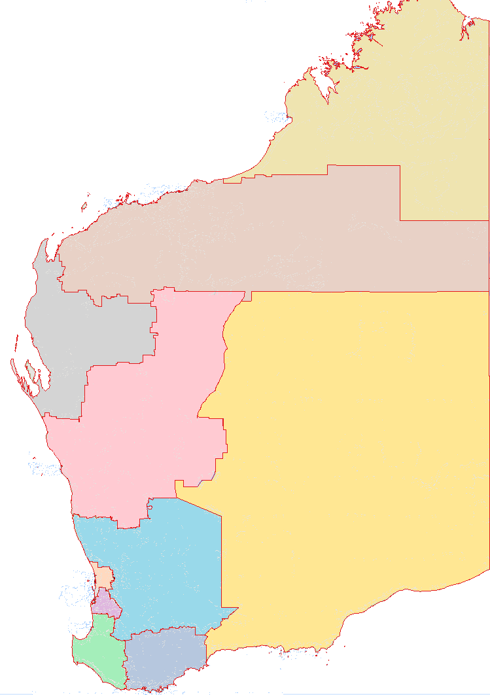
Busselton
Albany
Geraldton
Broome
Port Hedland
Kalgoorlie-Boulder
Esperance
Bunbury
Karratha
South West
Great Southern
Peel
Perth
Wheatbelt
Mid West
Goldfields-Esperance
Gascoyne
Offshore Western Australia
Pilbara
Kimberley

Region | Gross regional product 2022-23 |  | Population 2022-23 |  | Mining sales 2023
Region | $billion | Share (%) | No. | Share (%) | $billion | Share (%)
Perth | 285.2 | 64.0 | 2,154,205 | 74.8 | 0.1 | 0.0
Pilbara(a) | 85.7 | 19.2 | 59,961 | 2.1 | 142.5 | 57.6
South West | 18.5 | 4.2 | 197,587 | 6.9 | 8.8 | 3.5
Goldfields- Esperance | 15.7 | 3.5 | 57,779 | 2.0 | 22.5 | 9.1
Peel | 11.1 | 2.5 | 162,077 | 5.6 | 9.3 | 3.8
Mid West | 9.0 | 2.0 | 57,617 | 2.0 | 4.5 | 1.8
Wheatbelt | 8.7 | 2.0 | 77,066 | 2.7 | 2.9 | 1.2
Great Southern | 5.6 | 1.3 | 65,222 | 2.3 | 0.0 | 0.0
Kimberley | 4.5 | 1.0 | 39,389 | 1.4 | 1.0 | 0.4
Gascoyne | 1.3 | 0.3 | 10,324 | 0.4 | 0.3 | 0.1
WA total | 445.3 | 100.0 | 2,881,227 | 100.0 | 247.6 | 100.0
Note – Original series. Estimated resident population. Vertical axis does not start at zero. (a) Includes Offshore Western Australia for mining sales.
Source: WA Department of Primary Industries and Regional Development, Remplan; based on ABS data; and WA Department of Energy, Mines, Industry Regulation and Safety.

Population growth by broad region and major urban centre: 2002-03 to 2022-23
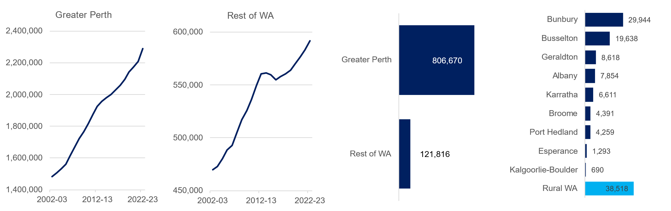
Original series Estimated resident population. Vertical axis does not start at zero.
Source: Based on ABS data

Western Australia’s population is concentrated in the Perth metropolitan area and most of Western Australia’s gross state product is also allocated to Perth. However, most of the State’s merchandise exports and economic activity originates from production in regional areas. While mining production takes place in most regions, the Pilbara is the dominant mining region, particularly for iron ore and liquefied natural gas.
Further economic information and data on Western Australia’s regions can be found at the Regional WA Data Hub. Information on individual regions can be accessed via the links below.
Gascoyne | Kimberley | Pilbara
Goldfields-Esperance | Mid West | South West
Great Southern | Peel | Wheatbelt

Visit Western Australia's economy and international trade (www.wa.gov.au) for more information on Western Australia’s economy, trade relationships and key export industries.

Western Australia Trade Profile  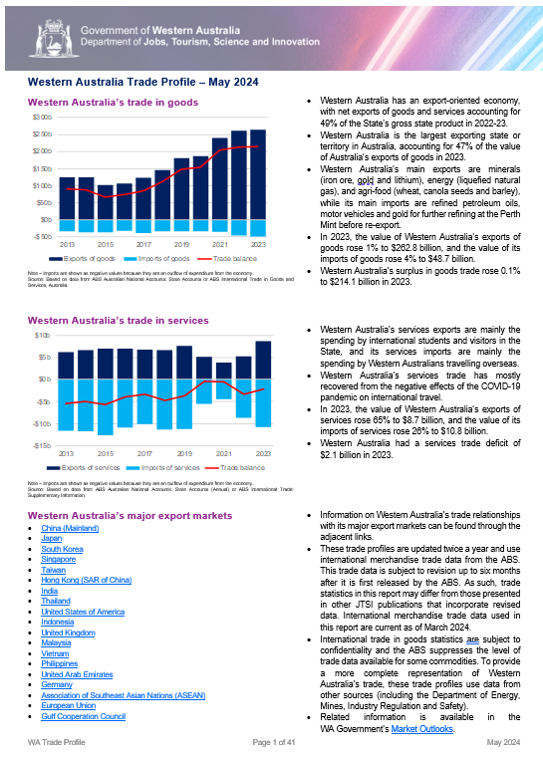 | Western Australia Iron Ore Profile  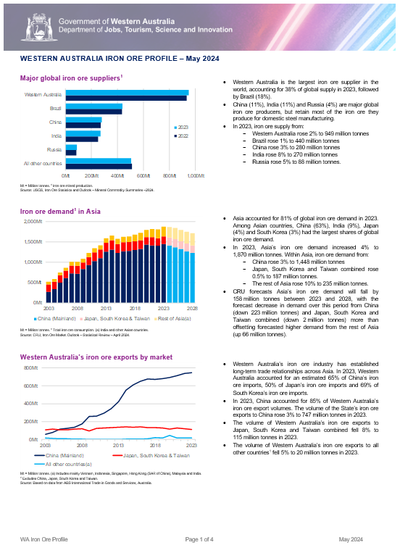
Western Australia LNG Profile  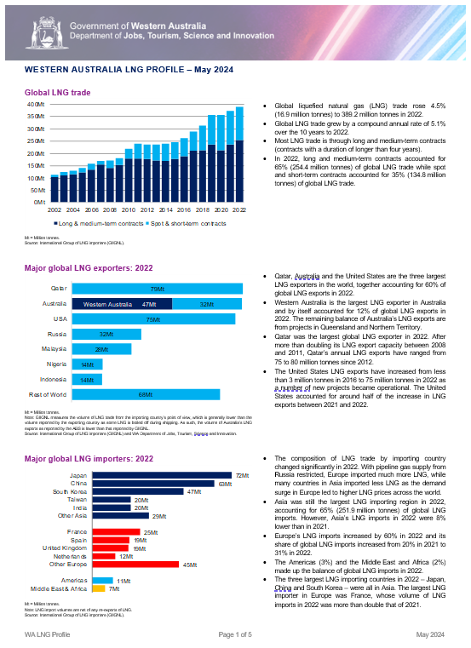 | Western Australia Battery and Critical Minerals Profile  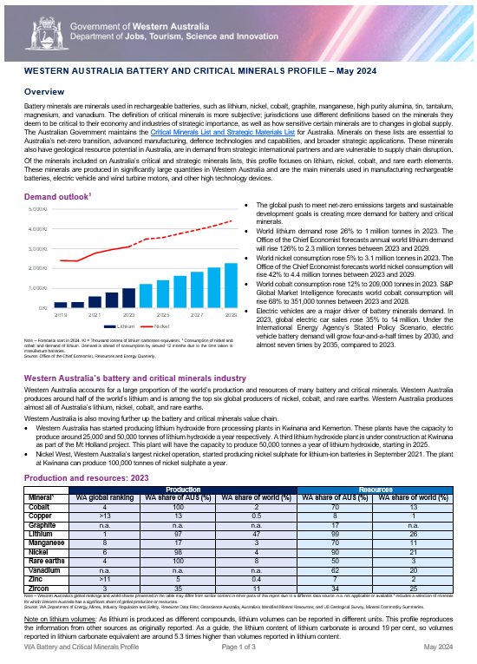
For any queries or feedback on these products, please contact us at economic.analysis@jtsi.wa.gov.au

