WESTERN AUSTRALIA IRON ORE PROFILE – January 2025

Global iron ore production and trade¹
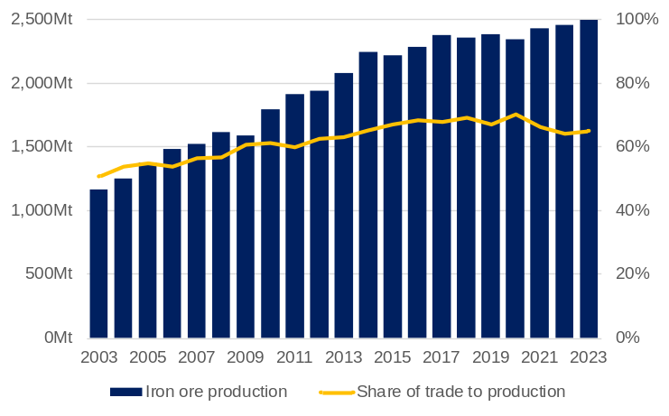
Mt = Million tonnes. ¹ China’s iron ore production adjusted to world average.
Source: Office of the Chief Economist – Resources and Energy Quarterly.

- The volume of global iron ore production increased rapidly from the early 2000s to the mid-2010s, largely in response to higher demand from China. Production volumes were relatively stable from 2017 to 2019, fell in 2020 due to the COVID-19 pandemic, but then grew in 2021 as China’s post-pandemic stimulus led to higher demand.
- Global iron ore production was 2,492 million tonnes in 2023, 1.5% higher than in 2022.
- The share of iron ore trade in global iron ore production has also increased since the early 2000s, as China sourced a greater proportion of its iron ore supply from imports.
  - The share of iron ore trade to global iron ore production increased from 51% in 2003 to 65% in 2023.

Major global iron ore suppliers¹
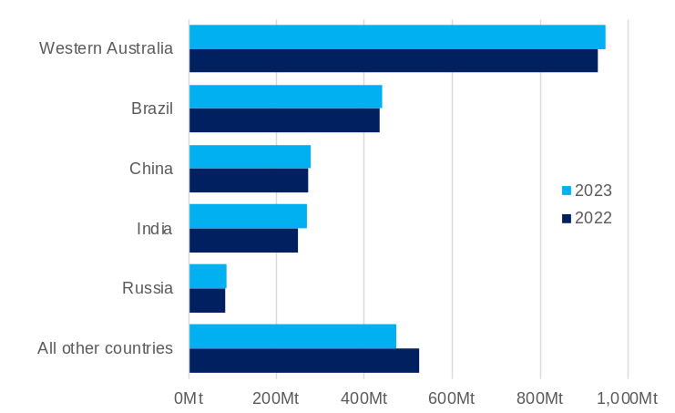
Mt = Million tonnes. ¹ Iron ore mined production.
Source: USGS, Iron Ore Statistics and Outlook – Mineral Commodity Summaries – 2024.

- Western Australia is the largest iron ore supplier in the world, accounting for 38% of global supply in 2023, followed by Brazil (18%).
- China (11%), India (11%) and Russia (4%) are major global iron ore producers, but retain most of the iron ore they produce for domestic steel manufacturing.
- In 2023, iron ore supply from:
  - Western Australia rose 2% to 949 million tonnes
  - Brazil rose 1% to 440 million tonnes
  - China rose 3% to 280 million tonnes
  - India rose 8% to 270 million tonnes
  - Russia rose 5% to 88 million tonnes.
- Over the next few years, a significant increase in iron ore supply is expected from the Simandou project in Guinea, which is currently under construction with first production scheduled for late 2025 or early 2026. The long-term production capacity of Simandou is potentially in excess of 150 million tonnes a year.

Iron ore imports by market
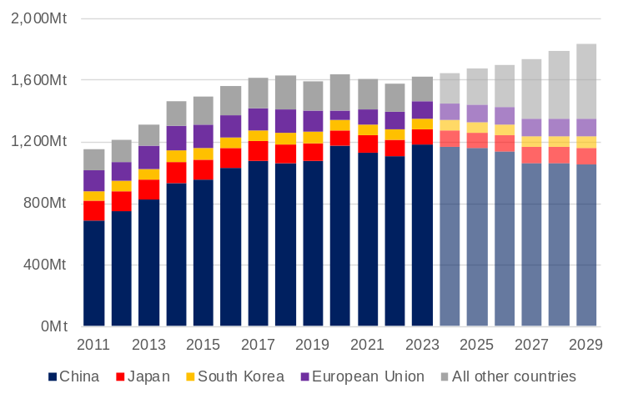
Mt = Million tonnes
Source: Office of the Chief Economist – Resources and Energy Quarterly.

- China’s share of global iron ore trade has increased over time as the volume of its imports has increased and the volume of Japan’s imports has fallen. In 2023:
  - China imported 1,180 million tonnes (73% of global iron ore imports)
  - Japan imported 102 million tonnes (6% of global iron ore imports)
  - South Korea imported 68 million tonnes (4% of global iron ore imports).
- The Office of the Chief Economist forecasts that China’s iron ore imports will fall from 2024, but that global iron ore trade volumes will increase as the fall in China’s imports is offset by higher imports from other countries. Key to this forecast is a large increase in iron ore imports from India (from 5 million tonnes in 2023 to 89 million tonnes in 2029) and the rest of Asia (from 53 million tonnes in 2023 to 117 million tonnes in 2029).

Iron ore price¹
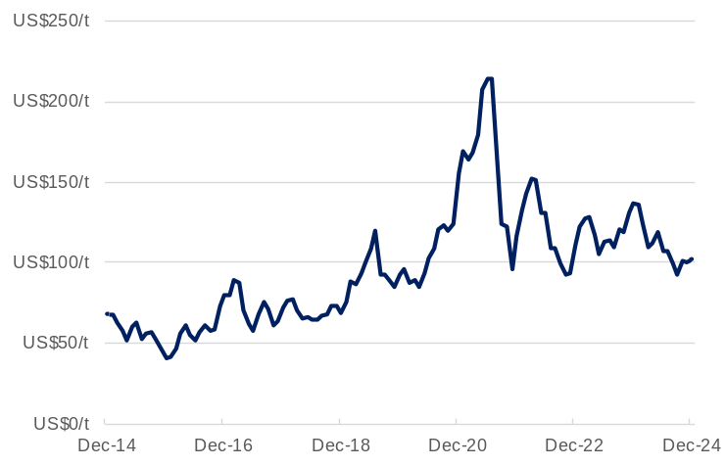
¹ The monthly average benchmark (62% iron content) iron ore price delivered to China inclusive of cost and freight.
Source: World Bank, Commodity Markets.

- The iron ore price trended down through the first nine months of 2024, with downward pressure on the price coming from a weakening in Chinese steel production, steady global iron ore supply and a build-up of port inventories in China. This trend was reversed in late-September 2024 after the Chinese Government announced a range of economic stimulus measures that led to the iron ore price increasing back over US$100 a tonne.
  - The average monthly iron ore price was US$102.2 a tonne in December 2024, 10.1% higher than the recent low in September 2024.
- The WA Government Mid-year Financial Projections Statement 2024-25 forecasts the iron ore price will average US$95.3 a tonne in 2024-25 and US$71.0 a tonne from 2025-26, reflecting a forecasting approach of the iron ore price returning to its long-term average.

Western Australia’s iron ore exports¹
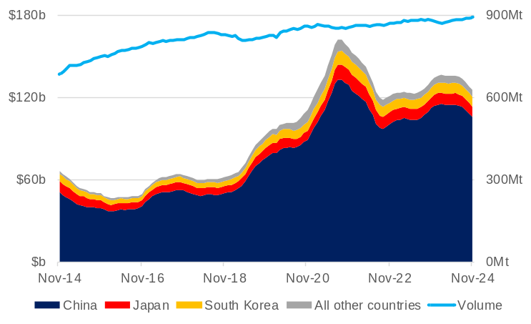
¹ 12-month rolling total for both value and volume. Mt = Million tonnes.
Source: Based on data from ABS International Trade in Goods and Services, Australia.

- The volume of Western Australia’s iron ore exports over the 12 months to November 2024 was 891.8 million tonnes.
- The value of Western Australia’s iron ore exports in the 12 months to November 2024 was $125.7 billion, 5.0% lower than in the 12 months to November 2023.
- In the 12 months to November 2024, the value of Western Australia’s iron ore exports to:
  - China was $105.9 billion (84.3% of the total)
  - Japan was $7.5 billion (6.0% of the total)
  - South Korea was $7.2 billion (5.8% of the total)
  - All other countries was $5.0 billion (4.0% of the total).

Iron ore exploration expenditure¹
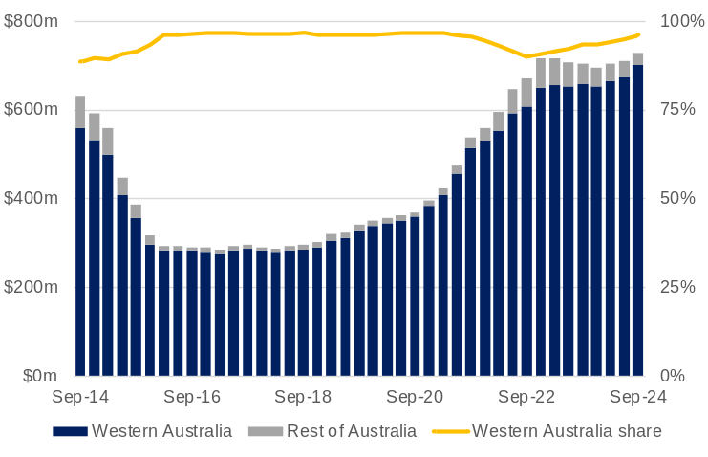
¹ Four-quarter rolling total.
Source: Based on data from ABS Mineral and Petroleum Exploration, Australia.

- Higher iron ore prices in recent years have led to greater expenditure on iron ore exploration in Western Australia.
- In the four quarters to September 2024, expenditure on iron ore exploration in Western Australia was $700 million, 6.5% higher than in the four quarters to September 2023.
- Western Australia accounts for nearly all of Australia’s iron ore production and iron ore reserves, and therefore nearly all iron ore exploration expenditure in Australia.
  - In the four quarters to September 2024, Western Australia accounted for 96% of total iron ore exploration expenditure in Australia.
Western Australia’s iron ore sales by major producer¹
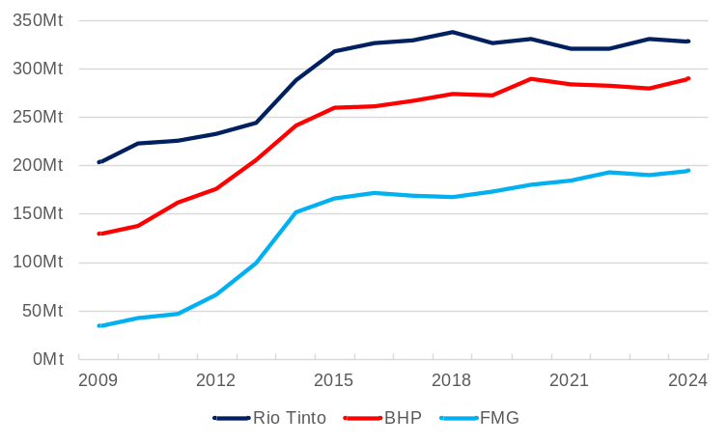
Mt = Million tonnes. ¹ Western Australian operations only. Inclusive of third-party tonnes. Wet tonnes.
Source: Rio Tinto, BHP and Fortescue Metals Group Investor Information, Operations reports.

- Rio Tinto, BHP and FMG are the largest global iron ore producers behind Vale from Brazil.
- Rio Tinto’s iron ore shipments from Western Australia fell 1.0% to 329 million tonnes in 2024. Guidance for shipments in 2025 is 323 to 338 million tonnes. Rio Tinto’s rail and port capacity is 360 million tonnes a year and it is developing new mines to enable its production to meet this capacity.
- BHP’s iron ore sales volumes from Western Australia increased 3.6% to 290 million tonnes in 2024. Production guidance for 2024-25 is 282 to 294 million tonnes. BHP is expanding its port capacity to 330 million tonnes a year.
- FMG’s iron ore shipments from Western Australia increased 2.3% to 194 million tonnes in 2024. Guidance for shipments in 2024-25 is 190 to 200 million tonnes. FMG’s port capacity is 210 million tonnes a year.

Major iron ore projects¹ in Western Australia
Operator | Mine/deposit | Capex  ($m) | Capacity (Mtpa) | Fe content² | Start of operations
Recently completed
FMG | Eliwana | 1,800 | 30 | 60 | 2020
GWR Group | Wiluna West | 200 | 10 | 60 | 2020
Atlas Iron | Sanjiv Ridge | 53 | 5 | 57 | 2020
BHP | South Flank | 4,700 | 80 | 62 | 2021
Rio Tinto | West Angelas C+D | 735 | n.a. | 62 | 2021
Mt Gibson | Shine | 20 | 1.5 | 59 | 2021
Rio Tinto | Western Turner Syncline 2 | 1,000 | 30 | 62 | 2021
Rio Tinto | Gudai-Darri | 4,300 | 43 | 59 | 2022
Rio Tinto | Robe Valley | 1,200 | n.a. | 62 | 2022
FMG | Iron Bridge 2* | 5,600 | 22 | 67 | 2023
MRL | Onslow Iron | 2,500 | 30 | 58 | 2024
Under construction or committed
Rio Tinto | Western Range | 3,000 | 25 | 62 | 2025
BHP | Western Ridge Crusher | 943 | 25 | n.a | 2027
Mtpa = million tonnes per annum. n.a. – not available or not applicable. * Magnetite. ¹ Includes mines and rail and port infrastructure. ² Product grade if available, otherwise reserve grade for direct shipping ores.
Source: S&P Global Market Intelligence; CRU, Iron Ore Market Outlook – Project list; and company investor information (announcements, reports and presentations).

- Rio Tinto started developing its Western Range project in early 2023, with annual production of 25 million tonnes of iron ore expected to start in 2025. Rio Tinto has also approved a $110 million pre-feasibility study to progress development of the 40 million tonnes a year Rhodes Ridge project.
- BHP completed its development of South Flank in May 2021 and ramped up production to 80 million tonnes a year in 2023-24. BHP has announced approval for the Western Ridge Crusher Project, expected to deliver an average of 25 million tonnes of iron ore annually from 2027, replacing production volumes from other depleting orebodies around Newman.
- Fortescue Metals Group (FMG) has developed Iron Bridge (Magnetite) Stage 2. The project will produce 22 million tonnes a year of high-grade magnetite concentrate.
- Construction on Mineral Resources Limited’s (MRL) Onslow Iron project began in August 2022. MRL delivered first ore on ship in May 2024, ahead of schedule.

Western Australia’s iron ore exports by port
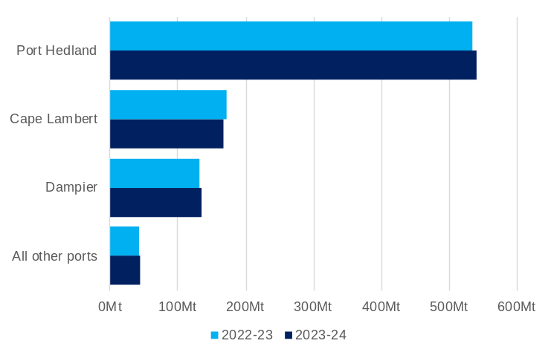
Mt = Million tonnes.
Source: Based on data from ABS International Trade in Goods and Services, Australia.

- Port Hedland accounted for 61% of Western Australia’s iron ore export volumes in 2023-24 The next largest ports in Western Australia for iron ore export volumes in 2023-24 were Cape Lambert (19%) and Dampier (15%).
- In 2023-24, the volume of iron ore exports from:
  - Port Hedland rose 1% to 540 million tonnes
  - Cape Lambert fell 2% to 168 million tonnes
  - Dampier rose 1% to 135 million tonnes
  - All other ports rose 2% to 44 million tonnes.
- The Port of Port Hedland is planning to increase iron ore export capacity to 660 million tonnes a year. FMG has approval to expand its material handling capacity at Herb Elliott Port to 210 million tonnes a year.

Western Australia’s iron ore sales volume
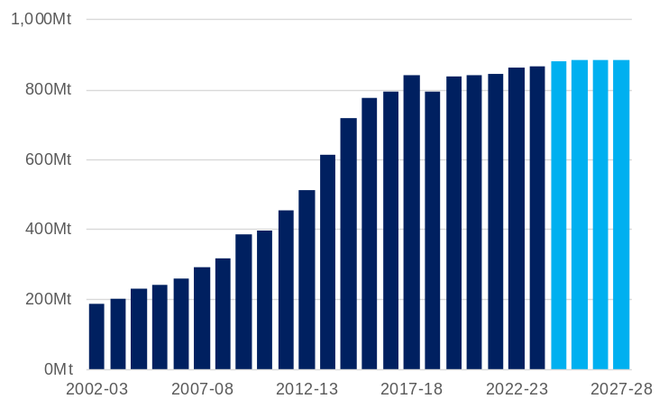
Mt = Million tonnes.
Source: WA Department of Energy, Mines, Industry Regulation and Safety, Resource Data Files; and WA Government State Budget 2024-25 (May 2024).
¹ S&P Global Market Intelligence.

- The volume of Western Australia’s iron ore sales increased rapidly from the early 2000s and has settled at a high level.
- Western Australia’s iron ore sales volumes were 866 million tonnes in 2023-24 and the WA Government Mid-year Financial Projections Statement 2024-25 forecasts sales volumes will increase to 881 million tonnes in 2024-25, 883 million tonnes in 2025-26 and hold at 884 million tonnes in 2026-27 and 2027-28.
- Western Australia produced mainly iron ore fines (73%) in 2023, followed by lump (23%) and concentrate (4%).¹
  - Major iron ore fines products in 2023 were FMG’s Chichester Hub Fines (97.3 million tonnes), BHP’s Mining Area C Fines (85.7 million tonnes) and FMG’s Solomon Hub Fines (66.7 million tonnes).
  - Major iron ore lump products in 2023 were BHP’s Mining Area C Lump (36.1 million tonnes), Rio Tinto’s Brockman Lump (26.1 million tonnes) and Hancock Prospecting’s Roy Hill Lump (24.4 million tonnes).
  - Iron ore concentrates in 2023 were from CITIC Pacific’s Sino Iron (19.5 million tonnes) and FMG’s Iron Bridge (10.9 million tonnes) operations.

Western Australia’s iron ore sales and royalty receipts¹
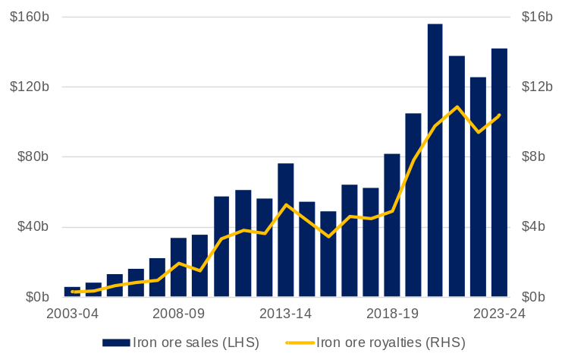
¹ Regulation 86A of the Mining Regulations 1981 requires that royalties be paid within 30 days following the end of a quarter. As a result, cash receipts are necessarily offset by one quarter. The value of royalty receipts is different to the value of royalty income published in State Budget papers, which is accounted for in the year the royalty liability is accrued, rather than paid.
Source: WA Department of Energy, Mines, Industry Regulation and Safety, Resource Data Files.

- The value of Western Australia’s iron ore sales increased 13% to $142.0 billion in 2023-24.
  - The peak value of Western Australia’s iron ore sales in a financial year was $155.6 billion in 2020-21, when the iron ore price averaged US$155 a tonne and $206 a tonne in Australian dollar terms.
- The Western Australian Government’s iron ore royalty receipts increased 10% to $10.4 billion in 2023-24.
  - The peak value of iron ore royalty receipts in a financial year was $10.8 billion in 2021-22.
- In 2023-24, iron ore royalties accounted for 86% of Western Australia’s royalty receipts (excluding North West Shelf grants).
- The WA Government Mid-year Financial Projections Statement 2024-25 forecasts iron ore royalty income will decline to $5.6 billion in 2027-28, based on the assumption that the iron ore price will return to its long-term average.

Western Australia’s iron ore industry employment¹
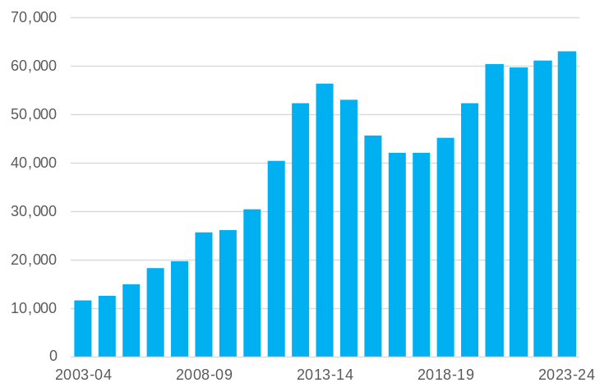
¹ Direct employment. Full-time equivalent (average on site).
Source: WA Department of Energy, Mines, Industry Regulation and Safety, Resource Data Files.

- Direct full-time equivalent (FTE) employment in Western Australia’s iron ore industry increased 2.9% to 62,950 in 2023-24.
- Iron ore accounted for 47% of direct FTE employment in Western Australia’s minerals mining industry in 2023-24 (excluding exploration).
- Western Australia’s largest employing iron ore mine sites in 2023-24 were:
  - FMG’s East Pilbara Iron Ore (6,178 FTE) and Solomon (4,002 FTE)
  - BHP’s Mining Area C (4,349 FTE)
  - Citic Pacific’s Sino-Cape Preston Iron (3,702 FTE)
  - Roy Hill Iron Ore (3,663 FTE).

