
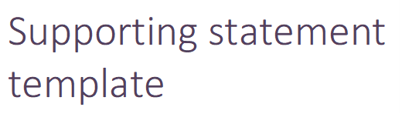

STATEMENT AS REQUIRED BY SECTION 74(1)(ca)(ii)
OF THE MINING ACT 1978 (AS AMENDED)

SUPPORTING STATEMENT FOR A MINING LEASE APPLICATION
(Name of project/tenement number)

Name of qualified person
Select membership. Add membership number
Company Name
Click or tap to enter a date of this report.

Contents
1. Background 3
2. Project development and mining timeline 4
3. Mining method 4
4. Processing 4
5. Site and infrastructure 5

Background
Company name has prepared this supporting statement to accompany the mineralisation report for Mining Lease Application (MLA) on name of project and/or tenement numbers.
The proposed mining lease covers the area between describe the location and illustrate clearly (Figure 1).
Provide information on any associated tenements associated with the MLA if appropriate.
The MLA totals state area Ha and is a conversion from a portion/whole of Exx/xxxx and a portion/whole of Exx/xxxx held by tenement holder.
This statement has been prepared in accordance with Section 74(1)(ca)(ii) of the Mining Act 1978, being;
“The statement referred to in subsection (1)(ca)(ii) and (iii) shall set out information about the mining operations that are likely to be carried out in, on or under the land to which the application relates including information as to —
    - when mining is likely to commence; and
    - the most likely method of mining; and
    - the location, and the area, of land that is likely to be required for the operation of plant, machinery and equipment and for other activities associated with those mining operations”.

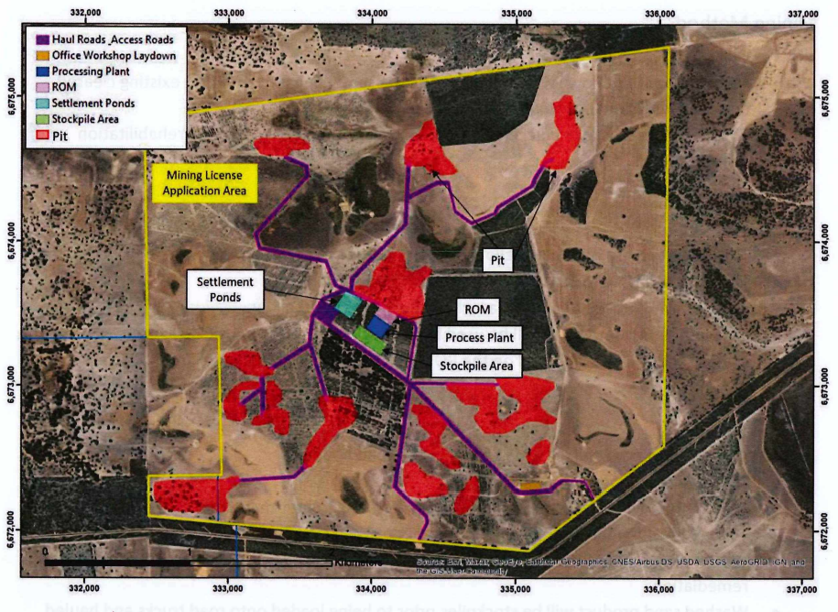
Figure 1. Proposed area of MLA (yellow) showing area of proposed open pits, the processing plant, and other areas required for infrastructure.

Map must show the plant location (if within MLA boundary), and should include the proposed mining lease boundary, the resource location, pit locations, and other infrastructure related to the mining operation. A legend should be included and everything should be labelled and legible. Include proper map elements – coordinates, coordinate system, legend title, location, and scale.
If necessary, enlarge image to A4 or A3 or attach as an appendix figure and combine into PDF.

Project development and mining timeline
Make it very clear when mining is most likely to commence, as this must have a date. Section 74(7) of the Mining Act 978 defines ‘likely’ to mean reasonably likely having regard to the information available to the applicant when the application is made
A statement providing a timeframe for the likely commencement of mining i.e. the year(s) mining is expected to likely commence is enough detail to satisfy this requirement. A statement to the effect that mining will commence once feasibility studies are finalised is not definitive enough to meet the required content of the supporting statement. Note this date can also be supported with an assortment of development clauses.
For example
The company anticipates mining at the deposit/MLA to commence in 2024/2025 subject to completion of the following:
- Further resource drilling to complete a JORC compliant mineral resource estimate on the deposit/MLA
- Negotiating a workable Mining Agreement with native title claimants
- Securing a suitable partner with the necessary skills
- Completion of a scoping study
- Selected infill drilling and metallurgical and geotechnical test work
- Obtaining various government approvals to mine

Mining Method
Describe the proposed mining methodology.
For example
The proposed mining method will be by open pit, utilising conventional drill and blast methods, excavator, dump truck and ancillary equipment of appropriate size and capacity.

Processing
Describe the proposed processing methodology. If the location of the plant is not included due to processing at an alternate location, then a statement needs to be made on where processing is to be conducted.
For example
Mined material will be processed at our existing processing plant xxx.
Building of a new processing plant is unlikely to be located on the MLA, with ore to be transported to one of several gold producers in the region that have surplus milling capacity.

Site and Infrastructure
Outline the location, and the area, of land that is likely to be required for the operation of plant, machinery and equipment (infrastructure) and for other activities associated with those mining operations, in relation to the zone (or zones) of significant mineralisation and the mining lease boundary.
For example
Infrastructure required for a future mining operation includes:
- Open pit
- New waste dump
- Haul roads
The proposed infrastructure is described below and is shown in Figure 1.
The proposed main haul road is accessed from xxx.
The proposed open pit is likely to be located within the outline of mineralisation shown in Figure 1. The final design of an open pit will be subject to final resource and reserve estimates and feasibility studies.
Waste material will be stockpiled on the eastern side of the mineralised area to form a new waste dump.
Final locations, areas and geometries may change subject to environmental, heritage and economic assessments.

Note taking the time to make a good Figure 1, has the potential to cover all the necessary information for the supporting statement. However, if more figures are required to describe the operation then they should be supplied and follow the same criteria of being clear, well-labelled etc.

