Agents and Contractors
A Disability Access and Inclusion Plan (DAIP) ensures everyone can enjoy your services and facilities, and your employees can benefit from a diverse and equitable workplace. All staff and officers should have a sound understanding of your DAIP and its strategies, as well as their individual roles and responsibilities in implementing the plan. This expectation extends to agents and contractors who complete work, and deliver services, projects and events on behalf of your authority.
Under the Disability Services Act 1993 (the Act), public authorities are to take all practicable measures to ensure their DAIP is implemented by its officers, employees, agents, and contractors.

What is an agent and contractor?
For the purposes of application:
- An agent is a person or business authorised to act on another’s behalf. For example, a real estate agent that acts on behalf of the public authority in the purchase or sale of land.
- A contractor is an entity who performs a service or delivers a product under an agreement (or contract) with a public authority. For example, web designer, builder or event management company.
Agents and contractors include non-government and not-for-profit organisations where there is an exchange of money (including grants and sponsorships) to undertake work, deliver services, projects and or events.

Agent and contractor responsibilities
The intent of the Act is to ensure agents and contractors who carry out work or provide services for public purposes conduct their business consistent with the contracting public authority’s DAIP.
Agents and contractors should:
- read and understand the public authority’s DAIP
- conduct their business in a manner consistent with the public authority’s DAIP
- confirm access and inclusion obligations have been met in line with the public authority’s requirements
- complete DAIP reporting as determined by the public authority.

Public authority responsibilities
The Act requires public authorities to develop and implement processes to ensure agents and contractors implement their DAIP and report any DAIP related activities. For State Government contracts awarded under the Delivering Community Services in Partnership Policy, all contractors are required to meet DAIP obligations.
Public authorities should:
- include an agent and contractor policy or statement in their DAIP
- introduce a special condition of contract for procurement processes. Refer to Attachment 1: Special condition clause example
- ensure agents and contractors have access to the public authority’s DAIP and understand their responsibilities in meeting DAIP requirements
- determine agent and contractor DAIP reporting requirements
- set up and maintain a reporting process appropriate to (i) size and functions of the public authority and (ii) scale and scope of agent and contractor works.
The Australian Disability Network has information and resources on accessible procurement processes available at Procurement - Australian Disability Network.

Determining agent and contractor DAIP reporting obligations
Public authorities will vary in their approach to agent and contractor DAIP reporting requirements. Determining whether individual agents and contractors should report on their DAIP activities is the responsibility of each public authority.
Considerations should apply to the scale of work:
- Is the work or service – short, medium or long term?
- Is the work or service an ongoing service agreement or one-off minor task?
- Is the work or service a State Government contract awarded under the Delivering Community Services in Partnership policy? If yes, reporting should be a requirement.
The scope of work should also factor into reporting considerations:
- Is there a direct or indirect impact on the public?
- How significant is the risk to the public authority if the agent or contractor is not aware of their DAIP obligations?
- How significant is the cost of works or service?

Agent and Contractor Reporting: Decision Making Tree

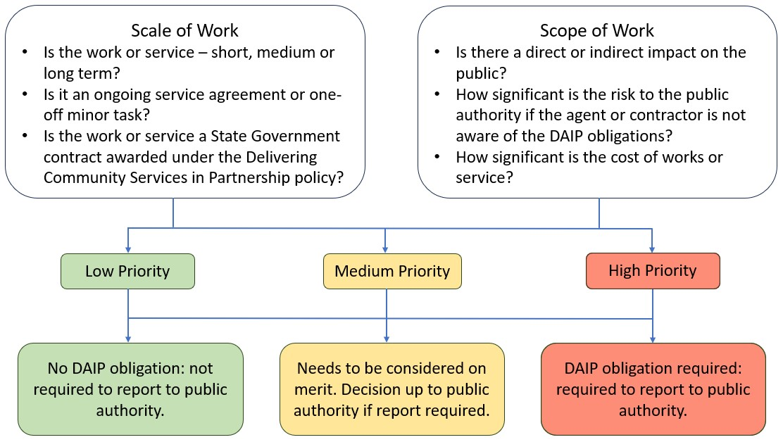

Reporting structure and formats
There are no requirements on how DAIP reporting for agents and contractors is managed and structured. Individual public authorities should determine their reporting requirements and a process for collecting, collating and recording agent and contractor DAIP activities and obligations.
Department of Communities staff can provide advice via phone and email, or schedule an online meeting or in-person meeting to discuss DAIP agent and contractor responsibilities.
For further information, please email: StateDisabilityStrategy@communities.wa.gov.au

Attachment 1: Special condition clause example
A Special Condition of Contract was developed by the State Solicitors Office for use in State Government contracts. This clause can be used by public authorities in WA required to develop and implement a DAIP under the Disability Services Act 1993 (WA).
Tenders must state their intended compliance with all conditions and any special conditions of a tender. If the tenderer becomes the preferred provider, the agency can then enter into negotiations about the special condition.
It is highly recommended that a hyperlink to the DAIP is provided in any tender and contract documentation.
The Special Condition of Contract clause is:
Disability Access and Inclusion Plan
If the Contract involves the supply of services to the public, then the successful Respondent will:
- To the extent practicable, implement the Customer’s Disability Access and Inclusion Plan prepared under the Disability Services Act 1993.
- Provide a report to the Customer by [insert date] in each year of the Contract Term reporting on the extent to which the successful Respondent has implemented the Customer’s Disability Access and Inclusion Plan.
For the purpose of this clause the Customer refers to the public authority. The clause is broad, but is consistent with the general intent of the Disability Services Act 1993.
This clause will:
- apply only to new contracts or contract variations.
- apply to services provided to the public.
- not apply to services provided directly to the public authority itself, such as cleaners and rewiring of telephones.
In agreeing to the special condition, the tenderer agrees to:
- undertake the contract in a manner consistent with their principal’s DAIP.

