Mandatory Reporting Information System: User Document

Contents
1 Introduction Screen 3
2 Reporter Screen 9
3 Children and Adults Screen 11
3.1 Children Section 13
3.2 Adults Section 16
3.3 Relationships Section 17
4 Details of the Sexual Abuse Screen 18
5 Documents Screen 20
6 Summary Screen 21
7 Additional Helpful Tools and Functions 22

Introduction Screen
Purpose of this screen
Ø The Introduction screen is the entry point into the Mandatory Reporting Information System.
Ø The responses to the questions in this screen will determine whether a mandatory report is required. If it’s not required, the system will provide an alternative contact point and method by which to raise your concerns.
Ø The screen also provides important definitions and information you should have at hand and be aware of before beginning the mandatory report.

The Timeout Function
The system will timeout after 60 minutes of inactivity on the screen and will clear any data from the report that has been entered.
Note – there is no time limit within which to enter and submit the report. The 60-minute timeout is only for when there are no entries being made in the report or activity on the open screen.
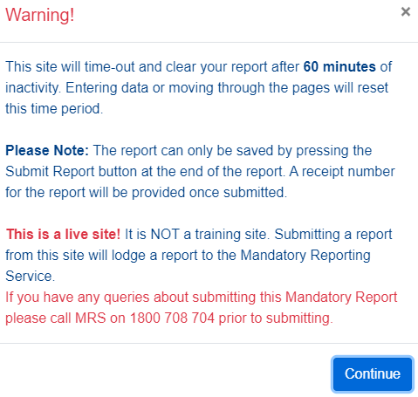

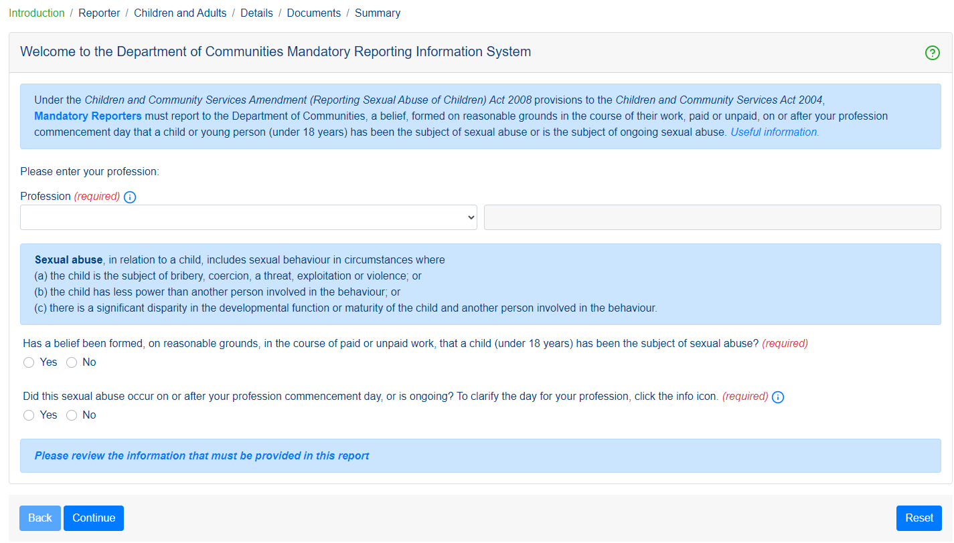

The Reset Button
Click the Reset button to clear the system of entered data at any point and any screen when making the report.
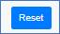
Note that clicking Reset will clear the entire report that’s been entered, not just the screen you’re currently on. A system prompt will warn that the entire report will be cleared. Click Cancel if you do not want to lose the information already entered.
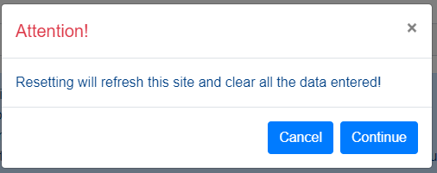

Profession
Select your profession from the list of options that are available for selection in the Profession field.
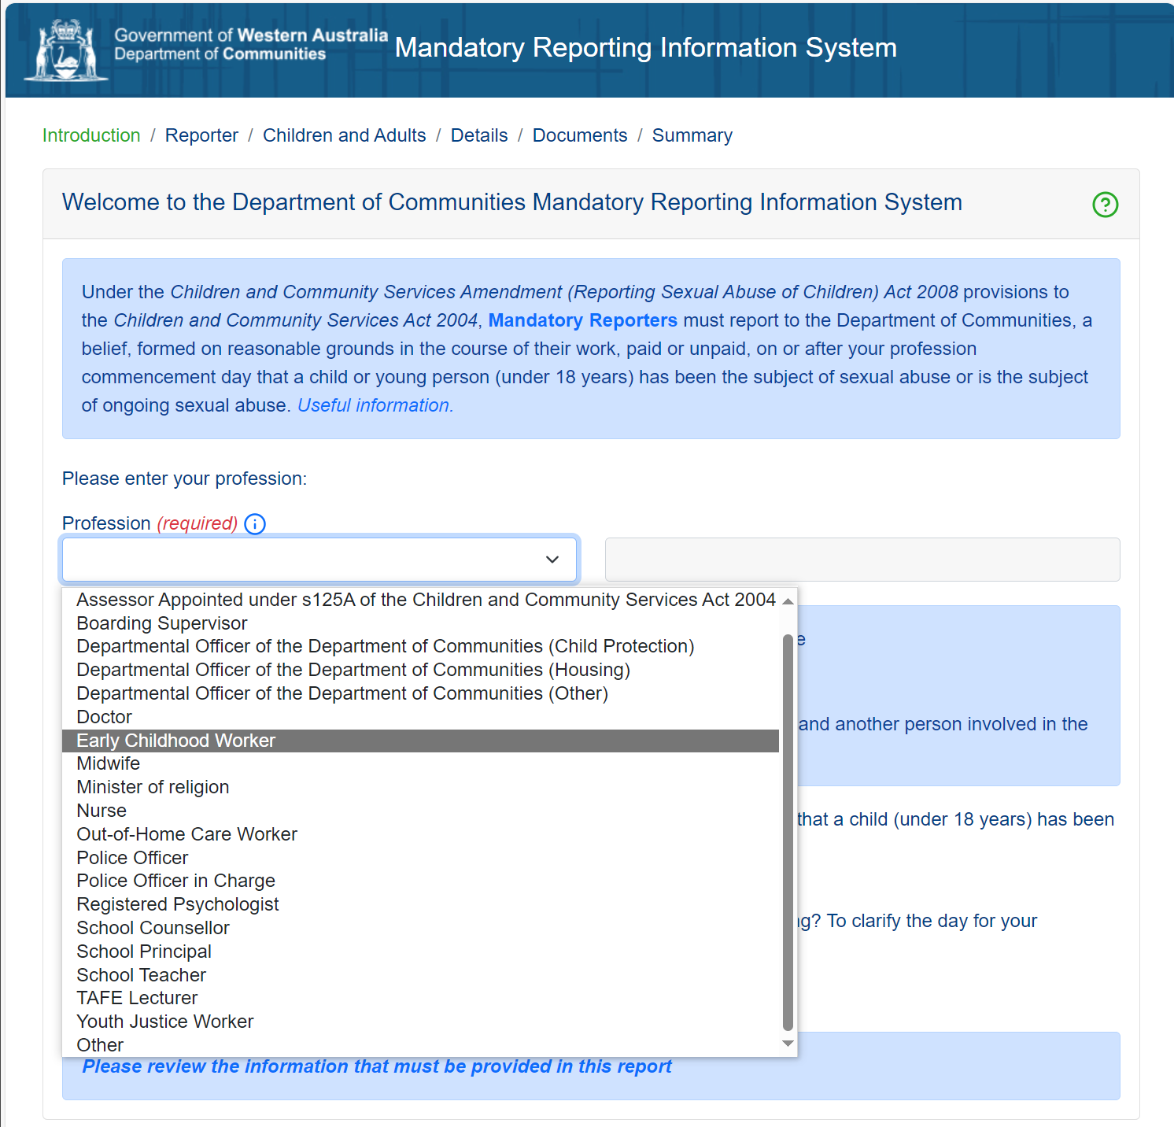

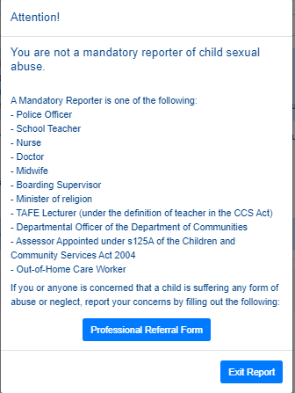
If you choose “Other” as your Profession, you are not required to make a mandatory report and a prompt will appear to complete an online “Professional Referral Form” to the Department of Communities. You should also refer to the child protection policy and procedures for your organisation.

If you click “Exit Report”, you will be redirected to the Department of Communities Child Protection site for further information.
Forming a belief
You are required to select “yes” or “no” for each of the two questions below:
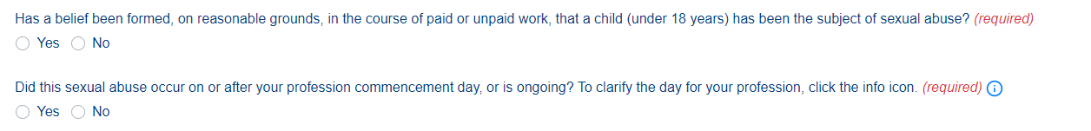
If you respond “No” to either question you are not required to make a mandatory report and a prompt will appear to complete an online “Professional Referral Form” to the Department of Communities.
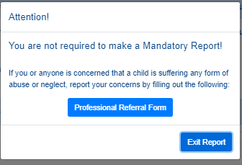
If you click “Exit Report”, you will be redirected to the Department of Communities Child Protection site for further information.

Commencement day
Commencement day is the date on which the person becomes a mandatory reporter under the law. Commencement day varies for the different mandatory reporter groups.
1 January 2009
- Police Officer
- Nurse
- Teacher
- Midwife
- Doctor
1 January 2016
- Boarding Supervisor
1 November 2022
- Minister of religion
15 July 2023
- TAFE Lecturer (under the definition of teacher in the Children and Community Services Act 2004)
1 November 2023
- Departmental officer of the Department of Communities
- Assessor appointed under s125a of the Children and Community Services Act 2004
- Out-of-home care worker
1 May 2024
- School counsellor
- Psychologist
1 November 2024
- Early childhood worker
1 May 2025
- Youth justice worker

Once you have entered your profession and answered “yes” to the two questions, click “Continue” to go to the next screen - Reporter.
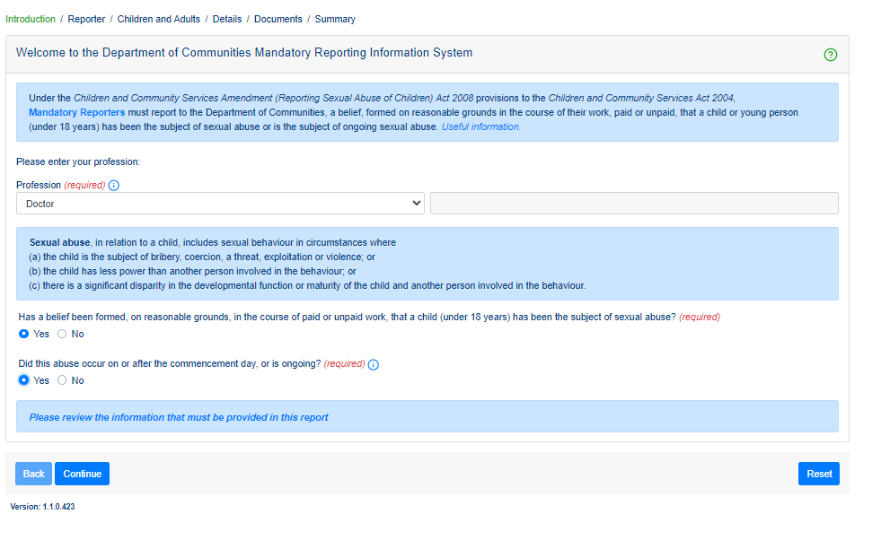

Questions and information on the Introduction screen
Profession | Ø The Profession you select will determine whether you are an “Approved Class of Person” – i.e. if you are making the report on behalf of another Mandatory Reporter - and will determine the format and the information you will need to provide in the Reporter Details section of the system.  Click the information icon to view the professions that fall under the “Approved Class of Person” category.  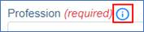  Ø Note – if you are a School Principal you will be provided with an extra question in which to indicate if you are submitting the report as an “Approved Class of Person” on behalf of another Mandatory Reporter, or if you are making the report as the Mandatory Reporter yourself.
Information links | Click on “Mandatory Reporters” in the text in the banner at the top of the screen to view the list of Mandatory Reporting occupations.  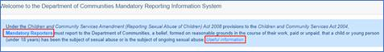  Click on Useful Information for links that open relevant information sites and resources. These will open in a separate tab while the tab in which the Mandatory Reporting system’s Introduction page also remains open and from which you will be able to progress into the system to make your report.
Information links | Click on the information icon beside the Profession field to see which occupations in the Profession list are classed as an “Approved Class of Person” and which are classed as “Mandatory Reporters”.  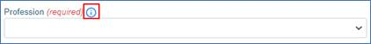
Information links | Click on the “Please review ….” text at the bottom of the Introduction screen to see the information that you should have at hand to provide in your report.  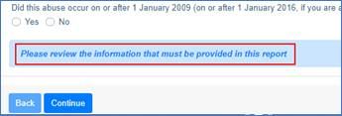

Reporter Screen
Purpose of this screen
Ø Provide the name and contact details of the Mandatory Reporter.

Note: If you are submitting a report as an “approved class of person” refer to the help icon for further information.
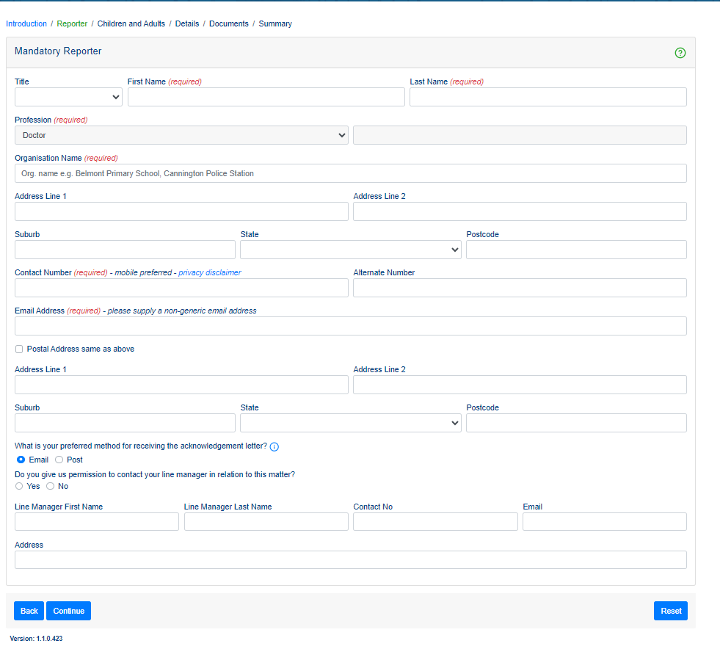

Completing the Reporter section
Mandatory fields  Information that must be provided | The required information fields that must be completed in this section are:  Ø First and Last names  Ø Organisation Name  Ø Contact number and email address  Required fields are clearly marked as required on the screen and must be completed to proceed to the next screen in the system.  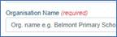
Organisation  Name and Address | Ø Enter the name of your organisation into the Organisation Name field.  Ø As you enter the name of your organisation, a list of organisations whose name contains a match with the entry being made, in any part of their name, will display for selection.  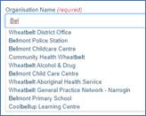  Ø Click to select your organisation’s name from the displayed list.  Ø The organisation’s Address fields will automatically be completed when an organisation is selected from the displayed list.
Organisation  Name and Address | If your organisation is not shown in the list of names, continue typing your organisation’s name and its address into the Organisation Name and Address fields.  On receipt of your report, the Mandatory Reporting Service will arrange for your Organisation and its address to be added to the system to be available for selection in the future.  If the address is incorrect, you will be able to remove and replace the incorrect address by entering the correct address into the Address fields. You may wish to email the Mandatory Reporting Service at mrs@communities.wa.gov.au to advise of the updated address so they can arrange for the address to be corrected on the system for future reports.
Contact Number and Email Address | Contact Number:  Please provide your mobile number where possible.  The Mandatory Reporting Service will only use this number to contact you in relation to the report. No confidential information will be sent to the number and your number will not be disclosed to any party including any of the people included in the report.  Click on the Privacy disclaimer link beside the Contact Number field to see further information in relation to the number you provide.
Contact Number and Email Address | Email Address:  Please provide a specific email address for you rather than a generic email address for your organisation.

Once you have completed all information click “Continue” to progress to the next screen – Children and Adults.

Children and Adults Screen
Screen layout
The screen is divided into 3 separate sections:
- Ø Children section: details of the child/ren of concern and any other children that are relevant to this report are entered here.
- Ø Adults section: details of the parents, guardians or carers and any other adults that are relevant to this report are entered here.
- Ø Relationships section: details of how the people included in this report are related to or are known to one another are entered here.
Note it is likely you will need to scroll up and down through the screen multiple times to add additional children and adults and relationships in the relevant sections of the screen before moving onto the next screen of the report

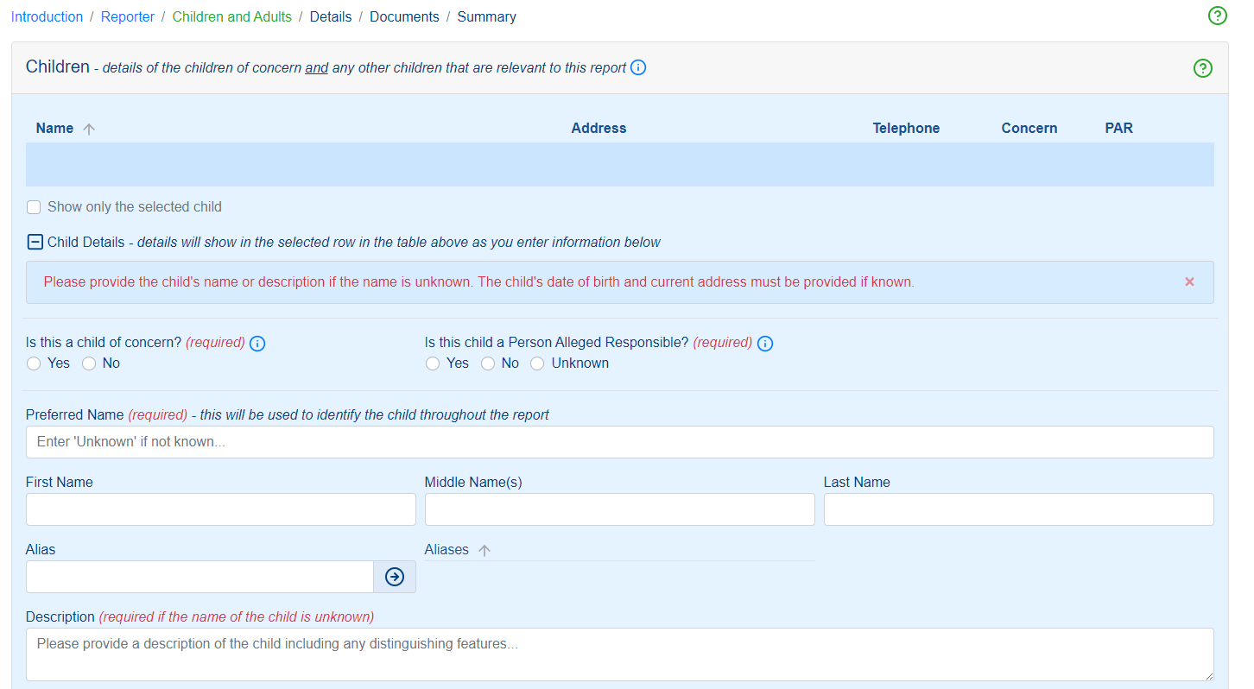

Helpful tools and functions
Information | Click on these information icons at various point in the screen to display additional information and definitions:  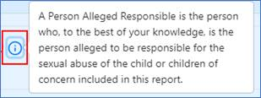
Sorting arrows | The summary tables contain sorting arrows to sort the listed children, adults, and relationships in the tables by ascending or descending order.  For example, children or adults can be sorted by the Name column to display the listed children or adults by ascending or descending alphabetical name order.  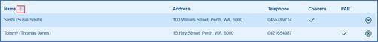  Click on any of the tables’ column headings to sort the table by that column’s entries.  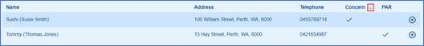
Using the Show only the selected child or adult tick box | The Show only the selected tick boxes below the Children and Adults Summary tables will filter the tables to only show the selected child or adult in the table.  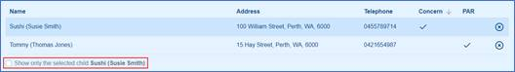  It’s a useful tool to use when there are many children or adults included in the report. Using it will reduce the amount of screen space taken by an extended table which contains multiple children or adults.  Refer to the Children and Adults sections above for instructions on how to use this function.
Hide and Unhide  sections of the screen | Click the hide icon to contract the display on the screen by hiding selected sections from the screen.  Click the unhide icon for the screen display to be expanded to re-display the section that was hidden.  It is a useful tool by which to reduce the amount of information displayed and the length of the screen’s display.

3.1 Children Section
Adding children to the report
Ø Add the child/children of concern to the report and provide their details
Ø Add the person/s alleged to be responsible (PAR) for the sexual abuse to the report and provide their details in the Children’s section if the PAR is a child
Ø Add any other children that may be relevant to this report and provide their details – for example:
§ Children who may have been witnesses to or are aware of the sexual abuse
§ Children who have a close or significant relationship with the child of concern or the person alleged responsible

How to use the Children’s section
Adding more than one child to the report | When there is more than one child to be included in the report – each child and their details should be added to the report, one at a time.  It is recommended that the child of concern and his/her details are entered as the first child in the report.
Adding more than one child to the report | Click the Add an additional child button at the bottom of the Children’s section to add additional children and their details to the report.

Child of Concern
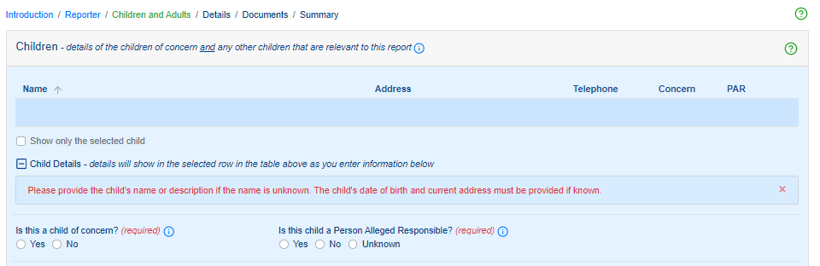
Clicking the child of concern “information icon” provides the below:
A child is defined as anyone under the age of 18. A child of concern specifically relates to a child that has been the subject of sexual abuse or is the subject of ongoing sexual abuse.

Sexual abuse, in relation to a child, includes sexual behaviour in cirumtances where
- the child is the subject to a bribery, coercion, a threat, exploitation or violence; or
- the child has less power than another person in the behaviour or
- there is a significant disparity in the developmental function or maturity of the child and another person involved in the behaviour
Person Alleged Responsible
Clicking the Person Alleged Responsible “information icon” provides the below:
A Person Alleged Responsible is the person who, to the best of your knowledge, is the person alleged to be responsible for the sexual abuse of the child or children of concern included in this report.

Information about a child/children
This section requires you to provide the information/details of a child/children relevant to this report.
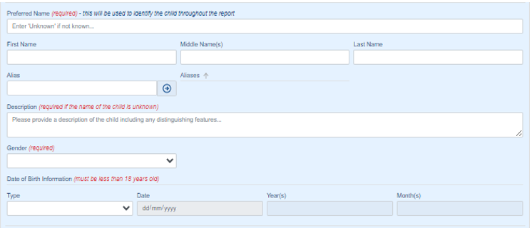
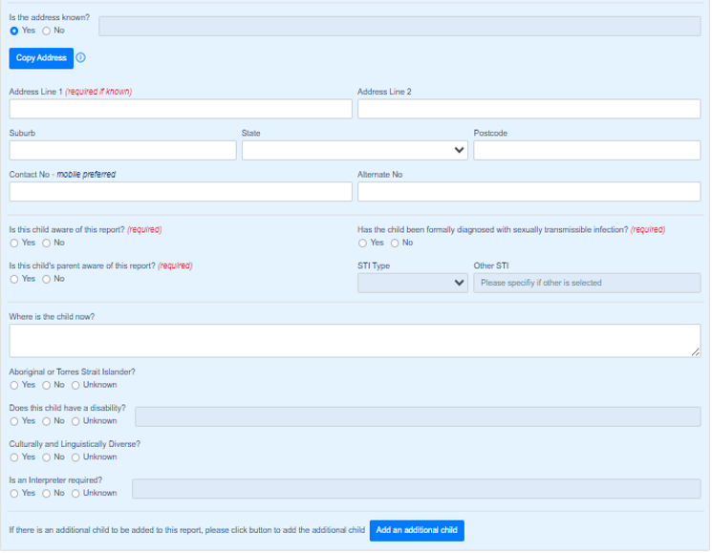
If you do not know if a child has been formally diagnosed with a sexually transmissible infection, click “No”.
If there is an additional child to be added to this report, click “Add an additional child”.

3.2 Adults Section
The Adults section is to be completed for each adult being included in the report.
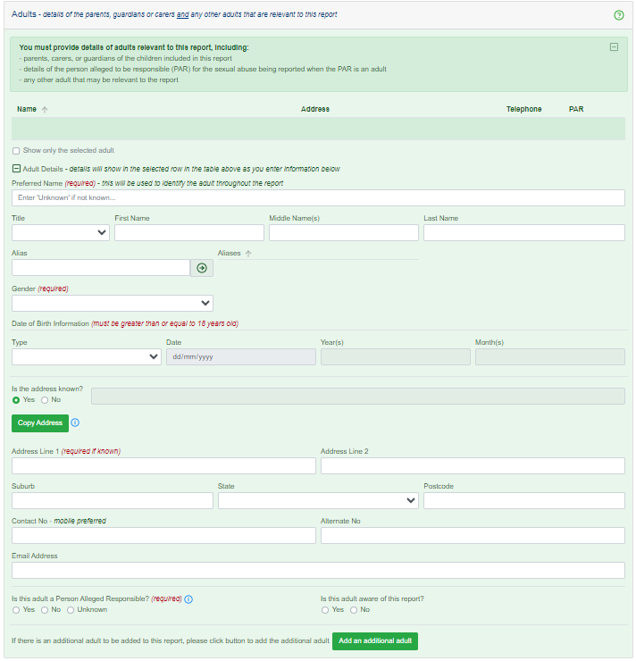
Click “Add an additional adult”, if there is an additional adult to be added to this report.

3.3 Relationships Section
This is the section of the Children and Adults screen in which Relationships are added between all the people that have been added to the report – i.e. how the people are related to or are known to one another.
The best case is to provide as many linkages and relationships between the people included in the report to provide the Mandatory Reporting Service with as detailed a picture as possible of the incident or abuse being reported and the background to it.
At the minimum, these are the relationships that should be provided with this report:
Ø the relationship between the child/ren of concern and the child’s parent/s, carer/s or guardian/s
Ø the relationship between the child/ren of concern and the person/s alleged to the responsible for the sexual abuse (PAR)
Ø the relationship between each child included in the report and their parent/s, carer/s or guardian/s
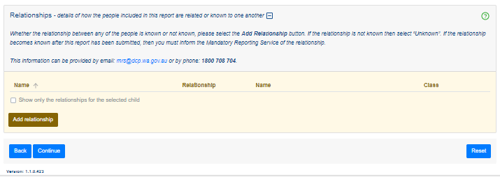
To add a relationship, click “Add relationship”.

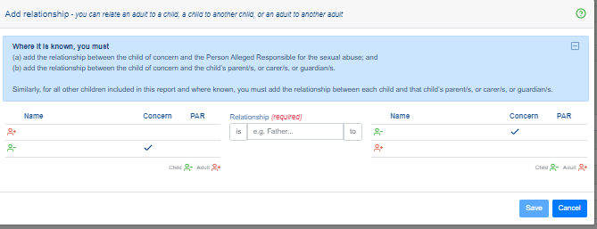
Once you have completed all three sections, click “continue” to go to the next screen – Details.

Details of the Sexual Abuse Screen
Purpose of this screen
Ø Provide the details of the alleged sexual abuse being reported.
Ø Provide any known family and background information of the child/ren of concern that may be relevant.
Ø Provide any known family and background information of the person/s alleged to be responsible (PAR) for the sexual abuse that may be relevant.
Ø Provide the Police Incident Report Number if known.
Ø Indicate if the report being submitted follows a verbal report that has already been made to the Mandatory Reporting Service (MRS).

If you answer “Yes” to the question “is this a written report following a verbal report that has been made to the Mandatory Reporting Service”, you will be prompted to provide the Verbal Report Number.
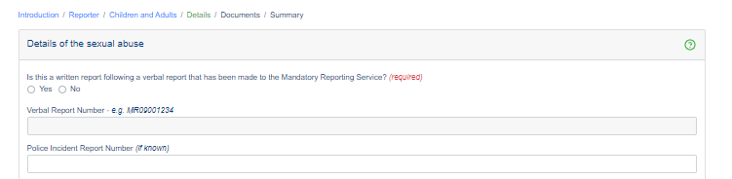
If the report is not a follow up to a verbal report, then continue to provide information on:
- Police Incident Report (if known)

- Details of incident or circumstances - Describe your concerns and provide details of the alleged sexual abuse.
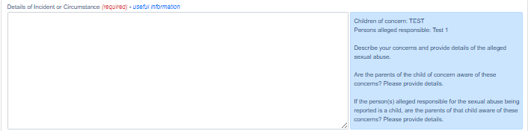
- Relevant family information – Describe the current family situation of the child of concern and include any details that may be relevant to this report.
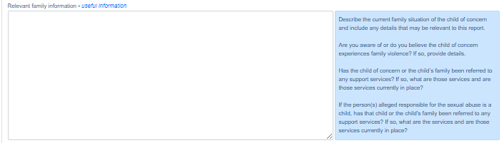
- Other relevant information – Any other child protection concerns for the child of concern.
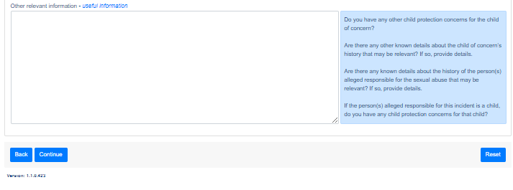
Click “Continue” to go to the next screen – Documents.

Documents Screen
Purpose of this screen
Ø Attach any additional documentation that may be relevant to the report.
Ø The documents attached in this screen will be submitted with the system’s report to the Mandatory Reporting Service

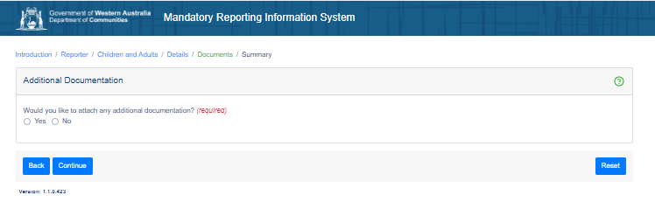
Warning: If you have additional documentation to add/attach, please do not upload any child exploitation image or materials.
The maximum allowed file size of each attachment if 10 MB.
The total allowable attachments size limit is 100 MB.
File name for each attachment must be no more than 64 characters.
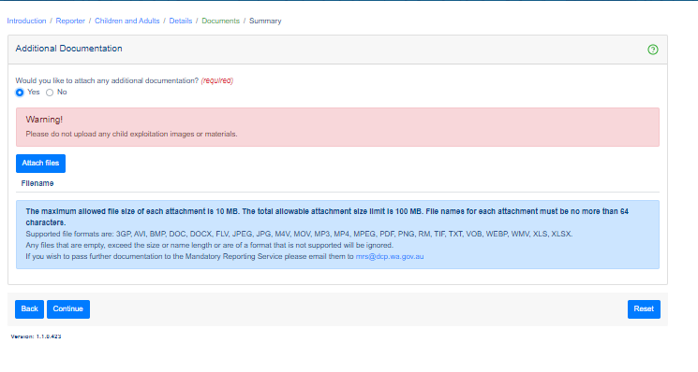
If you do not have any additional documentation, click “No” and then “Continue”.
Click “Continue” to go to the next screen – Summary.

Summary Screen
Purpose of this screen
This is the final screen in the system. No entries are required in this screen. Use this screen to:
Ø View a summary of the report’s entries from the previous screens to verify and ensure that all information has been provided as intended
Ø Submit the report to the Mandatory Reporting Service

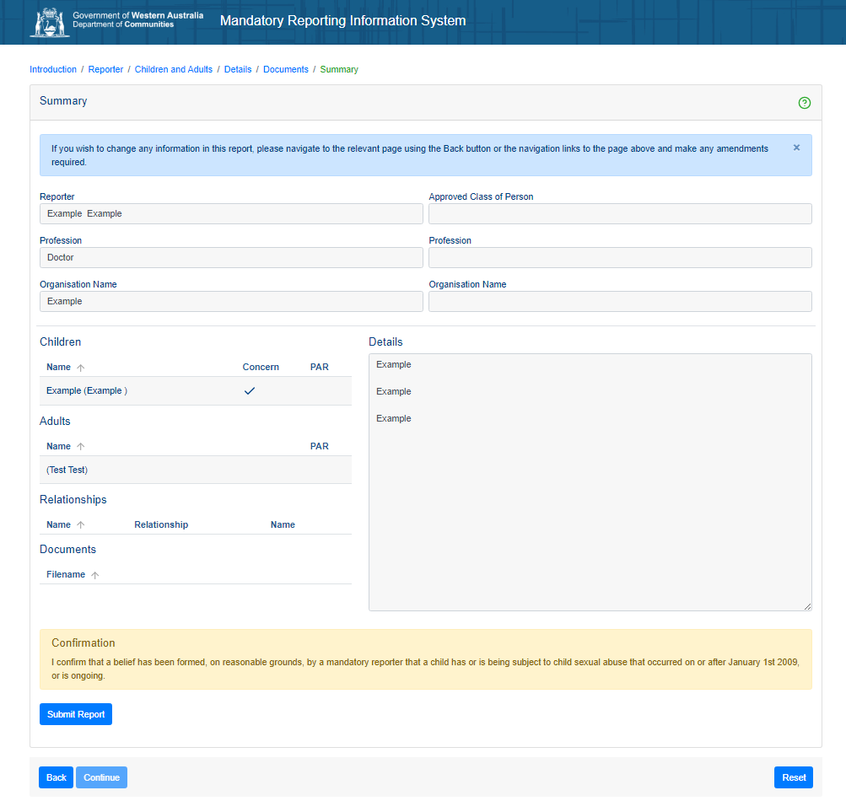
If you wish to change any information in this report, you can navigate to the relevant screen using the “Back” button or the navigation links at the top of the screen and make any amendments required.

Once you are ready to submit your mandatory report click “Submit Report” – you will be prompted that the report is created, and you can download the report if you would like to.
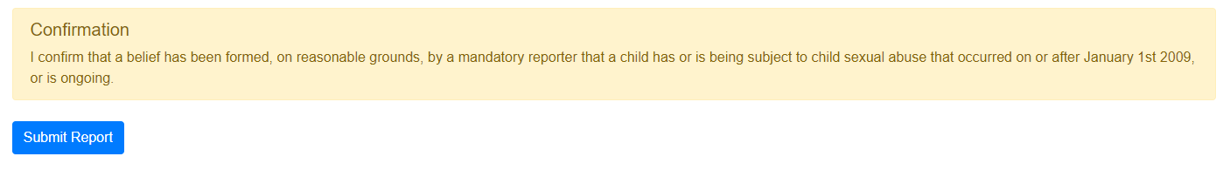
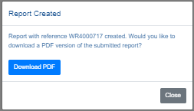

Additional Helpful Tools and Functions

Navigating through the system -  Continue & Back buttons | Use the Continue button to progress through the screens.  Click the Back button to return to completed screens to review and amend information you’ve already entered.  The buttons are located at the bottom left of each screen.  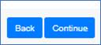
Navigating through the system -  Continue & Back buttons | Alternatively, use the links located at the top of each screen to navigate backward through the screens already completed to review and amend as required. Click on the screen you wish to revisit in the link to navigate directly into that screen.  Note - this function does not allow you to progress forward into screens not yet completed.
Information | Click on any of these information icons at various points through the system to display additional information and definitions.
Help  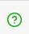 | Click on the Help icons located within each screen to access system help and tips to assist you with completing your report. Each Help icon in each screen links to the specific screen and/or area of its location and will provide a guide on how to complete that specific area of the system.

