Western Australia Economic Profile – May 2025

Western Australia – Economic conditions
The main updates in this month’s Economic Profile relate to the release of labour market data, private new capital expenditure for the March quarter 2025, and Western Australia’s mineral and petroleum sales.
Labour market
Western Australia’s labour market continues to have limited spare capacity. While there was a sizeable increase in the unemployment rate in April 2025 (from 3.6 per cent to 4.2 cent), the underemployment rate fell by a similar amount (from 5.8 per cent to 5.2 per cent), leaving the underutilisation rate unchanged at 9.4 per cent.
The ongoing tight labour market likely contributed to an uptick in nominal wage growth in Western Australia in the March quarter 2025, with year-on-year growth in the wage price index increasing to 3.7 per cent (compared to 3.3 per cent in the December quarter 2024). With inflation receding, there was also an increase in real wages, although with Perth’s consumer price index growing faster than the Australian average, the increase in real wages was slightly lower in Western Australia than nationally.
The outlook for the labour market in Western Australia is still robust. The number of internet job advertisements, which had been trending down from mid-2023 to mid-2024, has stabilised in recent months at a relatively high level. There are some different patterns emerging for job advertisements across occupation groups and regions, with a slightly stronger trend for occupations related to the mining, construction and manufacturing industries, and the regions of the State where those industries have a relatively larger presence.
Private new capital expenditure
Western Australia’s private new capital expenditure rose to $45.6 billion in the year to the March quarter 2025, with expenditure in both mining and non-mining industries increasing. Western Australia accounted for over 60 per cent of Australia’s mining industry’s new capital expenditure in the year to the March quarter 2025, while its share of non-mining new capital expenditure over this period was around 10 per cent. The ABS survey of expected expenditure suggests there will be some drop off in private new capital expenditure in Western Australia in the next financial year, with some of this reflecting the completion of high-value work on large projects.
Mineral and petroleum sales
The value of Western Australia’s mineral and petroleum sales fell 10.2 per cent to $223.4 billion in 2024. Although the sales volumes of iron ore, liquefied natural gas, and lithium were at or around record levels, lower average prices for these commodities across the year meant that their sales values were down compared to 2023. Gold was an exception, with a much higher average price driving an 18.7 per cent increase in the value of Western Australia’s gold sales in 2024 to $23.7 billion, despite a 4.2 per cent fall in sales volume.

Economic conditions – Contents

Whole of economy
State final demand
Commodity prices and exchange rates
Consumer prices and interest rates
Labour market – employment
Labour market – spare capacity and vacancies

Link to Economic structure and industries section
Labour market – wages
Population
Housing
Construction
Regional labour markets and construction
International trade

Whole of economy
Back to contents

Gross state/domestic product (change)
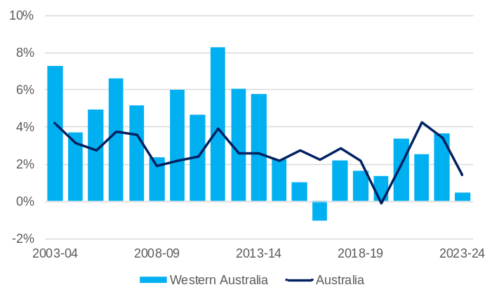
Note – Chain volume measures. Original series. Annual change.
Source: Based on ABS data.
- Gross state product (GSP) is a measure of the total economic production of a state or territory and is the state/territory equivalent of a nation’s gross domestic product (GDP).
- Western Australia’s GSP was less affected by the COVID-19 pandemic in 2019-20 compared to other states and territories and grew at a relatively consistent rate in the next three financial years.
- Western Australia’s real gross state product (GSP) rose 0.5% in 2023-24, lower than the growth of Australia’s real gross domestic product (GDP) of 1.4%.
- Western Australia’s lower growth in 2023-24 was mainly due to contractions in the mining and agriculture, forestry and fishing industries. Production in metal ore mining and oil and gas was disrupted due to adverse weather conditions and maintenance activities, while grain production volumes declined after bumper harvests in previous years.
- The WA Government Pre-election Financial Projections Statement 2024-25 forecasts Western Australia’s real GSP will rise 2.25% in 2024-25 and 2.5% in 2025-26.

State final demand by component (contribution to change)
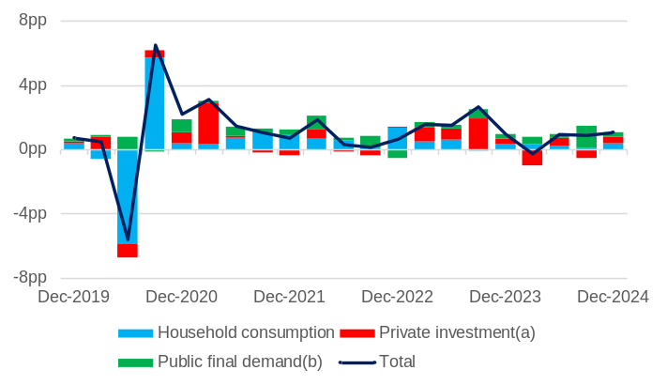
Note – Chain volumes measures. Seasonally adjusted series. Quarter-on-quarter change. pp = percentage points. (a) Private gross fixed capital formation. (b) General government final consumption expenditure and public gross fixed capital formation.
Source: Based on ABS data.
- State final demand (SFD) measures total consumption and investment by the private and public sectors. SFD accounts for most of Western Australia’s GSP – 67% ($305.8 billion) in 2023-24 – although this share is low compared to other states and territories due to net exports being particularly high for Western Australia.
- Western Australia’s real SFD rose 1.1% in the December quarter 2024, following a 0.9% rise in the September quarter 2024.
- Private investment made the largest contribution, adding 0.42 percentage points to SFD growth in the December quarter 2024, with household consumption adding 0.36 percentage points and public final demand adding 0.27 percentage points.
- The WA Government Pre-election Financial Projections Statement 2024-25 forecasts Western Australia’s real SFD will rise 3.75% in 2024-25 and 2.75% in 2025-26.

Interstate comparison of state final demand by component (contribution to change): December quarter 2024
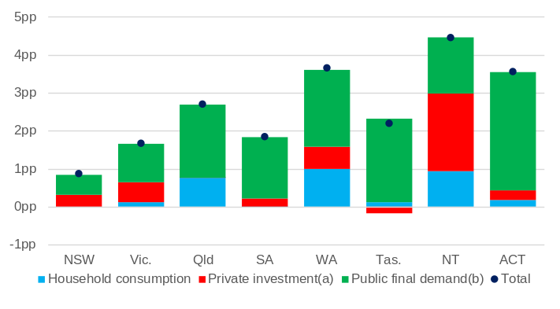
Note – Chain volumes measures. Seasonally adjusted series. Change between the sum of the latest four quarters and the sum of the same quarters of the previous year. pp = percentage points. (a) Private gross fixed capital formation. (b) General government final consumption expenditure and public gross fixed capital formation.
Source: Based on ABS data.
- Western Australia’s real SFD grew 3.7% in the year to the December quarter 2024. This was the second highest growth rate of all the states and territories, behind the Northern Territory (4.5%).
- In the year to the December quarter 2024, contributions to Western Australia’s real SFD growth were:
- Public final demand: 2.0 percentage points
- Household consumption: 1.0 percentage points
- Private investment: 0.6 percentage points.
- In the year to the December quarter 2024, the contribution to real SFD growth of:
- household consumption was the highest in Western Australia, followed by the Northern Territory.
- private investment was the second highest in Western Australia, behind the Northern Territory.
- public final demand was the third highest in Western Australia, behind Tasmania and the Australian Capital Territory.

State final demand
Back to contents

Household consumption by component (contribution to change): December quarter 2024
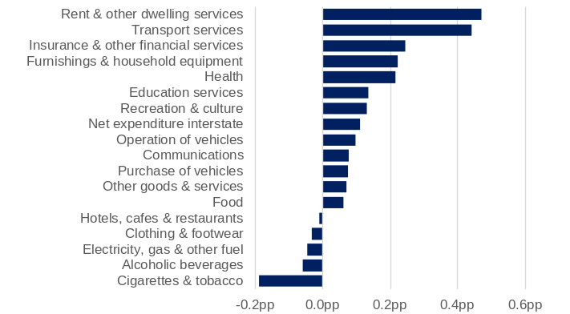
Note – Chain volume measures. Seasonal adjusted series. Change between the sum of the latest four quarters and the sum of the same quarters of the previous year. pp = percentage points.
Source: Based on ABS data.
- Household consumption in Western Australia increased 2.0% in the year to the December quarter 2024.
- Spending on rent and other dwelling services (up 2.3%) contributed the most to growth in Western Australia’s household consumption in the year to the December quarter 2024. Other leading contributors to growth in household consumption over this period were:
- transport services (up 8.6%)
- insurance and other financial services (up 3.2%)
- furnishings and household equipment (up 5.1%).
- Spending on cigarettes and tobacco (down 13.2%) detracted the most from Western Australia’s household consumption in the year to the December quarter 2024, followed by alcoholic beverages (down 3.6%) and electricity, gas and other fuel (down 2.6%).

Private investment by component (contribution to change): December quarter 2024
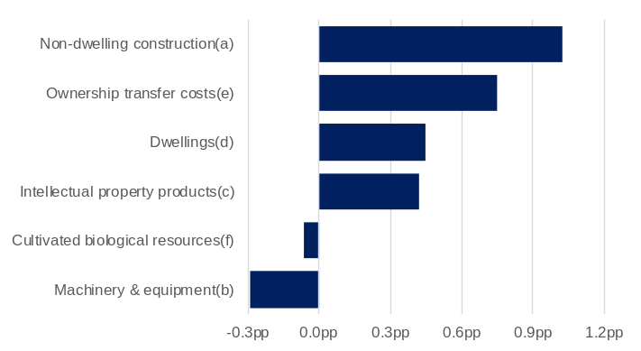
Note –. Chain volumes measures. Seasonally adjusted series. Change between the sum of the latest four quarters and the sum of the same quarters of the previous year. pp = percentage points. (a) Non-residential buildings and other structures. (b) Transport equipment and other machinery and equipment. (c) Computer software, research and development, entertainment, literary or artistic originals, and mineral exploration. (d) Buildings or parts of buildings used as residences. (e) Fees, commissions, stamp duty and other government charges for transferring ownership of dwellings and non-dwelling constructions. (f) Livestock and plantations of trees yielding repeat products (e.g. vineyards and orchards).
Source: Based on ABS data.
- Private investment in Western Australia increased 2.3% in the year to the December quarter 2024.
- Spending on non-dwelling construction (up 2.5%) contributed the most to growth in Western Australia’s private investment in the year to the December quarter 2024, followed by spending on ownership transfer costs (up 13.7%) and dwellings (up 2.9%).
- The increase in non-dwelling construction, which consists of non-residential buildings and other structures, over the past year was largely driven by new engineering construction in mining and energy projects in Western Australia.

Public final demand by component (contribution to change): December quarter 2024
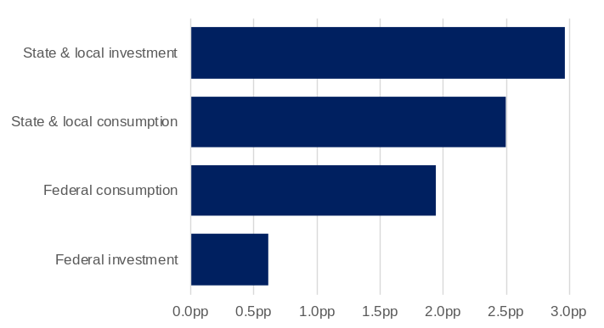
Note – Chain volumes measures. Seasonally adjusted series. Change between the sum of the latest four quarters and the sum of the same quarters of the previous year. pp = percentage points.
Source: Based on ABS data.
- Public final demand, which comprises local, state and federal government consumption and investment, increased 8.0% in the year to the December quarter 2024.
- State and local government investment (up 17.6%) contributed the most to growth in the State’s public final demand in the year to the December quarter 2024, followed by state and local government consumption (up 5.2%).
- The increase in state and local government investment over the past year has been driven by Western Australian Government investments in large-scale road, rail, and utilities projects, including METRONET, as well as spending on social benefits to households in the form of utilities rebates.

Commodity prices and exchange rates
Back to contents

Mineral commodity prices (index)
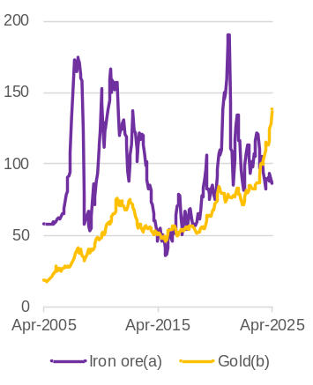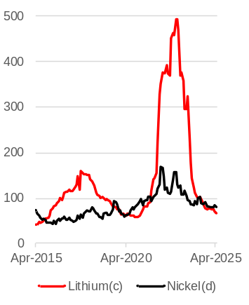
Note – Index based on current prices in US dollars. Original series. February 2024 = 100.0. (a) China spot price per dry tonne of 62% Fe fines on a cost, insurance, and freight basis. (b) London afternoon fixing price per troy ounce of 99.5% fine. (c) Asia lithium carbonate price per tonne on a cost, insurance and freight basis. (d) London Metal Exchange (LME) Cash.
Source: World Bank and S&P Global Market Intelligence.
- Prices for Western Australia’s main mineral commodity exports have fluctuated considerably over the past five years.
- Iron ore prices have tended to fluctuate with announcements and market speculation over policies to stimulate construction activity in China. The iron ore price has stabilised over the past few months, settling at around US$100 a tonne. The average monthly price in April 2025 was US$97.2 a tonne.
- Lithium prices fell significantly as additional supply incentivised by high prices in 2022 came online, coupled with slower than expected sales growth in electric vehicles. The decline has continued, with the average monthly price for lithium carbonate in April 2025 at US$9,000 a tonne.
- Nickel prices have followed a similar, albeit less spectacular, trajectory to lithium prices. The average monthly price for nickel in April 2025 was US$15,219 a tonne.
- Gold has been an exception, with prices continuing to climb to record high levels due to falling interest rates (decreased competition for higher-yielding investments) and geopolitical tensions stimulating the safe-haven demand for gold.
- The gold price was US$3,218 per troy ounce in April 2025, 38% above the price one year ago.

Non-mineral commodity prices (index)

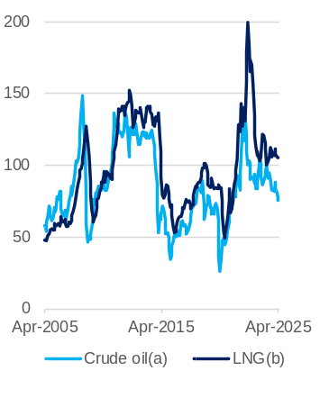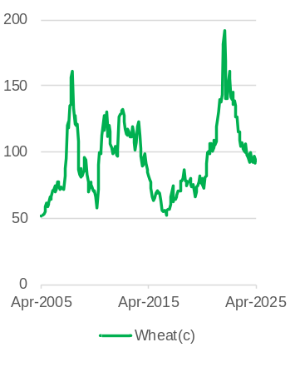
Note – Index based on current prices in US dollars. Original series. February 2024 = 100.0. (a) Crude oil, United Kingdom Brent price per barrel. (b) Japan liquefied natural gas import price per million British thermal units on a cost, insurance, and freight basis. (c) United States hard red winter Gulf export price per tonne.
Source: World Bank.
Prices for Western Australia’s main energy exports have also fluctuated over the past five years, with geopolitical factors influencing the supply and demand for these commodities.
- The crude oil price increased sharply in early 2022 from the onset of the Russia-Ukraine conflict but fell back as global markets settled. The average monthly crude oil price in fell to US$67.7 a barrel in April 2025, the lowest for four years.
- LNG prices are largely linked to crude oil prices but the disruption in global gas trade in 2022 added a degree of volatility to the LNG market. The average monthly LNG price in April 2025 was US$12.4 per mmBTU.
- Global wheat prices tend to move with actual and expected growing conditions in major wheat producing regions. Trade policies and changes in input costs (especially for transport) can also affect wheat prices, which partly explains the similar movements between the wheat price and the oil price in recent years. The average monthly price for wheat in April 2025 was US$250 a tonne.

Australian dollar exchange rates
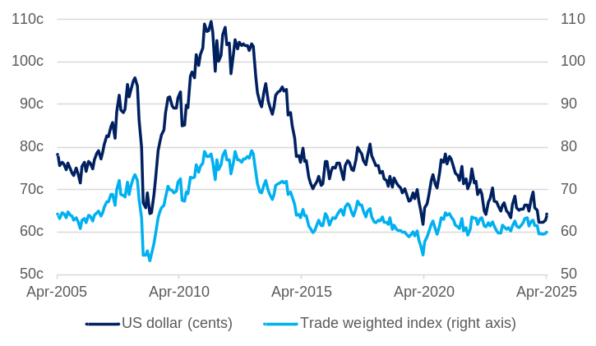
Note – Trade weighted index May 1970 = 100.0.
Source: RBA.
- The Australian dollar exchange rate is influenced by many factors, including the price of Australia’s main export commodities, and actual and expected differences in interest rates.
- The Australian dollar appreciated against the US dollar in April 2025, as the US currency weakened due to concerns over its economic outlook. The Australian dollar averaged 64.2 US cents in April 2025, 2.2% higher than the previous month but 1.7% lower than one year ago.
- The trade-weighted index (TWI) accounts for a group of 17 foreign currencies based on their shares of trade with Australia and provides a broader measure of the Australian dollar.
- The TWI has been relatively stable over the past few years, as the Australian dollar’s depreciation against the US dollar was offset by its appreciation against some other currencies. The TWI in April 2025 was 0.5% higher than the previous month but 3.7% lower than one year ago.

Consumer prices and interest rates
Back to contents

Consumer price index (change)
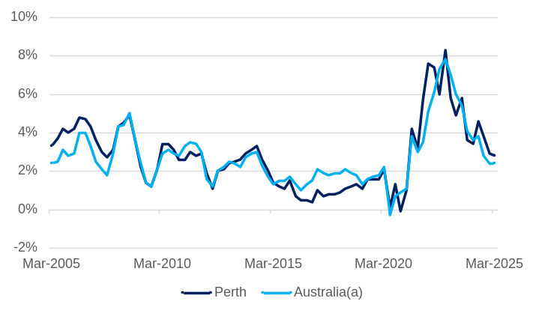
Note – Original series. All groups consumer price index. Year-on-year change in quarterly index. (a) Weighted average of eight capital cities.
Source: Based on ABS data.
- Consumer price inflation in Perth has fallen significantly over the past two years, from a high of 8.3% in the December quarter 2022.
- Perth’s annual inflation rate, as measured by year-on-year growth in the consumer price index (CPI), was 2.8% in the March quarter 2025, down from 2.9% in the previous quarter.
- However, Perth’s annual CPI inflation has been above Australia’s annual CPI inflation over the past four quarters.
- In the March quarter 2025, Australia’s annual inflation rate was 2.4%, unchanged from the previous quarter.
- The measure of Perth’s CPI in the WA Government’s State Budget excludes the electricity sub-index, to smooth the effect of successive household electricity credits. On this basis, the WA Government Pre-election Financial Projections Statement 2024-25 forecasts Perth’s annual average CPI will rise 2.75% in both 2024-25 and 2025-26.

Consumer price index by component (contribution to change): March quarter 2025
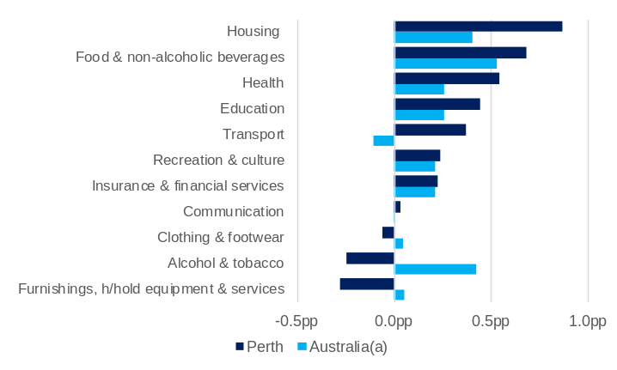
Note – Original series. All groups consumer price index. Year-on-year change in quarterly index. pp = percentage points. (a) Weighted average of eight capital cities.
Source: Based on ABS data.
- Housing (up 4.1%) made the largest contribution to the year-on-year growth in Perth’s CPI in the March quarter 2025. Price increases were particularly high for new dwellings purchased by owner-occupiers (up 10.1%) and rents (up 8.9%).
- Other CPI components that contributed to the rise in Perth’s CPI in the year to the March quarter 2025 included:
- food and non-alcoholic beverages (up 3.6%)
- health (up 4.9%)
- Food and non-alcoholic beverages (up 3.2%) made the largest contribution to Australia’s year-on-year CPI growth in the March quarter 2025, followed by alcohol and tobacco (up 6.5%) and housing (up 2.0%).

Monetary policy interest rates
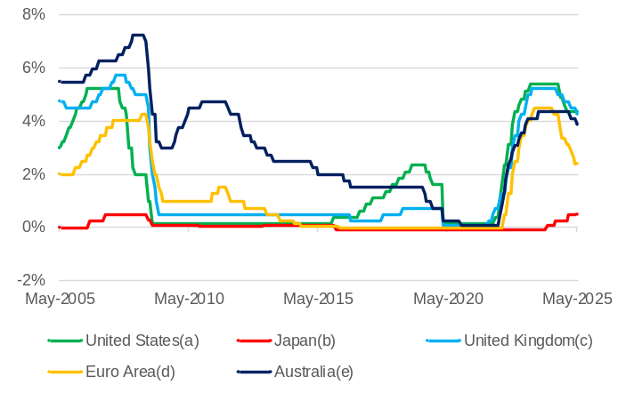
Note – As of 20 May 2025 (a) Federal funds maximum target rate until December 2008 and the midpoint of the target range for the federal funds rate from January 2009 onwards. (b) Policy rate. (c) Bank rate. (d) Refinancing rate. (e) Cash rate.
Source: RBA and Central Banks.
- Higher inflation led to many countries tightening monetary policy from late 2021 to 2023. In 2024, some countries started cutting interest rates as inflation and inflationary expectations eased.
- The Reserve Bank of Australia increased Australia’s official interest rate from 0.10% to 4.35% between May 2022 and November 2023. The Reserve Bank Board cut the cash rate by 25 basis points in February 2025 and a further 25 basis points to 3.85% in May 2025.
- Monetary policy in the US, UK and Euro Area followed a similar trajectory to Australia in 2022 and 2023, but earlier disinflation allowed central banks in these markets to start cutting interest rates sooner than Australia. Rate cuts in these markets have been:
  - European Central Bank: 210 basis points from June 2024, with the policy rate at 2.40% in April 2025.
  - Bank of England: 100 basis points from August 2024, with the policy rate at 4.25% in May 2025.
  - US Federal Reserve: 100 basis points from September 2024, with the policy rate at 4.38% in May 2025.
- Japan has been an exception as its increase in inflation occurred later. The Bank of Japan increased interest rates for the first time in 17 years in March 2024 with further increases in July 2024 and January 2025. The policy rate remained at 0.5% in May 2025.

Labour market – employment
Back to contents

Employment and total monthly hours worked (change)
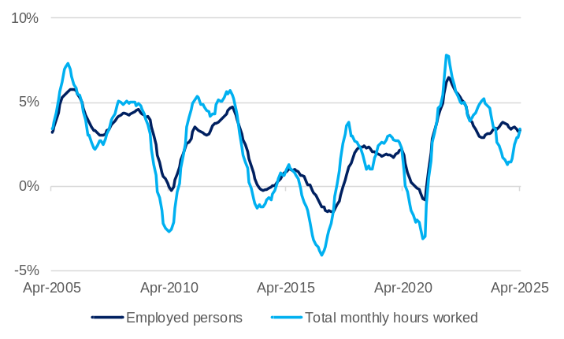
Note – Seasonally adjusted series. 12-month rolling average for employed persons and total monthly hours worked. Year-on-year change in monthly series.
Source: Based on ABS data.
- Employment growth in Western Australia has fallen from the very high rates of growth reached during the economic recovery from the COVID-19 pandemic but has been sustained at a relatively high level as high net overseas migration has resulted in a large increase in the working age population.
- Western Australia’s annual average employment rose 3.3% to 1.62 million in April 2025.
- The WA Government Pre-election Financial Projections Statement 2024-25 forecasts Western Australia’s annual average employment will increase by 3.25% in 2024-25 and 1.75% in 2025-26.
- Growth in hours worked has been lower than employment growth over the past year, although the gap is narrowing.
- Western Australia’s annual average monthly hours worked in all jobs rose 3.4% to 228.3 million hours in April 2025.
- With growth in hours worked marginally outpacing growth in employment, there was a slight increase in the annual average of hours worked per employed person (per month) in April 2025 to 140.7 hours.

Employment by industry (change): March quarter 2025
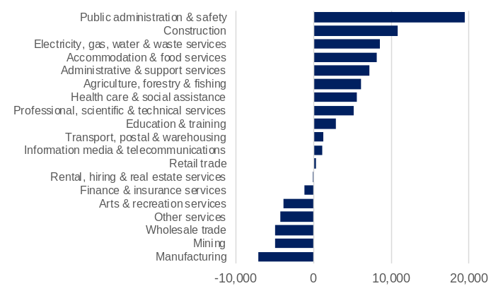
Note – Original series. Change between the sum of the latest four quarters and the sum of the same quarters of the previous year. Data is collected for the middle month of each quarter (February, May, August and November).
Source: Based on ABS data.
- Public administration and safety had the largest rise in average employment in Western Australia, rising by 19,488 between the four quarters to March 2024 and March 2025. Construction (up 10,762) and electricity, gas, water and waste services (up 8,485) also had large increases in average employment over the same period.
- Western Australia’s two largest exporting industries – mining and manufacturing – had the largest declines in average employment over the past year.
  - Average employment in the manufacturing industry fell by 7,075 between the four quarters to March 2024 and March 2025, while average employment in the mining industry fell by 4,958 over the same period.

Participation rate
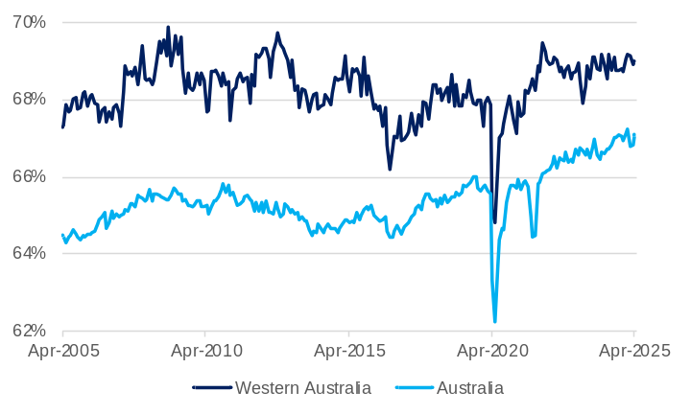
Note – Seasonally adjusted series. Monthly series.
Source: Based on ABS data.
- Western Australia’s participation rate was 69.0% in April 2025, up from 68.9% in March 2025.
- Australia’s participation rate was 67.1% in April 2025, up from 66.8% in March 2025.
- Western Australia’s participation rate has consistently been higher than Australia’s participation rate. The largest recorded difference was in October 2012 at 4.5 percentage points.
- The WA Government Pre-election Financial Projections Statement 2024-25 forecasts Western Australia’s participation rate will average 69.0% in 2024-25 and 68.9% in 2025-26.

Labour market – spare capacity and vacancies
Back to contents

Underutilisation rate
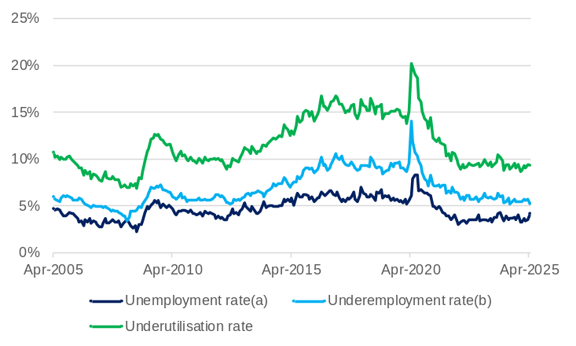
Note – Seasonally adjusted series. Monthly series. Underutilisation rate is the sum of the unemployment and underemployment rates. (a) Proportion of unemployed in the labour force (people without a job who are actively looking for work). (b) Proportion of underemployed in the labour force (workers wanting more hours).
Source: Based on ABS data.
Western Australia’s underutilisation rate, which is the sum of the unemployment and underemployment rates, remained unchanged at 9.4% in April 2025.
- The unemployment and underemployment rates for Western Australia in April 2025 moved in opposite directions from the previous month:
- The unemployment rate was 4.2% in April 2025, up from 3.6% in March 2025.
- The underemployment rate was 5.2% in March 2025, down from 5.8% in March 2025.
- Western Australia’s record low underutilisation rate was 6.9% in October 2008, when the unemployment rate was 2.3% and the underemployment rate was 4.6%.
- Western Australia’s record high underutilisation rate was 20.2% in April 2020 during the initial stages of the COVID-19 pandemic, when the unemployment rate was 6.1% and the underemployment rate was 14.1%.

Internet vacancies by occupation group
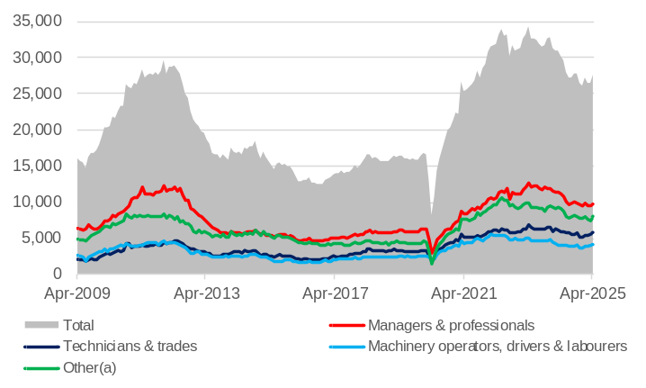
Note – Seasonally adjusted series. Online job advertisements on SEEK, CareerOne and Australian JobSearch. Excludes job advertisements on other online job boards, employer web sites, newspapers, and word of mouth. (a) Community and personal services; clerical and administrative; sales; and other.
Source: Jobs and Skills Australia.
- Job vacancies in Western Australia fell significantly during the initial stages of the COVID-19 pandemic but increased sharply as the economy recovered and some employers had difficulty filling vacancies in an environment of constrained labour supply. Job vacancies are still above pre-COVID-19 levels but have fallen noticeably over the past two years.
- Western Australia had 27,607 internet job advertisements in April 2025, 4.4% more than the previous month but 8.4% less than one year ago.
- In April 2025, there were 0.39 internet job vacancies for every unemployed person in Western Australia. This ratio has declined from its peak of 0.68 in August 2022, although it remains much higher than its historical low of 0.09 in May 2020.
- Job vacancies in machinery operators, drivers and labourers rose 0.1% to 4,105 over the year to April 2025, while there were falls in in the following occupation groups:
- Managers and professionals fell 12.4% to 9,721
- Technicians and trades fell 0.6% to 5,824
- The other occupation group (which includes community and personal services; clerical and administrative; and sales) fell 12.3% to 7,953.

Unemployment¹ to employment ratio by industry: March quarter 2025
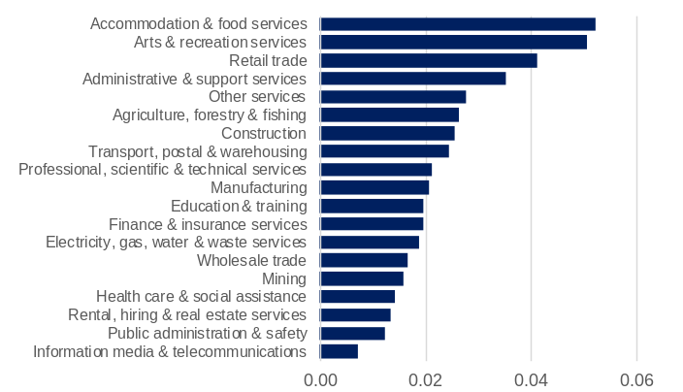
Note – Original series. Average of the latest four quarters. Data is collected for the middle month of each quarter (February, May, August and November). ¹ Unemployed persons by industry of last job.
Source: Based on ABS data.
- The number of unemployed persons by industry of last job indicates the size of the potential pool of additional workers available for each industry. Given the largest employing industries tend to have the largest number of unemployed people who last worked in that industry, the ratio of unemployed to employed persons provides a better basis to compare industries.
- The industries with the highest average unemployment to employment ratios in the four quarters to March 2025 were:
- accommodation and food services (0.052)
- arts and recreation services (0.051)
- retail trade (0.041).
- The industries with the lowest average unemployment to employment ratios in the four quarters to March 2025 were:
- information media and telecommunications (0.007)
- public administration and safety (0.012)
- rental, hiring and real estate services (0.013).

Labour market – wages
Back to contents

Wage price index (change) and labour utilisation rate
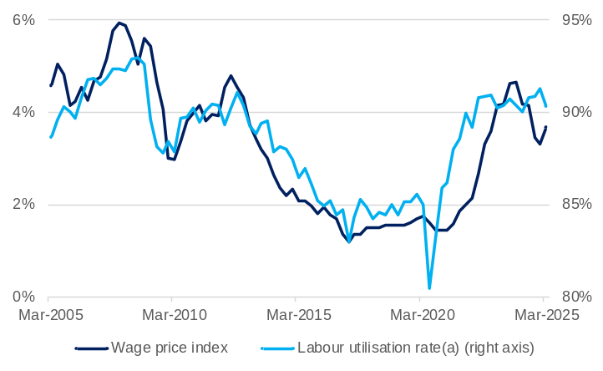
Note – Current prices. Original series. Year-on-year change in quarterly wage price index. 2008-09 = 100.0. Right vertical axis does not start at zero. (a) The labour utilisation rate is the proportion of persons in the labour force not underutilised.
Source: Based on ABS data.
- Wage growth in Western Australia generally corresponds with the rate of labour utilisation; that is, when the rate of labour utilisation is high and spare capacity is low, employers offer higher wages to attract and retain workers. However, the correlation between labour utilisation and wage growth has not been as strong in recent years.
- The labour utilisation rate increased sharply in the economic recovery from the COVID-19 pandemic, but it took some time for wage growth to respond.
- The labour utilisation rate and wage growth have moved in opposite directions over the past four quarters.
- Wage growth in Western Australia, as measured by the year-on-year change in the wage price index (WPI), increased from 3.3% in the December quarter 2024 to 3.7% in the March quarter 2025.
- The WA Government Pre-election Financial Projections Statement 2024-25 forecasts Western Australia’s annual average wages will rise 3.75% in 2024-25 and 3.5% in 2025-26.
- Wage growth has also increased at a national level, with the year-on-year change in Australia’s WPI increasing from 3.2% in the December quarter 2024 to 3.4% in the March quarter 2025.

Wage price index (nominal and real change)
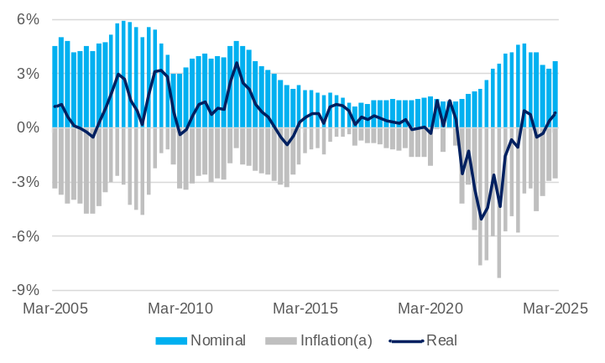
Note – Original series. Nominal = index of current prices. Real = index of current prices deflated by all-groups consumer price index for Perth. Year-on-year change in quarterly indexes. (a) Change in all-groups consumer price index for Perth are multiplied by negative one, given inflation detracts from real wages.
Source: Based on ABS data.
- Although nominal wage growth increased in Western Australia over the three years to 2023, for most of this time the rate of inflation has was higher, resulting in falling real wages. The extended period of inflation being higher than nominal wage growth resulted in real wages falling back to a level previously seen in 2011.
- Real wages have grown year-on-year in four of the past six quarters in Western Australia, largely due to easing inflation.
- Real wages in Western Australia rose 0.8% in the March quarter 2025, following a rise of 0.4% in the previous quarter.
- In the March quarter 2025, the year-on-year change in the wage price index (3.7%) was higher than the year-on-year change in the consumer price index (2.8%).
- Real wages in Australia have grown year-on-year in each of the past six quarters, from 0.2% in the December quarter 2023 to 1.0% in the March quarter 2025.

Interstate comparison of average weekly earnings¹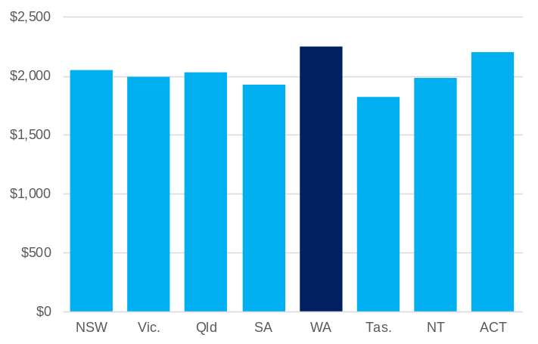
Note – Seasonally adjusted series. Data is collected for the middle month of the June and December quarters (May and November). ¹ Full-time adult total earnings.
Source: Based on ABS data.
- Western Australia has higher average weekly earnings than the rest of Australia, due in part to the relatively high proportion of full-time workers in Western Australia employed in the highly paid mining and mining services industries.
- In the December quarter 2024, average weekly earnings in Western Australia were $2,245, 10% higher than the national average of $2,044.
- Other Australian jurisdictions with average weekly earnings above the national average in the December quarter 2024 were:
- Australian Capital Territory ($2,202)
- New South Wales ($2,052).
- Australian jurisdictions with average weekly earnings below the national average in the December quarter 2024 were:
- Tasmania ($1,825)
- South Australia ($1,923)
- Northern Territory ($1,981)
- Victoria ($1,993)
- Queensland ($2.033).

Population
Back to contents

Estimated resident population (change)
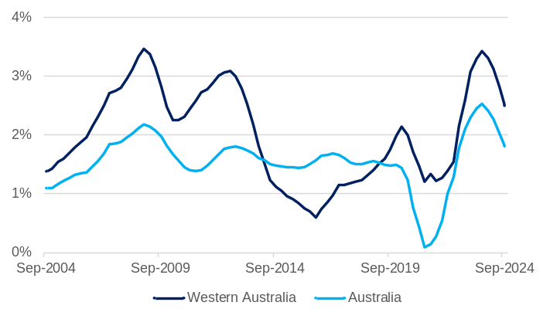
Note – Original series. Year-on-year change in quarterly series.
Source: Based on ABS data.
- Western Australia’s population has been growing at a high rate, relative to both the past ten years and to the national rate.
- Western Australia’s population growth rate reached a high of 3.4% in the year to the September quarter 2023 but has decreased in each of the past four quarters to 2.5% in the year to the September quarter 2024.
- Australia’s population growth rate in the year to the September quarter 2024 was 1.8%.
- Western Australia’s estimated residential population was 2.98 million in the September quarter 2024, accounting for 10.9% of Australia’s estimated resident population of 27.31 million.
- In the year to the September quarter 2024, Western Australia’s population grew by 72,612, with the increase comprising:
- net overseas migration of 50,760 (13.4% of the Australian total)
- natural increase of 12,878 (12.4% of the Australian total)
- net interstate migration of 8,974.
- The WA Government Pre-election Financial Projections Statement 2024-25 forecasts Western Australia’s population will grow by 1.9% in 2024-25 and 1.8% in 2025-26.

Net overseas migration
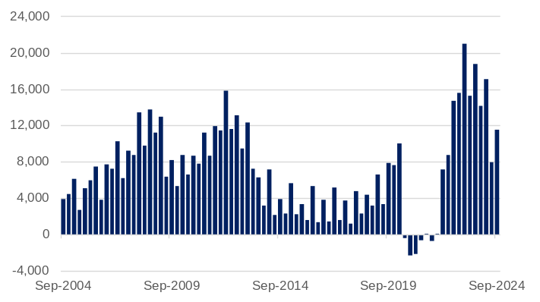
Note – Original series. Quarterly series. Overseas arrivals less departures.
Source: Based on ABS data.
- Western Australia’s net overseas migration was significantly affected by the closing and then re-opening of borders during the COVID-19 pandemic.
- In the year to the September quarter 2024, Western Australia’s net overseas migration was 50,760, 28.2% less than in the year to the September quarter 2023.
- Net overseas migration was 11,564 in the September quarter 2024, down from the record high of 20,995 in the March quarter 2023.
- Western Australia’s share of Australia’s net overseas migration was 12.9% in the September quarter 2024, which is above the long-term average of around 12%.
- Western Australia’s share of Australia’s net overseas migration has fluctuated over time based on economic conditions in the State relative to other parts of Australia.

Interstate migration
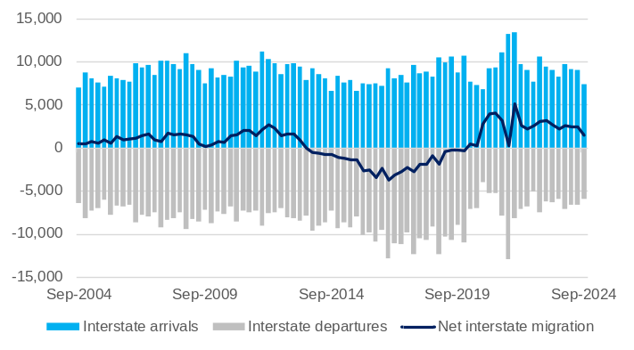
Note – Original series. Quarterly series.
Source: Based on ABS data.
- Western Australia has had positive net interstate migration since mid-2020. This followed 25 quarters of negative net interstate migration from the March quarter 2014 to the March quarter 2020.
- In the year to the September quarter 2024, Western Australia’s net interstate migration was 8,974, with:
- 35,358 interstate arrivals
- 26,384 interstate departures.
- Net interstate migration was 1,469 in the September quarter 2024, lower than the 2,411 in the previous quarter.

Housing
Back to contents

Dwelling building activity
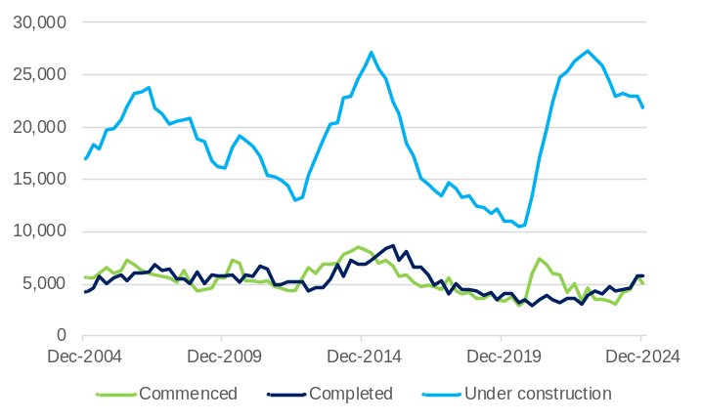
Note – Seasonally adjusted series for dwelling commencements and completions and original series for dwellings under construction. Quarterly series.
Source: Based on ABS data.
- The number of dwellings completed usually tracks the number of dwellings commenced with a lag as dwellings are built. Changes in the average time taken to complete builds will disrupt this relationship, as has been experienced in recent years in Western Australia.
- Stimulus measures introduced by the Australian and Western Australian Government in mid-2020 contributed to a large increase in the number of dwelling units commenced.
- However, longer timeframes for housing construction meant that there was not a corresponding increase in the number of dwelling units completed. This resulted in a sharp increase in the number of dwellings under construction.
- The number of dwellings under construction has fallen somewhat over the past two years as the rate of completions has picked up. However, an increase in the number of dwellings commenced in the past year has kept the number of dwellings under construction at a relatively high level.
- Between the December quarters of 2023 and 2024, Western Australia’s number of dwelling units:
- commenced rose 62% to 5,010
- completed rose 32% to 5,769
- under construction fell 5% to 21,837.

House and rental price indexes
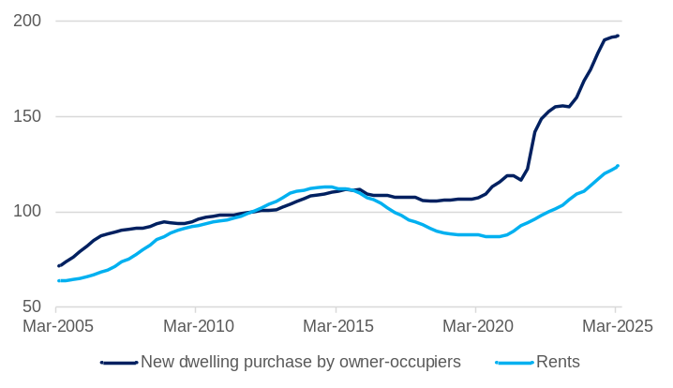
Note – Original series. Quarterly series. 2011-12 = 100.0.
Source: Based on ABS data.
The combination of a surge in demand from high population growth and constraints in delivering new supply has resulted in increases in house and rental prices.
- Prices for new dwellings purchased by owner-occupiers in Perth rose 0.4% in the March quarter 2025, to be 10.1% higher than in the March quarter 2024.
- Perth’s rents rose 1.7% in the March quarter 2025, to be 8.9% higher than in the March quarter 2024.
- Rental prices in Perth started to grow from 2021 as vacancy rates fell to very low levels. Perth’s rental vacancy rate has been rising over the past few months. The Real Estate Institute of Western Australia’s vacancy rate measure for March 2025 was 2.5%.

Median price of established house transfers (unstratified): December quarter 2024
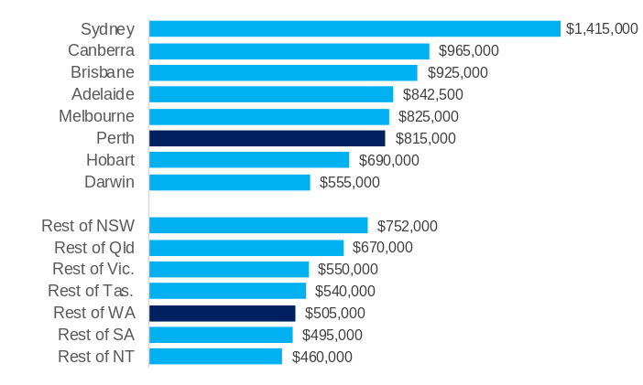
Note – Current prices. Original series. Quarterly series.
Source: Based on ABS data.
- House prices in Perth increased significantly over the past year, although are still lower than most other Australian capital cities.
- Perth’s median established house price was $815,000 in the December quarter 2024, 4.5% higher than the previous quarter and 20.7% higher than the December quarter 2023.
- Sydney’s median established house price ($1.42 million) remained the highest of all Australian capital cities.
- House prices in the rest of Western Australia have also grown significantly over the past year but similarly are lower than most of the other non-capital city regions of Australia.
- The median established house price for the rest of Western Australia (excluding Perth) was $505,000 in the December quarter 2024, 3.1% higher than the previous quarter and 13.5% higher than the December quarter 2023.
- The WA Government Pre-election Financial Projections Statement 2024-25 forecasts Western Australia’s median house price will rise 15.8% in 2024-25 and 6.1% in 2025-26.

Construction
Back to contents

Private new capital expenditure
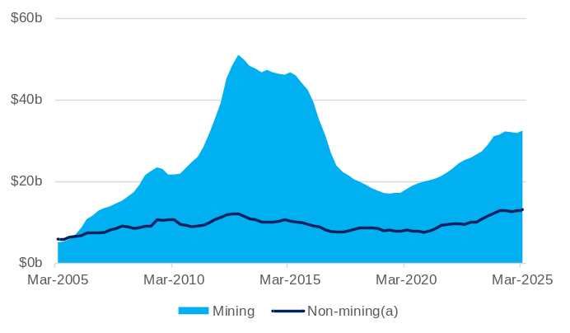
Note – Current prices. Original series. Quarterly series. 4-quarter rolling sum. (a) All industries other than mining; agriculture, forestry and fishing; public administration and safety; and superannuation funds.
Source: Based on ABS data.
- Private new capital expenditure in Western Australia increased over the past year in both mining and non-mining industries. In the year to the March quarter 2025, the value of Western Australia’s new capital expenditure in the:
- mining industry rose 2.8% to $32.4 billion
- non-mining industry rose 2.2% to $13.2 billion.
- Western Australia accounted for 24.4% of the value of Australia’s private new capital expenditure in the four quarters to the March quarter 2025, including 61.5% of Australia’s mining industry new capital expenditure and 9.8% of Australia’s non-mining industries new capital expenditure.
- The ABS survey of expected expenditure suggests private new capital expenditure in Western Australia will rise 1.2% to $45.5 billion in 2024-25, before falling 18.5% to $37.1 billion in 2025-26, with expenditure in the:
- mining industry expected to fall 18.8% to $26.6 billion
- non-mining industry expected to fall 17.6% to $10.6 billion.

Construction activity
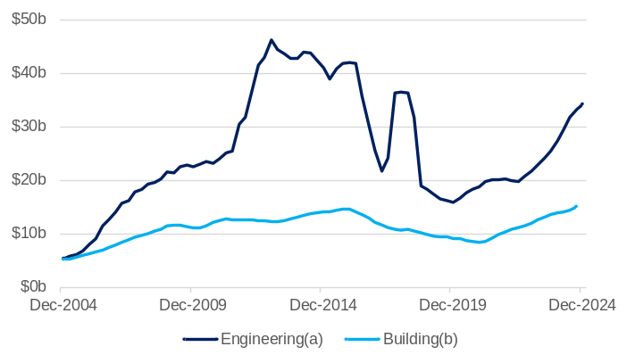
Note – Current prices. Seasonally adjusted series. 4-quarter rolling sum. (a) Roads, highways and subdivisions; bridges, railways and harbours; electricity generation and transmission and pipelines; water storage and supply, sewerage and drainage; telecommunications; heaving industry; recreation and other structures. (b) Residential, commercial, industrial and other non-residential buildings.
Source: Based on ABS data.
- The value of engineering construction activity in Western Australia rose 24.2% to $34.2 billion in the four quarters to the December quarter 2024. This was largely due to increases in the value of construction for:
- heavy industry, up 20.5% to $18.3 billion
- electricity generation, transmission and distribution and pipelines, up 61.5% to $4.9 billion.
- The value of building activity in Western Australia increased 11.2% to $15.6 billion in the four quarters to the December quarter 2024. The value of:
- residential building activity rose 12.3% to $9.1 billion
- non-residential building activity rose 9.8% to $6.5 billion.

Construction activity in the pipeline
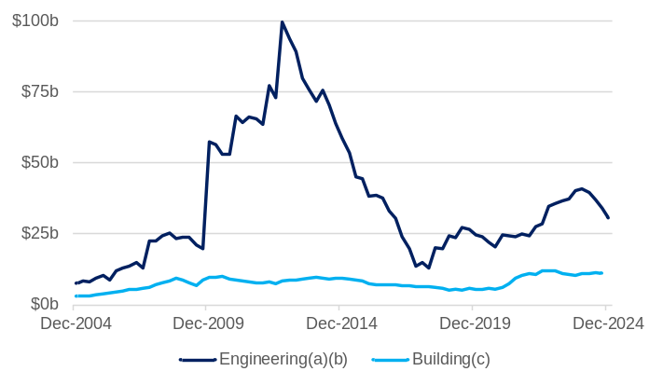
Note – Current prices. Original series. Quarterly series. (a) Data just for Western Australia is not available for some quarters; the data presented here is the national total excluding all states and territories except for Western Australia and the Northern Territory. (b) Value of work remaining on jobs under construction at the end of the quarter. (c) Sum of the value of work remaining on jobs under construction and work not yet commenced at the end of the quarter.
Source: Based on ABS data.
- The value of engineering construction activity in the pipeline increased significantly in the early 2010s as investment was committed to several new iron ore and liquefied natural gas projects and then fell as these projects were constructed. The pipeline of activity picked up in recent years with investment in new projects, but the value of work in the pipeline has passed its recent peak.
- The value of engineering construction work yet to be done in Western Australia and Northern Territory^{(a)} fell 10.2% to $30.6 billion in the December quarter 2024.
- The value of building activity in the pipeline increased from mid-2020 to mid-2022, encouraged by stimulus measures introduced by the Australian and Western Australian Government, then fell across 2023 as higher construction costs and interest rates deterred new investment, before stabilising in 2024.
- The value of building activity in the pipeline in Western Australia rose 3.7% to $11.8 billion in the December quarter 2024, with the value of activity in the pipeline for:
- residential building up 7.9% to $6.9 billion
- non-residential building down 1.9% to $4.8 billion.

Regional labour markets and construction
Back to contents

Internet vacancies by region
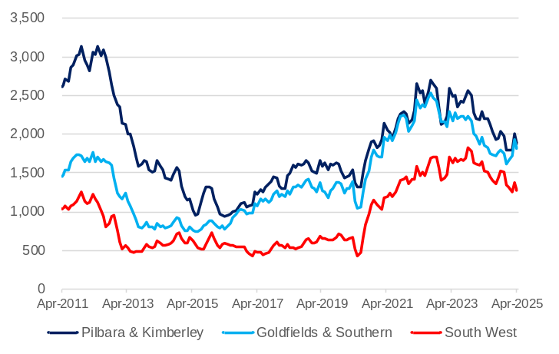
Note – Original series. Monthly series. 3-month moving average. Custom Internet Vacancy Index regions.
Source: Jobs and Skills Australia.
- Internet job vacancies have been falling across Western Australia’s non-metropolitan regions over the past two years, although they remain at relatively high levels.
- Between April 2024 and 2025, internet vacancies in the:
  - Pilbara and Kimberley region fell 15% to 1,877
  - Goldfields and Southern region fell 2% to 1,815
  - South West region fell 17% to 1,268.
- Professional occupations largely drove the decline in internet job vacancies across Western Australia’s regions in the year to April 2025, including:
  - medical practitioners and nurses (down 37%) and engineers (down 30%) in the Pilbara and Kimberley region.
  - medical practitioners and nurses (down 33%) and health diagnostic and therapy professionals (down 32%) in the South West region.
  - medical practitioners and nurses (down 25%) and science professionals and veterinarians (down 19%) in the Goldfields and Southern region.
- Internet job vacancies also fell significantly for technicians and trades workers in the Pilbara and Kimberley region (down 13%), and for community and personal service workers in the South West region (down 31%).

Unemployment rate by region
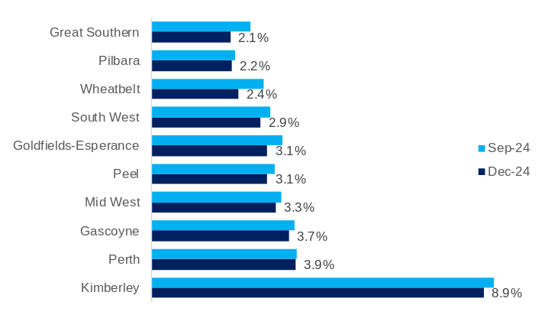
Note – Smoothed seasonally adjusted series. Development commission regions.
Source: Jobs and Skills Australia.
The unemployment rate was below 4% across Western Australia’s regions in the December quarter 2024, with the exception of the Kimberley region.
- The Kimberley generally has the highest unemployment rate of Western Australia’s regions. However, the unemployment rate of 8.9% for the Kimberley in the December quarter 2024 was much lower than prior to the COVID-19 pandemic (16.2% in the December quarter 2019).
- The unemployment rate declined in all Western Australia’s regions in the December quarter 2024. The Wheatbelt region (3.0% to 2.4%) had the largest decline in unemployment rate in the December quarter 2024, followed by the Great Southern region (2.7% to 2.1%).

Building approvals per capita by region: 2023-24

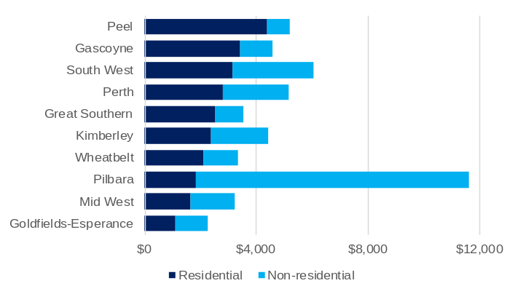
Note – Current prices. Original series. Monthly series. pp = percentage points. Development commission regions. (a) Residential building approvals for the construction of houses and apartments. (b) Non-residential building approvals for the construction of commercial buildings (retail/wholesale trade, transport, offices), industrial buildings (factories, warehouses, agriculture) and other non-residential buildings (education, religion, health, entertainment/recreation, short-term accommodation).
Source: Based on ABS data.
- The labour-intensive nature of the building industry means large parts of a region’s workforce are active when building activity is high. Building approvals can therefore provide a good indication of broader economic conditions across regional economies.
  - A comparison of building approvals on a per capita basis accounts for differences in regional populations and provides an indication of relative demand across regions.
- In 2023-24, the value of residential building approvals per capita was highest in the Peel region ($4,404), followed by the Gascoyne ($3,421) and South West region ($3,162).
- The value of non-residential building approvals per capita was extremely high in the Pilbara region ($9,766) in 2023-24, reflecting the industrial and commercial buildings needed to support the Pilbara region’s large mining industry. The value of non-residential building approvals in the Pilbara region almost quadrupled to $593 million in 2023-24.

International trade
Back to contents

Exports of goods
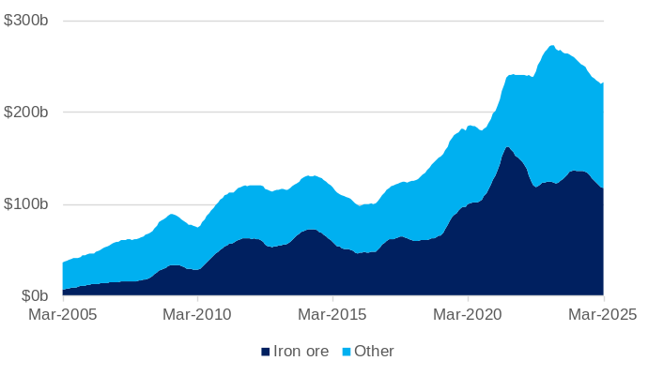
Note – Current prices. Free on board. Original series. 12-month rolling sum.
Source: Based on ABS data.
- The value of Western Australia’s exports has increased over the past decade, driven by high prices for iron ore, liquefied natural gas, battery and critical minerals and grains. With the prices for these commodities returning to longer-term averages, the value of Western Australia’s exports has fallen from its peak.
- Western Australia exported $232.8 billion of goods in the year to March 2025, 9.3% less than in the year to March 2024.
- In the year to March 2025, the value of exports of:
- iron ore was $117.7 billion, 13.3% less than in the year to March 2024
- non-iron ore was $115.1 billion, 4.7% less than in the year to March 2024.
- The peak value of Western Australia’s exports over a 12-month period was $272.1 billion in April 2023. The peak value of Western Australia’s iron ore exports over a 12-month period was $162.2 billion in September 2021.

Imports of goods
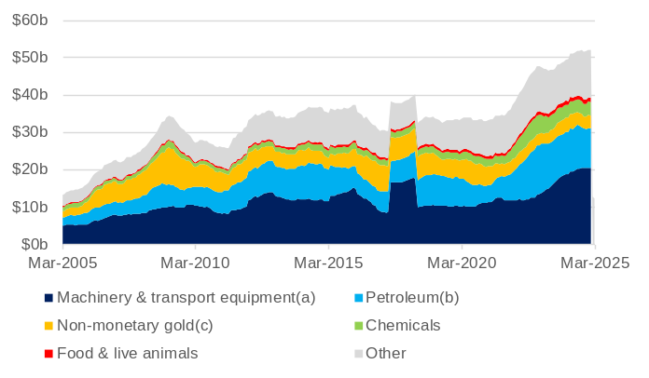
Note – Current prices. Customs value. Original series. 12-month rolling sum. The large increase in the value of imports in 2017 was due largely to the arrival of the Prelude floating LNG plant. (a) Includes road vehicles. (b) Petroleum, petroleum products and other mineral fuels. (c) For further refining at the Perth Mint.
Source: Based on ABS data.
- The value of Western Australia’s imports increased significantly in 2022, driven by the higher oil price. Although a fall in the oil price has led to a reduction in the value of petroleum imports, higher prices and increased demand for a range of other goods have led to ongoing increases in the total value of Western Australia’s imports.
- Western Australia imported $51.6 billion of goods in the year to March 2025, an increase of 3.9% from the year to March 2024.
- In the year to March 2025, the value of imports of:
- machinery and transport equipment was $20.7 billion, 9.8% more than in the year to March 2024
- petroleum was $10.3 billion, 7.6% less than in the year to March 2024
- non-monetary gold was $3.3 billion, 16.3% less than in the year to March 2024
- chemicals was $3.7 billion, 12.4% more than in the year to March 2024
- food and live animals was $1.2 billion, 13.8% more than in the year to March 2024.

Shipping freight rates
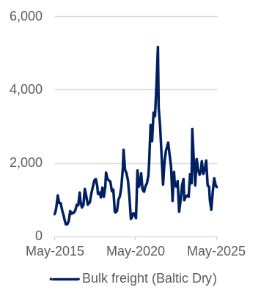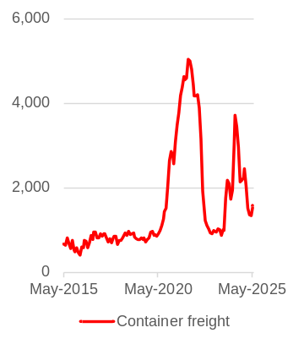
Note – Current prices. Original series. Monthly series. The Baltic Dry Index is a composite of three sizes of cargo ships measured by deadweight (DWt) tonnage (or weight of cargo excluding the weight of the ship).
Source: Trading Economics.
- The Baltic Dry Index (BDI) measures the cost of shipping raw materials over 20 sea routes. The BDI is a useful global trade indicator because 90% of the world’s goods trade occurs via maritime transport.
- The BDI increased rapidly from mid-2020 to a peak in September 2021 as the global economy began to recover from the COVID-19 pandemic, which saw increasing demand for raw materials. The BDI fell back to pre-COVID-19 levels in mid-2022 and has been volatile since. It fell 3% to 1,340 in May 2025 after a 13% fall in April 2025 and a 30% rise in March 2025.
- The containerized freight index (CFI) measures the cost of transporting goods in containers from China’s major ports.
- Similar to the BDI, the CFI increased rapidly from mid-2020, reaching a peak in December 2021 as the global economic recovery combined with disruptions in supply led to a large increase in container freight rates.
- The CFI rose from 887 in September 2023 to 3,714 in June 2024 but has since fallen by 57% to 1,586 in May 2025. The decline has been due to slowing consumer demand in North America and Europe and improved vessel availability.

Western Australia – Economic structure and industries
The Western Australian economy has been shaped over time by the physical and geographical attributes of the State: its large land mass and coastline, extensive mineral and petroleum resources, and the distance between the State’s major population centres and other Australian and overseas cities. Over recent decades, Western Australia’s economy has also been shaped by national and global developments, notably domestic economic reforms and global policies such as trade liberalisation that encouraged the growth of industries in which the State has a comparative advantage. At the same time, economic development in China and other Asian countries with limited mineral and petroleum resources led to an increase in demand for the State’s export commodities, predominantly iron ore and liquefied natural gas.
These forces created a mining expansion in Western Australia that can be roughly broken down into three phases: an initial phase from the mid-to-late 2000s when higher demand led to an increase in commodity prices; an investment phase from the late-2000s to mid-2010s that was the supply response to higher demand and prices, and involved the construction of many large-scale resource projects; and a production phase from the mid-2010s after those projects become operational. The scale of new activity the mining expansion generated in Western Australia significantly changed the structure of the economy. In summary, the striking features of Western Australia’s current economic structure are the relatively high share of merchandise exports in its gross state product, the large share of these exports that go to China, and the mining industry’s high share of investment and gross state product.
The mining expansion contributed to Western Australia enjoying a sustained period of economic growth, often in excess of national levels. This included during the COVID-19 pandemic, when the mining industry in Western Australia was largely able to sustain production volumes and benefit from higher iron ore prices, while other economies with a higher reliance on services exports experienced a significant downturn when these exports were curtailed by travel restrictions.
However, the impact of Western Australia’s economic growth on household incomes has changed through the phases of the mining expansion. The investment phase required a significant domestic workforce, which boosted labour demand and wages, but the workforce requirements diminished once projects became operational. With the capital for mining projects being largely owned outside the State, and while commodity prices are high enough to generate substantial profits, a higher proportion of the income from Western Australia’s economic output now flows outside of the State. So, while in 2023-24 Western Australia’s gross state product per capita was 57 per cent higher than the Australian average, gross disposable household income per capita was only 9 per cent higher than the Australian average.
The mining industry will likely continue to make the largest contribution to Western Australia’s economic output of any industry for decades to come. However, the main driving force of the mining expansion – growth in China’s steel production from economic development and urbanisation – is receding, and mining cannot be expected to contribute to Western Australia’s economic growth in the same way it has for the past two decades. With the mining industry now accounting for a higher share of Western Australia’s gross state product, the State’s economy is also potentially more vulnerable to changes in commodity prices. Western Australia’s economy must also adapt to other long-term trends, including climate change, and technological changes such as the increasing use of AI and automation.
In recognition of these challenges, in 2019 the Western Australian Government released Diversify WA, a framework that identified priority sectors for strategic development that match Western Australia’s perceived strengths with global trends. This was followed in 2023 by the release of Future State: Accelerating Diversify WA, which focuses on the most significant opportunities for international investment to Western Australia. The outcomes from economic diversification have to date been mixed; while there has been growth in some of the priority sectors, this has not translated to growth in real per capita household incomes. The key reason for this has been an absence of productivity growth. Higher productivity growth across the economy will be required to sustain increases in per capita incomes.

Economic structure and industries – Contents
Gross state product
Per capita incomes
International trade (annual)
Productivity
Industry gross value added
Industry investment
Industry employment
Gender indicators
Aboriginal indicators
Environment
Mining and energy industries
Primary industries and defence industries
Tourism and international education
Regions

Gross state product
Back to contents

Gross state product by broad component
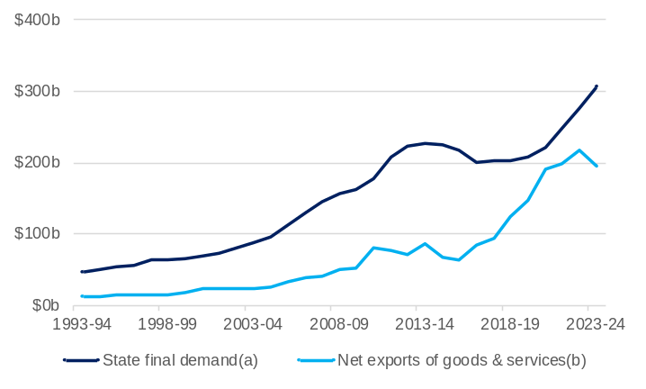
Note – Current prices. Original series. (a) Household and general government final consumption expenditure, and gross fixed capital formation. (b) Exports less imports of goods and services. Changes in state final demand can be exaggerated by large swings in business investment without adjusting for the associated changes in imports.
Source: Based on ABS data.
- The nominal value of Western Australia’s gross state product (GSP) in 2023-24 was $455.7 billion.
- GSP can be divided into state final demand, which measures total consumption and investment, and net (international) exports of goods and services. In 2023-24:
- the value of Western Australia’s state final demand was $305.8 billion, 67% of GSP expenditure
- the value of Western Australia’s net exports of goods and services was $193.8 billion, 43% of GSP expenditure
- net interstate trade and other items detracted $43.9 billion (10%) from Western Australia’s GSP in 2023-24.
- Cycles of activity in the mining industry have had a significant effect on the balance of state final demand and net exports in Western Australia’s GSP over the past 20 years.
- Investments in mining projects led to a large increase in state final demand from the early 2000s to the mid-2010s. The newly installed capacity from this investment then contributed to high growth in net exports from the mid-2010s.
- As projects were completed and the pipeline of new projects became smaller, the value of state final demand contracted. State final demand has recovered strongly in recent years.

Gross state product by component (share)
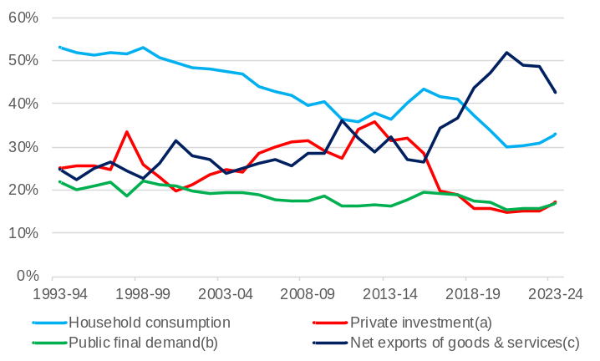
Note – Current prices. Original series. (a) Private gross fixed capital formation. (b) General government final consumption expenditure and public gross fixed capital formation. (c) Exports less imports of goods and services.
Source: Based on ABS data.
- Western Australia’s economy is more reliant on international trade compared to 30 years ago. The GSP share of net exports of goods and services increased from 25% in 1993-94 to 43% in 2023-24, with a peak of 52% in 2020-21 during the COVID-19 pandemic when goods exports remained strong while services imports fell.
- The GSP share of private investment has been influenced by cycles of mining investment. The share peaked at 36% in 2012-13 when construction activity on multiple iron ore and liquefied natural gas projects was at its height but fell to 17% in 2023-24 as the mining expansion moved from its construction to the operation phase and output from these projects contributed to net exports.
- While household consumption and public final demand in Western Australia have grown over time, their share of the economy has fallen as net exports have grown at a faster rate. The GSP share of household consumption fell from 53% in 1993-94 to 33% in 2023-24, while the GSP share of public final demand fell from 22% in 1993-94 to 17% in 2023-24.

Comparison of gross state/domestic product of component (share): 2023-24
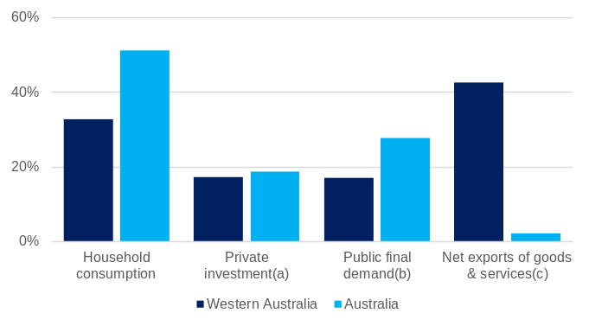
Note – Current prices. Original series. (a) Private gross fixed capital formation. (b) General government final consumption expenditure and public gross fixed capital formation. (c) Exports less imports of goods and services.
Source: Based on ABS data.
- The changes in Western Australia’s economy over the past 30 years means it now has an economic structure that is quite different to the rest of Australia.
- Household consumption accounted for 51% of Australia’s gross domestic product (GDP) in 2023-24, much higher than its share of Western Australia’s GSP in 2023-24, but similar to the share of Western Australia’s GSP in 1993-94.
- As Western Australia accounts for a high share of Australia’s exports, the GDP share of net exports for Australia (2% in 2023-24), is much lower compared to its share of Western Australia’s GSP.
- The GDP shares of private investment (19% in 2023-24) and public final demand (28% in 2023-24) are higher compared to their shares of Western Australia’s GSP, although this is partly explained by the high share of net exports in Western Australia’s GSP.

Per capita incomes
Back to contents

Gross state/domestic product per capita
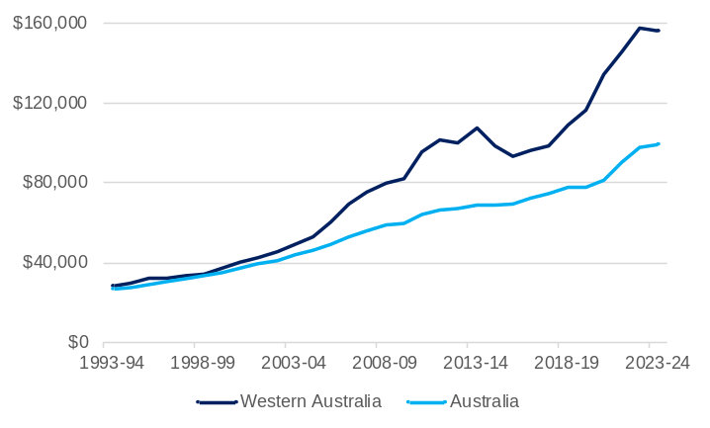
Note – Current prices. Original series.
Source: Based on ABS data.
- Western Australia’s nominal GSP has grown at a faster rate than Australia’s nominal GSP over the past 20 years, resulting in a large gap between Western Australia’s GSP per capita and Australia’s GDP per capita.
- In 2003-04, Western Australia’s GSP was $95.8 billion, which was 11.1 per cent of Australia’s GDP. In 2023-24, Western Australia’s GSP was $455.7 billion, and its share of Australia’s GDP had grown to 17.1%.
- In 2003-04, Western Australia’s GSP per capita was $48,744, which was 12% higher than Australia’s GDP per capita of $43,586. In 2023-24, Western Australia’s GSP per capita was $155,644, 57% higher Australia’s GDP per capita of $99,128.

Gross state product by factor income
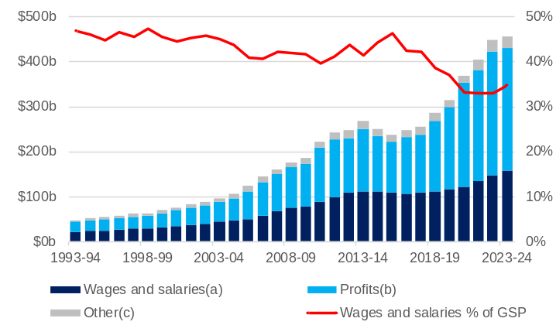
Note – Current prices. Original series. (a) Compensation of employees. (b) Gross operating surplus and gross mixed income. (c) Ownership of dwellings; taxes less subsidies on production and imports; and statistical discrepancy.
Source: Based on ABS data.
- The growth of the mining industry in Western Australia has had a significant effect on the distribution of GSP across factor incomes (the returns to labour and capital).
- Higher commodity prices in the mid-2000s led to profits assuming a greater share of Western Australia’s GSP.
- The high labour demand from the construction of multiple major projects in the early to mid-2010s contributed to the share of wages and salaries in Western Australia’s GSP increasing back to 46% in 2015-16.
- The combination of these projects moving into a far less labour-intensive operational phase and high commodity prices led to profits again assuming a greater share of Western Australia’s GSP.
- In 2023-24:
- Wages and salaries were $158.3 billion (35% of GSP)
- Profits were $269.9 billion (59% of GSP)
- The ‘Other’ category (ownership of dwellings; taxes less subsidies on production and imports; and statistical discrepancy) was $27.5 billion (6% of GSP).

Gross household disposable income per capita
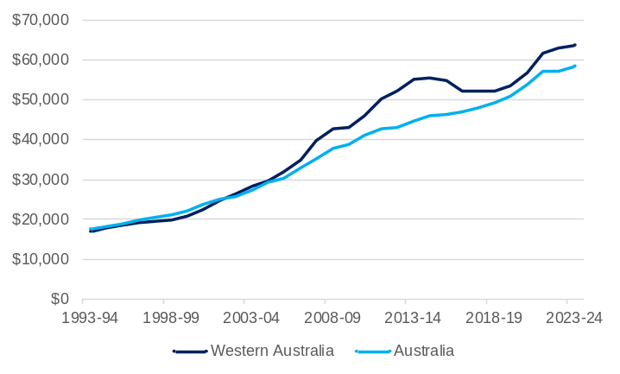
Note – Current prices. Original series.
Source: Based on ABS data.
- A high share of the capital that has generated large profits in recent years in Western Australia is owned outside the State. This means that a significant portion of the additional income from Western Australia’s recent GSP growth has flowed outside the State. As such, the difference in gross household disposable income per capita between Western Australia and Australia is a lot smaller than it is for gross state/domestic product per capita.
- Western Australia’s gross household disposable income per capita tracked largely in line with the national average from 1993-94 to 2001-02 but has been consistently higher than the national average since 2002-03.
- The gap was highest in 2013-14, during the construction phase of the mining expansion, when Western Australia’s gross household disposable income per capita was $55,124, 23% higher than the national figure of $44,793. The gap closed in the transition to the operational phase but has widened slightly in recent years.
- In 2023-24, Western Australia’s gross household disposable income per capita was $63,814, 9% higher than the national figure of $58,599.

International trade (annual)
Back to contents

Exports and imports of goods
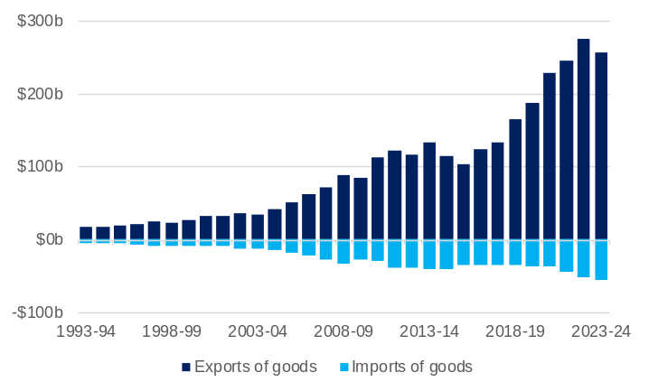
Note – Current prices. Original series. Imports of goods are displayed as negative values given they detract from gross state product.
Source: Based on ABS data.
- Western Australia has a very large surplus in goods trade. High-volume production of minerals, energy and agricultural commodities generates significant revenue and the small domestic market for these commodities means much of that revenue is through exports.
- Between 1993-94 and 2023-24, the value of Western Australia’s goods exports increased at an average annual rate of 10%, driven by significant growth of mineral and petroleum exports.
- The value of Western Australia’s goods exports was $256.2 billion in 2023-24 (48% of Australia’s total goods exports).
- Western Australia’s major imports are refined petroleum oils, motor vehicles, non-monetary gold (for further refining at the Perth Mint) and chemicals.
- Between 1993-94 and 2023-24 the value of Western Australia’s goods imports increased at an average annual rate of 9%.
- The value of Western Australia’s goods imports was $55.7 billion in 2023-24 (13% of Australia’s goods imports).

Exports and imports of services
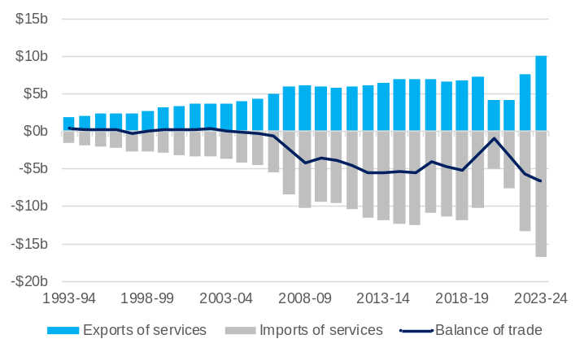
Note – Current prices. Original series. Imports of services are displayed as negative values given they detract from gross state product.
Source: Based on ABS data.
- In contrast to its trade in goods, Western Australia usually has a deficit in its trade in services. The deficit emerged in the mid-2000s when growth in incomes led more Western Australians to travel overseas (an import of services).
- The restrictions on travel and trade associated with the COVID-19 pandemic led to a sharp fall in the value of both imported and exported services. This briefly returned the balance of services trade to close to parity in 2020-21, however the re-opening of borders has led to higher growth in services imports compared to services exports.
- In 2023-24:
- The value of Western Australia’s services exports was $10.0 billion (8.0% of Australia’s services exports)
- The value of Western Australia’s services imports was $16.7 billion (10.4% of Australia’s services imports).

Exports of goods by market
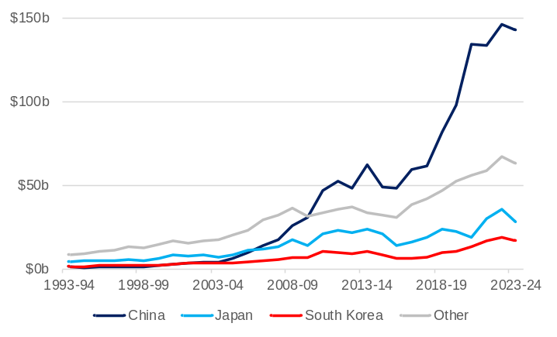
Note – Current prices. Original series. Free on board.
Source: Based on ABS data.
- The growth in Western Australia’s goods exports over the past 30 years has been largely due to higher demand from China, in particular for iron ore.
- In 1993-94, China accounted for 7% of Western Australia’s goods exports. In that year, Japan was the State’s largest export market, accounting for 28% of Western Australia’s goods exports, with South Korea accounting for 9%.
- China became Western Australia’s largest market for goods exports in 2006-07, overtaking Japan which had been the largest market since 1962-63.
- In 2023-24, Western Australia’s largest market for goods exports was China ($143.1 billion or 57%), followed by Japan ($28.3 billion or 11%) and South Korea ($16.5 billion or 7%). All other countries accounted for $63.0 billion or 25% of total merchandise exports.
- In 2023-24, Western Australia’s largest market for goods imports was China ($10.3 billion or 20%), followed by the United States ($7.3 billion or 14%) and Malaysia ($4.0 billion or 8%).

Productivity
Back to contents

Contribution to change in real gross state product from the three Ps
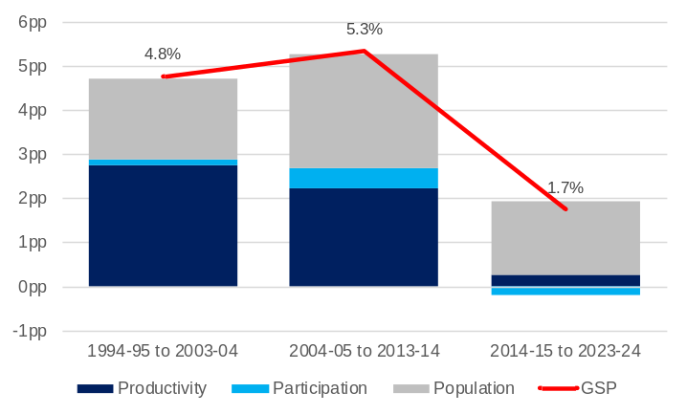
Note – Chain volume measures. Original series. Compound annual average change. pp = percentage points.
Source: Based on ABS data.
- The 3P framework provides an indication of the contribution to economic growth from changes in population, participation (hours worked per person) and productivity (GSP per hour worked).
- The 3Ps can work with or against each other. For example, economic growth can occur from investment which increases GSP per hour worked, creating higher wages which entice more people into the workforce and higher population growth through migration. In contrast, high population growth without investment growth can depress productivity through a lower capital-to-labour ratio.
- Growth in Western Australia’s gross state product over the past three decades was highest when the contribution of productivity was high. Between 1994-95 and 2013-14, while Western Australia’s population grew relatively quickly, this was matched by increased levels of private investment, which contributed to steady productivity growth.
- Productivity growth has slowed noticeably in Western Australia over the past decade, a trend that has also occurred at the national level.

Multifactor productivity
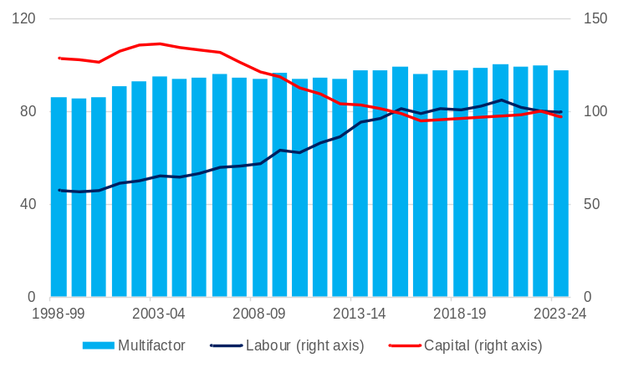
Note – Chain volume measures. Original series. Gross value added based multifactor productivity indexes. Market sector industries only. Index 2022-23 = 100.0.
Source: Based on ABS data.
- Productivity can be considered in relation to different inputs.
- Labour productivity is the ratio of output to labour input, that is, the amount of output produced for an hour of work.
- Capital productivity is the ratio of output to capital input, that is, output per unit of capital.
- Multifactor productivity (MFP) is the ratio of a measure of output to a combined input of labour and capital.
- Analysing the contribution of labour and capital to productivity can be complex as:
- Changes in labour productivity can also reflect changes in capital, and changes in capital productivity in labour.
- There can be a lag between a discrete capital investment taking place and that capital starting to contribute to output. For example, many resource projects in Western Australia involve large capital investment which takes place over a few years before producing output over multiple decades.
- Western Australia’s multifactor productivity fell 2.3% in 2023-24, after rising 0.5% in 2022-23.

Net capital stock per capita (change)
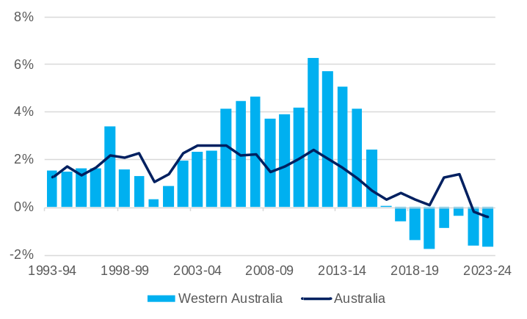
Note – Chain volume measures. Original series. Annual change.
Source: Based on ABS data.
- The net capital stock is a measure of wealth representing the net present value of an economy’s assets. The net capital stock is the value of an economy's gross capital stock accounting for depreciation.
- Productivity growth has generally been higher in Western Australia and Australia when there has been a sustained increase in the net capital stock per capita as each worker on average has access to more productive capital.
- As mining activity expanded in 2000s, Western Australia’s net capital stock per capita increased rapidly relative to the national figures. Between 2005-06 and 2015-16, when private investment and capital deepening was at its peak, Western Australia’s net capital stock per capita grew at an annual average of 4.4%, compared to 1.8% for Australia over the same period.
- Net capital stock per capita has been in decline in Western Australia since 2017-18. The move to the operational phase of the mining expansion, the depreciation of existing capital and the recent increase in net overseas migration have contributed to capital shallowing.

Industry gross value added
Back to contents

Contribution to change in real gross state product by industry
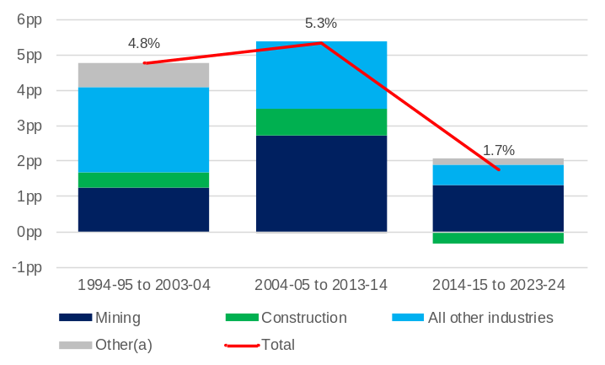
Note – Chain volume measures. Original series. Compound annual average change. pp = percentage points. (a) Ownership of dwellings, balancing item and statistical discrepancy.
Source: Based on ABS data.
- The mining industry has made a consistent contribution to GSP growth over the past 30 years, but the different phases of the mining industry’s expansion has affected the contribution to growth from other industries.
- GSP growth was relatively well-balanced in Western Australia until the mid-2010s, with mining industry output increasing together with output from other industries. Investment in new projects led to growth in the construction industry, and the labour-intensive nature of this phase of the mining industry’s expansion had spillover effects into other industries.
- The end of construction on many major projects led to further increases in mining output as projects became operational. However, it also meant the construction industry was a drag on GSP growth from 2014-15 to 2019-20. The less labour-intensive nature of the operational phase also had implications for economic activity in other industries.
- While Western Australia’s GSP growth has been lower in recent years, it has also become more balanced, as increases in mining output have become more modest and the economic recovery from the COVID-19 pandemic has benefited a range of industries.

Industry gross value added
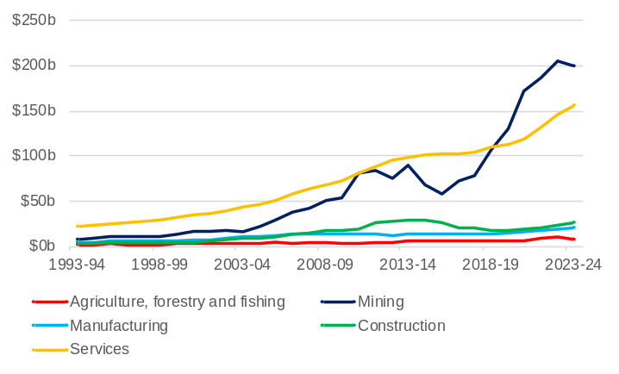
Note – Current prices. Original series.
Source: Based on ABS data.
- Industry gross value added (GVA) is a measure of the additional value created by an industry in the production of goods and services. The nominal value of GVA is influenced by both the volume of production from an industry and the prices at which it sells goods and services.
- Over the past 30 years, both the volume of the mining industry’s production and the average prices it has received for that production have increased significantly. Mining industry GVA increased from $7.4 billion in 1993-94 to $198.6 billion in 2023-24. The mining industry’s share of GSP grew from 16% in 1993-94 to 44% in 2023-24.
- The GVA of all services industries increased from $22.1 billion in 1993-94 to $156.0 billion in 2023-24.
- Although the GVA of the agriculture, forestry and fishing, and manufacturing industries has increased, as more resources have been allocated to mining, the GSP share of these industries has fallen.

Industry gross value added: 2023-24
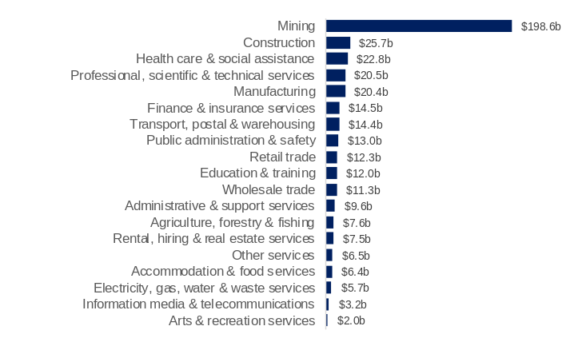
Note – Current prices. Original series.
Source: Based on ABS data.
- Goods-producing industries accounted for 55% ($252.2 billion) of Western Australia’s GSP in 2023-24, including:
- mining (44% or $198.6 billion)
- construction (6% or $25.7 billion)
- manufacturing (5% or $20.4 billion)
- agriculture, forestry and fishing (2% or $7.6 billion).
- Services industries accounted for 36% ($161.7 billion) of GSP in 2023-24, including:
- healthcare and social assistance (5% or $22.8 billion)
- professional, scientific and technical services (5% or $20.5 billion)
- transport, postal and warehousing (3% or $14.4 billion)
- finance and insurance (3% or $14.5 billion).
- Dwelling ownership and other items accounted for the remaining 9% of GSP in 2023-24.

Industry investment
Back to contents

Contribution to change in gross fixed capital formation by industry
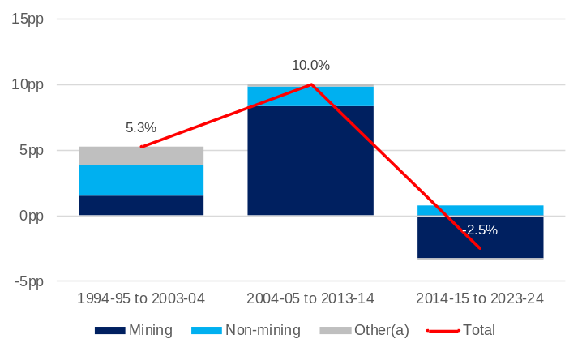
Note – Chain volume measures. Original series. Compound annual average change. pp = percentage points. (a) Dwellings and ownership transfer costs.
Source: Based on ABS data.
- The capital-intensive nature of the mining industry means that cycles of mining investment have had a significant impact on changes in gross fixed capital formation (investment) in Western Australia.
- Between 1994-95 and 2003-04, investment was distributed relatively evenly with mining investment growing from $8.6 billion to $13.7 billion while non-mining investment grew from $7.7 billion to $15.9 billion. Other investment, in the form of dwellings and other ownership transfer costs, made up a proportionally larger share of total investment at this time.
- Over the decade to 2013-14, mining investment grew rapidly. There was a complementary increase in investment in non-mining industries.
- The slowdown in mining investment over the next decade coincided with a slowdown in non-mining investment, although the less capital-intensive nature of non-mining industries meant this slowdown was less pronounced.

Gross fixed capital formation by industry
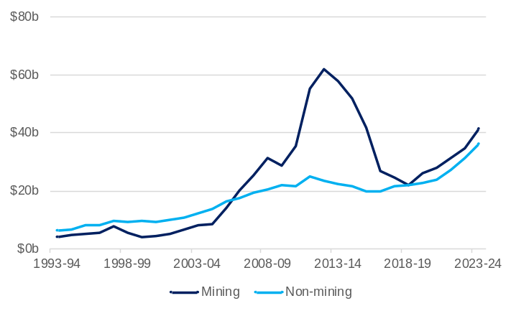
Note – Current prices. Original series.
Source: Based on ABS data.
- Prior to the large expansion in the mining industry in the 2000s, investment was more evenly distributed across industries in Western Australia. In 1999-00, the mining industry accounted for 21% of total investment in Western Australia.
- Mining overtook non-mining industries in total value of investment in 2006-07. This was followed by a large spike in mining industry investment, peaking at $62 billion (64% of total investment) in 2012-13 before falling significantly over the following five years. By 2018-19, mining investment had returned to near parity with non-mining investment.
- From 2018-19, there has been steady growth in the value of investment in both mining and non-mining industries, potentially providing a more balanced platform for growth for the Western Australian economy.

Industry gross fixed capital formation: 2023-24
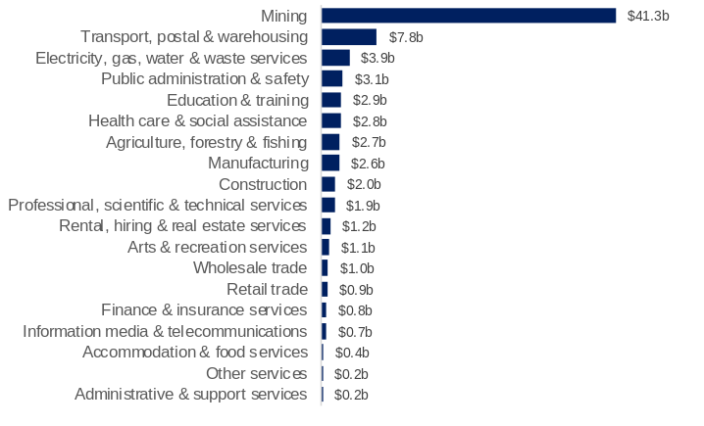
Note – Current prices. Original series.
Source: Based on ABS data.
- The mining industry accounted for 44% ($41.3 billion) of Western Australia’s investment in 2023-24, followed by:
- transport, postal and warehousing (8% or $7.8 billion)
- electricity, gas, water and waste services (4% or $3.9 billion)
- public administration and safety (3% or $3.1 billion).
- The largest increase in Western Australia’s investment in 2023-24 was in mining (up $6.0 billion or 17%), followed by transport, postal and warehousing (up $930 million or 13%).
- The only industry in Western Australia with a decrease in investment in 2023-24 was information, media and telecommunications (down $60 million or 7%).

Industry employment
Back to contents

Contribution to change in employment by industry
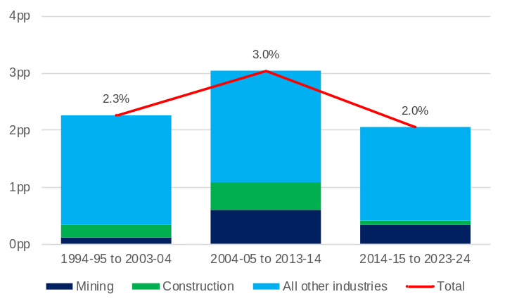
Note – Original series. Pp = percentage points. Compound annual average change.
Source: Based on ABS data.
- While the Western Australian economy went through a period during which growth in investment and economic output was dominated by the mining industry, as a less labour-intensive industry, mining has not made as large a contribution to employment growth in Western Australia. However, changes in employment in the mining and construction industries tend to have flow-on effects to employment in other industries in Western Australia.
- The contribution of the mining and construction industries to employment growth was most pronounced in the decade to 2013-14 during the height of the mining expansion. In this period, total employment in Western Australia grew by 3.0% with the mining and construction industries combining to contribute 1.1 percentage points of this increase.

Industry employment
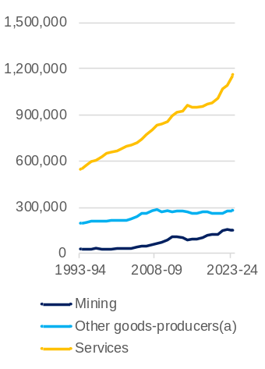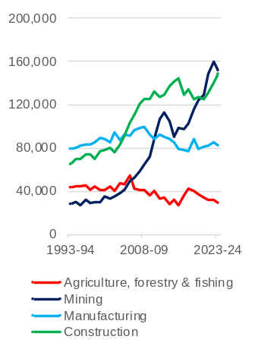
Note – Original series. Annual average employed persons. (a) Agriculture, forestry and fishing; manufacturing; construction; and electricity, gas, water and waste services.
Source: Based on ABS data.
- Over the past 30 years, the main changes in the composition of Western Australia’s employment have been the growth in employment in mining, construction and services industries and the declining share of employment in manufacturing and agriculture.
- In 1993-94 the largest employers by industry in Western Australia were retail trade (11% of total employment), manufacturing (10%) and healthcare and social assistance (9%).
- Manufacturing was overtaken in its contribution to total employment by construction in 2004-05, and mining in 2009-10. The manufacturing industry’s share of total employment in Western Australia in 2023-24 (5%) was half of its share in 1993-94.
- The agricultural industry in Western Australia has become more capital intensive and more productive, so despite increases in output, it has required fewer workers. The agriculture, forestry and fishing industry’s share of total employment in Western Australia fell from 6% in 1993-94 to 2% in 2023-24.

Industry employment: 2023-24
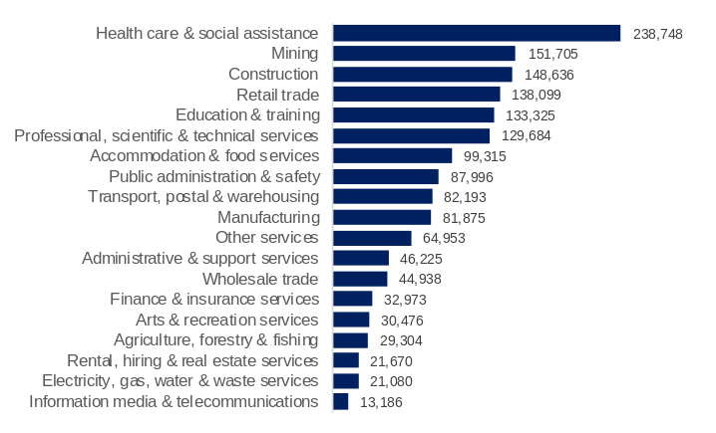
Note – Original series. Annual average employed persons.
Source: Based on ABS data.
- Services industries accounted for 74% of Western Australia’s employment in 2023-24, including:
- healthcare and social assistance (15%)
- retail trade (9%)
- education and training (8%).
- Goods producing industries accounted for 26% of Western Australia’s employment in 2023-24, including:
- mining (10%)
- construction (9%)
- manufacturing (5%).

Gender indicators
Back to contents

Average weekly hours worked per person (15 years and over)
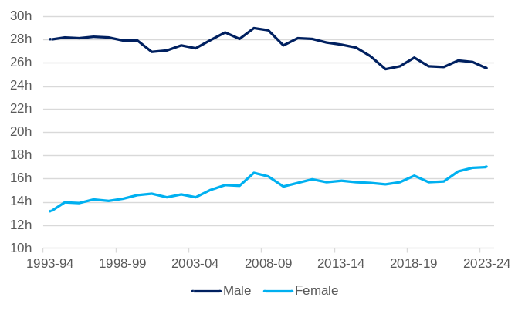
Note: Original series. Annual averages. The average is calculated as the total number of hours worked divided by the civilian population for males and females, not the number of employed males and females.
Source: Based on ABS data.
- Average hours worked by males in Western Australia is higher than it is for females, but the gap has narrowed over the past 30 years owing to an increase in the labour force participation rate for females and a decline in average hours worked by males.
- In 1993-94, the average weekly hours worked for each male in Western Australia was 28.0, compared to 13.2 for each female.
- In 2023-24, the average weekly hours worked for each male in Western Australia was 25.6, compared to 17.0 for each female.
- The ratio of average hours worked for each female to average hours worked for each male increased from 0.47 in 1993-94 to 0.67 in 2023-24.

Share of industry employment by gender: 2023-24
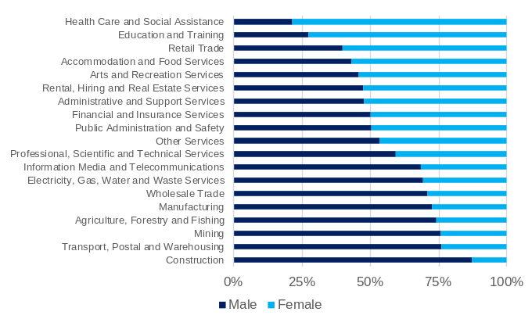
Note – Original series. Annual average employed persons.
Source: Based on ABS data.
- In 2023-24, males accounted for 53% of average employment in Western Australia, while females accounted for 47%. However, there are significant differences in the male and female share of employment across individual industries.
- The industries with the highest share of males in employment in Western Australia in 2023-24 were construction (87%), transport, postal and warehousing (76%) and mining (76%).
- The industries with the highest shares of females in employment in Western Australia in 2023-24 were health care and social assistance (78%), education and training (72%) and retail trade (60%).
- Financial and insurance services, and public administration and safety both had close to a 50:50 split in male and female employment in 2023-24.

Average earnings and the gender pay gap
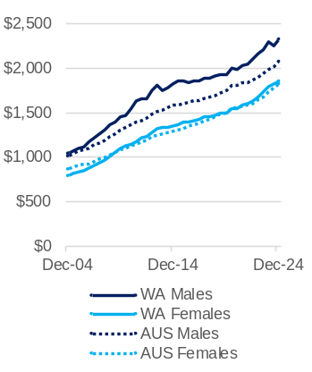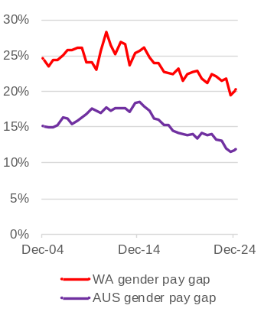
Note: Original series. Data is collected for the middle month of the June and December quarters (May and November). Average weekly ordinary time earnings of full-time adult employees. The gender pay gap for a given point in time is calculated as the difference in the earnings of males and females, divided by male earnings.
Source: Based on ABS data.
- The gender pay gap can be expressed as the difference in the earnings of males and females, expressed as a proportion of male earnings.
- In the December quarter 2024:
- In Western Australia, the average of weekly ordinary time earnings for full-time adult males was $2,330, while for females it was $1,860, resulting in a gender pay gap of 20.2%.
- In Australia, the average of weekly ordinary time earnings for full-time adult males was $2,073, while for females it was $1,826, resulting in a gender pay gap of 11.9%.
- Although average earnings for females are higher in Western Australia than they are for Australia as a whole, the gender pay gap in Western Australia is higher than the national average. The relatively high share of mining industry employment in Western Australia’s total employment, the high share of males in mining industry employment, and the relatively high earnings for mining industry employees are contributing factors to Western Australia’s higher gender pay gap.
- The gender pay gap in Western Australia has trended down since reaching a peak of 28.2% in the June quarter 2011, while the gender pay gap in Australia has trended down since reaching a peak of 18.6% in the December quarter 2014.

Aboriginal Indicators
Back to contents

Educational attainment and employment¹
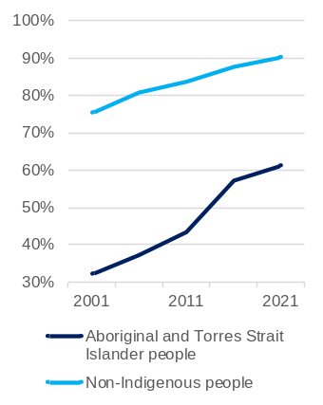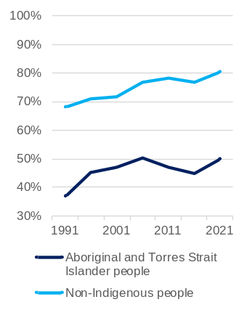
Note: The left-hand side chart shows the share of people aged 20-24 who had completed year 12 or equivalent or a non-school qualification at Certificate III or above. The right-hand side chart shows the share of people aged 25-64 years who are employed.
Source: Based on ABS Census data.
- Between 2001 and 2021, the percentage of people aged 20-24 years in Western Australia who had completed year 12 or equivalent or a non-school qualification at Certificate III or above who identified as:
  - Aboriginal or Torres Strait Islander almost doubled, increasing from 32.2% in 2001 to 61.1% in 2021.
  - Non-indigenous increased from 75.5% to 90.4%.
- The share of people aged 25–64 years in Western Australia who identified as Aboriginal or Torres Strait Islander and were employed increased from 36.8% in 1991 to 49.8% in 2021. However, this was lower than the peak for this figure of 50.4% recorded in 2006.
- Over the same period, the percentage of people aged 25-64 in Western Australia who identified as non-indigenous and were employed increased from 68.0% to 80.4%.

Industry share of total employment: 2021 Census
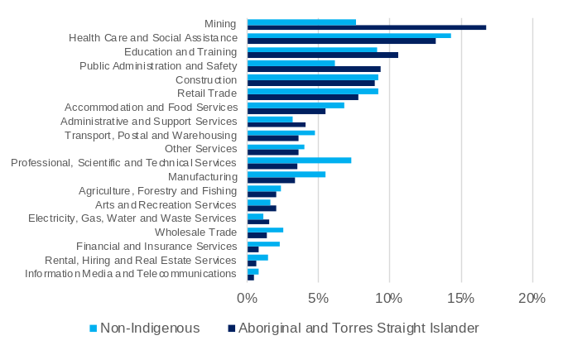
Note: Calculation of shares excludes categories 'inadequately described', 'not stated' and 'not applicable'.
Source: Based on ABS Census data.
- In 2021, the mining industry accounted for 16.7% of employment of people in Western Australia who identified as Aboriginal or Torres Strait Islander, followed by health care and social assistance (13.3%) and education and training (10.6%).
- Industries in which the share of employment for people who identified as Aboriginal and Torres Strait Islander were larger than the share of employment for non-indigenous people in Western Australia included:
  - mining (16.7% compared to 7.7%)
  - public administration and safety (9.4% compared to 6.2%)
  - education and training (10.6% compared to 9.2%).
- Industries in which the share of employment for people who identified as Aboriginal or Torres Strait Islander were smaller than the share of employment for non-indigenous people in Western Australia included:
  - professional, scientific and technical services (3.5% compared to 7.3%)
  - manufacturing (3.4% compared to 5.6%)
  - financial and insurance services (0.8% compared to 2.3%).

Distribution of total personal income (weekly): 2021 census
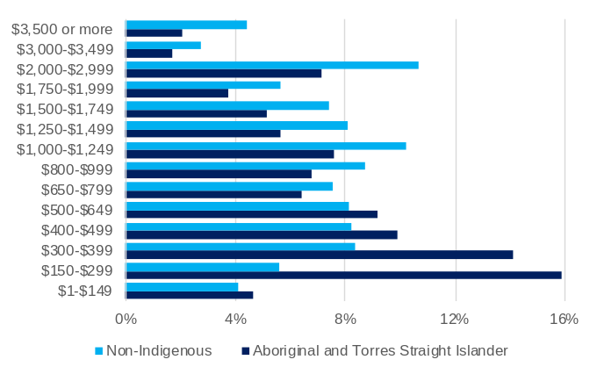
Note: Calculation of shares excludes categories 'not stated', 'not applicable', ‘negative income’ and ‘nil income’.
Source: Based on ABS Census data.
- In 2021, people identifying as Aboriginal and Torres Strait Islander in Western Australia were significantly over-represented in lower income brackets and under-represented in higher income brackets relative to non-indigenous Western Australians.
- Among Western Australians identifying as Aboriginal or Torres Strait Islander:
  - 67.0% had total personal income of less than $1,000 per week, compared with 50.8% of non-indigenous Western Australians.
  - 10.9% had total personal income of $2,000 or more per week, compared to 17.9% of non-indigenous Western Australians.

Environment
Back to contents

Electricity generation by fuel type
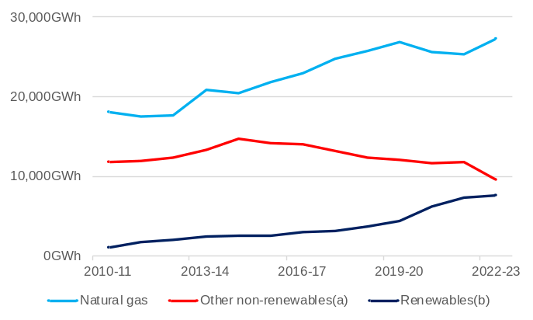
Note – (a) Coal and oil (included multi-fuel fired power plants prior to 2013-14). (b) Wind, solar, biogas and hydro. Gigawatt hours.
Source: Department of Climate Change, Energy, the Environment and Water.
- The growth in Western Australia’s electricity generation was primarily through natural gas in the 2010s but is now increasingly through renewables.
- Western Australia’s total electricity generation was 44,478 gigawatt hours (GWh) in 2022-23, 16% of the Australian total.
- Mining and manufacturing accounted for 16,704 GWh of electricity generation in Western Australia in 2022-23, which equated to:
- 38% of Western Australia’s total electricity generation
- 65% of Australia’s total electricity generation for mining and manufacturing.
- Natural gas contributed 27,303 GWh in 2022-23, and its share of Western Australia’s total electricity generation increased to 61%, just below the peak share of 62% in 2019-20.
- Other non-renewables (principally coal) contributed 9,538 GWh in 2022-23, 21% of Western Australia’s electricity generation.
- The output of renewables has increased significantly in recent years growing from 2,998 GWh in 2016-17 to 7,637 GWh in 2022-23. In 2022-23, renewables accounted for 17% of Western Australia’s electricity generation, including wind (8%), small-scale solar (7%) and large-scale solar (2%).

Greenhouse gas emissions by sector
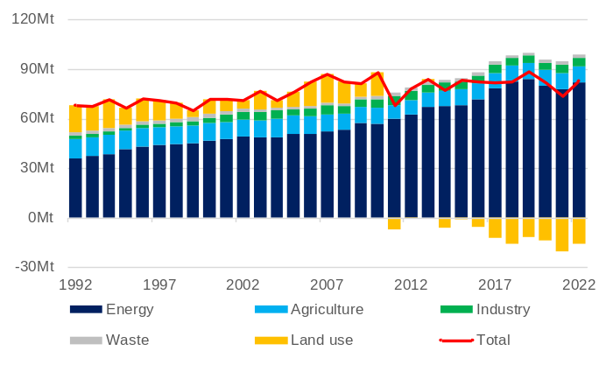
Note – Mt = million tonnes. Carbon dioxide equivalent AR5.
Source: Department of Climate Change, Energy, the Environment and Water.
- Western Australia’s net CO₂ equivalent emissions were 67.9 million tonnes (Mt) in 1992 and 82.5 Mt in 2022. Between these two years, Western Australia’s net emissions have ranged from 64.7 Mt in 1999 and 88.3 Mt in 2019.
- Of Western Australia’s emissions in 2022:
- energy contributed 81.7Mt
- agriculture contributed 9.7 Mt
- industry contributed 5.1 Mt
- waste contributed 1.9 Mt
- land use contributed an emissions reduction of 15.9 Mt.
- The emissions of the energy sector increased by 128% between 1992 and 2022.
- The most dynamic movement has come from the role of land use, which has evolved from contributing 16.4 Mt of emissions in 1992 to an emissions reduction of 15.9 Mt in 2022.

Interstate comparison of greenhouse gas emissions per dollar of gross state product
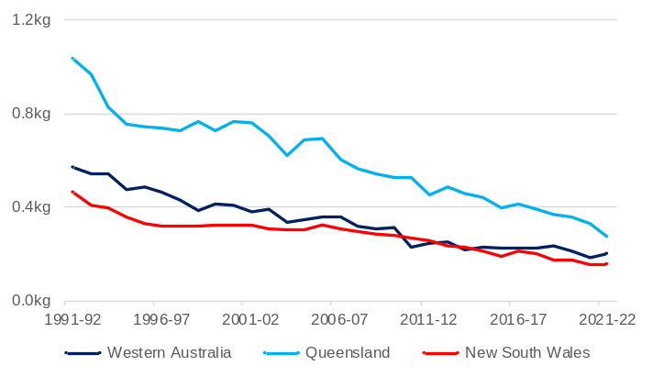
Note – Kilograms of carbon dioxide equivalent per dollar of gross state product (chain volume measures).
Source: Department of Climate Change, Energy, the Environment and Water.
- While total greenhouse gas emissions have increased in Western Australia over the past 30 years, the emissions intensity of economic activity has declined, as it has in other Australian states.
- Using the measure of emissions in kilograms of carbon dioxide equivalent per dollar of real GSP, between 1991-92 and 2021-22:
- Western Australia’s emissions intensity fell from 0.57 to 0.20, a reduction of 64%.
- Queensland’s emissions intensity fell from 1.04 to 0.27, a reduction of 74%.
- New South Wales emissions intensity fell from 0.46 to 0.16, a reduction of 66%.

Mining and energy industries
Back to contents

Global production share and ranking: 2024
Commodity | WA | Rest of Australia | Rest of World | WA’s global ranking
Lithium | 41.5% | 0.4% | 58.1% | 1
Garnet | 37.1% | 0.0% | 62.9% | 1
Iron ore | 35.6% | 0.4% | 64.0% | 1
Rutile | 27.8% | 15.7% | 56.4% | 1
LNG | 11.9% | 8.1% | 80.0% | 3
Zircon | 11.5% | 22.0% | 66.6% | 3
Alumina | 8.1% | 4.0% | 87.9% | 2
Rare earth oxides | 7.6% | 0.0% | 92.4% | 3
Gold | 6.3% | 2.5% | 91.3% | 3
Salt | 3.6% | 0.3% | 96.1% | 6
Nickel | 3.5% | 0.0% | 96.5% | 5
Manganese | 2.9% | 13.7% | 83.4% | 7
Illmenite¹ | 1.7% | 2.8% | 95.5% | 10
Cobalt | 1.7% | 0.0% | 98.4% | 4
Lead | 1.3% | 9.7% | 89.0% | 12
Zinc | 0.5% | 8.8% | 90.8% | >11
Copper | 0.3% | 3.1% | 96.6% | >13
Note – Mt = million tonnes. Kt = thousand tonnes. t = tonnes. Mct = million carats. 1 Excludes ilmenite feedstock for synthetic rutile production. Sum of the shares of WA, Rest of Australia and Rest of World may not add to 100% due to rounding.
Source: WA Department of Energy, Mines, Industry Regulation and Safety, Resource Data Files.
- Western Australia is the main exporter of minerals and petroleum in Australia and accounts for a significant proportion of the world’s minerals and petroleum production.
- Western Australia had 138 higher-value, export-oriented mining projects in 2023-24, including:
- 16 major mineral processing operations that transformed bauxite into alumina, gold doré into gold bars, nickel ore into nickel concentrate (through toll treatment) and nickel concentrate into nickel matte, nickel powder, nickel briquettes, and nickel sulphate; rutile and synthetic rutile into titanium dioxide pigment; zircon into fused zirconia; silica sand into silicon metal; spodumene concentrate into lithium hydroxide; and rare earth concentrate into rare earth carbonate.
- 20 projects that produced oil, gas and condensates from 50 fields in onshore and offshore areas of the State.

Sales of mineral and energy commodities
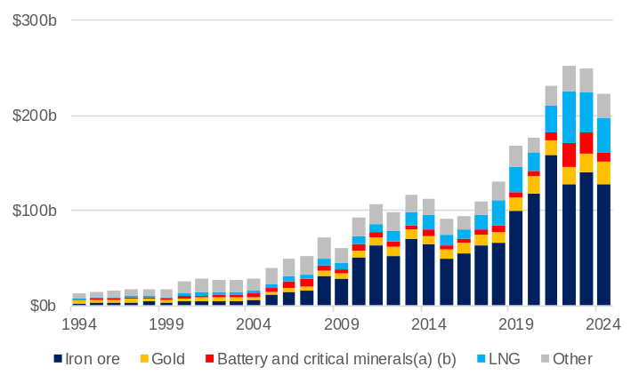
Note – Current prices. Original series. (a) Lithium (spodumene), nickel, cobalt, copper, manganese and rare earths.
(b) Data for lithium (spodumene), manganese and rare earths are not available in certain years.
Source: WA Department of Energy, Mines, Industry Regulation and Safety, Resource Data Files.
- Western Australia’s minerals and petroleum sales fell from $248.8 billion in 2023 to $223.4 billion in 2024. Minerals sales fell 10.4% to $172.7 billion and petroleum sales fell 9.6% to $50.7 billion.
- Iron ore sales were down 8.3% to $128.1 billion in 2024, though it was the third highest sales value for iron ore for a calendar year. The sales value was supported by a near record sales volume for a calendar year of 866 million tonnes, but the average unit sales price was down from A$162 a tonne in 2023 to A$148 a tonne in 2024.
- The value of LNG sales fell 14.7% to $36.1 billion in 2024 as prices were at the lowest levels in several years.
- The value of gold sales increased from $16.0 billion in 2021 to $23.7 billion in 2024, a record high despite a drop in sales volume over this period. The average unit price of gold sales rose 51.4% between 2021 and 2024.
- The value of lithium sales fell 68.6% in 2024 to $5.0 billion in 2024. While the sales volume of spodumene concentrate rose to a record 3.8 million tonnes, prices fell to the lowest level since the second half of 2021.

Sales of mineral and energy commodities: 2024

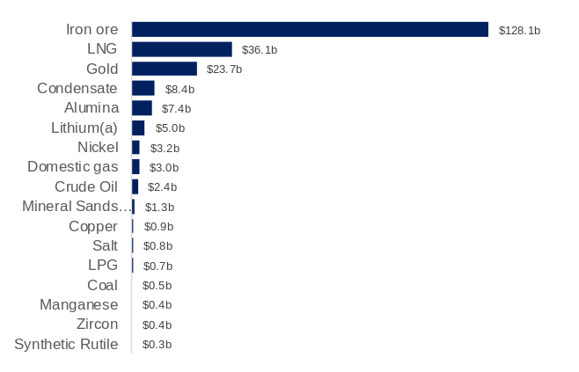
Note – Current prices. Original series. (a) Spodumene. (b) Garnet, illmenite, leucoxene, zircon and rutile.
Source: WA Department of Energy, Mines, Industry Regulation and Safety, Resource Data Files.
- Iron ore accounted for 57.4% of the value of Western Australia’s minerals and petroleum sales in 2024, followed by LNG (16.2%) and gold (10.6%).
- The largest increases in the value of Western Australia’s minerals and petroleum sales in 2024 were in:
- gold (up $3.7 billion or 18.7%)
- alumina (up $0.8 billion or 12.2%).
- The largest decreases in the value of Western Australia’s minerals and petroleum sales in 2024 were in:
- iron ore (down $11.7 billion or 8.3%)
- lithium (down $11.0 billion or 68.6%)
- LNG (down $6.2 billion or 14.7%).

Primary industries and defence industries
Back to contents

Agriculture, forestry and fishing industry gross value added
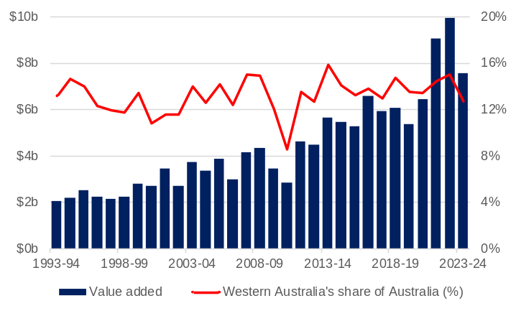
Note – Current prices. Original series.
Source: Based on ABS data.
- The GVA of Western Australia’s agriculture, forestry and fishing industry increased at an average annual rate of 4.5% between 1993-94 and 2023-24.
- Fluctuations in GVA from year to year reflect variability in growing conditions on the output of major component industries such as grain and canola as well as price fluctuations for the export commodities that make up the industry.
- A sharp decline in Western Australia’s agricultural contribution in 2009-10 and 2010-11 resulted from a number of factors including drought in Western Australia’s South West and Wheatbelt regions, floods in various parts of the state and the impact of the global financial crisis on agricultural commodity prices.
  - The GVA of Western Australia’s agriculture, forestry and fishing industry jumped considerably in 2021-22, increasing from $6.5 billion to $9.0 billion, and again in 2022-23 to $9.9 billion as conducive growing conditions and restrictions in supply from other markets led to higher demand for Western Australia’s grains exports.
- Between 1993-94 and 2023-24, Western Australia contributed an average of 13.2% to the GVA of Australia’s agriculture, forestry and fishing industry, with a high of 15.9% in 2013-14.

Exports of agricultural commodities
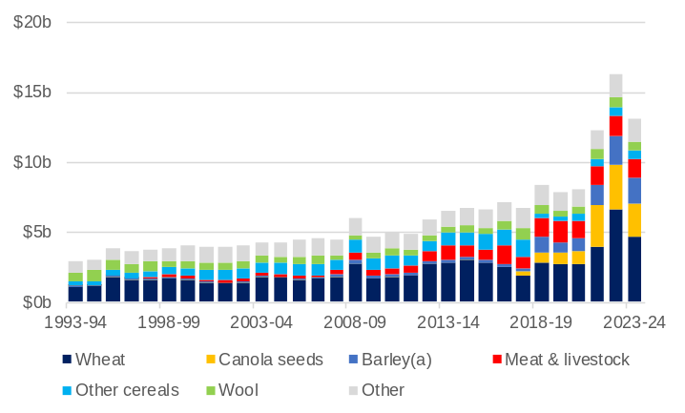
Note – Current prices. Original series. Total excludes confidential items. (a) Confidential before Aril 2018.
Source: Based on ABS data.
Agriculture has long been one of Western Australia’s largest export industries.
- In 2023-24, Western Australia’s top agricultural exports were:
- wheat ($4.7 billion)
- canola seeds ($2.4 billion)
- barley ($1.8 billion).
- meat and livestock ($1.4 billion).
- Between 2018-19 and 2023-24, Western Australia’s exports of:
- wheat increased from $2.8 billion (33% of agricultural exports) to $4.7 billion (36% of agricultural exports)
- canola seeds increased from $733 million (9% of agricultural exports) to $2.4 billion (18% of agricultural exports).

Defence industry gross value added
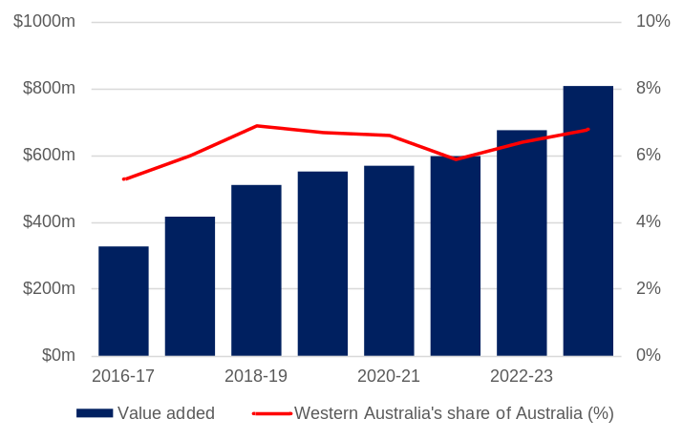
Note – Current prices. Original series.
Source: Based on ABS data.
- The defence industry is an emerging part of Western Australia’s economy.
- GVA from expenditure by the Department of Defence contributed $808 million to the Western Australian economy in 2023-24. This was an increase of 19% from the previous year.
- Between 2016-17 and 2023-24, the defence industry’s contribution to the Western Australian economy more than doubled from $327 million to $808 million and Western Australia’s share of Australia’s total defence GVA increased from 5.3% to 6.8%.
- In 2023-24 the jurisdictions with the largest share of Australia’s total defence GVA were:
- New South Wales ($3.5 billion or 29%)
- Victoria ($2.5 billion or 21%)
- South Australia ($2.0 billion or 17%)
- Australian Capital Territory ($1.7 billion or 15%)
- Employment associated with defence expenditure in Western Australia increased to 4,600 in 2023-24.

Tourism and international education
Back to contents

Visitor expenditure
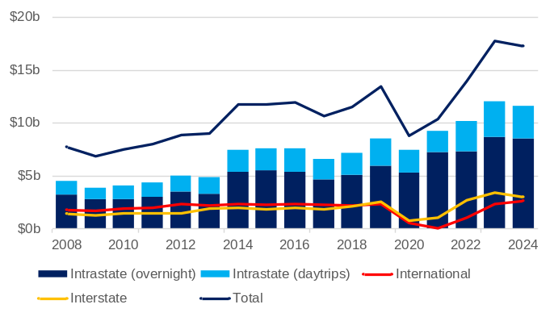
Note – Current prices. Original series.
Source: Tourism Research Australia.
- While experiences varied for businesses across the tourism industry during the COVID-19 pandemic, in aggregate, the domestic market was able to support overall activity when international travel was restricted. Following the re-opening of the State’s borders, spending by international visitors has returned to close to its pre-pandemic high, while spending by interstate and intrastate visitors have surpassed their pre-pandemic levels, leading to record visitor expenditure in 2023. However, total visitor expenditure eased in 2024.
- Tourists in Western Australia spent a total of $17.2 billion in 2024, 2.9% ($514 million) less than in 2023.
- In 2024, in Western Australia:
- intrastate visitor spend (including daytrips) fell 3.1% to $11.6 billion
- interstate visitor spend fell 12.7% to $3.0 billion
- international visitor spend rose 12.4% to $2.6 billion.
- The tourism industry contributed $13.2 billion to Western Australia’s GSP in 2022-23 and supported 110,800 jobs.

Exports^{(a)} of education-related travel services
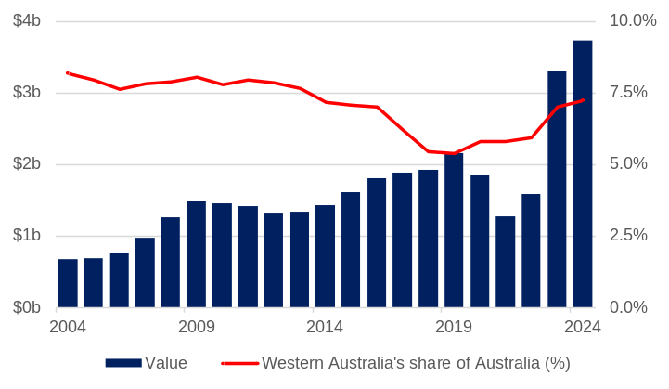
Note – Current prices. Original series. (a) The value of education-related services exports can include expenditure by international students that is funded from income earned while in Australia.
Source: Based on ABS data.
- The value of education-related travel services exports provides a measure of the direct economic contribution of the international education sector.
- In 2019, prior to the impact of the COVID-19 pandemic, education-related travel services exports were $2.2 billion. The value of education-related travel services exports fell 41% to $1.3 billion between 2019 and 2021, as new international students were restricted from travelling to the State due to the pandemic.
- The international education sector rebounded as international students returned following the re-opening of the State’s borders in early 2022. Western Australia’s education-related travel services exports were $3.7 billion in 2024.

International student enrolments by sector
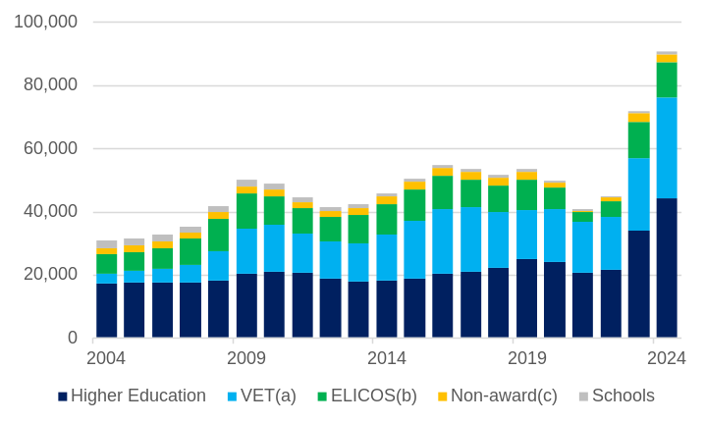
Note – Original series. (a) Vocational education and training. (b) English language intensive courses for overseas students. (c) Enabling courses and foundation studies.
Source: Commonwealth Department of Education.
- International student enrolments fell in 2020 and 2021 due to COVID-19 travel restrictions but began to recover in 2022. Enrolments then grew by 60% in 2023 and a further 26% in 2024.
- In 2024, Western Australia had 90,829 international student enrolments. This was 8.3% of Australia’s international student enrolments, which was Western Australia’s highest share of the Australian total since 2006.
- Western Australia’s international students come mostly from Asia. In 2024, the largest shares of Western Australia’s international student enrolment numbers were from:
- India (17.1%)
- Bhutan (13.2%)
- China (9.4%)
- Philippines (6.5%)
- Pakistan (6.1%).
- In 2024, most international student enrolments were in higher education (49%) and vocational education and training (35%).

Regions
Back to contents

Gross state product, population and minerals and petroleum sales by development commission region
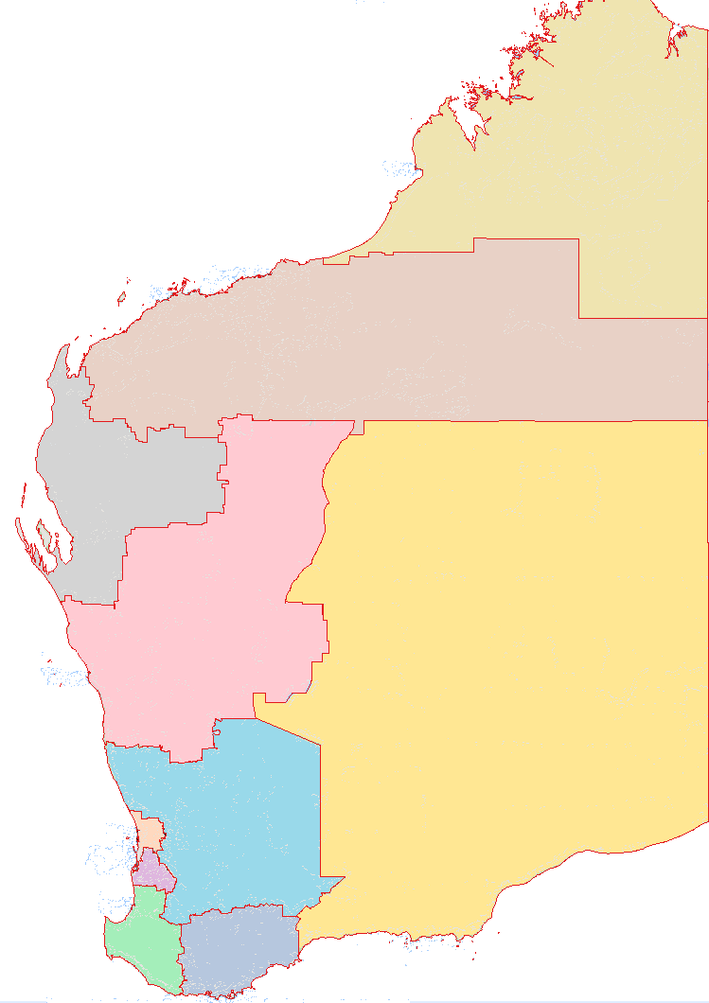
Mid West
Busselton
Albany
Geraldton
Broome
Port Hedland
Kalgoorlie-Boulder
Esperance
Bunbury
Karratha
South West
Great Southern
Peel
Perth
Wheatbelt
Goldfields-Esperance
Gascoyne
Offshore Western Australia
Pilbara
Kimberley

Region | Gross regional product 2023-24 |  | Population 2023-24 |  | Mining sales 2024
Region | $billion | Share (%) | No. | Share (%) | $billion | Share (%)
Perth | 288.6 | 63.3 | 2,222,968 | 75.0 | 0.1 | 0.0
Pilbara(a) | 89.3 | 19.6 | 60,746 | 2.0 | 129.0 | 74.7
South West | 19.5 | 4.3 | 201,659 | 6.8 | 2.6 | 1.5
Goldfields- Esperance | 15.2 | 3.3 | 58,134 | 2.0 | 22.7 | 13.1
Peel | 11.1 | 2.4 | 168,461 | 5.7 | 9.9 | 5.7
Wheatbelt | 9.2 | 2.0 | 78,517 | 2.6 | 2.5 | 1.5
Mid West | 9.0 | 2.0 | 58,127 | 2.0 | 5.0 | 2.9
Great Southern | 5.8 | 1.3 | 66,002 | 2.2 | 0.0 | 0.0
Kimberley | 4.5 | 1.0 | 39,934 | 1.3 | 0.6 | 0.3
Gascoyne | 1.4 | 0.3 | 10,530 | 0.4 | 0.3 | 0.2
WA total(b) | 455.7 | 100.0 | 2,965,078 | 100.0 | 172.7 | 100.0
Note – Original series. Estimated resident population. (a) Includes Offshore Western Australia for mining sales. (b) Components do not sum to the total because the total includes Migratory - Offshore - Shipping (WA), Christmas Island LGA and Cocos Islands LGA.
Source: WA Department of Primary Industries and Regional Development, Remplan; based on ABS data; and WA Department of Energy, Mines, Industry Regulation and Safety.

Population growth by broad region and major urban centre: 2003-04 to 2023-24
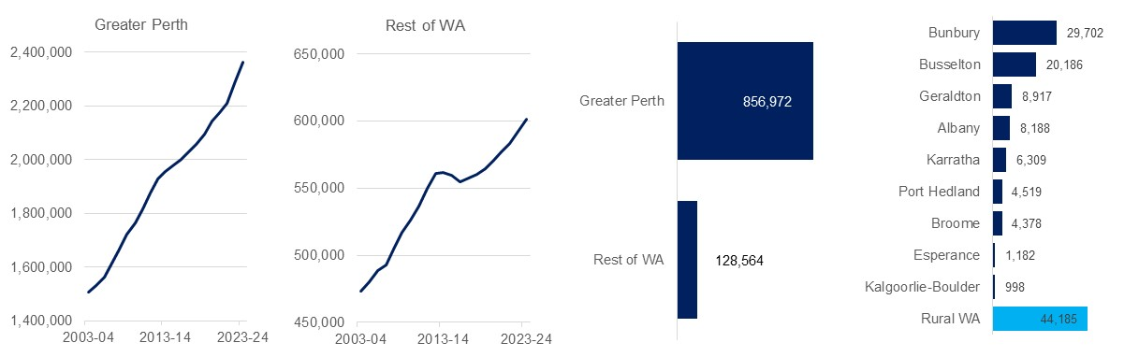
Original series Estimated resident population. Vertical axis does not start at zero. Source: Based on ABS data

Western Australia’s population is concentrated in the Perth metropolitan area and most of Western Australia’s gross state product is also allocated to Perth. However, most of the State’s merchandise exports and economic activity originates from production in regional areas. While mining production takes place in most regions, the Pilbara is the dominant mining region, particularly for iron ore and liquefied natural gas.
Further economic information and data on Western Australia’s regions can be found at the Regional WA Data Hub. Information on individual regions can be accessed via the links below.
Gascoyne | Kimberley | Pilbara
Goldfields-Esperance | Mid West | South West
Great Southern | Peel | Wheatbelt

Visit Western Australia's economy and international trade (www.wa.gov.au) for more information on Western Australia’s economy, trade relationships and key export industries.

Western Australia Trade Profile  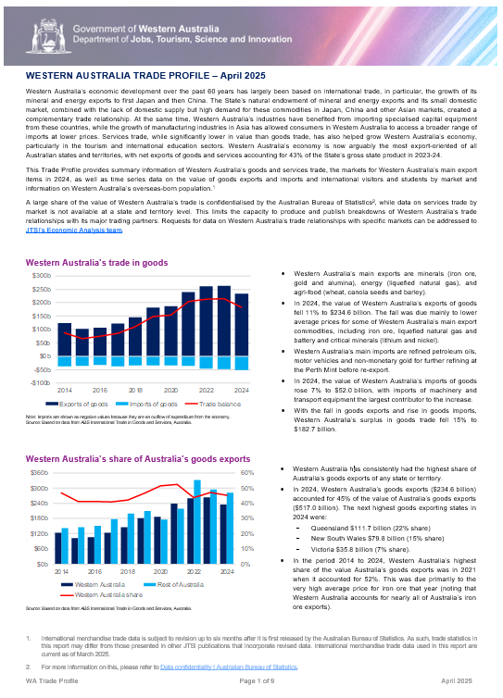 | Western Australia Iron Ore Profile  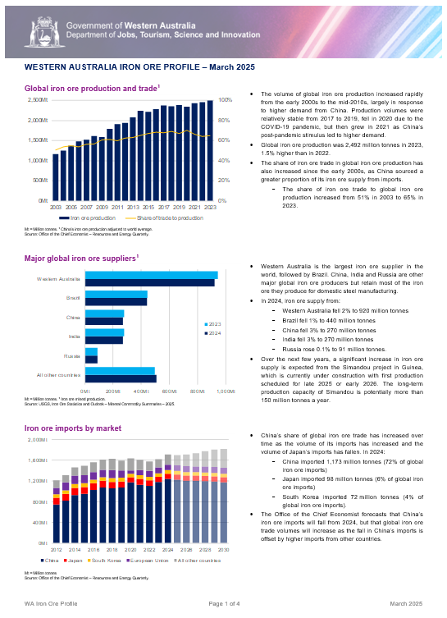
Western Australia LNG Profile  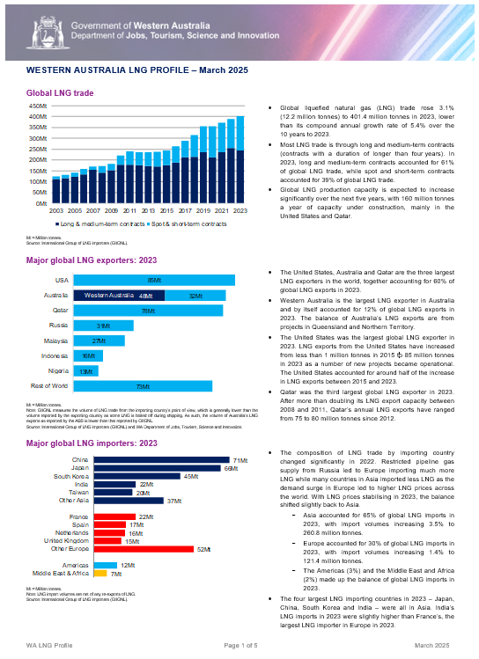 | Western Australia Battery and Critical Minerals Profile  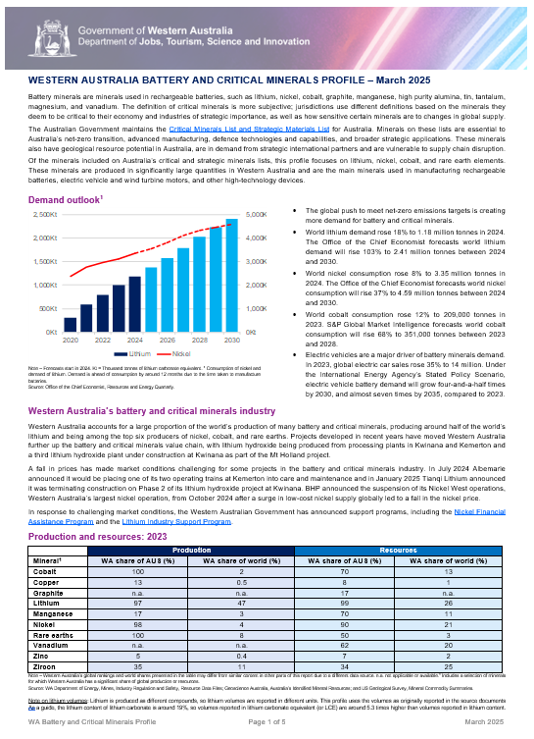
For any queries or feedback on these products, please contact us at economic.analysis@jtsi.wa.gov.au

