WESTERN AUSTRALIA LNG PROFILE – April 2025

Global LNG trade
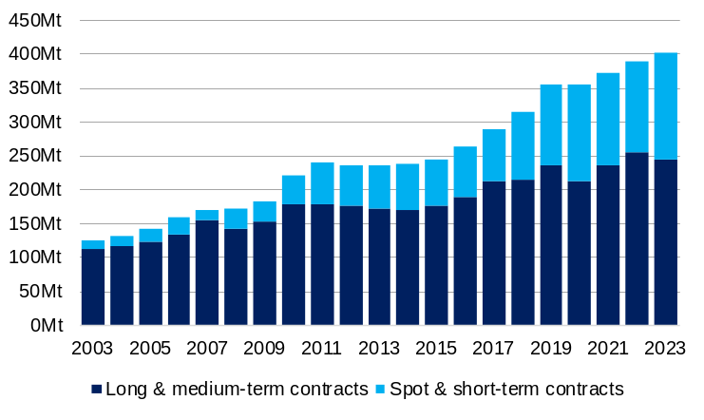
Mt = Million tonnes.
Source: International Group of LNG importers (GIIGNL).

- Global liquefied natural gas (LNG) trade rose 3.1% (12.2 million tonnes) to 401.4 million tonnes in 2023, lower than its compound annual growth rate of 5.4% over the 10 years to 2023.
- Most LNG trade is through long and medium-term contracts (contracts with a duration of longer than four years). In 2023, long and medium-term contracts accounted for 61% of global LNG trade, while spot and short-term contracts accounted for 39% of global LNG trade.
- Global LNG production capacity is expected to increase significantly over the next five years, with 160 million tonnes a year of capacity under construction, mainly in the United States and Qatar.

Major global LNG exporters: 2023
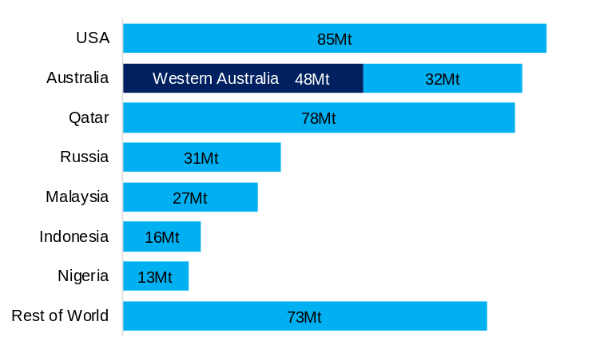
Mt = Million tonnes.
Note: GIIGNL measures the volume of LNG trade from the importing country’s point of view, which is generally lower than the volume reported by the exporting country as some LNG is boiled off during shipping. As such, the volume of Australia’s LNG exports as reported by the ABS is lower than that reported by GIIGNL.
Source: International Group of LNG importers (GIIGNL) and WA Department of Jobs, Tourism, Science and Innovation.

- The United States, Australia and Qatar are the three largest LNG exporters in the world, together accounting for 60% of global LNG exports in 2023.
- Western Australia is the largest LNG exporter in Australia and by itself accounted for 12% of global LNG exports in 2023. The balance of Australia’s LNG exports are from projects in Queensland and Northern Territory.
- The United States was the largest global LNG exporter in 2023. LNG exports from the United States have increased from less than 1 million tonnes in 2015 to 85 million tonnes in 2023 as a number of new projects became operational. The United States accounted for around half of the increase in LNG exports between 2015 and 2023.
- Qatar was the third largest global LNG exporter in 2023. After more than doubling its LNG export capacity between 2008 and 2011, Qatar’s annual LNG exports have ranged from 75 to 80 million tonnes since 2012.

Major global LNG importers: 2023
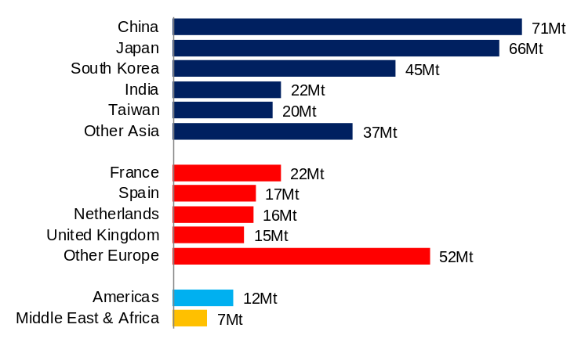
Mt = Million tonnes.
Note: LNG import volumes are net of any re-exports of LNG.
Source: International Group of LNG importers (GIIGNL).

- The composition of LNG trade by importing country changed significantly in 2022. Restricted pipeline gas supply from Russia led to Europe importing much more LNG while many countries in Asia imported less LNG as the demand surge in Europe led to higher LNG prices across the world. With LNG prices stabilising in 2023, the balance shifted slightly back to Asia.
  - Asia accounted for 65% of global LNG imports in 2023, with import volumes increasing 3.5% to 260.8 million tonnes.
  - Europe accounted for 30% of global LNG imports in 2023, with import volumes increasing 1.4% to 121.4 million tonnes.
  - The Americas (3%) and the Middle East and Africa (2%) made up the balance of global LNG imports in 2023.
- The four largest LNG importing countries in 2023 – Japan, China, South Korea and India – were all in Asia. India’s LNG imports in 2023 were slightly higher than France’s, the largest LNG importer in Europe in 2023.

Major LNG importers in Asia¹
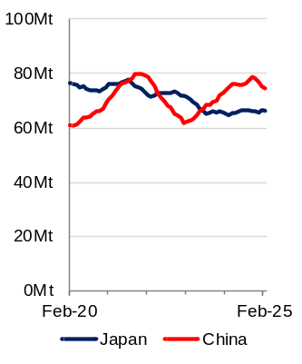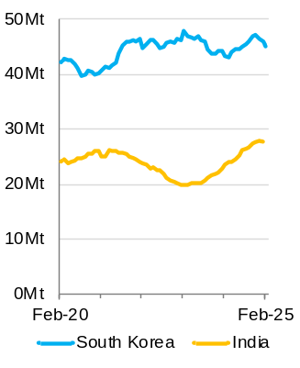
¹ 12-month rolling total. Mt = Million tonnes.
Source: WA Department of Jobs, Tourism, Science and Innovation estimates based on data from CEIC China Premium Database; Japanese Ministry of Finance; Korean Customs Service; Indian Ministry of Commerce and Industry; and EnergyQuest, Australian LNG Monthly Report.

- China’s LNG imports increased significantly between 2016 and 2021 as part of its strategy to increase the share of natural gas in its energy mix. There was a large fall in China’s LNG imports in 2022, as overall gas demand fell, and more gas was sourced from pipeline imports and domestic production. LNG import volumes recovered in 2023 and 2024, although they have fallen in recent months due to weaker gas demand and higher volumes of domestic production and pipeline imports. In the 12 months to February 2025, China’s LNG imports were 74.2 million tonnes, 0.3% more than in the 12 months to February 2024.
- Japan’s LNG imports peaked in 2014 and have fallen by around 25% since but have stabilised over the past year. Japan imported 66.3 million tonnes of LNG in the 12 months to February 2025, 1.9% more than in the 12 months to February 2024.
- South Korea imported 45.1 million tonnes of LNG in the 12 months to February 2025, 3.9% more than in the 12 months to February 2024.
- India imported 27.6 million tonnes of LNG in the 12 months to January 2025, 20.7% more than in the 12 months to January 2024.

Asia LNG prices (per mmBTU)
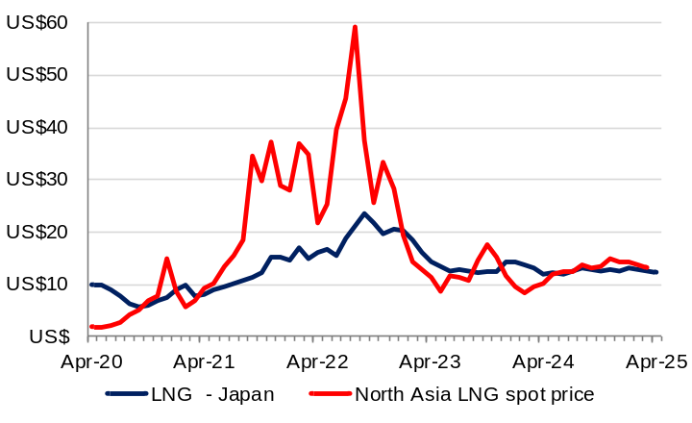
mmBTU = Million British thermal units.
Note: The North Asia LNG spot price is the front month price at the end of the reference month. The chart shows the Sling North Asia price to October 2019 and the JKM price from November 2019.
Source: World Bank, Commodity Markets (Monthly); EnergyQuest, LNG Report.

- Average LNG import prices in Asia generally move with the oil price (with a lag of three to four months) as the bulk of LNG trade in Asia is made through long-term supply contracts with prices linked to the oil price. As such, average LNG import prices increased in 2021 and 2022, fell in 2023 and 2024.
- The average LNG import price to Japan was US$12.43 per mmBTU in April 2025, 4.6% higher than in April 2024.
- LNG spot prices are subject to more volatility as LNG spot trade is used to alleviate short-term deviations from expected demand and supply. LNG spot prices were particularly volatile between 2021 and 2023 as restricted natural gas supply in Europe led to higher demand for LNG, which flowed through to higher Asian LNG spot prices. As global LNG trade has settled, the LNG spot price has fallen back to around the same level as the contract price.
- At the end of March 2025, the JKM front month price was US$13.09 per mmBTU.

Australia’s LNG exports
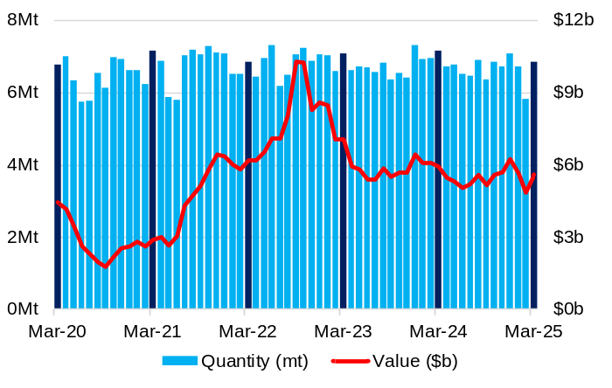
Source: Based on data from ABS International Trade in Goods and Services, Australia.

- The monthly volume of Australia’s LNG exports has been quite stable over the past five years, as there have been no significant changes to total production capacity over this period. Export volumes drop in some months when projects undergo maintenance.
- Australia exported 6.8 million tonnes of LNG in March 2025.
- In the 12 months to March 2025, Australia exported 79.6 million tonnes of LNG, 1.6% less than in the 12 months to March 2024.
- With monthly export volumes generally stable, changes in the value of Australia’s LNG exports have occurred mostly through changes in average LNG prices.
- Australia exported $5.6 billion of LNG in March 2025.
- In the 12 months to March 2025, Australia exported $65.4 billion of LNG, 6.4% less than in the 12 months to March 2024.

Western Australia’s LNG export capacity
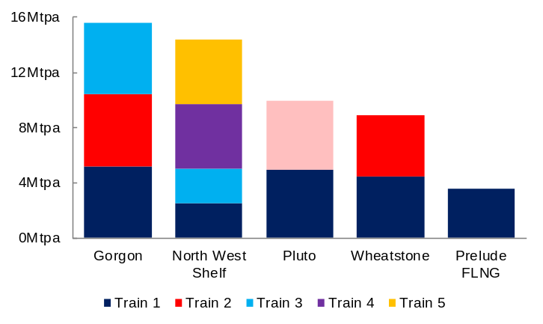
Note: North West Shelf’s Train 2 was physically and electrically isolated from the rest of the Karratha Gas Plant from January 2025. Pluto Train 2 is expected to be operational in 2026.
Source: WA Department of Jobs, Tourism, Science and Innovation based on published information.

- Western Australia has an established and reliable LNG export industry. The State’s first LNG project, the North West Shelf, marked 35 years of LNG exports in 2024.
- Western Australia currently has five operating LNG export projects. The North West Shelf, Pluto, Gorgon and Wheatstone projects all source gas from the Carnarvon Basin and have onshore LNG trains in Western Australia’s Pilbara region. The Prelude project is a floating LNG vessel located in the Browse Basin offshore Western Australia.
- Western Australia’s current total LNG export capacity is around 47 million tonnes a year.
- In November 2021, a final investment decision was made for a second LNG train for the Pluto project with a capacity of 5 million tonnes a year. Pluto Train 2 is expected to begin exporting LNG in 2026.

Western Australia’s natural gas reserves and resources as at February 2025
Basin | Reserves (PJ) | Contingent resources (PJ)
Carnarvon | 44,802 | 22,196
Browse | 16,230 | 18,138
Bonaparte | 4,104 | 9,833
Perth | 1,389 | 1,478
Canning | - | 260

Note: PJ = petajoules. Reserves and resources are categorised by probability or likelihood of recovery. Reserves refer to 2P reserves that are proved (90%) and probable (50%). Contingent resources refer to 2C resources (best estimate of contingent resources). Bonaparte Basin figures refer to Australia’s share of reserves and resources.
Source: EnergyQuest, Energy Quarterly (March 2025).

- Western Australia’s LNG projects are underpinned by large, conventional gas reserves in the Carnarvon and Browse Basins, which provide LNG buyers with security of supply.
- Western Australia also has onshore shale and tight gas resources in the Canning, Carnarvon and Perth basins.
- In the four quarters to December 2024, petroleum exploration expenditure in Western Australia was $484 million. This was 34% of total petroleum exploration expenditure in Australia over this period.

LNG shipping duration: days
 | China  (Shanghai) | Japan  (Tokyo) | Korea  (Incheon) | India  (Gujarat)
Western Australia | 8 | 7 | 8 | 9
Queensland | 8 | 9 | 9 | 14
Qatar | 14 | 12 | 13 | 2
United States | 20 | 22 | 21 | 21
Nigeria | 23 | 22 | 23 | 15

Note: Days shipping is based on a vessel at maximum speeds of 19.5 knots.
Source: WA Department of Jobs, Tourism, Science and Innovation based on information from Shipscene and the International Group of LNG Importers (GIIGNL).

- Western Australia’s LNG projects are located relatively close to Asia, comparing favourably (with the exception of India) to the shipping distances from Qatar.
- The shipping distance from Western Australia’s projects to Japan is around 3,400 nautical miles or about 8 days travel, with similar shipping distances to South Korea and China.
- The expansion of the Panama Canal in 2016 shortened the trade route for LNG exports from the US to Asia. However, shipping to Asia from the US Gulf Coast still takes more than twice the time of shipping from Western Australia.

Domestic gas price index¹ by market (% change²)
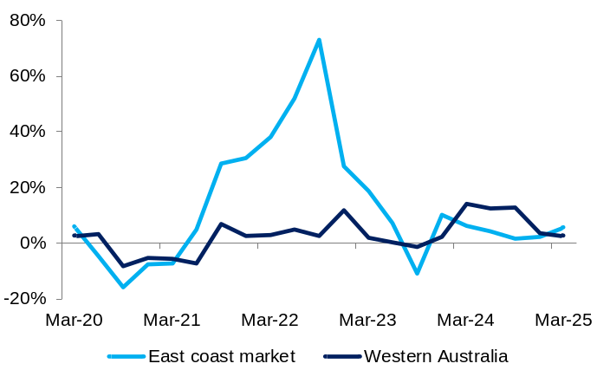
¹ Output prices of the domestic gas extraction industry. Original series.² Change from same quarter of previous year.
Source: Based on data from ABS Producer Price Indexes, Australia.

- The WA Domestic Gas Policy requires LNG exporters to make gas available to Western Australian consumers, equivalent to 15% of their LNG exports. This policy has helped stabilise domestic gas prices in Western Australia relative to Australia’s East coast market.
- The price of domestic gas extraction in Western Australia increased 2.7% between the March quarters of 2024 and 2025. Over the same period, the price of domestic gas extraction in the East coast market increased 5.7%.
- The relative price stability in Western Australia indicates that domestic supply has largely been sufficient to meet demand, while in the East coast market the influence of international oil and LNG demand and prices on the domestic gas market has contributed to greater volatility in the domestic gas price.

Western Australia’s LNG sales
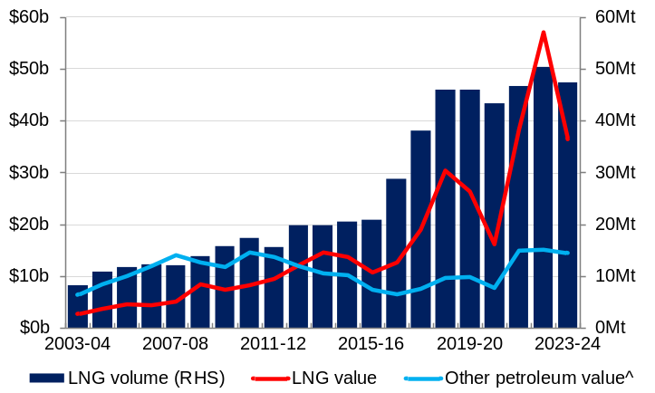
Mt = Million tonnes. ^ Includes condensate, crude oil, LPG and domestic gas.
Source: WA Department of Energy, Mines, Industry Regulation and Safety, Resource Data Files.

- The volume of Western Australia’s LNG sales in 2023-24 was 47.3 million tonnes, 5.9% lower than 2022-23.
- Lower volumes and a fall in average LNG prices led to a fall in the value of Western Australia’s LNG sales in 2023-24. The value of Western Australia’s LNG sales fell by 36% to $36.5 billion in 2023-24.
- The lower sales value for LNG in 2023-24 led to a fall in LNG’s share of Western Australia’s mineral and petroleum sales. In 2023-24, LNG accounted for 15% of the value of Western Australia’s total sales of minerals and petroleum ($237.7 billion), compared to 22% in 2022-23.
- Western Australia’s LNG projects also produce condensate and liquefied petroleum gas (LPG), mostly for export markets, and supply the majority of Western Australia’s domestic gas.

Western Australia’s LNG sales by market
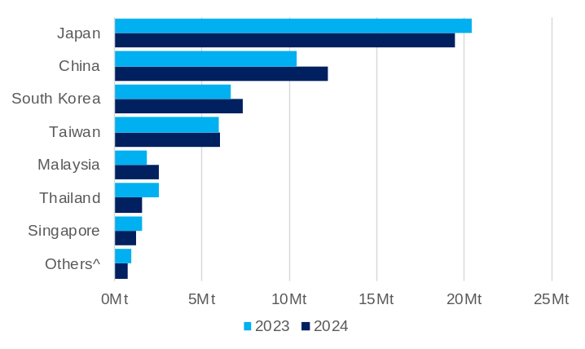
Mt = Million tonnes. ^ 2022-23 includes Brunei, India, Indonesia, Kuwait and Netherlands; 2023-24 includes India and Indonesia.
Source: EnergyQuest, Australian LNG Monthly Report.

- Japan was Western Australia’s first LNG customer in 1989 and remains the state’s largest customer. Western Australia accounted for around 28% of Japan’s LNG imports in 2023.
- In 2006, Western Australia became the first jurisdiction in the world to export LNG to China via the North West Shelf’s contract with Guangdong Dapeng LNG. Western Australia accounted for around 13% of China’s LNG imports in 2023.
- Of Western Australia’s total LNG exports in 2024:
  - Japan accounted for 38%
  - China accounted for 24%
  - South Korea accounted for 14%
  - Taiwan accounted for 12%
  - Malaysia accounted for 5%.

Western Australia’s LNG production by company: 2024
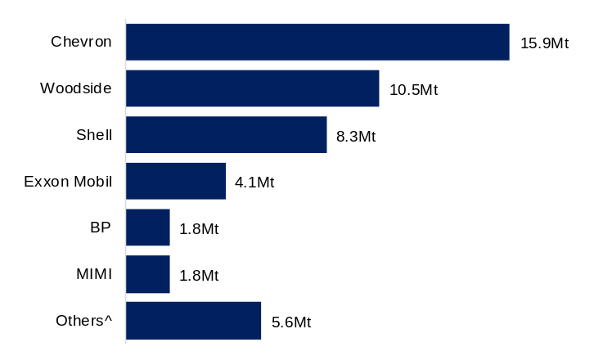
Mt = Million tonnes. ^ Includes Kufpec, CNOOC, PE Wheatstone, Tokyo Gas, Inpex, Kansai Electric, Kogas, Osaka Gas, Kyushu Electric, CPC and Jera.
Source: EnergyQuest, Energy Quarterly (March 2025).
- In 2024, Chevron (33%), Woodside (22%) and Shell (17%) accounted for the largest shares of Western Australia’s LNG production.
- Chevron has a 1/6th share of the North West Shelf project and is the operator and largest stakeholder in the Gorgon and Wheatstone projects.
- Woodside is the operator of the North West Shelf project. Woodside’s share of the North West Shelf project increased from 1/6 to 1/3 following its merger with BHP’s oil and gas portfolio in 2022. Woodside also has a 90% share and is the operator of the Pluto project and a 13% share of the Wheatstone project.
- In December 2024, Woodside and Chevron announced an agreement for an asset swap, which includes Woodside acquiring Chevron’s interest in the North West Shelf project and Chevron acquiring Woodside’s interest in the Wheatstone project. The transaction is expected to be finalised in 2026.
- Shell has a 1/6th share of the North West Shelf project, a 25% share of the Gorgon project and is the operator and largest stakeholder of the Prelude floating LNG project.

Western Australia’s LNG projects and associated developments¹ (as of 30 April 2025)
Project | Stakeholders | Capex  ($b) | Capacity (Mtpa) | Start of  operations | Details
North West Shelf  Trains 1-5 | Woodside (33.33%)²  BP (16.67%)  Chevron (16.67%)²  MIMI (16.67%)  Shell (16.67%) | 34.0 | 14.4 | September 1989 | The North West Shelf LNG project is located within the Burrup Strategic Industrial Area in Western Australia’s Pilbara region.  Trains 1 and 2 began in 1989, Train 3 in 1992, Train 4 in 2004 and Train 5 in 2008. Train 2 has now been taken offline.
Pluto  Train 1 | Woodside (90%)  MidOcean Energy (5%)  Kansai Electric (5%) | 15.0 | 4.9 | April  2012 | Pluto is currently a single train LNG project located within the Burrup Strategic Industrial Area in Western Australia’s Pilbara region.  In November 2021, a final investment decision was made to backfill and expand the Pluto LNG project with gas from the Scarborough fields (see Scarborough and Pluto Train 2 below).
Gorgon  Trains 1-3 | Chevron (47.3%)  ExxonMobil (25%)  Shell (25%)  Osaka Gas (1.25%)  MidOcean Energy (1%)  JERA (0.417%) | 55.0 | 15.6 | March 2016 | Gorgon is a three-train LNG project located on Barrow Island in Western Australia’s Pilbara region. Gorgon exported its first LNG cargo in March 2016. Trains 2 and 3 began production in October 2016 and March 2017 respectively.  In June 2023, Chevron announced first production from Gorgon Stage 2, which will help maintain gas supply to the Gorgon project through eleven additional wells in the Gorgon and Jansz-lo fields.
Wheatstone  Trains 1-2 | Chevron (64.14%)²  KUFPEC (13.4%)  Woodside (13%)²  PE Wheatstone (8%)  Kyushu Electric (1.46%) | 40.0 | 8.9 | October 2017 | Wheatstone is a two-train LNG project located within the Ashburton North Strategic Industrial Area in Western Australia’s Pilbara region. Train 1 began production in October 2017 and Train 2 began production in June 2018.
Prelude  Floating LNG vessel | Shell (67.5%)  Inpex (17.5%)  KOGAS (10%)  CPC (5%) | 19.6 | 3.6 | June  2019 | Prelude is a floating LNG project located in the Browse Basin. Prelude also produces up to 1.3 million tonnes of condensate a year and 0.4 million tonnes of LPG a year. The vessel is expected to operate at the Prelude gas field for 25 years and will also source gas from other fields (see Crux below).
Waitsia Stage 2  Development | Mitsui E&P (50%)  Beach Energy (50%) | 1.3 | n.a. | 2025 | Waitsia Stage 2 involves further development of the Waitsia gas field, including a production facility capable of producing 250 terajoules of gas a day. The Waitsia Joint Venture has an agreement to enable Waistia gas to be tolled and processed through the North West Shelf facilities to produce up to 7 million tonnes of LNG.  In April 2024, Beach Energy announced that first gas from the project would be delayed to 2025.
Jansz-lo Compression | See Gorgon | 6.0 | n.a | 2026 | In July 2021, Chevron announced it would build and install a 27,000 tonne floating field-control station, a 6,500 tonne subsea compression infrastructure and a 135-kilometre submarine power cable from the Jansz-lo gas field to the Gorgon project’s three LNG trains and gas plant on Barrow Island.
Scarborough and Pluto Train 2 | Scarborough Gas Fields  Woodside (74.9%)  JERA (15.1%)  LNG Japan (10%) | 18.8 | 5.0 | 2026 | Scarborough involves an offshore floating production unit capable of providing feed gas to produce 8 million tonnes a year of LNG plus domestic gas. The onshore development involves a new LNG train, modifications to Pluto Train 1 to allow it to process up to 3 million tonnes a year of LNG from Scarborough gas and a new domestic gas plant capable of producing 225 terajoules of gas a day.  In July 2024, Woodside announced project costs had increased by 4% to US$12.5 billion (estimated to be A$18.8 billion).
Scarborough and Pluto Train 2 | Pluto Train 2  Woodside (51%)  Global Infrastructure Partners (49%)
Crux | Shell (82%)  SGH Energy (15%)  Osaka Gas (3%) | 3.5 | n.a. | 2027 | In May 2022, Shell announced it would proceed with the development of the Crux gas field in the Browse Basin, which will be connected to the Prelude floating LNG vessel via a 160 kilometre pipeline.
Mtpa = million tonnes per annum. Capex = Capita expenditure. n.a. – not applicable.
¹ Major projects under construction or committed only. ² In December 2024, Woodside and Chevron announced an agreement for an asset swap, which includes Woodside acquiring Chevron’s interest in the North West Shelf project and Chevron acquiring Woodside’s interest in the Wheatstone project. The transaction is expected to be finalised in 2026.
Source: EnergyQuest, Energy Quarterly; WA Department of Jobs, Tourism, Science and Innovation; and company investor information (announcements, reports and presentations).

