Ready Contracts
Construction Contract Adjustment

This guide provides instructions on the steps required for adding a Construction Contract Adjustment.
There are defined tasks for the Super’s Rep and for the Contract Manager and this guide provides instructions for only the Super’s Rep tasks.

Locate the process via the Contract Dashboard Linked Processes widget.
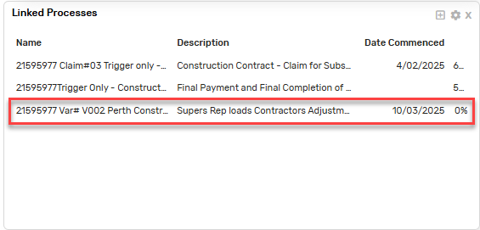
Enter the Assessed Adjustment Claim
- Click on the plus icon to add a new variation

Adjustment Header
- Enter the Adjustment header information including:
- Adjustment Type:
- Brief Statement: justification of the Adjustment
- Additional Information (if applicable)
- Adjustment Cause: select from the list.
- Attachment: upload a copy of the Contractor’s original claim
- Click Add

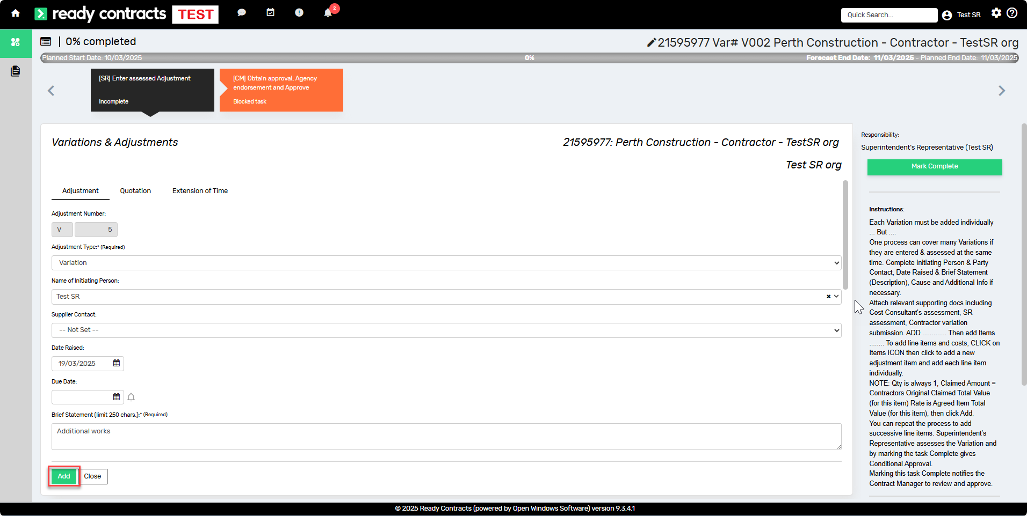

If the Adjustment relates to Extension of Time, click on the Extension of Time tab and complete the information.

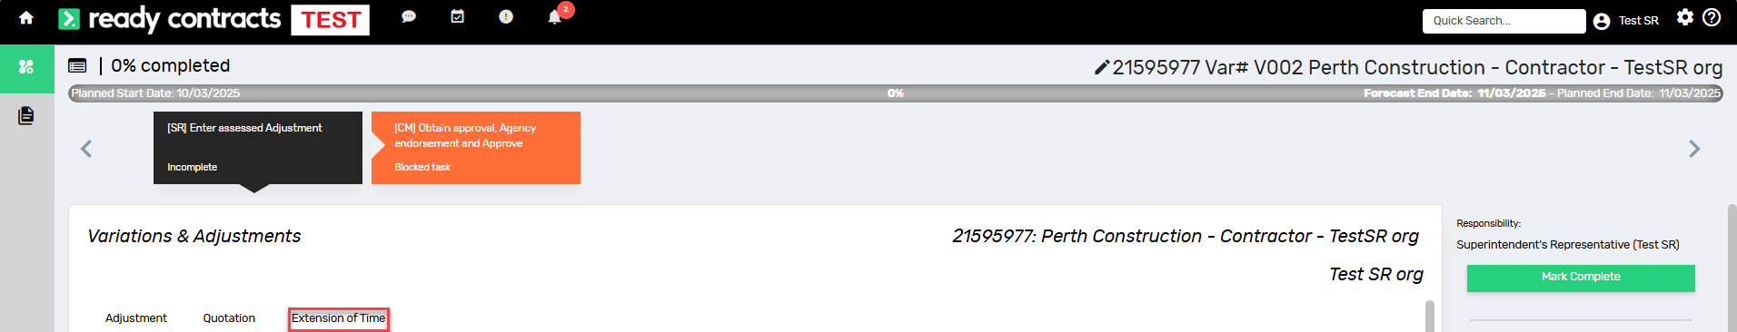

Adjustment Items
- Click the Items icon to add Adjustment line items,
- Then click the plus icon to Add an Adjustment item
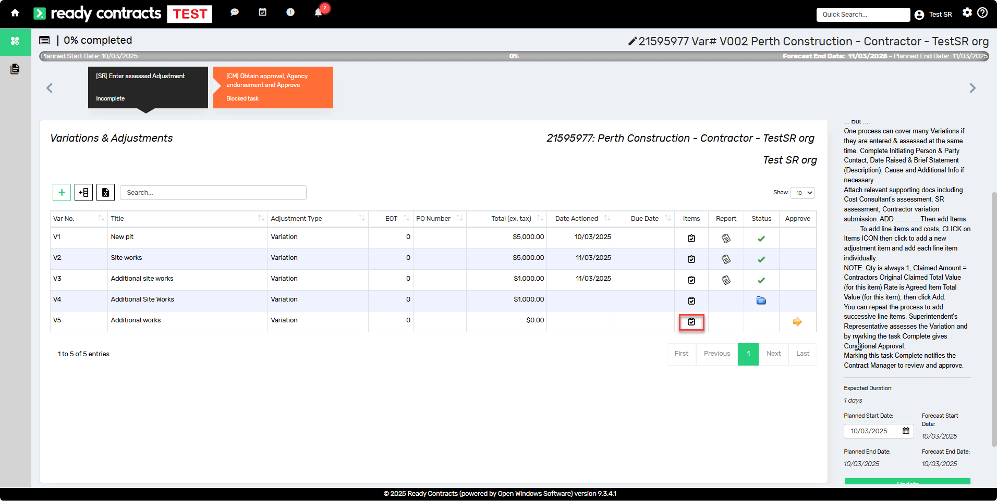

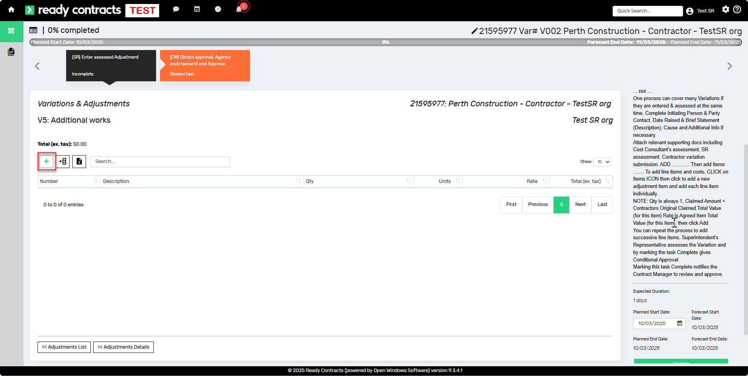
Populate the following:
- Item description:
- Quantity = 1
- Claimed Amount: the original amount submitted by the Contractor
- Rate: the lump sum of the variation item

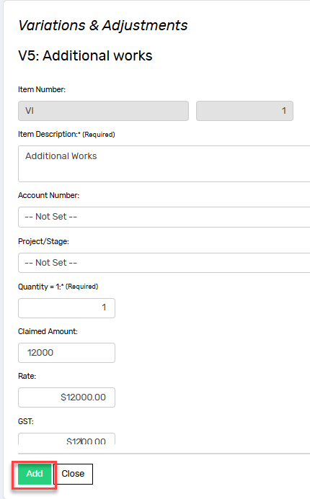
- Click Add
- Click on Adjustment Details to Preview the Certificate
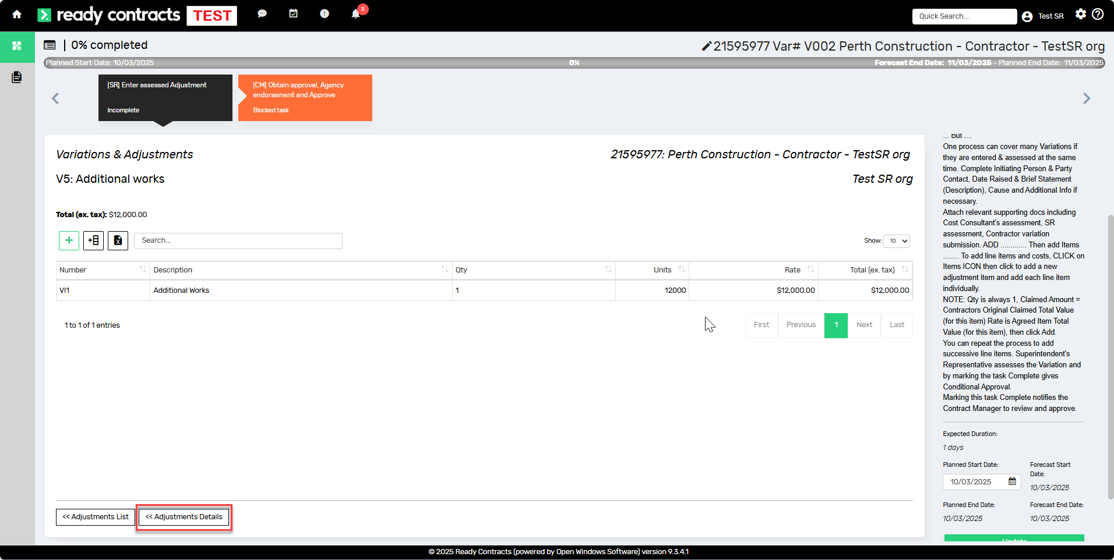
- Click on Preview Certificate button to preview the certificate and review the information.

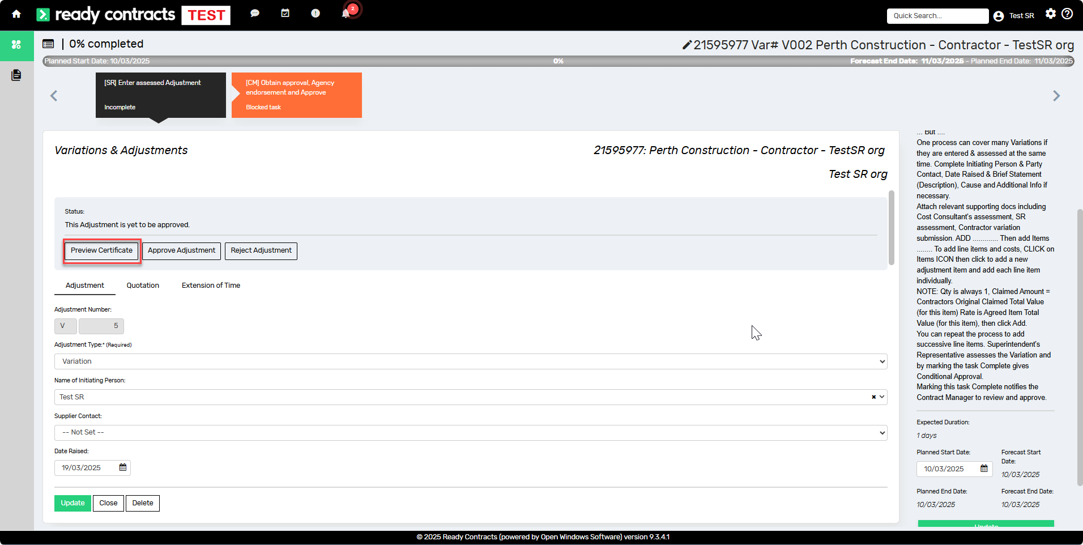

- Click 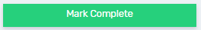

Marking this task Complete notifies the Contract Manager that you have completed your tasks.

The remaining tasks are for the Contract Manager to complete.

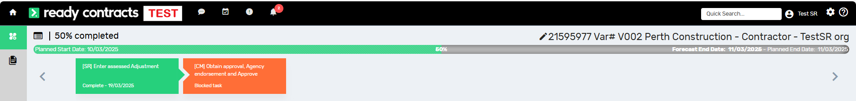

Document control
Approving Authority:  Senior Project Advisor |  | Business Unit:  Building and Contracts
Effective Date |  | Review Date | 20/11/2024
Replaces QRG | Construction Contract Adjustment
EDRMS File No. |  | Document No & Version | 1.0
Scope | Ready Contracts Construction Contract Adjustment process

