Quick Reference Guide
This QRG aligns with the Project Management Framework
Ready Contracts
Construction Contract First Payment Claim

This guide provides instructions on how to assess and approve the first payment claim of a Construction contract.
Contents
Where to find the First Payment Claim process 2
Contractor Lodges 1st Payment Claim with Super’s Rep (Day 0) 3
Assess the Contractor’s Claim 5
Construction Program approved 6
Full Bill of Quantities (BoQ) received if applicable 7
Check Bank Guarantees 7
Preview Certificate, Certify and then send to Contractor (by Day 10) 7
Attest to compliant Stat Decs by uploading compliant documents 8

Important Reminders:
- If valid Bank Guarantee(s) are NOT received prior to day 10 of the FIRST Payment Claim process then the Super’s Rep MUST APPROVE PAYMENT CLAIM as ZERO dollars giving the reason that the required securities were not received (this reason must be stated on the payment certificate).
- PACMan checks every night for payment claims, details of which are recorded in a file and sent to the Financial system for payment.
- There are 3 steps that must be met in order for this payment claim to be PAID:
- The Payment Claim was loaded via a process.
- The Payment Certificate has been saved.
- The process is marked as complete by the Contract Manager.

You will receive an email and an in-system reminder that the Contract Manager has completed the Contract setup.

Where to find the First Payment Claim process
The First Payment Claim process can be found in Contracts > Contract Dashboard > Linked Processes widget

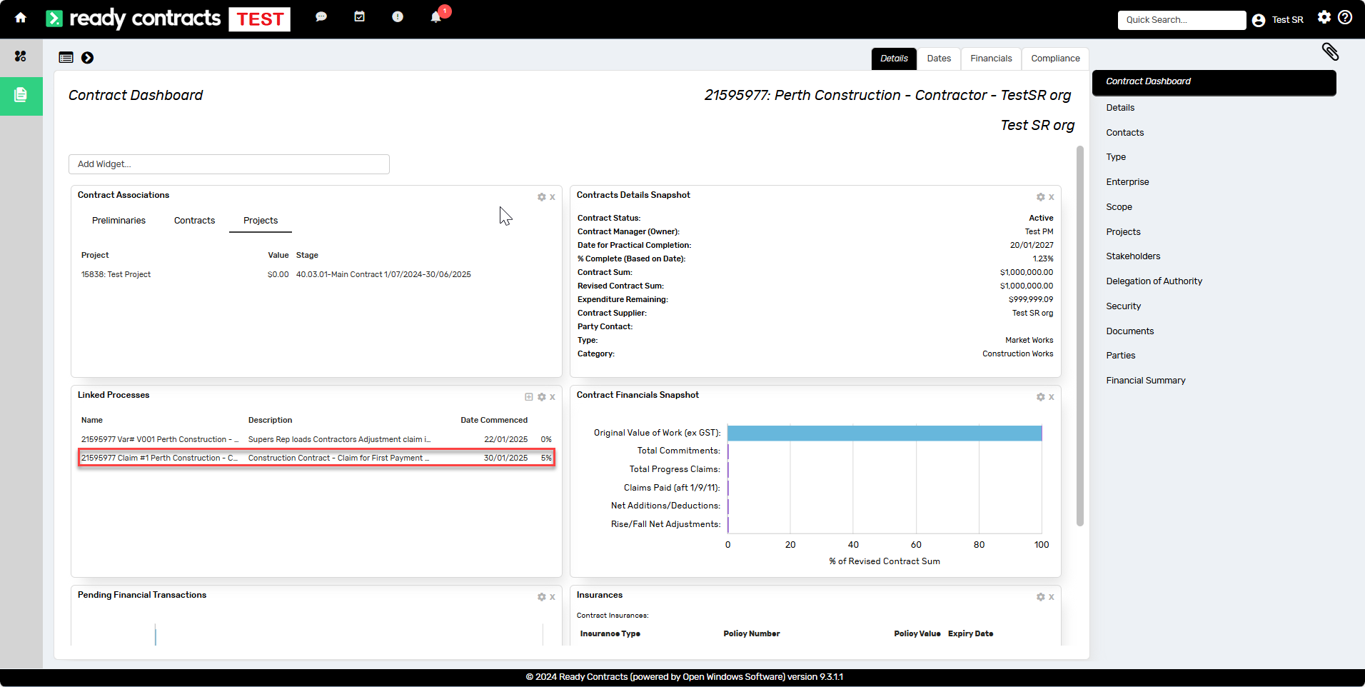
Click on the process to get started.
Note: The Contractor's claim MUST be loaded through this process.

You will notice that the Superintendent’s Representative (SR) tasks are grouped. Some tasks will be marked Blocked and some Not Applicable depending on the Form of Contract and the task responsibilities.
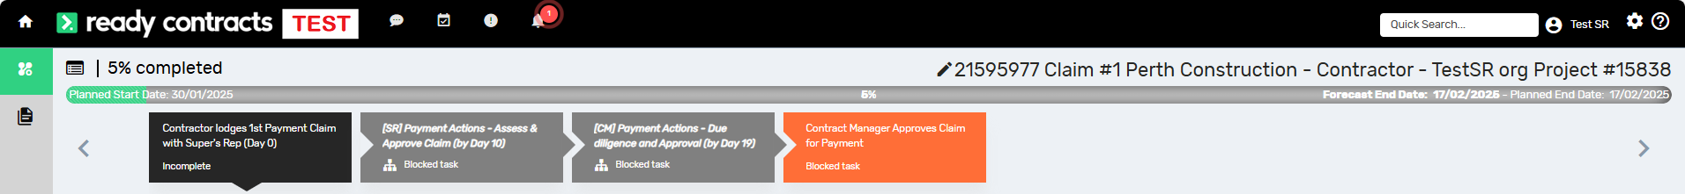

Contractor Lodges 1st Payment Claim with Super’s Rep (Day 0)

The Add Payment Claim entry screen will display
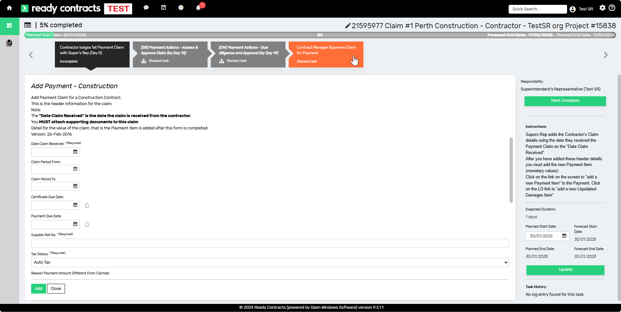

- When completing the Add Construction Payment form ensure you enter the following information:
- Date Claim Received (Date the SR received the claim)
- Claim Period From (Must be provided)
- Claim Period To (Must be provided)
- Supplier Reference Number (Builders Reference Number)
- Reason Payment Amount Different from Claimed (n/a here, only entered when the claim has been assessed)
- All the relevant checkboxes are ticked
- All supporting documentation uploaded

- Once you have entered this information click Add.

Before adding amount details for this claim, check the following:
- Payment Number (reflects process link)
- Process Link (reflects same payment number)
- Select the plus icon .
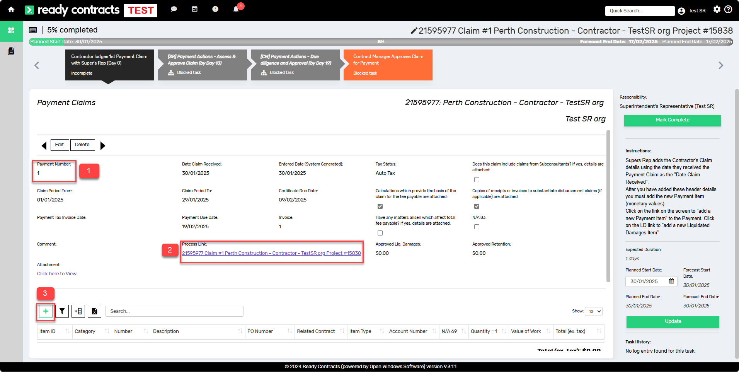

- Select Add Payment Item
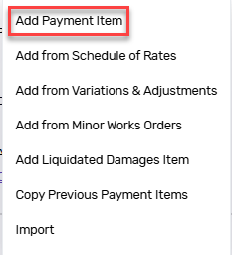

- Enter the following details:
- Account Number (leave this as the default)
- Item ID (number this sequentially)
- Number (number this sequentially)
- Description (Enter a description of the payment)
- Claimed amount (enter the claimed amount)
- Quantity (this should always be 1)
- Value of Work (assessed amount)
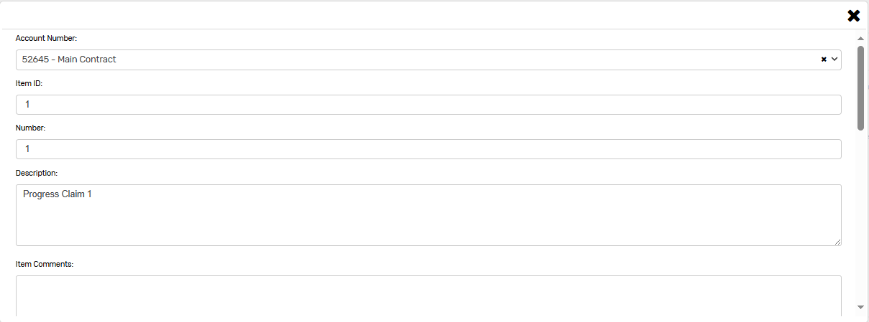
- Click Add.
Use the  button to complete the task

Assess the Contractor’s Claim
- You may receive advice from the Cost Manager & Contract Manager (if applicable)
- Review the contractor’s claim

If you are certifying the value of work as being the same as what the contractor claimed, click to progress.

If you are certifying the value of work as being different to what the contractor claimed, then advise the contractor that you have revised the claim and you must write your reason on the payment certificate (a statement that only says “refer attached QS report” is not acceptable as a reason). To add the reason to the certificate, access the payment certificate screen, click on “Edit Payment” within the header, and type the reason in the “Reason Payment Amount Different from Claimed” field.

If the payment claim contains provisional sums, load adjustments to reflect actual values incurred
- If the contract doesn’t contain Provisional Sums, select 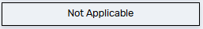
- If the task is applicable, complete the adjustment task.

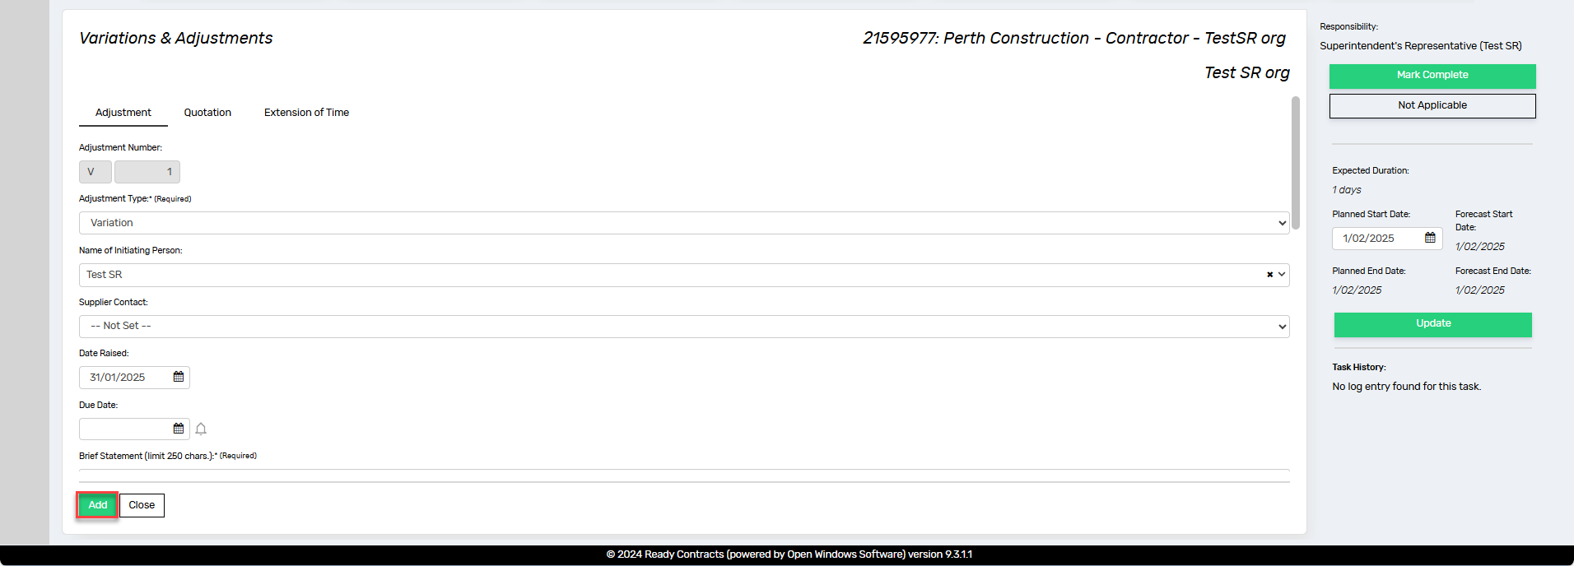
- Complete all relevant fields and click Add.
- Click on the Items icon  and then the plus icon to enter the provisional sum details
- Enter the details. If it is a reduction in provisional sum, enter a negative adjustment

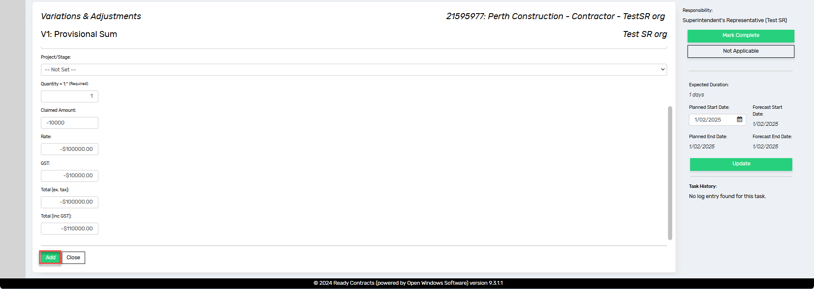

- Click Add
- Click on the <<Adjustments List button and then the yellow arrow to approve the adjustment
- Click to progress

Construction Program approved
This is an external task.
- Read instructions and to confirm that the Construction Program has been received and approved.
- If the Construction Program has not been received, the payment claim must be amended to equal $0.00. Refer step 5 above.

Full Bill of Quantities (BoQ) received if applicable
- Read instructions and to confirm that the Bill of Quantities has been received and approved if applicable.
- If the priced Bill of Quantities is applicable and has not been received, the payment claim must be amended to equal $0.00. Refer step 5 above.
- Click if a priced Bill of Quantities is not applicable to the contract

Check Bank Guarantees
- Review existing Securities. If no securities exist, the payment claim must be amended to equal $0.00. Refer step 5 above
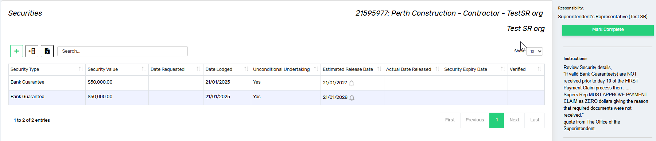
- Click to proceed

If the Contractor's Claim was adjusted, advise Contractor and Contract Manager
This is an external task
if you advised the Contractor by email that the payment claim they submitted was adjusted and ensure you have entered the contractual reason on the payment certificate (by clicking on “Edit Payment” within the payment certificate header and type the reason in the “Reason Payment Amount Different from Claimed” field. The reason cannot simply be listed as “refer attached QS report”).
If not, select .

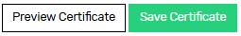
Preview Certificate, Certify and then send to Contractor (by Day 10)
- Click the Preview Certificate button
- If satisfied, click Save Certificate
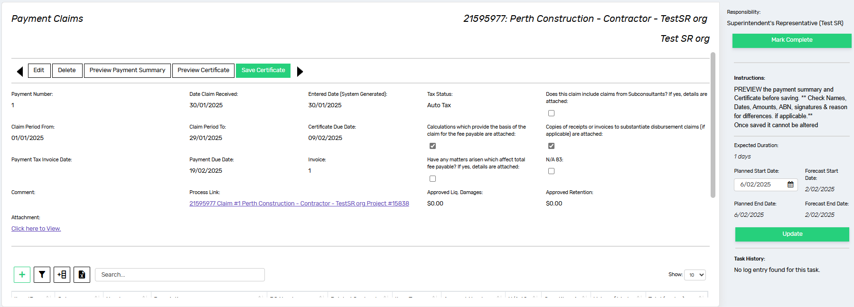
- You will need to confirm this action by clicking Save a second time. When you complete this step, the payment certificate is listed in the Payment Approval History list at the bottom of the payment claim screen
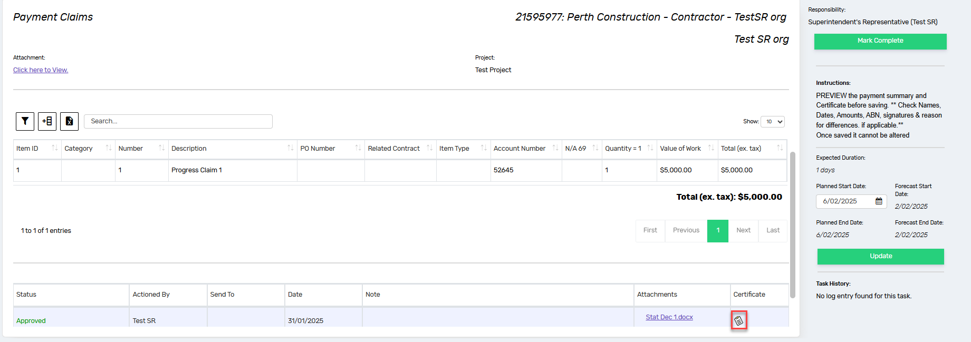
- Click to proceed

Attest to compliant Stat Decs by uploading compliant documents
This task is automatically marked Not Applicable if the contract is a PBA (Project Bank Account) contract.
- If it is not a PBA contract, this task is automatically applicable, so proceed by clicking on the plus icon
- Enter the Document Title, select Statutory Declarations as the Document Type and Upload New Document
- Click Add
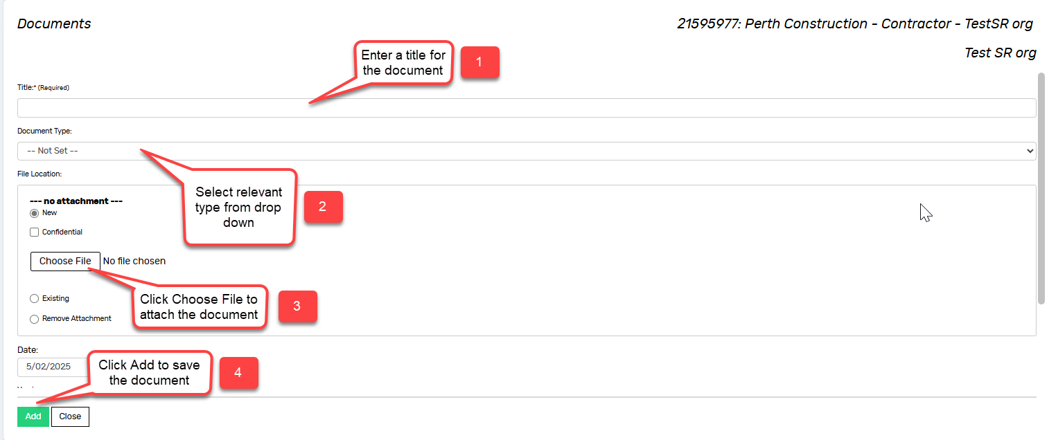
- Click to proceed

Your tasks for the 1st Payment Claim are now complete.
The Contract Manager will be notified that you have completed these tasks.
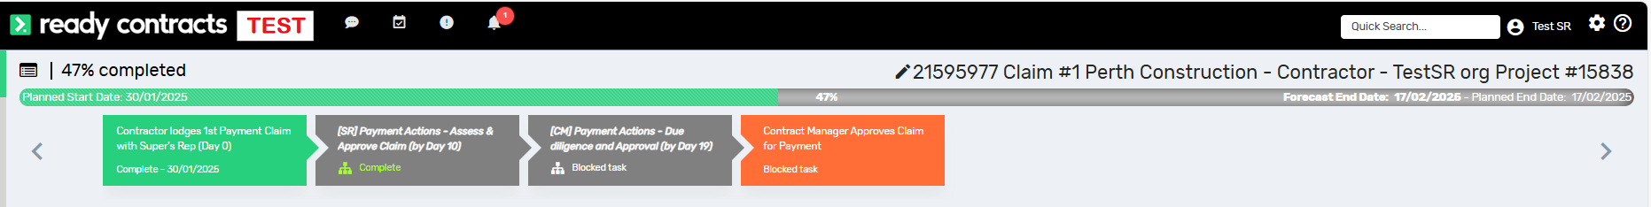

Document control
Approving Authority:  Senior Project Advisor |  | Business Unit:  Building and Contracts
Effective Date |  | Review Date
Replaces QRG | [SR] Construction Contract – Claim for First Payment
EDRMS File No. |  | Document No & Version | 1.0
Scope | Ready Contracts First Payment Claim

