Quick Reference Guide
This QRG aligns with the Project Management Framework
Ready Contracts
Construction Contract Subsequent Payment Claim

This guide provides instructions on how to assess and approve the subsequent payment claim of a Construction contract.
Contents
Where to find the Subsequent Payment Claim process 1
Contractor Lodges Subsequent Payment Claim with Super’s Rep (Day 0) 2
Assess the Contractor’s Claim 4
If Rise and Fall applies 5
Preview Certificate, Certify and then send to Contractor (by Day 10) 6
Attest to compliant Stat Decs by uploading compliant documents 6

Important Reminders:
- Ready Contracts checks every night for payment claims, details of which are recorded in a file and sent to the Financial system for payment.
- There are 3 steps that must be met in order for this payment claim to be PAID:
- The Payment Claim was loaded via a process.
- The Payment Certificate has been saved.
- The process is marked as complete by the Contract Manager.

Where to find the Subsequent Payment Claim process
The Subsequent Payment Claim process can be found in Contracts > Contract Dashboard > Linked Processes widget
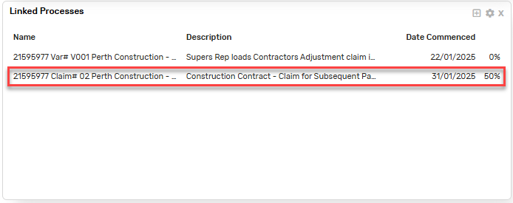
Click on the process to get started.
Note: The Contractor's claim MUST be loaded through this process.

You will notice that the Superintendent’s Representative (SR) tasks are grouped. Some tasks will be marked Blocked and some Not Applicable depending on the Form of Contract and the task responsibilities.
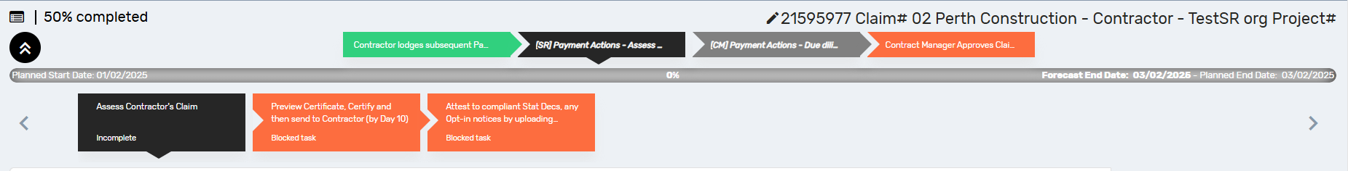

Contractor Lodges Subsequent Payment Claim with Super’s Rep (Day 0)
The Add Payment Claim entry screen will display
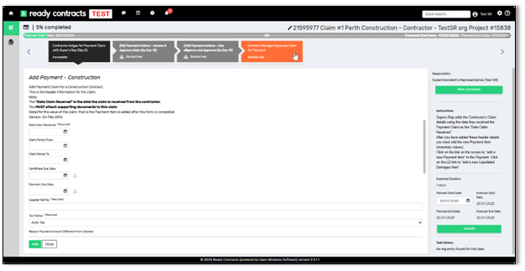

- When completing the Add Construction Payment form ensure you enter the following information:
- Date Claim Received (Date the SR received the claim)
- Claim Period From (Must be provided)
- Claim Period To (Must be provided)
- Supplier Reference Number (Builders Reference Number)
- Reason Payment Amount Different from Claimed (n/a here, only entered when the claim has been assessed)
- All the relevant checkboxes are ticked
- All supporting documentation uploaded

- Once you have entered this information click Add.

Before adding amount details for this claim, check the following:
- Payment Number (reflects process link)
- Process Link (reflects same payment number)
- Select the plus icon .
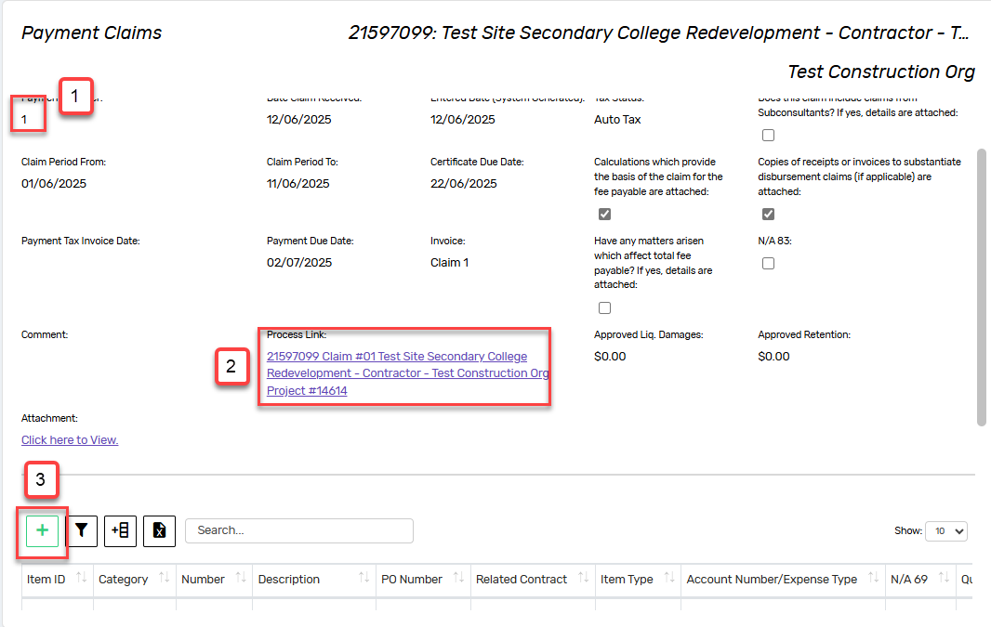

- Select Add Payment Item
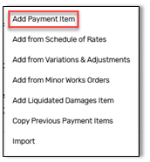

- Enter the following details:
- Account Number (leave this as the default)
- Item ID (number this sequentially)
- Number (number this sequentially)
- Description (Enter a description of the payment)
- Claimed amount (enter the claimed amount)
- Quantity (this should always be 1)
- Value of Work (assessed amount)
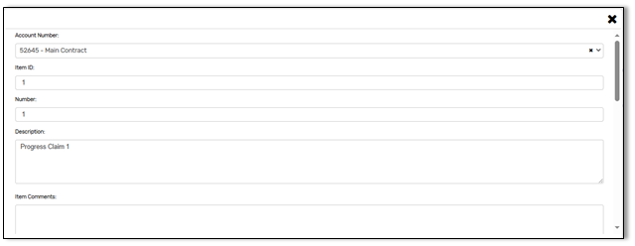
- Click Add.

- Use the  button to complete the task

Assess the Contractor’s Claim
- You may receive advice from the Cost Manager & Contract Manager (if applicable)
- Review the contractor’s claim

If you are certifying the value of work as being the same as what the contractor claimed, click to progress.

If you are certifying the value of work as being different to what the contractor claimed, then advise the contractor that you have revised the claim and you must write your reason on the payment certificate (a statement that only says “refer attached QS report” is not acceptable as a reason). To add the reason to the certificate, access the payment certificate screen, click on “Edit Payment” within the header, and type the reason in the “Reason Payment Amount Different from Claimed” field

If Rise and Fall applies
If the contract is subject to Rise and Fall, this must be calculated prior to certifying the payment.
- Click the Calculate Rise And Fall button
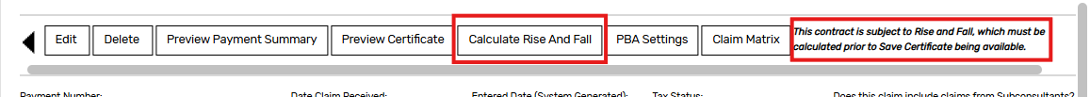
- Enter the Effective Value. This is defaulted to the full payment claim amount, however is editable if necessary. Refer to Rise and Fall provisions for guidance.
- Click 
- Click 
- Click Confirm on the warning validation message.

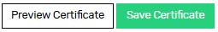
Preview Certificate, Certify and then send to Contractor (by Day 10)
- Click the Preview Certificate button
- If satisfied, click Save Certificate
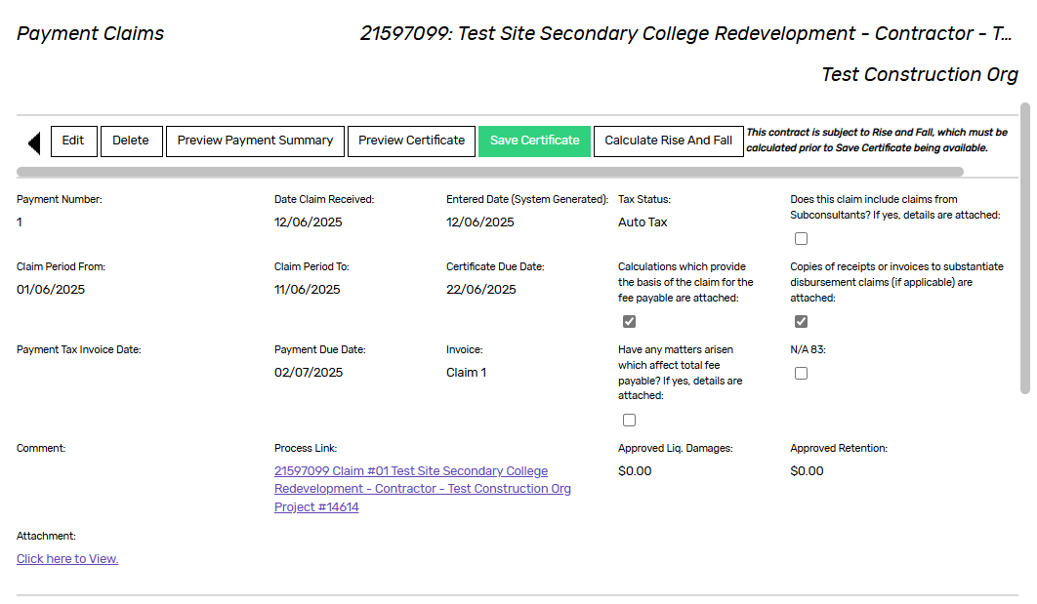
- You will need to confirm this action by clicking Save a second time. When you complete this step, the payment certificate is listed in the Payment Approval History list at the bottom of the payment claim screen
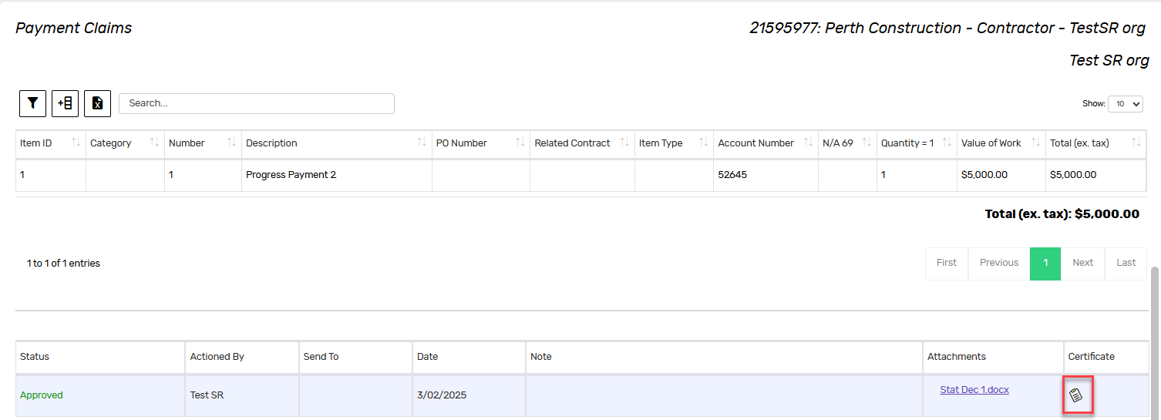
- Click to proceed

Attest to compliant Stat Decs by uploading compliant documents
This task is automatically marked Not Applicable if the contract is a PBA (Project Bank Account) contract.
- If it is not a PBA contract, this task is automatically applicable, so proceed by clicking on the plus icon
- Enter the Document Title, select Statutory Declarations as the Document Type and Upload New Document
- Click Add
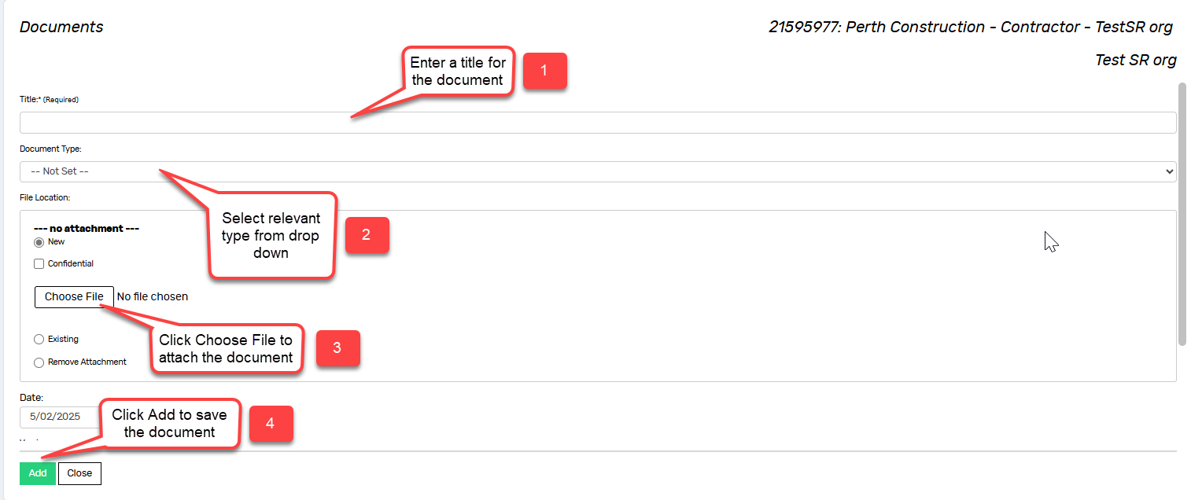
- Click to proceed

Your tasks for the Subsequent Payment Claim are now complete.
The Contract Manager will be notified that you have completed these tasks.

Document control
Approving Authority:  Senior Project Advisor |  | Business Unit:  Building and Contracts
Effective Date |  | Review Date | 20/11/2025
Replaces QRG | Construction Contract – Claim for Subsequent Payment
EDRMS File No. |  | Document No & Version | 2.0
Scope | Ready Contracts Subsequent Payment Claim

